
AI-Powered Voice Agent for Saudi Labor Law Inquiries
Prepared By
Name: Hussam Almokayed ID No.: 253001038
Name: Fatimah Aldeghaither ID No.: 253000292
Submitted in fulfillment of the requirements for the degree Master of Science in Artificial Intelligence
College of Informatics, Midocean University, UAE
Supervisor: Dr. Hager Saleh

Abstract
This thesis presents an AI-powered Arabic voice agent for answering Saudi Labor Law inquiries using a modular pipeline that integrates automatic speech recognition (ASR), retrieval-augmented generation (RAG), large language models (LLMs), text-to-speech (TTS), guardrails, and latency optimization. The motivation is that labor-law inquiries are repetitive, high-volume, and legally sensitive, while conventional intent-menu automation cannot reliably handle natural spoken Arabic questions or provide grounded legal citations. The proposed system builds a leakage-safe legal knowledge base from official Saudi Labor Law articles and HRSD frequently asked questions, creates structured and fixed-size chunks, indexes them in ChromaDB, and evaluates dense, sparse, hybrid, and reranked retrieval strategies. The generation layer compares ALLaM-7B and Qwen2.5-7B under the same retrieved legal context and uses constrained prompting and reliability gates to reduce unsupported answers. The evaluation covers retrieval quality, answer accuracy, faithfulness, hallucination behavior, ASR quality, TTS intelligibility proxy, ablations, and end-to-end latency. On the expanded legal evaluation set, the best retrieval configuration achieved Recall@1 of 0.836, Recall@5 of 0.965, MRR of 0.890, and nDCG@5 of 0.909. ALLaM-7B achieved slightly higher answer accuracy than Qwen2.5-7B (0.73 versus 0.69), but a paired McNemar test indicated that the difference was not statistically significant (p = 0.63). The RAG-based system reduced wrong or hallucinated legal citations from 25% in the No-RAG baseline to 4%. The voice layer achieved an ASR WER of approximately 0.198 and CER of 0.046 under synthetic speech evaluation, while latency optimization reduced end-to-end response time from 4.07 seconds to 3.03 seconds, with perceived streaming latency of approximately 0.95 seconds. These results show that a carefully designed Arabic legal RAG pipeline can improve citation grounding and practical responsiveness for voice-based legal assistance, while human-recorded speech and human TTS quality ratings remain important future validation steps.
Keywords: Arabic voice agent, Saudi Labor Law, retrieval-augmented generation, automatic speech recognition, text-to-speech, ChromaDB, legal question answering, hallucination reduction.

Table of Contents
Section | Page
Abstract | 2
Chapter 1: Introduction and Overview | 4
Chapter 2: Background and Related Work | 5
Chapter 3: Methodology and Proposed System | 7
Chapter 4: Experimental Setup and Evaluation Protocol | 9
Chapter 5: Results and Analysis | 10
Chapter 6: Discussion, Limitations, and Future Work | 13
Chapter 7: Conclusion | 14
References | 15
Appendix A: Reproducibility Checklist | 16

Chapter 1: Introduction and Overview

1.1 Overview
Conversational artificial intelligence has become an important interface between users and digital services. Recent progress in ASR, LLMs, RAG, and TTS makes it possible to design voice agents that understand spoken input, retrieve trusted knowledge, generate grounded answers, and respond in natural speech. These capabilities are particularly useful in public-service and legal-information settings, where users need accessible and accurate answers rather than generic conversation.
Saudi Labor Law inquiries are a suitable and challenging domain for such a system. Users may ask about probation periods, end-of-service benefits, employment contracts, working hours, resignation, termination, transfer, and other rights and obligations. These questions often require precise citation to an article or official FAQ answer. A wrong answer may mislead a worker or employer; therefore, the system must be designed to reduce hallucination and to clearly cite retrieved legal evidence.

1.2 Problem Definition
Labor-law service channels face three connected problems. First, the number of repetitive inquiries can be high, which increases waiting time and service pressure. Second, conventional menu-based automation cannot cover the wide range of natural Arabic questions that users may ask. Third, legal answers require factual grounding, because unsupported statements or wrong article citations can reduce trust and cause practical harm. These challenges become more complex in Arabic voice interaction because spoken queries may include dialectal forms, informal phrasing, hesitations, and transcription errors.
The research problem is therefore: how can an Arabic voice agent be designed to answer Saudi Labor Law inquiries in a way that is grounded in official sources, robust to natural questions, measurable across retrieval and generation components, and responsive enough for an interactive voice experience?

1.3 Research Aim and Objectives
The main aim of this thesis is to design, implement, and evaluate an Arabic AI voice agent for Saudi Labor Law inquiries. The system combines ASR, RAG, LLM generation, guardrails, TTS, and latency optimization in a single experimental pipeline.
- Build a leakage-safe Saudi Labor Law and HRSD FAQ knowledge base from official sources.
- Evaluate multiple retrieval strategies, including dense retrieval, BM25, hybrid retrieval, and hybrid retrieval with reranking.
- Compare Arabic-capable LLMs for grounded legal answer generation under the same retrieved context.
- Implement safety controls such as intent detection, reliability gating, citation constraints, and safe refusal for out-of-scope questions.
- Evaluate the voice interface using ASR WER/CER, TTS intelligibility proxy, and end-to-end latency.
- Quantify the value of RAG using baselines and ablations, especially No-RAG versus RAG legal-citation behavior.

1.4 Thesis Contributions
- An end-to-end Arabic voice-agent architecture specialized for Saudi Labor Law inquiries.
- A leakage-safe legal RAG data preparation pipeline that separates indexed knowledge from held-out evaluation data.
- A retrieval benchmark over structural and fixed-size chunking using dense, sparse, hybrid, and reranked retrieval strategies.
- A grounded answer-generation benchmark comparing ALLaM-7B and Qwen2.5-7B with legal-citation constraints.
- A rigorous evaluation layer using bootstrap confidence intervals, paired significance testing, LLM-as-judge analysis, and ablation studies.
- A voice-layer and latency analysis showing the practical responsiveness of the system and identifying remaining bottlenecks.

1.5 Thesis Organization
Chapter 2 reviews the background and related work in voice agents, Arabic ASR, RAG, Arabic legal question answering, LLMs, and TTS. Chapter 3 presents the methodology and proposed system architecture. Chapter 4 describes the experimental setup and evaluation protocol. Chapter 5 reports and analyzes the results. Chapter 6 discusses the findings, limitations, and future work. Chapter 7 concludes the thesis.

Chapter 2: Background and Related Work

2.1 Conversational Voice Agents
A voice agent is a conversational system that receives user speech, transcribes it to text, interprets or retrieves the relevant context, generates a response, and produces speech output. Modern systems increasingly use modular pipelines because each component can be evaluated and optimized separately. For a legal domain, this modularity is important because errors can originate from transcription, retrieval, generation, or synthesis; a single overall accuracy number is not enough to diagnose the system.

2.2 Automatic Speech Recognition for Arabic
ASR converts spoken input into text. Whisper demonstrated strong multilingual speech recognition performance through large-scale weak supervision [3]. However, Arabic remains challenging because of dialect diversity, morphology, pronunciation variation, and the gap between spoken dialects and formal legal text. For this reason, this thesis evaluates ASR using WER, CER, and latency rather than assuming perfect transcription.

2.3 Retrieval-Augmented Generation
RAG addresses a core weakness of LLMs: their tendency to produce fluent but unsupported answers. In RAG, external documents are retrieved at inference time and supplied to the LLM as grounding evidence. Survey work describes RAG as a way to improve accuracy, transparency, and domain specificity for knowledge-intensive tasks [4]. In legal applications, RAG is especially relevant because answers should cite official articles or policy text rather than rely only on parametric model memory.

2.4 Arabic Legal Question Answering
Arabic legal question answering combines the general challenges of Arabic NLP with the strictness of legal reasoning. The model must understand the question, retrieve relevant provisions, avoid unsupported extrapolation, and present an answer that users can trust. Prior Arabic legal and religious QA studies show the value of grounding and domain-specific retrieval, but many focus either on text-only QA or on domains other than Saudi Labor Law. This thesis addresses that gap by implementing a complete voice-enabled legal RAG pipeline for Saudi Labor Law inquiries.

2.5 Large Language Models for Arabic Legal Answers
LLMs are transformer-based models capable of generating fluent answers, but fluency alone is insufficient in legal contexts. This thesis evaluates ALLaM-7B, an Arabic-focused model developed to advance Arabic language technology, and Qwen2.5-7B, a strong multilingual instruction model [10], [11]. Both models are tested under the same retrieved context so that the comparison focuses on grounded answer generation rather than differences in retrieval input.

2.6 Text-to-Speech and Responsiveness
TTS converts generated text back into speech. In a real voice agent, perceived responsiveness is as important as answer accuracy, because long delays make the system feel unusable. This thesis therefore measures end-to-end latency and distinguishes between total response time and perceived latency under streaming. TTS naturalness and MOS require human listening panels; therefore, this project treats them as future work and uses ASR round-trip WER/CER as an intelligibility proxy.

2.7 Research Gap
Existing studies typically address one component at a time: Arabic ASR, legal RAG, LLM answer generation, or TTS. Fewer studies integrate these modules into a single Arabic voice-agent pipeline and evaluate retrieval, generation, safety, voice quality, ablation, and latency together. There is also limited work focused specifically on Saudi Labor Law inquiries using official sources, article-level grounding, leakage-safe evaluation, and citation-error analysis. This thesis contributes by closing this integration and evaluation gap.

2.8 Summary of Related Work
Area | Representative Work | Relevance to This Thesis | Remaining Gap
RAG Survey | Gao et al. [4] | Provides conceptual foundation for retrieval-grounded generation. | General RAG, not Arabic legal voice agents.
Whisper ASR | Radford et al. [3] | Supports multilingual ASR layer and WER evaluation. | Does not solve Saudi legal QA.
Arabic Legal Reasoning | ALARB and Arabic legal RAG studies [23], [24] | Shows importance of Arabic legal evaluation and grounding. | Mostly text-only and not labor-law voice systems.
Arabic RAG Optimization | Arabic RAG component studies [25] | Supports comparing chunking, embeddings, and reranking. | Not focused on Saudi Labor Law voice interaction.
Streaming / TTS | SpeechGPT, CM-TTS, LLMVoX [21], [22] | Motivates voice interaction and latency analysis. | TTS human quality assessment remains future work.

Chapter 3: Methodology and Proposed System

3.1 System Overview
The proposed system is a modular Arabic voice-agent pipeline. A user submits a spoken or written question. The ASR layer transcribes the audio if speech is used. The text query is processed by an intent gate that detects greetings, domain questions, and out-of-scope requests. For valid legal questions, the RAG layer retrieves relevant legal context from the ChromaDB vector database. The LLM then generates a constrained answer that cites the retrieved legal evidence. The TTS layer produces the spoken response. Evaluation modules measure each component separately and jointly.
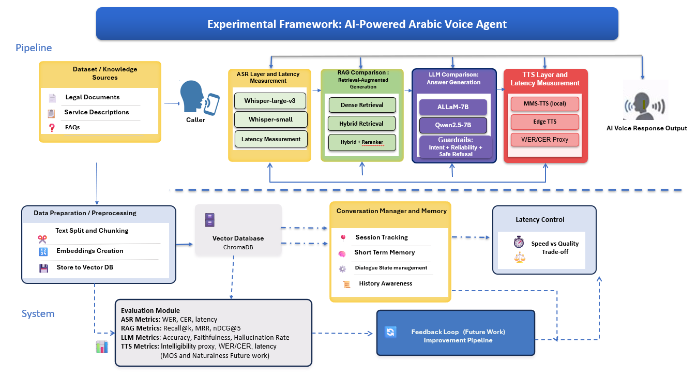
Figure 3.1: Proposed experimental framework for the AI-powered Arabic voice agent.
The figure represents the complete experimental framework. Quantitative claims in this thesis are limited to components implemented and evaluated in the notebooks. Future-work components, such as continuous feedback loops and human-rated TTS MOS, are clearly separated from final performance claims.

3.2 Data Sources
The knowledge base is built from official Saudi Labor Law articles and HRSD FAQ content. Using official sources is essential because the system answers legal-information questions and must avoid relying on unofficial summaries. The data collection stage scrapes law articles, article numbers, titles, and FAQ question-answer pairs, then runs integrity checks before downstream processing.

3.3 Data Preparation and Leakage Control
Data preparation includes Arabic text cleaning, normalization, removal of invalid records, separation of active and repealed articles, domain filtering for FAQs, and construction of a unified legal knowledge base. A leakage-safe split is applied to FAQ content so that evaluation items do not overlap with indexed items by ID. Content-level leakage detection using character n-gram similarity is also used to identify near duplicates. This is important because leakage can inflate retrieval and generation scores and make the system appear stronger than it actually is.

3.4 Chunking Strategies
Two chunking strategies are evaluated. Structural legal chunking preserves article-level and section-level legal boundaries, which is appropriate for law texts because article numbers and legal structure carry meaning. Fixed-size chunking is used as a baseline to test whether structure-aware chunking improves retrieval. This comparison strengthens the methodology because it avoids assuming that one segmentation strategy is best without evaluation.

3.5 Embeddings, Vector Store, and Retrieval
The retrieval layer evaluates multilingual-e5-large and BGE-M3 embeddings, BM25 sparse retrieval, hybrid retrieval, and BGE reranking. ChromaDB is used as the persistent vector store because it supports embedding storage, metadata, and retrieval workflows [6]. Hybrid retrieval combines lexical and semantic evidence, while the reranker reorders candidate passages using a query-passage relevance model. The best configuration is selected using Recall@k, MRR, and nDCG@5.

3.6 Reliability Gate and Guardrails
A legal voice agent should not answer every question. The system therefore includes an intent gate and reliability gate. Greetings and small-talk are handled separately. Out-of-scope questions receive a safe refusal. For in-domain questions, retrieval confidence is checked before the LLM is allowed to generate a legal answer. This design reduces hallucination risk and makes the system safer for legal-information use.

3.7 Grounded LLM Generation
The generation stage compares ALLaM-7B and Qwen2.5-7B using the same retrieved legal context. The prompt instructs the model to answer only from the retrieved evidence, cite the relevant article or official source, and avoid unsupported legal claims. Both models are evaluated using answer accuracy, citation correctness, faithfulness, hallucination rate, and latency.

3.8 Voice Layer
The voice layer implements speech input and spoken output. ASR is evaluated using WER, CER, and latency. TTS is evaluated using intelligibility proxy through TTS-to-ASR round-trip scoring. Because naturalness and MOS require human listeners, they are reported as future work rather than as final quantitative results.

3.9 Implementation Pipeline
Stage | Notebook | Purpose
Stage 01 | Data Collection | Scrape Saudi Labor Law articles and HRSD FAQ content.
Stage 02 | Data Preparation | Clean Arabic text, split data safely, build knowledge base and chunks.
Stage 03 | RAG Retrieval Evaluation | Build ChromaDB index and benchmark retrieval strategies.
Stage 04 | Evaluation Set Expansion | Generate and validate additional legal questions.
Stage 05 | LLM Generation | Compare ALLaM-7B and Qwen2.5-7B under retrieved context.
Stage 06 | Rigorous Evaluation | Compute bootstrap CIs, McNemar test, and LLM-as-judge metrics.
Stage 07 | Voice Layer | Evaluate ASR/TTS and produce demo audio.
Stage 08 | Baselines and Ablations | Compare No-RAG vs RAG and retriever families.
Stage 09 | Latency Analysis | Measure and optimize end-to-end latency.

Chapter 4: Experimental Setup and Evaluation Protocol

4.1 Evaluation Design
The evaluation is designed to measure the system at multiple levels. Retrieval is evaluated before generation because poor retrieval limits answer quality. Generation is then evaluated under the best retrieval configuration. Voice and latency are evaluated separately to determine whether the system is usable as an interactive agent. Ablation experiments isolate the value of RAG by comparing the full system against No-RAG and weaker retrieval alternatives.

4.2 Retrieval Metrics
Retrieval quality is measured using Recall@1, Recall@5, MRR, and nDCG@5. Recall@k measures whether the gold legal article appears within the top-k retrieved results. MRR rewards systems that rank the first correct result higher. nDCG@5 evaluates ranking quality within the top five. Precision@k is not emphasized because each question has a single gold article, making Recall@k and ranking metrics more informative.

4.3 Generation Metrics
Generation is evaluated using answer accuracy, article-citation correctness, context support, faithfulness, hallucination rate, and latency. The evaluation distinguishes between a fluent answer and a legally grounded answer. This distinction is important because a legally sensitive domain requires support from retrieved official sources.

4.4 Statistical Testing
Bootstrap confidence intervals are used to estimate uncertainty in metrics. A paired McNemar exact test is applied when comparing ALLaM-7B and Qwen2.5-7B on paired question-level outcomes. This is more appropriate than simply comparing raw percentages because both models answer the same evaluation questions.

4.5 Voice and Latency Metrics
The ASR layer is evaluated using WER, CER, and ASR latency. WER measures word-level substitutions, deletions, and insertions, while CER is more robust for Arabic orthographic variation. TTS intelligibility is approximated through ASR round-trip scoring. End-to-end latency combines ASR, retrieval, generation, and TTS processing time, while perceived latency measures how quickly the user begins receiving the streamed response.
Module | Metric | Purpose
ASR | WER, CER, latency | Measure transcription quality and responsiveness.
RAG | Recall@1, Recall@5, MRR, nDCG@5 | Measure whether the correct legal article is retrieved and ranked highly.
LLM | Accuracy, faithfulness, hallucination rate | Measure answer correctness and support from retrieved context.
Ablation | No-RAG vs RAG; retrieval family comparisons | Quantify contribution of retrieval and reranking.
Latency | Total and perceived latency | Measure real-time usability of the voice agent.

Chapter 5: Results and Analysis

5.1 Retrieval Results
The strongest retrieval configuration was structural legal chunking with multilingual-e5-large, hybrid retrieval, and reranking. On the expanded legal evaluation set, this configuration achieved Recall@1 of 0.836 and Recall@5 of 0.965. The MRR was 0.890 and nDCG@5 was 0.909. These results indicate that the correct legal article is usually retrieved within the top results and often appears at a high rank.
Metric | Score | Interpretation
Recall@1 | 0.836 | The gold legal article is ranked first for 83.6% of questions.
Recall@5 | 0.965 | The gold legal article appears within the top five for 96.5% of questions.
MRR | 0.890 | The first correct result is usually ranked very high.
nDCG@5 | 0.909 | The ranking quality within the top five is strong.

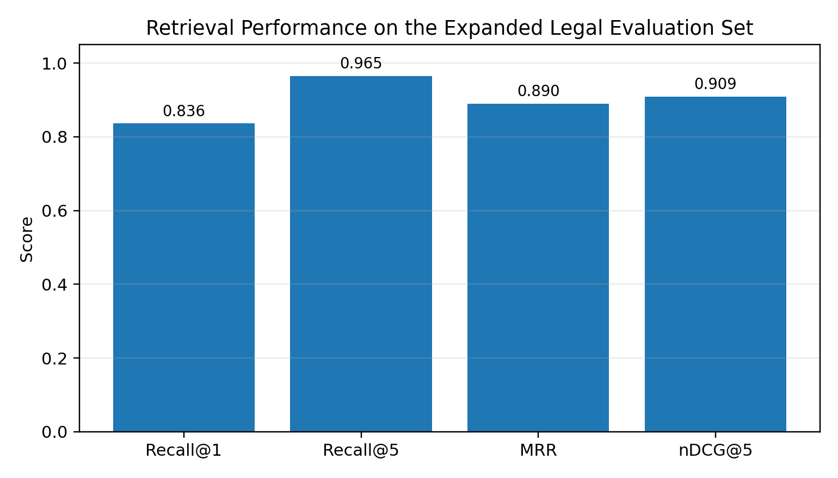
Figure 5.1: Retrieval performance on the expanded legal evaluation set.

5.2 LLM Generation Results
ALLaM-7B achieved an answer accuracy of 0.73, while Qwen2.5-7B achieved 0.69. Although ALLaM obtained a slightly higher score, the paired McNemar test produced p = 0.63, indicating that the difference was not statistically significant at conventional significance levels. Therefore, the correct academic interpretation is that ALLaM was slightly higher in this experiment, but the evidence is insufficient to claim a statistically significant superiority over Qwen2.5-7B.
Model | Answer Accuracy | Faithfulness | Academic Interpretation
ALLaM-7B | 0.73 | 0.84 | Slightly higher accuracy, but not statistically significant versus Qwen.
Qwen2.5-7B | 0.69 | 0.90 | Slightly higher faithfulness score in the judge summary.
McNemar test | p = 0.63 | - | No statistically significant paired difference.

5.3 Effect of RAG on Legal Citation Errors
The No-RAG versus RAG ablation is one of the most important findings. Without RAG, the system produced wrong or hallucinated legal citations in 25% of cases. With RAG, this error rate decreased to 4%. This reduction is highly relevant in a legal setting because citation correctness and source grounding are central to trust and safety.
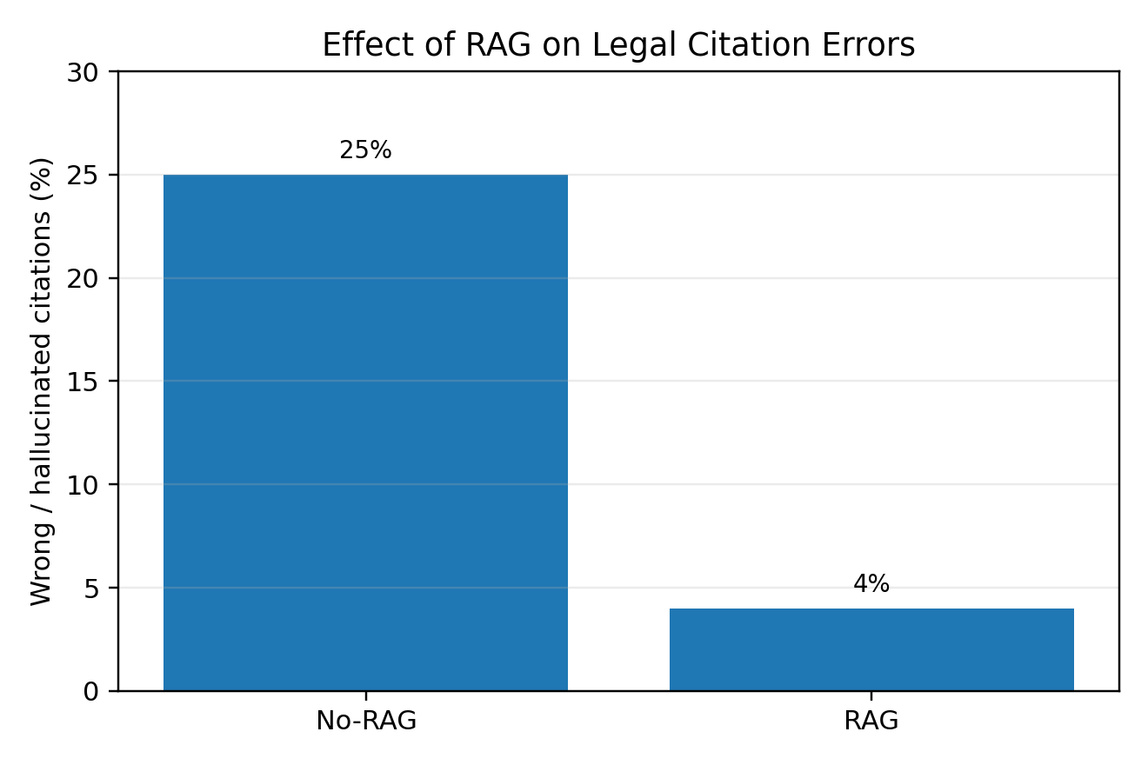
Figure 5.2: Reduction in wrong or hallucinated legal citations using RAG.

5.4 Voice Layer Results
The ASR evaluation produced WER of approximately 0.198 and CER of 0.046. These results are acceptable for an Arabic prototype, especially considering the difficulty of Arabic speech recognition. However, the evaluation uses synthetic speech and should be extended to real human recordings in future work. TTS intelligibility is reported as a proxy based on ASR round-trip scoring, while MOS and naturalness remain future work.
Component | Metric | Result | Status
ASR | WER | 0.198 | Measured
ASR | CER | 0.046 | Measured
ASR | Latency | 0.67 s | Measured
TTS | Intelligibility proxy | WER ≈ 0.20 / CER ≈ 0.05 | Proxy
TTS | MOS / Naturalness | Not measured | Future work

5.5 Latency Results
End-to-end latency improved from 4.07 seconds to 3.03 seconds after applying answer streaming and answer-length control. The perceived latency with streaming was approximately 0.95 seconds, which is important for user experience. The latency breakdown indicates that LLM generation and TTS are the main bottlenecks rather than ASR or retrieval.
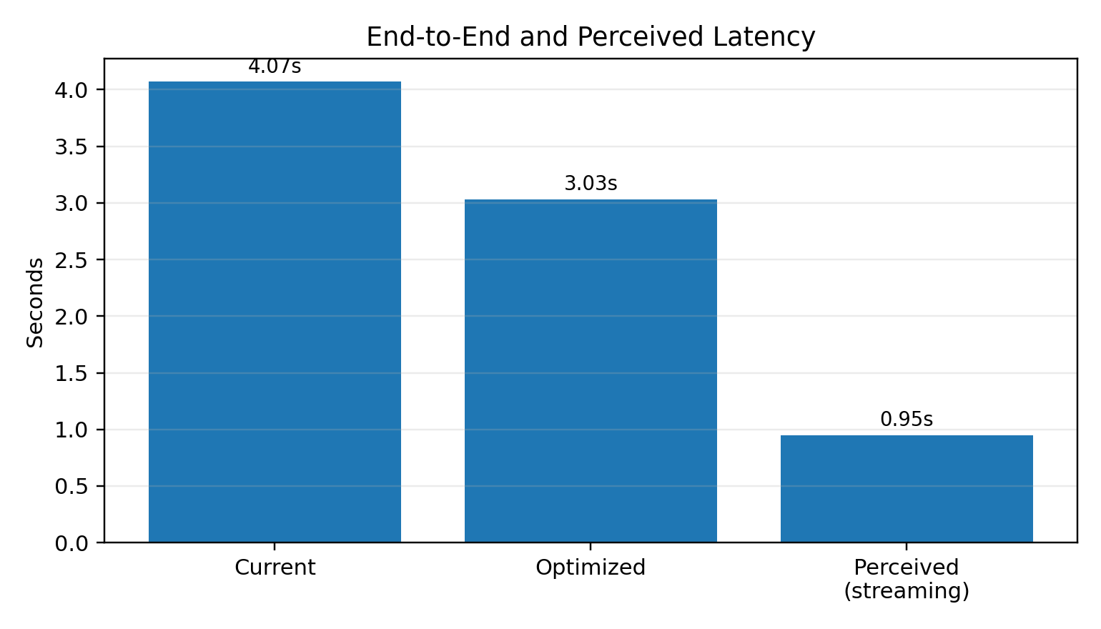
Figure 5.3: Current, optimized, and perceived streaming latency.

5.6 Consolidated Evaluation Summary
System Part | Main Result | Academic Meaning
RAG retrieval | Recall@5 = 0.965 | The correct article is usually available to the LLM.
Ranking quality | MRR = 0.890; nDCG@5 = 0.909 | The correct article is usually ranked highly.
LLM comparison | ALLaM 0.73; Qwen 0.69; p = 0.63 | No statistically significant difference.
Hallucination control | Wrong citations 25% -> 4% | RAG substantially improves legal grounding.
ASR | WER = 0.198; CER = 0.046 | Good prototype result; needs human-speech validation.
Latency | 4.07s -> 3.03s; perceived 0.95s | Usable direction for interactive voice response.

Chapter 6: Discussion, Limitations, and Future Work

6.1 Discussion of Retrieval Performance
The retrieval results show that structure-aware chunking, hybrid retrieval, and reranking are highly effective for Saudi Labor Law questions. Legal documents have explicit article boundaries and formal phrasing, so preserving structure helps retrieval. Hybrid retrieval benefits from both exact legal terminology and semantic similarity, while reranking improves the final ordering of candidate contexts.

6.2 Discussion of Generation Performance
The LLM results should be interpreted carefully. ALLaM-7B achieved slightly higher answer accuracy, while Qwen2.5-7B achieved slightly higher faithfulness in the judge summary. Because the McNemar test did not show a statistically significant difference, this thesis does not claim that one model is generally superior. Instead, the results suggest that both models can be viable candidates when combined with strong retrieval and guardrails.

6.3 Legal Safety and Hallucination Reduction
The strongest practical evidence in this thesis is the reduction of wrong or hallucinated legal citations from 25% to 4% after using RAG. This result directly supports the thesis argument that legal voice agents should not rely on LLM memory alone. In a legal-information setting, the system must retrieve official evidence and must refuse when reliable evidence is unavailable.

6.4 Limitations
- The system provides legal information and should not be presented as a substitute for professional legal advice.
- ASR evaluation used synthetic speech; real human recordings with different accents, noise levels, and speaking styles are needed.
- TTS MOS and naturalness were not measured by a human listening panel.
- Some evaluation questions were automatically generated and marked for expert review; full legal expert validation would strengthen the dataset.
- The system focuses on Saudi Labor Law and HRSD FAQ content, so it should not answer unrelated legal, religious, medical, or financial questions.
- Latency was measured in the implementation environment and may differ under deployment hardware, concurrency, or network conditions.

6.5 Future Work
- Collect real Arabic spoken questions from users across Saudi dialects and evaluate ASR under realistic audio conditions.
- Conduct human evaluation of TTS MOS, naturalness, and user satisfaction.
- Add expert legal review for automatically generated evaluation questions and borderline answers.
- Implement continuous feedback loops for correction, monitoring, and dataset expansion.
- Test additional Arabic and multilingual LLMs under the same retrieval context.
- Deploy the Gradio prototype in a controlled user study to measure task success, trust, and perceived helpfulness.

Chapter 7: Conclusion
This thesis designed and evaluated an AI-powered Arabic voice agent for Saudi Labor Law inquiries. The project integrated ASR, RAG, LLM generation, guardrails, TTS, ablations, and latency analysis into a complete experimental pipeline. The results show that retrieval quality is strong, with Recall@5 of 0.965 on the expanded legal evaluation set. The LLM comparison showed that ALLaM-7B achieved slightly higher answer accuracy than Qwen2.5-7B, but the difference was not statistically significant. Most importantly, the RAG-based system substantially reduced wrong or hallucinated legal citations from 25% to 4%, demonstrating the practical value of grounded retrieval for legal-information systems. The voice layer and latency analysis indicate that the prototype is moving toward usable interactive response times, while real human-speech testing and human TTS evaluation remain important future work. Overall, the thesis demonstrates that a carefully engineered Arabic legal RAG pipeline can improve the reliability and responsiveness of voice-based labor-law assistance.

References
[1] Ministry of Human Resources and Social Development, “Labor Law,” official HRSD Knowledge Centre, Saudi Arabia.
[2] Ministry of Human Resources and Social Development, “Frequently Asked Questions,” official HRSD website.
[3] A. Radford, J. W. Kim, T. Xu, G. Brockman, C. McLeavey, and I. Sutskever, “Robust Speech Recognition via Large-Scale Weak Supervision,” Proceedings of the 40th International Conference on Machine Learning, PMLR, vol. 202, pp. 28492-28518, 2023.
[4] Y. Gao et al., “Retrieval-Augmented Generation for Large Language Models: A Survey,” arXiv:2312.10997, 2023.
[5] P. Lewis et al., “Retrieval-Augmented Generation for Knowledge-Intensive NLP Tasks,” Advances in Neural Information Processing Systems, 2020.
[6] Chroma, “Chroma Docs: Introduction,” Chroma documentation.
[7] L. Wang, N. Yang, X. Huang, L. Yang, R. Majumder, and F. Wei, “Multilingual E5 Text Embeddings: A Technical Report,” arXiv, 2024.
[8] J. Chen, S. Xiao, P. Zhang, K. Luo, D. Lian, and Z. Liu, “BGE M3-Embedding: Multi-Lingual, Multi-Functionality, Multi-Granularity Text Embeddings Through Self-Knowledge Distillation,” Findings of the Association for Computational Linguistics: ACL, 2024.
[9] BAAI, “bge-reranker-v2-m3,” Hugging Face model card.
[10] A. Yang et al., “Qwen2.5 Technical Report,” arXiv:2412.15115, 2024.
[11] National Center for Artificial Intelligence, SDAIA, “ALLaM-7B-Instruct-preview,” Hugging Face model card.
[12] A. Vaswani et al., “Attention Is All You Need,” Advances in Neural Information Processing Systems, 2017.
[13] D. Jurafsky and J. H. Martin, Speech and Language Processing, 3rd ed. draft.
[14] K. P. Murphy, Probabilistic Machine Learning: An Introduction, MIT Press, 2022.
[15] C. D. Manning, P. Raghavan, and H. Schuetze, Introduction to Information Retrieval, Cambridge University Press, 2008.
[16] K. Järvelin and J. Kekäläinen, “Cumulated Gain-Based Evaluation of IR Techniques,” ACM Transactions on Information Systems, vol. 20, no. 4, pp. 422-446, 2002.
[17] B. Efron and R. J. Tibshirani, An Introduction to the Bootstrap, Chapman & Hall/CRC, 1993.
[18] Q. McNemar, “Note on the Sampling Error of the Difference Between Correlated Proportions or Percentages,” Psychometrika, vol. 12, pp. 153-157, 1947.
[19] D. Zhang et al., “SpeechGPT: Empowering Large Language Models with Intrinsic Cross-Modal Conversational Abilities,” Findings of EMNLP, 2023.
[20] X. Li et al., “CM-TTS: Enhancing Real-Time Text-to-Speech Synthesis Efficiency through Weighted Samplers and Consistency Models,” Findings of NAACL, 2024.
[21] S. Shikhar et al., “LLMVoX: Autoregressive Streaming Text-to-Speech Model for Any LLM,” Findings of ACL, 2025.
[22] I. Besrour, J. He, T. Schreieder, and M. Färber, “RAGentA: Multi-Agent Retrieval-Augmented Generation for Attributed Question Answering,” arXiv:2506.16988, 2025.
[23] J. Hrimech, M. Mghari, and Y. Zaz, “Retrieval-Augmented Generation for Arabic Legal Information: The Family Code Case Study,” TELKOMNIKA, vol. 23, no. 6, pp. 1495-1505, 2025.
[24] H. A. Shairah et al., “ALARB: An Arabic Legal Argument Reasoning Benchmark,” Proceedings of the Third Arabic Natural Language Processing Conference, 2025.
[25] J. Alsubhi et al., “Optimizing RAG Pipelines for Arabic: A Systematic Analysis of Core Components,” arXiv:2506.06339, 2025.

Appendix A: Reproducibility Checklist
- All implementation stages are organized as separate notebooks from Stage 01 to Stage 09.
- Intermediate outputs are stored in persistent folders such as 01_raw, 02_clean, 03_final, 04_chunks, 08_stage03_rag_results, and 09_stage04_llm_generation_results.
- The retrieval benchmark uses fixed evaluation metrics and saves the best retrieval configuration.
- The generation benchmark compares models under the same retrieved context.
- Statistical evaluation and ablation studies are separated from generation to avoid mixing model selection with final interpretation.
- Future-work metrics such as TTS MOS are not used as final claims.

