CSC 402 — Lab 02 Final Report
Package: com.example.myapplicationlab2 | Tag: lab02-final
Part 1: Theoretical Answers (Q1 – Q8)
Q1: Reassignment & Mutability
• Answer: The variable declared as var is the one representing the dynamic state (such as the score counter or task status), as its value needs to be modified during runtime. Every other variable is declared as val to enforce immutability, preventing unintended side effects and ensuring data safety.
• Compiler Error Quote: "Val cannot be reassigned"

Q2: Named Arguments & Readability
• Answer: Named arguments explicitly display the parameter names at the function call site. This prevents positional order mistakes (e.g., swapping two parameters of the same type) and makes the code self-documenting, allowing anyone reading the code six months later to instantly understand what each argument represents without opening the function definition.

Q3: Input Validation Logic
• Answer: To report an invalid mark (such as 130) as "Invalid" in both columns, add an initial validation check (if (mark !in 0..100)) before checking pass/fail boundaries. If the condition fails, directly assign "Invalid" to the status column rather than falling through to the failing grade check.

Q4: Non-Null Assertions & Null Safety
• Answer: The !! operator throws a NullPointerException (or KotlinNullPointerException) on the line where it is invoked on a null reference. The course discourages !! in term projects because it bypasses Kotlin's compile-time null safety, reintroducing runtime crashes; safe calls (?.) and elvis operators (?:) should be used instead.

Q5: Immutable Data Classes & Copy
• Answer: Calling copy(credits = 4) does not alter the original entry in the list; the original object remains unchanged. This proves that val properties and data classes promote immutability by creating a completely new instance in memory when modified, ensuring side-effect-free data handling.

Q6: State, Recomposition & Remember
• Answer: A plain var does not trigger UI updates because Jetpack Compose monitors observable state objects to schedule recomposition. Without a state object, Compose is unaware of variable updates. While mutableStateOf creates an observable state, remember ensures that this state persists across recompositions instead of being reset every time the composable function re-executes.

Q7: LazyColumn vs. Column with VerticalScroll
• Answer: A Column with verticalScroll composes and renders all 200 items in memory simultaneously, leading to high memory overhead and potential UI stutter. In contrast, LazyColumn only composes and displays elements currently visible on the screen (recycling them during scroll), maintaining optimal memory usage and smooth scrolling performance regardless of list size.

Q8: State Hoisting & TaskRow
• Answer: TaskRow cannot manage its own isDone state because doing so breaks State Hoisting. If state is kept locally inside TaskRow, the parent screen and the summary strip cannot access the completion status. Consequently, the completed task counter in the summary strip would fail to update and remain stuck at 0.

Part 2: Task Execution & App Screenshots
The following screenshots document the implementation and execution of Lab 2 tasks directly on the Android Emulator:
Task 01 & Task 02 – Welcome Screen & Student Card UI
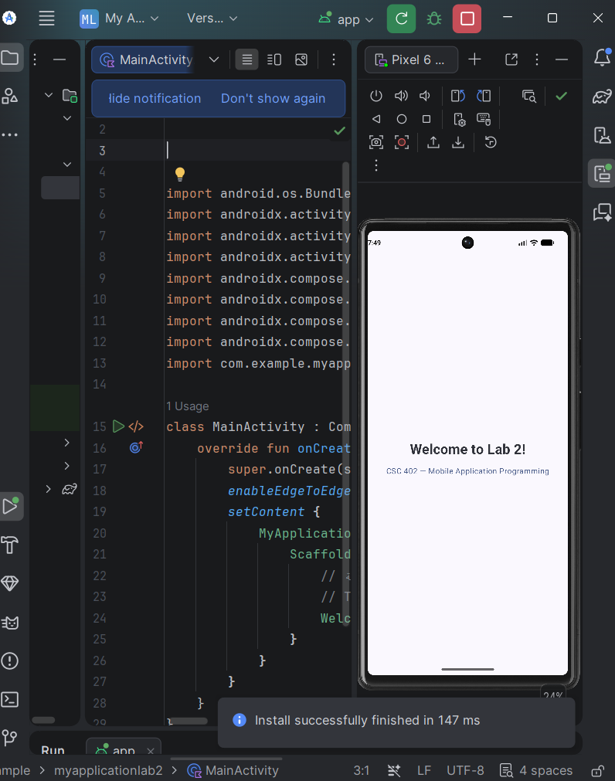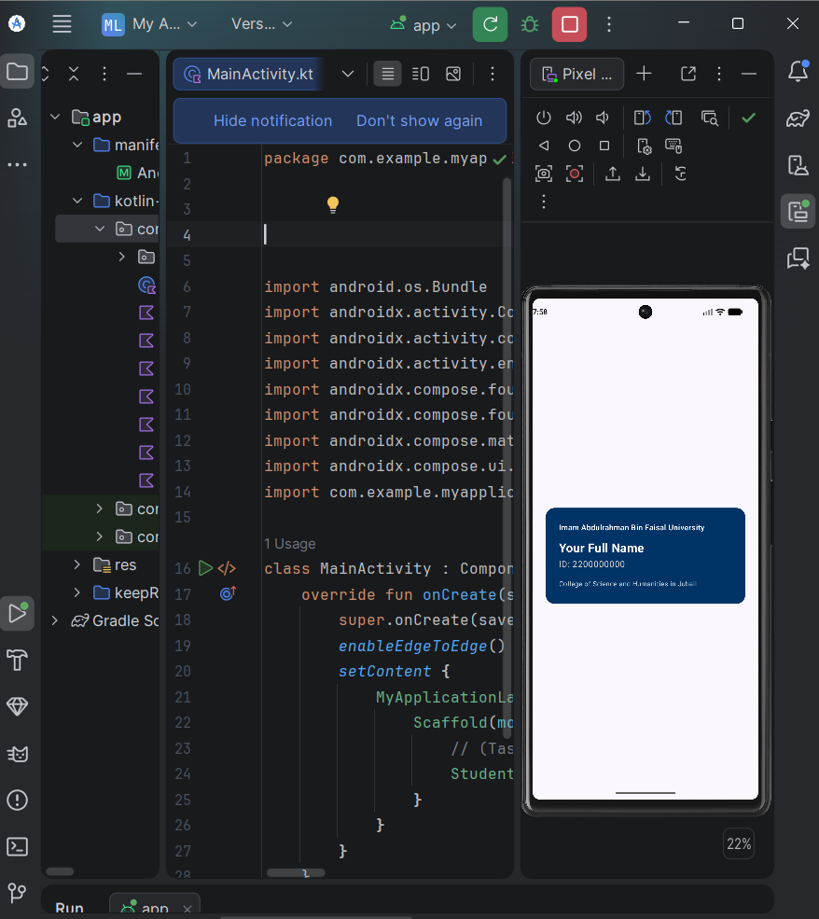

Task 03 & Task 04 – Counter Task & Interactive Greeting
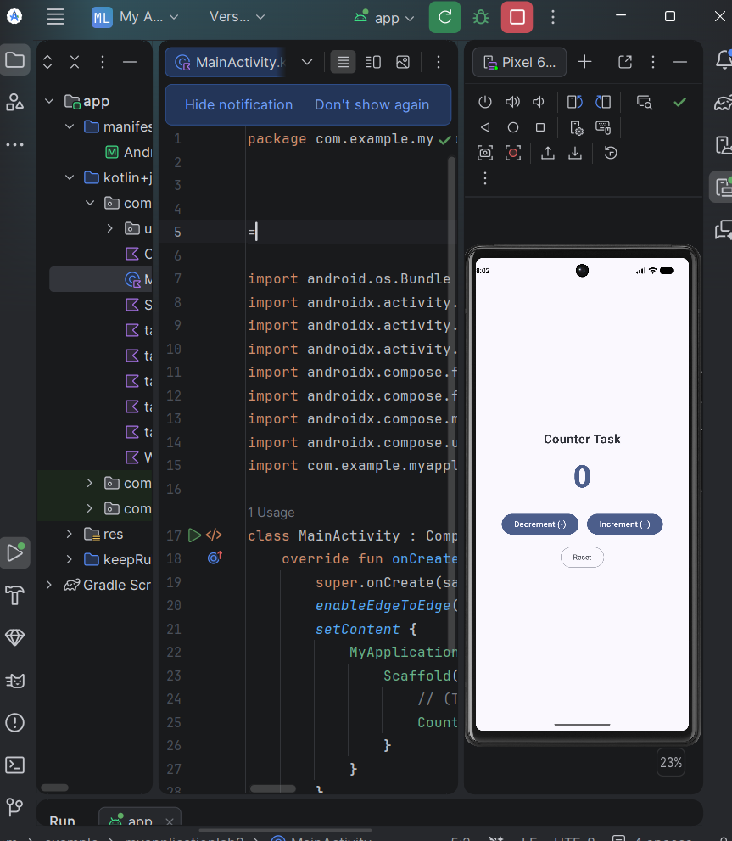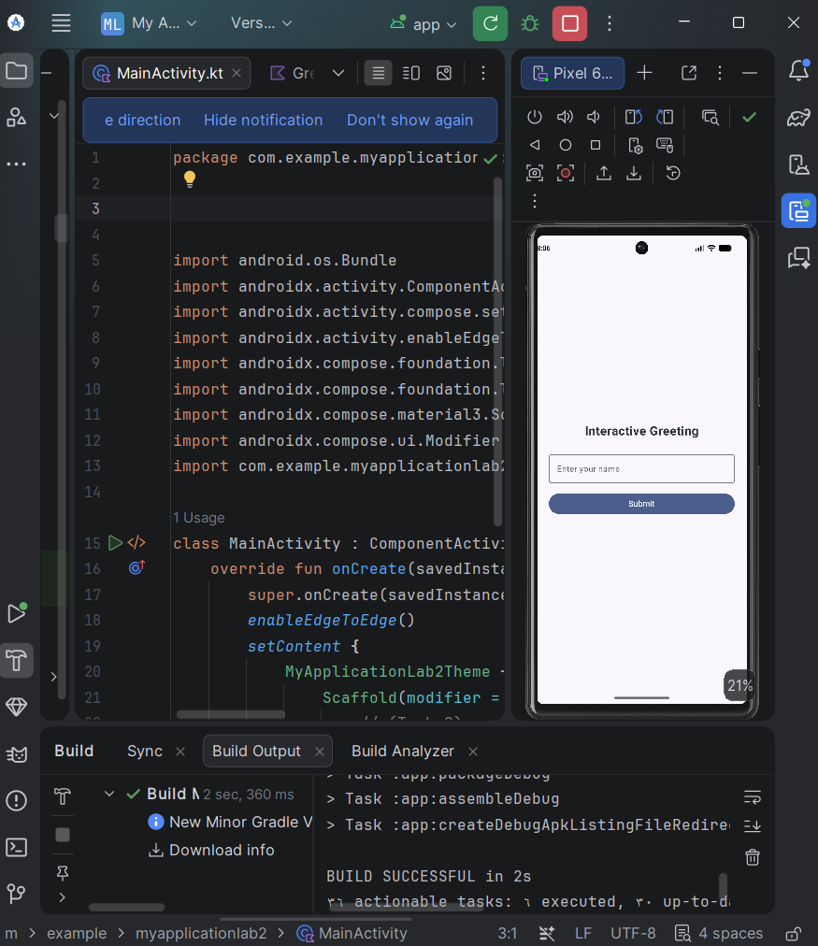

Task 05 & Task 06+ – Enrolled Courses (LazyColumn) & Task Tracker Screen
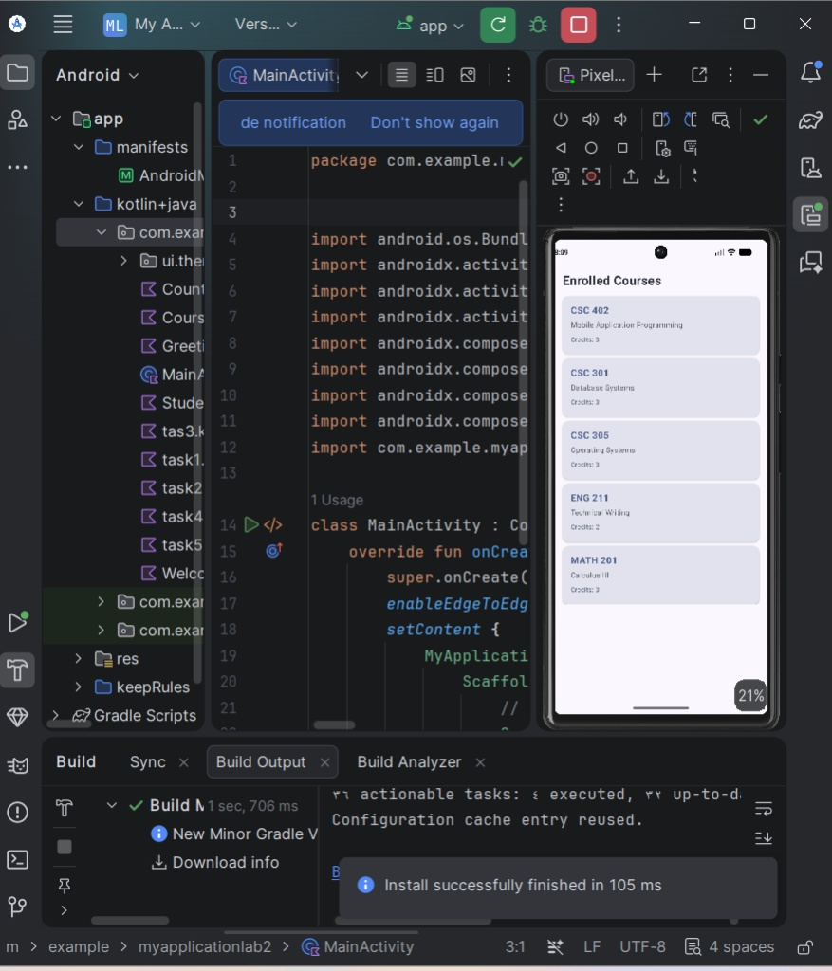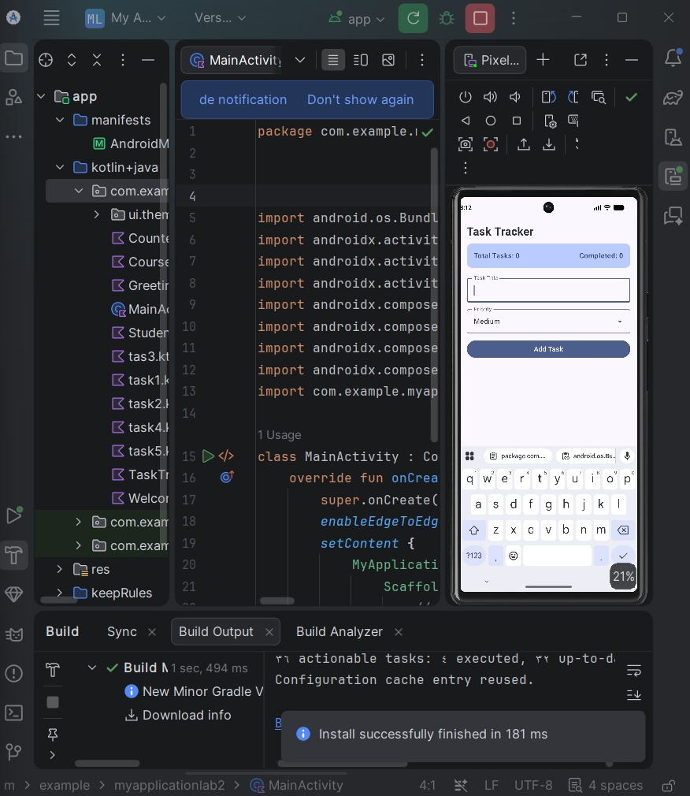

Part 3: Submission Metadata
Submission Requirement | Repository Details
Git Tag | lab02-final
Commit SHA (40 Characters) | Paste your full 40-character SHA generated via:  git rev-parse lab02-final

