 | TM240: Introduction to Computer Graphics  TMA Fall 26/27 (all branches version)

Cut-Off Date: Based on the Published Deadline. Total Marks: …. marks turned to 10 marks Contents
Warnings and Declaration…………………………………….………………………………......1

Question 1 ……………….…………………………………. ………………………………...…..2

Question 2 ………………………………………………………………………………….…..…..3

Question 3 ………………………………………………………………………………….…..…..4

Marking Criteria ...…………..………………………………………………………….………..…5

Plagiarism Warning:

As per AOU rules and regulations, all students are required to submit their own TMA work and avoid plagiarism. The AOU has implemented sophisticated techniques for plagiarism detection. You must provide all references in case you use and quote another person's work in your TMA. You will be penalized for any act of plagiarism as per the AOU's rules and regulations.

Declaration of No Plagiarism by Student (to be signed and submitted by student with TMA work):

I hereby declare that this submitted TMA work is a result of my own efforts and I have not plagiarized any other person's work. I have provided all references of information that I have used and quoted in my TMA work.

Name of Student:…………………………….. Signature:…………………………………………... Date:…………………………………………………

Question one | [10 marks]
Adopting appropriate Java code and using shape construction functions along with animation principles, construct an animation that is as similar as possible to the file.
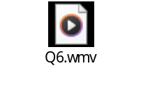
You are required to upload the full code in the answer file along with a video showing your output.
Please be limited with the graphics functions you learnt in the course.

Question Two | [10 marks]

- Adopting suitable Java primitives, implement one of the following shapes: [6 marks]
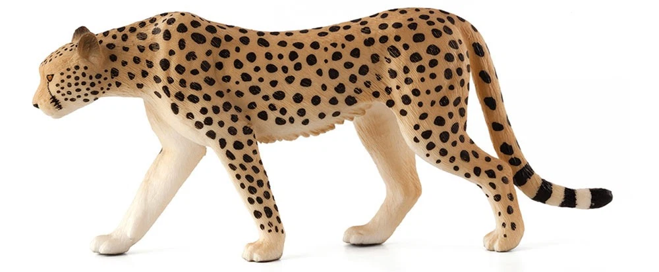
b) Snapshot the output of a) [1 Marks]
c) Use suitable rendering to fill-in the shape suitably using suitable and well aligned-texture to reflect the real shape of your drawing. [3 Marks]
Please be limited with the graphics functions you learnt in the course.
Question Three | [10 marks]
Having the following parametric equation:
X(t) = cos(3t);
Y(t) = sin(4t);
,while the output of this equation is:
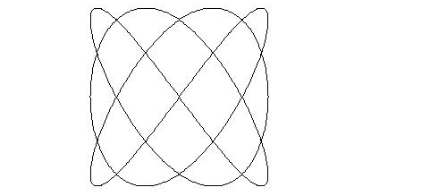
- Write an appropriate Java code segment to plot the above function.
- Modify the basic code to output the following shape:
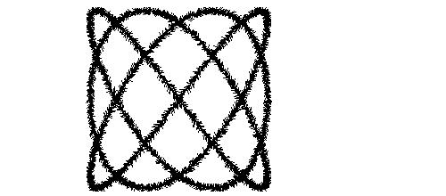
End of Questions

