Software Architecture Design (SAD)
and Requirements Specification

Rihla – Smart Tourism Platform
Version 1.1

SE322 – Software Design and Architecture
Prince Sultan University

Prepared by
Shahad Abunayan – 223410189
Sarah Alsharif – 223410117
Haifa Alajlan – 223410302
Nouf Alshakrah – 222511408

29 September 2026

Table of Contents
Revision History 3
1. Introduction 4
1.1 Purpose 4
1.2 Document Conventions 4
1.3 Intended Audience 4
1.4 Product Scope 4
1.5 References 4
2. Overall Description 4
2.1 Product Perspective 4
2.2 Product Functions 5
2.3 User Classes and Characteristics 5
2.4 Operating Environment 5
2.5 Design and Implementation Constraints 6
2.6 User Documentation 6
2.7 Assumptions and Dependencies 6
3. External Interface Requirements 6
3.1 User Interfaces 6
3.2 Hardware Interfaces 6
3.3 Software Interfaces 7
3.4 Communications Interfaces 7
4. System Features 7
4.1 Account Management 7
4.2 Discover and Search 7
4.3 Destination Details 8
4.4 Recommendations 8
4.5 Itinerary Management 8
4.6 Maps and Transport 8
4.7 Reviews and Ratings 8
4.8 Administration 8
5. Other Nonfunctional Requirements 9
5.1 Performance 9
5.2 Safety and Data Protection 9
5.3 Security 9
5.4 Software Quality Attributes 9
5.5 Business Rules 9
6. Software Architecture Design (4+1 View Model) 10
6.1 Scenario (User) View 10
6.2 Logical View 11
6.3 Process View 12
6.4 Development View 12
6.5 Physical View 13
Appendix A: Glossary 14
Appendix B: Proposed User Interface Screens 15
Appendix C: To Be Determined List 16

Revision History
Name | Date | Reason for change | Version
Shahad Abunayan and team | 30/09/2026 | Revised SRS, completed missing sections, and updated team details | 1.1

Introduction

1.1 Purpose
This Software Requirements Specification describes Rihla, a smart tourism mobile application for people travelling inside Saudi Arabia. It explains what the system should provide, who will use it, and the main limits that should be considered during design and development. This document is written for the project team, instructor, testers and other people who want to understand the system requirements.

1.2 Document Conventions
The word “shall” means a required function. “Should” means a desirable function that may be adjusted later. Each requirement has a priority: High, Medium or Low. Requirement IDs are used to make requirements easier to trace and test.

1.3 Intended Audience
Developers can use Sections 3 and 4 to understand the system functions and interfaces. Testers can use the IDs to prepare test cases. The instructor and stakeholders can focus on the purpose, scope and overall description in Sections 1 and 2.

1.4 Product Scope
Rihla combines tourism information, destination discovery and simple trip planning in one application. A user can explore attractions, receive recommendations, create an itinerary, view basic transport information and save trip details. The first release focuses on discovery and planning; full real-time transport and direct booking depend on the availability of external services.

1.5 References
The requirements were based on the previous Rihla project description and SRS, the SE322 project deliverable instructions, and general ideas related to Saudi Vision 2030 tourism services. External APIs mentioned in this document are examples and will be confirmed before implementation.

Overall Description

2.1 Product Perspective
Rihla is a standalone mobile application connected to a backend server. It can use external services for maps, tourism content, notifications and, in a later version, transport and payment. The application does not replace those services; it gives the user one simpler place to access travel information.

2.2 Product Functions
ID | Function | Priority
F-01 | Register, log in and manage a profile | High
F-02 | Browse and search destinations and attractions | High
F-03 | Show details, location, opening time and estimated cost | High
F-04 | Recommend places based on interests and location | Medium
F-05 | Create, edit, save and delete an itinerary | High
F-06 | Show map location and route information | High
F-07 | Show available transport information when provided by an external service | Medium
F-08 | Send reminders and important updates | Medium
F-09 | Allow users to rate and review visited places | Medium
F-10 | Allow an administrator to manage content and reported reviews | High

2.3 User Classes and Characteristics
User | Description
Guest | Can browse public destinations and read general information, but cannot save trips or submit bookings/reviews.
Registered traveler | Can manage a profile, save an itinerary, receive recommendations, and write reviews.
Tourism content administrator | Adds and updates destination information, checks reported content and manages users.
Service provider (future release) | May provide approved activity or transport information through the system.

2.4 Operating Environment
The mobile application shall support Android 10 or later and iOS 14 or later. The user needs a phone with internet access and, for nearby recommendations, permission to use location. The backend will run on a cloud server and use a database. Some saved itinerary information should remain viewable if the connection is temporarily unavailable.

2.5 Design and Implementation Constraints
The application should support Arabic and English, including RTL and LTR layouts. Personal data and payment-related information must be protected according to applicable Saudi regulations. The project also depends on the availability and limits of third-party APIs. The first version should avoid depending on a service that has not been confirmed or approved.

2.6 User Documentation
The application shall include a short onboarding guide, help and frequently asked questions. Error messages should explain what happened and what the user can do next.

2.7 Assumptions and Dependencies
Users are expected to have a smartphone. Destination information is assumed to be available from an approved source. Maps, notifications, transport and payment are external dependencies and can be unavailable. Exact providers and offline features will be decided before implementation.

External Interface Requirements

3.1 User Interfaces
The home screen shall include search, recommended places and categories such as history, nature and cultural attractions. Destination details shall show a picture, description, location, opening time, estimated cost and save button. The itinerary screen shall show activities by day and allow the user to edit or remove them. The main navigation shall include Home, Discover, My Trips and Profile. The interface shall support Arabic and English and use readable text and suitable contrast.

3.2 Hardware Interfaces
The application shall work on ordinary iOS and Android touchscreen phones. It may request GPS/location access for nearby places and route display. No special hardware is required.

3.3 Software Interfaces
External service | Purpose | Information exchanged
Maps service | Show locations and routes | Coordinates, place IDs and route details
Tourism content source | Provide attraction and event information | Names, descriptions, images, hours and locations
Authentication service | Support account and session management | Account credentials and authentication tokens
Notification service | Send reminders and booking or itinerary updates | Device token and notification content
Transport or payment service (later release) | Provide transport or payment functions if approved | Availability, status and transaction result

3.4 Communications Interfaces
Communication between the application and backend shall use HTTPS. REST APIs may be used for the application and external integrations. If a network request times out, the application shall display a clear message and keep already saved local information safe. Sensitive data shall not be sent through unencrypted communication.

System Features

4.1 Account Management
The system shall allow a user to register, log in, log out and update basic profile information. A user shall agree to the terms before registration. Priority: High.
Main flow: the user selects the feature, the system checks the request and permissions, reads or updates the required data, then shows a success or error message.

4.2 Discover and Search
The system shall allow a guest or registered user to search by place name, city, category or interest and filter the results. Priority: High.
Main flow: the user selects the feature, the system checks the request and permissions, reads or updates the required data, then shows a success or error message.

4.3 Destination Details
The system shall display a destination description, images, location, opening hours, estimated cost and available facilities. Priority: High.
Main flow: the user selects the feature, the system checks the request and permissions, reads or updates the required data, then shows a success or error message.

4.4 Recommendations
The system should suggest destinations using selected interests, previous saved places and approximate location. The user should be able to ignore or change recommendations. Priority: Medium.
Main flow: the user selects the feature, the system checks the request and permissions, reads or updates the required data, then shows a success or error message.

4.5 Itinerary Management
A registered user shall create an itinerary, add destinations, arrange activities by day, edit entries and delete the itinerary. Priority: High.
Main flow: the user selects the feature, the system checks the request and permissions, reads or updates the required data, then shows a success or error message.

4.6 Maps and Transport
The system shall show a destination on a map and provide route information. Real-time transport information shall only be shown when a reliable external source is available. Priority: Medium.
Main flow: the user selects the feature, the system checks the request and permissions, reads or updates the required data, then shows a success or error message.

4.7 Reviews and Ratings
A registered user shall be able to rate and review a place after visiting it. The administrator shall be able to hide inappropriate or reported content. Priority: Medium.
Main flow: the user selects the feature, the system checks the request and permissions, reads or updates the required data, then shows a success or error message.

4.8 Administration
The administrator shall add, edit, verify and remove destination content, manage reported reviews and view basic usage information. Priority: High.
Main flow: the user selects the feature, the system checks the request and permissions, reads or updates the required data, then shows a success or error message.

Other Nonfunctional Requirements

5.1 Performance
The home screen should load within 3 seconds on a normal 4G connection. Normal search results should appear within 4 seconds, excluding delay from an external service. The system should support at least 500 simultaneous users for the first project version. These values can be tested and adjusted after a prototype is available.

5.2 Safety and Data Protection
The application shall not store full payment card details on the device or application database. If a payment function is added, it shall be handled by an approved payment provider. The application shall warn the user when information is unavailable or outdated.

5.3 Security
Personal features shall require authentication. Passwords shall not be stored as plain text. Sessions shall expire after a reasonable period of inactivity. Users shall only access functions allowed by their role. Personal data shall not be shared with a third party without a valid reason and user consent where required.

5.4 Software Quality Attributes
Attribute | Requirement
Usability | A new user should understand the main functions without special training.
Reliability | The system should recover from temporary network or external-service failures without losing saved itineraries.
Maintainability | The code should be divided into clear modules and documented enough for another team member to understand.
Scalability | The backend should be deployable on a larger server if the number of users increases.
Portability | The application should support the planned Android and iOS versions.

5.5 Business Rules
ID | Rule
BR-01 | Only authenticated users can save or edit itineraries.
BR-02 | Only authenticated users can submit reviews and ratings.
BR-03 | A review may be reported and reviewed by an administrator.
BR-04 | Prices are displayed in Saudi Riyals by default.
BR-05 | A booking, if added in a later release, is not completed when payment authorization fails.
BR-06 | Destination content must be checked by an administrator before publication.
BR-07 | Transport data must show its last update time when it comes from an external source.
BR-08 | Guests can browse, but cannot save itineraries or submit reviews.
Possible later requirements include full offline itineraries, an administrator analytics dashboard, accessibility improvements following WCAG guidance, additional languages, direct activity booking and more transport providers. These are not required for the first prototype and should be reviewed before implementation.

6. Software Architecture Design (4+1 View Model)

6.1 Scenario (User) View
This view presents the system functionality from the users' perspective. The main actors are Guest, Registered Traveler, and Administrator. It shows the services available to each actor and provides the scenarios used to validate the other architectural views.
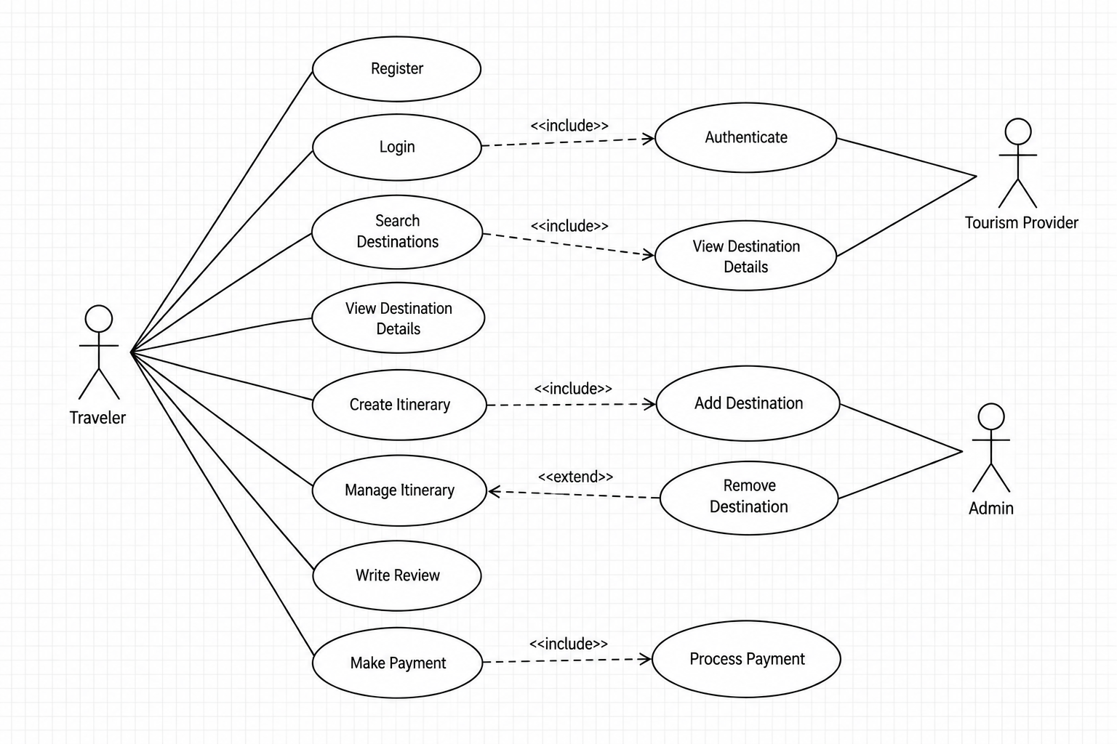
Figure 6-1. Use Case Diagram - Scenario (User) View

6.2 Logical View
The Logical View represents the main conceptual elements of Rihla and their relationships. The Class Diagram models the principal domain classes, while the Sequence Diagram shows the time-ordered interaction for searching and viewing destination information.
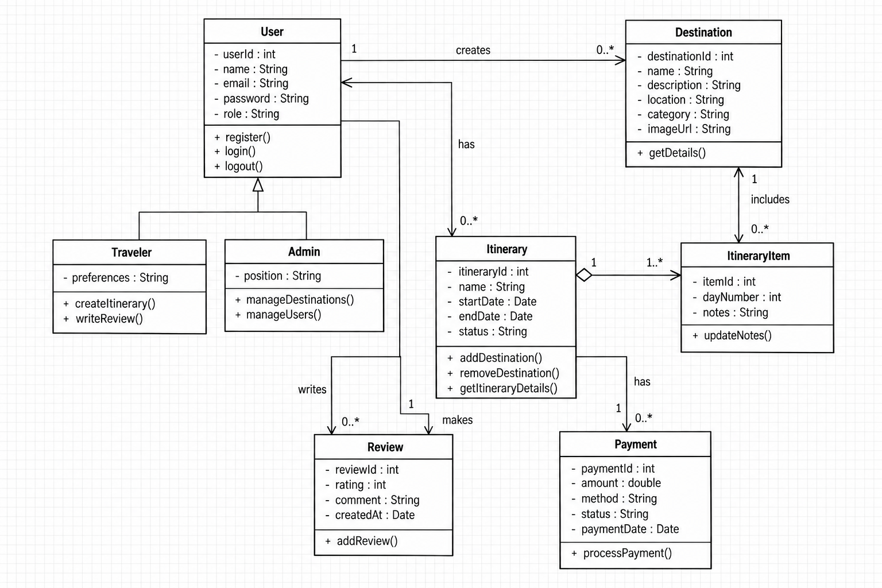
Figure 6-2. Class Diagram - Logical View
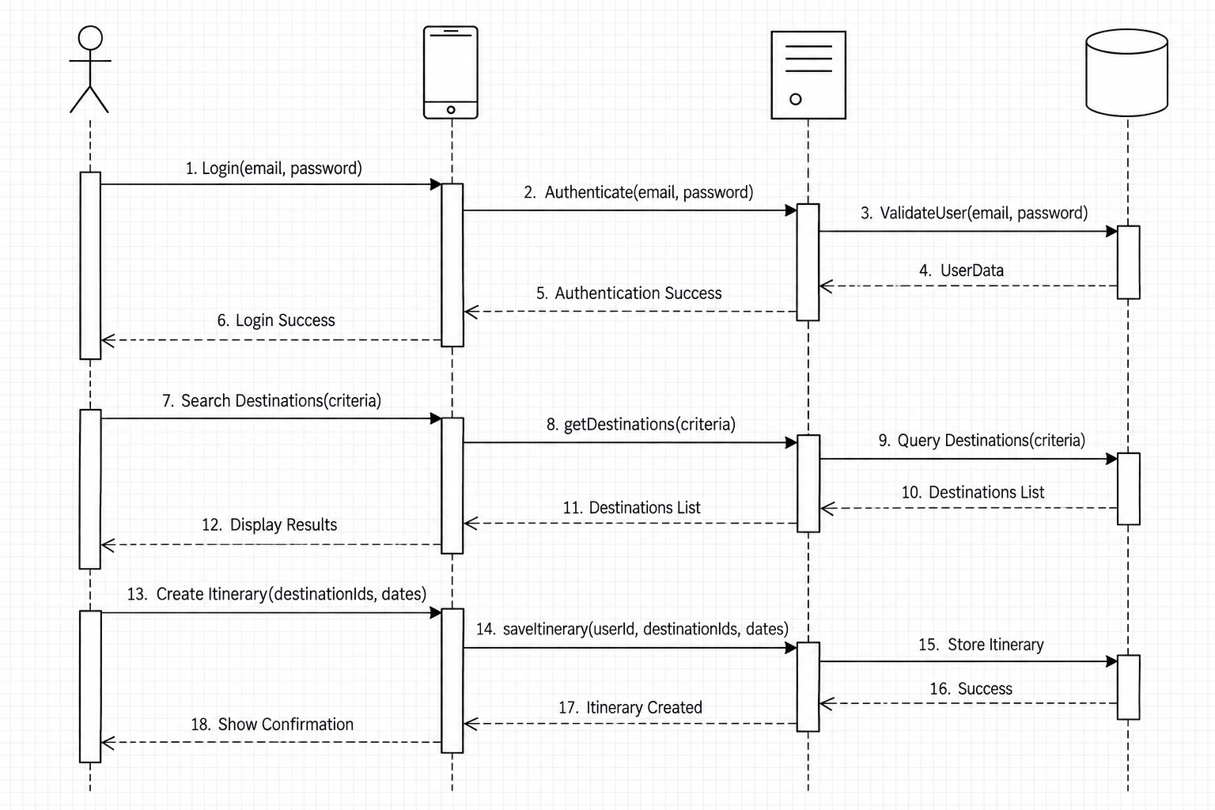
Figure 6-3. Sequence Diagram - Logical View

6.3 Process View
The Process View describes the runtime workflow of the system. The Activity Diagram illustrates the flow for itinerary management, including user authentication, retrieving itinerary data, processing traveler actions, database access, and returning the updated itinerary.
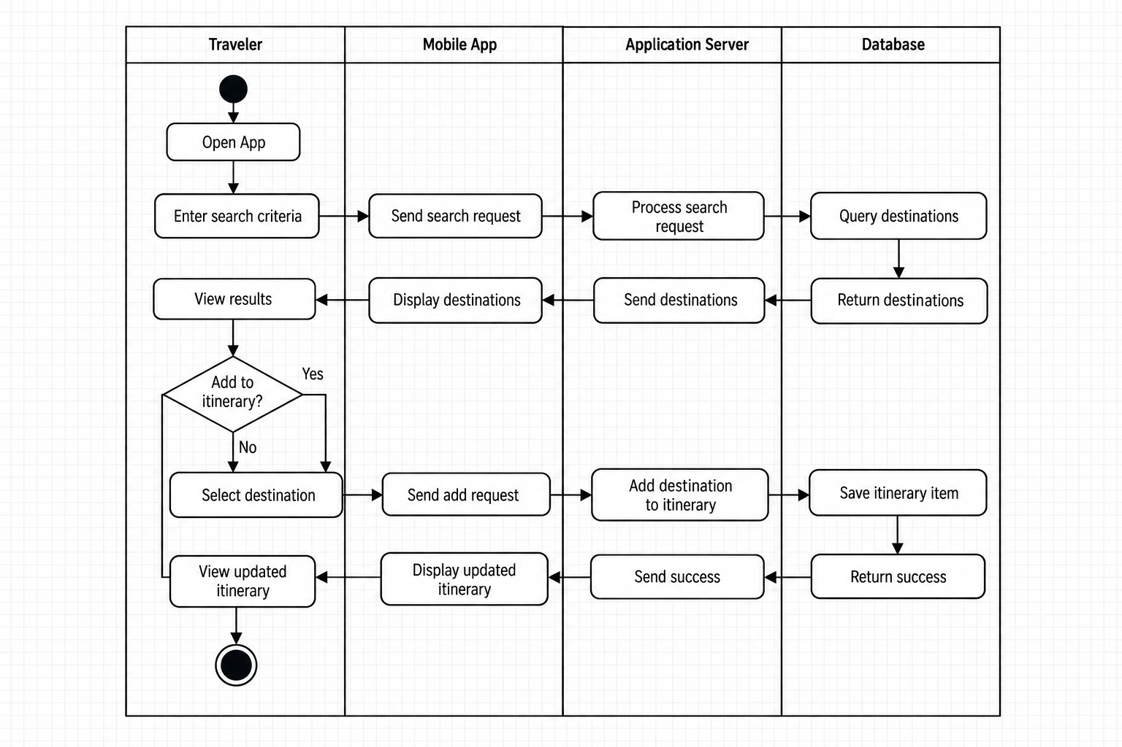
Figure 6-4. Activity Diagram - Process View

6.4 Development View
The Development View shows the static organization of the software implementation. The Component Diagram identifies the major Rihla software components, their interfaces, and their dependencies on external services.
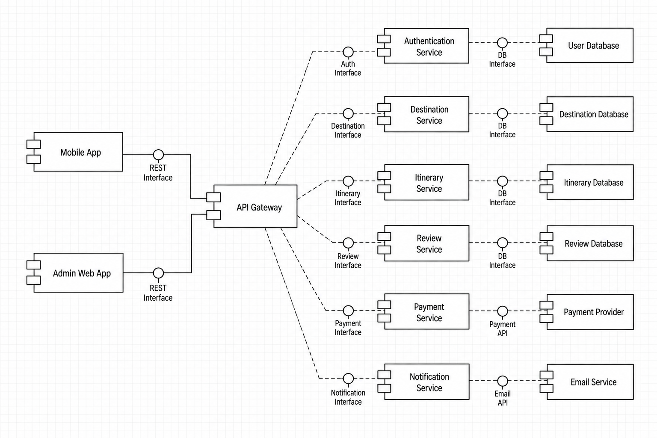
Figure 6-5. Component Diagram - Development View

6.5 Physical View
The Physical View shows how Rihla is deployed in its execution environment. The Deployment Diagram maps the mobile application, backend server, database, and external services to their physical nodes and communication links.
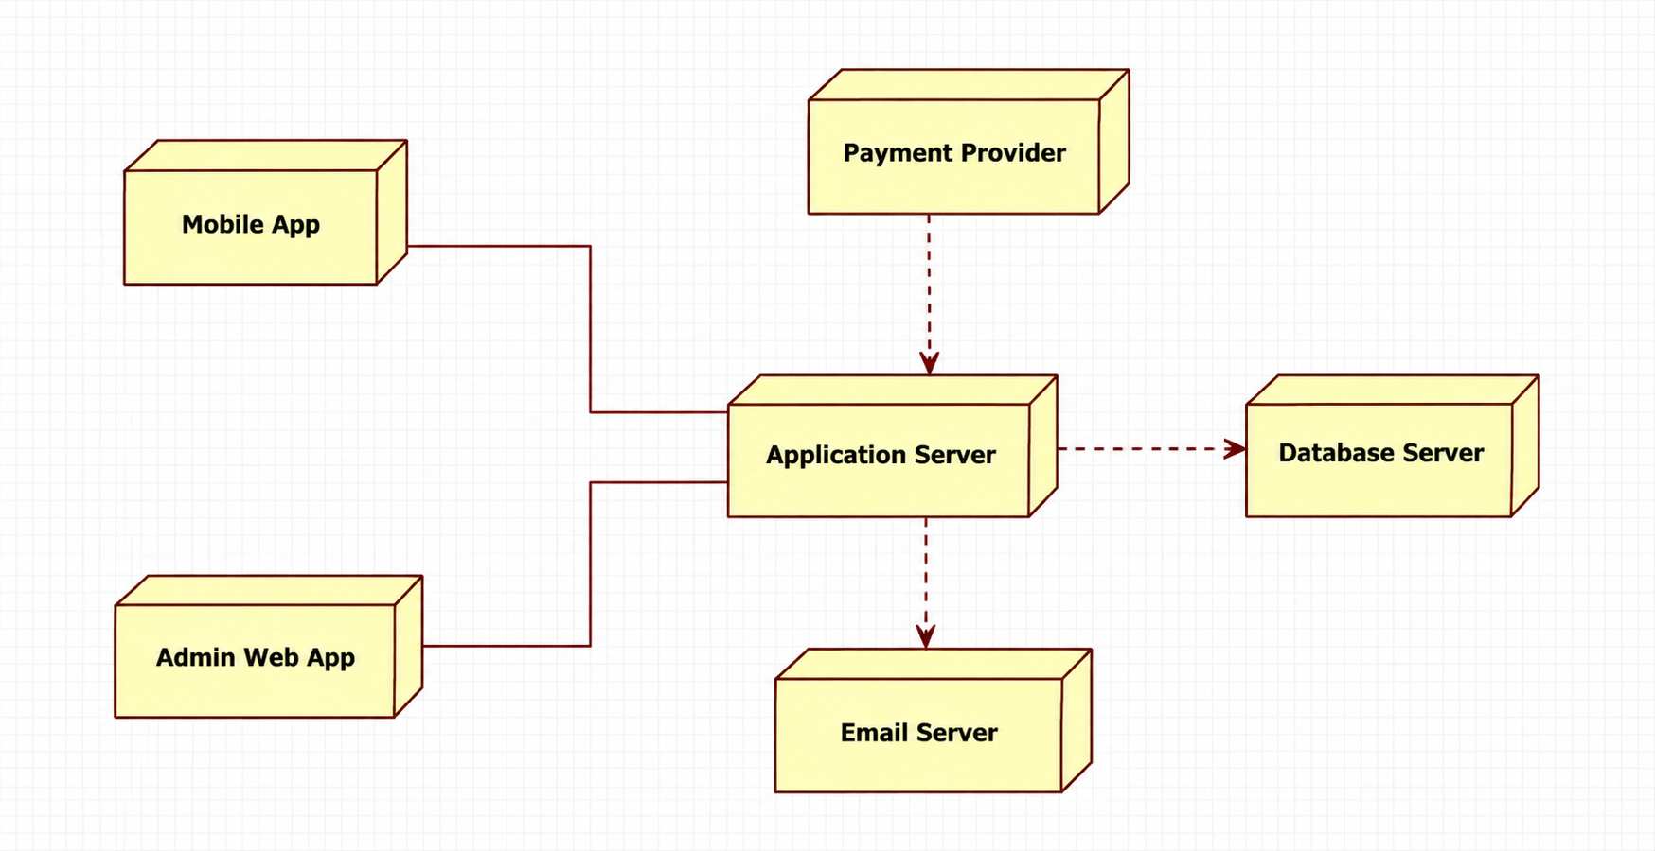
Figure 6-6. Deployment Diagram - Physical View

Appendix A: Glossary
Term | Meaning
Rihla | The Arabic word for journey and the name of the application.
API | A way for two software systems to exchange data.
Itinerary | A planned list of travel activities arranged by time or day.
Guest | A user who has not logged in.
Administrator | An authorized person who manages system content and users.
RTL / LTR | Right-to-left and left-to-right text direction.
External service | A system outside Rihla that provides a specific function.

Appendix B: Proposed User Interface Screens
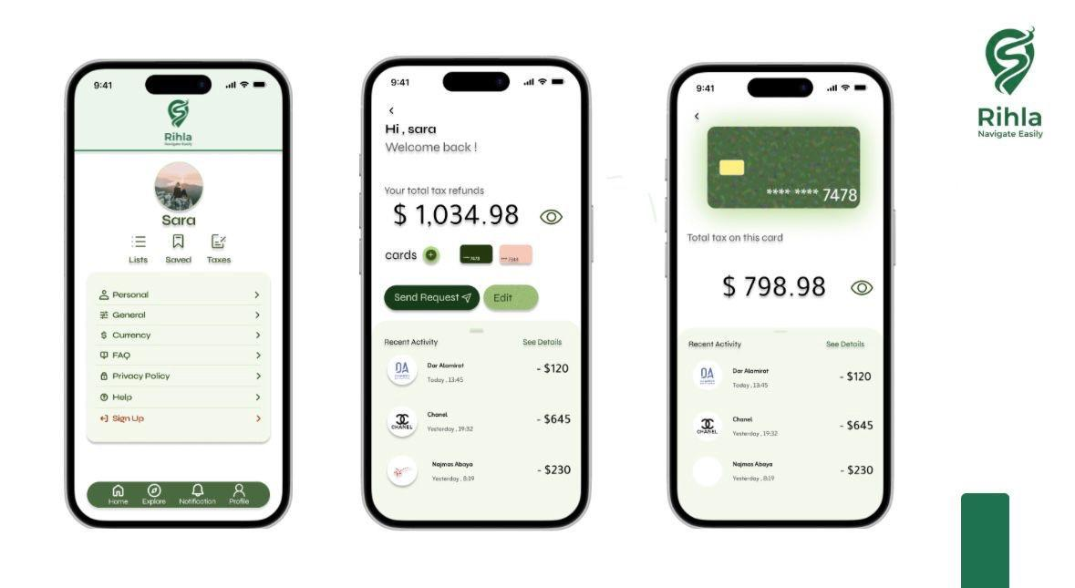
Figure D-1: Profile and account screens
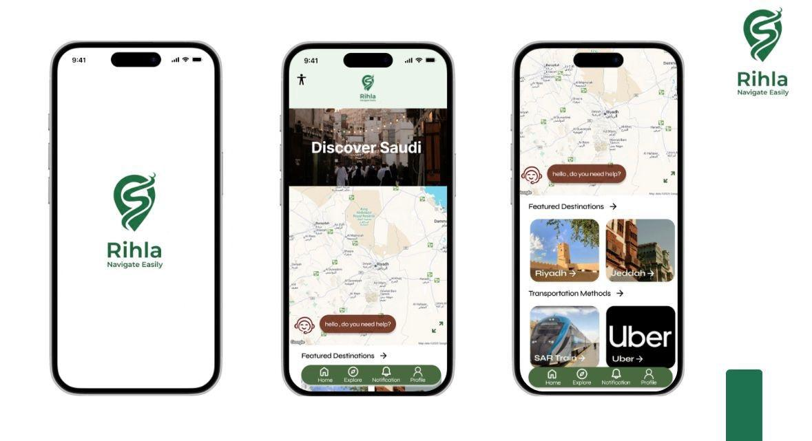
Figure D-2: Application splash screen, home screen and destination discovery
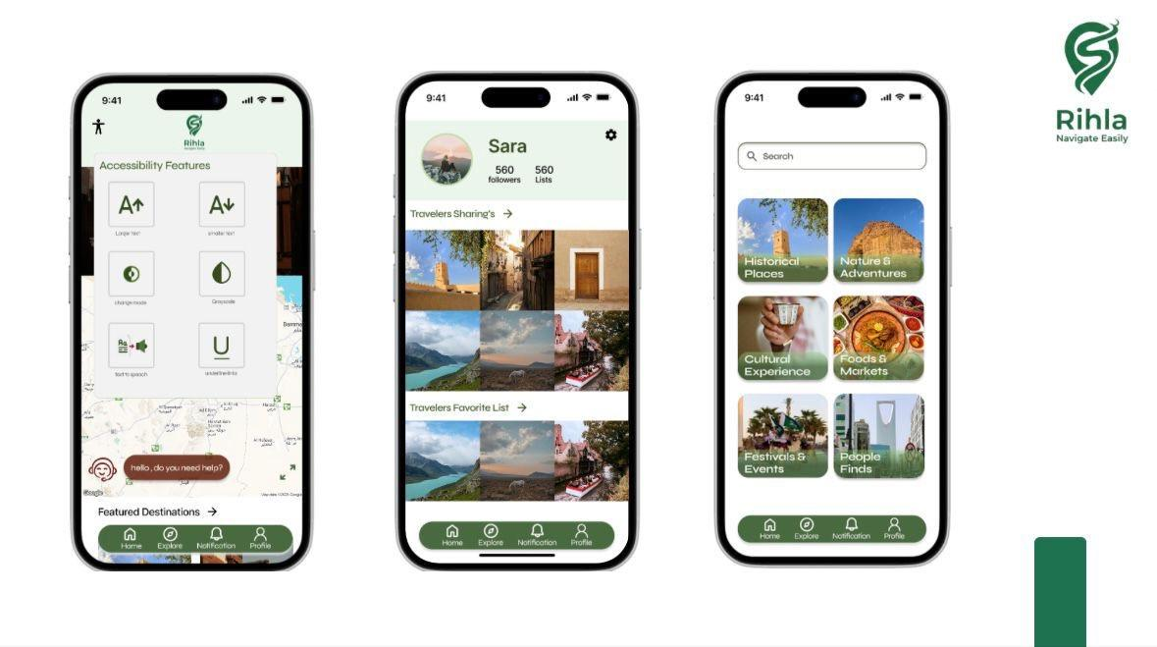
Figure D-3: Notifications and registration screens
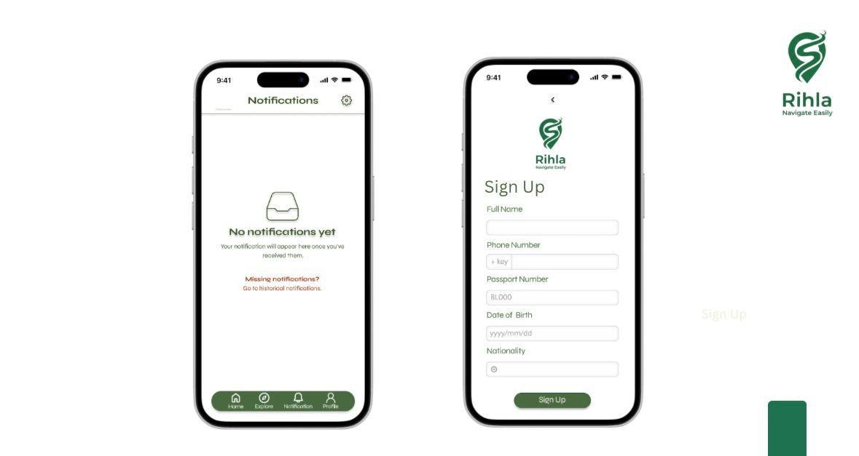
Figure D-4: Accessibility, profile and search/category screens

Appendix C: To Be Determined List
1. Final maps, tourism content, notification and payment providers.
2. Exact destinations included in the first release.
3. Whether direct booking is included or kept for a later release.
4. Offline caching method and amount of data stored on the device.
5. Final performance target after initial testing.

