COURSE : CLOUD COMPUTING LAB

SUBMITTED BY : FATIMA KASHIF
REG# 2023-BSE-018
SUBMITTED TO : SIR MUHAMMAD SHOAIB

LAB # 01
INSTALLATION OF UBUNTU AND VMWARE WORKSTATION PRO
CONFIGURING UBUNTU IN VMWARE

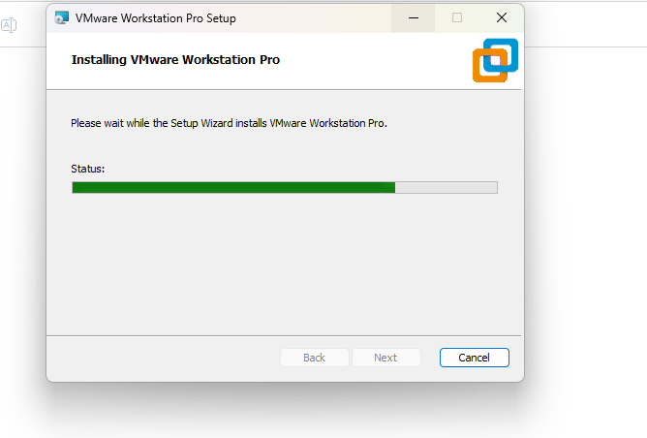

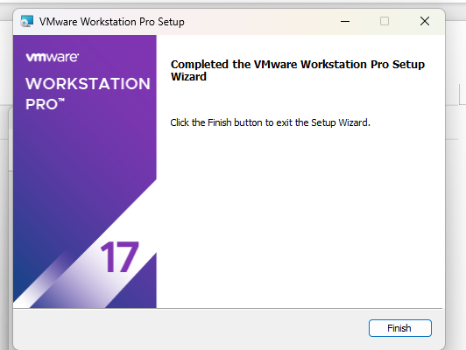

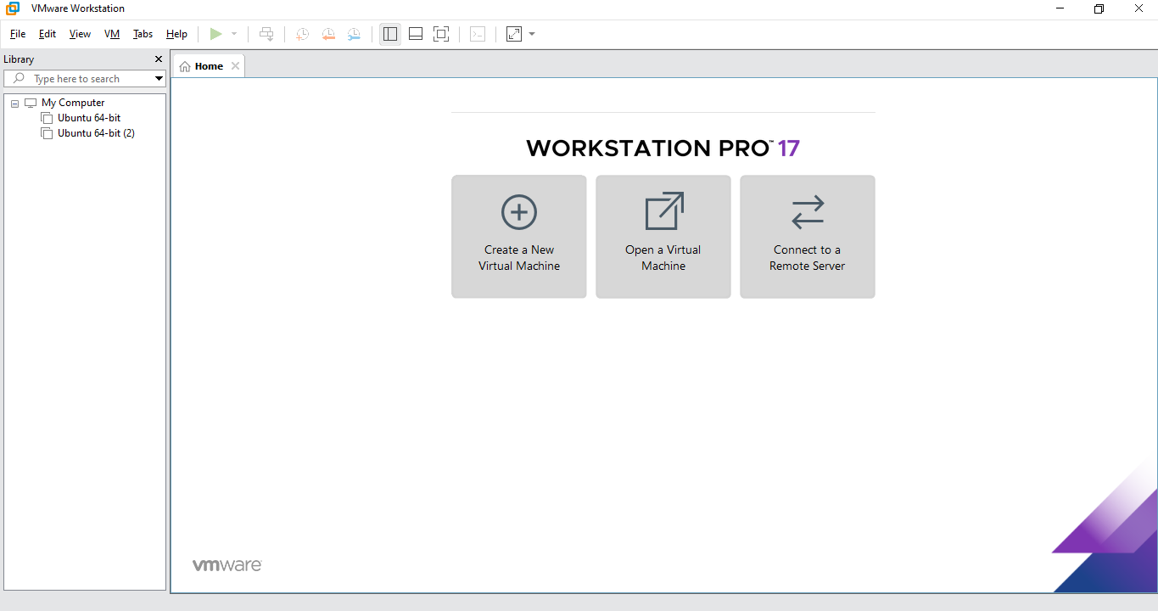

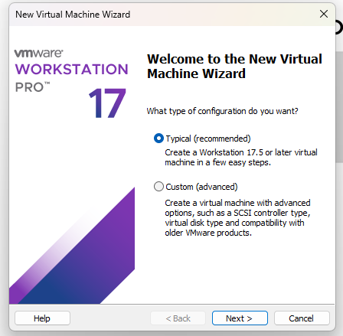
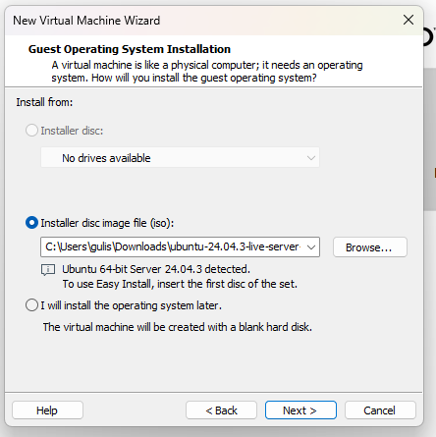
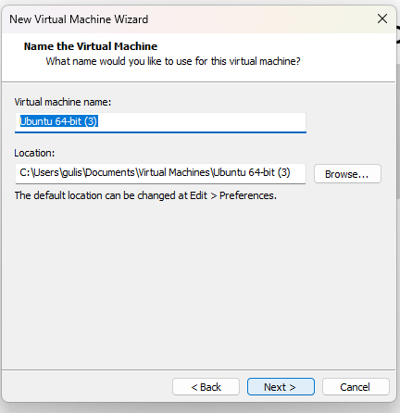
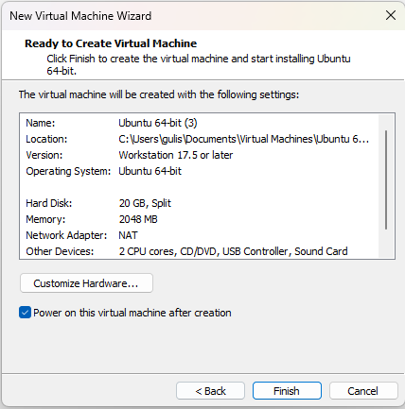

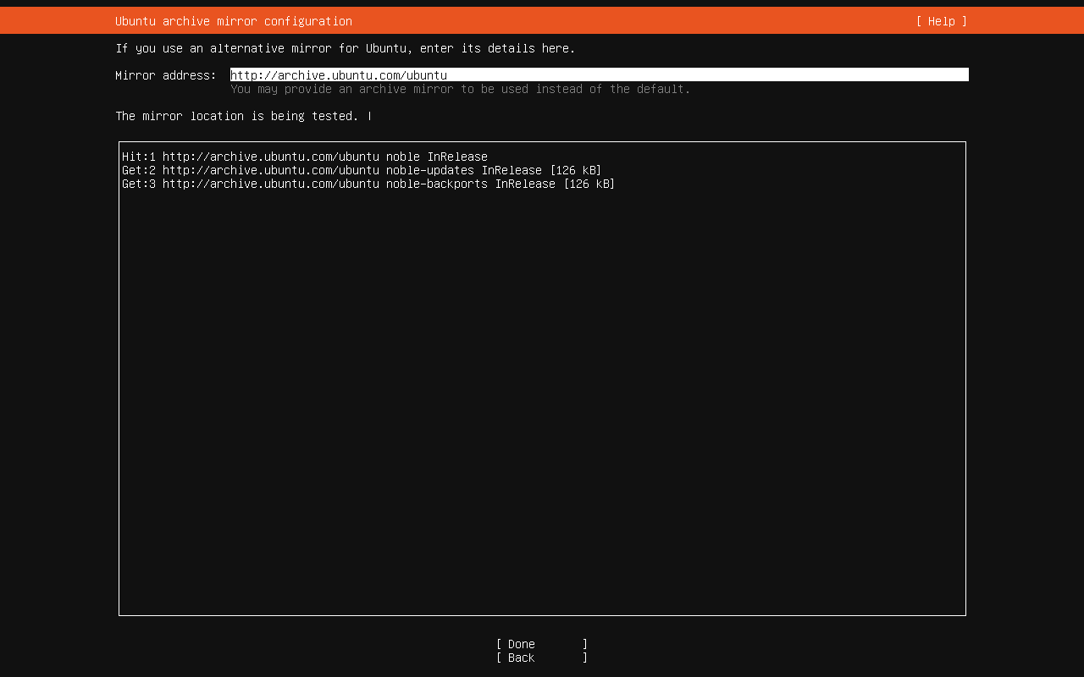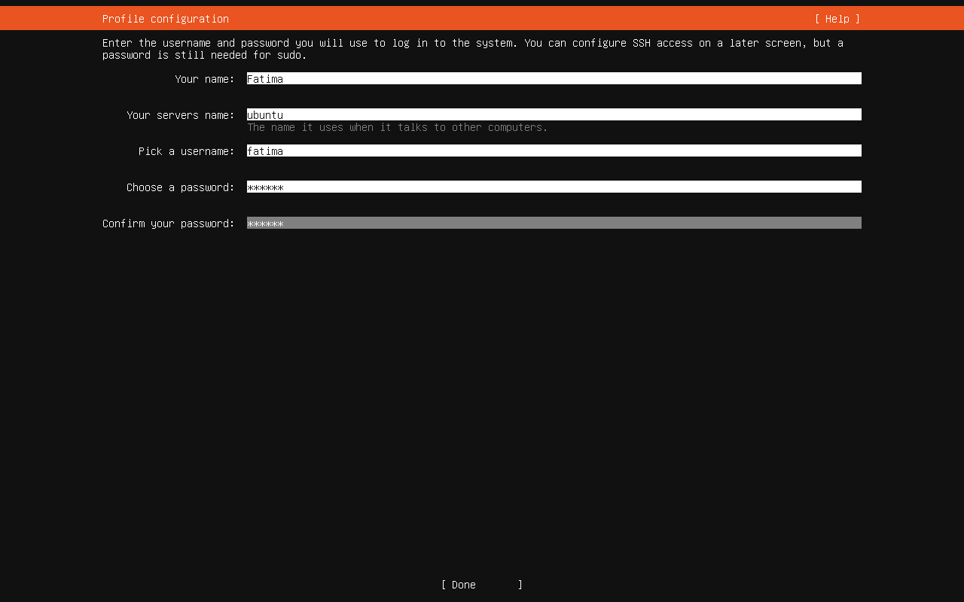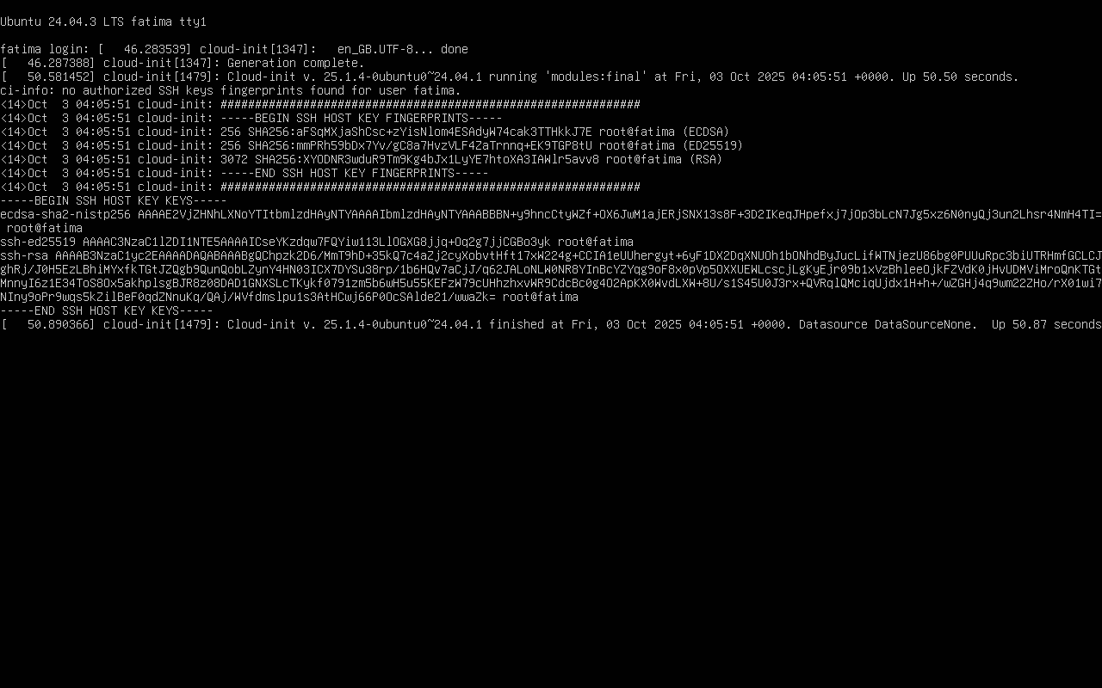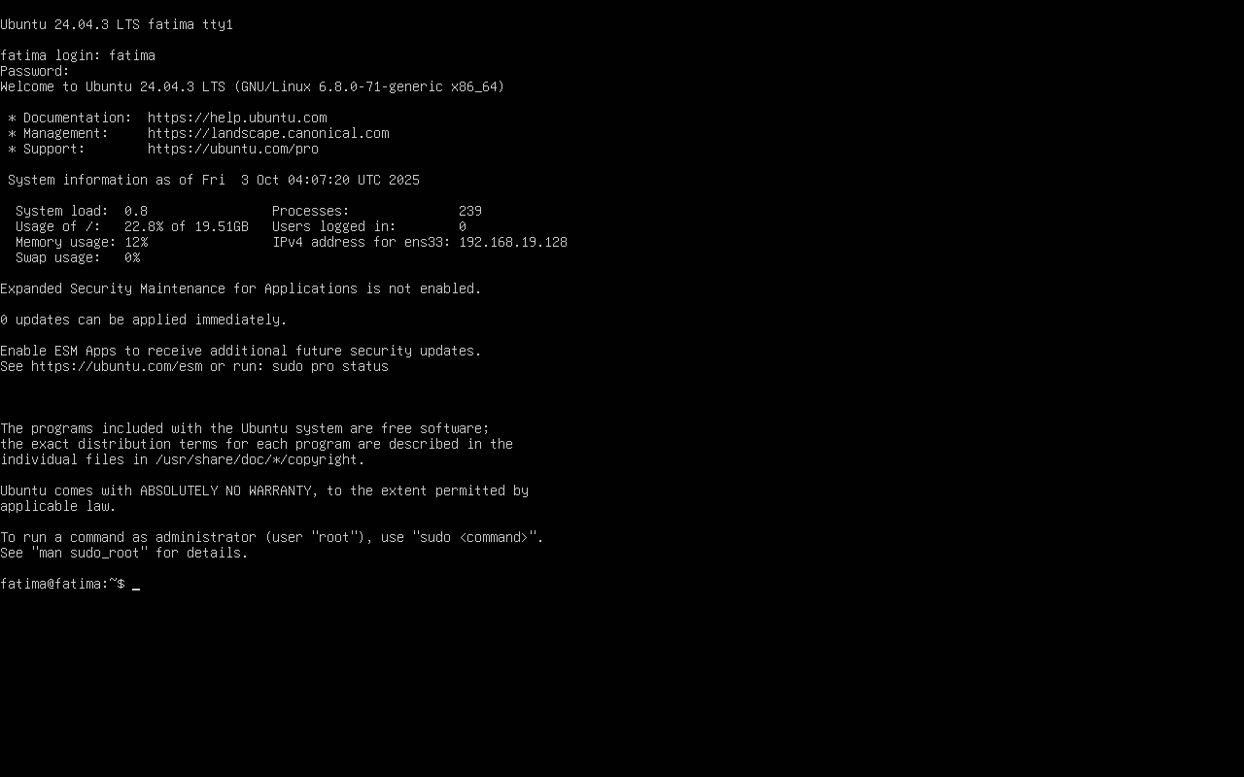

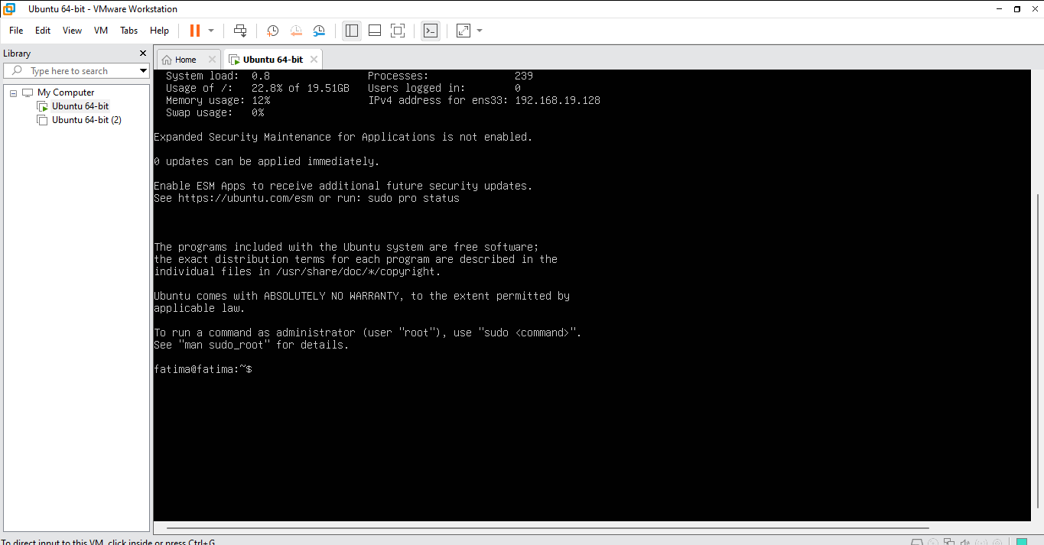

I AM LOGGED IN AS “FATIMA” IN VMWARE WORKSTATION PRO

