COURSE : CLOUD COMPUTING LAB
INSTRUCTOR : SIR MUHAMMAD SHOAIB

SUBMITTED BY : FATIMA KASHIF
REG# 2023-BSE-018

LAB # 03

Task # 01
Adding commit remotely
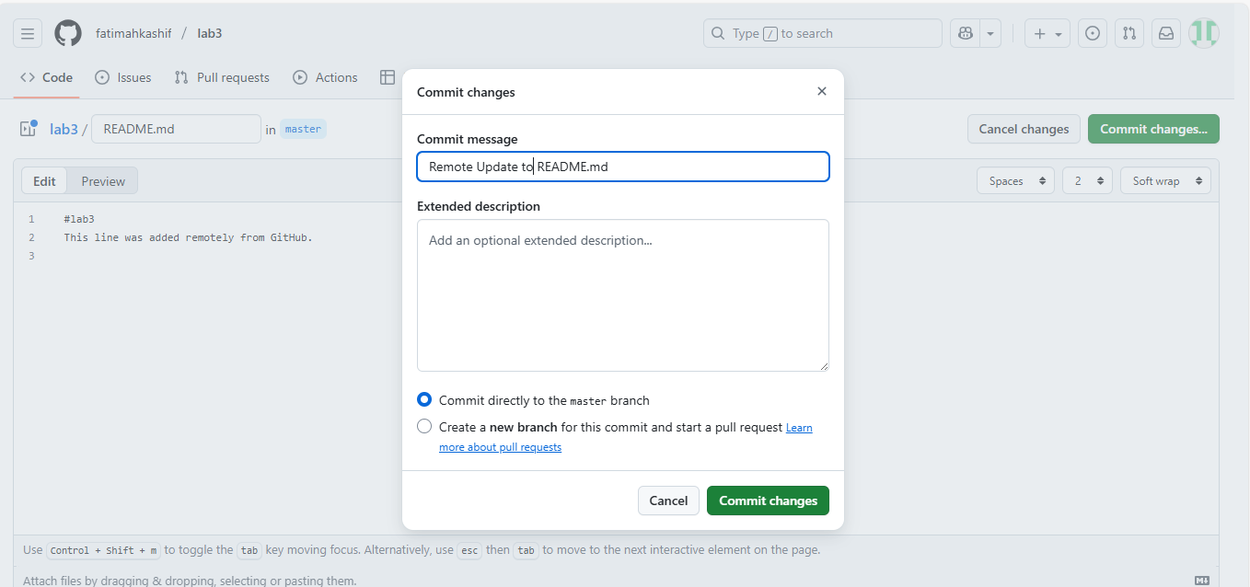
Local edit
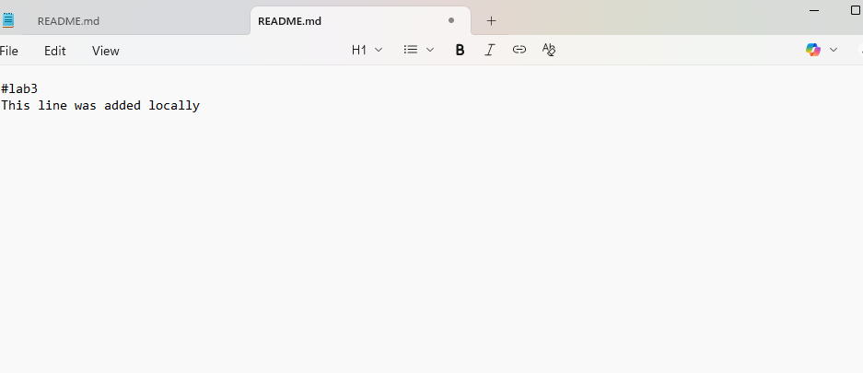

Adding commit locally
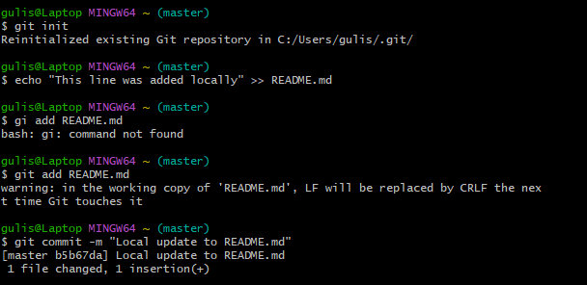
Push error
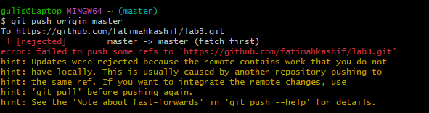
Merge commit with --no-rebase 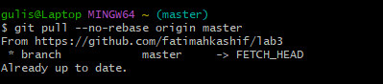
Push after merge
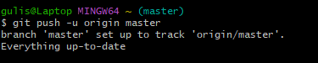

Rebase pull and push after rebase
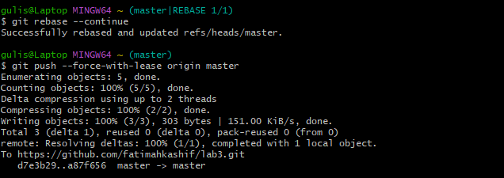

TASK # 02
Remotelt changes in README file
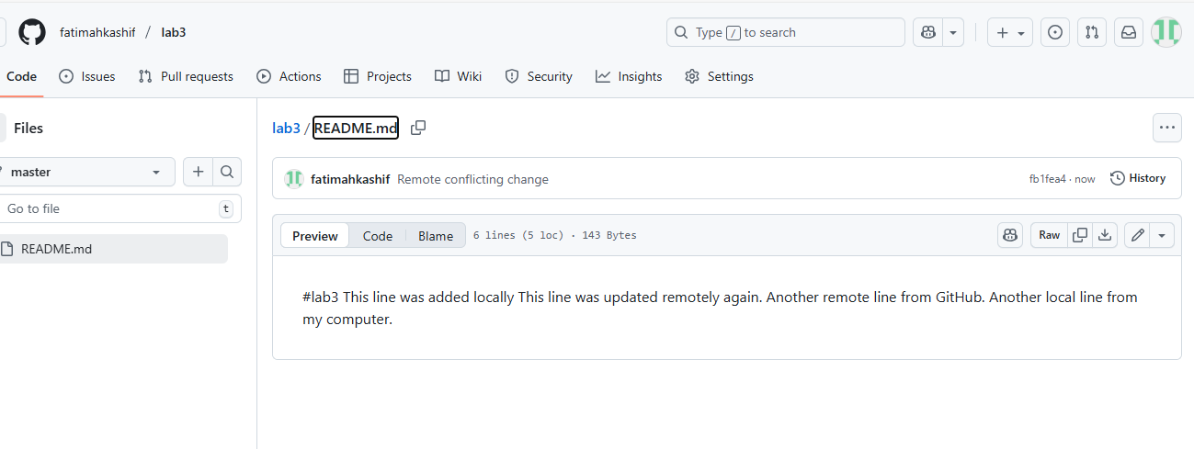
Local conflict edit
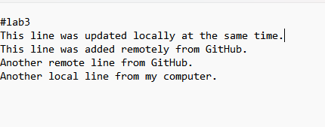

Local confilct commit
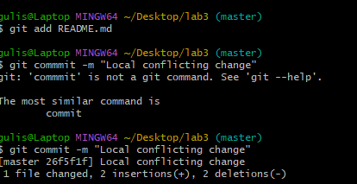

Conflict push error
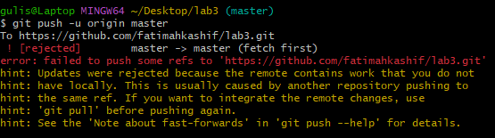
Conflict message
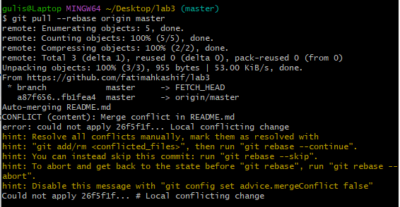
Resolved Readme fie
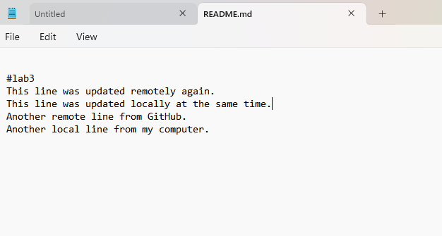
Reabse continue
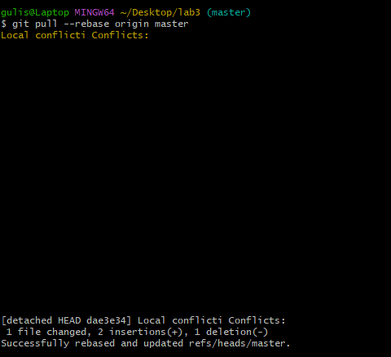

Push after resolve
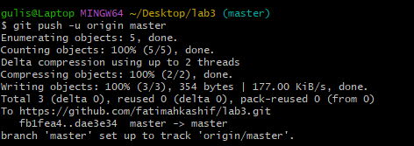

TASK # 03
Creating three files
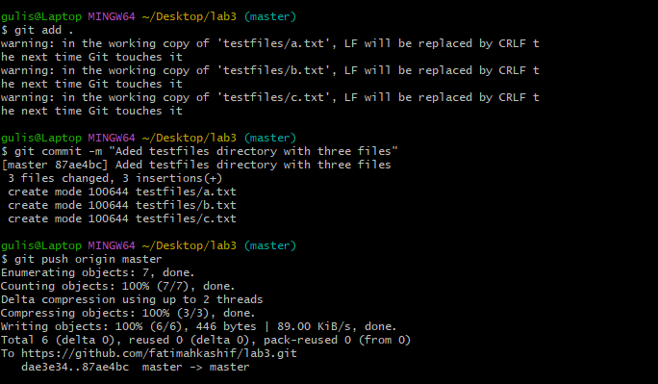
.gitignore to ignore testfiles directory
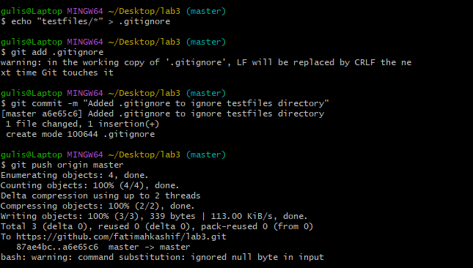
Repositiry still has testfiles
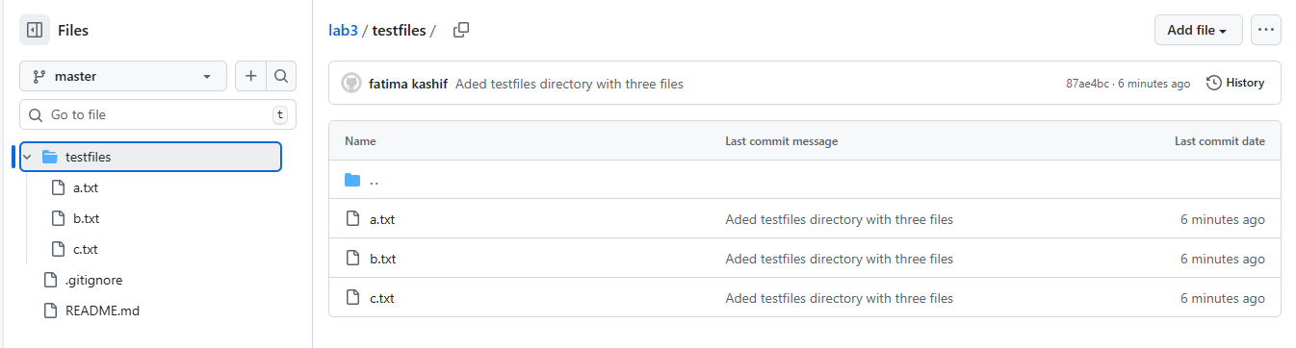
To remove already tracked files from Git (but not from your local system),
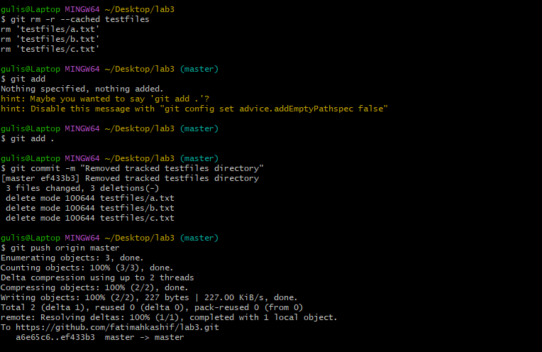
Check your GitHub repository again — the textfiles folder should now be deleted remotely.
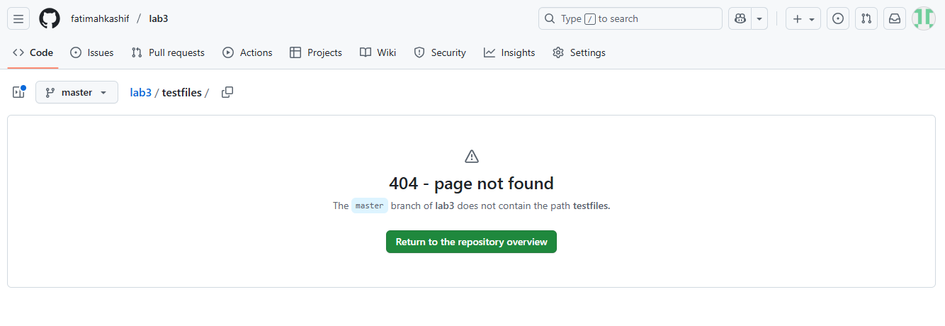
TASK # 04
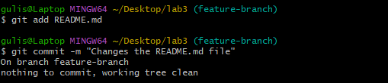
Checkout Error

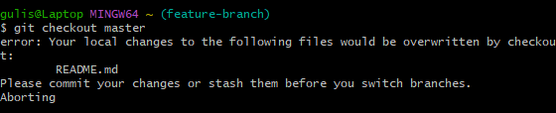
To fix this, stash your changes:
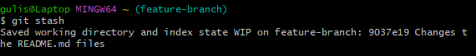
Try switching branches again — it should now work:
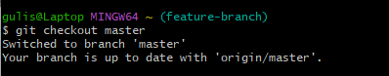
Return to your previous branch
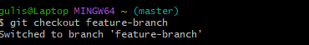
So check status
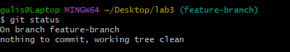

TASK # 05
View commit history:
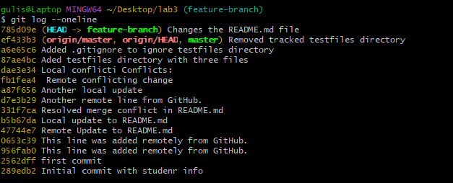Copy any previous commit hash (e.g., a1b2c3d).Checkout that commit:

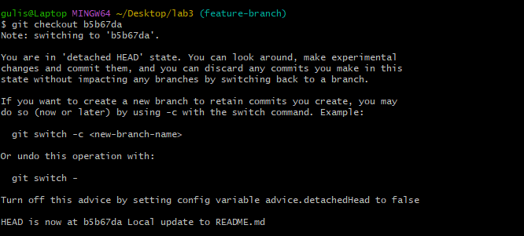

To return to your main branch:
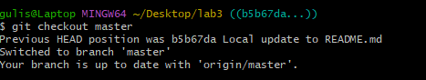

TASK# 06
Add a new line in any file and commit it
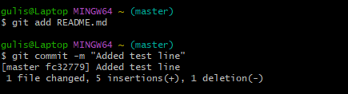
Add another change and commit again
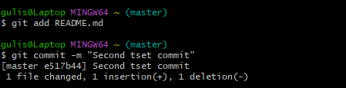
View the history before reset
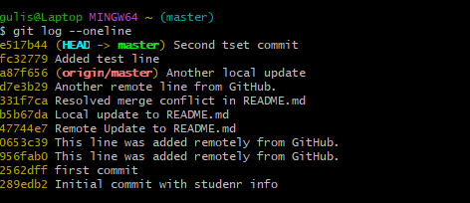
Check file contents for both changes
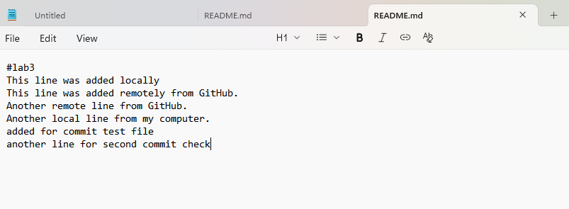
Perform a soft reset (keeps changes in working directory
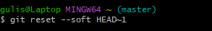

Check commit history after soft reset
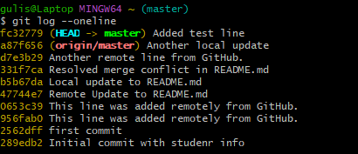
Verify changes in the file:
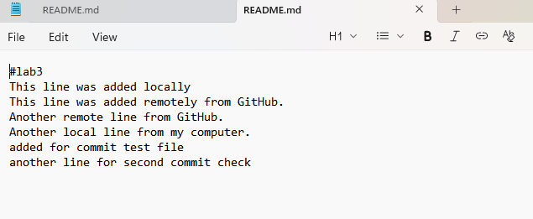
Perform commit
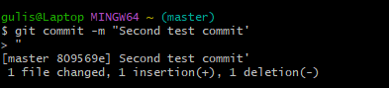
Perform a hard reset (discards changes completely)
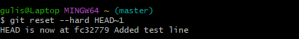
Check commit history after hard reset
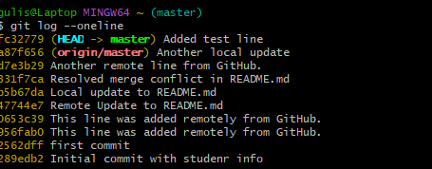
Verify changes in the file:
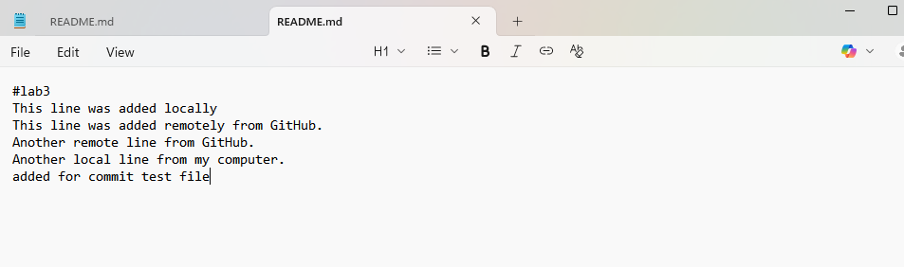
TASK # 07
Make a small change in any file.Stage it and commit:
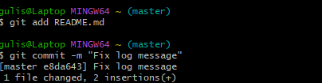
Realize you forgot to change another file. Update it now.Add it and amend the last commit
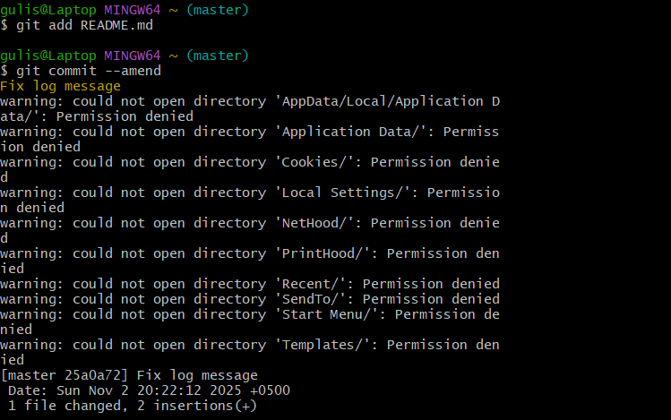

TASK # 08
Make a change and commit it:
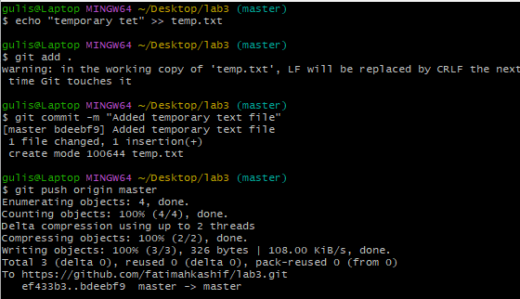
Now revert that commit safely (do not delete it):

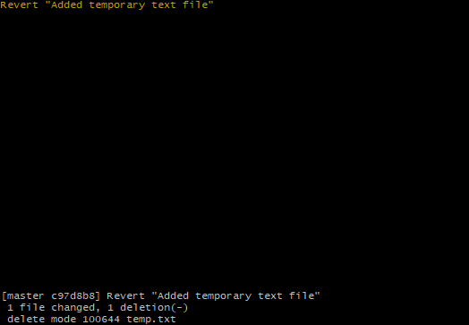
Push the revert commit:
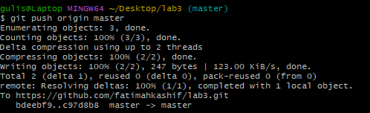

TASK # 09
Create a new branch
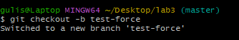
Make and commit a small change.
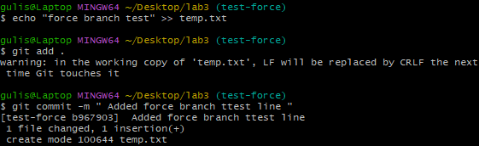
Push it :
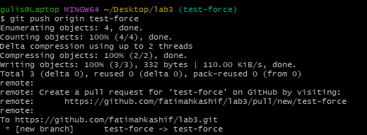
Perform a hard reset:
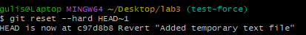
Push again:
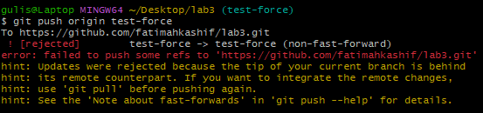

Now force-push to remote:
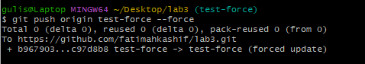

TASK # 10
Fork the Gitea Repository
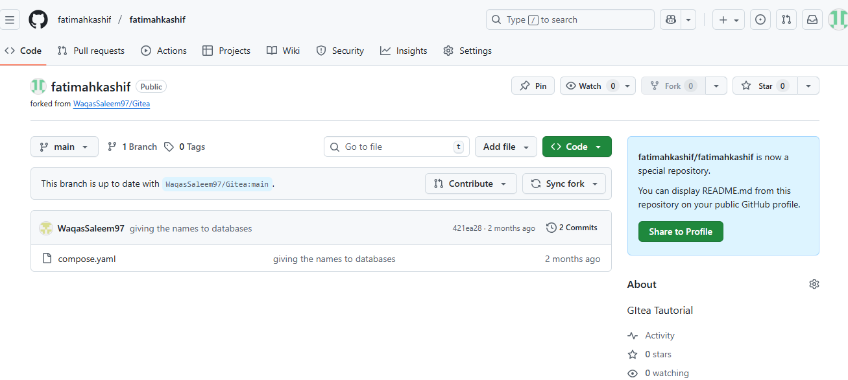
Open the Forked Repo in GitHub Codespaces
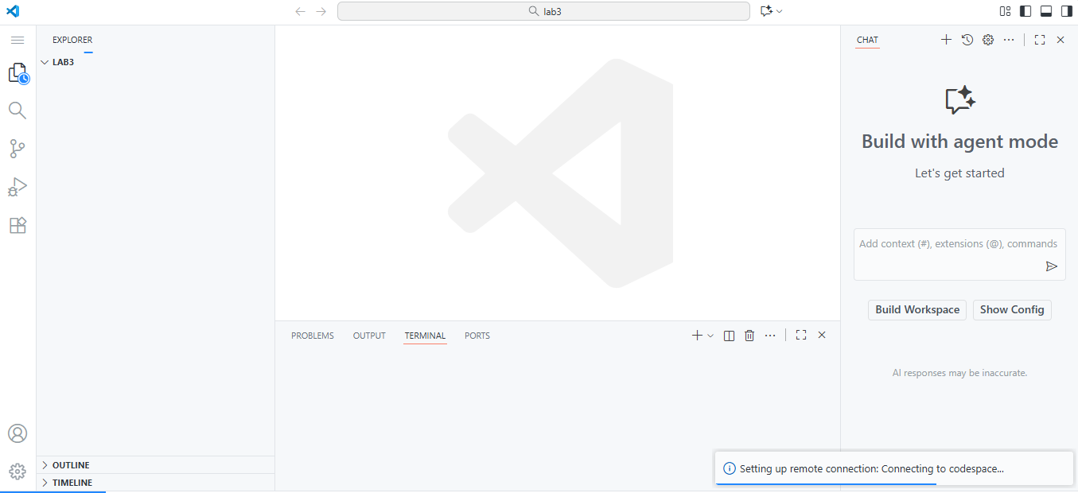
Start Gitea with Docker Compose
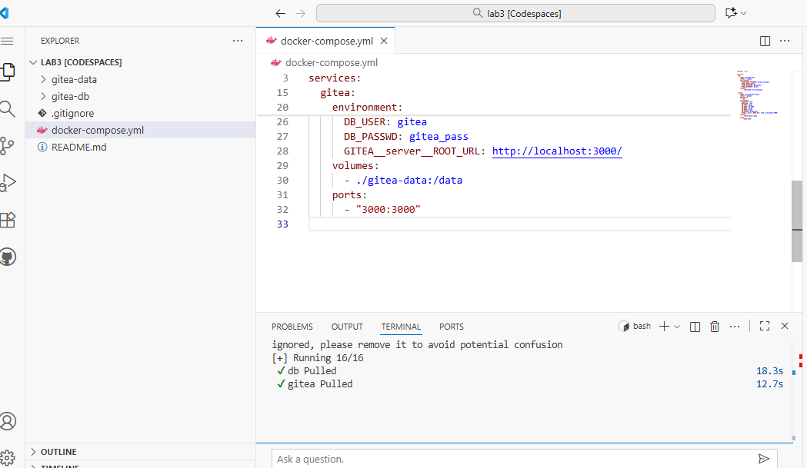
Access Gitea Web Interface
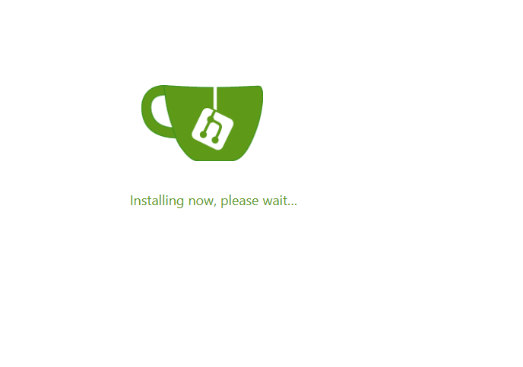
Install Gitea
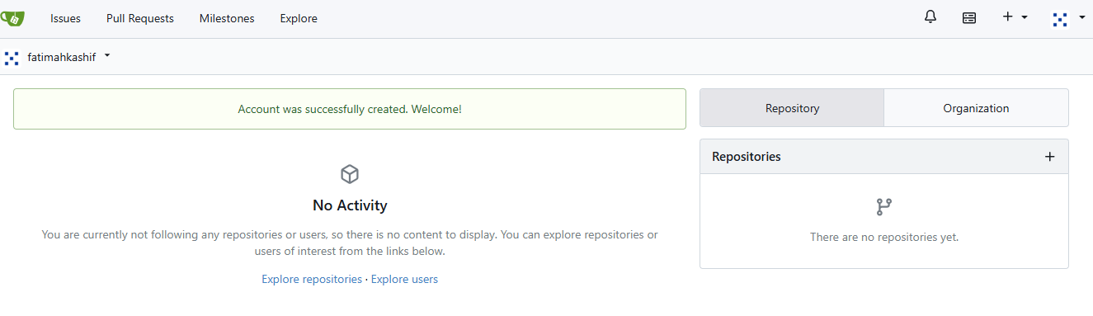
Log In to Gitea
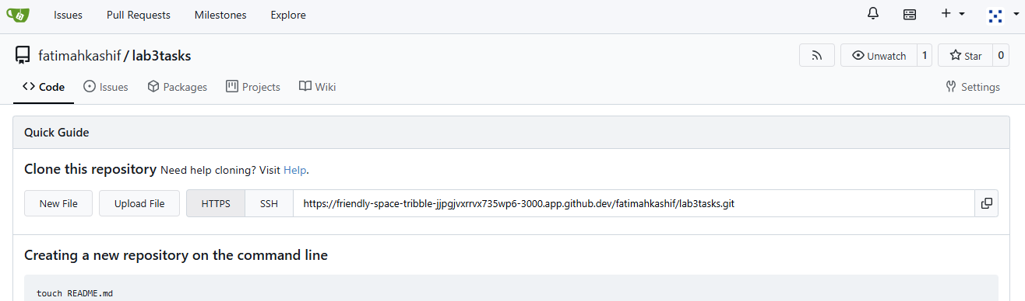
Create a New Repository in Gitea
TASK # 11
Create a GitHub Pages Repository
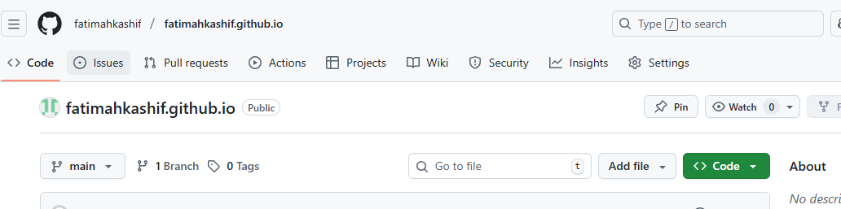
Add Static Website Code
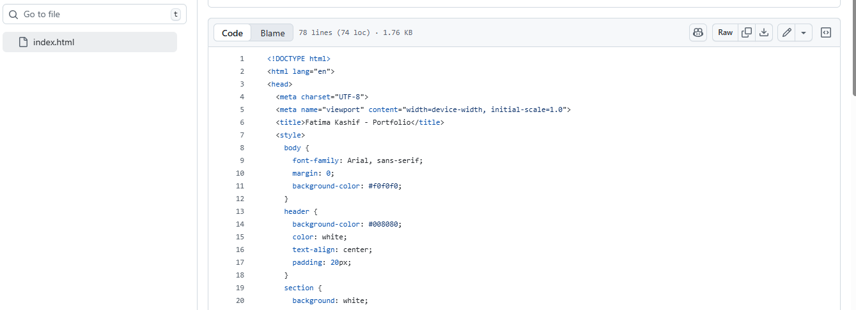
Push the Files to GitHub
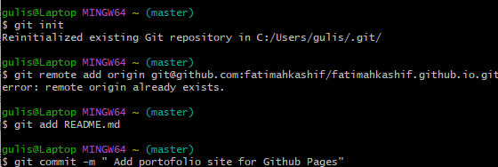
Check GitHub Pages Settings
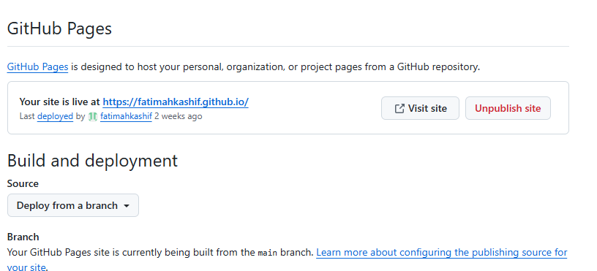
Visit Your Live Site
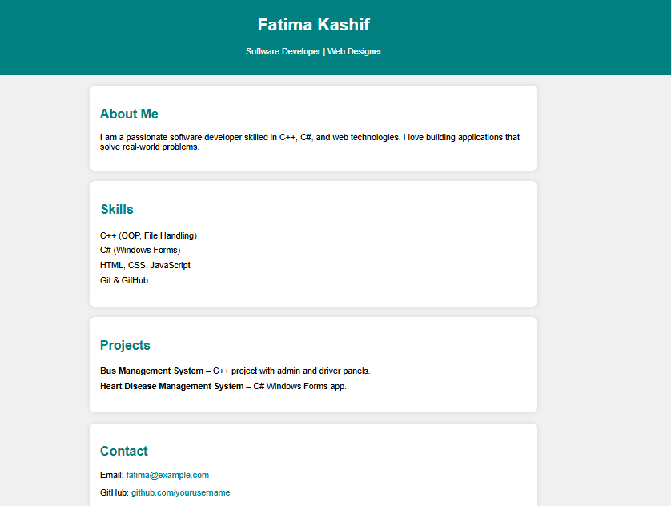

Evaluation Questions

Local vs Remote Conflict Resolution
Question no 2

Manual Merge Conflict Handling

3. Managing Ignored and Tracked Files

Commit History Manipulation and Recovery

