COURSE : CLOUD COMPUTING LAB
INSTRUCTOR : SIR MUHAMMAD SHOAIB

Submitted By: Fatima Kashif
Reg # 2023-SE-018

LAB # 06

TASK # 01
Set a root password (Ubuntu root is disabled by default; this enables su - temporarily for the lab)
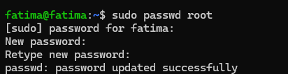
Switch to root and verify
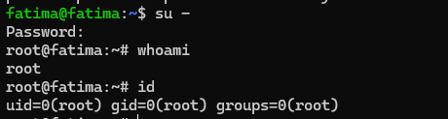
Switch back to your normal user:
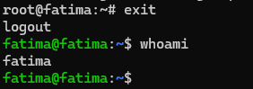

TASK # 02
Create user tom
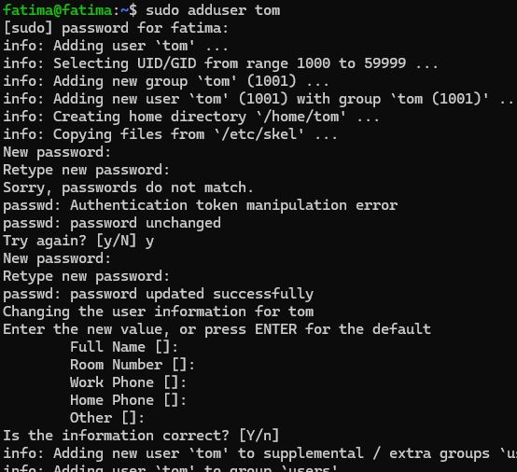

Verify tom in system files (view and visually confirm presence):
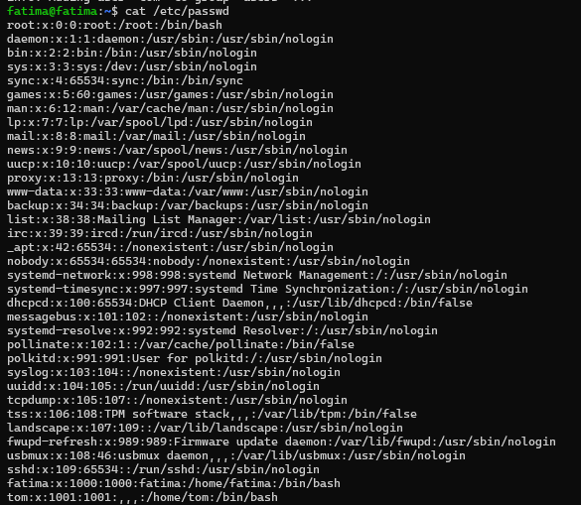
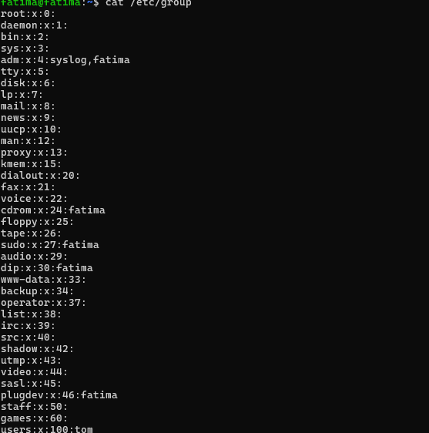
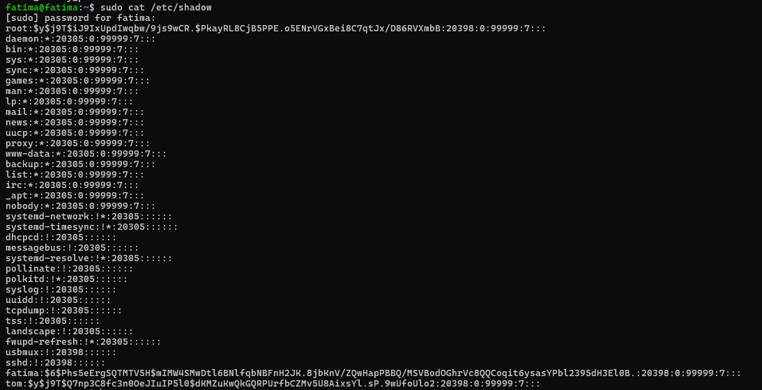
Task 3 – Create groups; change tom’s primary and secondary groups
Create groups and verify by viewing /etc/group (visually confirm entries exist):
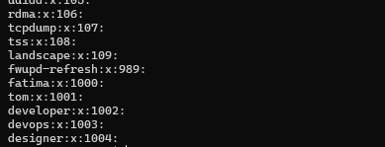
Change tom’s primary group to designer and verify:
Add secondary groups developer and devops to tom and verify:
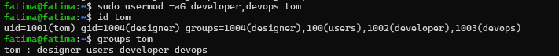
Replace all secondary groups so only tom (user’s own group) remains and verify
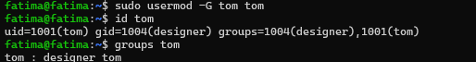

Task 4 – Create/delete users (Jerry, Scooby) and groups (jolly, anime)

Create users:
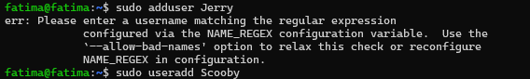
Try to log in as Scooby immediately (expected authentication failure because there is no password yet
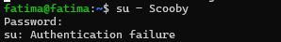
Set a password for Scooby
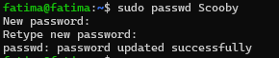

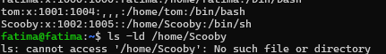

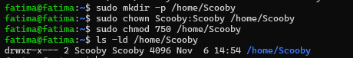

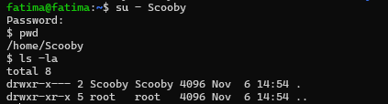

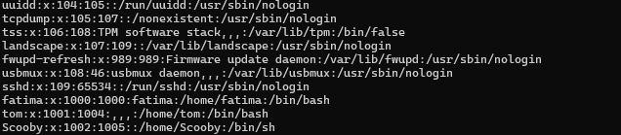

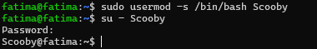

TASK # 05

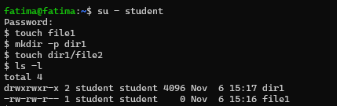
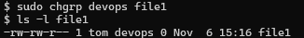

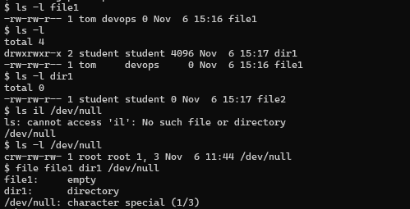

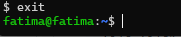

TASK #06

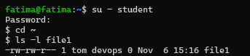

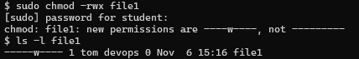

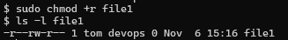

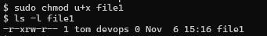

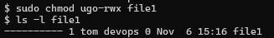

TASK # 07

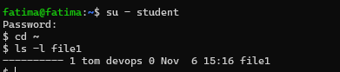

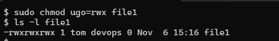

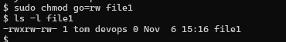

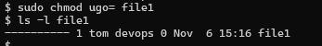

Task # 08

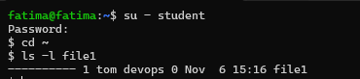

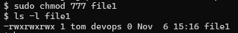

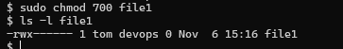

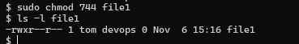

Task # 09

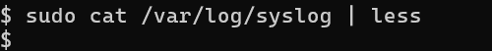

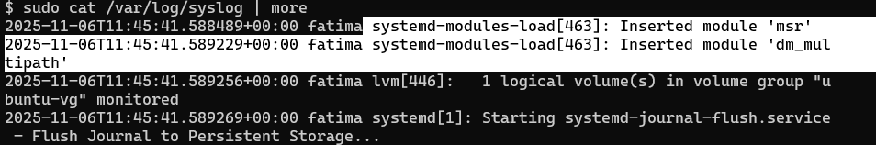

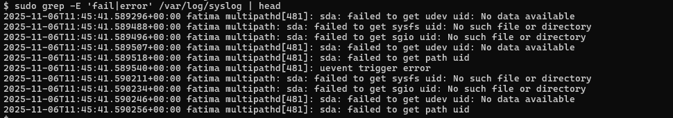

Task # 10

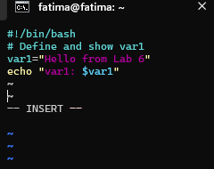

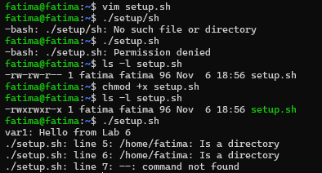

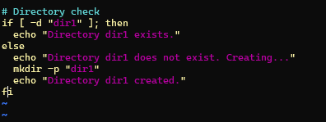
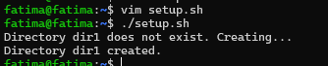

Task # 11

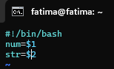

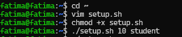

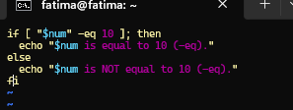

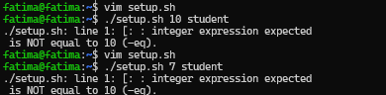

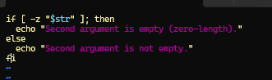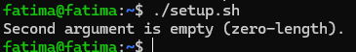

Task # 12

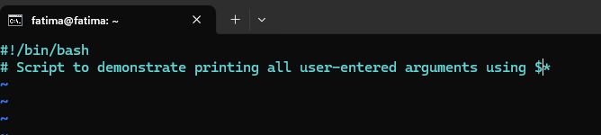

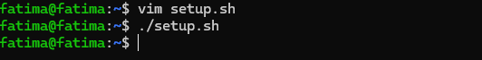

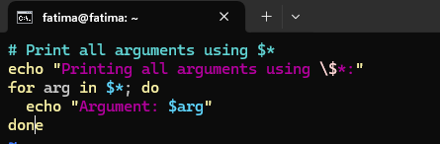

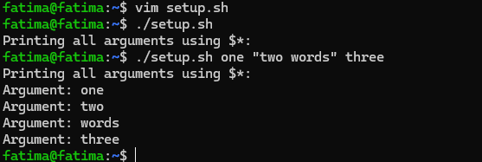

Task # 14
Fork into your account
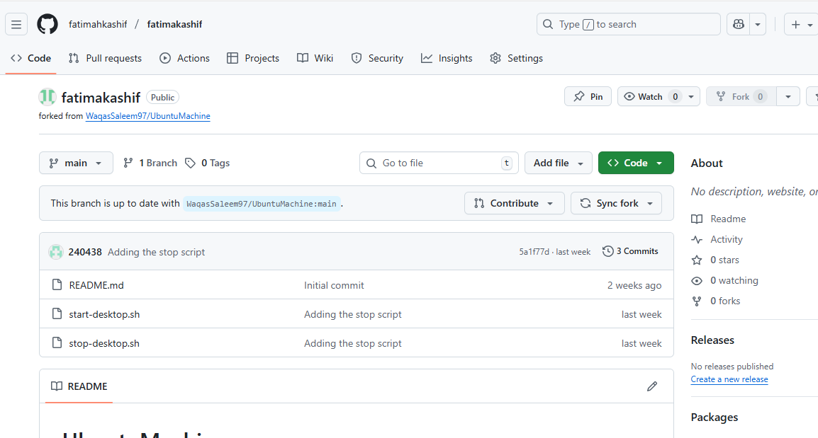

Opening codespace
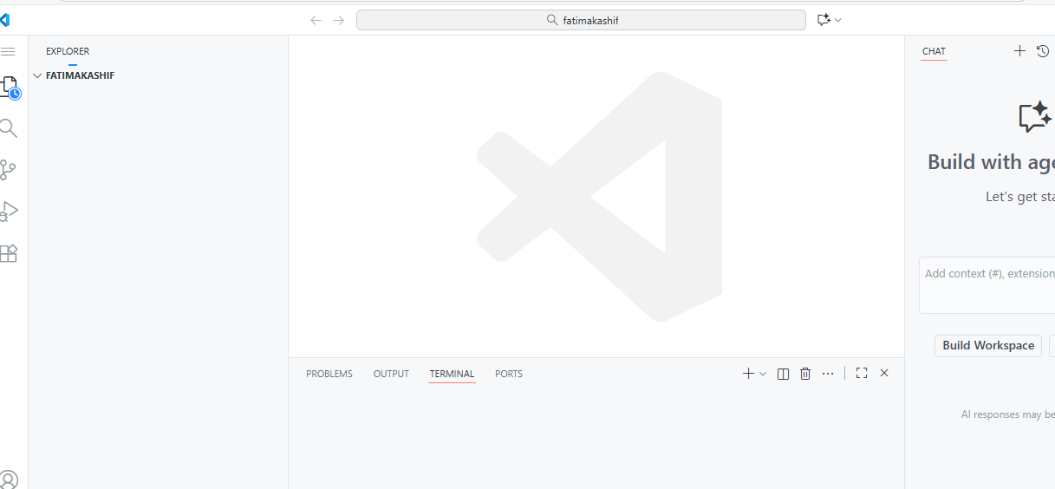

Exexuting command
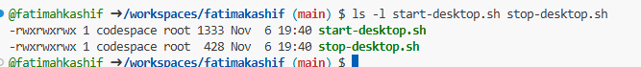

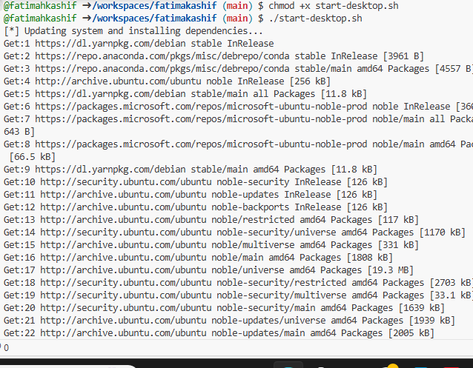

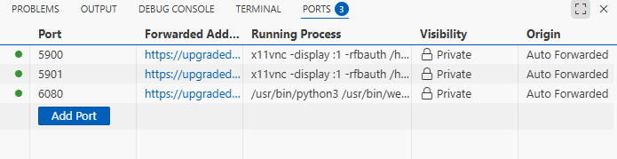

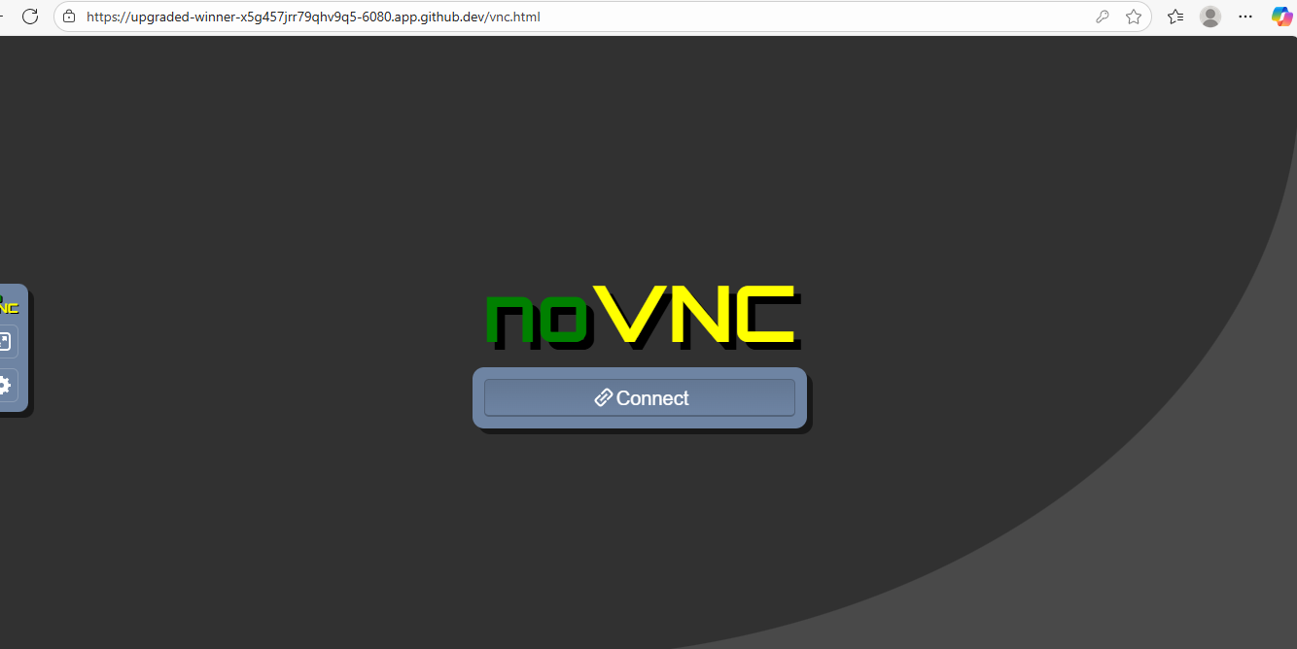

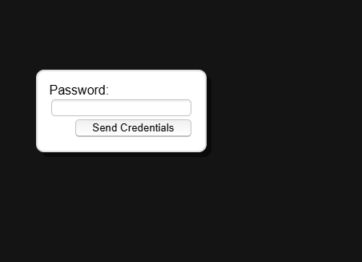

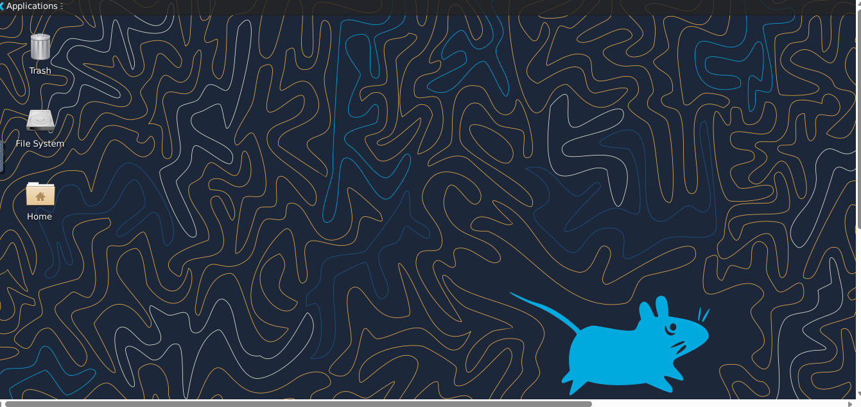

Stopping setup
