**Fatima Jinnah Women University**



**COURSE : CLOUD COMPUTING**

**INSTRUCTOR : SIR WAQAS SALEEM**

**ASSIGNMENT # 01**

**Submitted by**

Fatima Kashif

**Reg#**

1. BSE-018

**Task # 01 : Run gitea in codespace and run initial repo**

Set up GiteaServer inside GithubCodespace using HTTPs

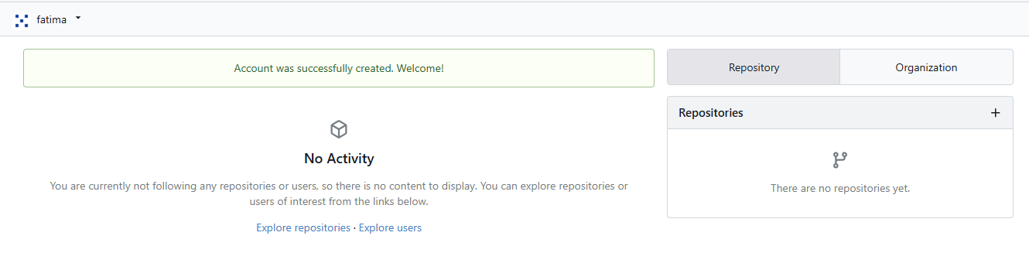

Create Repository On Gitea Server

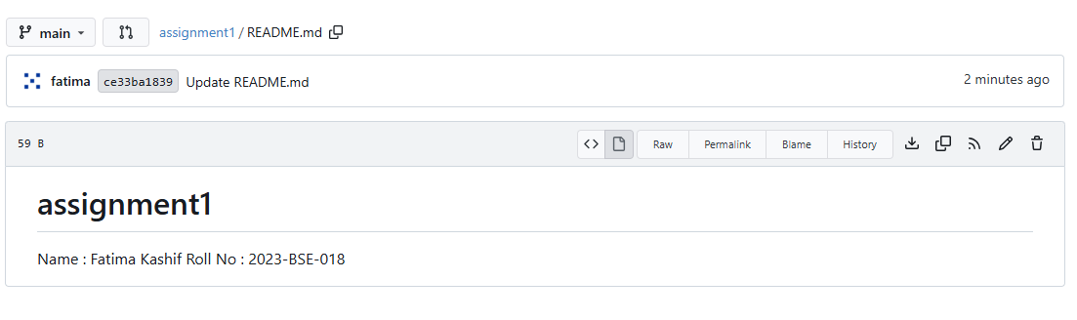

Add Remote Repository and Push Initial Commit to Gitea

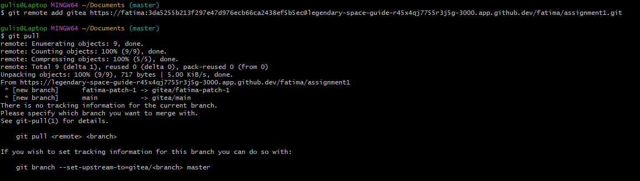

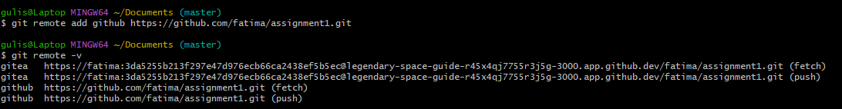

**Task 2: Mirror README.md from Gitea to GitHub**

Continue Working with Your Existing Repository & Create GitHub Repository

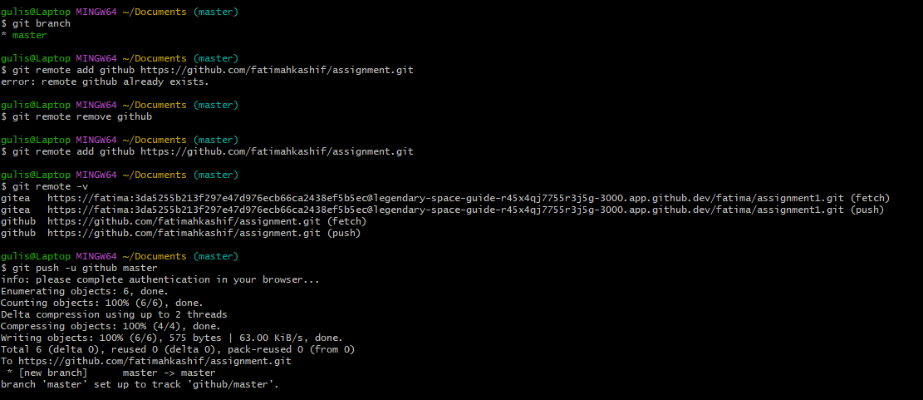

**Task 3: Use Git LFS for Large Files**

Install Git LFS &Large Files

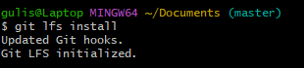

Add, Commit, and Push Large Files

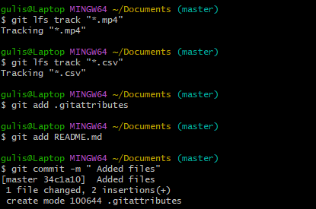

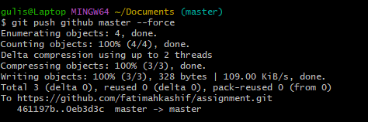

**Task 4: Create a Portfolio/CV with GitHub Pages**

Create a New Repository for GitHub Pages

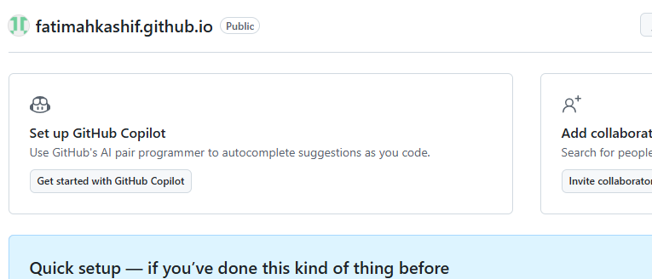

Design Your Portfolio/CV:

**Your site is live at <https://fatimahkashif.github.io/>**

