
NEAR EAST UNIVERSITY
Faculty of AI and Informatics
Department Of Computer Engineering
Inlithan Lab (AI Teaching Assistant)

Graduation Project II COM491

Students: Mohammed Abdurehman 20225878 Akhideno Ososese 20225181
Yedil Beken 20223752

Supervisor: Prof. Dr. Elbrus Imanov

Nicosia – 2026

NEAR EAST UNIVERSITY
Faculty of AI and Informatics
Department Of Computer Engineering
Inlithan Lab (AI Teaching Assistant)

Graduation Project II COM491

Students: Mohammed Abdurehman 20225878 Akhideno Ososese 20225181
Yedil Beken 2022375

Supervisor: Prof. Dr. Elbrus Imanov

Nicosia – 2026

ACKNOWLEDGEMENT

We would like to sincerely thank everyone who played a part in bringing Inlithan Lab to life, Which has been developed as an Al-assisting learning tool for technology-related fields. This project pushed us beyond what we thought was possible, and none of it would've happened without the help of some really good people around us. It just marks the beginning of our journey in the world of academics and represents our efforts in collectively advancing the arena of technology-assisted learning.
First off, huge thanks to our supervisor, Prof. Dr. Elbrus Imanov, for entrusting us with such an important project. He gave us the freedom to run with our idea while also keeping us grounded when we started overcomplicating things.
Near East University created the kind of environment where a project like this could exist. The Computer Engineering department gave us the tools, the labs, and honestly just the confidence to try something ambitious. We're grateful for that.
We also want to thank the classmates and the staff of the Department of Computer Engineering as a whole. Who sat with us during the early stages and gave us honest feedback. Their assistance provided us with the capability to undertake this challenging task.
And finally, our families and friends. They didn't fully understand what we were building, but they showed up anyway. That kind of support is hard to put into words.
We hope Inlithan Lab becomes something that future students and instructors actually use and find useful. That's the whole point.

ABSTRACT

Inlithan Lab is an AI-powered teaching assistant built to change how programming is taught in universities by creating personalized and applicable programming exercises based on modern industry standards. The core idea is pretty simple: teachers upload their syllabus, and the system uses AI to automatically generate relevant, practical coding activities and quizzes that match what's on the material.
The platform is fully integrated with GitHub to monitor or track the student coding activity (commits, pull requests, patterns) and use that data to adjust difficulty level according to the performance of every student. Students who are struggling get simpler exercises with more guidance. Students who are ahead get harder ones. The system adapts.
Inlithan Lab has two interfaces: a web app and a mobile app. Both are built around two types of users — teachers and students — with separate dashboards that show what each group actually needs. Teachers see class-wide analytics and can manage or edit AI-generated content. Students see their personal progress, upcoming tasks, and skill radar.
The platform also wraps around GitHub Copilot, making AI coding assistance part of the learning workflow rather than something students use to avoid learning. This document covers everything from the problem we're solving, the features we built, the technical architecture, to the 55-day roadmap and the prototype we've developed so far.

Table of Contents
ACKNOWLEDGEMENT 3
ABSTRACT 4
INTRODUCTION 7
. Problem Statement 7
. Target Users 7
. Significance of the Project 7
Literature Review 8
. GitHub Classroom 8
. Gradescope 8
. Coursera and edX (Adaptive Learning Features) 8
. Khanmigo (Khan Academy AI) 8
. What Makes Inlithan Different 9
CHAPTER 1 10
Comparison With Existing Tools 10
CHAPTER 2 11
Methodology 11
Data & Curriculum Collection 11
Tools and Technologies Used 11
CHAPTER 3 13
Journey of the Project 13
Why React and Flutter? 13
CHAPTER 4 14
System Architecture 14
GitHub Integration 14
CHAPTER 5 18
AI Activity Generation Engine 18
Adaptive Difficulty System 22
CHAPTER 6 26
Prototype Screens 26
Role Selection Screen 26
Student Dashboard 26
Teacher Dashboard 27
CHAPTER 7 29
Functional Requirements 29
Non-Functional Requirements 29
CHAPTER 8 30
Development Roadmap (55 Days) 30
Conclusion 31
References 32

INTRODUCTION

There's a gap in tech education that's been growing for a while now. Universities teach concepts that were relevant maybe five years ago, while the industry moves forward every few months. Students continue to find challenges in linking theoretical aspects to actual implementations. This scenario has led to fewer students participating and poor understanding. Graduate students who know how to write code but don't really know how software is actually built in a real company — version control, code review, CI/CD, AI tools. These things are standard in any real dev team, but rarely touched in classrooms.
At the same time, instructors are stretched thin. Creating good, relevant coding assignments takes time they often don't have. And even when assignments are good, they're the same for every student regardless of where they're at individually. A student who's already comfortable with loops gets the same exercise as someone still struggling to understand what a variable is. That doesn't make sense.
In this challenge, Inlithan Lab emerges. A lab where learning is constantly tested and adjusted. The system uses AI to generate programming activities directly from a teacher's syllabus, integrates with GitHub to track real coding behavior, and dynamically adjusts difficulty based on each student's performance.
This document explains how we got here, what we built, what it's supposed to do, and where we're taking it next.

Problem Statement
Tech instructors in universities and training programs face a few recurring problems:
- Creating coding assignments takes a lot of time, and there's often not enough of it
- Assignments go stale fast when tools and frameworks evolve quickly
- They don’t adapt to individual student performance
- They fail to integrate with real developer workflows
The consequence of all this is pretty predictable — students disengage, don't retain much, and graduate underprepared. Inlithan Lab is our attempt to fix that by bringing automation and adaptability into the teaching workflow.

Target Users
- Instructors and Teacher at universities, coding bootcamps, and corporate training programs
- Students learning programming, web dev, data structures, ML, DevOps, and similar topics
- Program directors who need to track and measure learning outcomes
- Institutions looking for scalable and modernized tech education tools

Significance of the Project
What's most important about the project? It makes it easier for teachers to teach and for students to learn – something that other resources have not been able to accomplish yet. The teacher puts in their syllabus one time. Then our system provides endless exercise options that reflect precisely what the students have learned so far. This way, students receive assignments that they're capable of

completing while still being challenging enough. Plus, the platform is connected to GitHub so we know the true coding skills of the students.
For institutions in places like Northern Cyprus, where specialized tech talent and up- to-date course materials can be hard to find, a tool like this could help programs stay relevant without demanding hours of extra work from instructors. That's what makes this worth building.

Literature Review
Before building Inlithan Lab, we spent time looking at what already exists. While there are various platforms attempting to implement adaptive learning in one way or another, there is not one which meets all our requirements. This is an overview of those available platforms and our considerations.

GitHub Classroom
GitHub Classroom is probably the closest thing to what we're building in terms of GitHub integration. Teachers can create assignments, distribute starter repos, and track student submissions. It's genuinely useful, and we use it ourselves.
The limitation is that it's just infrastructure — it doesn't generate activities, it doesn't adapt to student performance, and there's no AI layer. You still have to create all the content yourself. It's more of an assignment distribution tool than a teaching assistant.

Gradescope
Gradescope handles automated grading really well, especially for programming assignments. It can run test cases against student code and give scores automatically. Teachers love it because it saves grading time significantly.
What it doesn't do is generate content or adapt to students. It's on the output end of the teaching pipeline — grading what's already been submitted — not the input end where you're designing what students actually learn.

Coursera and edX (Adaptive Learning Features)
Both these platforms have implemented some aspects of adaptive learning, such as quiz difficulty adjustment, personalized course suggestions, and so forth. They've been doing this for years and have pretty mature systems behind it.
The problem is they're built for MOOCs with pre-made content. A university instructor can't just upload their own syllabus and have it generate custom activities. The content is fixed. Inlithan Lab is designed specifically for instructors who have their own curriculum and need tools that work with it.

Khanmigo (Khan Academy AI)
Khan Academy's AI assistant is impressive for K-12 and general subjects. It can tutor students through problems, explain concepts step by step, and flag where a student is getting stuck.
It's built for their specific content library though. There's no GitHub integration, no support for programming-specific workflows, and no teacher-facing curriculum ingestion. It's a tutoring bot, not a teaching assistant platform.

What Makes Inlithan Different
The gap we're trying to fill is the combination of: curriculum ingestion from the teacher's own syllabus, AI-generated activities that stay current, GitHub integration for real coding analytics, and dynamic difficulty adjustment — all in one place. None of the tools we looked at do all of that together.

CHAPTER 1

Comparison With Existing Tools
Below is a comparison of Inlithan Lab against the tools we reviewed:

Feature | Inlithan Lab | GitHub Classroom | Gradescope | Coursera | Khanmigo
AI Activity Generation | Yes | No | No | Partial | No
Syllabus Ingestion | Yes | No | No | No | No
GitHub Integration | Yes | Yes | No | No | No
Adaptive Difficulty | Yes | No | No | Partial | Partial
Teacher Dashboard | Yes | Limited | Yes | Limited | No

Feature | Inlithan Lab | GitHub Classroom | Gradescope | Coursera | Khanmigo
Student Dashboard | Yes | No | No | Yes | Yes
Mobile App | Yes | No | No | Yes | Yes
Custom Curriculum | Yes | Yes | Yes | No | No
As the table shows, no single tool covers all of these features together. That's the gap Inlithan Lab is filling.

CHAPTER 2

Methodology
This approach is consistent with the development of a real product rather than a homework assignment. First, there was an understanding of the current issue. Then we talked to some teachers and students we know. Then we worked backwards to figure out what we should build.
This process includes research, rapid prototyping, and iteration. Initially, the team considered such tools as wireframes and the feature list. Then we cut that list down to a realistic deliverable. The 55-day timeline we ended up with has us developing our product in phases, first branding, then setup, then core features, then testing.
Why do it this way? Because diving straight into coding without a design plan generally results in the wrong solution being developed. We didn't want to spend weeks coding a back-end without making sure the interfaces were sensible.

Data & Curriculum Collection
For the AI to generate useful activities, it needs to understand the course content. We designed the system to accept curriculum input in a few formats:
    - PDF or DOCX syllabi that teachers can upload directly
    - Structured input through a course creation form in the app
    - Topic and weekly objective mapping that the system uses to time activity generation
We also looked at a few real syllabus examples from computer engineering courses at NEU to test how well the AI could interpret them and generate relevant tasks. The results were encouraging — the activities it produced were genuinely aligned with the topic, though we're still working on making the difficulty calibration more consistent.
For the GitHub integration side, we use the GitHub REST API to pull commit history, PR data, and file change patterns. This gives us actual coding behavior — not just "did they submit" but "how did they write this code" — which is way more informative for adaptive learning.

Tools and Technologies Used
    - React framework (web frontend) and Flutter framework (mobile app)
    - Node.js and Express framework for the backend API
    - OpenAI GPT-4 model for activity creation and feedback generation
    - GitHub REST API for student coding analytics
    - Figma for UI design and prototyping
    - GitHub Copilot as a Copilot wrapper integration layer

CHAPTER 3

Journey of the Project
The idea behind this project came because of a rather uncomfortable revelation we made towards the end of our last semester. As we sat around and went through the subjects we had studied over the course of the last few years, there was one thing that stood out for all of us, and we were not happy about it. While we had done a great deal of programming classes, covered data structures, algorithms, networking, cybersecurity, and more, very little of what we learned had ever been applied.
This discussion became quite awkward as we questioned each other as to how we would answer a question during an interview as to what we had created. The answer was quite sobering: not much at all. We knew the theory, we understood the concepts, but we did not create anything using them. This became the central issue for us.
Therefore, the concept of Inlithan Lab stemmed from this very idea. What if there was some kind of tool that made such connection? What if there was something that turned the current topic taught by your tutor in class into an exercise that isn’t merely a textbook one, but something that you can truly use?
This is how our project began. We did not get inspired by some scientific article or a professor’s suggestion; we just knew that we were about to graduate and feel underprepared, so we decided to do something about it.

Why React and Flutter?
React was chosen for the web application, and Flutter was selected for mobile development because that was not an accident. React is currently the most popular framework in the industry for building frontends, so using React aligns with our aim to implement real-world development approaches. Additionally, it was easy to use React's component-based architecture to transfer design patterns from the teacher view to the student view.
As for mobile app, we were confused which technology we should choose between Flutter and React Native. One of us preferred to use React Native since we were already working with React, But Flutter outperformed React Native on mobile devices and compiled into native code for iOS and Android.
Node.js is the perfect backend technology for this task since it has a vast ecosystem and provides great support for GitHub and OpenAI APIs.

CHAPTER 4

System Architecture
The architecture of Inlithan Lab is built around four main layers: the frontend clients (web and mobile), the backend API, the AI layer, and the GitHub integration service.

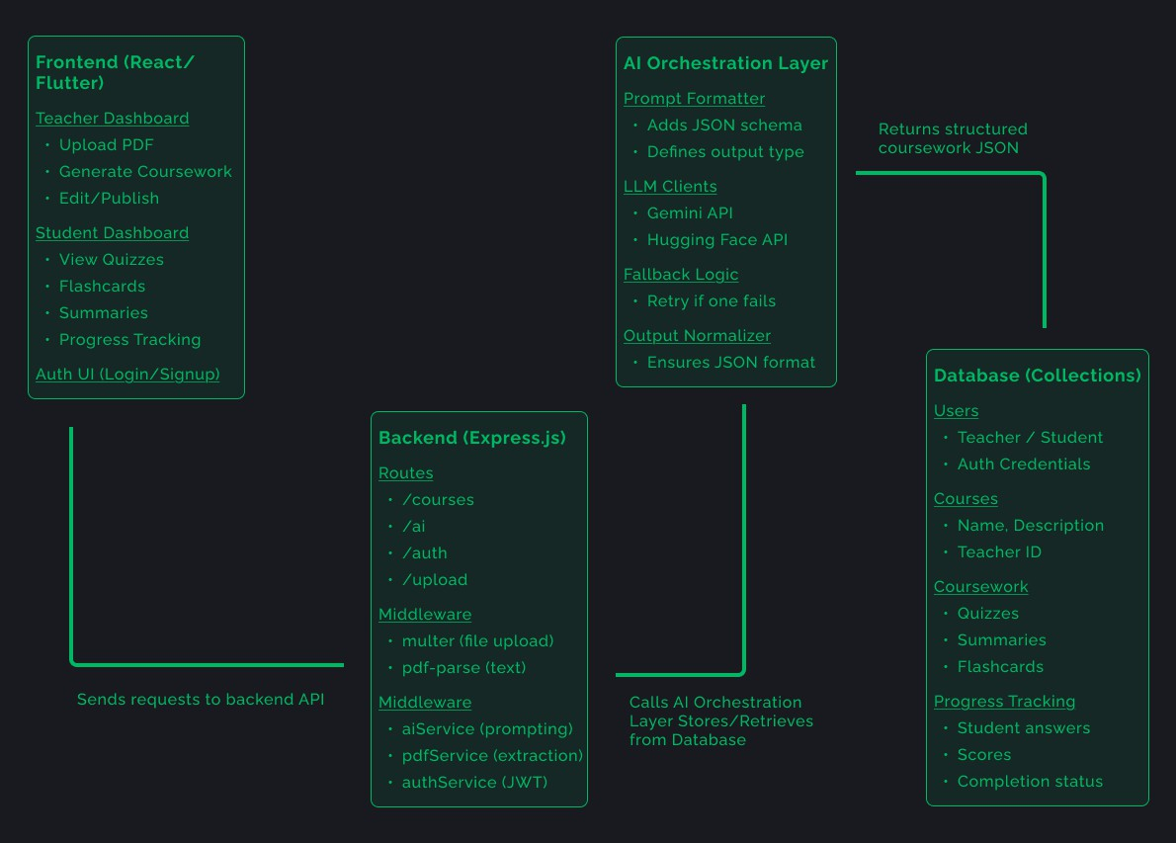

There's also an analytics service that aggregates data from GitHub activity and activity completion to build the dashboards for both teachers and students. This service is what powers the adaptive difficulty engine.

GitHub Integration
GitHub integration is one of the more technically interesting parts of the project. When a student links their GitHub account, the system creates a repo for each assignment and monitors it throughout the submission window. Specifically, it tracks:
    - Number of commits and commit frequency
    - Code quality signals from file changes and PR descriptions
    - Whether the student worked progressively or dumped everything in one commit near the deadline
    - Pattern matching against expected solutions to give partial feedback

GithubAdaptive.router.js
const express = require("express"); const passport = require("passport");
const { monitorRepo } = require("../services/githubService"); const adaptiveService = require("../services/adaptiveService");

const router = express.Router();

// Monitor repo and feed into adaptive difficulty router.get("/analyze/:studentId/:repo", async (req, res) => { try {
const { studentId, repo } = req.params;
const analysis = await monitorRepo(req.user.accessToken, repo);

// Map GitHub signals into adaptive profile
const score = analysis.progressive ? 0.9 : 0.4; // heuristic
const timeTaken = analysis.commitFrequency; // proxy for pacing

const updatedProfile = await adaptiveService.updateProfile(
studentId, "coding", // category score,
timeTaken
);

res.json({ success: true, analysis, updatedProfile });
} catch (err) {
res.status(500).json({ success: false, error: err.message });
}
});

module.exports = router;

GithubService.js
const axios = require("axios");
async function monitorRepo(token, repo) { const commitsRes = await axios.get(https://api.github.com/repos/${repo}/commits, { headers:
{ Authorization: token ${token} } });
const commits = commitsRes.data.map(c => ({ message: c.commit.message, date: c.commit.author.date, files: c.files || [] }));
const commitCount = commits.length; const commitFrequency = commitCount > 1 ? (new Date(commits[commitCount-1].date) - new Date(commits[0].date)) / commitCount : 0;
const progressive = commitCount > 3 && commitFrequency < (246060*1000);
// Simple code quality heuristic const qualitySignals = commits.filter(c => c.message.length > 20).length;
// Pattern matching stub const matchedPatterns = commits.some(c => c.message.includes("solution"));
return { commitCount, commitFrequency, progressive, qualitySignals, matchedPatterns, commits }; }
module.exports = { monitorRepo };

This data feeds directly into the adaptive difficulty algorithm. A student who's committing frequently and showing iterative problem solving gets classified as performing well on that concept. One who submits late with a single massive commit probably struggled. The system adjusts the next activity accordingly.

CHAPTER 5

AI Activity Generation Engine
The core of Inlithan Lab is the activity generation system. When a teacher uploads a syllabus, the system parses it into structured topics with weekly objectives. Each topic gets mapped to a prompt template that we've designed to produce consistent, high-quality coding exercises.
We use OpenAI's GPT-4 model for generation. The prompt includes the topic, the week number, the course level, and any specific constraints the teacher has set. The output is a structured activity with a problem description, starter code (if applicable), expected output, and a short explanation of why this skill matters in real dev work.
Server.js
const express = require("express");
const session = require("express-session"); const passport = require("passport");
const GitHubStrategy = require("passport-github2").Strategy; const githubRoutes = require("./routes/github.router");

const app = express(); app.use(express.json());

// Session + Passport
app.use(session({ secret: "secret", resave: false, saveUninitialized: false })); app.use(passport.initialize());
app.use(passport.session());

// Passport GitHub OAuth passport.use(new GitHubStrategy({
clientID: process.env.GITHUB_CLIENT_ID, clientSecret: process.env.GITHUB_CLIENT_SECRET, callbackURL: "http://localhost:5000/github/callback"
},
(accessToken, refreshToken, profile, done) => {
// Save GitHub profile + token in DB return done(null, { profile, accessToken });
}
));

passport.serializeUser((user, done) => done(null, user)); passport.deserializeUser((obj, done) => done(null, obj));

// Routes
app.use("/github", githubRoutes);

app.listen(5000, () => console.log("Server running on port 5000"));

Github.router.js
const express = require("express"); const passport = require("passport");
const { createAssignmentRepo, monitorRepo } = require("../services/githubService");

const router = express.Router();

// Step 1: Link GitHub account
router.get("/login", passport.authenticate("github", { scope: ["repo"] }));

// Step 2: Callback
router.get("/callback", passport.authenticate("github", { failureRedirect: "/" }), (req, res) => {
res.json({ success: true, message: "GitHub linked", user: req.user });
}
);

// Step 3: Create repo for assignment router.post("/create-repo", async (req, res) => { try {
const { assignmentName } = req.body;
const result = await createAssignmentRepo(req.user.accessToken, assignmentName);
res.json({ success: true, repo: result });
} catch (err) {
res.status(500).json({ success: false, error: err.message });
}
});

// Step 4: Monitor repo activity router.get("/monitor/:repo", async (req, res) => { try {
const result = await monitorRepo(req.user.accessToken, req.params.repo); res.json({ success: true, analysis: result });
} catch (err) {
res.status(500).json({ success: false, error: err.message });
}
});

module.exports = router;

GithubService.js
const axios = require("axios");
// Create repo for assignment async function createAssignmentRepo(token, assignmentName) { const res = await axios.post("https://api.github.com/user/repos",
{ name: assignmentName, private: true, description: Repo for assignment:
${assignmentName} }, { headers: { Authorization: token ${token} } }); return res.data; }
// Monitor repo activity async function monitorRepo(token, repo) { const commitsRes
= await axios.get(https://api.github.com/repos/${repo}/commits, { headers:
{ Authorization: token ${token} } });
const commits = commitsRes.data.map(c => ({ message: c.commit.message, date: c.commit.author.date }));
// Analysis const commitCount = commits.length; const commitFrequency = commitCount > 1 ? (new Date(commits[commitCount-1].date) - new Date(commits[0].date)) / commitCount : 0;
const lastCommit = commits[commits.length-1]; const progressive = commitCount > 3 && commitFrequency < (246060*1000); // < 1 day avg
return { commitCount, commitFrequency, progressive, lastCommit, commits }; } module.exports = { createAssignmentRepo, monitorRepo };

One thing we learned quickly is that generic prompts produce generic activities. "Create a Python exercise on loops" gives you something boring and basic. But "Create a Python exercise on loops for a second-year university student in week 4 of a data structures course, using a real-world scenario involving sorting customer records" produces something actually interesting and usable.
The grounding in the syllabus is what makes the activities relevant. Because the AI knows what's been covered in previous weeks, it can reference concepts the student already knows without re-teaching them. And because it knows what's coming next, it can sometimes introduce a hint at an upcoming topic to ease the transition.
    - Teacher Review Flow
AI-generated content isn't perfect, so teachers can review and edit any activity before it goes live. The teacher dashboard shows a queue of upcoming activities with an edit option. Most teachers we tested with said they edited maybe 20-30% of the generated activities — usually just tweaking the scenario or adjusting the starter code. That's a significant time saving compared to writing everything from scratch.

Adaptive Difficulty System
The adaptive difficulty engine works by maintaining a skill profile for each student. The profile tracks performance across different concept categories (loops, functions, APIs, etc.) and adjusts the difficulty level for future activities in that category.
Difficulty adjustment happens along a few dimensions:
- Problem complexity — how many steps are required to solve it
- Scaffolding level — how much starter code or guidance is provided
- Time constraint — how much time the student is expected to take
- Concept depth — surface level usage vs. deeper understanding required Data Schema
SkillProfiles { studentId: String, categories: {
loops: { attempts, avgScore, avgTime, difficulty }, functions: { ... },
apis: { ... }
}
}

Adaptive.router.js
const express = require("express");
const adaptiveService = require("../services/adaptiveService");

const router = express.Router();

// Get student skill profile router.get("/profile/:studentId", async (req, res) => { try {
const profile = await adaptiveService.getProfile(req.params.studentId); res.json({ success: true, profile });
} catch (err) {
res.status(500).json({ success: false, error: err.message });
}
});

// Update profile after activity submission router.post("/update/:studentId", async (req, res) => { try {
const { category, score, timeTaken } = req.body;
const updated = await adaptiveService.updateProfile(req.params.studentId, category, score, timeTaken);
res.json({ success: true, profile: updated });
} catch (err) {
res.status(500).json({ success: false, error: err.message });
}
});

// Generate next activity with adaptive difficulty router.post("/next/:studentId", async (req, res) => { try {
const { category } = req.body; const activity = await
adaptiveService.generateAdaptiveActivity(req.params.studentId, category);
res.json({ success: true, activity });
} catch (err) {
res.status(500).json({ success: false, error: err.message });
}
});

module.exports = router;

AdaptiveService.js
const db = require("../utils/db"); // MongoDB helper const { callLLM } = require("../utils/llmClients");

async function getProfile(studentId) {
return await db.SkillProfiles.findOne({ studentId });
}

async function updateProfile(studentId, category, score, timeTaken) { const profile = await getProfile(studentId) || { studentId, categories: {} };
const cat = profile.categories[category] || { attempts: 0, avgScore: 0, avgTime: 0, difficulty: "medium" };

// Update averages cat.attempts += 1;
cat.avgScore = (cat.avgScore * (cat.attempts - 1) + score) / cat.attempts; cat.avgTime = (cat.avgTime * (cat.attempts - 1) + timeTaken) / cat.attempts;

// Adjust difficulty
if (cat.avgScore > 0.8) cat.difficulty = "hard"; else if (cat.avgScore < 0.5) cat.difficulty = "easy"; else cat.difficulty = "medium";

profile.categories[category] = cat;
await db.SkillProfiles.updateOne({ studentId }, { $set: profile }, { upsert: true }); return profile;
}

async function generateAdaptiveActivity(studentId, category) { const profile = await getProfile(studentId);
const difficulty = profile?.categories[category]?.difficulty || "medium";

const prompt = `
Generate a ${difficulty} level activity for category "${category}". Return JSON with:
{
"problem": "string", "complexity": "low|medium|high", "scaffolding": "none|partial|full", "timeLimit": "minutes", "conceptDepth": "surface|deep"
}
`;

const response = await callLLM(prompt, "gemini"); return response;
}
module.exports = { getProfile, updateProfile, generateAdaptiveActivity }; Students who consistently perform well get less scaffolding and harder problems.
Students who are struggling get more guidance and simpler initial steps. The goal
isn't to make it easy — it's to keep it appropriately challenging, which is where learning actually happens.

CHAPTER 6

Prototype Screens
The following screens are from the current prototype of Inlithan Lab. The design was done in Figma first, then implemented in React for the web version and Flutter for mobile.

Role Selection Screen
When a user first opens the app, they choose their role. The role selection screen is intentionally simple — two cards, one for students and one for teachers. Each card explains briefly what the role provides access to.
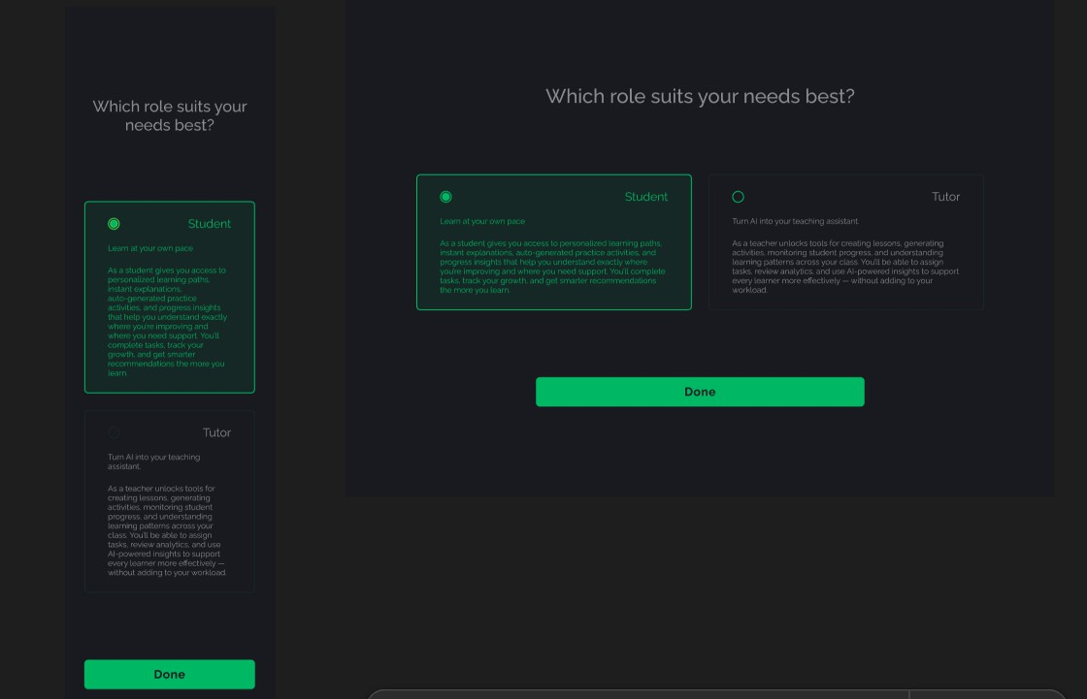

The clean separation of roles from the very first screen means the system can immediately load the right dashboard and show only relevant options. Teachers and students have very different needs, and conflating them in the UI creates confusion.

Student Dashboard
The student dashboard is the main screen a student sees when they log in. It shows their enrolled courses, upcoming activities, and progress at a glance. Key elements include:

    - Course list with current week highlighted
    - Activity cards showing task type (quiz, coding exercise, lab), estimated time, and due date
    - A skill radar showing strength across different concept areas
    - Quick access to the Lab AI for hints on current activities

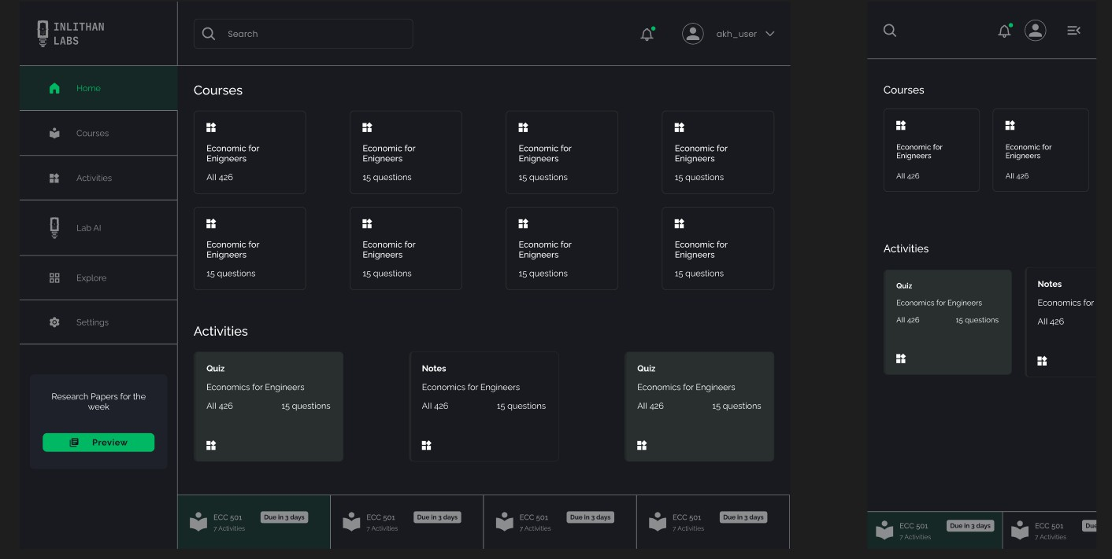
We spent a lot of time on the student dashboard because it's the screen students interact with most. The goal was to make the most important action — starting the current activity — require as few clicks as possible. Ideally one tap from the dashboard.

Teacher Dashboard
The teacher dashboard gives instructors a view across all their courses. It shows activity queues, submission rates, class-level performance trends, and alerts for students who might be falling behind.
    - Course cards with completion percentages
    - Activity management view with generate, edit, and schedule options
    - Student list with risk indicators (falling behind, not submitting, etc.)
    - Assignment tracking with upcoming due dates

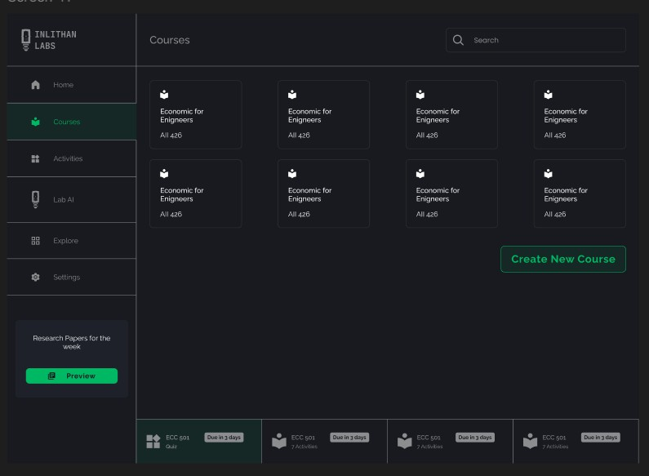
The risk indicator system is something we're particularly interested in developing further. Right now it flags students who haven't submitted in 3+ days or whose GitHub activity has dropped significantly. In future versions, we want to give more nuanced signals — not just "this student is behind" but "this student seems stuck on this specific concept."

CHAPTER 7

Functional Requirements
User and Role Management
    - Account creation via email, SSO, or GitHub OAuth
    - Three distinct roles: student, teacher, admin
    - Role-based permission system controlling access to features
    - Profile management and settings per role
Course and Curriculum Management
    - Course creation with dates, modules, and learning outcomes
    - Syllabus ingestion via PDF or DOCX upload
    - Topic mapping to weekly learning objectives
    - Standards alignment with internal or external frameworks
Activity Generation
    - Daily and weekly coding tasks generated from syllabus content
    - Mini-projects, labs, and concept quizzes
    - Real-world scenario framing for every activity
    - Teacher review and editing before activities go live
    - Auto-scheduling based on course timeline
Student Experience
    - Activity workspace with instructions, starter code, and acceptance criteria
    - Reinforcement tasks for weak concepts
    - Automated feedback on submissions
    - Progress indicators and skill radar
GitHub Integration
    - GitHub account linking via OAuth
    - Repo initialization for each assignment
    - Commit and PR tracking throughout the submission window
    - Coding behavior analytics feeding the adaptive engine

Non-Functional Requirements

    - Performance: dashboard and activity loading under 2 seconds
    - Scalability: multi-institution support with isolated data per tenant
    - Security: OAuth authentication, RBAC, and encrypted data storage
    - Maintainability: modular microservice architecture with clean APIs
    - Usability: minimal clicks to reach core actions
    - Extensibility: designed for future integrations with cloud IDEs and LMS platforms

CHAPTER 8

Development Roadmap (55 Days)
The 55-day roadmap was designed to go from nothing to a working prototype with all core flows functional. Here's how it breaks down:

Timeline | Focus Area and Deliverables
Weeks 1–2 | Branding & UI Design  Logo, color system, typography, design system, wireframes for teacher and student flows, component library in Figma
Weeks 3–5 | MVP Architecture  Backend scaffolding, database schema, curriculum ingestion pipeline, activity generation engine v1, API structure
Weeks 6–10 | Core Development  GitHub integration, student dashboard implementation, teacher dashboard, adaptive difficulty engine v1, mobile app (Flutter)
Week 11 | Testing & Refinement  Limited cohort testing with real students and instructor, bug fixes, UX polish, activity quality improvements, performance optimization

Currently, we are in week 8. Branding is finished, backend implementation is done, activity creation goes seamlessly, and the two dashboards have been integrated in the web app. The implementation of GitHub is around 70 percent complete as OAuth, repository creation, and commit tracking have been implemented successfully.
However, the Flutter app is delayed. We did not anticipate that the app building process was going to be completely different from that of React. It is planned to make the MVP for mobile apps ready by the end of week 10.

Conclusion
Inlithan Lab started as an idea from a frustrating lab session and turned into something we genuinely believe is useful. The core problem that tech education doesn't keep up with the industry, and assignments don't adapt to individual students is real, and the solution we've built addresses it directly.
The AI activity generation works. When you upload a real syllabus and watch it produce a week's worth of relevant, practical coding exercises in under a minute, it's genuinely impressive even to us, and we built it. The GitHub integration adds a layer of real-world context that most ed-tech tools simply don't have. The adaptive difficulty system is in early stages but the foundation is solid.
What remains unfinished is as critical to mention as what has been completed. The mobile application needs improvement. The adaptive difficulty engine lacks sufficient data to be considered adaptive. No clinical test on a group of students has taken place, meaning that all the assumptions regarding the interaction between the users and the system are yet to be confirmed.
The future actions can be described easily: the development of the mobile application, a user testing event with at least one course, adjustment of difficulty calibration using actual data, and development of reporting functionality for program directors.
We're confident in the direction. The feedback we've gotten from the instructors and students who've seen the prototype has been genuinely encouraging — not just polite. People get it pretty quickly, and they want it. That's a good sign.
Inlithan Lab is a first step, but we think it's a meaningful one.

References
    - Near East University, Faculty of Engineering, Department of Computer Engineering. https://neu.edu.tr/
    - OpenAI. GPT-4 Documentation. https://platform.openai.com/docs/models/gpt
-4
    - GitHub Copilot Documentation. https://docs.github.com/en/copilot
    - React Official Documentation. https://react.dev/
    - Flutter Official Documentation. https://flutter.dev/
    - Node.js Official Documentation. https://nodejs.org/en/docs/
    - Express.js Official Documentation. https://expressjs.com/
    - GitHub REST API Documentation. https://docs.github.com/en/rest
    - Agile Software Development – Roadmap Planning. https://www.agilealliance.org/glossary/roadmap/

