
Cloud Computing
Name: Fatima Jaleel
Reg #: FA24B1-SE-037
Section: VB
Submission to: Sir Waqas Saleem
Topic: Git, Gitea, GitHub, Git LFS, and GitHub Pages
Assignment 01
Task 1: Install Gitea and Push a Repository from the Ubuntu Server
Step 1.1: Install and Run Gitea on the Ubuntu Server
Verification of Gitea and PostgreSQL Docker containers running locally on the Ubuntu server. Displays the execution of docker compose ps showing both services in an active state, along with a curl request returning an HTTP 200 status code from [http://127.0.0.1:3000/](http://127.0.0.1:3000/).
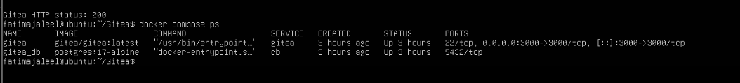
Step 1.2: Create and Push the Initial Repository
Initial push of the local Assignment01 repository to the Gitea remote. Shows git push -u gitea main executing successfully using Personal Access Token authentication without exposing sensitive credentials in the command or remote URL.
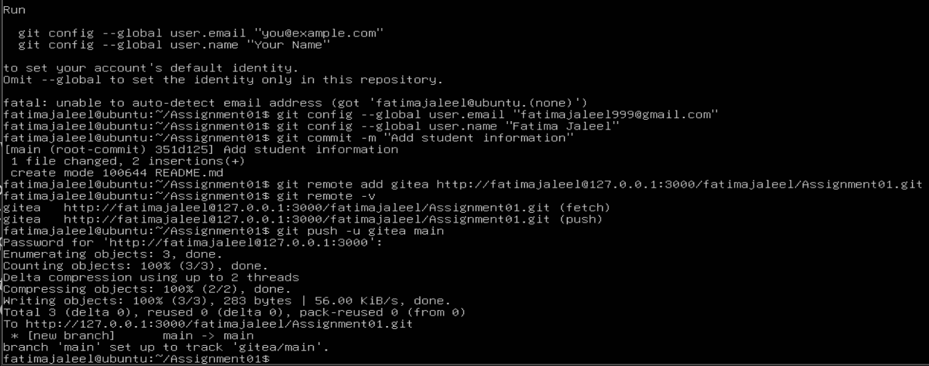
Step 1.3: Verify the Gitea Repository
Browser view of the public Assignment01 repository on the self-hosted Gitea server. Confirms the repository ownership, public visibility status, and rendered README.md containing student name and registration details.
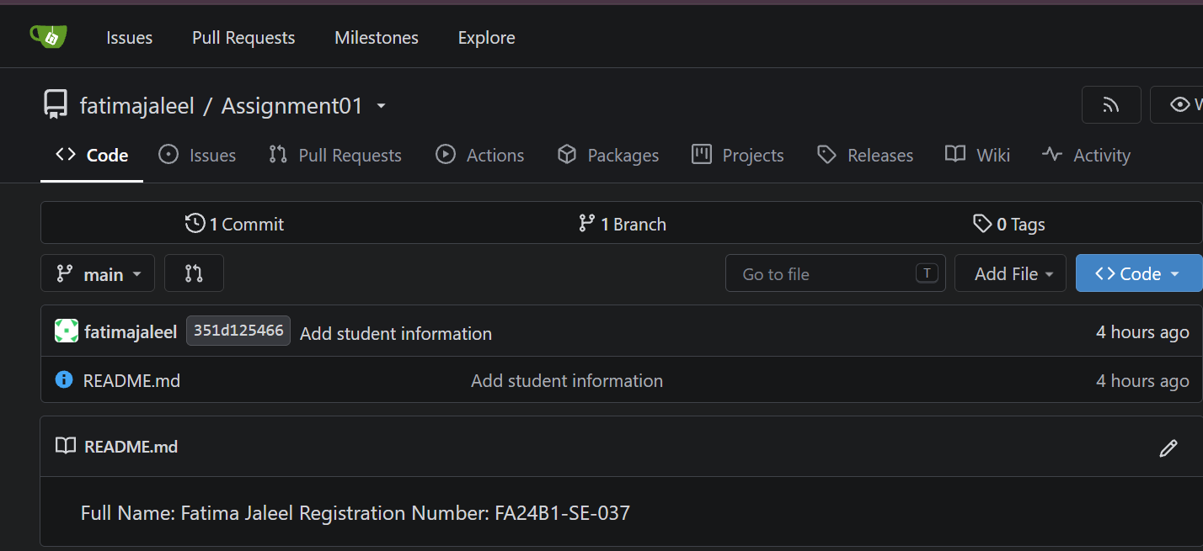
Task 2: Push the Same Repository to GitHub
Step 2.1: Create the GitHub Repository and Verify Both Remotes
Terminal verification of dual remote configuration on the local Ubuntu repository. Displays output from git remote -v listing clean fetch and push endpoints for both gitea and github remotes without embedded passwords or tokens. remotes without embedded passwords or tokens. 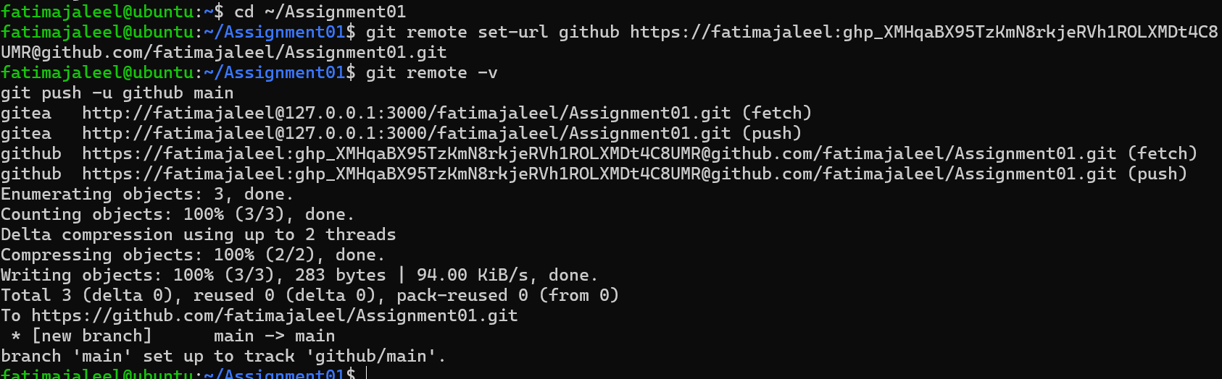
Step 2.2: Push to GitHub
Terminal output showing the successful execution of git push -u github main. Confirms branch tracking setup and initial object upload from the Ubuntu local repository to the GitHub remote repository.
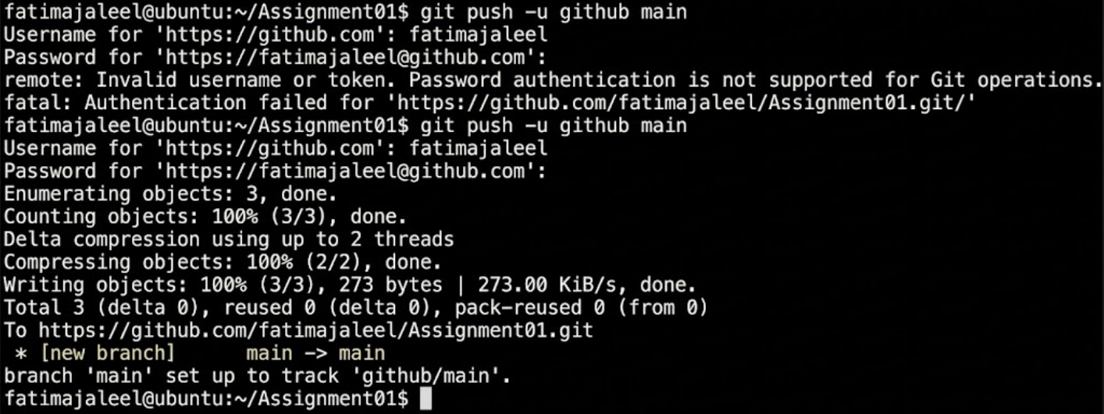
Step 2.3: Verify the GitHub Repository
Web browser view of the public GitHub Assignment01 repository. Confirms repository ownership, public status, and rendered README.md displaying student identification info.
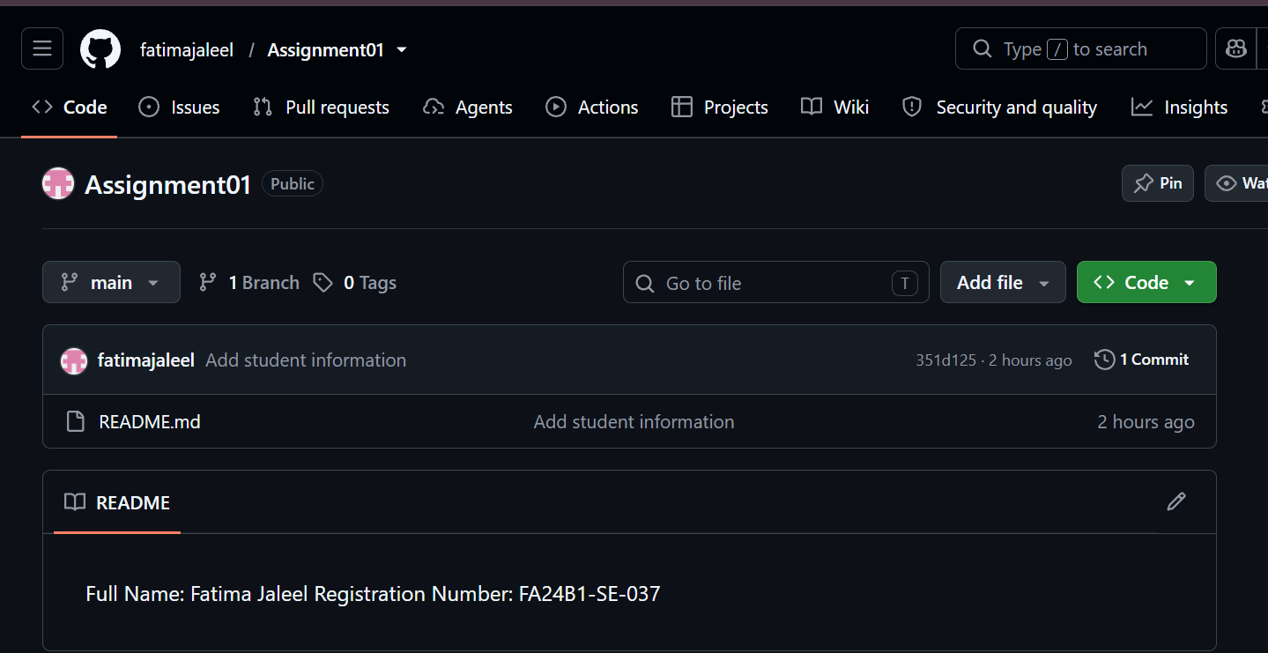
Task 3: Track Three Large Files with Git LFS
Step 3.1: Configure Git LFS
Initialization and configuration of Git LFS on the Ubuntu server. Displays output for git lfs install, git lfs version, tracking rule setup git lfs track "*.bin", and the resulting .gitattributes file.
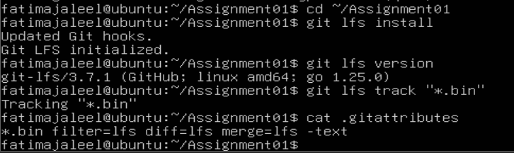
Step 3.2: Create and Verify Three LFS Files
Verification of large binary file tracking via Git LFS. Shows git lfs ls-files --size confirming that three created dummy files (large-file-1.bin, large-file-2.bin, large-file-3.bin) are tracked and exceed 100 MiB each.
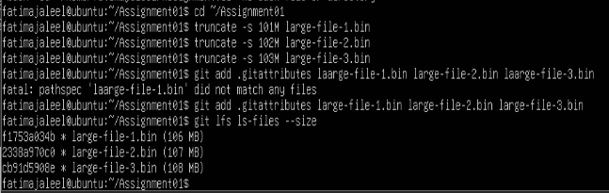
Step 3.3: Commit and Push the LFS Files
Terminal output of git push github main demonstrating Git LFS object uploading. Captures completed 100% (3/3) LFS pointer upload and successful commit push to GitHub.
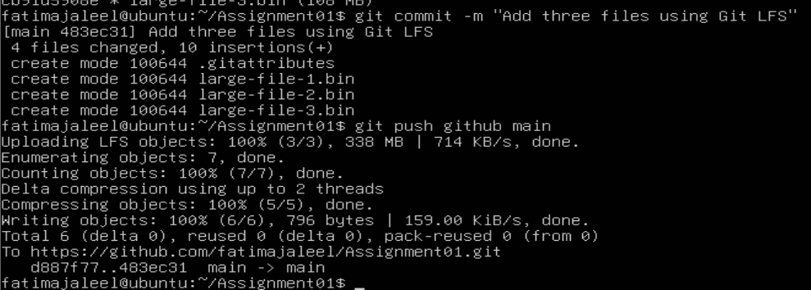
Task 4: Create a Portfolio or CV with GitHub Pages
Step 4.1: Create and Push the Portfolio Repository
Web browser view of the public <github-username>.github.io repository on GitHub. Confirms the presence of committed website source files, including index.html and styles.css.
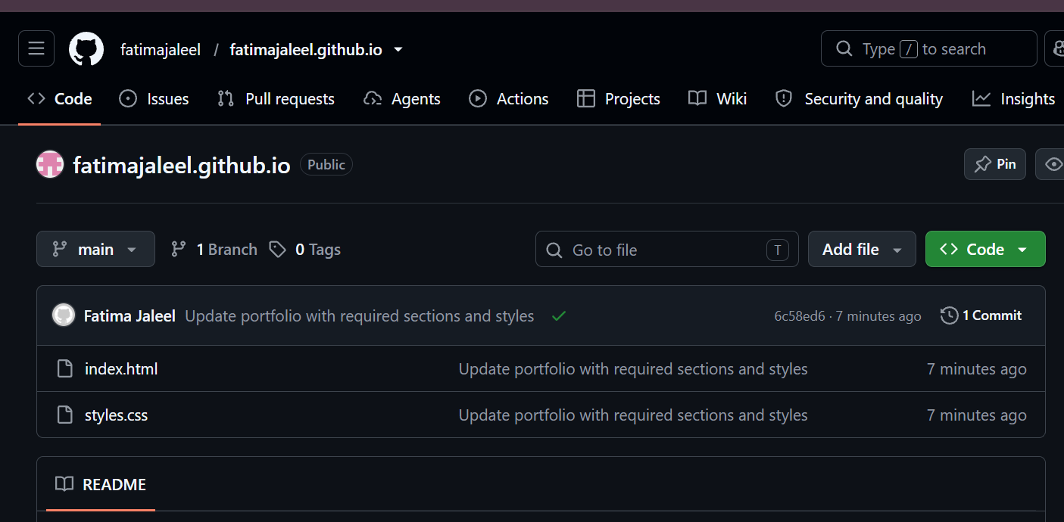
Step 4.2: Publish with GitHub Pages
GitHub Pages deployment status in repository settings (Settings -> Pages). Confirms build deployment from the main branch root folder and displays the active live site status banner.
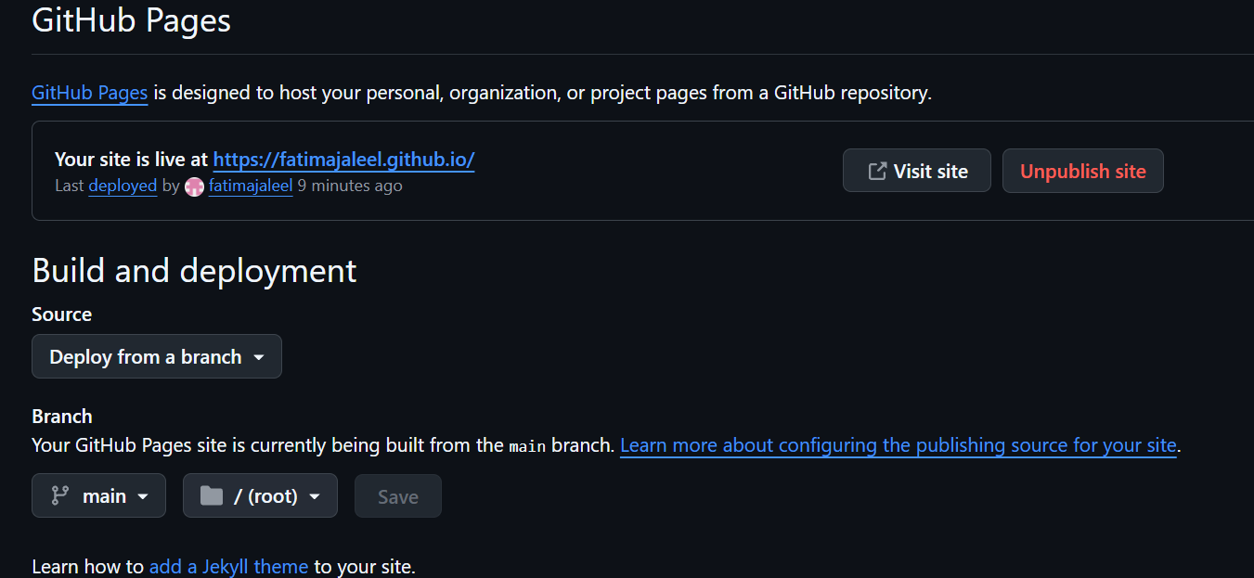
Step 4.3: Verify the Live Portfolio
Rendered portfolio website loaded in browser at https://<github-username>.github.io/. Displays complete browser URL bar alongside required portfolio sections (About Me, Education, Skills, Projects).


