Software Requirements Specification
for
ResuScan
Version 1.0 approved
Prepared by Fatima Javed, Simal Butt, Abdul Wahab, Eeman Abdullah, Masab
FAST NUCES Lahore
March 9,2025
Table of Contents
Table of Contents ii
Revision History ii
1. Introduction 1
1.1 Purpose 1
1.2 Document Conventions 1
1.3 Intended Audience and Reading Suggestions 1
1.4 Product Scope 1
1.5 References 1
2. Overall Description 2
2.1 Product Perspective 2
2.2 Product Functions 2
2.3 User Classes and Characteristics 2
2.4 Operating Environment 2
2.5 Design and Implementation Constraints 2
2.6 User Documentation 2
2.7 Assumptions and Dependencies 3
3. External Interface Requirements 3
3.1 User Interfaces 3
3.2 Hardware Interfaces 3
3.3 Software Interfaces 3
3.4 Communications Interfaces 3
4. System Features 3
4.1 System Feature 1 3
4.2 System Feature 2 (and so on) 3
5. Other Nonfunctional Requirements 4
5.1 Performance Requirements 4
5.2 Safety Requirements 4
5.3 Security Requirements 4
5.4 Software Quality Attributes 5
5.5 Business Rules 5
6. Other Requirements 5
Appendix A: Glossary 5
Appendix B: Analysis Models 5
Appendix C: To Be Determined List 6

Revision History
Name | Date | Reason For Changes | Version

Introduction
1.1 Purpose
ResuScan is an artificial intelligence resume analyzer that processes resume evaluation against job descriptions automatically. It assists job applicants in optimizing resumes and aids employers in sifting through applications.
1.2 Document Conventions
- AI-powered functionalities are denoted with bold text.
- Functional requirements are designated as FR-XX.
- Non-functional requirements are designated as NFR-XX.
1.3 Intended Audience and Reading Suggestions
- Developers: Focus on Sections 3 and 4. They will perform system implementation.
- Project Managers: Review Sections 1 and 2.
- Testers: Refer to Sections 4 and 5. They will do requirements validation.
1.4 Product Scope
The ResuScan provides resume parsing, keyword matching, automated scoring, ATS compatibility check and feedback and will also suggestions.
1.5 References
- OpenAI GPT documentation for AI integration.
- Django documentation for backend development.
- React.js documentation for frontend development.

Overall Description
2.1 Product Perspective
ResuScan is an independent resume evaluation software with AI and NLP models integrated.
2.2 Product Functions
Take resume details (Experience, Education, Skills):
- AI-powered resume suggestion.
- Resume insertion in PDF and DOCX formats.
- Screen resumes versus job descriptions.
- Score resumes for relevance to jobs.
- Give feedback for change
- AI-based resume analysis for improvements.
2.3 User Classes and Characteristics
- Job Seekers: Upload the resume and obtain feedback.
- Students: Users with limited work experience and not completely knowing how to fulfill requirements will have AI-generated content assistance.
- Recruiters: They employ ResuScan for resumes screening automatically.

Operating Environment
- Frontend: HTML, CSS and JavaScript
- Backend: Python (Flask/Django)
- Database: MySQL
- Cloud Storage: pandas, pyresparser and pdfminer3-based application.
2.5 Design and Implementation Constraints
- Must work with PDF and DOCX types.
- Job-descriptions need to be supplied for analysis.
2.6 User Documentation
- Step-by-step instructions for job seekers and recruiters on how to upload resumes and description.
- Analyze reports and feedback
- Interpret scoring and ATS compatibility results
- Refine resume formatting based on suggestions
- In PDF and web-based formats.
- Contains endpoints, request parameters, response formats, authentication methods
- Supplied as an interactive Swagger API Doc.

2.7 Assumptions and Dependencies
- Publicly accessible job market information will be used by AI models.
- Users will submit resumes in structured formats have basic resume-building knowledge.

External Interface Requirements
3.1 User Interfaces
- Web-based user dashboard to upload resumes.
- Graphical resume optimization feedback.
3.2 Hardware Interfaces
- No specific hardware requirements. Dedicated support for desktops and mobiles.
3.3 Software Interfaces
- Natural Language Processing (NLP) APIs
- Database: MySQL to store resume information OpenAI GPT API for AI-generated content.
3.4 Communications Interfaces
- HTTPS for secure communication.
- Secure API-based communication for retrieving and storing data.

System Features
4.1 Resume Parsing
Description: Extracts key details from resumes, such as experience, skills, and education.
Priority: High
Functional Requirements:
- FR-01: The system shall extract structured data (experience, skills, education) from uploaded resumes.
4.2 Keyword Matching
Description: Matches resume content with job descriptions to evaluate relevance.
Priority: High
Functional Requirements:
- FR-02: The system shall compare resumes against job descriptions and highlight keyword matches.
4.3 Automated Scoring
Description: Assigns a relevance score to each resume based on job description matching.
Priority: High
Functional Requirements:
- FR-03: The system shall calculate a percentage-based relevance score for resumes.
4.4 Feedback & Suggestions
Description: Provides recommendations to improve resume quality and ATS compliance.
Priority: High
Functional Requirements:
- FR-04: The system shall generate structured feedback with suggested resume improvements.
4.5 ATS Compatibility Check
Description: Ensures resumes are correctly formatted for Applicant Tracking Systems (ATS).
Priority: High
Functional Requirements:
- FR-05: The system shall check resume formatting to ensure compatibility with ATS.

5. Other Nonfunctional Requirements

5.1 Performance Requirements
The system should perform resume analysis efficiently to provide quick feedback. NFR-01; resume analysis should be completed within 15 seconds.

5.2 Safety Requirements
Ensures that uploaded resume data is securely stored and protected from loss. NFR-02; the system shall prevent data loss during resume uploads.

5.3 Security Requirements
- Multi-factor authentication (MFA) should be implemented for enhanced user account security.
- Protects user data and ensures secure authentication. NFR-03; the system shall implement secure login using OAuth 2.0 and JWT Tokens.

5.4 Software Quality Attributes
- Usability: Intuitive UI with guided prompts for users unfamiliar with resume building.
- Reliability: System uptime of 99.9% to ensure availability.
- Scalability: The system should support at least 100 concurrent users without performance degradation.
- Interoperability: Support for exporting resumes in PDF, DOCX, and TXT formats.
- Maintainability: Modular codebase to allow easy updates and feature expansion.

5.5 Business Rules
- Defines the access rules and restrictions for different user roles.
- Only registered users can access cloud storage features.

6. Other Requirements
- Legal compliance with GDPR and data privacy regulations.
- The system should maintain logs of AI-generated suggestions for auditing purposes.
- Periodic AI model updates to enhance accuracy.

Appendix A: Glossary
- NLP (Natural Language Processing): It enables the automated analysis of resumes and job descriptions. It helps extract meaningful insights from unstructured text and ensures accurate resume evaluation.
- ATS (Applicant Tracking System): Software used by companies to screen resumes for keywords before human review.
- JWT (JSON Web Token): Provides secure authentication and authorization. It ensures that only authenticated users can access the resume analysis system and view results.

Appendix B: Analysis Models
- Data-Flow Diagram (DFD) to show how data moves within the system. It helps developers, project managers, and stakeholders understand system processes and data interactions in a clear and structured way.
- Design Class Diagram to represent the structure of the system, showing classes, attributes, methods, and relationships between objects.

Appendix C: To Be Determined List
- Final selection of AI model versions (GPT-4, Claude, etc.).
- Specific cloud storage provider (Google Cloud, Azure).
DCD
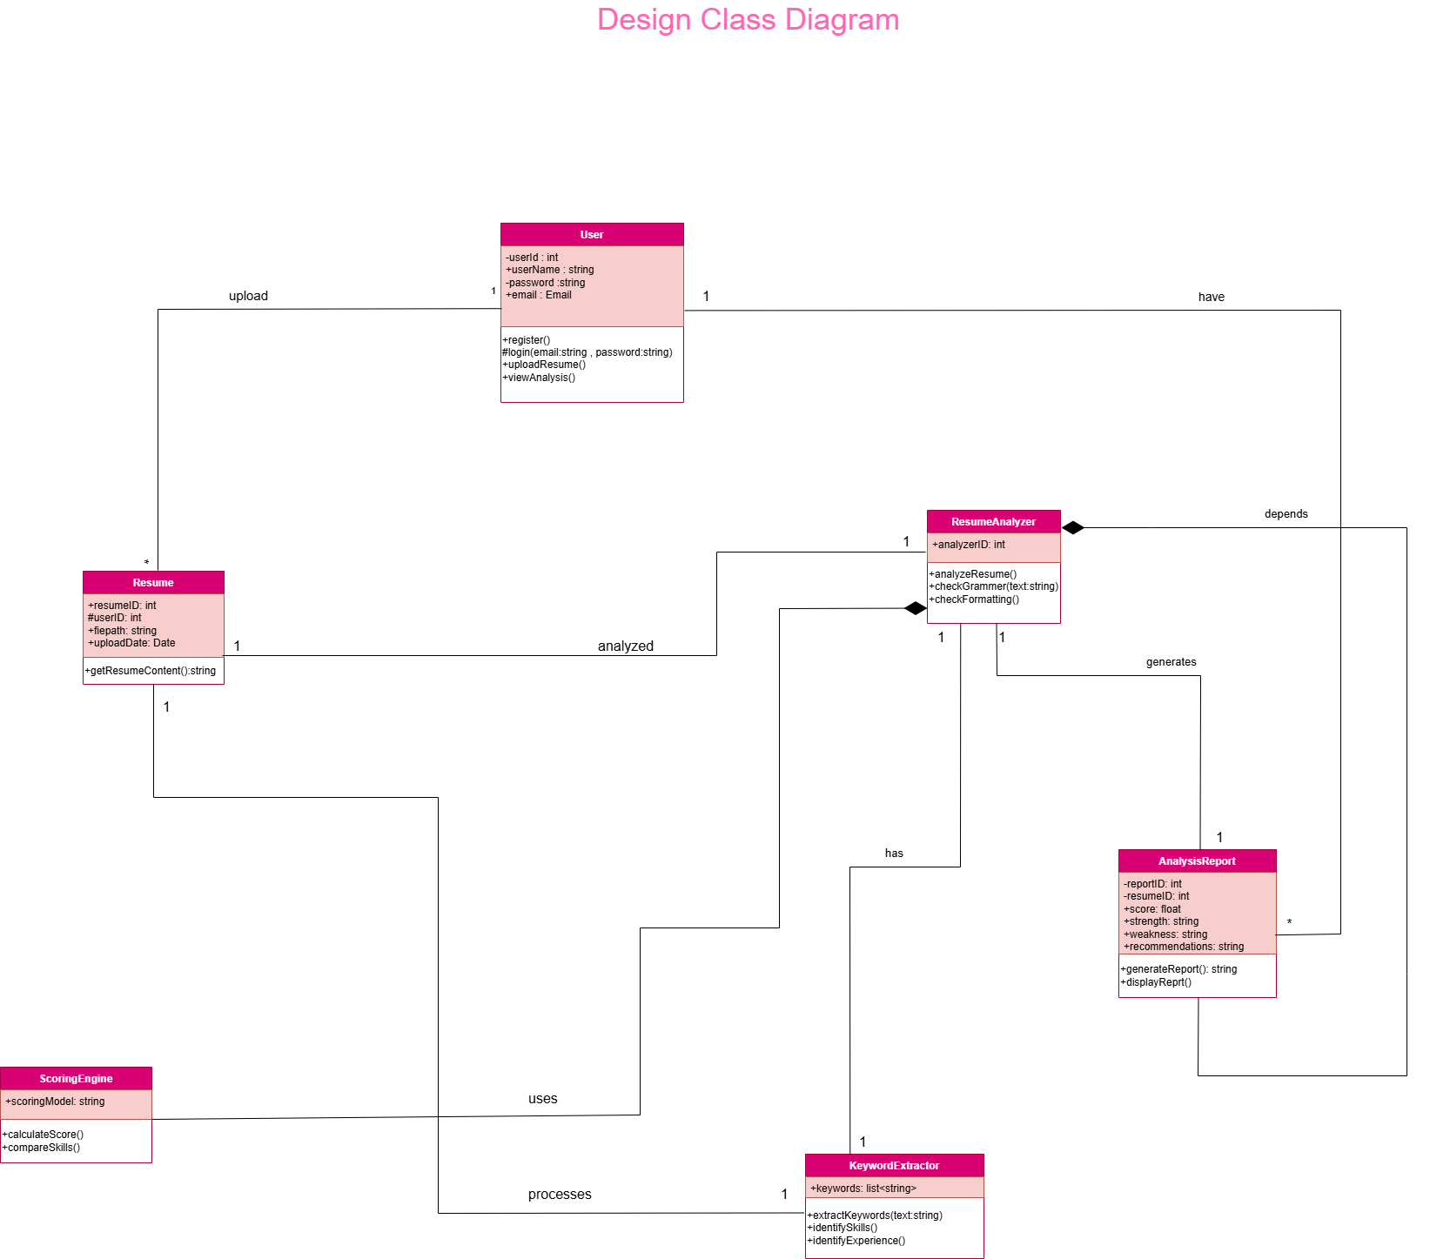

DFD
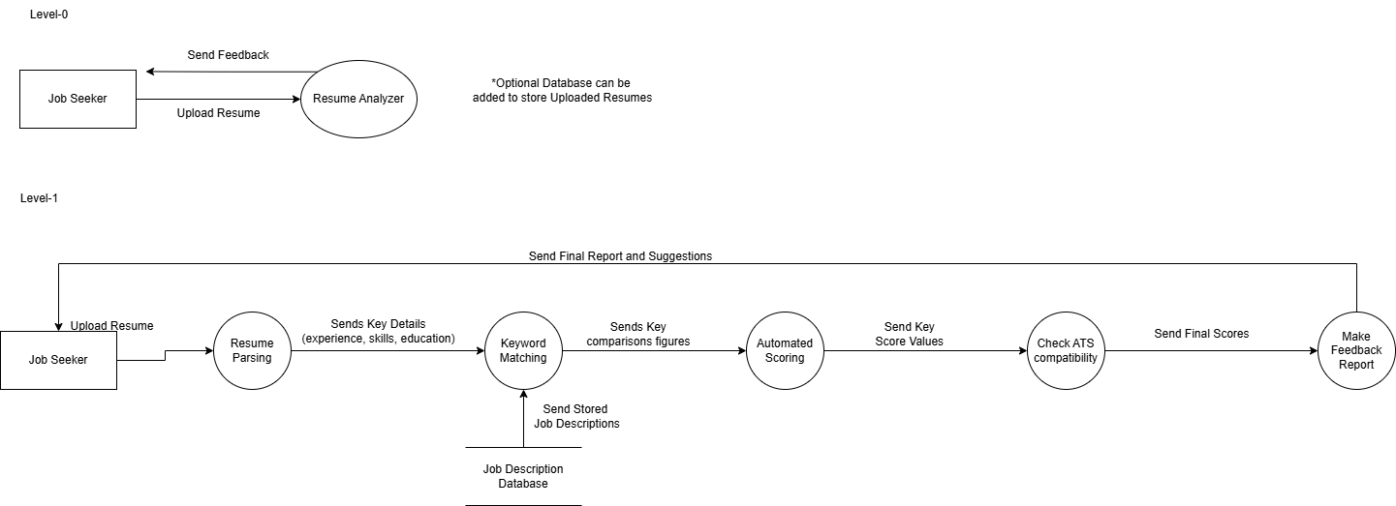Figma