UNIVERSITY OF LAHORE
FACULTY OF INFORMATION TECHNOLOGY

ARTIFICIAL INTELLIGENCE
CUSTOMER CHURN PREDICTION
USING MACHINE LEARNING
Assignment 1
Machine learning analysis of telecom customer behaviour to predict customer churn.
STUDENT NAME | Fatima Khalid
STUDENT ID | 70175282
COURSE | Artificial Intelligence
SUBMISSION | Jupyter Notebook + Final Report
SUBMITTED TO
______________________________
Ansar Naseem

Contents
1. Introduction 4
1.1 Background of Customer Churn 4
1.2 Purpose of the Project 4
1.3 Project Objective 4
2. Dataset Overview 5
2.1 Dataset Description 5
2.2 Dataset Shape and Columns 6
2.3 Data Types 7
2.4 Basic Statistical Summary 7
2.5 Target Variable, Churn 8
2.6 Description of Important Features 9
3. Data Preprocessing 10
3.1 Missing Value Analysis 10
3.2 Duplicate Record Check 11
3.3 TotalCharges Data Type Correction 11
3.4 Handling Missing TotalCharges Values 11
3.5 Removal of CustomerID 12
3.6 Final Data Quality Check 12
4. Exploratory Data Analysis 12
4.1 Churn Distribution 13
4.2 Contract Type vs Churn 14
4.3 Internet Service vs Churn 14
4.4 Monthly Charges vs Churn 15
4.5 Tenure vs Churn 16
4.6 Key EDA Observations 17
5. Feature Engineering and Encoding 17
5.1 Target Variable Encoding 18
5.2 Categorical Feature Encoding 18
5.3 Feature Selection 18
5.4 Separation of X and y 19
6. Training and Testing 20
6.1 Train Test Split 20
6.2 Training Data 20
6.3 Testing Data 21
7. Logistic Regression Model 21
7.1 Model Training 21
7.2 Accuracy 22
7.3 Precision 22
7.4 Recall 22
7.5 F1 Score 22
7.6 Classification Report 22
7.7 Confusion Matrix 23
8. Random Forest Model 24
8.1 Model Training 24
8.2 Accuracy 24
8.3 Precision 25
8.4 Recall 25
8.5 F1 Score 25
8.6 Classification Report 25
8.7 Confusion Matrix 26
9. Model Comparison 27
9.1 Performance Comparison 27
9.2 Best Performing Model 27
9.3 Model Selection Justification 28
10. Customer Churn Prediction 28
10.1 Sample Customer Information 28
10.2 Prediction Process 29
10.3 Final Churn Prediction 29
11. Key Findings 30
12. Model Limitations 30
13. Business Application of the Churn Prediction System 30
14. Conclusion 31
15. References 31

Introduction
Customer churn is a major concern for telecom companies because losing existing customers can reduce revenue and increase the cost of attracting new customers. Machine learning can help identify customers who are likely to leave by analysing their service usage, account information, contract type, charges, and other customer characteristics. In this project, a customer churn prediction system is developed using the provided telecom customer dataset. The target variable is Churn, where Yes indicates that a customer has left the company and No indicates that the customer has remained with the company. The assignment requires a complete machine learning workflow covering data loading, preprocessing, exploratory analysis, feature preparation, model training, evaluation, comparison, and final churn prediction.

Background of Customer Churn
Customer churn refers to the situation in which a customer stops using the services of a company. In the telecom industry, churn can be influenced by several factors, such as contract type, monthly charges, tenure, internet service, technical support, billing method, and other service-related conditions. Predicting churn allows a telecom company to identify customers who may be at risk of leaving.
The dataset used in this project contains customer-related information and a target variable named Churn. The purpose of analysing these features is to understand patterns that may be associated with customer departure. Exploratory Data Analysis is also used to study churn distribution and its relationship with important customer characteristics.

Purpose of the Project
The purpose of this project is to build a machine learning system that can predict whether a telecom customer is likely to churn or remain with the company. The project uses the provided customer dataset to train classification models and evaluate their predictive performance.
The work includes checking data quality, handling missing or incorrect values, encoding categorical variables, separating input features from the target variable, and dividing the dataset into training and testing sets. At least two classification algorithms are trained and compared to determine which model performs better.

Project Objective
The main objective is to develop an accurate and understandable customer churn prediction model. The project aims to:
- Identify important customer features associated with churn.
- Prepare and clean the telecom dataset for machine learning.
- Train Logistic Regression and Random Forest classification models.
- Evaluate both models using Accuracy, Precision, Recall, F1 Score, and Confusion Matrix.
- Compare the models and select the better-performing model.
- Use the selected model to predict churn for sample customer information.
The final system is intended to demonstrate how machine learning can support telecom companies in identifying customers who may require retention efforts.

Dataset Overview
The dataset used for this project is the Telco Customer Churn dataset provided with the assignment. It contains information about telecom customers, their services, account details, contact information, charges, and churn status. The dataset is used to understand customer behaviour and train machine learning models that predict whether a customer is likely to leave the company. The assignment requires the dataset structure, column names, data types, statistics, and target variable to be examined before model development.

Dataset Description
The dataset contains customer-level information collected from a telecommunications service provider. Each row represents one customer, while the columns describe different characteristics of that customer.
The dataset includes demographic information, subscribed services, account information, payment details, monthly charges, total charges, and churn status. These variables provide useful information for identifying patterns that may influence customer churn.
The Churn column is the target variable used in this project. It indicates whether a customer has left the company or remained with the company.
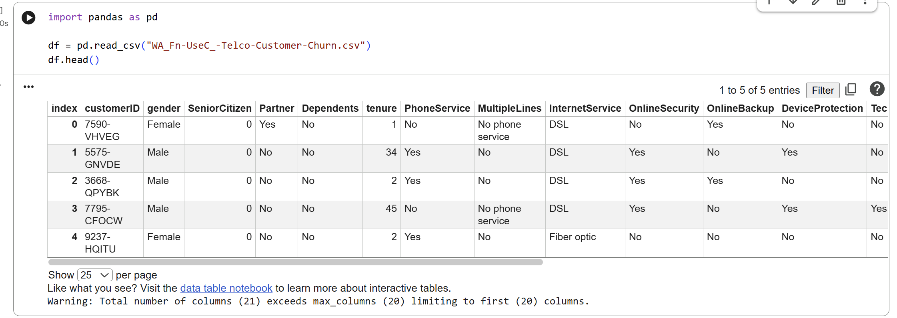

Dataset Shape and Columns
The dataset contains 7,043 customer records and 21 columns.
Dataset shape:
- Rows: 7,043
- Columns: 21
The original columns are:
- customerID
- gender
- SeniorCitizen
- Partner
- Dependents
- tenure
- PhoneService
- MultipleLines
- InternetService
- OnlineSecurity
- OnlineBackup
- DeviceProtection
- TechSupport
- StreamingTV
- StreamingMovies
- Contract
- PaperlessBilling
- PaymentMethod
- MonthlyCharges
- TotalCharges
- Churn
The dataset therefore contains a combination of customer characteristics, service-related variables, financial information, and the churn outcome.
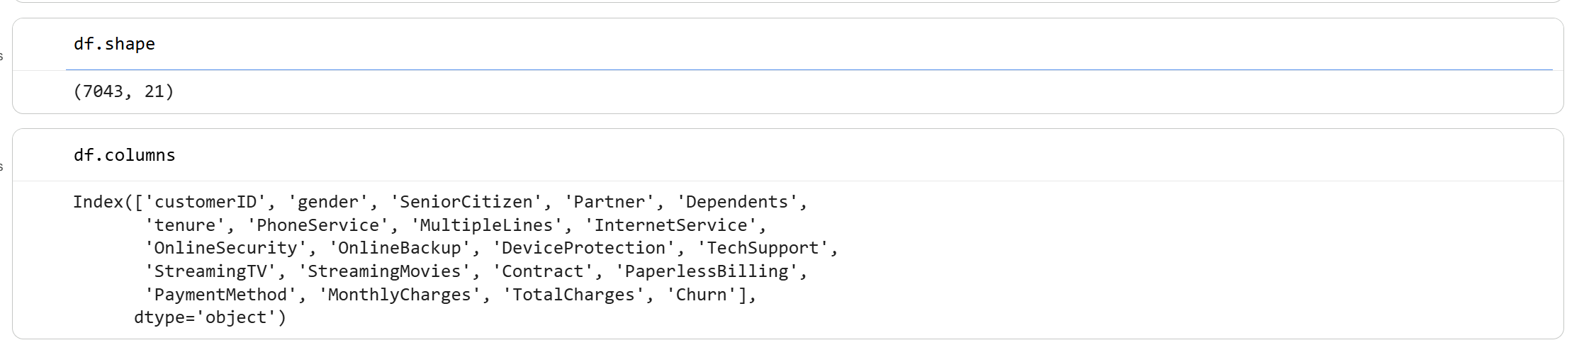

Data Types
The df.info() output showed that the dataset initially contained three main data types.
SeniorCitizen and tenure were stored as integer values.
MonthlyCharges was stored as a floating-point value.
Most other variables, including gender, Contract, InternetService, PaymentMethod, and Churn, were stored as object or categorical values.
An important issue was identified in the TotalCharges column. Although TotalCharges represents numerical information, it was initially stored as an object data type. This indicated that the column contained values that prevented Pandas from recognising it as numeric. This issue was addressed later during data preprocessing.
The initial dataset contained:
- 1 float64 column
- 2 int64 columns
- 18 object columns
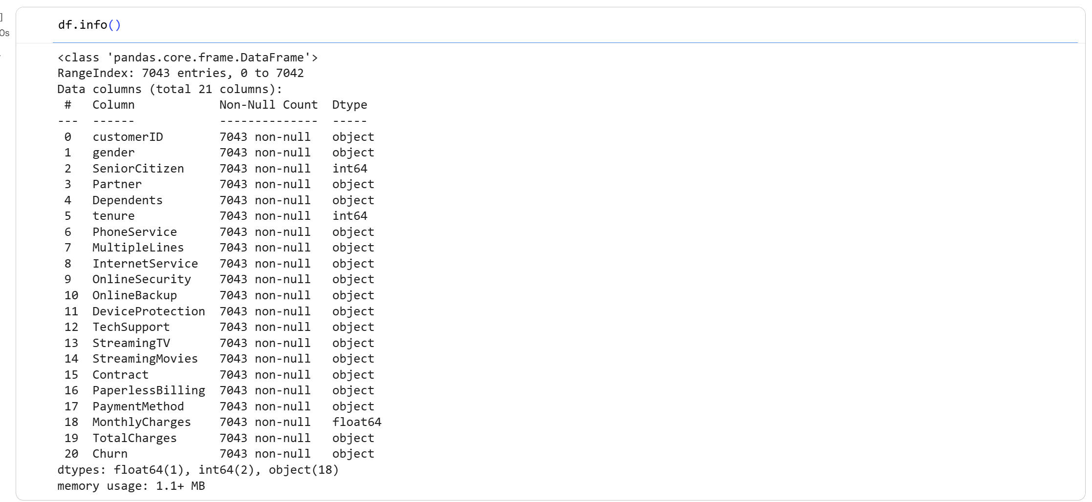

Basic Statistical Summary
The df.describe() function was used to examine the main numerical variables in the dataset.
The average customer tenure was approximately 32.37 months, with values ranging from 0 to 72 months. The median tenure was 29 months.
The average MonthlyCharges value was approximately 64.76. Monthly charges ranged from 18.25 to 118.75. The median monthly charge was 70.35.
The SeniorCitizen variable is binary, where 0 represents a non-senior customer and 1 represents a senior customer. Its mean value of approximately 0.16 indicates that senior citizens form a smaller proportion of the dataset.
The standard deviation for tenure was approximately 24.56 months, while MonthlyCharges had a standard deviation of approximately 30.09.
These statistics provide an initial understanding of customer duration and payment behaviour before performing detailed exploratory analysis.
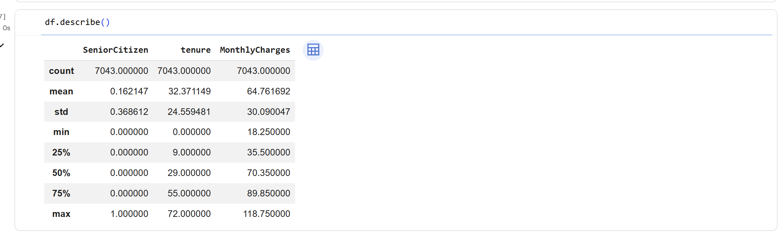

Target Variable, Churn
The target variable for this machine learning project is Churn.
The variable contains two categories:
No, the customer remained with the telecom company.
Yes, the customer left the telecom company.
The dataset contains 5,174 customers with Churn = No and 1,869 customers with Churn = Yes.
This represents approximately:
No = 73.46%
Yes = 26.54%
The distribution shows that the target classes are not equally balanced. Because of this difference, model performance should not be assessed using accuracy alone. Precision, Recall, F1 Score, and the Confusion Matrix are also important when evaluating the classification models. These evaluation measures are required by the assignment.
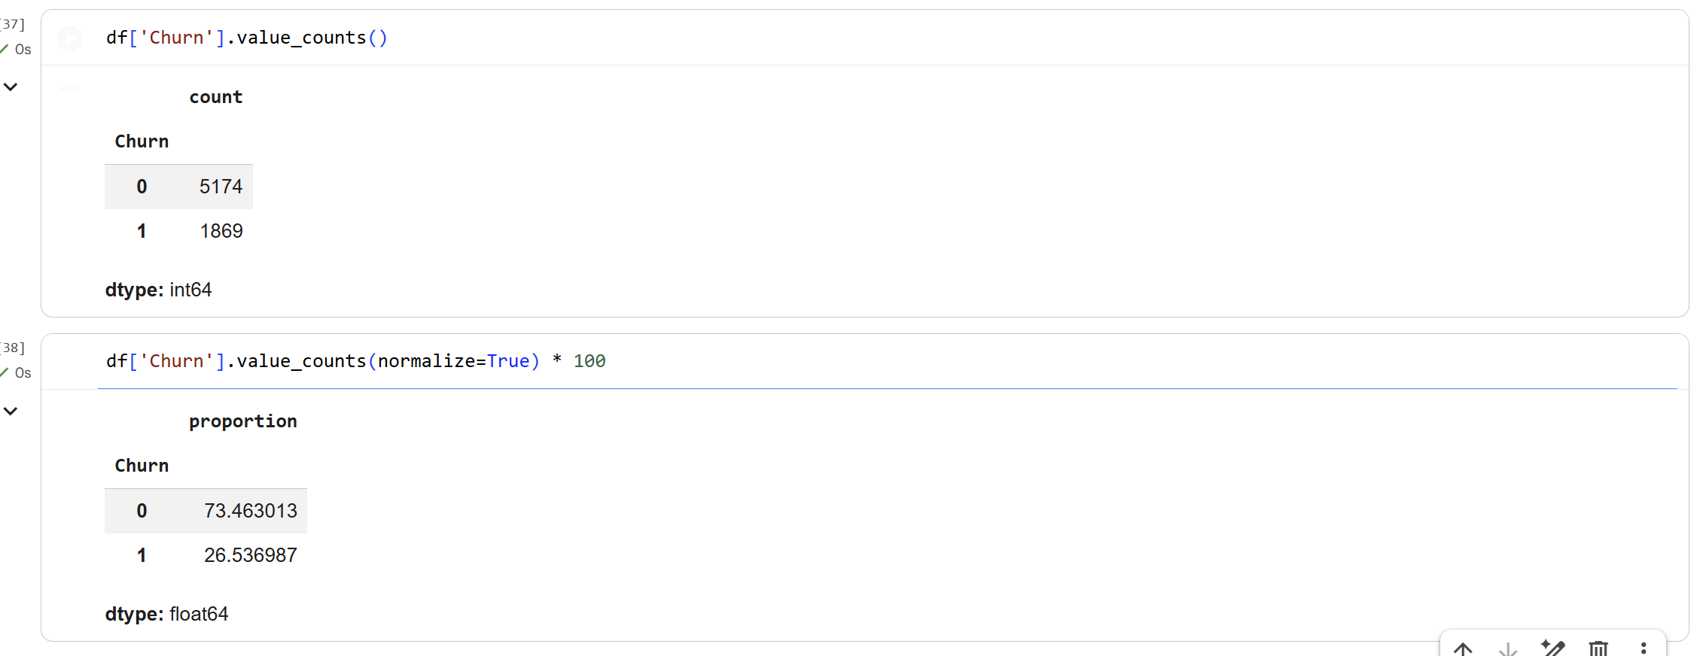
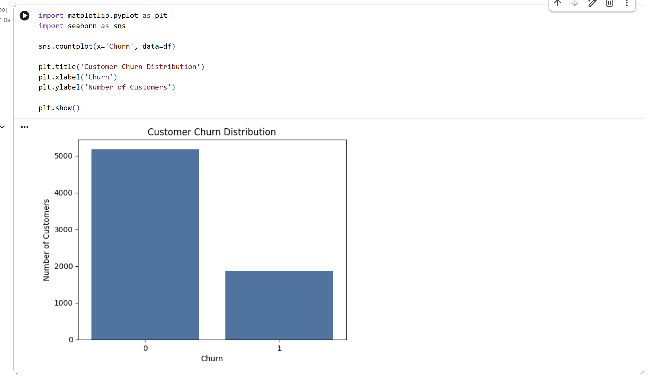

Description of Important Features
Several features in the dataset are particularly useful for understanding and predicting customer churn. The tenure variable represents the number of months a customer has stayed with the company, while Contract shows whether the customer has a month-to-month, one-year, or two-year agreement. MonthlyCharges represents the amount paid each month, whereas TotalCharges shows the total amount charged during the customer’s relationship with the company. InternetService identifies whether the customer uses DSL, Fiber optic, or no internet service. OnlineSecurity and TechSupport indicate whether additional security and technical support services are available. PaymentMethod shows how the customer makes payments, while PaperlessBilling indicates whether electronic billing is used. SeniorCitizen identifies senior customers, and Partner and Dependents provide information about the customer’s household situation. PhoneService and MultipleLines describe telephone services, while StreamingTV and StreamingMovies indicate the use of streaming services. Churn is the target variable that the machine learning models attempt to predict. Together, these features provide information about customer demographics, service usage, billing behaviour, account history, and contract arrangements, which can help identify customers who are more likely to leave the telecom company.

Data Preprocessing
Data preprocessing was performed to improve the quality of the dataset before training the machine learning models. The dataset was checked for missing values, duplicate records, incorrect data types, unnecessary columns, and other possible data quality issues. These checks were required to ensure that the data used for training and testing was consistent and suitable for machine learning.

Missing Value Analysis
The dataset was first checked for missing values using the isnull().sum() function. The initial result showed zero standard null values in all 21 columns. However, further inspection of the TotalCharges column revealed that some records contained blank spaces rather than standard missing values. A separate check using string cleaning identified 11 blank values in TotalCharges. This showed that checking only standard null values would not have detected the complete data quality issue.
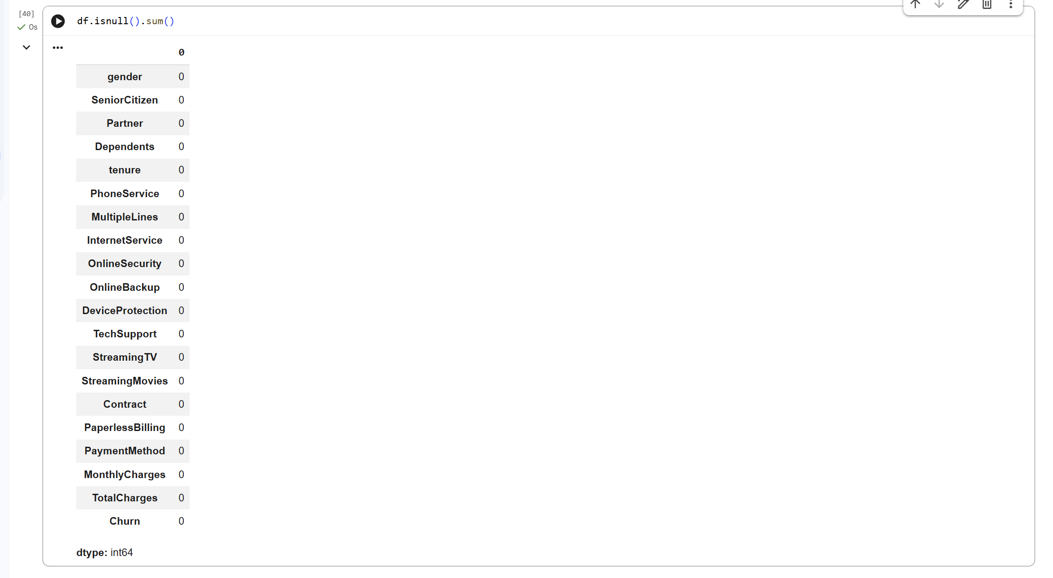
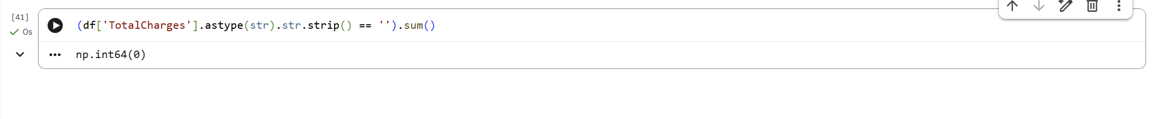

Duplicate Record Check
Duplicate records were checked using the duplicated().sum() function. The result was 0, which confirmed that the dataset did not contain any completely duplicated rows. Therefore, no records needed to be removed because of duplication. This helped preserve all 7,043 customer records for further analysis.

TotalCharges Data Type Correction
The df.info() output showed that TotalCharges was stored as an object data type, even though it represents numerical financial information. This happened because the column contained blank text values. The column was converted into a numeric format using pd.to_numeric() with errors set to coerce. As a result, the invalid blank entries were converted into NaN values, while the valid TotalCharges values became numerical data. After conversion, 11 missing values were identified.
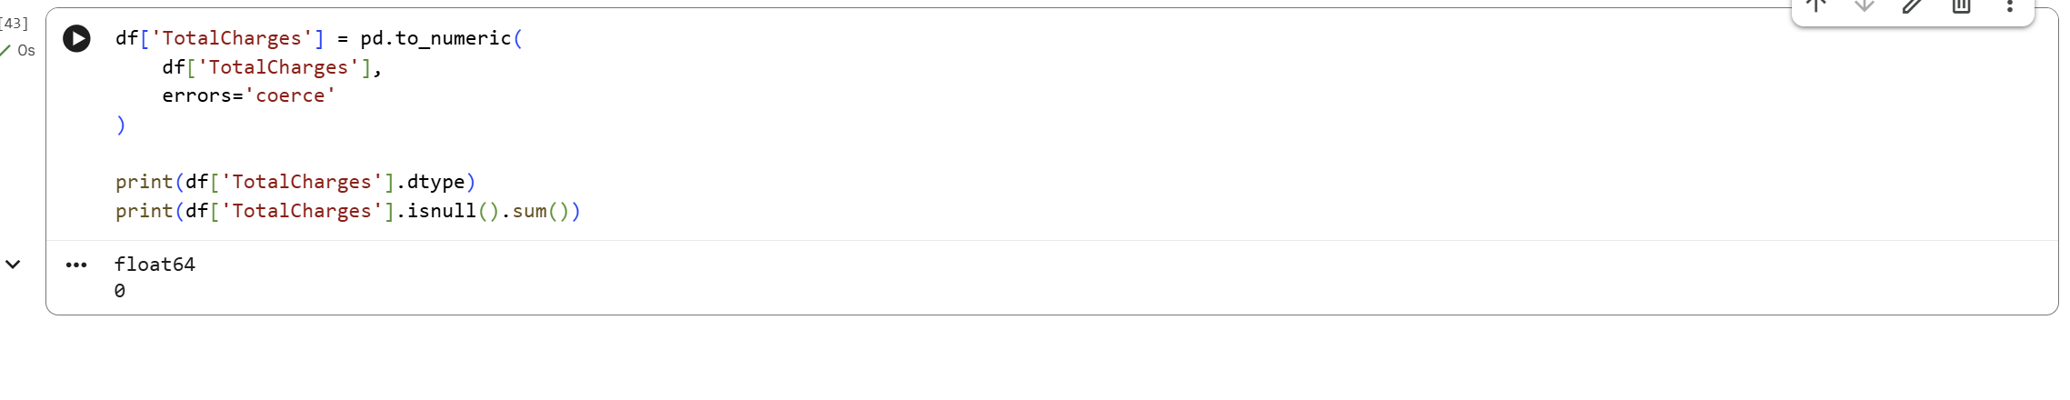

Handling Missing TotalCharges Values
The 11 missing TotalCharges records were examined before deciding how to handle them. All 11 customers had a tenure value of 0 months. This indicated that they were new customers who had not yet accumulated total service charges. For this reason, the missing TotalCharges values were replaced with 0 rather than removing the customers from the dataset. After filling these values, the missing-value count for TotalCharges became 0.
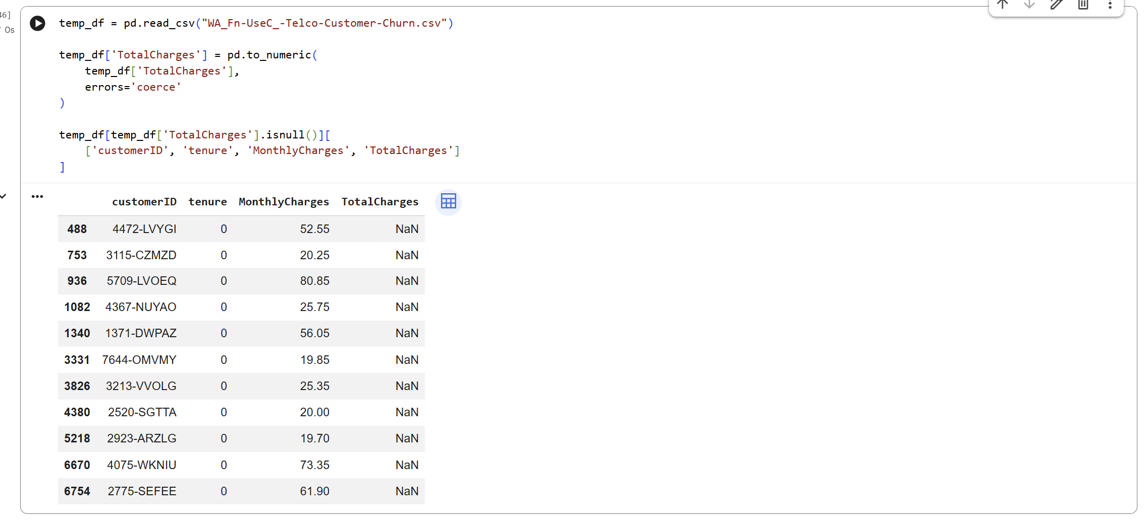

Removal of CustomerID
The customerID column was removed before model development. This column uniquely identifies each customer but does not describe customer behaviour, services, charges, or account conditions. Keeping a unique identifier could add unnecessary information to the machine learning model without improving churn prediction. After removing customerID, the dataset contained 20 columns.
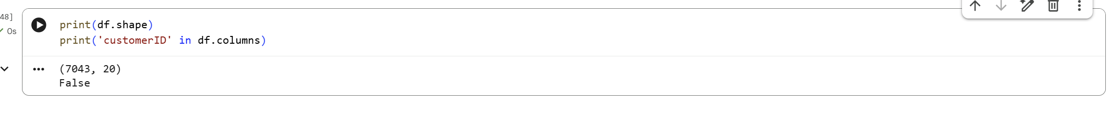
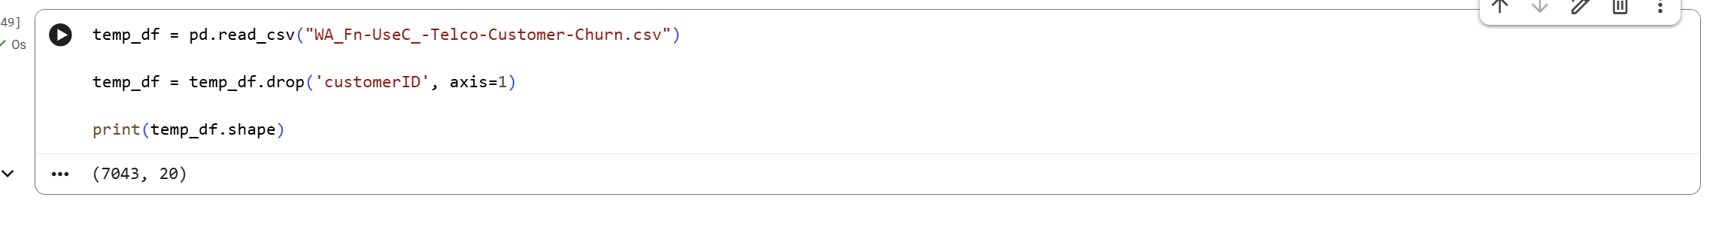

Final Data Quality Check
After preprocessing, the dataset contained no duplicate records and no remaining missing TotalCharges values. The TotalCharges column had been converted into a suitable numerical format, while customerID had been removed as an unnecessary identifier. The cleaned dataset therefore contained the relevant customer, service, billing, and churn-related variables required for exploratory analysis and machine learning. These preprocessing steps ensured that the data was ready for feature encoding, training, testing, and model evaluation.

Exploratory Data Analysis
Exploratory Data Analysis was performed to understand customer behaviour and identify patterns related to churn. Visualizations were used to examine the overall churn distribution and its relationship with contract type, internet service, monthly charges, and customer tenure. This step helps identify which customer characteristics may be useful for predicting churn. The assignment specifically requires suitable tables and visualizations to explore churn patterns and important customer characteristics.

Churn Distribution
The churn distribution showed that most customers remained with the telecom company. Out of 7,043 customers, 5,174 customers had Churn = No, while 1,869 customers had Churn = Yes. This represents approximately 73.46% non-churn customers and 26.54% churn customers.
The distribution indicates that the dataset is moderately imbalanced because the number of customers who remained is considerably higher than the number who left. Therefore, model performance should later be evaluated using multiple classification measures rather than accuracy alone.
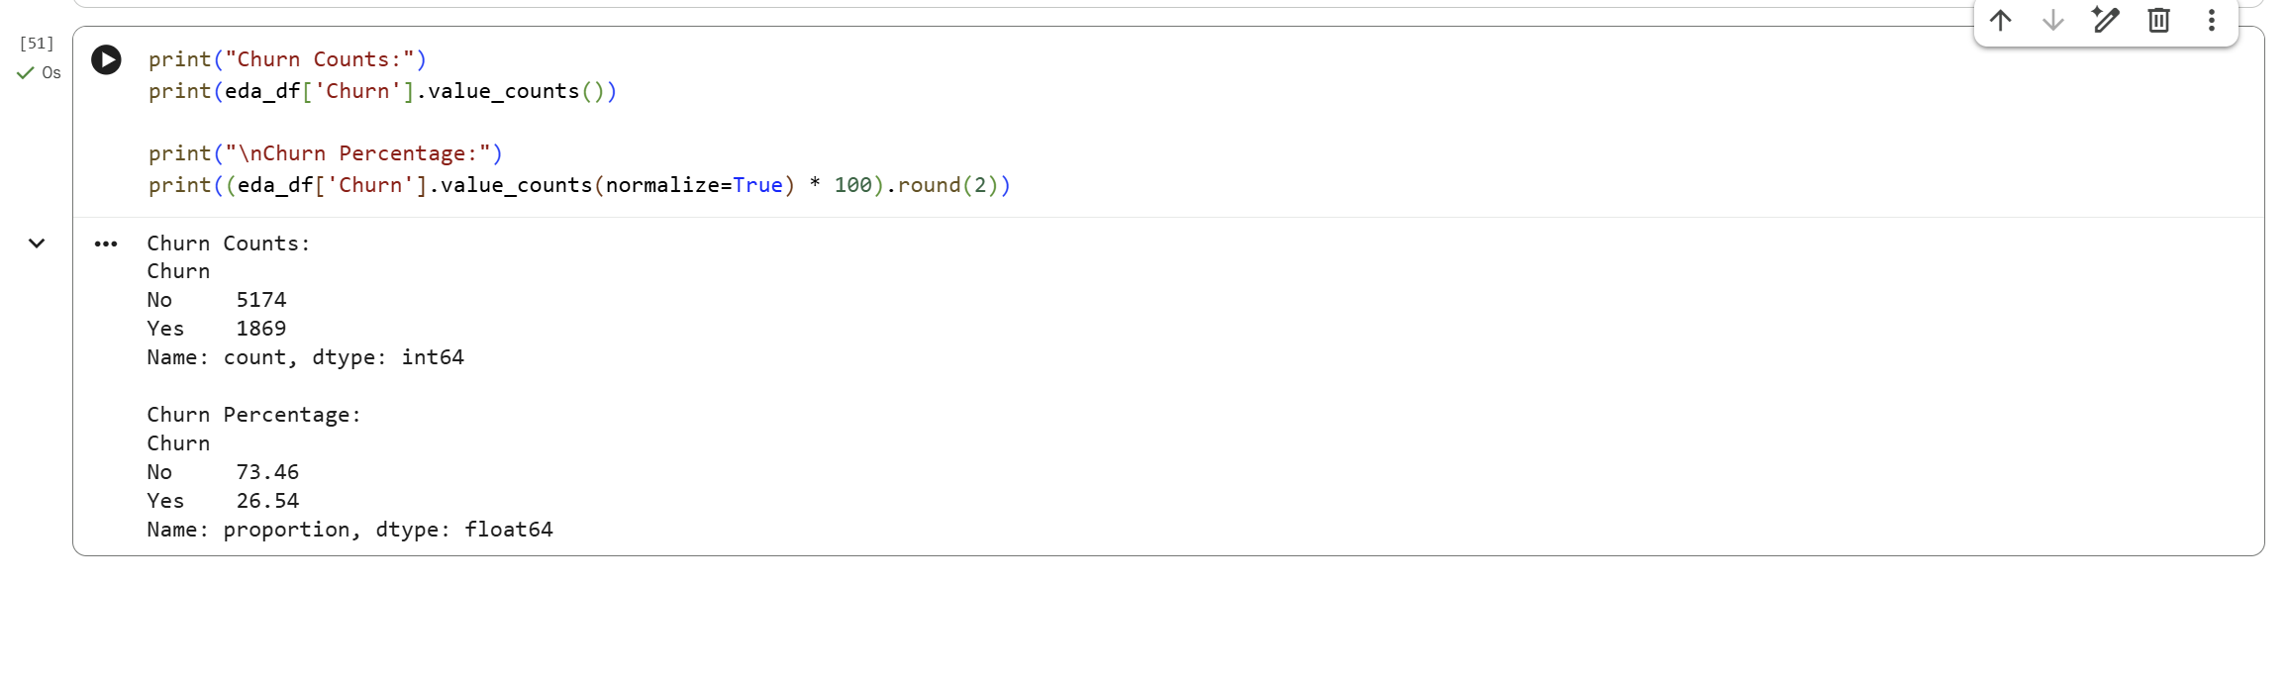
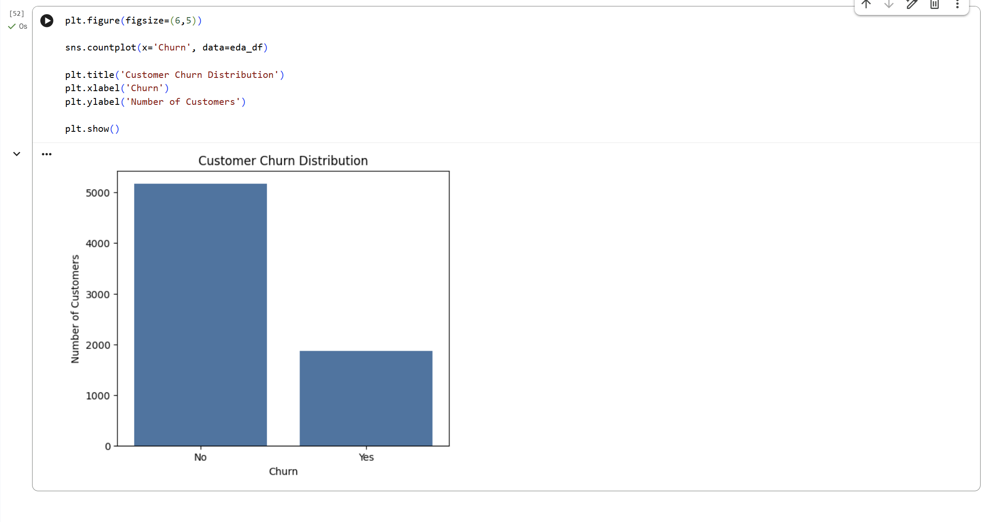

Contract Type vs Churn
The relationship between contract type and churn showed a clear difference between short-term and long-term customers. Customers with month-to-month contracts had the highest churn rate at approximately 42.71%.
The churn rate for customers with one-year contracts was approximately 11.27%, while customers with two-year contracts had the lowest churn rate at approximately 2.83%.
This pattern suggests that customers with longer contracts are less likely to leave the telecom company, while customers with flexible month-to-month contracts represent a higher churn risk.
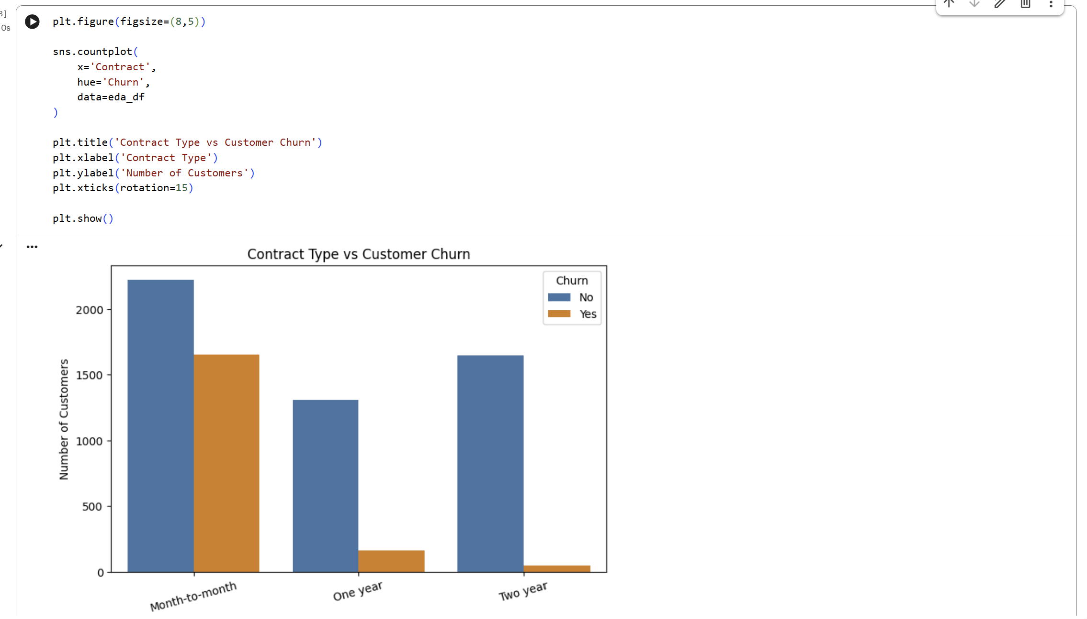
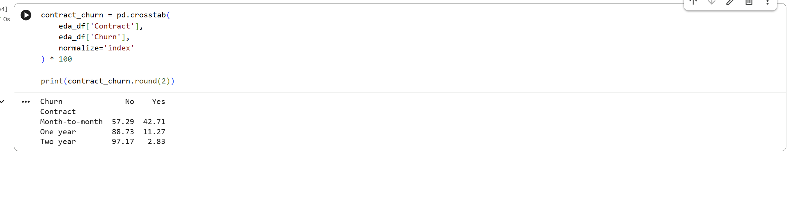

Internet Service vs Churn
Internet service type also showed an important relationship with customer churn. Fiber optic customers had the highest churn rate at approximately 41.89%. DSL customers had a considerably lower churn rate of approximately 18.96%.
Customers with no internet service showed the lowest churn rate among these groups at approximately 7.40%.
These results indicate that customers using Fiber optic service were more likely to churn in this dataset. This feature may therefore provide useful information to the prediction models.
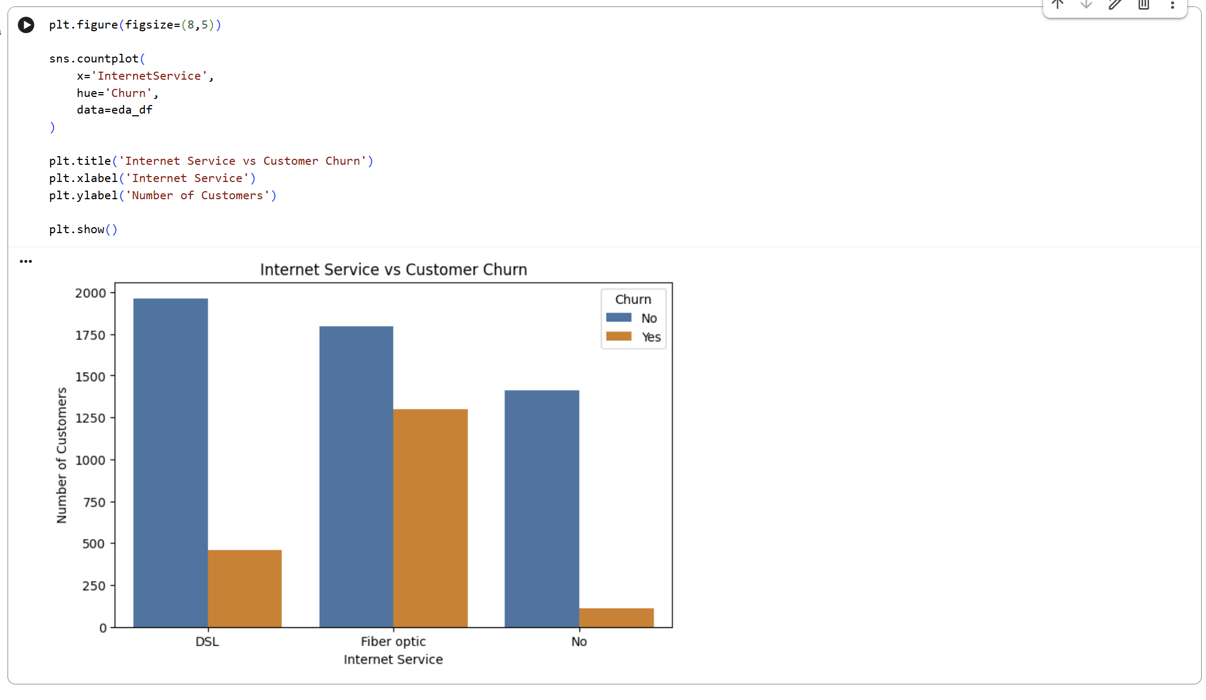
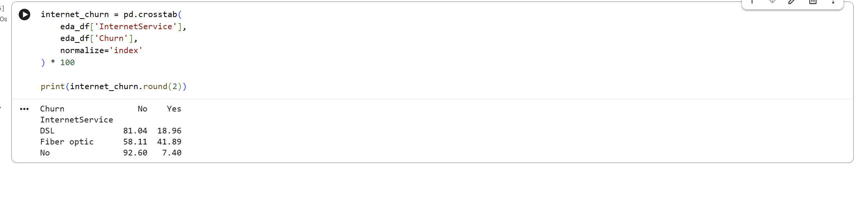

Monthly Charges vs Churn
The analysis of MonthlyCharges showed that customers who churned generally had higher monthly charges than customers who remained.
The average MonthlyCharges for customers with Churn = Yes was approximately 74.44, compared with approximately 61.27 for customers with Churn = No.
The boxplot also showed that the distribution of monthly charges for churned customers was generally higher. This suggests that higher monthly service costs may be associated with an increased likelihood of churn.
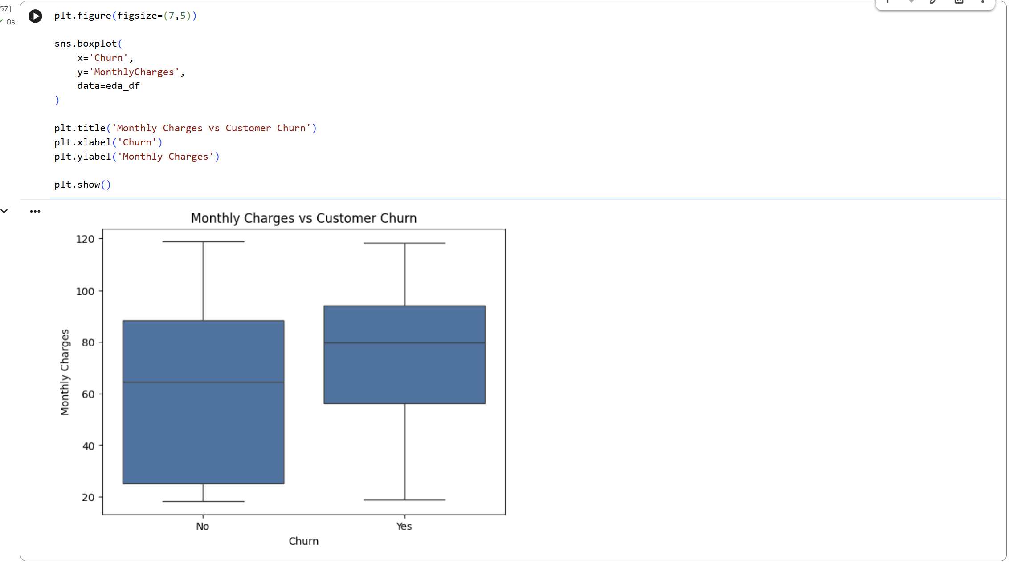
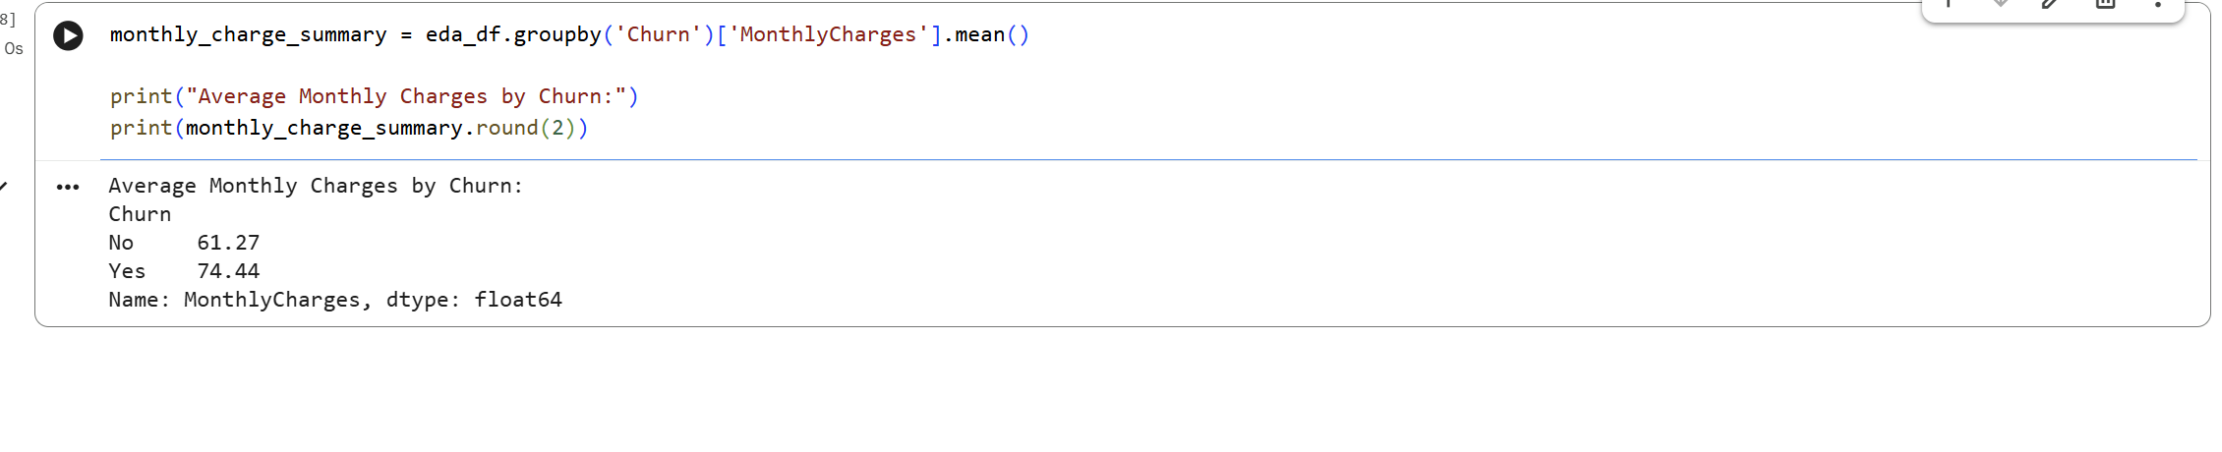

Tenure vs Churn
Customer tenure showed a strong difference between churned and retained customers. Customers who remained with the company had an average tenure of approximately 37.57 months, while customers who churned had an average tenure of approximately 17.98 months.
The median tenure was approximately 38 months for non-churn customers and only 10 months for churn customers.
This indicates that newer customers were more likely to leave the company, while customers who had maintained their service for longer periods were more likely to remain.
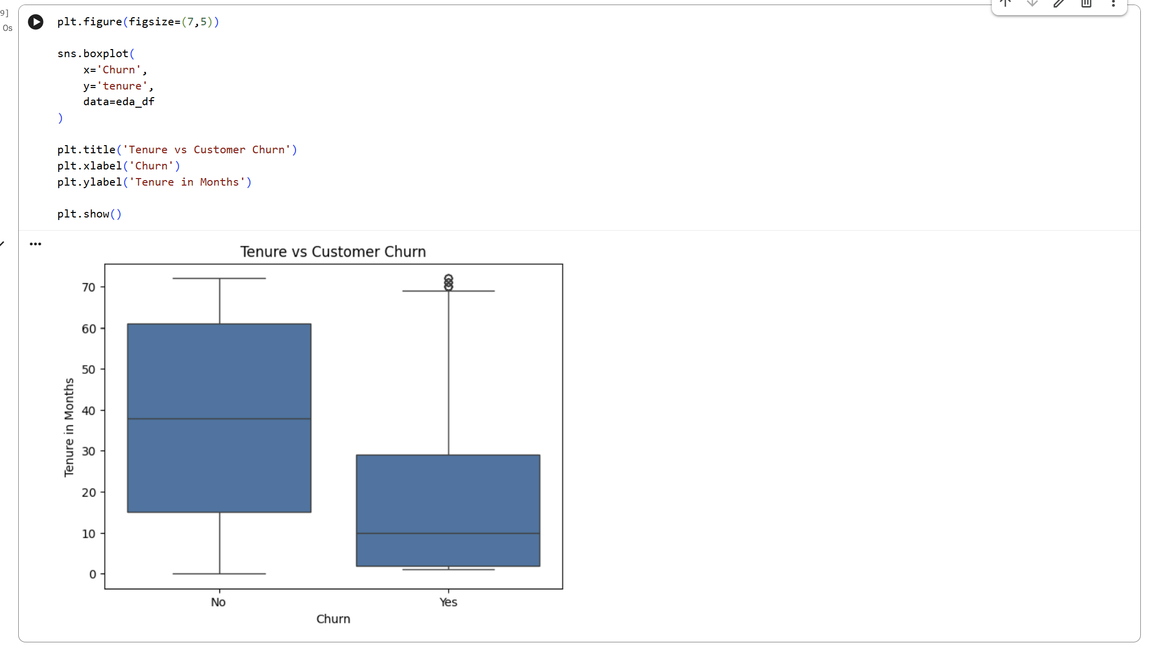
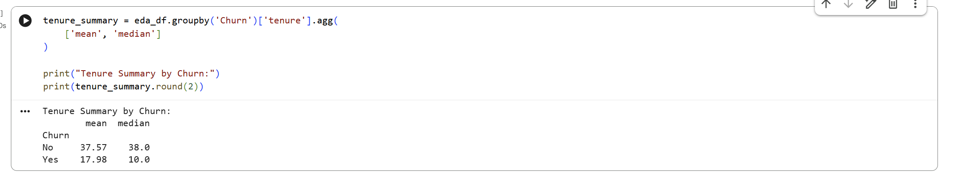

Key EDA Observations
The exploratory analysis identified several important churn patterns. Month-to-month contract customers showed substantially higher churn than customers with longer contracts. Fiber optic customers also experienced a higher churn rate than DSL customers and customers without internet service. Customers who churned generally paid higher monthly charges and had much shorter tenure than customers who remained.
Overall, contract type, internet service, monthly charges, and tenure appear to be useful variables for customer churn prediction. These findings also provide useful business insight because they highlight customer groups that may require greater attention from retention teams.

Feature Engineering and Encoding
After completing data cleaning and exploratory analysis, the dataset was prepared for machine learning. Machine learning algorithms require numerical input, so the categorical variables were converted into numerical form. The target variable was also encoded, and the predictors were separated from the target variable before model training. This step follows the assignment requirement to transform useful features and clearly separate X from y.

Target Variable Encoding
The target variable Churn originally contained two text categories, Yes and No. These values were converted into numerical form so that the classification models could process them. Churn = No was encoded as 0, while Churn = Yes was encoded as 1. In this way, a value of 1 represented a customer who left the company, while 0 represented a customer who remained.
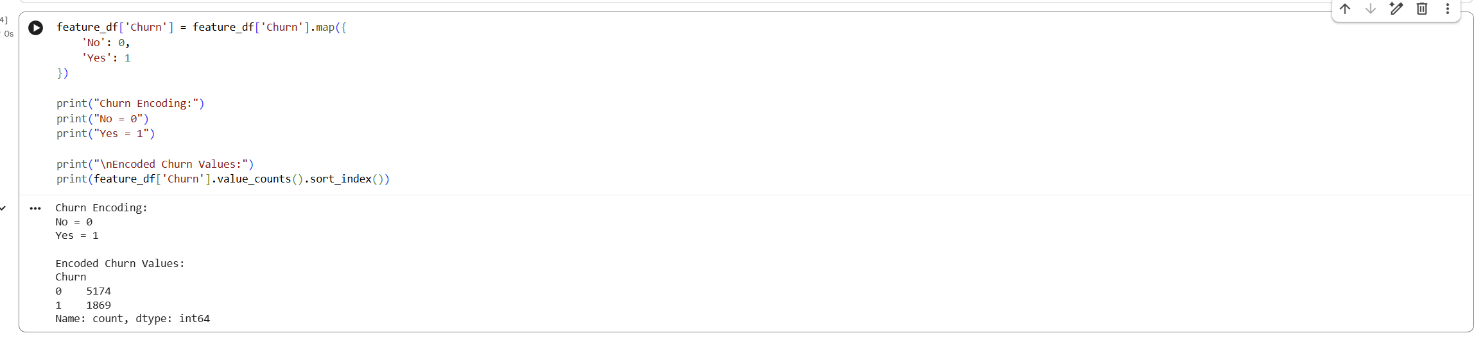

Categorical Feature Encoding
Several predictor variables, such as gender, Contract, InternetService, PaymentMethod, and TechSupport, were categorical. These variables could not be used directly by the machine learning models in their original text form.
The pandas get_dummies() function was therefore used to convert categorical variables into numerical dummy variables. The drop_first=True option was used to avoid creating unnecessary duplicate categories. After encoding, the dataset contained only numerical features suitable for machine learning.
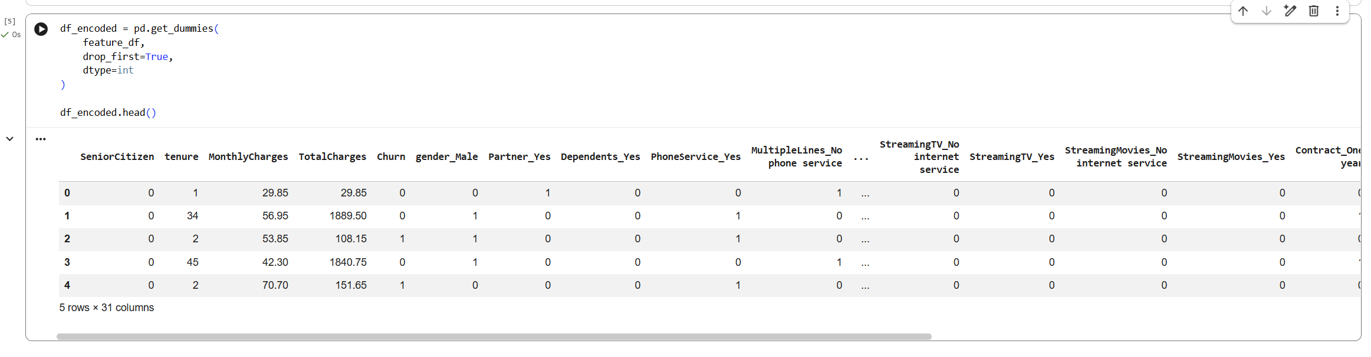

Feature Selection
The features used for model development were selected from the cleaned dataset. The customerID column had already been removed because it was only a unique identifier and did not provide meaningful information about customer behaviour.
The remaining variables included customer demographics, service information, contract details, payment methods, tenure, MonthlyCharges, TotalCharges, and other service-related features. These variables were retained because they may contain useful information for predicting customer churn.
No additional manual feature removal was performed at this stage because the remaining variables were relevant to the customer churn problem.
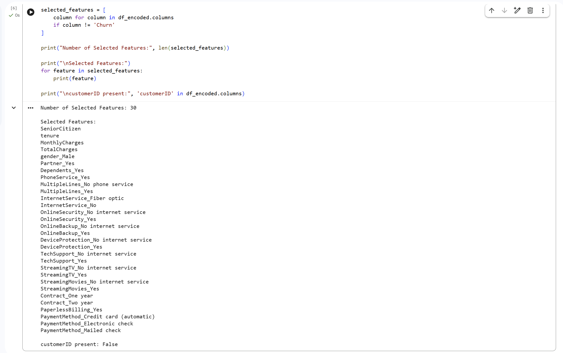

Separation of X and y
After encoding, the dataset was divided into input features and the target variable. All predictor variables were stored in X, while the encoded Churn variable was stored in y.
X contained the customer characteristics used by the models to make predictions. y contained the correct churn outcome that the models attempted to learn.
This separation prepared the dataset for the next stage, where it was divided into training and testing sets for model development and evaluation.
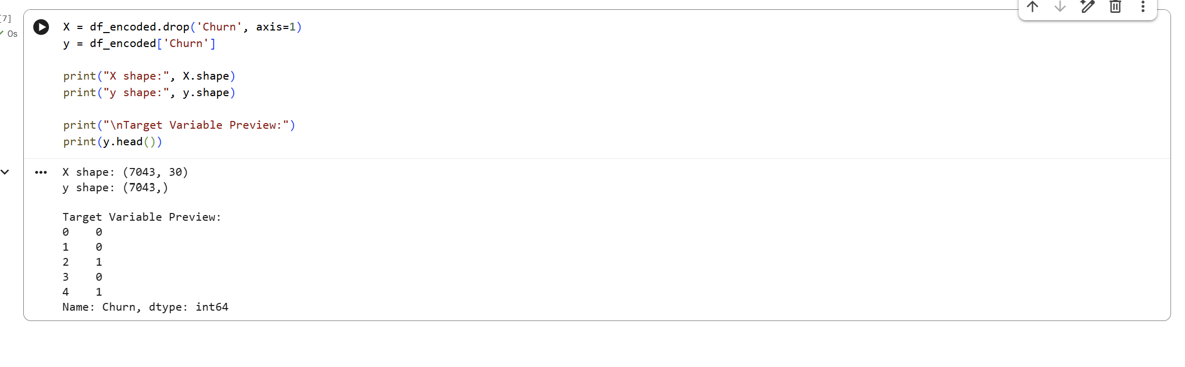

Training and Testing
After feature encoding and separating the input features from the target variable, the dataset was divided into training and testing sets. The training data was used to teach the machine learning models, while the testing data was kept separate to evaluate how well the trained models performed on unseen customer records. The assignment requires the dataset to be split before training at least two classification models.

Train Test Split
The dataset was divided using the train_test_split() function from Scikit-learn. An 80:20 split was selected, where 80% of the customer records were used for training and 20% were used for testing. A random_state value of 42 was used to make the split reproducible.
The stratify=y option was also applied so that the proportion of churn and non-churn customers remained similar in both the training and testing datasets. This was useful because the original target variable contained more non-churn customers than churn customers.
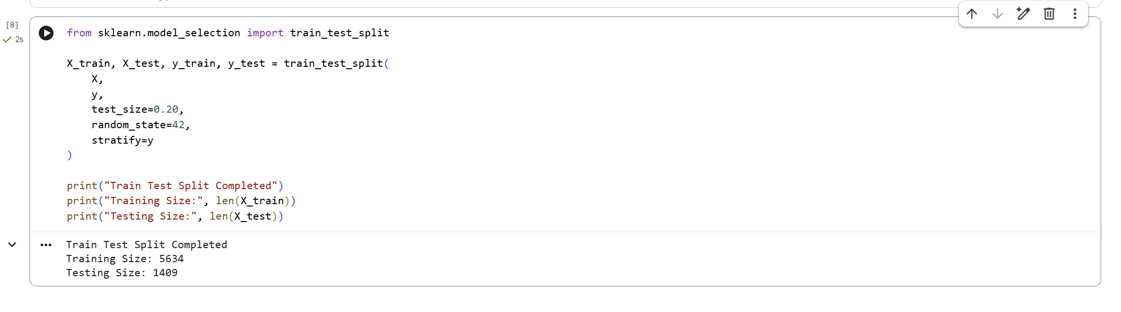

Training Data
The training dataset contained 80% of the available customer records. It was used by Logistic Regression and Random Forest to learn relationships between customer characteristics and churn behaviour.
X_train contained the predictor variables, while y_train contained the corresponding Churn values. The model used these records to learn patterns related to customer services, contracts, tenure, charges, and other characteristics.
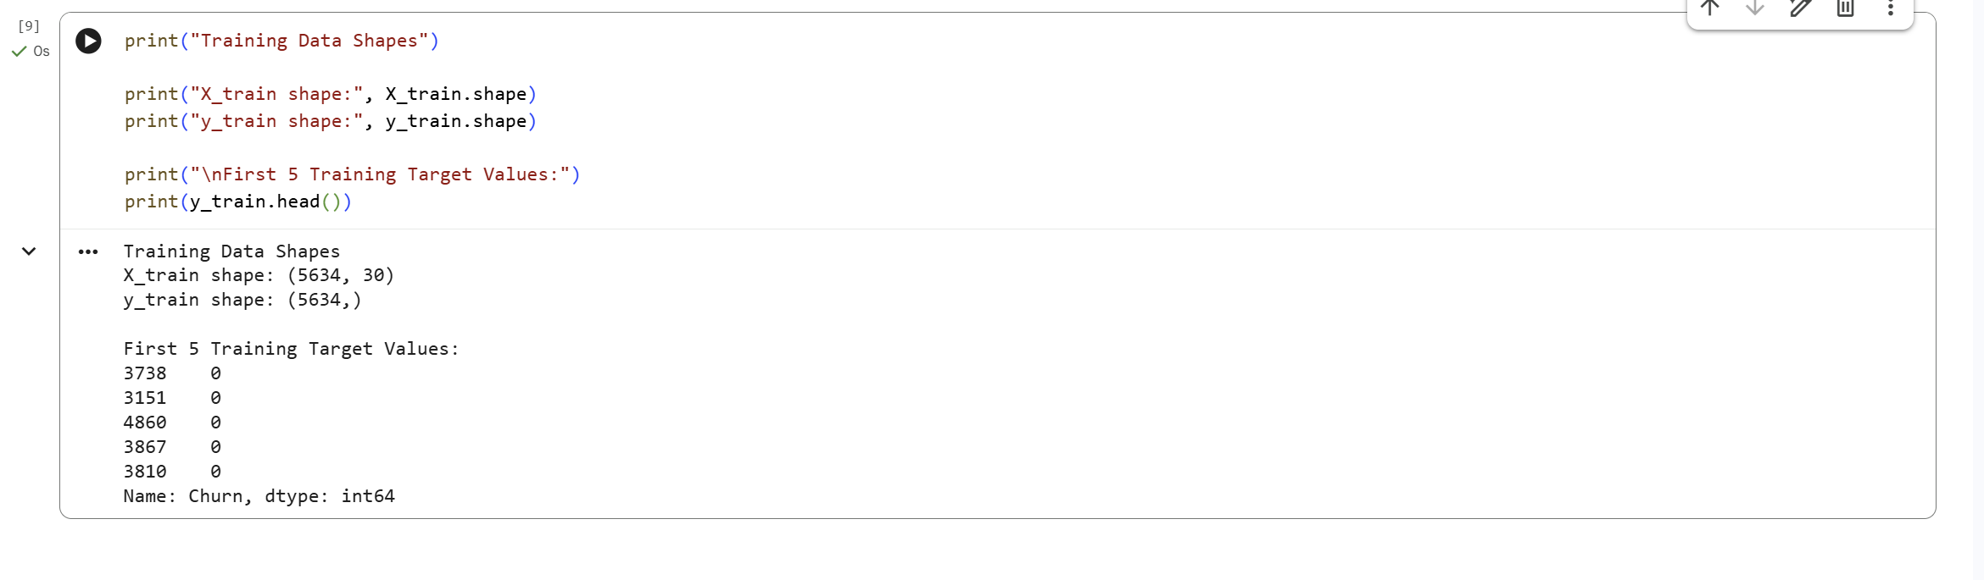

Testing Data
The remaining 20% of the dataset was reserved for testing. These records were not used during model training. Instead, they were used to evaluate how accurately each trained model could predict customer churn on unseen data.
X_test contained the testing features, while y_test contained the actual churn outcomes. Predictions generated from X_test were later compared with y_test using Accuracy, Precision, Recall, F1 Score, Classification Report, and Confusion Matrix.

Logistic Regression Model
Logistic Regression was used as the first classification model for customer churn prediction. The input features were standardized using StandardScaler before training because the dataset contained numerical variables with different scales. The model was trained on the training dataset and then used to predict churn outcomes for the testing dataset.

Model Training
The Logistic Regression model was trained using the scaled training data. A maximum of 2,000 iterations and a random state of 42 were used. After training, the model successfully generated predictions for the testing dataset.
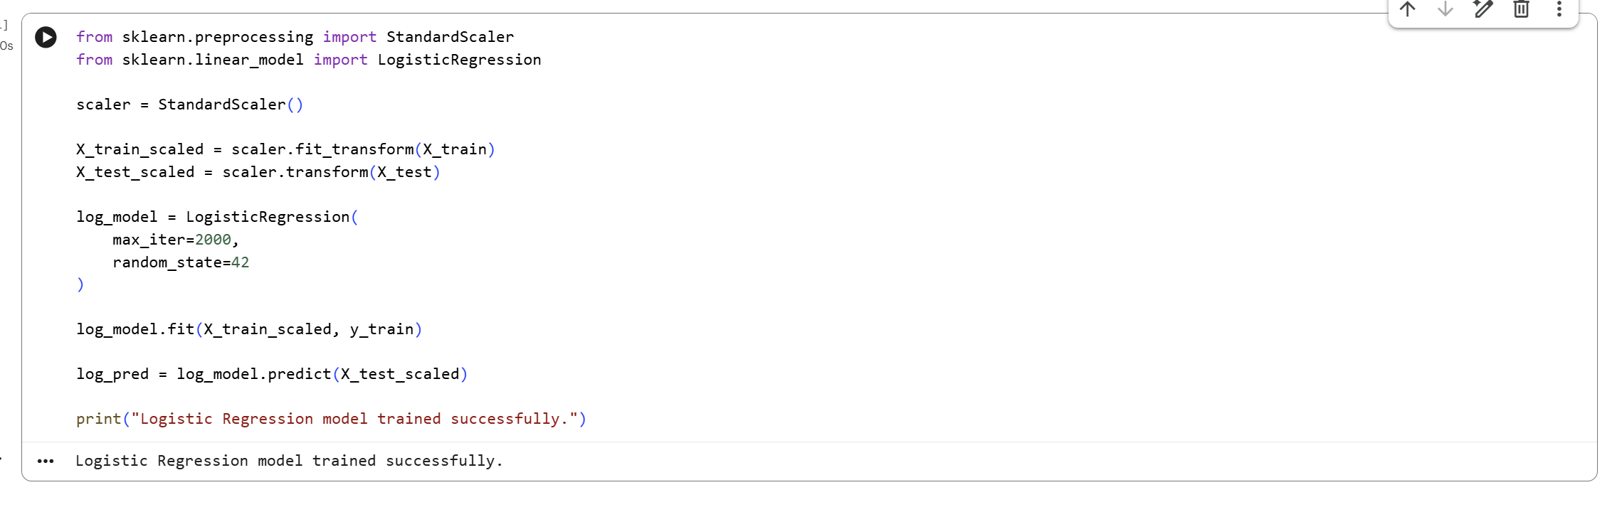

Accuracy
The Logistic Regression model achieved an accuracy of 0.807, equivalent to 80.70%. This means that approximately 80.7% of the customers in the testing dataset were classified correctly as either Churn or No Churn.
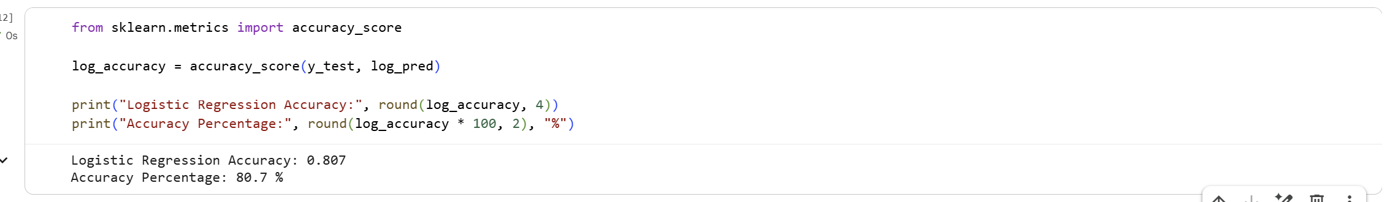

Precision
The model achieved a precision score of 0.6584 for the churn class. This means that approximately 65.84% of the customers predicted as churners were actually churn customers.
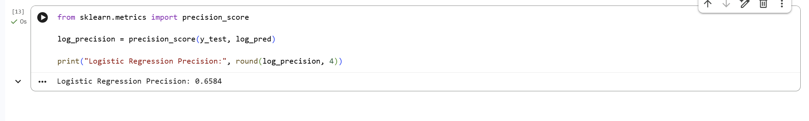

Recall
The Logistic Regression model achieved a recall score of 0.5668. This indicates that the model correctly identified approximately 56.68% of the customers who actually churned.
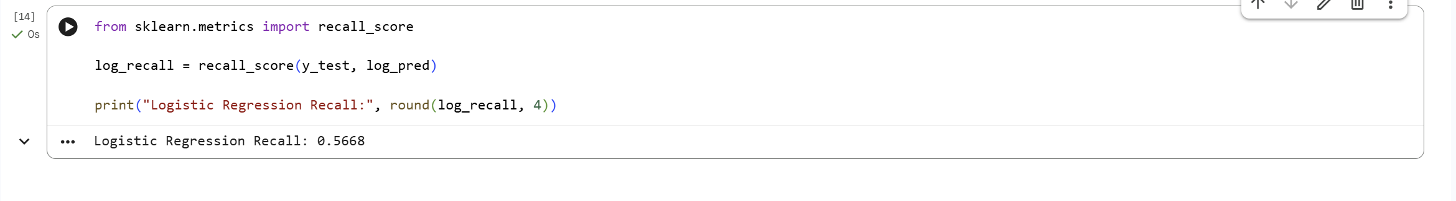

F1 Score
The model achieved an F1 Score of 0.6092. The F1 Score provides a balanced measurement of Precision and Recall. This result shows moderate performance in identifying churn customers while considering both false positive and false negative predictions.
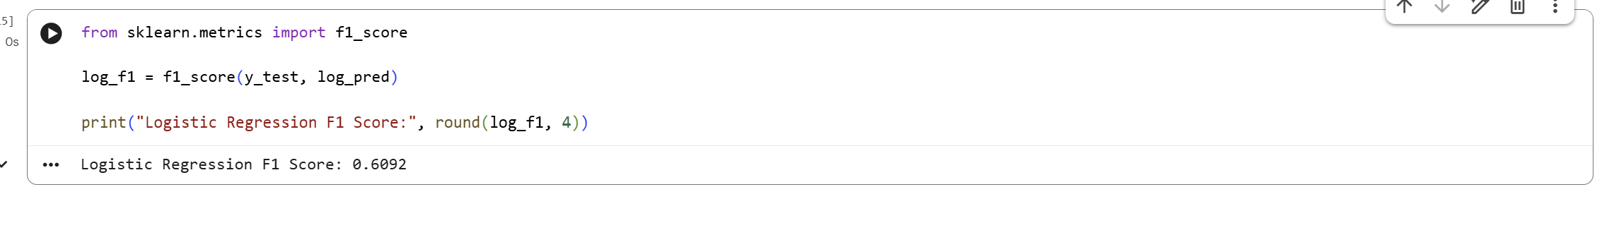

Classification Report
The classification report provided detailed results for both customer classes. For No Churn customers, the model achieved a precision of 0.85, recall of 0.89, and F1 Score of 0.87. For Churn customers, the precision was 0.66, recall was 0.57, and F1 Score was 0.61. The overall accuracy reported was approximately 0.81 across 1,409 testing records.
These results show that the Logistic Regression model performed better at identifying customers who remained with the company than customers who churned. This difference is also influenced by the larger number of No Churn customers in the dataset.
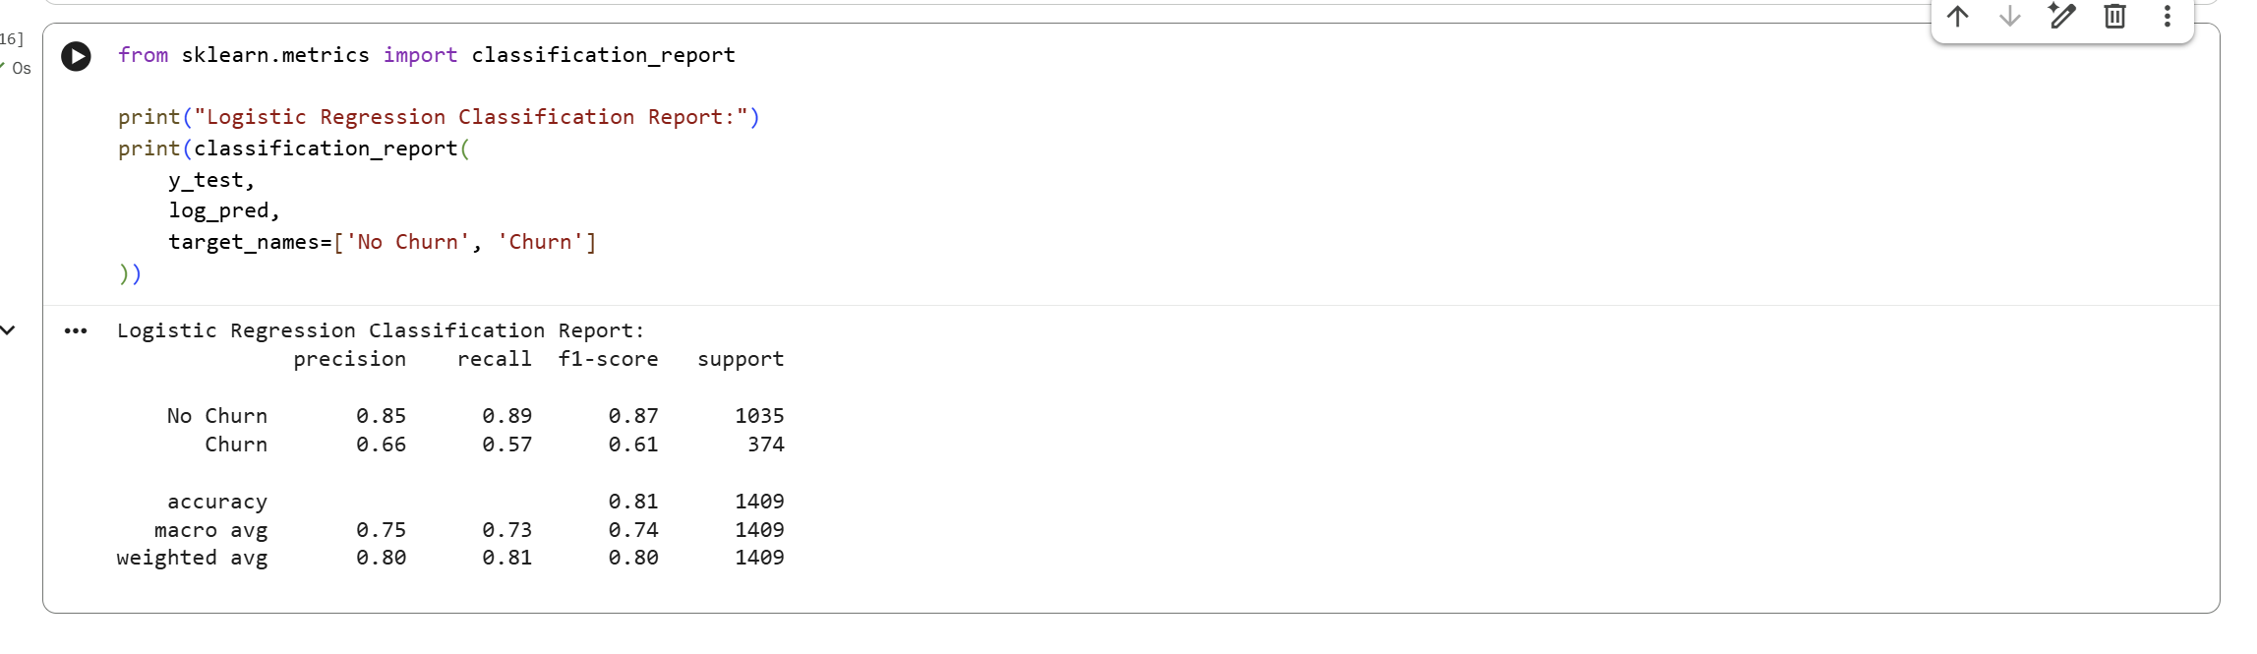

Confusion Matrix
The Logistic Regression Confusion Matrix produced the following results:
- True Negatives = 925
- False Positives = 110
- False Negatives = 162
- True Positives = 212
The model correctly identified 925 customers as No Churn and 212 customers as Churn. However, 110 customers were incorrectly predicted as churners, while 162 actual churn customers were incorrectly classified as No Churn.
The confusion matrix confirms that the model performs strongly for non-churn customers but misses some customers who actually churned.
- Accuracy = 80.70%
- Precision = 65.84%
- Recall = 56.68%
- F1 Score = 60.92%
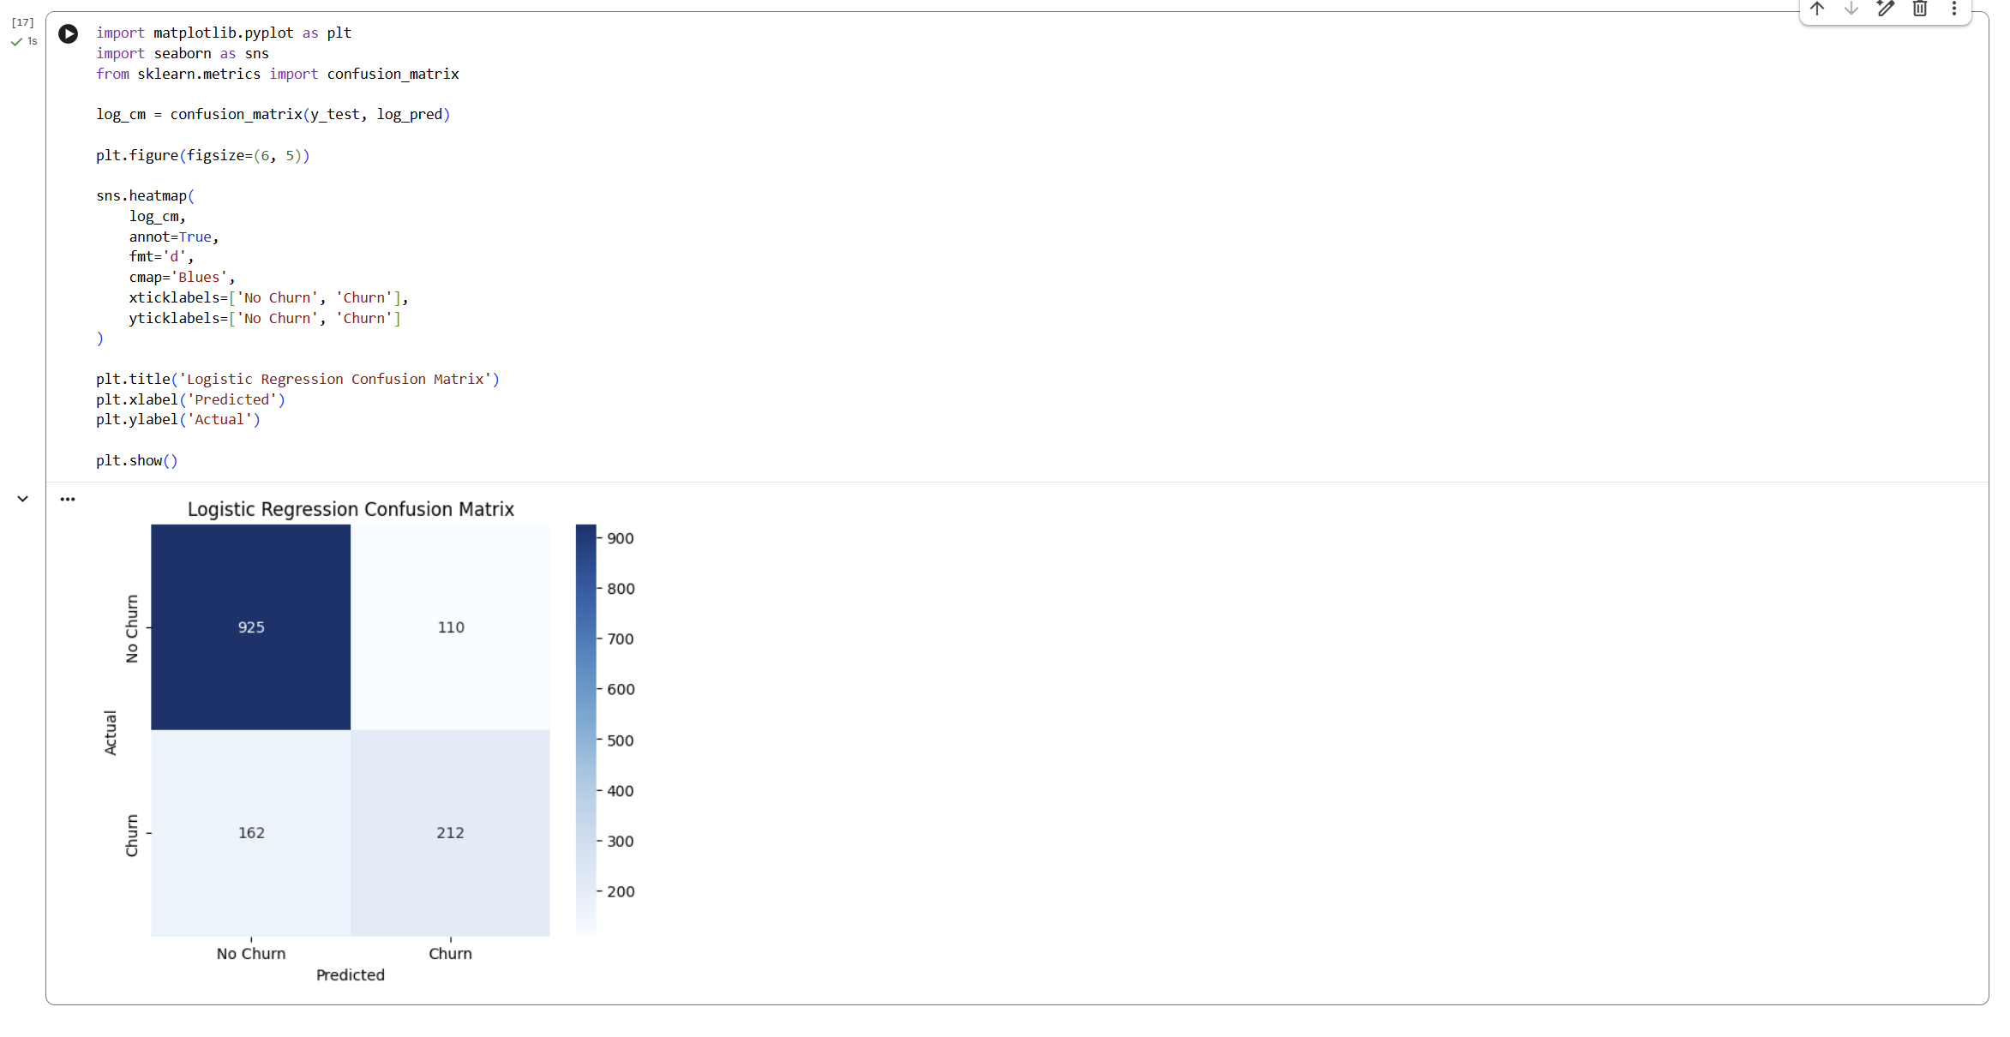

Random Forest Model
Random Forest was used as the second classification model for customer churn prediction. The model was trained using 100 decision trees with random_state = 42. Unlike Logistic Regression, feature scaling was not required because Random Forest is based on decision trees. After training, the model generated churn predictions for the testing dataset.

Model Training
The Random Forest classifier was trained using X_train and y_train. A total of 100 estimators were used to build the model. The training process completed successfully, and predictions were generated using X_test.
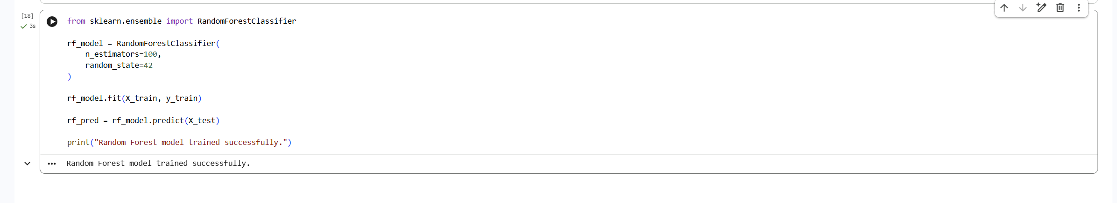

Accuracy
The Random Forest model achieved an accuracy of 0.785, equivalent to 78.50%. This means that approximately 78.5% of the 1,409 customers in the testing dataset were correctly classified as either Churn or No Churn.
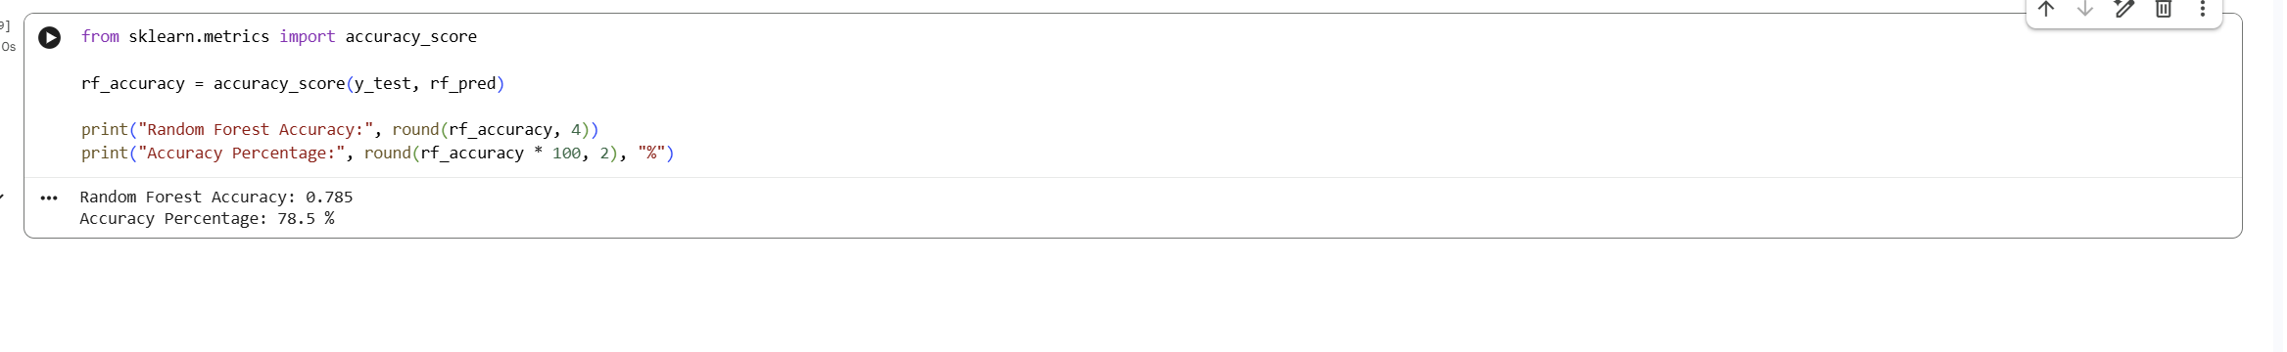

Precision
The Random Forest model achieved a precision score of 0.6179 for the churn class. This means that approximately 61.79% of customers predicted as churners actually belonged to the churn group.
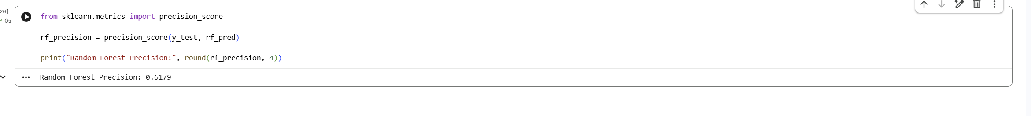

Recall
The model achieved a recall score of 0.4973. This indicates that Random Forest correctly identified approximately 49.73% of the customers who actually churned. The result also shows that the model missed a considerable number of actual churn customers.
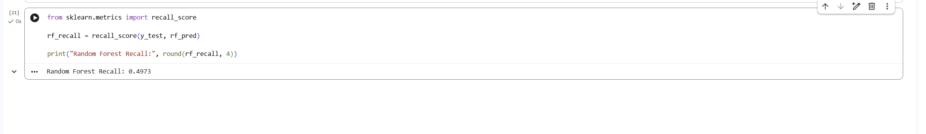

F1 Score
The Random Forest model achieved an F1 Score of 0.5511. This score combines Precision and Recall and provides a balanced measure of the model's performance for the churn class.
The Random Forest model achieved a precision score of 0.6179 for the churn class. This means that approximately 61.79% of customers predicted as churners actually belonged to the churn group.
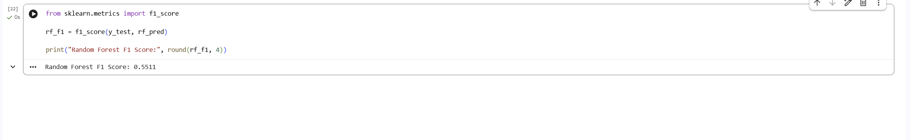

Classification Report
The classification report showed that Random Forest performed better for No Churn customers than for Churn customers. For the No Churn class, the model achieved a precision of 0.83, recall of 0.89, and F1 Score of 0.86, based on 1,035 records.
For the Churn class, the model achieved a precision of 0.62, recall of 0.50, and F1 Score of 0.55, based on 374 records. The overall classification accuracy was approximately 0.78 across 1,409 test records. The weighted average F1 Score was 0.78, while the macro average F1 Score was 0.70.
These results indicate that Random Forest was more successful at identifying customers who remained with the company than customers who churned.
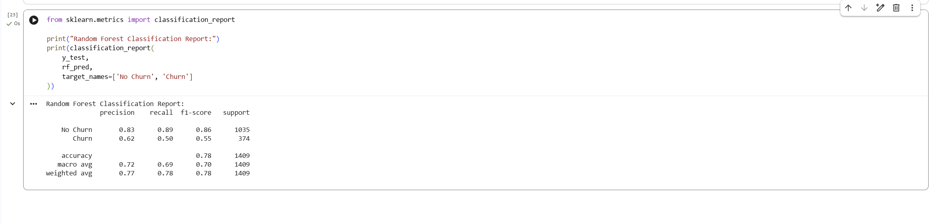

Confusion Matrix
The Random Forest Confusion Matrix produced the following results:
True Negatives = 920
False Positives = 115
False Negatives = 188
True Positives = 186
The model correctly predicted 920 customers as No Churn and 186 customers as Churn. However, 115 customers were incorrectly predicted as churners, while 188 actual churn customers were incorrectly classified as No Churn.
The relatively high number of false negatives explains the lower Recall score for the churn class.
Final Random Forest results:
Accuracy = 78.50%
Precision = 61.79%
Recall = 49.73%
F1 Score = 55.11%
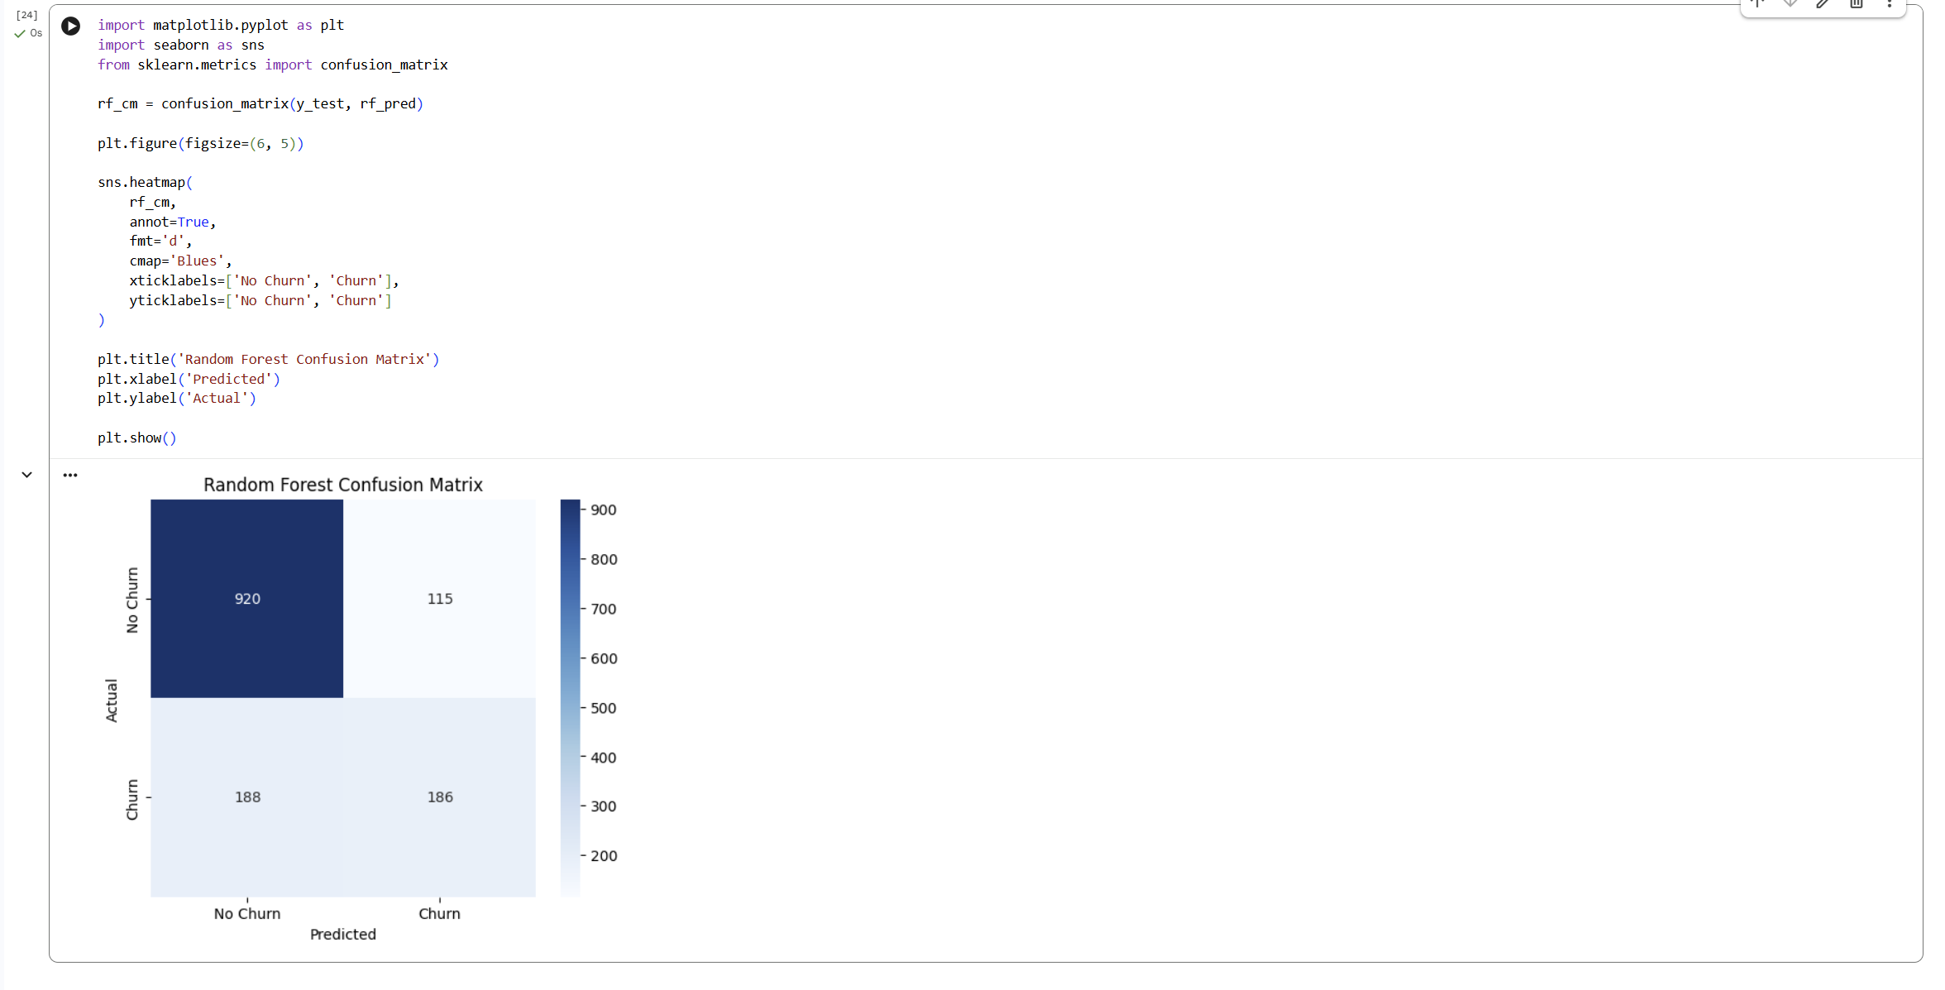

Model Comparison

Performance Comparison
The performance of Logistic Regression and Random Forest was compared using Accuracy, Precision, Recall, and F1 Score. Logistic Regression achieved an accuracy of 0.8070, precision of 0.6584, recall of 0.5668, and F1 Score of 0.6092. Random Forest achieved an accuracy of 0.7850, precision of 0.6179, recall of 0.4973, and F1 Score of 0.5511.
The comparison shows that Logistic Regression performed better across all four evaluation metrics. Its higher Recall and F1 Score also indicate stronger performance in identifying customers who actually churned.
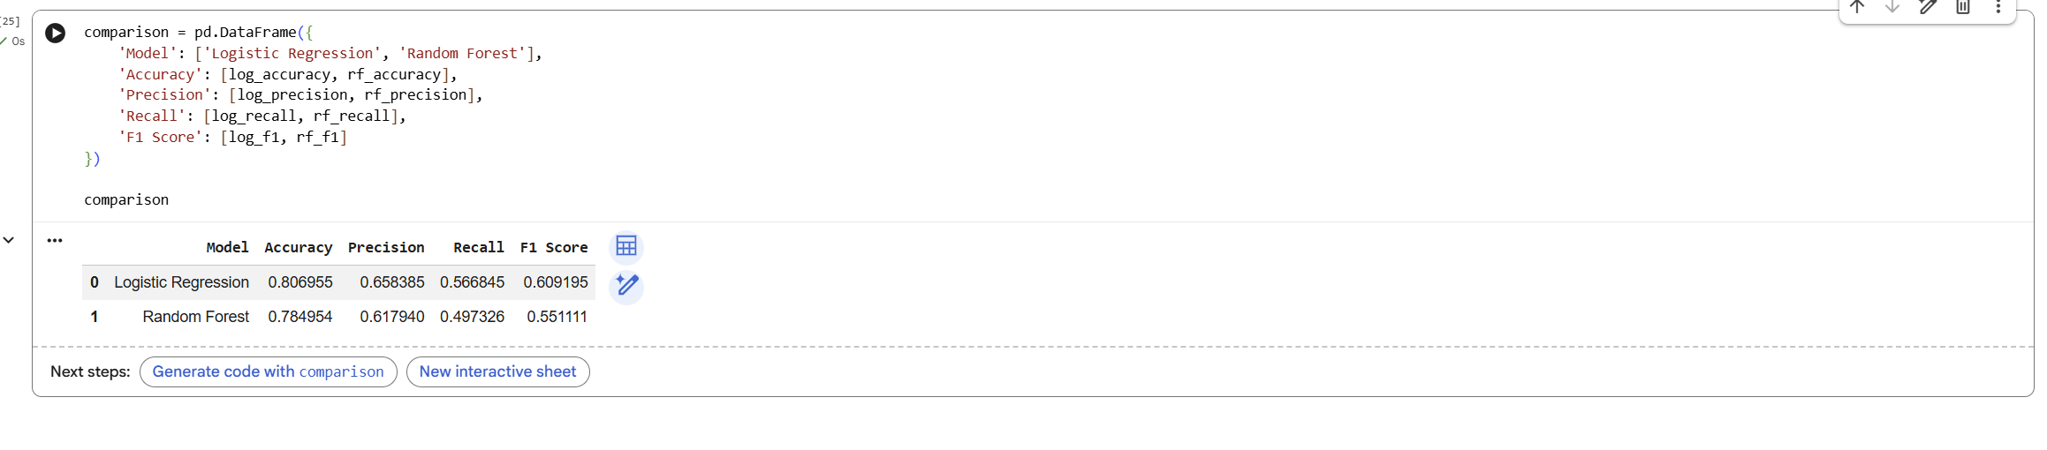

Best Performing Model
Based on the evaluation results, Logistic Regression was identified as the best-performing model. It achieved an accuracy of approximately 80.70%, compared with 78.50% for Random Forest.
Logistic Regression also achieved higher Precision, Recall, and F1 Score. Its Precision was 65.84%, Recall was 56.68%, and F1 Score was 60.92%. Therefore, Logistic Regression was selected as the final model for customer churn prediction.
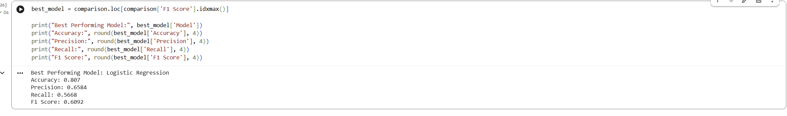

Model Selection Justification
Logistic Regression was selected because it provided better overall classification performance than Random Forest. Its higher accuracy indicates that it correctly classified a greater proportion of test customers. It also achieved higher Precision, meaning that its churn predictions were more reliable.
The higher Recall of Logistic Regression was especially important because it identified a larger proportion of customers who actually churned. Its F1 Score of 0.6092 was also higher than the Random Forest F1 Score of 0.5511. Considering all four evaluation measures, Logistic Regression was the more suitable model for this dataset.
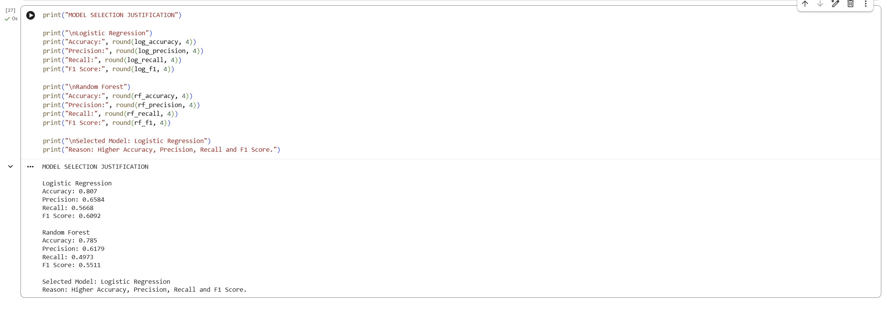

Customer Churn Prediction

Sample Customer Information
A sample customer record was created to demonstrate the practical use of the selected model. The customer was male, not a senior citizen, had no partner or dependents, and had been with the telecom company for 12 months. The customer used phone service and Fiber optic internet but did not use Online Security, Online Backup, Device Protection, or Tech Support.
The customer had a month-to-month contract, used paperless billing, and paid through electronic check. The MonthlyCharges value was 85.00, while TotalCharges was 1020.00. Streaming TV and Streaming Movies were also enabled.
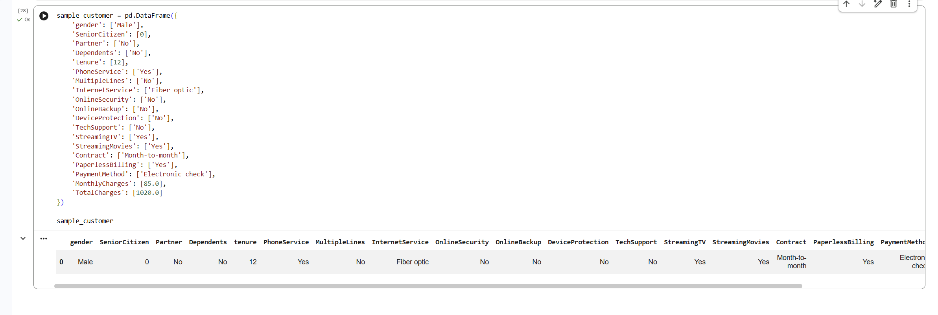

Prediction Process
The sample customer record was converted into numerical form using dummy encoding. The encoded data was then aligned with the same 30 input features used to train the machine learning model. This ensured that the new customer record had exactly the same structure as the training dataset.
Because Logistic Regression was selected as the best-performing model, the sample customer features were transformed using the previously fitted StandardScaler. The scaled data was then passed to the trained Logistic Regression model. The prediction process completed successfully with a sample shape of 1 row and 30 features.
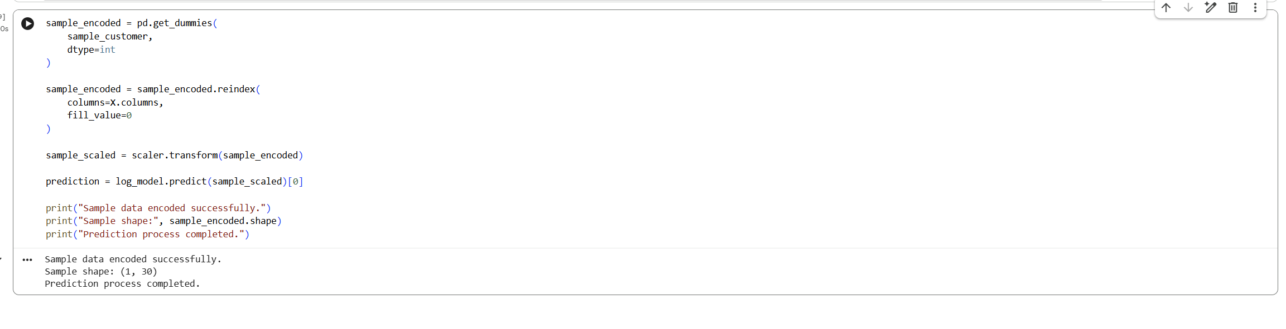

Final Churn Prediction
The final prediction produced by the Logistic Regression model was:
Prediction: Churn
This means that the model classified the sample customer as likely to leave the telecom company. Characteristics such as a month-to-month contract, Fiber optic internet service, relatively short tenure, lack of technical support, and higher monthly charges were consistent with patterns observed among customers with higher churn risk during the exploratory analysis.
A telecom company could use this type of prediction to identify at-risk customers and apply suitable retention strategies before the customer leaves.
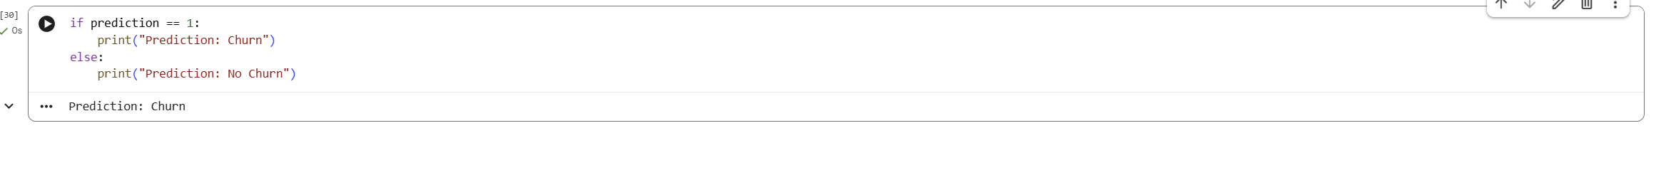

Key Findings
The analysis identified several clear patterns associated with customer churn. Customers with month-to-month contracts had the highest churn rate at approximately 42.71%, while one-year and two-year contracts showed much lower churn rates. Fiber optic customers also showed a comparatively high churn rate of approximately 41.89%. Customers who churned had higher average monthly charges, approximately 74.44, compared with 61.27 for customers who remained. Tenure was another important factor. Churn customers had an average tenure of approximately 17.98 months, while non-churn customers averaged approximately 37.57 months.
The modelling results also showed that Logistic Regression performed better than Random Forest. Logistic Regression achieved 80.70% accuracy, 65.84% precision, 56.68% recall, and a 60.92% F1 Score. Random Forest achieved 78.50% accuracy, 61.79% precision, 49.73% recall, and a 55.11% F1 Score. Therefore, Logistic Regression was selected as the final model.

Model Limitations
Although the developed churn prediction system produced useful results, several limitations should be considered. The model was trained only on the information available in the provided telecom dataset, so customer behaviours or factors that are not included in the dataset cannot influence the predictions. The target variable was also imbalanced, with considerably more No Churn customers than Churn customers. This contributed to stronger performance for the No Churn class.
The selected Logistic Regression model correctly identified many customers but did not detect every churn case. Its recall of 56.68% means that some customers who actually churned were incorrectly classified as No Churn. Customer behaviour may also change over time, so a model trained on historical data may require regular retraining with newer customer information. The prediction should therefore support business decisions rather than serve as the only basis for customer management.

Business Application of the Churn Prediction System
The churn prediction system can help a telecom company identify customers who have a higher likelihood of leaving. Customers predicted as Churn could be prioritised for retention activities before they cancel their services.
For example, the company could provide personalised discounts, improved technical support, contract upgrade offers, service reviews, or loyalty incentives to high-risk customers. The exploratory analysis suggests that customers with month-to-month contracts, shorter tenure, higher monthly charges, and certain service combinations may deserve closer attention.
The model can also support customer service and marketing teams by helping them focus resources on customers with greater churn risk. Over time, prediction results could be combined with updated customer information to improve retention planning and reduce customer loss. The assignment specifically requires discussion of how a churn prediction system could be used by a telecom company.

Conclusion
his project developed a complete machine learning system for predicting telecom customer churn. The work included dataset understanding, data cleaning, exploratory analysis, feature encoding, train-test splitting, model development, evaluation, comparison, and prediction for a sample customer.
Two classification models were evaluated. Logistic Regression achieved the strongest overall performance with 80.70% accuracy, 65.84% precision, 56.68% recall, and a 60.92% F1 Score. Random Forest produced lower results across the same measures. Logistic Regression was therefore selected as the final model.
The exploratory analysis showed that contract type, tenure, internet service, and monthly charges were strongly associated with churn behaviour. The final model successfully processed a new sample customer and produced a Churn prediction. Overall, the project demonstrates how machine learning can help telecom companies identify customers at risk of leaving and support more focused retention decisions. The assignment requires the final conclusion to discuss the best model, important observations, limitations, and potential business use, all of which are addressed in this report.

References
McKinney, W. (2010). Data structures for statistical computing in Python. Proceedings of the 9th Python in Science Conference, 56 to 61.
Pedregosa, F., Varoquaux, G., Gramfort, A., Michel, V., Thirion, B., Grisel, O., et al. (2011). Scikit-learn: Machine learning in Python. Journal of Machine Learning Research, 12, 2825 to 2830.
The Pandas Development Team. (2026). pandas documentation. pandas.
Scikit-learn Developers. (2026). Scikit-learn documentation. Scikit-learn.
Hunter, J. D. (2007). Matplotlib: A 2D graphics environment. Computing in Science and Engineering, 9(3), 90 to 95.
Waskom, M. L. (2021). seaborn: Statistical data visualization. Journal of Open Source Software, 6(60), 3021.

