Student Number: 230713176
Business Analytics, Applied Modelling, & Prediction ST2187 Coursework Report

Prepared by: Fatema Mansoor Ali Mohammed
Word Count: 1483
Submission date: 1st March 2025
Table of Contents

Preface 3
Executive Summary 3
Dashboards Analysis 4
1. Sales Overview 4
2. Sales and Profit by Segment 6
3. Geographic Analysis 8
4. Shipping Costs and Discounts 10
5. Company Evaluation 12
Conclusion 14

Furniture Market in the Asia-Pacific Region:
Performance Overview (2020-2023)

Preface
In today’s data-driven business world, data analysis visualization tools are more accessible than ever. Utilizing these tools is the building block for uncovering insightful analysis from all the trends and patterns in our dataset. Transforming raw numbers into simple visuals is a powerful skill that makes data easier to be interpreted and communicated through to senior management, allowing for better decisions and strategies.

Executive Summary
Over the years, the APAC has maintained its position as the leading market and generated the highest revenue throughout all years, representing %50 of our customers. Furniture companies in the market achieved a total of 41,158 items sold, resulting in $3.58 million in revenue and a gross profit of $436.6K that yields a profit ratio of 12.19%.
The analysis shows that the furniture industry shows a strong sales performance marked by a consistent upward trend throughout the years. However, there have been remarkable losses for tables across several companies that be analyzed.
This report presents a breakdown based on a Tableau Story that consists of five dashboards (listed below), highlighting the trends and the evident relationships that affect the company’s overall profitability.
❶ Sales Overview | The overall sales trends within the furniture industry, seasonal trends, and the leading furniture companies in the market.
❷ Sales and Profit by Segment | The distribution of sales and profit among three segments: consumer, corporate and home office customers.
❸ Geographic Analysis | A country level performance among countries in the Asia Pacific.
❹ Shipping Costs and Discounts | A breakdown of shipping costs and discounts on furniture products, and how they affect profit.
❺ Furniture Companies Evaluation | A performance overview of furniture companies in the Asia Pacific.

Dashboards Analysis
- Sales Overview

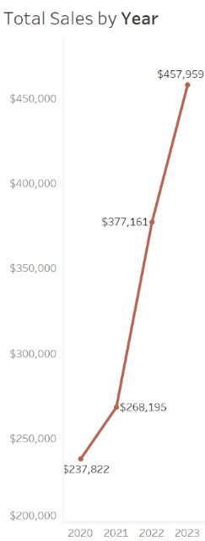
Initially, sales of the furniture market in the Acia Pacific show a slight increase starting from $237,822 in 2020 up to $268,195 in 2022. In the following two years, there was a sharp rise in sales that marked a 70.8% growth rate.
The monthly sales chart below shows fluctuations in sales volume that reflect seasonal patterns. Seasonality plays a significant role in business performance and understanding the external factors allows us to make better judgments. The rise in sales in June can be explained through weather changes, as more people get into renovating and home improvements in the summer. After that follows a remarkable drop in July, as summer vacations arise and most families prioritize trips and activities over buying furniture. Furthermore, the following spike in August could be a caused by summer clearance sales before the fall season, which attracts many customers.
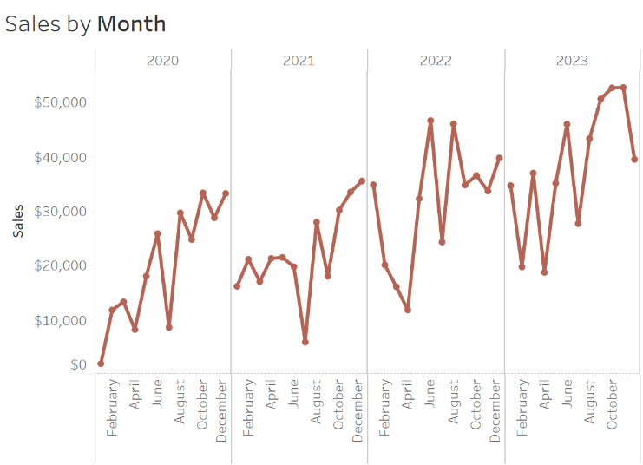
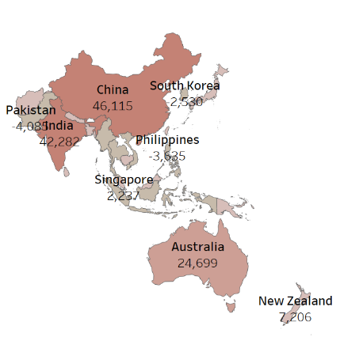
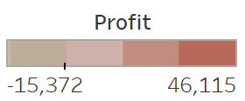
Overall, China, India and Australia are the major contributors to the total profit in the market; while Pakistan, Philippines and South Korea incur the highest losses.

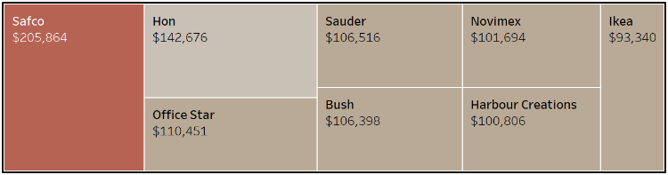
Safco, Hon, Office Star, Sauder and Bush are among the leading companies in the furniture industry in terms of sales volume across all years.

Competition among these companies can be observed through the charts below. Initially, Ikea was the leading company for bookcases, with total sales of $21,751. As the years went by, Sauder took its place in 2023, marking a total of $48,783.
On the other hand, Novimex and Lesro maintained their positions throughout the years for chairs and tables, respectively.
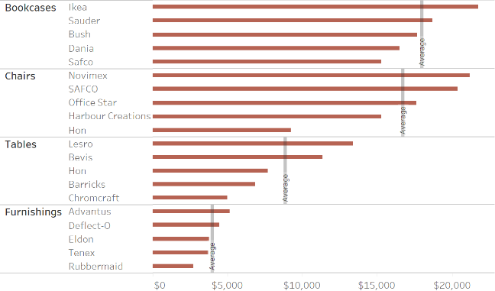
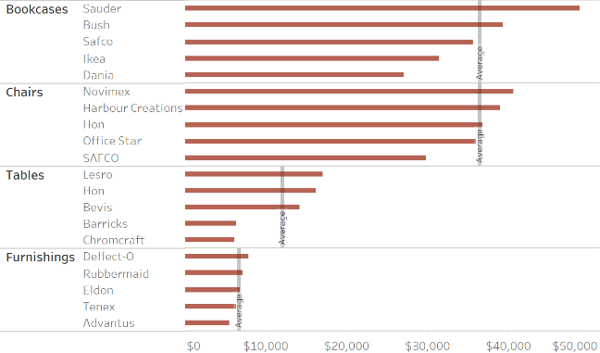
Sales Revenue by Company Across Subcategories: 2020 vs 2023

  - Sales and Profit by Segment

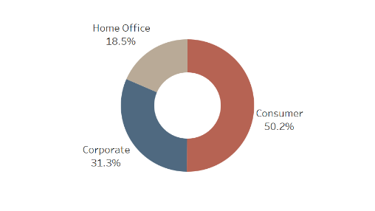
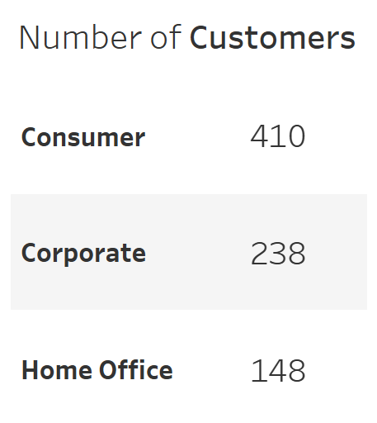
Customers are split into three segments: Consumer, Corporate and Home Office.
The Consumer segment takes up 50.2% of the total furniture sales. The rest 50% of sales is shared between Corporate and Home Office customers.

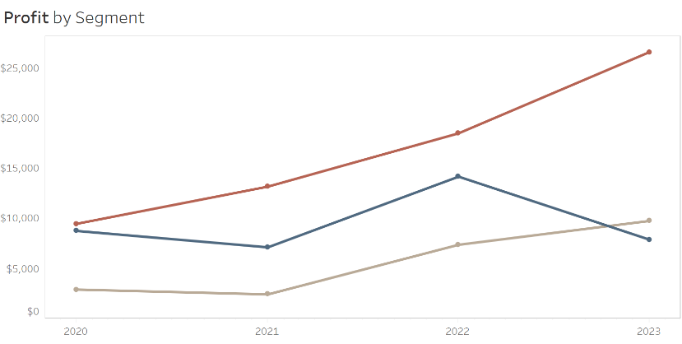
Initially, the total profit for the Consumer and Corporate segments was roughly equivalent in 2020; being at $9,441 for the Consumer and $8,730 for the Corporate segment. As the years went by, Consumer profit showed a consistent growth in profit that reached up to $26,542 in 2023. In contrast, the Corporate profit fluctuated throughout the years with a spike in 2022 that resulted in a profit of $14,138, followed by a decline.

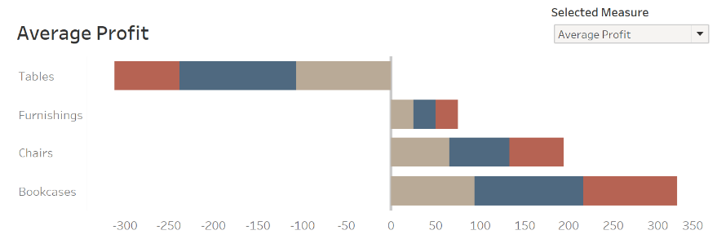
On average, the profit for most categories is proportionally distributed among all three segments, while tables is the only sub-category that experiences a negative profit.

Key findings:
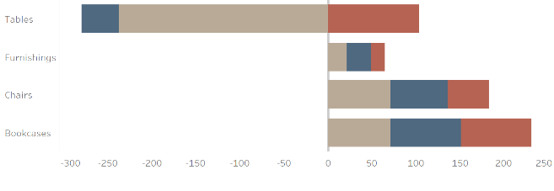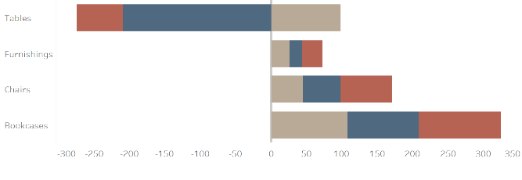
In 2021, the Home Office segment was responsible for 85% of the average losses. The Consumer segment, however, resulted in an average profit of $103, marking a growth rate of 155% from 2020.
The Corporate segment incurred an average loss of $209 in 2023, marking the lowest profit across all years. In contrast, Home Office profits went up to an average of $99, after three years of incurring losses.

  - Geographic Analysis

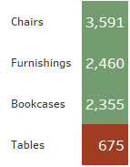
Collectively, a total of 3,591 units of chairs were sold, 2,460 furnishing pieces, 2,355 bookcases and 675 tables. The low quantity of tables sold in comparison to other furniture items could be due to the inherent nature of tables themselves; as they are considered as a permanent fixture and bought less frequently. In contrast, chairs and furnishings need to be replaced more frequently for comfort or style trends.
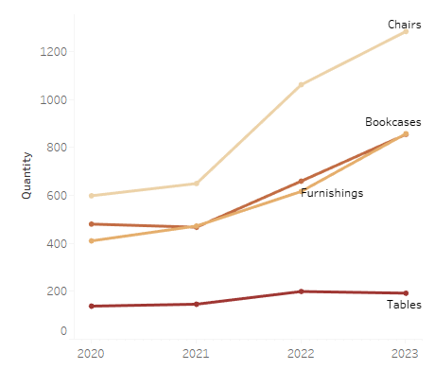
Among all categories, the quantity of chairs sold saw the largest increase in quantity from 2021-2023, while the quantity of tables remained almost constant over the years. Looking at the chart, the lines for bookcases and furnishings are overlapping; making it harder for us to analyze and distinguish each of their performance based on quantity sold alone.
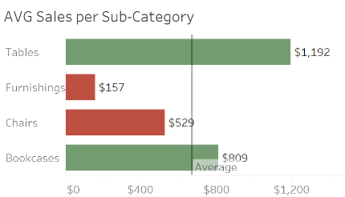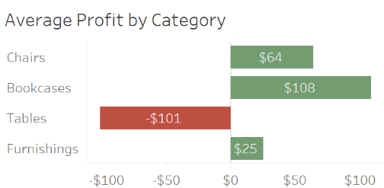
On average, tables and bookcases generate the largest amount of sales across all years, while chairs and furnishings generate the lowest. Despite this, tables continued to score the highest amount of losses, with an average of -$101.
To gain a better insight regarding the previous trends, we need to look into the performance of countries in the Asia Pacific to see which countries have the biggest influence.
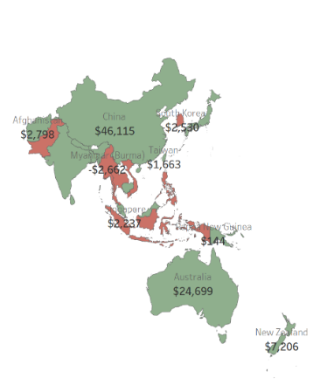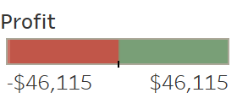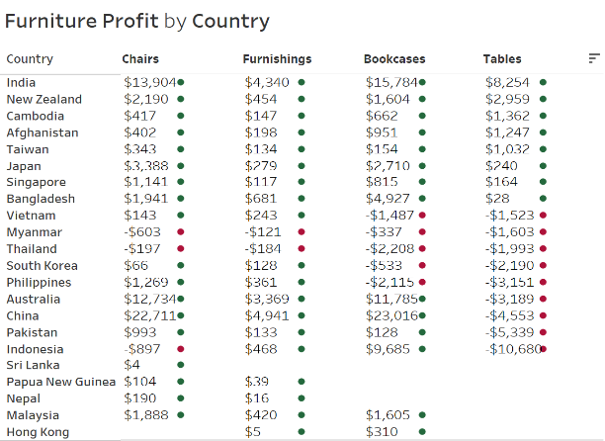
Overall, China, India and Australia are the top contributors to furniture profit.
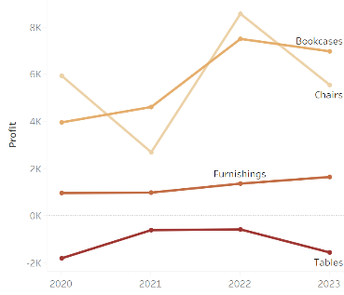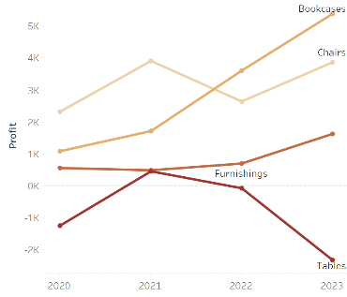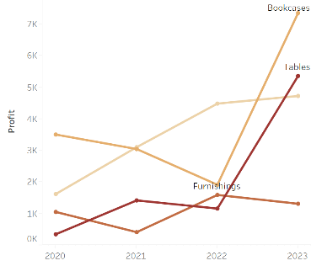
China
Australia
India
Both China and Australia have a negative profit for tables, while the profit for India is positive for all subcategories across all years. Additionally, as the profit of tables declined for China and Australia in the later years, there was a drastic increase in India’s profit that reached to a total of $5,351 in 2023, while the profit for Australia was at its lowest.
Furthermore, Pakistan, China, Australia, Philippines and other countries (highlighted above) exhibit similar negative profit trends for tables. The country responsible for most losses is Indonesia, marking a total of -$10,680. Almost 50% of the Indonesia’s table losses occurred in 2021.

- Shipping Costs and Discounts

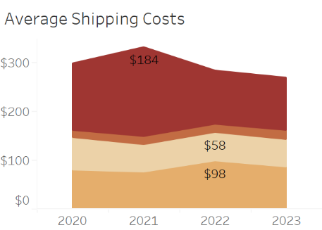
To understand the trends observed in furniture profit, we can start by analyzing the effect shipping costs and discounts. Due to the nature of furniture products being heavy, bulky and fragile, the shipping process is more costly and more complicated.
Overall, the total shipping costs of furniture summed up to $145,308. On average, tables are the most costly to ship, followed by bookcases and chairs. There was a spike in the average shipping costs for tables in 2021.

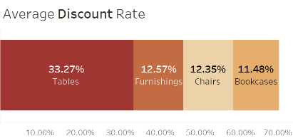
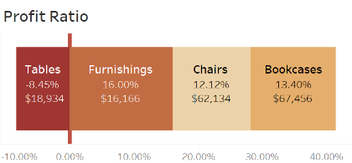
Another crucial factor affecting profitability is discount rates. On average, the discount on tables is significantly higher than other products (being at around 30%) while the discount on other sub-categories is roughly similar. Consequently, tables experience a remarkably low profit margin of -8.45% and a total loss of $18,934.

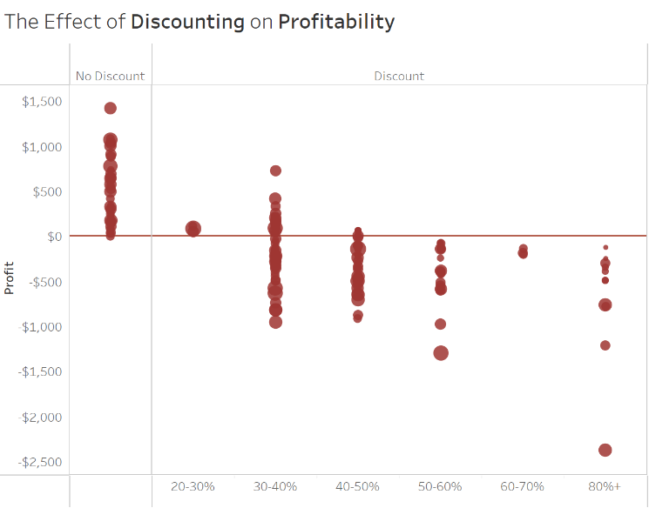
Looking at the scatter plot, we can clearly analyze the effect of discounts on the profit of tables. In the absence of discounts, the profit for tables is non-negative throughout all years. More losses occur as we go along the discount axis, indicating that higher discount rates are a major factor in the negative profit of tables we observed earlier.
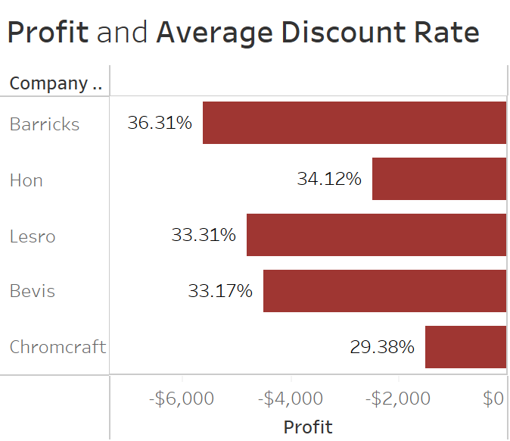
Tables from the companies Barricks, Lesro and Bevis that were sold within the range of 30% incurred the large losses.

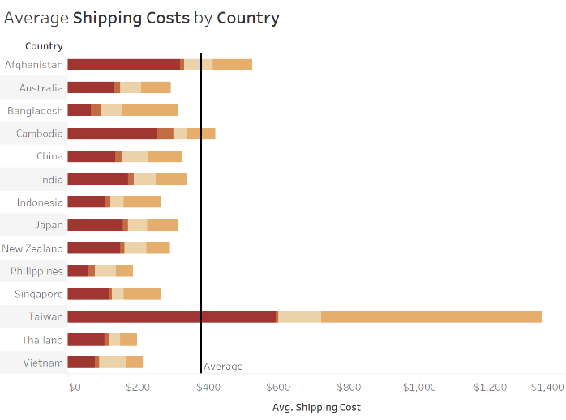
Referring back to shipping costs, we would typically expect that the company’s profit is highly affected by shipping costs. However, looking at the bar chart on the right, the country that incurs the highest average shipping costs for tables, bookcases and chairs is Taiwan. Referring back to the Furniture Profit by Country table, profits for Taiwan are positive across all years. It should be noted that there are missing values in some years of Taiwan’s profit that significantly affect the relationship between profit and shipping costs. Alternatively, Indonesia’s average shipping costs are well below the average line, yet it marked the highest loss of -$10,680. This tells us that while the relationship between discounting and profitability was obvious for the profit of furniture, the same wasn’t easily implied for shipping costs. Extra measures and careful considerations should be taken for a more accurate analysis.

- Company Evaluation

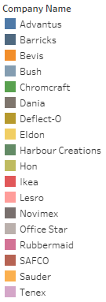
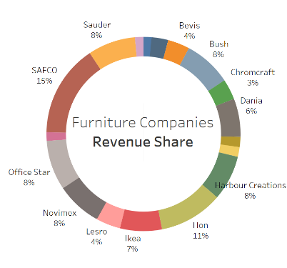
In total, furniture sales for each subcategory in the Asia Pacific is distributed among 20 companies. The distribution of sale percentages remains roughly similar throughout all years.

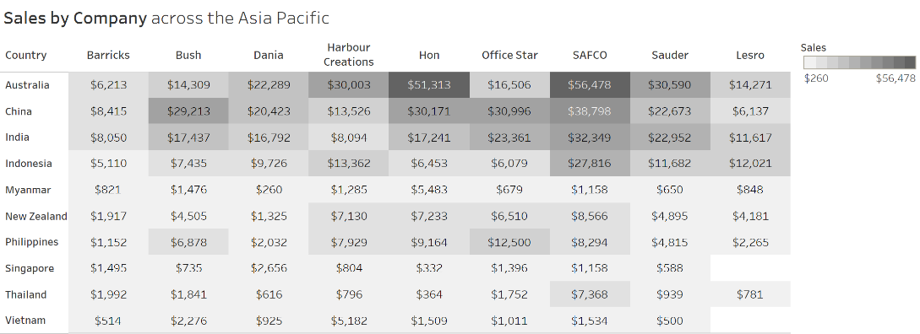

Remarkable trends:
SAFCO | Office Star | Sauder | Lesro
SAFCO has the highest revenue share of products, mostly from bookcases. Their products are mostly dominant in Australia, China, India and Indonesia. Sales in Indonesia went up by $7,182. | In 2022, the company achieved the highest amount of sales from chairs, a total of $92,107. The company has the highest revenue recorded from Philippines across all other furniture companies. | From 2021- 2022, the leading company for bookcases in India was SAFCO, with a revenue of $6,964 and $4,576, respectively. In 2023, Sauder marked a total sales of $12,934 for bookcases in India, outperforming SAFCO after two years of leading the sales. | Lesro generated the highest amount of sales for tables across all years, with a 4% share of APAC furniture revenue. However in India, it contributed to 17% of furniture sales, coming in second place after Sauder.

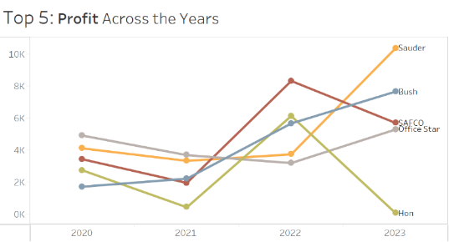
  - Sauder’s profit increased sharply from $3,740 in 2022 to $10,370 in 2023.
  - Both SAFCO and Hon experienced similar trends with a peak in 2022, but the loss for Hon was steeper.

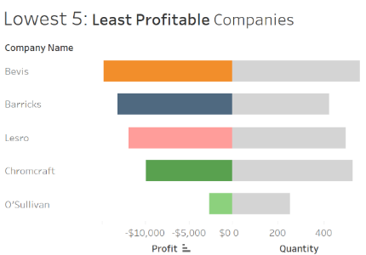
- Overall, the company that resulted in the highest amount of losses is Bevis. All losses were caused by tables.
- In 2023, Barricks recorded the lowest profit of -$12,642, while Bevis came in second with almost half of losses, being at -$5,524.

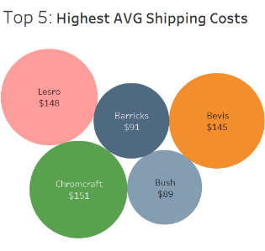
- Barricks, Bevis, Lesro and Chromcraft are among the top 5 countries with the highest average costs, indicating the negative relationship between shipping costs and profits.

Conclusion
The performance of furniture products across countries in the Asia Pacific shows remarkable positive trends, most notably in Australia, China and India. Products by the companies SAFCO, Hon and Office Star have managed to consistently outperform other products. As more people are working from home, the growth in the Home Office segment opens up a promising opportunity for our products. The substantial losses incurred by tables has been hindering the growth rate of furniture. While discounts typically serve as an incentive for customers, higher discount rates were shown to be highly correlated with negative profits, suggesting that better discounting strategies should be considered.

