Fatima Madey
CNet ID: fmadey
4/24/2026
https://github.com/fatimamadey/mpcs-sqa/tree/main/assignment3

Coverage Report
https://github.com/fatimamadey/mpcs-sqa/blob/main/assignment3/tests/index.html
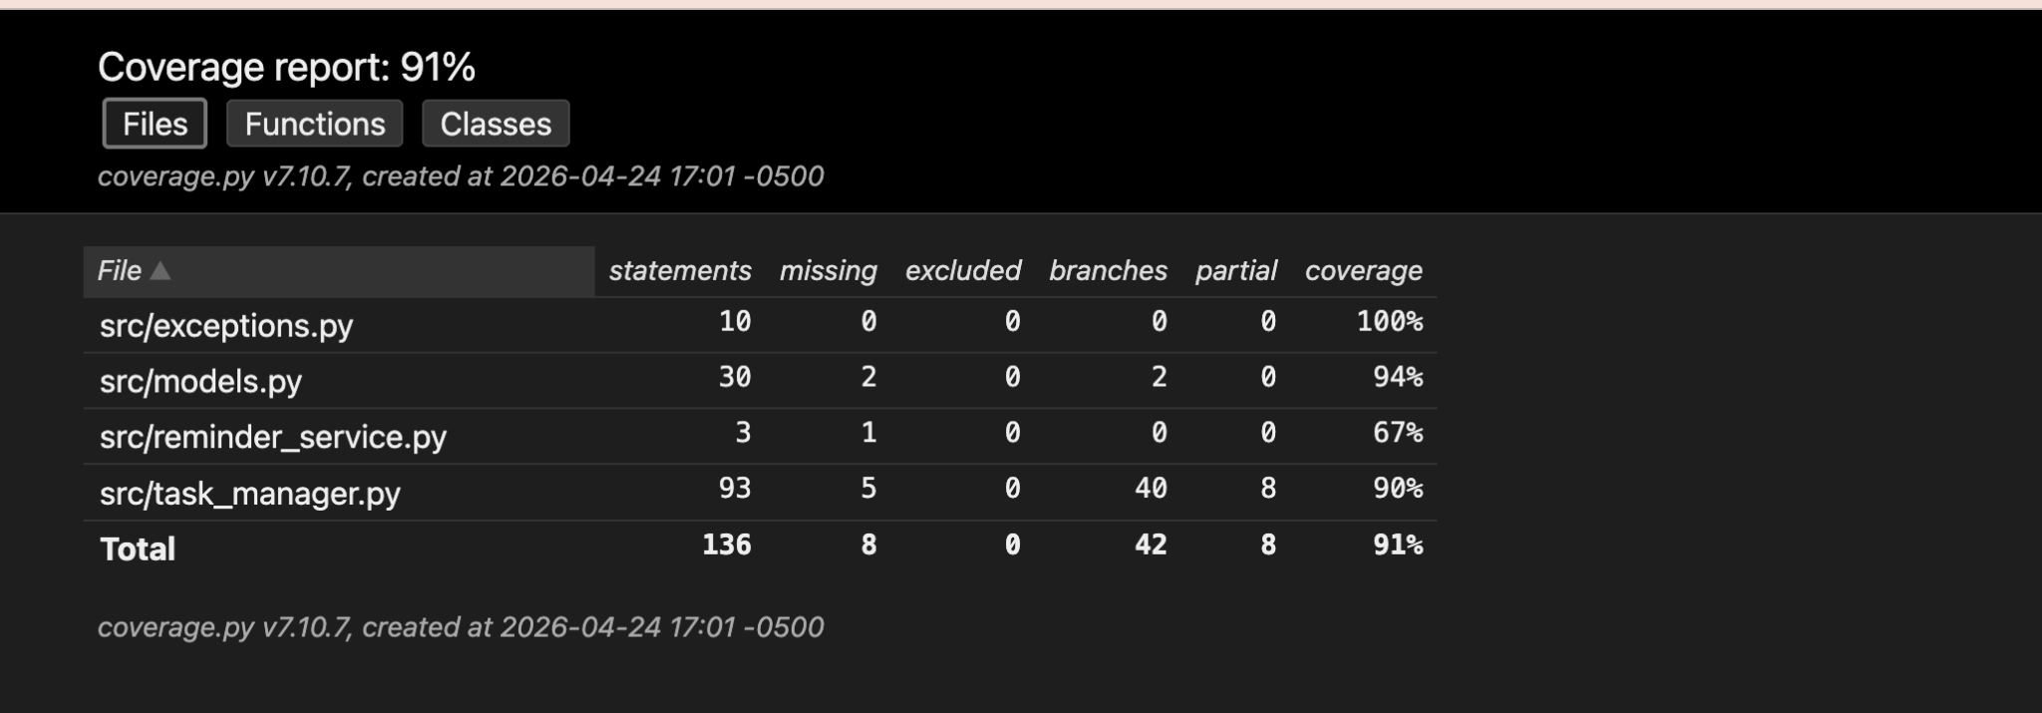
Figure 1: Coverage Report of Files

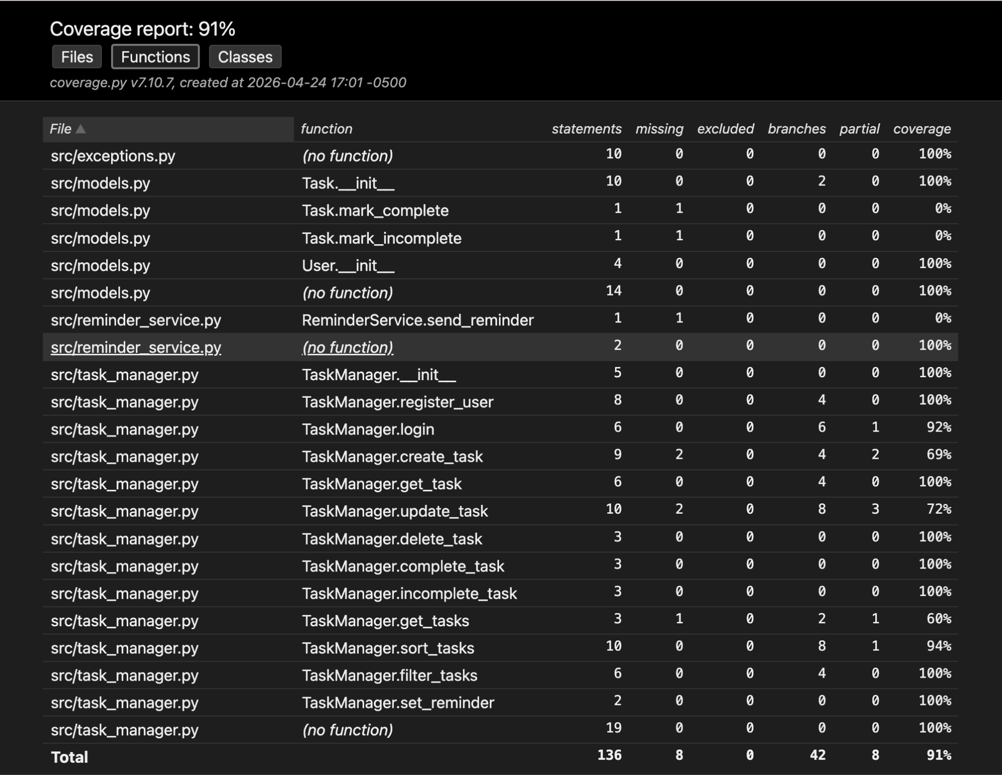
Figure 2: Coverage Report of Functions
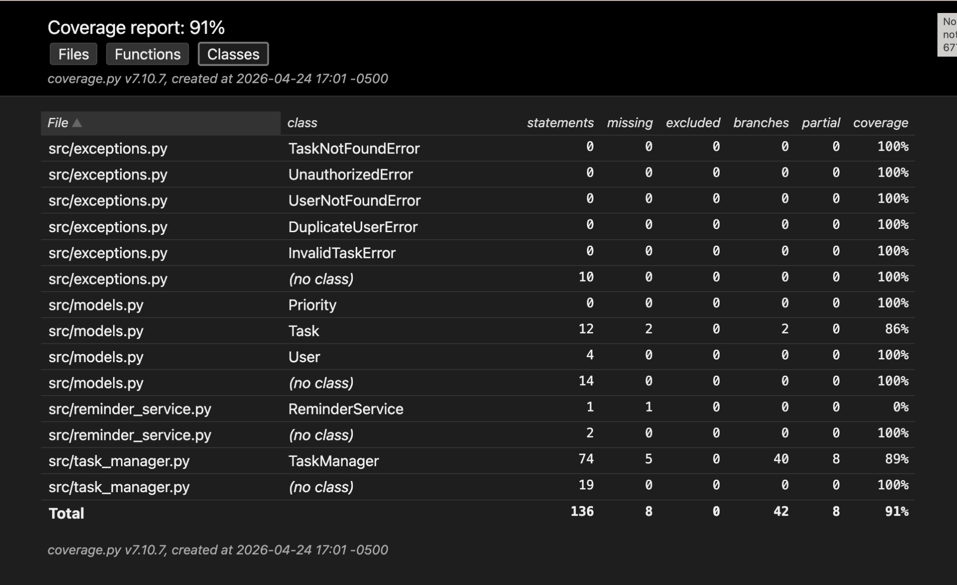
Figure 3: Coverage Report of Classes

Reflection

What was Built
I implemented Task, User, and Priority classes in models.py to organize the core data for the application.

I put most of the logic (auth, CRUD, sorting, filtering, reminders) into the TaskManager class so everything is handled in one place. Copilot suggested using plain Python dicts (self.users, self.tasks) for storage, which I decided to keep because it avoids overengineering and makes the system easier to reason about. It also means every test gets a fresh TaskManager instance with no shared state, so tests are deterministic and can run in any order.

For reminders, I needed something with an “outgoing side effect” that tests could observe or replace, so I created a simple ReminderService that doesn’t actually send anything. Instead, it just takes in values. I then inject it into TaskManager, which ended up being important for testing because I could swap it out with a mock when I needed to verify behavior. This felt like a clean way to introduce dependency injection without adding unnecessary complexity.

We were told not to raise bare Exception, so I created specific exception classes (TaskNotFoundError, UnauthorizedError, UserNotFoundError, DuplicateUserError, InvalidTaskError) in src/exceptions.py. This made it easier to write tests that assert on exact failure cases instead of just checking that something failed.

All 25 tests are in tests/test_task_manager.py. I used two fixtures: manager (a fresh TaskManager) and registered_user (a manager with one user already registered) to keep setup consistent and avoid repeating code across tests.

Test Strategy and Coverage
The hardest category for me was definitely boundary/edge cases. At first, I kept writing tests that felt like the same thing as invalid input (like blank titles or wrong passwords), and it started to feel repetitive. I had to think more about what actually counts as a boundary, like a one-character title or calling complete_task twice on the same task.

For branch coverage, I honestly didn’t fully understand how to read the percentage at first. Looking at the report, most of the uncovered or partial branches are in places like sort_tasks, filter_tasks, and update_task, where there are multiple conditionals (different sort keys, optional filters, etc.). To fully close the gap, I would need more tests targeting those specific branches, like invalid update fields or missing due dates. I didn’t cover every branch because some of them felt less important compared to the main behaviors, and adding tests for all of them would start to feel like testing implementation details instead of behavior.

Test Doubles and Isolation
The main place I used a test double was with ReminderService. For most tests, I just used the default version as a dummy. In test_set_reminder_delegates_to_reminder_service, I replaced it with a mock (MagicMock) so I could verify that send_reminder was actually called with the right arguments.

I would say I ended up taking more of a Classical approach. I didn’t mock everything, just the one external dependency. Most of the logic is already in-memory and deterministic, so using real objects made the tests simpler and more meaningful.

The Four Pillars — The Best and Weakest Test (≈125 words)
The test I’m most proud of is test_tasks_from_different_users_are_independent. It checks something pretty important (that users can’t see each other’s tasks), so it gives good regression protection. It also only looks at behavior (what tasks each user gets back), so it wouldn’t break if I changed how tasks are stored internally, which makes it more resistant to refactoring. It runs fast since everything is in memory, and it’s easy to read since the setup and assertions are straightforward.

The weakest test is probably test_create_task_returns_task_with_correct_title. It basically just checks that fields are set correctly, which doesn’t exercise much logic. It wouldn’t catch many real bugs, so it’s weak on regression protection. I still kept it because it’s a simple baseline test and helps confirm that the basic create flow works before testing more complex behavior.

Looking Back
If I started over, I would probably split up TaskManager a bit more. Right now, it handles both user logic and task logic, which works, but it makes some parts feel a little crowded. I was also raising exceptions and checking edge cases in multiple places, like in the Task class and in the Task manager, so I realized I was repeating code logic that wasn’t needed.

One thing that surprised me was how easy it was to write when you get in the flow of it. At first, it was hard to come up with tests, but the more you wrote, the easier it was to come up with them. And writing tests made me understand my code way better.

AI Usage Disclosure
I used AI (Copilot) at the beginning to generate a skeleton of the project. I gave it the assignment description and asked it to create the src structure (exceptions.py, models.py, reminder_service.py, task_manager.py) and a basic test file layout with fixtures. All of the unit tests, coverage decisions, and this reflection were written by me. I also asked for help figuring out how to generate branch coverage since I didn’t initially understand how to read it or generate it.

Screenshots Appendix
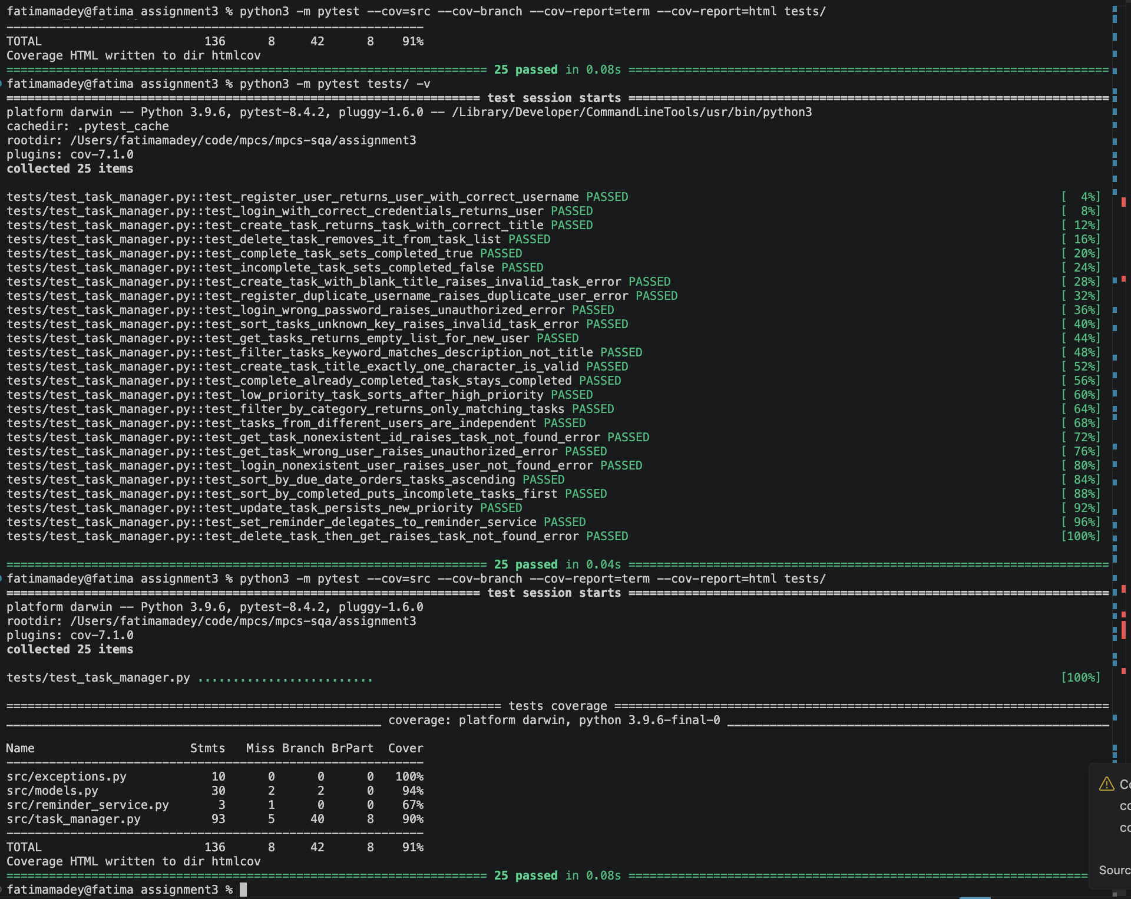
Figure 4: Terminal Output from Running Tests and Overview of Coverage

