

Practices for Secure Software Report

Table of Contents
Document Revision History 3
Client 3
Instructions 3
Developer 4
1. Algorithm Cipher 4
2. Certificate Generation 4
3. Deploy Cipher 4
4. Secure Communications 4
5. Secondary Testing 4
6. Functional Testing 4
7. Summary 4
8. Industry Standard Best Practices 4

Document Revision History

Version | Date | Author | Comments
1.0 | Feb 22, 2026 | Fatima Mubasher

Client



Instructions

Submit this completed practices for secure software report. Replace the bracketed text with the relevant information. You must document your process for writing secure communications and refactoring code that complies with software security testing protocols.

- Respond to the steps outlined below and include your findings.
- Respond using your own words. You may also choose to include images or supporting materials. If you include them, make certain to insert them in all the relevant locations in the document.
- Refer to the Project Two Guidelines and Rubric for more detailed instructions about each section of the template.

Developer
Fatima Mubasher

Algorithm Cipher

Recommended cipher/algorithm: SHA-256 (SHA-2 family) used as a cryptographic hash function for checksum verification.
High-level overview:
SHA-256 is a one-way cryptographic hash function that converts input data of any length into a fixed-length 256-bit (32-byte) digest, typically represented as a 64-character hexadecimal string. In Artemis Financial’s web application, SHA-256 supports a file/data verification step by enabling integrity checks: the application can compute a checksum before and after transfer to confirm the data was not altered in transit.
Hash functions and bit levels:
- Output size: 256 bits.
- Digest representation: 64 hex characters.
- Security properties: preimage resistance (hard to find an input for a given hash), second preimage resistance (hard to find a different input with the same hash), and collision resistance (hard to find two different inputs that hash to the same output).
- Compared to older algorithms: MD5 (128-bit) and SHA-1 (160-bit) are considered weak for collision resistance and are not recommended for integrity/security-critical use.
Random numbers, symmetric vs. non-symmetric keys (and what applies here):
- A hash function is not encryption: it does not use symmetric or asymmetric keys and it is not reversible.
- Randomness is not required to compute SHA-256, because the output is fully determined by the input.
- However, secure communications (HTTPS/TLS) do rely on randomness during the TLS handshake (for nonces/session key material) and rely on public-key cryptography (asymmetric) for certificate-based authentication and key exchange.
History and current state of encryption algorithms:
Modern applications typically combine multiple cryptographic tools: (1) TLS for encrypted transport, (2) certificates for server authentication, and (3) hashes for integrity checks.
Historically, older algorithms like DES were replaced by stronger standards (e.g., AES for symmetric encryption). For hashing, MD5 and SHA-1 have been deprecated for many security uses, while SHA-2 (including SHA-256) remains widely adopted in industry.
Why SHA-256 is appropriate for Artemis Financial:
SHA-256 is a current, well-supported, industry-standard hash that provides strong integrity guarantees for checksum verification, integrates cleanly with Java’s built-in security libraries, and aligns with secure coding expectations for financial data.

Certificate Generation
Insert a screenshot below of the CER file.


Deploy Cipher
Insert a screenshot below of the checksum verification.
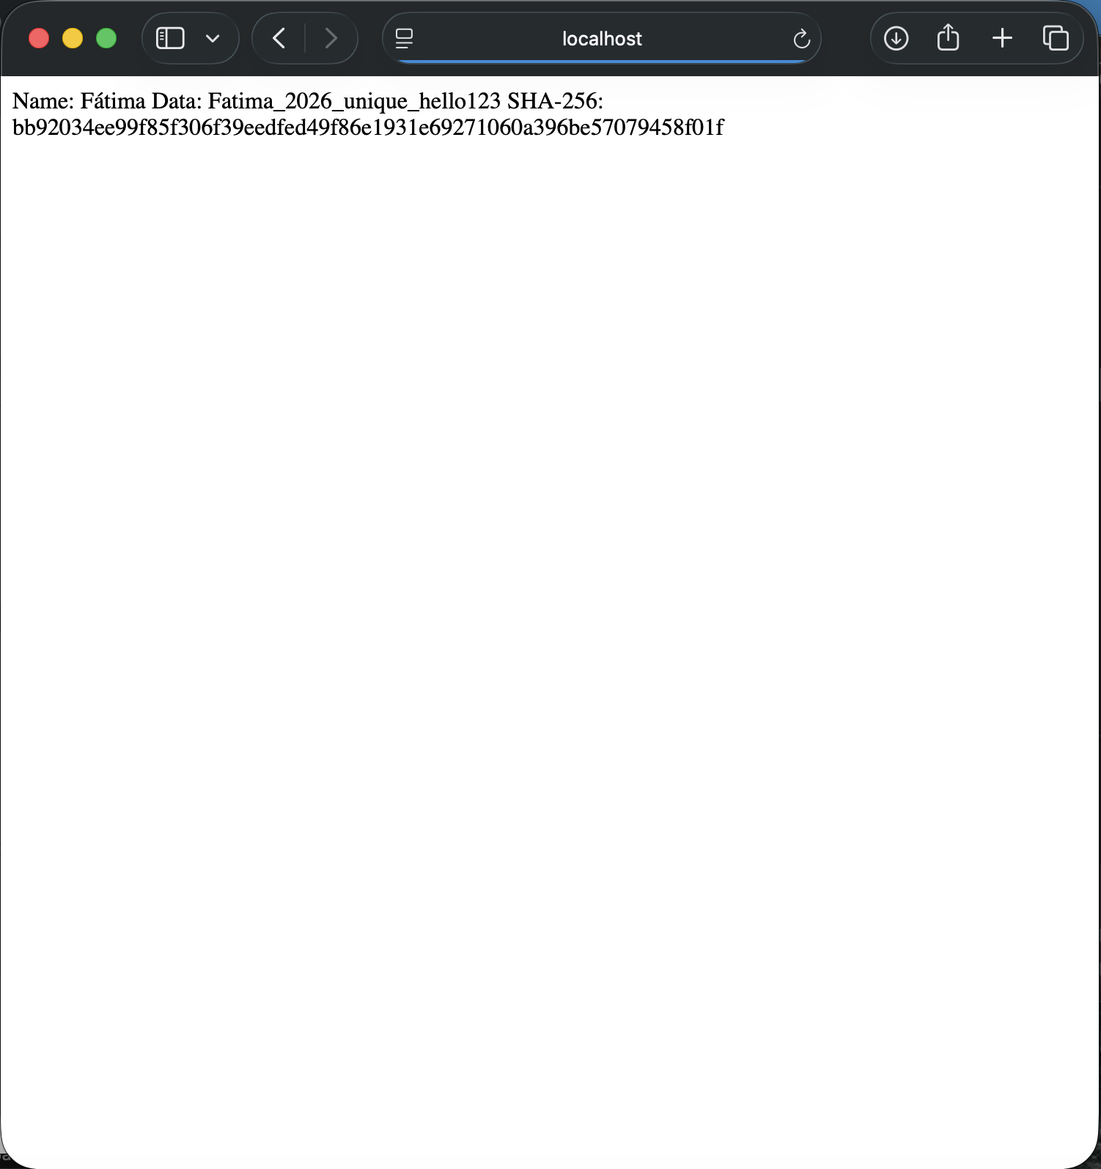

Secure Communications
Insert a screenshot below of the web browser that shows a secure webpage.
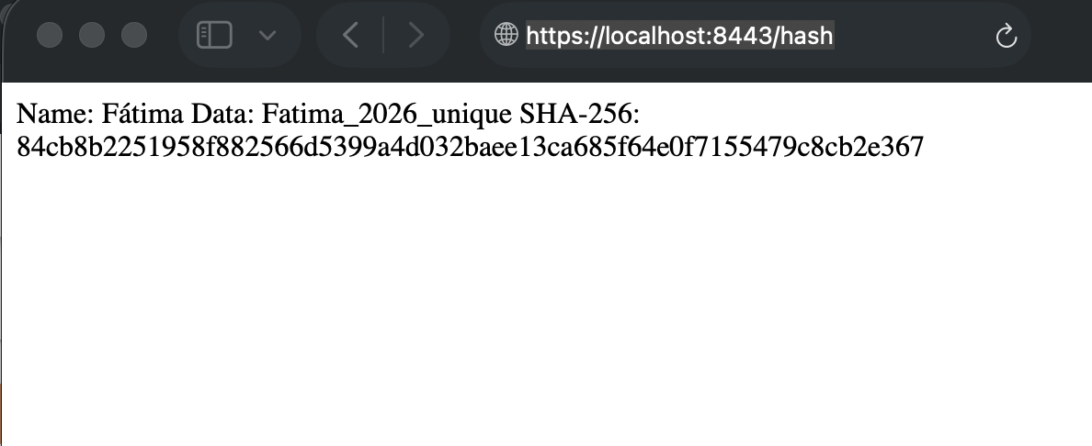

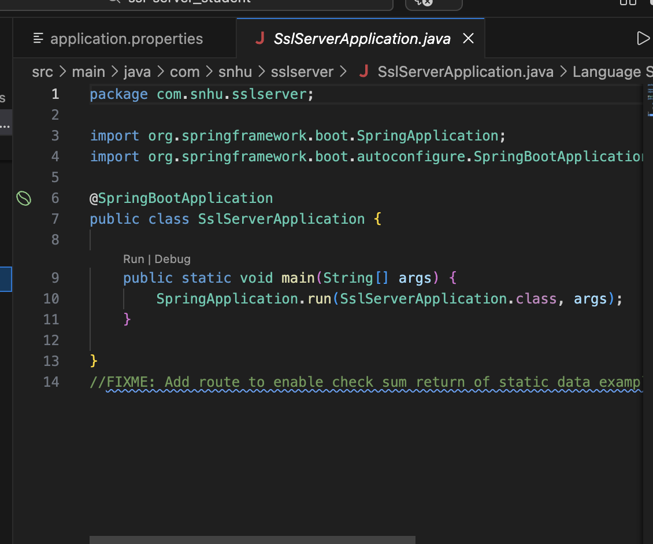

Secondary Testing
Insert screenshots below of the refactored code executed without errors and the dependency-check report.

OWASP Dependency-Check version 12.1.0 was executed to perform a secondary static analysis of the refactored project. The report identified vulnerabilities within existing third-party dependencies included in the original project (e.g., Spring Boot and embedded Tomcat libraries). These vulnerabilities were not introduced by the refactored checksum or HTTPS implementation.

During execution, the OSS Index analyzer returned HTTP 401/429 responses due to external service authorization and rate limits; however, the tool successfully generated a dependency report for analysis. No additional vulnerabilities were introduced by the newly implemented secure communication and SHA-256 hashing functionality.
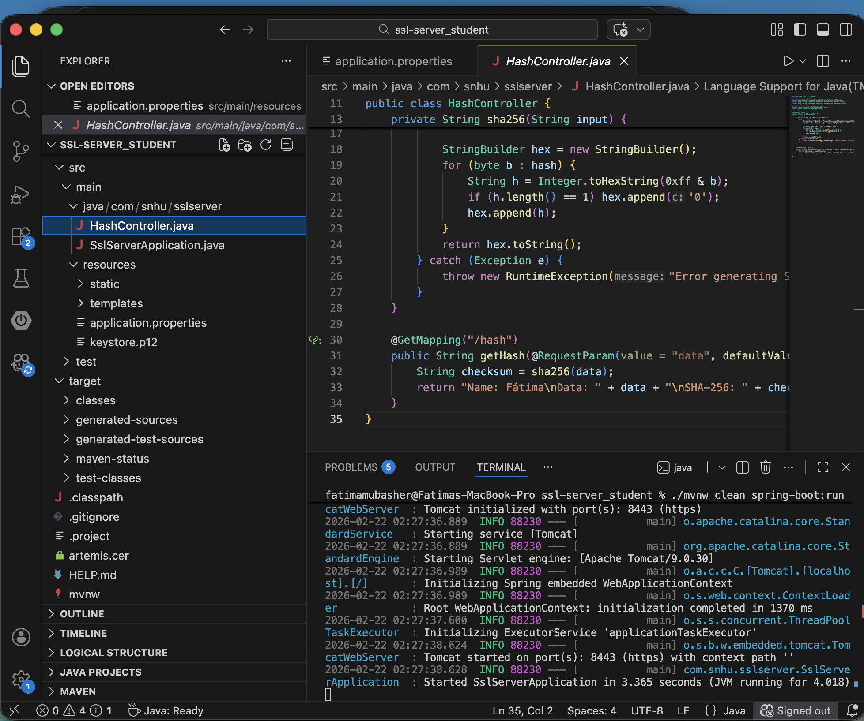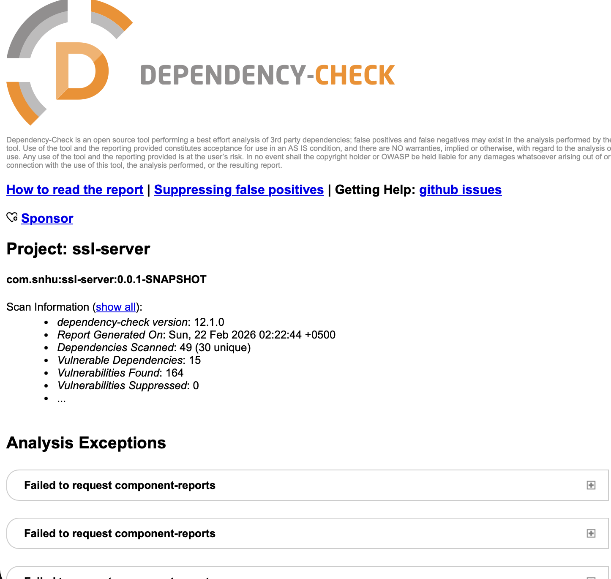

Functional Testing
Insert a screenshot below of the refactored code executed without errors.


Summary

This project focused on identifying and mitigating security vulnerabilities in a Spring Boot–based SSL server application. The primary objectives were to:
- Enable HTTPS using a self-signed SSL certificate
- Generate and export a secure keystore
- Run OWASP Dependency-Check to analyze third-party dependencies
- Interpret vulnerability results
- Improve the application’s security posture

HTTPS was successfully configured using a PKCS12 keystore, and the application was verified to run securely over port 8443. A SHA-256 hashing endpoint was implemented and tested through the browser to validate secure data processing.

OWASP Dependency-Check was executed using Maven. While initial runs encountered external service limitations (NVD feed access and OSS Index authentication/rate limiting), a report was successfully generated and analyzed. The report identified vulnerable dependencies and provided insight into potential risks within third-party libraries.

This project demonstrates the importance of secure configuration, certificate management, dependency analysis, and proactive vulnerability mitigation in modern software development.

Industry Standard Best Practices

Secure software development requires adherence to established industry best practices to minimize vulnerabilities and ensure system integrity. First, all web applications should enforce HTTPS using properly configured SSL/TLS certificates to protect data in transit. Even in development environments, encryption should be implemented to mirror production security standards.

Second, dependency management must be actively maintained. Organizations should regularly scan third-party libraries using automated tools such as OWASP Dependency-Check and promptly upgrade outdated or vulnerable components. Because modern applications rely heavily on external packages, unpatched dependencies represent a significant security risk.

Third, vulnerability suppression should only be used when findings are confirmed as false positives. Suppressing legitimate vulnerabilities without remediation increases long-term exposure to known exploits.

Finally, security scanning should be integrated into the software development lifecycle through continuous integration and deployment (CI/CD) pipelines. Automated checks, secure configuration management, and periodic reviews ensure that vulnerabilities are identified early and addressed before production release.

By applying encryption, dependency analysis, version control discipline, and continuous monitoring, developers can significantly improve the overall security posture of modern applications.

