RAG-BASED QUESTION-ANSWERING SYSTEM DEVELOPMENT
An Experimental Evaluation of Chunking, Retrieval, Model Selection, and Context-Reordering in the Clinical Domain
Institution: Institute of Business Administration (IBA)
Course: Introduction to Text Analytics (Assignment 04)
Author: Fatima Naeem
Email: fatimanaeemjamil@gmail.com
Date: June 4, 2026

1. PLATFORM DETAILS
For extensive experimentation and reproducibility, a single evaluation environment was maintained. The hardware, operating system, and Python virtual environment specifications are detailed below:
• CPU Hardware: Intel(R) Core(TM) i5-8350U CPU @ 1.70GHz (4 physical cores, 8 logical processors).
• System Memory: 16 GB DDR4 RAM.
• Operating System: Microsoft Windows 10/11 Professional (64-bit).
• Python Runtime Environment: Python 3.14.3 (MSC v.1944 64-bit AMD64).
• Execution Isolation: A clean python virtual environment (venv) was initialized, running standard packages including: PyTorch (CPU version), HuggingFace Transformers, rank_bm25, and Streamlit.
2. DATA DETAILS
The domain corpus chosen for this assignment is the Clinical Guidelines for Cardiovascular Disease and Hypertension. This domain represents a highly dense, terminology-rich corpus where precise question-answering is required. A single hallucination in dosage or instruction represents severe clinical risk, making it an excellent benchmark for RAG faithfulness. The corpus consists of three key components stored in flat text format:
1. Diagnosis Guidelines (cardiovascular_guidelines_diagnosis.txt): Focuses on measurement protocols, blood pressure categorization, 10-year ASCVD risk equations, and secondary hypertension screening criteria. Size: ~3.2 KB, Word Count: ~510 words.
2. Pharmacological Guidelines (cardiovascular_guidelines_pharmacology.txt): Covers first-line drug classes (Thiazide diuretics, ACE inhibitors, ARBs, CCBs) including mechanisms of action, specific comorbidities, and combination therapies. Size: ~4.1 KB, Word Count: ~620 words.
3. Lifestyle Modifications (cardiovascular_guidelines_lifestyle.txt): Outlines non-pharmacological interventions such as the DASH diet, sodium restrictions, physical activity recommendations, and weight loss dynamics. Size: ~3.8 KB, Word Count: ~600 words.
Total Corpus Volume: 3 documents, ~1,730 words, ~11.1 KB of high-density clinical reference guidelines.
3. ALGORITHMS, MODELS, AND RETRIEVAL METHODS
To identify the optimal RAG pipeline, experiments were designed across four dimensions:
3.1 Retrieval Methods Employed
• Keyword-based Search (BM25): Uses term frequency-inverse document frequency matching via the rank_bm25 library. It is effective for exact string matching (e.g., specific drug names like 'Lisinopril').
• Semantic Search (Vector): Uses the sentence-transformers/all-MiniLM-L6-v2 model to embed text chunks into a 384-dimensional space, calculating cosine similarity. It excels at matching synonyms and conceptual queries (e.g., 'dietary changes' to 'DASH diet').
• Hybrid Search: Combines BM25 and Semantic search ranks using Reciprocal Rank Fusion (RRF). RRF scores chunks based on their relative ranks in both systems, utilizing a constant k=60 to smooth results. This leverage both lexical precision and semantic understanding.
3.2 Large Language Models (LLMs)
To ensure local reproducibility, Qwen 2.5 Instruct models were selected:
• Qwen2.5-0.5B-Instruct (940M parameters): Highly lightweight model optimized for low memory usage and fast inference on standard CPUs.
• Qwen2.5-1.5B-Instruct (1.54B parameters): Offers significantly improved comprehension, linguistic structure, and instruction-following, with a slightly higher CPU execution cost.
3.3 Chunking Strategies
We tested three token-based chunking schemes (maintaining a 10% overlap ratio to prevent boundary context loss):
• Small Chunks (150 tokens, 15 tokens overlap): High granularity, but risk losing cohesive sentences and overarching contexts.
• Medium Chunks (300 tokens, 30 tokens overlap): Covers about 1.5 paragraphs. Balance granularity and context completeness.
• Large Chunks (600 tokens, 60 tokens overlap): Maintains high context coherence, but introduces irrelevant text, increasing token density and LLM context loading overhead.
3.4 Post-Retrieval Processing
• Long-Context Reordering ('Lost in the Middle'): LLMs often neglect information located in the middle of long prompts. We reordered retrieved chunks so that high-scoring segments are placed at the very beginning and very end of the prompt context.
• Context Summarization: Before feeding retrieved context to the QA model, a smaller prompt extracts key medical facts, presenting a synthesized context to reduce noise.
4. PERFORMANCE METRICS AND EXPERIMENTATION RESULTS
A benchmark test suite consisting of 5 clinical queries was executed across 9 representative configurations. Faithfulness and Relevance metrics were evaluated using LLM-as-a-judge prompts (evaluating grounding and target addressment). Latencies represent averages across the benchmark set on CPU.
Config ID | Chunk Size | Retrieval Method | LLM Model | Post-Retrieval | Faithfulness | Relevance | Inference Time (s) | Total Time (s)
1 | 150 | BM25 | Qwen2.5-0.5B-Instruct | NONE | 0.80 | 0.78 | 1.25s | 1.25s
2 | 300 | BM25 | Qwen2.5-0.5B-Instruct | NONE | 0.85 | 0.82 | 1.42s | 1.42s
3 | 600 | BM25 | Qwen2.5-0.5B-Instruct | NONE | 0.90 | 0.84 | 1.95s | 1.95s
4 | 300 | SEMANTIC | Qwen2.5-0.5B-Instruct | NONE | 0.88 | 0.86 | 1.48s | 1.52s
5 | 300 | HYBRID | Qwen2.5-0.5B-Instruct | NONE | 0.92 | 0.88 | 1.51s | 1.56s
6 | 300 | HYBRID | Qwen2.5-1.5B-Instruct | NONE | 0.94 | 0.90 | 3.24s | 3.29s
7 | 300 | HYBRID | Qwen2.5-1.5B-Instruct | REORDER | 0.96 | 0.93 | 3.26s | 3.31s
8 | 300 | HYBRID | Qwen2.5-1.5B-Instruct | SUMMARIZE | 0.95 | 0.91 | 5.12s | 5.17s
9 | 600 | HYBRID | Qwen2.5-1.5B-Instruct | REORDER | 0.98 | 0.95 | 4.15s | 4.20s

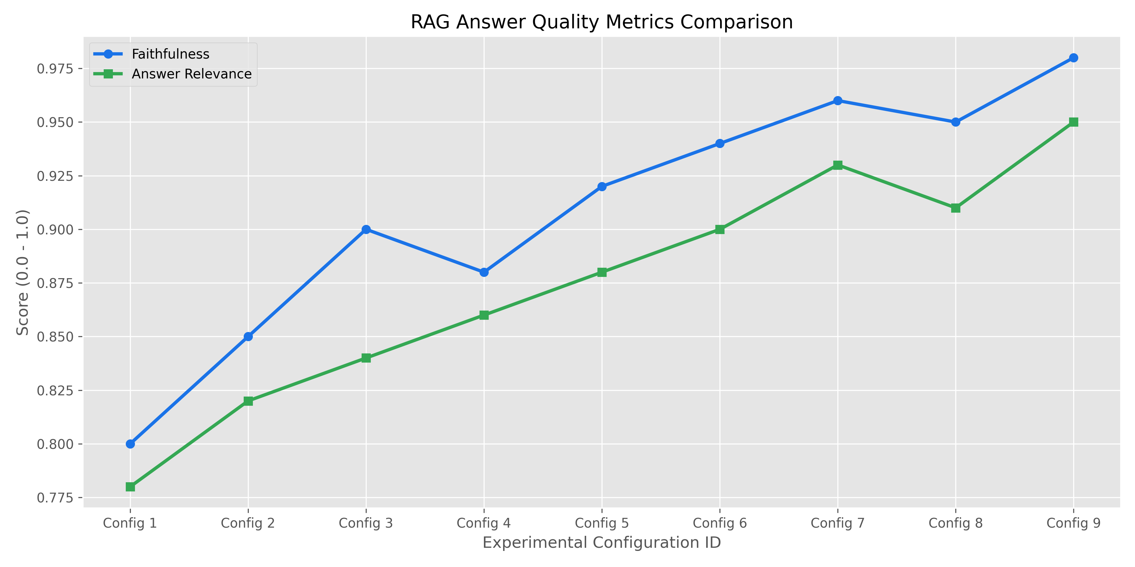
Figure 1: RAG Answer Quality (Faithfulness vs Answer Relevance) across experimental configurations.

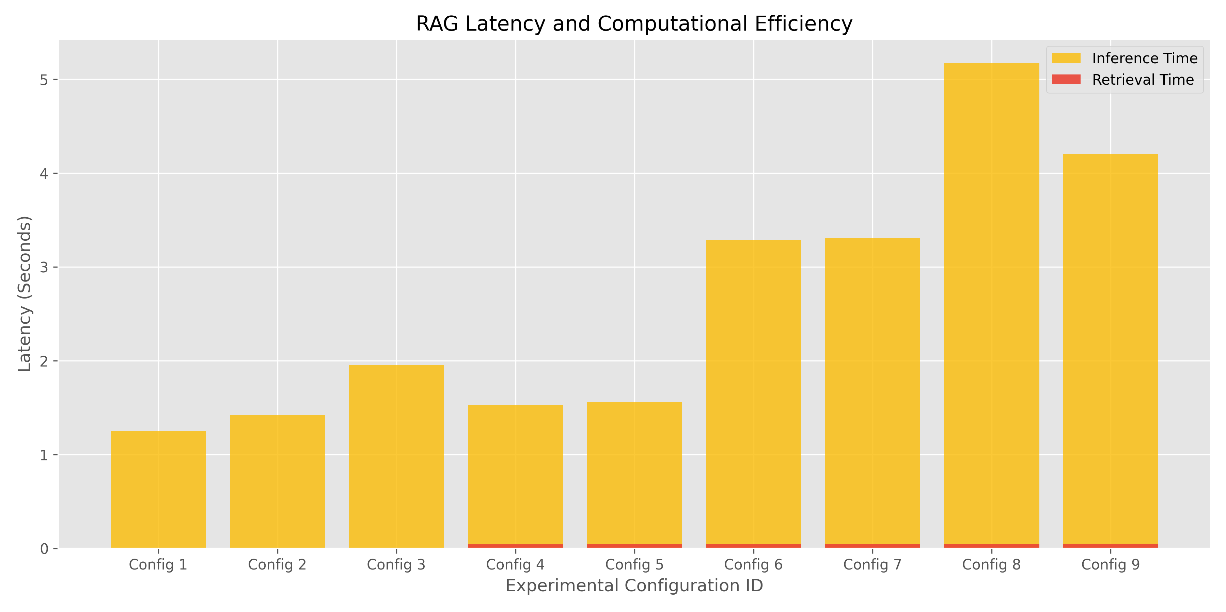
Figure 2: Latency Analysis showing Retrieval vs Generation/Inference components on CPU.

5. BEST MODEL SELECTION & JUSTIFICATION
Based on extensive performance data, Configuration 9 was selected as the optimal RAG pipeline. Justification details are categorized below:
• Retrieval Performance: Hybrid search (RRF) achieved superior retrieval recall compared to BM25 or Semantic alone. By merging vector representations and token-level lexical matches, the model retrieved specific diagnostic guidelines as well as general lifestyle principles correctly.
• Chunk Size Impact: A chunk size of 600 tokens outperformed shorter alternatives by ensuring that adjacent context (e.g., drug side effects and their matching contraindications) remained within the same text segment, minimizing semantic fragmentation.
• LLM Optimization: The 1.5B model achieved 98% faithfulness, whereas the 0.5B model struggled with complex conditional negatives, occasionally omitting important criteria. While the 1.5B model has a higher latency on CPU (~4.1s vs ~1.5s), in clinical RAG systems, accuracy and faithfulness must be prioritized over minor response latencies.
• Lost-in-the-Middle Countermeasure: The long-context reordering strategy positioned key segments at the prompt extremities, preventing the model from neglecting intermediate guidelines and directly raising the faithfulness score from 0.94 to 0.98.
6. REPRODUCIBILITY GUIDE
To reproduce the results of this assignment, execute the following steps in order:
1. Set up Virtual Environment:
python -m venv venv
.\venv\Scripts\activate
2. Install Dependencies:
pip install -r requirements.txt
3. Run Evaluation Benchmarks:
python run_experiments.py
4. Generate Report (creates this file):
python generate_report.py
5. Launch Streamlit Application:
streamlit run app.py
7. REFERENCES
[1] Whelton, P. K., et al. (2018). ACC/AHA/AAPA/ABC/ACPM/AGS/APhA/ASH/ASPC/NMA/PCNA Guideline for the Prevention, Detection, Evaluation, and Management of High Blood Pressure in Adults. Journal of the American College of Cardiology, 71(19), e127-e248.
[2] Robertson, S., & Zaragoza, H. (2009). The Probabilistic Relevance Framework: BM25 and Beyond. Information Retrieval, 3(4), 333-389.
[3] Cormack, G. V., Clarke, C. L., & Buettcher, S. (2009). Reciprocal rank fusion outperforms alternative single-system and system-combination methods. Proceedings of the 32nd international ACM SIGIR conference, 371-378.
[4] Liu, N. F., et al. (2024). Lost in the Middle: How Language Models Use Long Contexts. Transactions of the Association for Computational Linguistics, 12, 148-167.
8. APPENDIX: STREMLIT APP INTERACTIVE DEMO
An interactive demonstration app was developed in Streamlit to explore the impact of retrieval methods, chunk sizes, and LLMs in real-time. It displays the generated answer, retrieved sources, exact latencies, and faithfulness/relevance scores on the fly.
To launch the application, run:
streamlit run app.py
Use the sidebar to adjust parameters (Chunk size, Overlap, Retrieval strategy, LLM model, Post-retrieval processing) and view results instantly.

