* I’ve included my game Cyber Chase! because it was the first game that challenged my artistic skills. Cyber Chase! was created to be both a mobile and a pc game and this greatly altered the art style used for the game. I had to create art that was easy to digest but also intriguing and art that was detailed but not detailed enough to cause headaches due to the fast-paced nature of the game. My team also did a great job with the coding and level-design so I had to create art that would fit the theme and fit the mechanics appropriately.

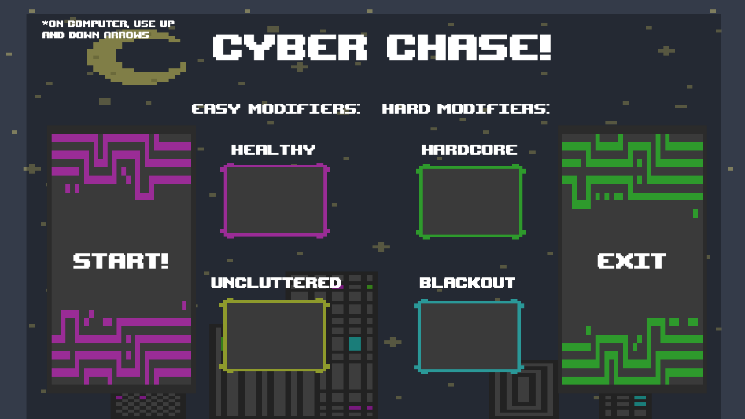

* I included my game Digging Deep because it was my very first game-design group project. Digging Deep is a top-down game, and I created the art for it. The process of creating this game was a first-time experience for me and it really taught me how to communicate and express ideas for mechanics and art. I also chose this game because it was my first time making art for a game. My team also did a great job with organizing the setting and coding which made the game feel unique.

* This game is called A Traveler’s Quest. I’ve chosen this game because it was the first game I created where I was the main coder. I created many new scripts for the game like moving/falling platforms, character teleportation, and ladder climbing. This challenged my coding abilities and helped me understand coding better. My team also did a great job with the art style, level-design, and the overall theme/flow of the game.

* I’ve chosen my essay called The Future of Gaming because I did a great job at finding statistics and citing them. The claim for my essay was that gaming will lean towards pc’s rather than consoles in the future and provided facts to support my claim. I did a great job at organizing the essay’s paragraphs into an order that could be easily understood and I also did a great job with my grammar.

**The Future of Gaming**

The popularity of gaming during the 80's has continued throughout the decades and the gaming industry will continue to expand rapidly throughout future years. Recently there has been a trend with game remasters, remakes, and sequels that has been taking over the market. Gaming will expand and thrive on nostalgia in the future, but it will instead be on PC’s rather than next-gen consoles. This can be supported by the current age demographic of consumers, the statistics of console gaming compared to PC gaming, and the current trend of remastered games.

Age demographic is very important when it comes to what games are popular or best-selling. Although age varies widely in gamers, the leading population of gamers, 38%, are between the ages of 18 to 34 (Branka, 2023). This information is important because if we look at the best-selling games of 2022, we see most of the list is made up of game sequels or games that are part of a series (The NPD Group, 2023). This evidence enforces the idea that people between the ages of 18 and 34 enjoy and invest into new games that they have experienced in their younger years. To add onto this, as years go by, demographics will continue to shift to newer generations which will cause game developers to reconsider what their consumers are most likely to buy.

With little analysis of the statistics of console vs. PC gaming we could be inclined to think that console gaming will win over PC gaming. But if we take into consideration who game developers target their games for, we can see that the future of PC gaming looks brighter than console gaming. While most gamers game on consoles, 60% of developers target PC gaming over console gaming (Branka, 2023). PC gaming is targeted because game developers want maximum profit, but they also want players to experience their games with the highest levels of graphics to show the game’s capabilities. Many PS4 exclusives have been released on PC for this sole reason. If we look at a list of PlayStation exclusives released for PC, we notice that they are games that are meant to be played with high resolution screens (Bowen, 2022). Sony has also stated that they wish to make about 50% of their exclusives available for PC (Bunn, 2022). This information states that game developers want their audience to focus on PC gaming rather than console gaming.

Game remasters, remakes, and sequels have been steadily dominating the gaming industry. With games like: Grand Theft Auto V (2013), Red Dead Redemption 2(2018), and The Last Of Us Part 1(2022) we can see this trend will not be going away soon. In 2021 some of the best-selling games were remasters and remakes (Statt, 2021). This evidence shows that people have a tendency to enjoy games that make them nostalgic and with this information we can predict that future generations will continue this cycle.

To conclude, gaming will continue to flourish throughout the future decades and part of its success will be fueled by nostalgia. Game developers make their consumer base with both graphics and nostalgia, and this is the reason why 60% of game developers choose to prioritize PC gaming and remasters/sequels. PC gaming offers players with the highest quality of graphics and remasters/sequels make the player reminisce about the feeling they had when they first played the original game. This is important because game developers want to get maximum profit and get a loyal consumer base, which PC gaming and remasters both provide. The future of gaming is not concrete but with these facts we can strongly predict that game remasters and PC gaming will definitely become a priority for most game developers.

* The assignment below is a short story I created. This was my first time writing a short story for a game and I did a good job with the introduction of the story. I also did a good job with the suspense, character personalities, and plot. The characters personalities are not the same and create an interesting dynamic. I also did a great job with leaving the story’s end vague which is meant to allow readers to interpret the ending.

The lights appeared out of the darkness. Jackie and Ava are stunned at the sight. There’s an endless forest ahead of them with no signs human life around. The only strange thing about the forest is a path bordered with dim lights. The previous day they were preparing for their band concert and stumbled across a glowing orb that pulled them into an alternate dimension. But they couldn’t remember this, at least not yet.

“Where are we. . . and where did everyone else go?” Ava asks to Jackie.

“I have no clue. Maybe this is like a dream or something. Or maybe we’re in a survival show. . . you know what if the papers we signed for the stage rental were a complete lie and we actually signed up for this instead.” Jackie says in a joking tone. “Nobody reads the forms so it’s entirely possible.”

“Okay stop joking around we need to find someone or something to get us out of here. This path probably leads us where we need to go.”

“Well, I guess we will find out.” Jackie says but knew they are very unlikely to find out. She was starting to remember more about the previous day.

Jackie and Ava start to walk along the path hoping to find answers to where they are. They walk for a mile until they encounter a man with a mask. The mask was dark blue and had black eyes. It resembled a kids Halloween costume. Ava looked at Jackie with concern and then shouted out at the man.

“Hello? We need help! We are lost!”

As soon as the man heard Ava, he started sprinting towards them. He was very tall and fast. The strange man was also carrying a machete that was hidden in his black trench coat.

“Umm Ava why would you do that?” Jackie yelled as they started to run.

Both Ava and Jackie were extremely frightened. They run as fast they could for what feels like hours but is only a couple of minutes. The strange man whistles loudly. It is a whistle that sounds like a cry and attracts more strange people. They come out of the bushes, down from the trees, and almost seem like they appear from thin air. Jackie and Ava are fast, but these people are faster.

Suddenly, Jackie trips on a dried-out tree root and cuts her hand on a sharp stick. Ava notices her and stops to help her up but it is too late. The masked people catch up to them and they are surrounded. There is no escape.

“What do you want from us? We are just lost and mean no harm! Please just let us go! Come on, you seem like reasonable people we just need a couple answers---” Ava exclaimed but was interrupted by a woman that looked like their leader.

“No, we cannot help you, but you can help us.” The woman took of her mask. Jackie and Ava could not believe it. The woman behind the mask was Ava’s sister.”

* I chose my first Pro Builder level because it allowed me to interpret what I learned from blender into unity. There were many changes to how the models worked but I did well with adjusting to the changes. I also did well with the symmetry of the level and with adding more unique parts to the level like some of the obstacles.

