**Hafiza Fatima Sabir 116**

**BSAI-3B**

**Lab_Task_1**

**Tic Tac Toe (Dynamically)**

**Overview**

This is a two-player Python game of Tic Tac Toe.  
Players compete to mark spaces on a 3x3 grid using their assigned symbols (**X** for Player 1 and **O** for Player 2). The first to align three marks in a row, column, or diagonal wins the game.

If all spots are taken without a winner, the match ends in a draw.

**Game Flow:**

**Player Setup**

At the start, the game asks for the names of both players.

* Player 1 is assigned **X**
* Player 2 is assigned **O**  
  Player 1 always begins.

**The Board**

The game board shows positions numbered 1–9:

1 | 2 | 3

---|---|---

4 | 5 | 6

---|---|---

7 | 8 | 9

As moves are made, the numbers are replaced with **X** or **O** depending on the player’s turn.

**Making a Move**

On each turn, the current player enters a number (1–9) to place their symbol.

* If the choice is invalid or the spot is already taken, the player must choose again.
* Valid moves immediately update the board for both players to see.

**Deciding the Winner**

After every move, the game checks all winning combinations:

* Any horizontal row
* Any vertical column
* Either diagonal

If a player forms three in a row, the game declares them the winner and ends immediately.

**Tie Game**

If the board fills completely without any winning line, the game ends in a tie, and players are encouraged to try again.

**Example Run:**

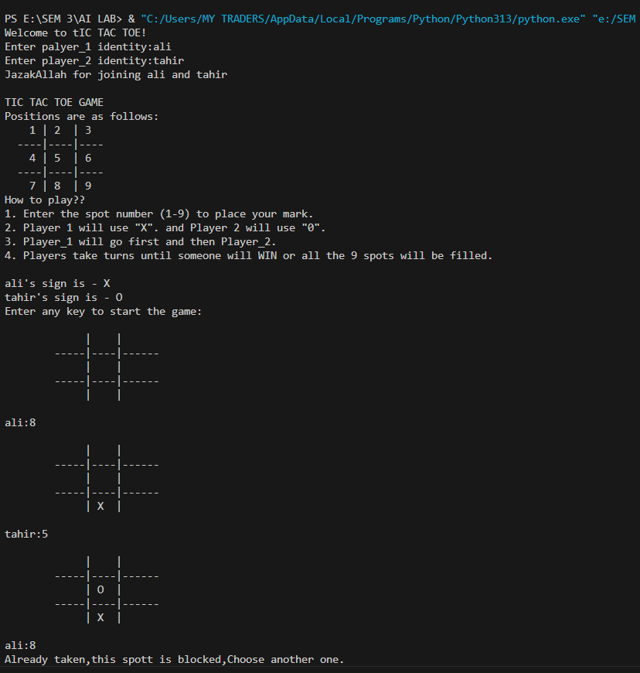

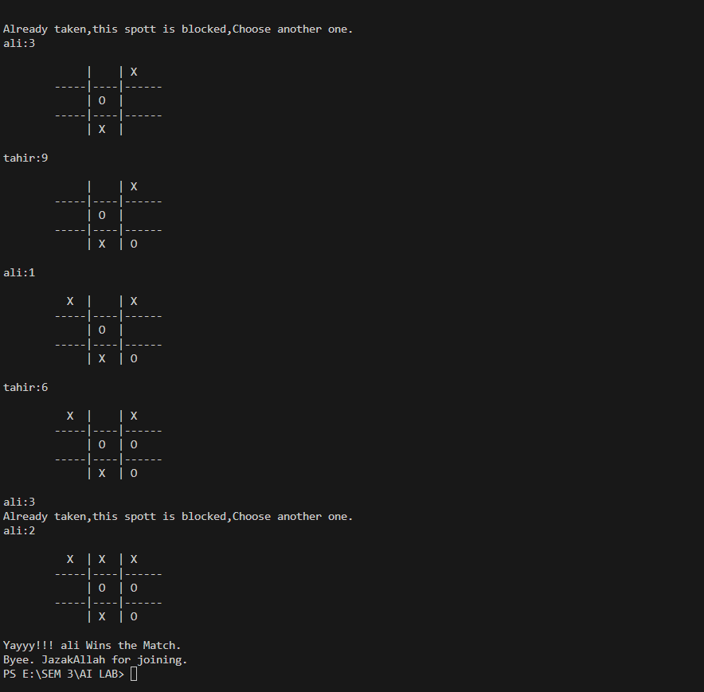

**Features**

* Simple two-player gameplay
* Clear instructions and board display
* Prevents invalid or repeated moves
* Declares winner as soon as conditions are met
* Detects tie when no moves are left