DISEASE SIMULATION
Fundamentals of Programming
Fatima Siraj
22765585
OVERVIEW
Purpose: The purpose of this program is to create a disease simulation through population where the user inputs parameters like the population size, neighborhood type, and the health status rates. The simulation runs through over each timestep (several months) and shows how the disease spreads, how people move, and how the health of the population changes over these several months. The result is displayed as a scatter plot.
IMPLEMENTATION OF THE FUNCTIONS
Function name: UserInputs
This function is implemented for the user to enter the neighbor type and the rates for health status which determines how the disease progresses over time.
Function name: InitializePopulation
This function initializes the population by distributing healthy and infected people by creating grids for each health status by placing 80% healthy and 20% infected people on the grid.
Function name: MovePeople
This function makes people move on the grid. The first and fifth extension from the assignment brief is implemented in this function. Based on the chosen neighborhood type from UserInputs, this function determines how people will move. Additionally, it allows for a chance to move long distances using airports.
Function name: HealthStatus
This function updates the health statues like recovery, death, infected, and immunity based on the rates provided by the user.
Function name: Barriers
This function applies barriers where people cannot move and limits the spread of disease.

Function name: Visualize
This function visualizes the population’s health status at each timestep by using the coordinates of the people and then plots the people represented as dots. Then it adds the title and grid.
Function name: PrintHealthStatus
This function just prints the number of people in each health status.
Function name: Simulation
This function runs the main simulation by calling the other functions by applying barriers to the grid at each timestep moving the people, updating their health status and printing the statistics.

USER GUIDE
Requirements to run the code:
Make sure you have python3 installed.
Make sure you have Anaconda installed.
Alternatively, you can run this code on visual studio code.
Install spyder on anaconda and run the code by clicking the green play button on the top of the screen.
When running the code, enter the neighbor type and the rates for health status and this will display the scatter plot representing the health status of the population on the grid.

TRACEABILITY MATRIX
Feature number | Feature | Code references | Test references | Completion date
1. | Get inputs from user for the neighborhood type, the total population, and rates for the health status | UserInputs | Tested to ensure the function handles valid and invalid inputs effectively | 20/11/24
2. | Initializes the population grid and randomly assigns people as healthy or infected. | InitalizePopulation | Checked if the output displays 80% healthy and 20% infected number of people on the grid | 20/11/24
3. | Moves the people on the grid depending on their current neighborhood type. | MovePeople | Checked if the people move based on the neighborhood type. | 21/11/24
4. | Updates the health status based on the provided rates by the user | HealthStatus | Checked if the health status matches the expected probabilities | 21/11/24
5. | Apply barriers that prevent people from moving | Barriers | Checked if the barrier locations prevent the people to move | 21/11/24
6. | Creates a visual representation of the population’s health status at each timestep | Visualize | Checked if the points, colors, and images are saved. | 22/11/24
7. | Prints the number of people in each health status | PrintHealthStatus | Checked if the plotted points, and colors are displayed correctly. | 22/11/24
8. | Runs the whole disease simulation | Simulation | Ran the simulation with using different inputs and checked if all functions that the function calls work as expected. | 23/11/24

DISCUSSION
Function name: UserInputs
This function prompts the user to input neighborhood type, population, and health status rates for the simulation to progess. It is implemented by using while loops to handle valid and invalid inputs.
Function name: InitalizePopulation
This function initializes the population by randomly assigning healthy people as 80% and infected people as 20% and is implemented by creating empty grids for each health status and places the 80% healthy people and 20% infected people on the grid.
Function name: MovePeople
This function moves people based on their neighborhood types. It is implemented by using if else statements for checking the neighborhood type the user inputs. If the neighborhood type is Moore, people can move in 8 directions in all adjacent cells. If neighborhood type is Von Neumann, people can move in 4 directions like up, down, left, right.
Function name: HealthStatus
This function updates the health status based on infection, recovery, death, and immunity rates the user inputs and is implemented by using the function np.random.binomial which decides the chance of these health changes.
Function name: Barriers
This function applies barriers to prevent people moving through grid cells and is implemented by setting the barriers as grid coordinates.
Function name: Visualize
This function displays a visualized representation of the population’s health at each timesteps with using different types of colors for each for the health status. It is implemented by using matplotlib to create scatter plots.
Function name: PrintHealthStatus
This function prints each health type for the population and is implemented by counting people in each health state, then it prints the results for each time step.
Function name: Simulation
This function runs the whole simulation by calling the functions and updating the number of people’s movement, health, barriers, and statistics for each time step. It is implemented by calling other functions in a loop to simulate the disease spread over time

UML DIAGRAM

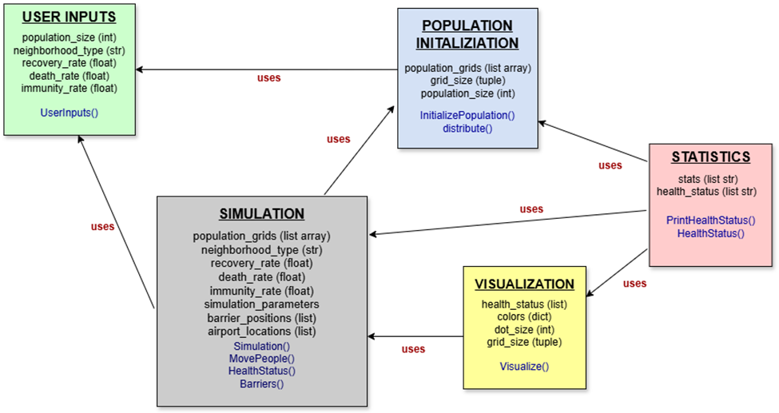

UML diagram:
The arrows represent what each box uses. (what each box is dependent on)
For example, Simulation uses User input and Population initialization for receiving parameters to run the simulation and set the initial population grid.
The blue text represents the functions (methods) and the black text represents the attributes.

SHOWCASE
INTRODUCTION
In this assignment, I have implemented 8 functions to create the simulation through a population on a grid where I adjusted different parameters. This simulation runs with two different neighborhood type like Moore or Von Neumann and rates for the health status.
To run this simulation, the user would have to enter the total population, the two neighborhood type, and provide the health status rate like recovery, death, infected, and immunity.
The output will then run a number of timesteps to 19 and will give a visualized scatter plot representing the health status for the population.
Health status of the people represented as colors in the scatter plot:
Color key: Infected: red, healthy: blue, recovered: purple, dead: black, immune green

The main command to run the simulation:
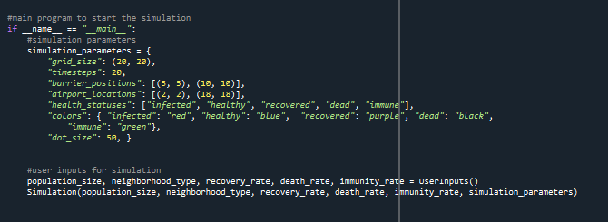

Scenario 1: User inputs high death rate and low recovery
User Inputs: Population: 300 Neighborhood type: Von Neumann Recovery: 0.05
Death rate: 0.3 Immunity: 0.1
Output at month 0 (start of simulation): Infected: 45, Healthy: 239 Recovered:2, Dead:13, Immune: 0
Month 10: Infected: 2, Healthy: 225, Recovered: 4, Dead:48, Immune:3
Month 19: Infected: 0, Healthy: 218, Recovered: 1, Dead:50, Immune:6
Population health status at month 0 (initially)
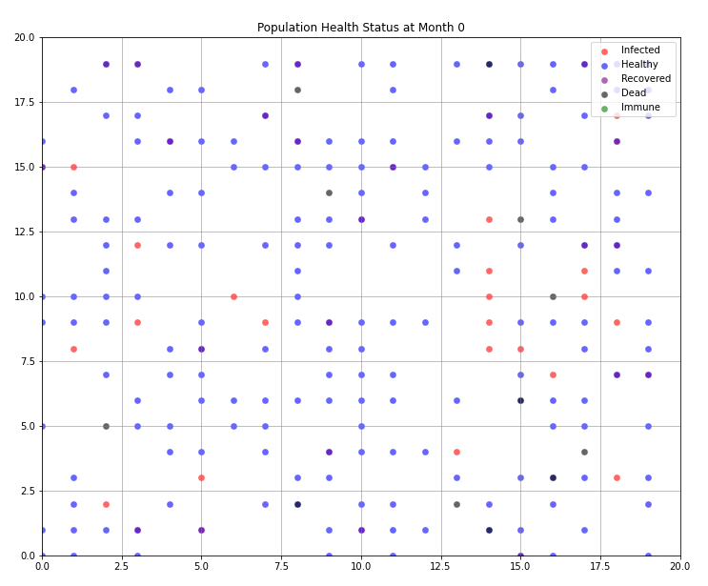
This plot shows large number of healthy people. It also shows people with infections spreading quickly due to the low recovery rate. Deaths increase with each timestep (month) due to the high rate of deaths.

Population health status at month 10:
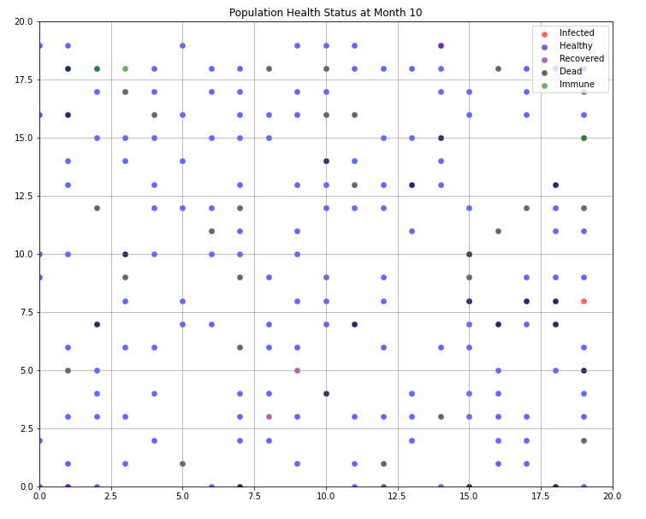
At month 10, the number of infected people has dropped as these people either died or recovered. The death rate has increased by 48 due to the high rate of death. Very few of the recovered people have become immune due to the low rate of immunity.
Population health status at month 19:
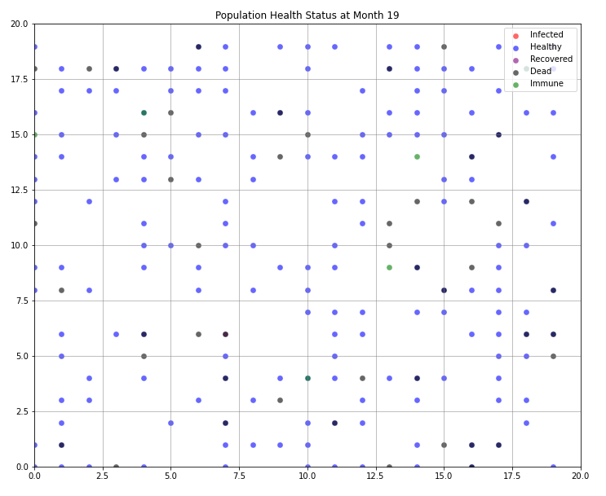
No more infected people shown, as the disease has mostly run so most of them died or recovered. The health population decreased as many healthy people got infected earlier. Only a few people recovered and few have become immune after recovery. Additionally, the number of deaths increased.
Scenario 2: User inputs high immunity with fast recovery
User inputs: Population: 150
Neighborhood type: Moore
Recovery: 0.3
Death rate: 0.05
Immunity: 0.5
Output at month 0 (start of simulation): Infected:16, Healthy:120, Recovered:8, Dead:1, Immune:4
Month 10: Infected: 1, Healthy: 117, Recovered: 0, Dead:3, Immune: 25
Month 19 (end of simulation): Infected: 0, Healthy: 114, Recovered: 0, Dead:3, Immune:24

Population health status at month 0:
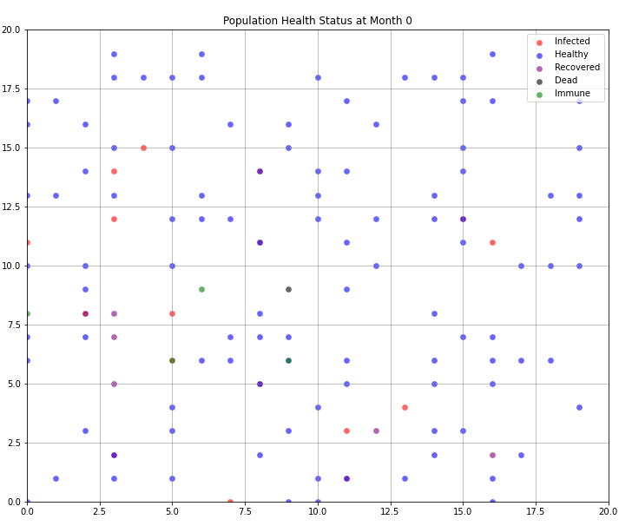
Disease just started, so only 16 people infected in the population and most of the people are still healthy. A few people have already recovered and become immune already due to the fast recovery rate. Additionally, only one died.

Population health status at month 10:
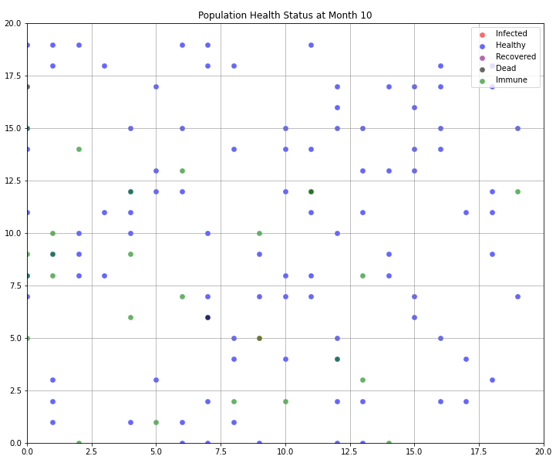
The number of infected people decreased. 0 recovery as people have recovered earlier due to fast recovery. Due to the high rate of immunity, a large number of people have become immune.
Population health status at month 19:
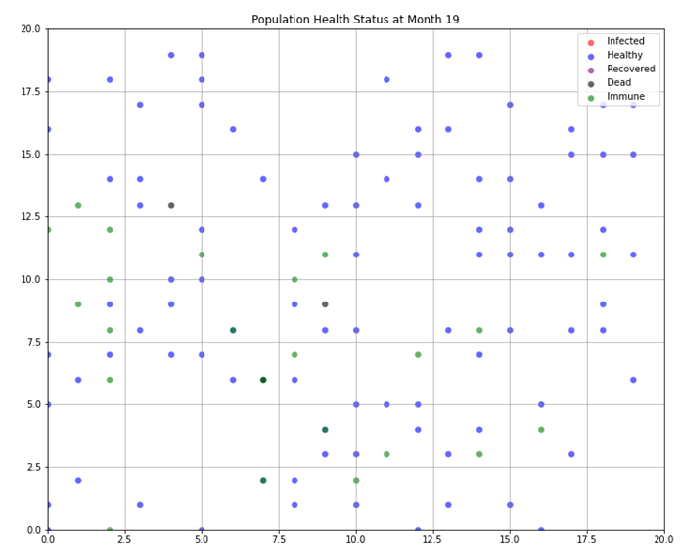
As this is the end of simulation, there are no more infected people as the rate was high for recovery and immunity so everyone either recovered or became immune. The number of healthy people have remained the people and the number of immune people have increased due to the high immunity rate.
Scenario 3: User inputs low immunity rate and slow recovery rate
User inputs: Population: 150
Neighborhood type: Von Neumann
Recovery: 0.1
Death rate: 0.1
Immunity: 0.05
Output at month 0 (start of simulation): Infected:34, Healthy:158, Recovered:5, Dead:1, Immune:0
Month 10: Infected:2, Healthy: 151, Recovered: 18, Dead:12, Immune: 8
Month 19 (end of simulation): Infected: 0, Healthy: 150, Recovered: 11, Dead:13, Immune:14

Population health status at month 0:
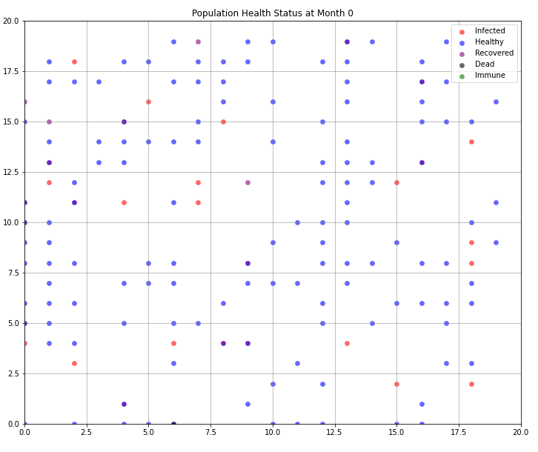
At the start of the simulation, 34 people were infected and 158 people were healthy. As the recovery rate is 10% there are only 5 people recovered so it will take time for people to recover. At the start only individual died and no one has immune yet.

Population health status at month 10:
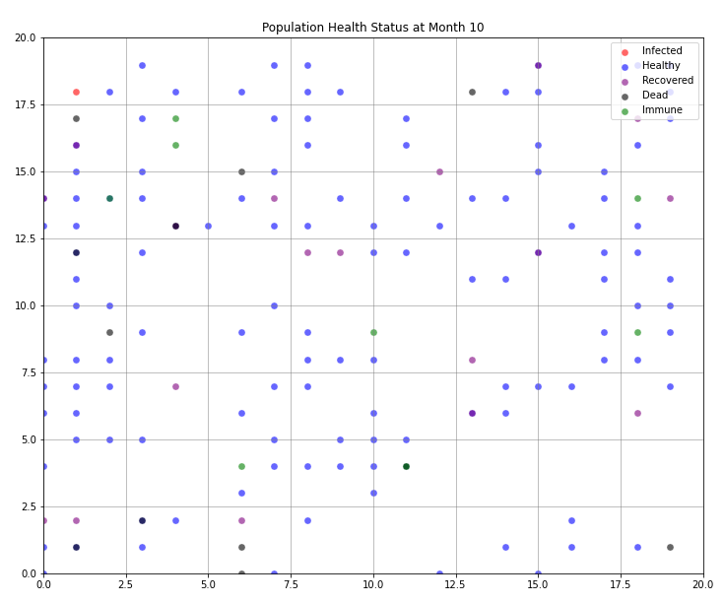
This is the middle of the simulation, where the number of people infected has dropped significantly and the number of recovered people has increased. Only 10 people recovered till this time as the recovery rate is slow. The number of deaths has increased to 12 due to the 10% death rate. Due to the rate of immunity as 5%, 8 people have gained immunity this may be from surviving the infection.
Population health status at month 19:
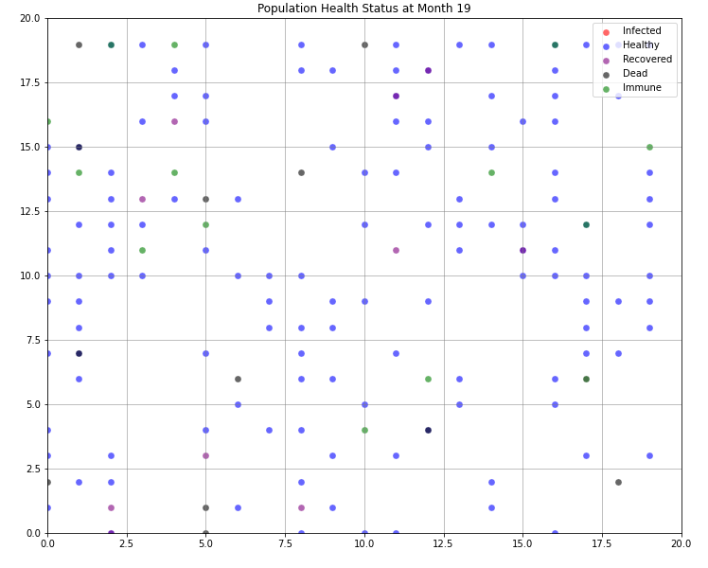
No new infections have occurred by the end of simulation and the number of people recovered has slightly increased as the recovery rate is low. 13 people have died by this time as the death rate 10% has caused a small increase in the number of deaths. 14 people have become immune by the end of simulation. This is a slight increase due to the slow rate of immunity.
CONCLUSION
Overall, in this assignment I created a disease spread simulation through a population with different health status which was represented through a visualized scatter plot. This simulation allows users to input parameters like health status rates, neighborhood type, and number of population and then this program visualizes the population’s health status which is represented in a scatter plot. The scatter plot presents the health status of people during 19 months of time.

FUTURE WORK
In future work, I believe there are more features that can be improved through using exceptional error handling when implementing functions to avoid any unexpected issues when running the simulation. Additionally, by creating a visual bar chart to represent the statistics of health status which can make it easier for users to understand.

REFERENCES
Curtin University. (2024). COMP1005 –Fundamentals of Programming Topic 6.
Curtin University. (2024). COMP1005 –Fundamentals of Programming Topic 7.
JGraph Ltd. (n.d.). draw.io. Draw.io. https://www.drawio.com/

