

**Department of**

**Computer Science and Engineering**

**Lab Report - 07**

Course No. : CSE-308

Course Title : System Analysis and Design Laboratory

Submitted By :

Name : 1 . Tasmim Sultana(129)

2 . Fatama Jannat Tisha (131)

3 . Kamelia Zaman Moon (299)

4 .Umma Salma (302)

5 . Sabrina Afrin Toma (304)

Session : 2017-18

Semester : 3rd year 1st Semester

Date : 19-07-2020

Submitted To :

Md Musfique Anwar

Associate Professor , Department of Computer Science and Engineering

Dr. Md Humayun Kabir

Professor , Department of Computer Science and Engineering

Jahangirnagar University, Savar

**Experiment No.:** 07

**Title:** Data Flow Diagram Level 0 and Level 1 for Online Class & Examination System.

**Objective:** To create data flow diagram level 0 and level 1 for selected project.

**Procedure:**

1. **Data Flow Diagram Level 0:**
   1. We open a tool to create the DFD level 0 diagram.
   2. We identify what the system and entities will be.
   3. We link between the system and entities.
   4. We name the connections for the actions if needed.
   5. **Diagram:**

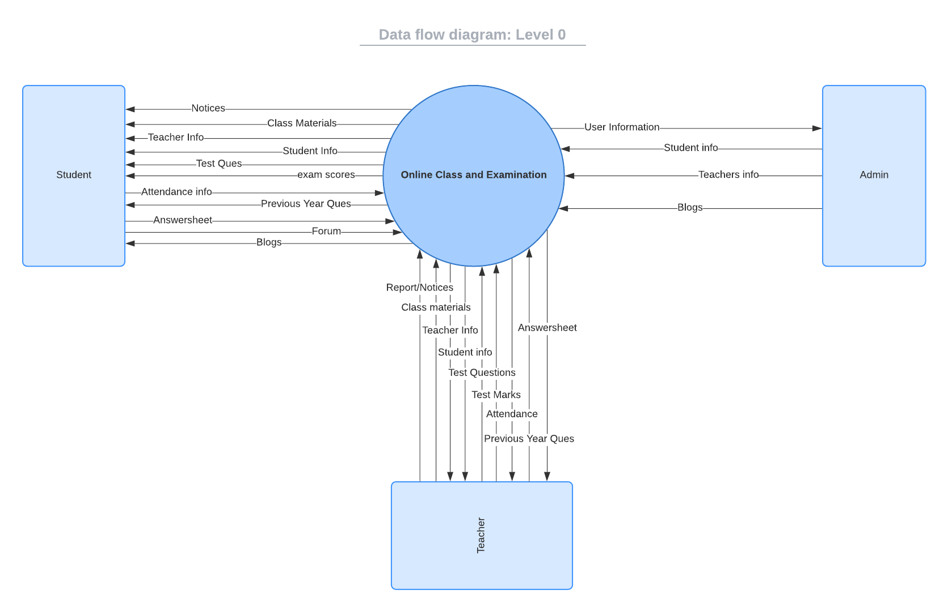

1. **Data Flow Diagram Level 1:**
   1. We open a tool to create the DFD level 1 diagram.
   2. We identify what the entities, methods and data storage will be.
   3. We link between the entities and methods. Also methods and data storages.
   4. **Diagram:**

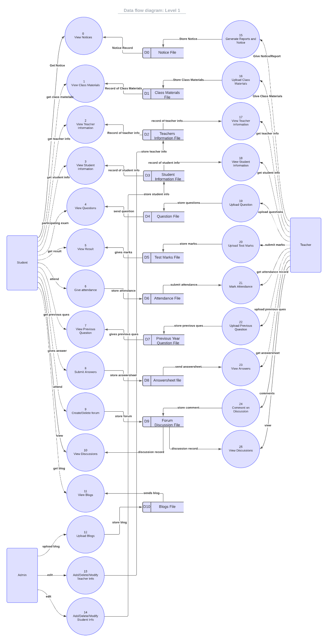

**Discussion:** From this project we got to learn about data flow diagram level 0 and level 1. DFD level 0 reflects an abstraction view, showing the system as a single process with its relationship to external entities. It represents the entire system as a single bubble with input and output data indicated by incoming/outgoing arrows. In DFD level 1, there are the main functions of the system and break down the high-level process of 0-level DFD into subprocesses.