

**Department of**

**Computer Science and Engineering**

**Lab Report - 08**

Course No. : CSE-308

Course Title : System Analysis and Design Laboratory

Submitted By :

Name : 1 . Tasmim Sultana(129)

2 . Fatama Jannat Tisha (131)

3 . Kamelia Zaman Moon (299)

4 .Umma Salma (302)

5 . Sabrina Afrin Toma (304)

Session : 2017-18

Semester : 3rd year 1st Semester

Date : 18-4-2021

Submitted To :

Md Musfique Anwar

Associate Professor , Department of Computer Science and Engineering

Dr. Md Humayun Kabir

Professor , Department of Computer Science and Engineering

Jahangirnagar University, Savar

**Experiment No.:** 08

**Title:** Data Processing Subsystem & Management Information System

**Objective:** To get an idea about how the Management Information System(MIS) obtains data from the Data Processing Subsystem. To identify subsystem databases. To identify subsystems and modules.

**Procedure:**

1. We determine which are the subsystem and processing systems for our project.

2. We determine which the modules are.

3. Then we connect processes to the modules.

**Diagram**

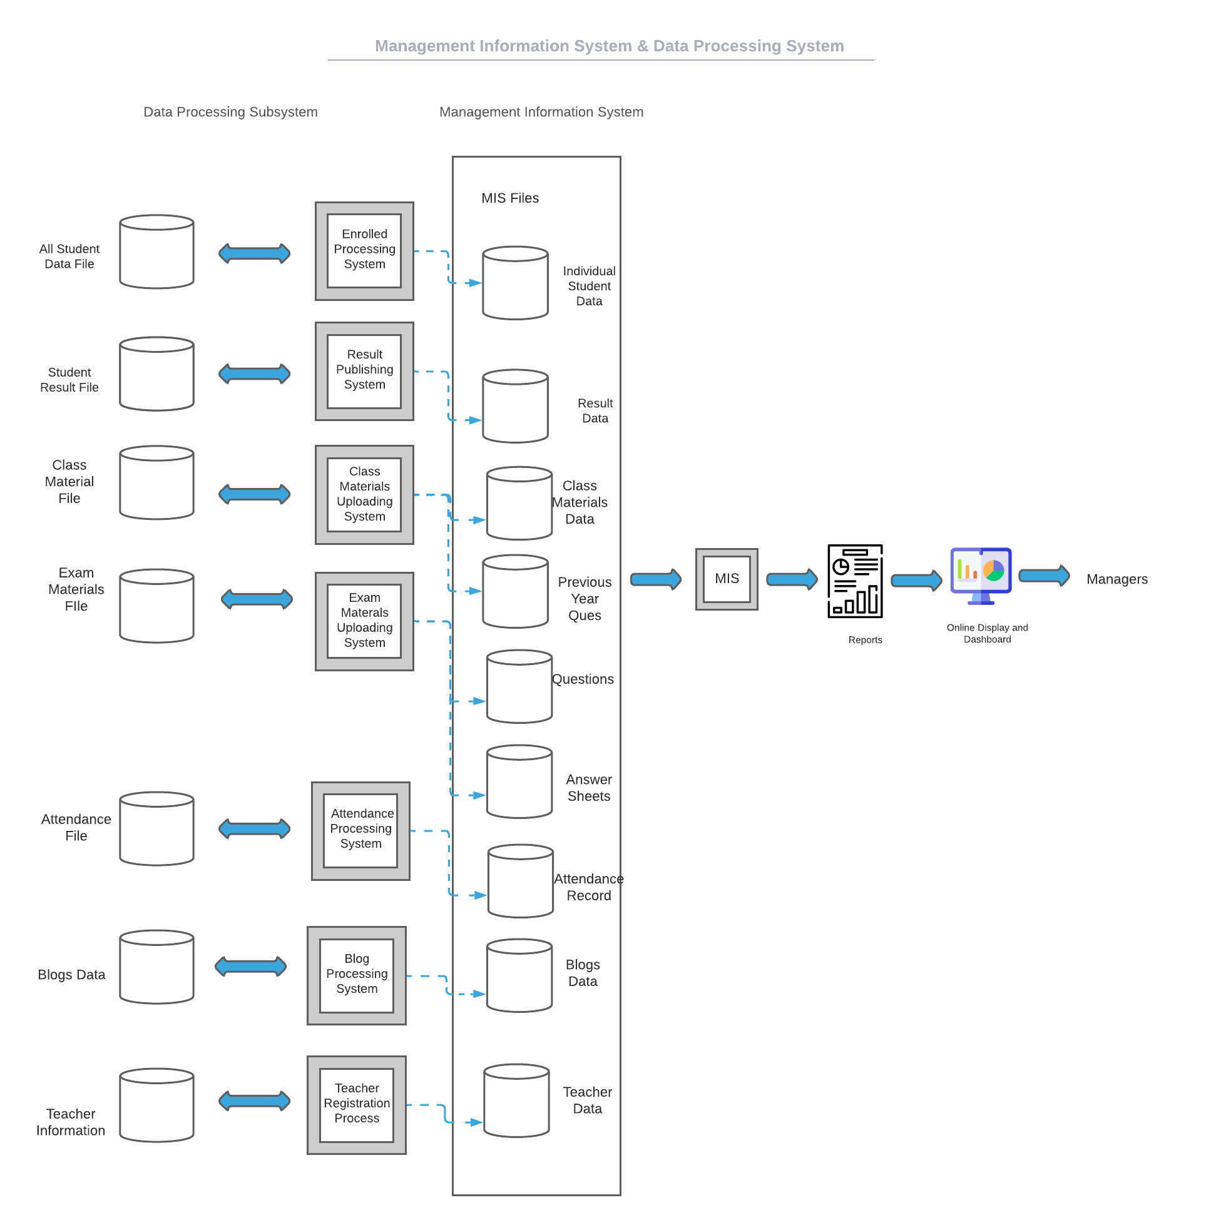

**Discussion:** The term management information systems (MIS) designates a specific category of information systems serving management-level functions. Management information systems (MIS) serve the management level of the organization, providing managers with reports and often online access to the organization’s current performance and historical records. Typically, MIS are oriented almost exclusively to internal, not environmental or external, events. MIS primarily serve the functions of planning, controlling, and decision making at the management level. Generally, they depend on underlying transaction processing systems for their data.

          MIS summarize and report on the company’s basic operations. The basic transaction data from TPS are compressed and are usually presented in long reports that are produced on a regular schedule.