

**Department of**

**Computer Science and Engineering**

**Lab Report - 09**

Course No. : CSE-308

Course Title : System Analysis and Design Laboratory

Submitted By :

Name : 1 . Tasmim Sultana(129)

2 . Fatama Jannat Tisha (131)

3 . Kamelia Zaman Moon (299)

4 .Umma Salma (302)

5 . Sabrina Afrin Toma (304)

Session : 2017-18

Semester : 3rd year 1st Semester

Date : 19-07-2020

Submitted To :

Md Musfique Anwar

Associate Professor, Department of Computer Science and Engineering

Dr. Md Humayun Kabir

Professor, Department of Computer Science and Engineering

Jahangirnagar University, Savar

**Experiment No.:** 09

**Title:** Network flow diagram for Online Class & Examination System.

**Objective:**  To create a network flow diagram for the selected project.

**Procedure:**

1. Internet service providers mainly provide the connection to the internet and server.

2. The Internet service provider is connected to the corporate wired LAN, Clients, Wireless LAN.

3. ISP provides Ethernet which is connected with Hub.

4. The Internet is connected to a wireless ISP and a Mobile Wi-FI network.

5. Modem is connected with Wireless LAN and gateway.

6. Router is connected to a wireless LAN and switch.

**Diagram**

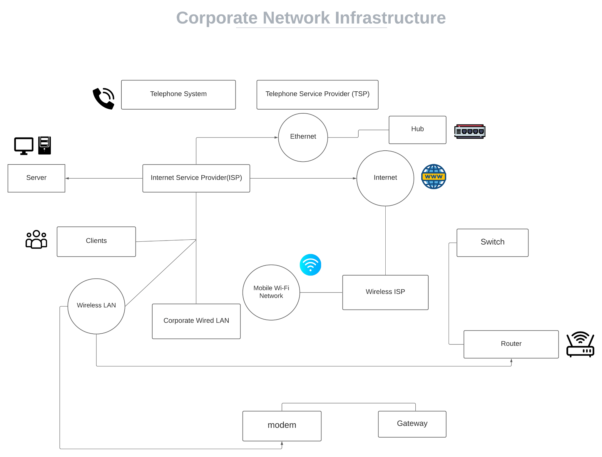

**Discussion:** Network infrastructure refers to all of the resources of a network that make network or internet connectivity, management, business operations, and communication possible. Network infrastructure comprises hardware and software, systems and devices, and it enables computing and communication between users, services, applications, and processes. Anything involved in the network, from servers to wireless routers, comes together to make up a system’s network infrastructure. Network infrastructure allows for effective communication and service between users, applications, services, devices, and so forth.