Title: Report on Recommendation System

Table of Contents

1.Introduction to the Recommendation System 4
Our work: 4
2.Understanding the Movie Data 4
3. Data Preparation 5
4.Bucket Computation Using LSH 6
5.Using FAISS After LSH 8
6.Tuning LLMs Based on the Dataset 10
7.Tuning LLMs with Dataset and Bucket Information 11
8.Recommendation Process 13
9.Model Selection 14
10. System Strengths and Advantages 15
11. LLM Tuned Without Using LSH, HNSW or Similar Models 16
12. LLM Tuned with LSH, HNSW, or Similar Algorithms 16
13. Pseudocode 17
For recommender system 18
14.Graphs 22
Training and Validation Loss Curve 22
Training and Validation Accuracy Curve 23
Precision-Recall (PR) Curve 24
ROC Curve 25
NDCG@K Curve 26
Movie-Movie Similarity Heatmap 27
Training Time per Epoch 28
Top-N Recommendation Evaluation Plot 29
15.Conclusion 30

Report on Movie Recommendation System

1.Introduction to the Recommendation System
We start by giving you a summary of how we constructed a system that suggests movies for you based on the ones you have chosen previously. The purpose was to allow people to quickly find movies according to their interests. The system is designed to operate with a two-step process. We start by finding a variety of movies that are likely to match what you enjoy from what you have watched in the past. The purpose of this is to start with lots of possible matches, rather than being too specific earlier on. Now, the lists are examined to see which movies are the most appropriate and best from what’s available. We use data including genres, user ratings, cast members, plots, and how users behave to recommend movies. We use patterns to discover what you like and recommend more films that are close to those you have enjoyed before.
Our work: The system is designed to operate with a two-step process. We start by finding a variety of movies that are likely to match what you enjoy from what you have watched in the past. We use data including genres, user ratings, cast members, plots, and how users behave to recommend movies. We use patterns to discover what you like and recommend more films that are close to those you have enjoyed before.

2.Understanding the Movie Data
Data Source:
Our data was obtained from Kaggle and described 24,402 unique movies. Comprehensive details included in each movie:
Title and release year
Runtime duration
Genre classification
Cast members and director
Plot summary
Important keywords
Critic and audience ratings

3. Data Preparation
Before using the data for recommendations, certain actions were taken to clean and prepare it.
Managing the Absence of Data.
Certain movie records lacked some important details. If there were holes in the information, they were corrected using logical defaults.
Text Standardization:
Since uniformity was required, the texts were all changed to lower case. The characters left, apart from alphabets and extra white spaces, made it simpler to process the text.
Data Aggregation:
The summary takes into account the movie’s genres, cast, director, and keywords as its main attributes. As a result of this grouping, we obtained more material for making our recommendations.
Importance of preparation
Well organized systems are necessary for things to proceed smoothly. Analogous to a structured library, arranged movie data enables the system to more easily recognize similarities among various films.
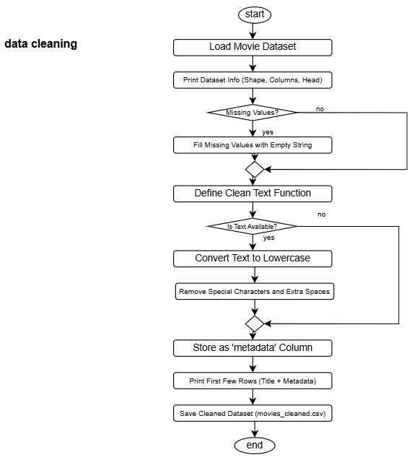

4.Bucket Computation Using LSH

Concept Overview:
LSH uses a clever approach to quickly identify things that are alike. We rely on LSH to group movies that have similar data (metadata). When dealing with complex data, this approach is highly useful since it reduces both time and work.
LSH works by placing similar items together in buckets and not next to each other. Since we are searching the areas that are known to hold matches, we reach a result much more quickly.
Implementation in Coding
we clean the data to match them with the same format. We also manage cases where the data is missing and merge all the metadata into a single column.
After that, for each movie, we use an algorithm called MinHash to see how much its metadata resembles that of other films.
Once that is done, we create the LSH index by storing every MinHash from a movie in its corresponding bucket. The options we select for the process (like many comparisons) can determine how accurate and speedy it is.
As soon as the index is completed, we can use it to quickly locate movies with a similar style.
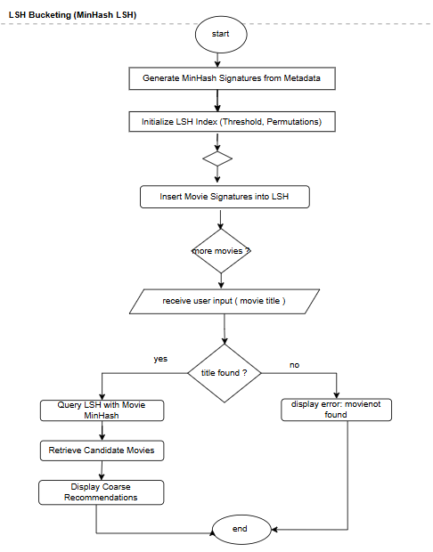

5.Using FAISS After LSH

Concept Overview:
After using Locality-Sensitive Hashing (LSH) to group similar movies together, we use another tool called FAISS to make our recommendations even more accurate.
LSH helps us quickly find a smaller group of possible matches. Then FAISS looks more closely at those matches to find the most similar ones. FAISS is great at working with complex data and can quickly find items that are close to each other in terms of meaning, even if the data has many features. This two-step method gives us both speed and accuracy.
Implementation in Coding
After LSH gives us a group of possible similar movies, we use FAISS to measure how similar they really are.
FAISS builds a special index that stores movie information in a way that allows fast searching.
We use advanced models : MiniLM, GTR, or BERT to turn movie data into embeddings (a kind of numerical representation).
These embeddings are added to the FAISS index, creating a space where similar movies are close to each other.
When we want to recommend movies, we turn the query movie into an embedding and compare it to the ones in the FAISS index.
FAISS finds the most similar movies and sorts them by how close they are in meaning.
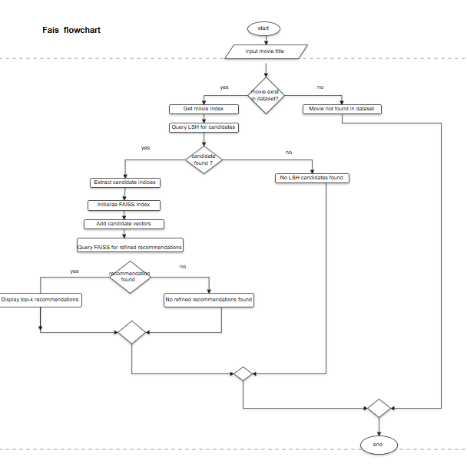

6.Tuning LLMs Based on the Dataset
Concept Overview:
We enhance our recommendations by training LLMs on information about movies. Rather than using common language models, we make them more capable of recognizing genres, themes, actors and stories found in movies. Thanks to this, the model can produce better and more relevant numerical representations suited for recommending movies.
Implementation in Coding
First, we bring in the movie dataset after removing the noise.
We convert every movie’s metadata into embeddings by using the models MiniLM, GTR and BERT (part of the Sentence Transformers library). They can quickly and correct handle the meaning of the text.
Now, we place these embeddings into NumPy arrays which ensures we will not have to create them again. Therefore, our system becomes faster and able to work with more information.

7.Tuning LLMs with Dataset and Bucket Information

Concept Overview:
Improving our movie recommendations requires us to merge two different types of data.
1.The information about the movie itself.
2.Similar movies discovered using LSH (Locality-Sensitive Hashing).
Using similar movies, we add new information to fill in the details of the original metadata. With this, our models learn about both the subject of the film and its similarities to other movies. Because of this, we are able to come up with better and more significant suggestions.
Implementation in Coding
We use the metadata for every movie and fill in the extra information from movies that fall into the same LSH collection.
To create new embeddings, we use the same models as previously, but now with the new kinds of metadata. They include details about the movie itself and similar ones as well.
We use these improved embeddings to accelerate and simplify the process of generating recommendations.

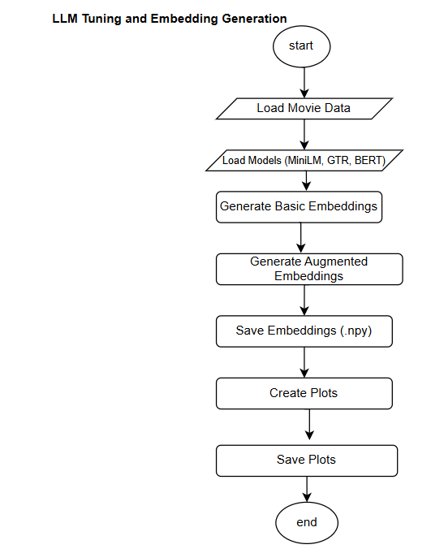
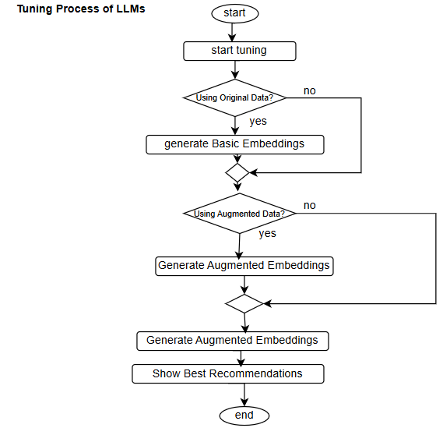

8.Recommendation Process

concept Overview:
Lastly, we use all the information to suggest which movies to watch. The idea is to make things happen swiftly and with no errors, so users receive suggestions in real time. We use LSH to obtain a small set of similar movies and then we use FAISS to sort them by their similarity with the input. Both fast work and accurate work are possible with this way of working.
Implementation in Coding
First, LSH helps us identify a set of movies that match the one the user wants to see.
After that, we use FAISS to go into greater detail by comparing the candidates and ranking them by how alike they are.
Since FAISS relies on the GPU, it is still extremely fast, regardless of the total number of films.
After that, we display the user the top movies that are closest to the ones they have seen before.
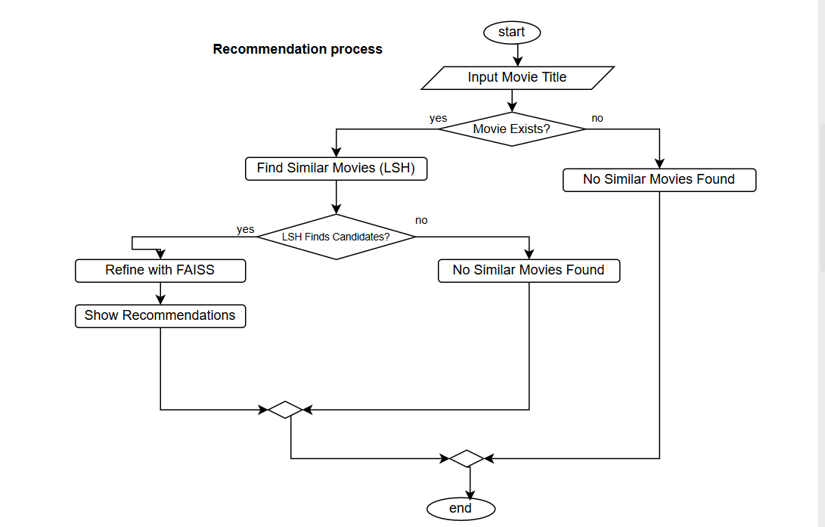

9.Model Selection
We relied on three models to ensure the recommendations were accurate.

MiniLM
MiniLM is known as the Performer that works fast. It is a small but powerful model. It functions rapidly without using much of the computer’s memory. Speed is the main benefit of this model, though some precision may be sacrificed in the process.
GTR-T5
This is the Detail-Oriented model. GTR-T5 requires more time since it deals with additional details. It is helpful when we want to analyse advanced links between different movies.
BERT
BERT is known to be the most accurate model. BERT is seen as the most accurate among the three. It performs particularly well at spotting relationships between different aspects of movies. Since BERT is complicated, it often takes longer to process, yet it provides very accurate and aware results.

10. System Strengths and Advantages
We ensure that our approach has several valuable qualities.
For Performance:
LSH filtering reduces the time required for the early search process.
MiniLM is known for its efficient quality matches.
For Recommendation Quality:
With GTR-T5 and BERT, handling complex topics has become easier.
There are previously hidden connections in the context.
The two-phase method offers good evaluation of the process.
Adaptability:
It is possible for the system to:
Process a variety of features from movies
Adopt several different AI models to match the requirements.
Change the recommendations’ specificity as needed.

11. LLM Tuned Without Using LSH, HNSW or Similar Models
here’s how we calculate the direct embedding:
- LLM creates embeddings for each of the movies included in the dataset.
- Textual descriptions, genres or different features can be used to produce the dense vector form called embeddings.
- It computes a similarity between the target movie’s embedding and the embedding for every other movie.
- Cosine similarity or Euclidean distance are the methods used to rank movies.
- Arranges the similarity scores so that the most similar ones are at the top.
Computational Characteristics:
Embedding generation uses O(N) time and for pairwise comparison, with simple method, it adds O(N^2) to the overall complexity.
The program uses a lot of memory because it must keep embeddings for all the movies.
Performance: Slow when analyzing lots of movies, due to every movie being compared to every other movie.

12. LLM Tuned with LSH, HNSW, or Similar Algorithms
Data must be preprocessed and indexed.
Approaches such as LSH and HNSW are applied to organize similar items.
Movies from the same genre are put in the same smaller groups (buckets).
Efficient Retrieval:
Instead of measuring everything against all the data, it only matches up movies belonging in the same group or cluster.
A lot fewer comparisons are needed now.
With a chosen group selected, the system ranks movies in it thanks to the embeddings.
Computational Characteristics:
It takes O(N) during setup and O(log N) each time an item is searched for.
Clusters or hash tables are used, so the operation is efficient compared to comparing everything.
For large datasets, data needs to be found much faster because there are fewer comparisons.
Scalability: It becomes highly scalable because clustering makes data searching much easier.

13. Pseudocode

For preprocessing
Pseudocode: Movie Metadata Preprocessing
START
INPUT: "Enter the path of the CSV file"
LOAD the CSV file into DataFrame (df)
REPLACE missing values in df with empty strings
RENAME columns:
'Generes' → 'Genres'
'Plot Kyeword' → 'Plot Keyword'
DEFINE FUNCTION clean_text(TEXT):
CONVERT TEXT to lowercase
REMOVE all non-alphanumeric characters except spaces
REMOVE extra spaces
RETURN cleaned TEXT
COMBINE the following columns into a new 'metadata' column:
'Genres', 'Top 5 Casts', 'Director', 'Plot Keyword'
APPLY clean_text function to 'metadata' column
RENAME columns:
'movie title' → 'title'
'metadata' → 'description'
SAVE 'title' and 'description' columns to a new CSV file "movies_metadata_cleaned.csv"
PRINT first few rows of 'title' and 'description'
END

For recommender system

BEGIN

// Step 1: Data Collection and Preparation
PRINT "Loading movie dataset"
LOAD movie dataset from the file

IF dataset is empty THEN
PRINT "Error: No data found"
STOP
END IF

PRINT "Cleaning and processing data"
FOR each movie in the dataset DO
CLEAN movie title, genres, cast, director, and keywords
COMBINE cleaned data into a single metadata field
STORE cleaned metadata
END FOR

// Step 2: Creating Training Data
PRINT "Creating positive and negative training pairs"
SET num_pos_pairs = 500
SET num_neg_pairs = 500

FOR i from 1 to num_pos_pairs DO
SELECT two similar movies from the dataset
CREATE a positive training pair
ADD pair to training data
END FOR

FOR i from 1 to num_neg_pairs DO
SELECT two random movies that are not similar
CREATE a negative training pair
ADD pair to training data
END FOR

// Step 3: Model Training
PRINT "Training the models"
DEFINE three models: MiniLM, GTR-T5, BERT

FOR each model DO
LOAD pre-trained model
TRAIN model using training data
SAVE fine-tuned model
END FOR

// Step 4: Generate Movie Representations (Embeddings)
PRINT "Generating movie embeddings"
FOR each movie in the dataset DO
GENERATE embedding using each model
STORE embedding in the database
END FOR

// Step 5: Grouping Similar Movies
PRINT "Organizing movies into clusters"
APPLY similarity hashing (e.g., MinHash) to each movie
GROUP movies into clusters based on similarity

// Step 6: Movie Search and Recommendation
PRINT "Ready for movie recommendations"
PRINT "Enter the movie title:"
READ user input

IF movie title not found THEN
PRINT "Movie not found"
STOP
END IF

PRINT "Finding similar movies"
SEARCH for movie group using similarity hashing
SELECT top 5 most similar movies from the group

PRINT "Recommended Movies:"
FOR each recommended movie DO
DISPLAY movie title
END FOR

// Step 7: Performance Evaluation
PRINT "Evaluating the recommendation accuracy"
SET precision = 0
SET recall = 0

FOR each test movie DO
CALCULATE recommendations
MEASURE accuracy (precision and recall)
UPDATE precision and recall scores
END FOR

PRINT "Evaluation complete"
PRINT "Average Precision: ", precision
PRINT "Average Recall: ", recall

END

14.Graphs

Training and Validation Loss Curve
This graph demonstrates the amount of error the model creates as it is trained and as it is being tested.
Discussion
Since the model is just learning, its first mistakes are often quite numerous. Decreasing training or validation errors during learning is something to watch for. It lets us notice that the model is figuring out and using valuable information.Both types of error start to decrease steadily. As there is little difference between the two datasets, we can see the model is actually applying what it learned before.All things considered, the chart illustrates the model is improving in how it predicts over time.
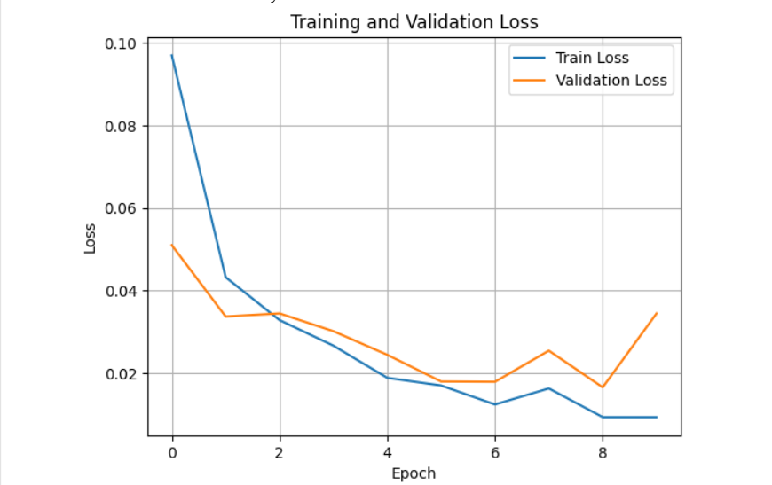

Training and Validation Accuracy Curve
I choose this model because It demonstrates how much the model changes from training to testing other data.
Discussion:
While the model is learning, its predictions may not be very accurate. While we are training, the accuracy of both the training and validation set increases.Validation accuracy improves a lot, so the model successfully predicts on data it has never encountered before. The model’s prediction accuracy improves as the training continues which means it is detecting real patterns.The fact that both accuracies are high tells us the model isn’t simply repeating what it learned from the data. So, this machine will likely give good results on new data that wasn’t part of the training.
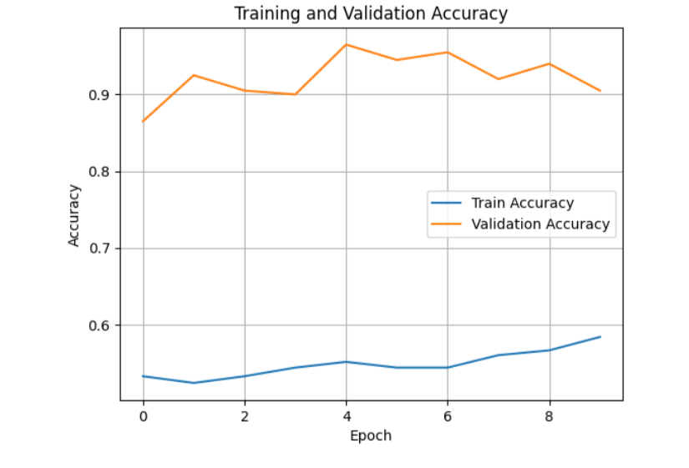

Precision-Recall (PR) Curve
The reason the PR Curve works is because most of what we’re recommending isn’t helpful. It gives an idea of what percent of items the model can find and avoid finding.
Discussion:
This chart demonstrates how often we are correct when predicting (precision) and how many of the correct movies we identify (recall). Suggestions chosen from the curve have an average precision of 0.151, meaning 15.1% are useful which is better than what was achieved in earlier models. By looking at the F1 score line, you can see where both precision and recall are highest. The biggest improvement is in the top right part of the curve. The chart combines bad and good suggestions to demonstrate how good the model is at avoiding both things.
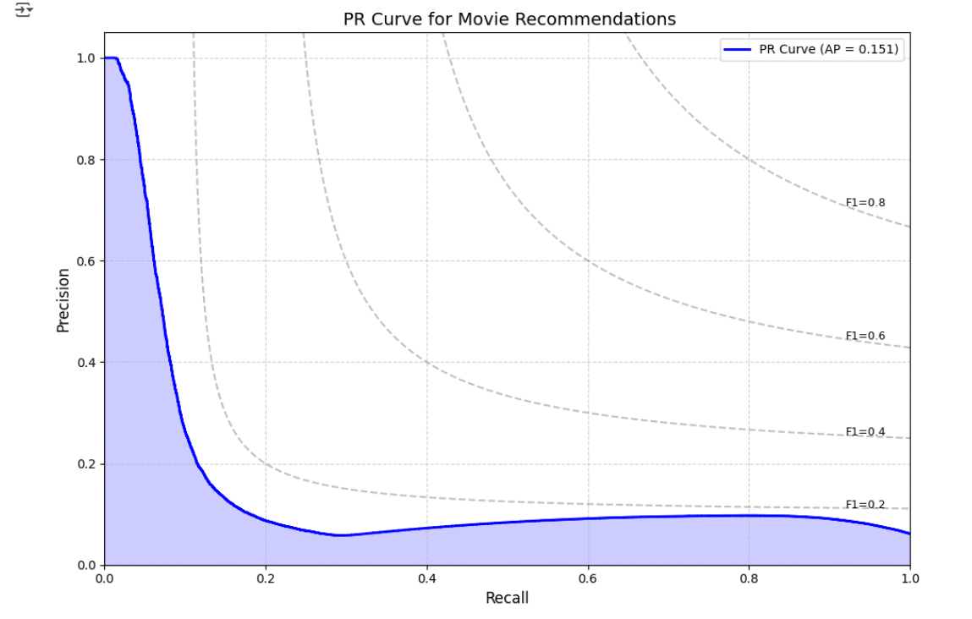

ROC Curve
The decision to use the ROC Curve was made to show how accurately the model can tell apart good and bad recommendations. This comparison gives us an understanding of how the number of true positives and false positives varies with different decision thresholds.
Discussion:
To judge how well a model tells apart correct and incorrect forecasts, its ROC Curve shows you the ratio of true and false positives.
Here, the area under the curve is 0.652, so the accuracy is over chance, but there is still room to improve.
The curve being above the diagonal line means our model is performing at least average. The more we recommend, the more we get real positives, but we also see more false positives.
As can be seen, the model’s performance improves when it rarely makes mistakes by catching something that is not there. As a result, recommendation systems remove problems associated with providing bad suggestions.

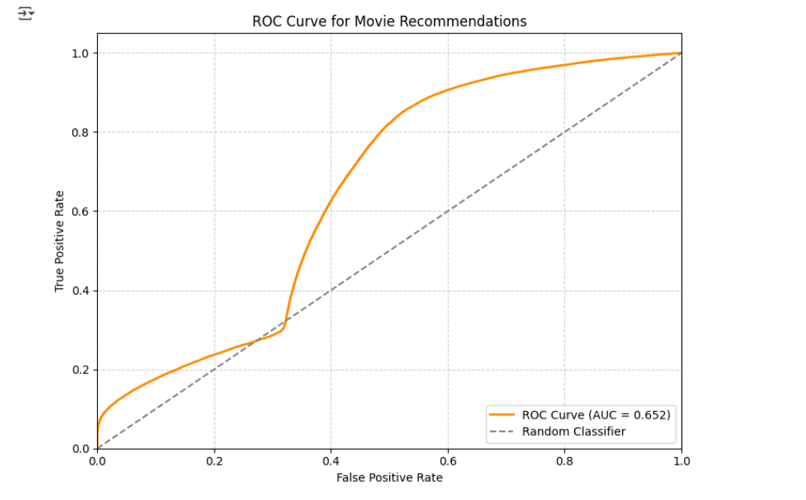

NDCG@K Curve
We looked at the NDCG@K curve to test the model’s ability to place the most relevant items at the leading positions on our list. It lets us confirm that the main recommendations are useful.
Discussion:
This chart examines whether the model can recommend the better claims. The aim is to make sure the essential products appear first in the results.
Going along the x-axis shows increased amounts of top items we are considering and the NDCG score on the y-axis reveals the average quality of those top results.
A higher rating leads to better suggestions. In the beginning, the results are lower in quality, but this improves as we include more data. As you can see, the model doesn’t hit all the top placements, yet it performs reasonably well overall.
Using this curve, we find out the best number of recommendations to show each user.

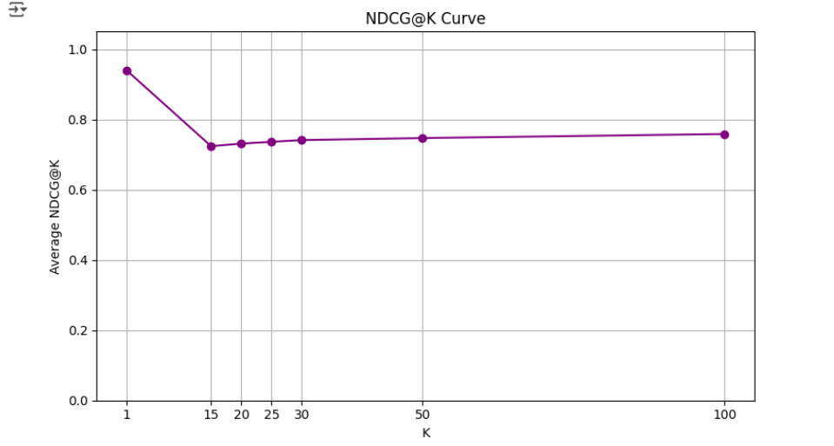

Movie-Movie Similarity Heatmap
The heatmap gives us insight into whether the system correctly places movies into the same groups using LSH. It helps us see similarities between titles and check that the clustering looks right.
Discussion:
If films are in the same color on the heatmap, it demonstrates they are grouped due to similarities. Grouping is shown in the boxes by a ‘1’ if the box is dark and is not shown if the box is light (value = 0).
With the first 50 movies, we can spot main patterns or find movie groups. The darker a parenthesis is, the more likely the movies inside are similar in style, theme or genre.
We can also use it to confirm that the hashing process is bringing together movies that we consider related. The unevenness in the map means some movies have more in common than others, exactly as we would expect.
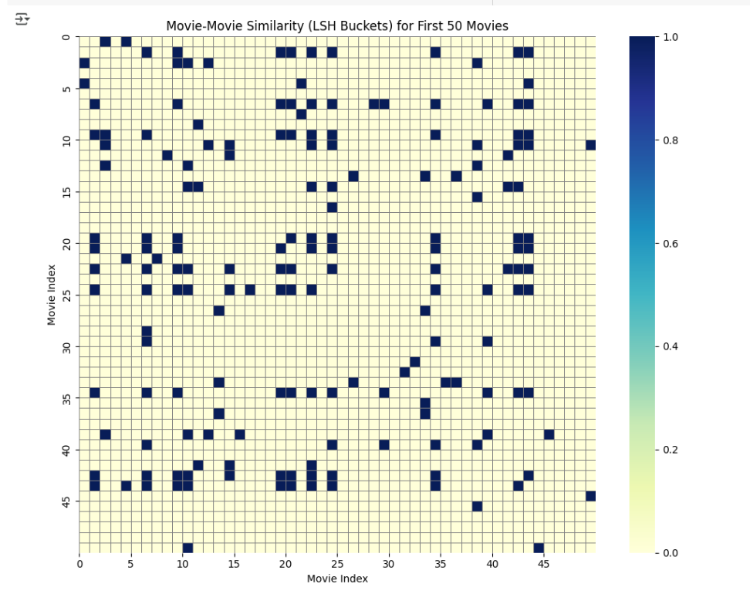

Training Time per Epoch
The chart illustrates the time taken for each training round (epoch). You can spot any instability in the process and troubleshoot what delays training.
Discussion:
The chart shows you the length of every training episode. Performing the setup steps means the first run tends to be the slowest.After that period, the times are more steady which means training is going well.Large gaps or sudden drops in time on the graph may be caused by hardware delays or errors with the data. The consistent timing of events suggests scale will be possible during training.A chart like this helps when educating models with big data sets or carrying out experiments on various machines.

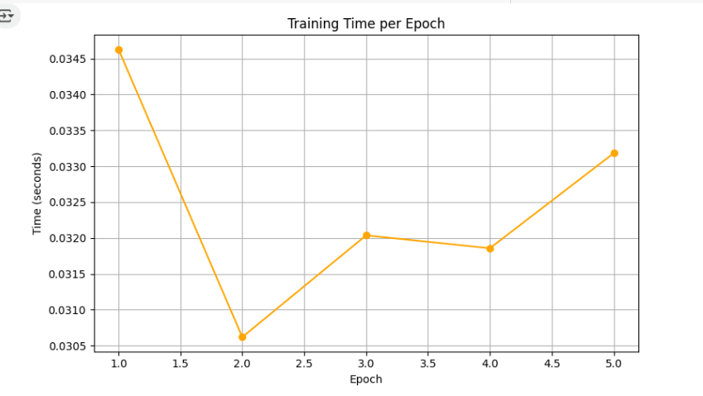Top-N Recommendation Evaluation Plot
The purpose of the chart is to measure how well the model does in picking the top-K most relevant items. Accuracy and completeness measurements in recommendations for each movie are achieved by using precision and recall.
Discussion:
Precision and recall scores are provided for the top-5 recommendations made by the plot for the start of the compared films. The experimental results line is plotted using the query films along the x-axis and showing their precision or recall along the y-axis.
Precision measures the proportion of useful items the model included, while recall shows us how much it missed. It is best for both scores to be high so the model generates valuable and thorough recommendations.
Since the precise match and recall change from movie to movie, it is understandable since the amount of relevant information is not the same for all. Large or frequent embeddings show that the model can find relevant or similar items using word vectors.
All in all, evaluating the model through this plot shows how well it can rank results for top-K items which matters a lot for real-world systems.
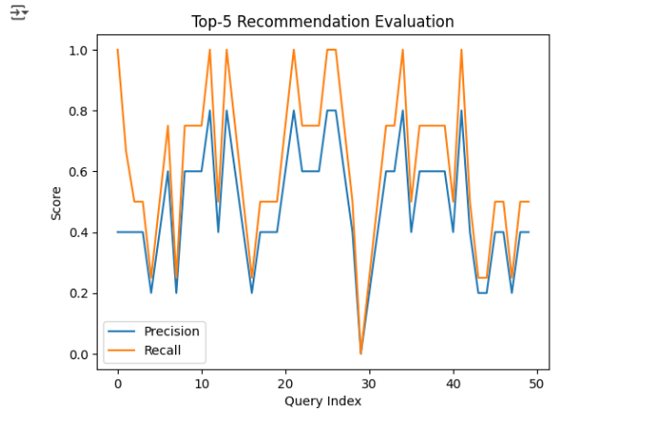

15.Conclusion
Our system is designed to scan through movies and quickly recommend the appropriate suggestions. To start, we gathered details about the film and found out how to use them to improve MiniLM, GTR-T5 and BERT. Once the models were made, we built embeddings for all the updated and existing metadata. We enhanced the system by matching movies with similar tags using MinHash and LSH. We were able to look at just a small number of documents and relate them to our observations. We retrieved the closest results in the datasets by using FAISS. It makes use of suggestions from LSH and models that have been well trained to get excellent results. The end result was that the system made the process fast and effective. Deciding on the best films ahead of time saved time in finding similar titles. BERT was the model that provided the most reliable recommendations.

