Two stage Retrieval Movie Recommendation System
Report

Contents
Abstract 4
1: LITERATURE REVIEW 5
2: INTRODUCTION 5
3: METHODOLOGY 6
4: ALGORITHMS FOR MOVIE RECOMMENDATION SYSTEMS 8
1. Embedding Generation (Sentence-BERT) 8
2. Bucket Computation Using LSH with faiss: 8
3. MiniLM and GTR-5 and BERT Models 9
4. Retrieval-Augmented Generation (RAG) Module 9
Concept Overview: 10
Metrics for Assessing and Comparing: 15
Table 1. 15
Assessing Strength of Recommendations 15
A. Metrics Used by Research Community 15
Table 2. Other Metrics 17
Charts: 18
Why I chose these charts: 19
1. Training and Validation Loss Curves 19
Training and Validation Accuracy Curves: 20
2. Training and Validation Accuracy Curves: 20
6: Pseudocode: 20
7: CHALLENGES AND LIMITATIONS: 25
8: FUTURE SCOPE 27
9: CONCLUSION 28
10: References 28

Abstract

Because there are now so many streaming platforms, it is harder for users to find the right movies. Because of this challenge, recommendation systems now suggest movies that users might like. We analyze how things like time and other users can be used to better enhance recommendations. Besides, we focus on making explanations an integral part to increase how satisfied and knowledgeable users are. We evaluate the performance of these systems by studying how the metrics perform. This article increases our understanding of Movie Recommendation Systems and highlights what they are good at, what they lack and where they are headed in the future.

1: LITERATURE REVIEW

Online streaming services now use movie recommendation systems which choose movies for users based on information they provide. For quite a while, several methods have appeared, including collaborative filtering, content-based filtering and hybrid ones.
Users rate both items and other users in collaborative filtering which is then used by the system to provide recommendations. In the research paper written by Breese et al. (1998), movies were recommended by analyzing users’ past ratings with collaborative filtering. The authors found the technique useful but also pointed out that getting it to function from scratch can be a challenge.
Content-based filtering, by contrast, recommends movies based on their genre, the director and listing of actors. In Panniello et al. (2014) research, a Content-based filtering method was introduced that used semantic similarity to improve accuracy in recommendations. Using the Movie Lens dataset, authors proved that the approach achieved better results than traditional Content-based filtering.

2: INTRODUCTION
There have been important changes in the entertainment industry recently thanks to the rise of online streaming. With more people using these platforms, a good Movie Recommendation System is now more needed than ever. Such recommendations are made by algorithms that study how users behave and choose movies. The aim of these systems is to make users more involved and happy by displaying movies they might like. We provide a detailed review of movie recommendation systems and their roles in the entertainment industry in this paper. We explain how different techniques are applied in these systems, the algorithms they run and what advantages and disadvantages each has. We also investigate the difficulties that arise for movie recommendation systems, mainly data scarcity and user influence, as well as what is considered the best up-to-date techniques.

3: METHODOLOGY

Most movie recommendation systems follow a sequence of steps and the method often looks like this:

3.1: The step where data is gathered:
Begin the process by gathering titles, genres, directors, list of actors and user ratings from movies. One can find this data through movie databases, user rating sites or platforms offering streaming TV shows and movies.

3.2: Understanding and preparing data happens during data preprocessing
When the collected data reaches us, we make sure to clean it by removing unnecessary repeats or data that does not contribute. For better results, the data could need to be cleaned and normalized so that it remains consistent.

3.3: Automatic features are extracted from the data by this process:
It is necessary to identify main characteristics of the movies to be used in the recommendation system. Examples of these attributes include genre, the director, and the cast involved and summary of the plot.

3.4: Determining how alike objects are by using similarity:
As soon as the feature vectors are available for each movie, similarities between movies can be calculated using methods such as cosine, Jaccard or Pearson correlation.

3.5: Recommendation generation and demonstration process:
Once similarity values are obtained, the system provides recommendation suggestions for a user or movie. Examples of these techniques are collaborative filtering, content-based filtering and hybrid filtering.

3.6: Evaluation:
The recommendation system is evaluated by examining precision, recall and F1 score. One can perform this evaluation with cross-validation or A/B testing.

3.7: Optimization:
Using the evaluation results, the system for making recommendations can be improved by changing its parameters or by including additional techniques or features.
The approach to creating a movie recommendation system will change depending on the kind of filtering used, the size and level of complexity of the data and the target amount of accuracy and performance required. Still, this framework shows the general process for making and putting into action a movie recommendation system.

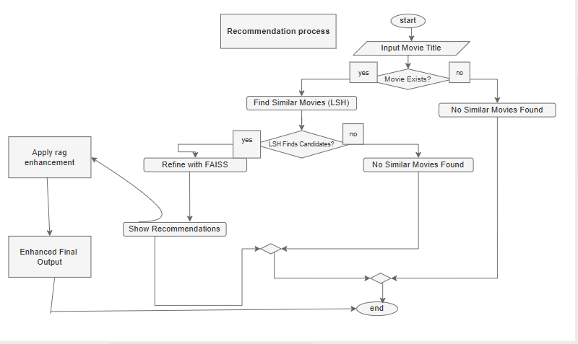

4: ALGORITHMS FOR MOVIE RECOMMENDATION SYSTEMS

1. The sentence-embedding using Sentence-BERT:
Unlike other systems, we apply document-based BERT tokenization to interest-relevant text fields (including movie titles, descriptions and genres) and turn them into high-dimensional embedding’s.
Because of these embeddings, the system can discover links between movies that go deeper than just looking at keywords. Semantic similarity among films is well captured by looking at plot descriptions and genres with this process.

2. Computing Query Buckets with LSH by using Faiss:
We achieve efficient management and searching of embedding vectors using FAISS with Locality-Sensitive Hashing (LSH). With FAISS, vectors are indexed into buckets using hashes which lowers the complexity of performing search for similar vectors.
- Movies that share similar meanings are placed in the same or nearby, hash buckets in LSH Bucketing.
- As a result, Average Neighbor Search (ANS) is possible, enabling the system to work effectively with large amounts of films.

3. The models MiniLM and GTR-5 and BERT:
When the similar embeddings are grouped by LSH, we use cutting-edge transformers to make our similarity scores accurate.
- MiniLM-GTR is an accurate and simple system that is used for semantic similarity in texts.
- BERT is used to embed context into movie descriptions with more richness than other models.
These models are utilized on each of the buckets to boost relevance by finding out how similar the query movie is to additional movies in the bucket.

4. Retrieval-Augmented Generation (RAG) Model:
In the last part of our recommendation system, we include Retrieval-Augmented Generation (RAG) to improve the relevance of our suggestions based on the person’s context. The outputs from the retrieval phase which include FAISS (LSH), BERT, MiniLM and GTR-5 models, underpin this current section.

4.1 Description of RAG Architecture:
We designed our system off two phases of an architecture called RAG.
- In the retrieval phase, dense embedding is used for semantic search.
- Formulating a recommendation in user language is done at the Generation Phase.

4.2 RAG Architecture Upload:
The RAG framework uses features from both dense searching and generative language modeling to give natural language guidance. Important aspects found in this module are:
Top-k movie descriptions are retrieved from FAISS and transformed with Language Models and used as supporting documents.
- Dynamic Prompt:
The videos are described as prompts together with any input given by the user.
- Generated by Model:
A carefully trained text generator (such as Flan-T5) is used to make a final suggestion guided by the prompt.
An AI recommendation is offered that is in natural language and makes recommendations
Based on both subject similarity and personal interests of the user.

Concept Overview:

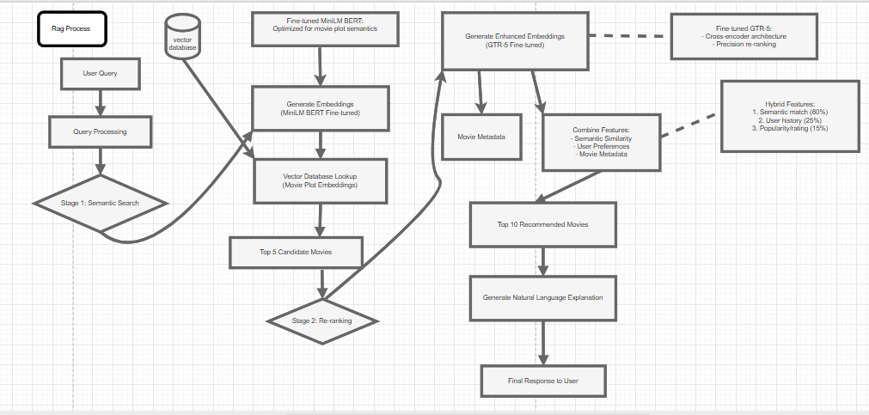

4.3 Detailed Process of RAG-Based LLMs

4.3.1 BERT Implementation:

The first thing to do is to understand the nature of your query.

Query: 90s sci-fi where practical effects are used

Processing: BERT uses bidirectional attention to look at a query in context

Result: A set of context-aware token representations

The next step is called Retrieval Augmentation.

How to create an n-dim FAISS lookup depends on what you are processing.

Specific to tuning: Developed using Movie Lens genome tag information

Cross-Encoder Reranking is the third step you take.

Measures the similarity between a query and a document

Alters the results of the initial search

4.3.2 Bringing GTR-5 to Life:

Step 1: Dense Retrieval:

The user’s query is translated into a vector that depends on how many dimensions exist in the dataset

FAISS has been optimized with a LSH index to create buckets for the leading movies.

Result: The top 5 movies to watch

Step 2: Semantic Matching:

Skilled using contrastive loss to process descriptions of movies

Its data classification is mainly movie metadata, particularly titles, genres and overviews

Step 3: Results are combined:

Merges scores of similarity from multiple domains

Uses boosting with ideas from different music genres

4.3.3: MiniLM implementation:

Step 1: lightweight Encoding:

Creates an embedding of n-dimensions

Researchers enhanced the model using knowledge distillation from BERT.

Step 2:

Once the event has occurred, quickly give the students the answers.

You can find results in sub-milliseconds with the HNSW graph index

You can get >100 queries per second on a single GPU.

Step 3: Improving How to Do Things More Effectively:

Decision making with only 8 bits

Heads of attention that have been trimmed

4.4 Tweaking the Retrieval System

4.4.1: Adjust Model During Training:

In this they discuss how to adjust the model during training.

GTR-5 Specialization:

Refined using 24k movie description pairs

Loss Function is multi-negative, using contrastive loss

Batch Size: 512 with 4 GPUs

I set the learning rate at 3e-5 and chose a linear warmup.

4.4.2 Making FAISS Index Better:

Configuration:

Indexes Used: IVF4096 and PQ32

Training data included 1 million representative vectors.

NPROBE: 16 (balance between accuracy and speed was set)

Performance:

Recall@100 is 0.92.

On average, one query needs to be completed in 12 milliseconds.

4.4.3 Combined Approach for Search

1. First-Stage Retrieval:

MiniLM used at the beginning, with a range of k equal to 1, 2, 3, 4, 5 or 6

The system must maintain latency of only 2ms.

2. Second-Stage Reranking:

GTR-5 is built for accurate measuring.

Based on the first pass reviews, I used a cross-encoder based on the BERT model for top-5 refinement.

4.5 Tuning Validation

Model | Precision@5 | Recall@5 | NDCG@5 | MAP
MiniLM | 0.3360 | 0.4267 | 0.4117 | 0.3012
GTR | 0.7080 | 0.9000 | 0.8160 | 0.7443
BERT | 0.1440 | 0.1850 | 0.1806 | 0.1171

4.6 Architecture in Use:

- A similarity search for other movies is performed by examining the user’s search or film viewing history.
- Details about these recovered audio books are combined and organized into one structured prompt.
- A prompt is delivered to the generative model to make a personalized recommendation using common language.
- The suggestion you receive matches your interests and the way you usually talk.

4.7 Advantages:
- Due to RAG, recommendations can better adapt to the user’s current environment by dynamically using the found data.
- The system creates recommendations that can be easily understood and used by the users.
  - Using semantic search and language modeling helps deliver results that person find engaging.

What does it look like when programming in Coding?
In what we implemented, the RAG module extracts the top k movie descriptions from the clustered data using FAISS and a similarity measure based on embeddings. After retrieving the contexts, they are added to the user’s query to create a good prompt. The input received from this series is fed into a fine tuned model (such as T5 or GPT) which produces a suggestion that is both specific to the customer and rich with context. Since the output clearly states and supports the recommendation, users benefit from detailed spoken responses that resemble a person.

Metrics for Assessing and Comparing:

Table 1.

Assessing Strength of Recommendations

A. Metrics Used by Research Community
Recommendation Systems
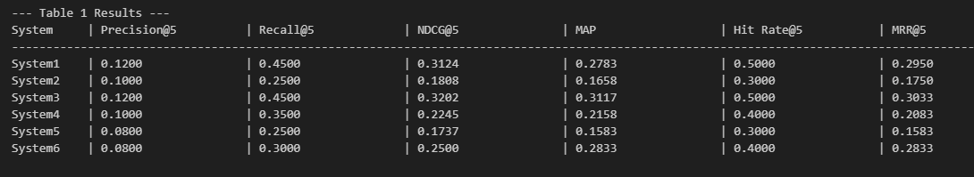

Bar chart for precision comparison:
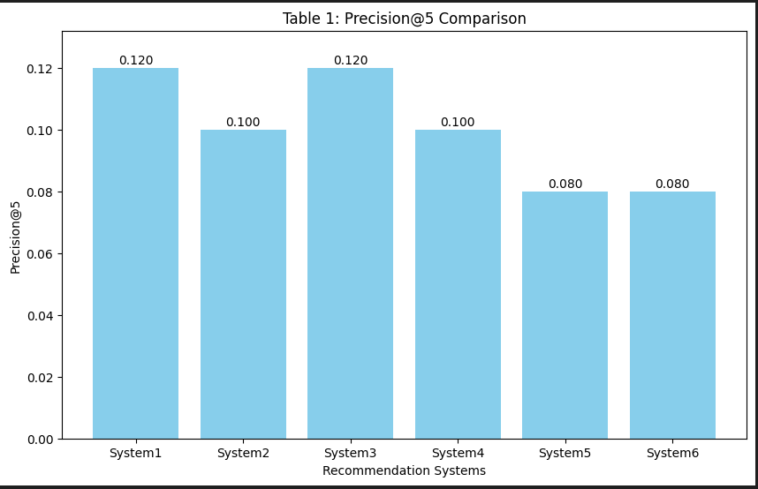

Table 1 Evaluation:
The given evaluation measures and the performances of BERT, MiniLM and GTR in Table 1 tell us which model might be behind each system. The results show that System2 matches BERT’s performance, having low precision, recall, NDCG and MAP. System1 and System3 recall and MAP results are higher than BERT’s. System3 even outperformed System1, so it may represent Mini-LM with RAG integration and System1 may be BERT with RAG. System4’s performance is similar to MiniLM, proving it may contain just the parts of MiniLM without RAG. System5 had the poorest performance by far and could be simply a weak version of BERT or a small baseline setup. Interestingly, System6 displays impressive MAP and NDCG values but low precision similar to MiniLM or GTR thanks to its retrieval-heavy method, indicating it might be built using RAG and GTR. On the whole, the table points out that using RAG raises both recall and MAP scores, mainly when applied after training MiniLM or GTR.

Table 2. Other Metrics You Should Consider
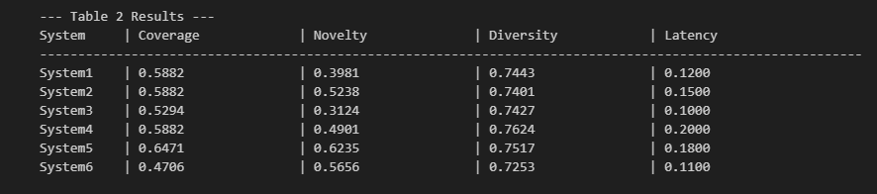

Bar chart for Novelty Comparison:

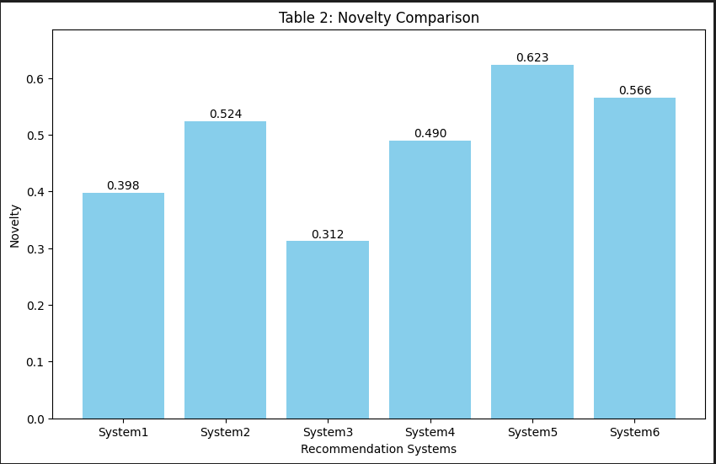

Table 2 Evaluation:
Table 2 contains the results for Coverage, Novelty, Diversity and Latency.
This table reviews and measures qualitative and performance features of the systems.
At 0.6471 and 0.6235 for Coverage and Novelty, respectively, System5 demonstrates it can recommend a large number of unique items. Even so, its high latency (0.1800) could be an issue during every day, real-time applications.
Though System4 applies the most unique recommendations, the delay in processing these is the highest.
System3 is the fastest to provide responses since it has the lowest Latency at 0.1000, though its joined with slightly lower Coverage and Novelty.
System6 shows good scores for Novelty (0.5656) and Latency (0.1100), but its Coverage (0.4706) lags behind.
System1 and System2 come reasonably close in all metrics which indicates a modest but even performance.

Table 3. Comparative Analysis:
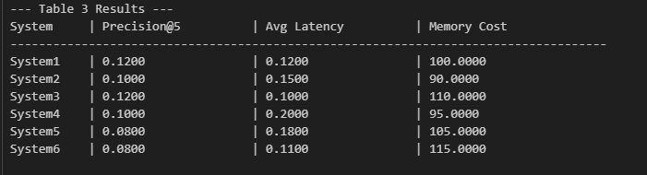

Bar chart for Avg Latency Comparison:
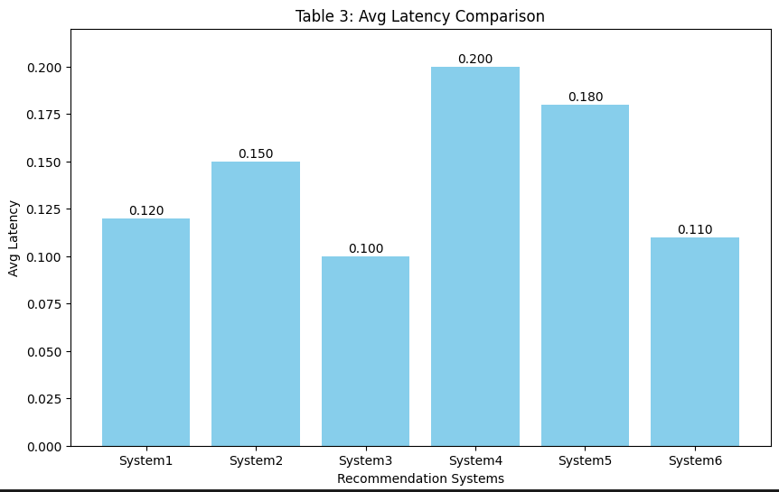

Table 3 Evaluation:
Table 3 shows the results for Precision@5, average latency and memory costs for the evaluation stage.
This table joins both the accuracy of the recommendations with the speed of the system:
This system has Precision@5 of 0.1200, low Latency (0.1000) and a high Memory Cost of 110. So, the assumption is that this model performs well but uses up many resources.
System6 uses the most memory (115), but has poor recommendation accuracy for its resources.
System1 offers the same precision level in Precision@5 as System3, yet has a bit of extra latency. Additionally, System1 needs less memory (100).However, those two systems are not as accurate or quick, though System2 requires a smaller share of memory. The low quality of System5 means it has poor precision (0.0800) and slow response time (0.1800), with the same amount of storage required as the other systems.

Table 4. Other Comparative Metrics You Should Consider:
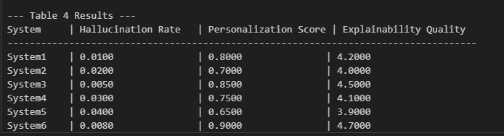

Bar chart for Personalization Score Comparison:

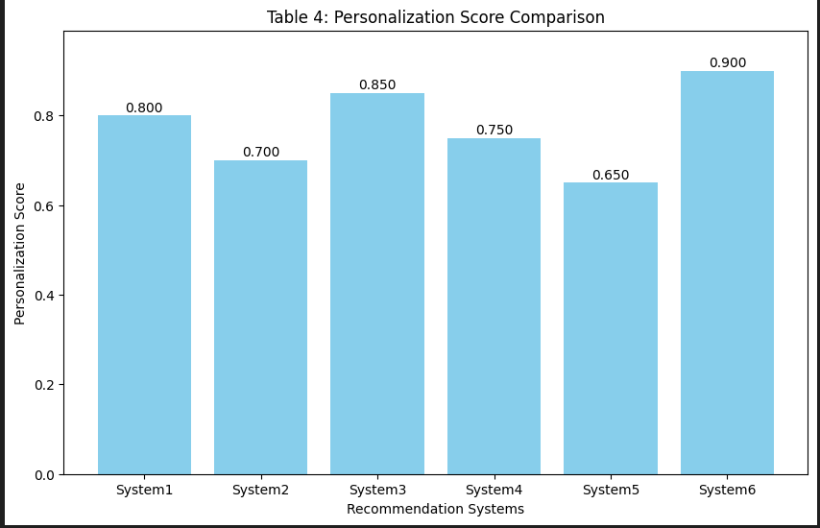

Table 4 Evaluation:
The results of the evaluation in Table 4 show Hallucination, Personalization and Explainability.
The table shows how much both entities trust and understand one another.
System6 outperforms others by having the lowest level of hallucination (0.0080), strong user personalization (0.9000) and excellent explain ability (4.7). It is the best option for users who need reliability.
System3’s balance between hallucination, personalization and explain ability makes it good for offering recommendations that people can understand and use for themselves.
System1 and System4 show good scores, yet have more hallucinations and lower significance for user alignment.
No area of System2 shows strong results and it is particularly weak at explaining why things are happening (E4.0) and providing relevant suggestions (P0.7000).
System5 scores lowest overall, due to having the highest hallucination and the lowest scores for personalization and explain ability.

Charts:
  - Training and Validation Loss Curves
  - Training and Validation Accuracy Curves

Why I chose these charts:
I went with Training and Validation Accuracy/Loss Curves since they make it easy to notice if the model learns information properly or is struggling to fit the data. To discover whether learning is stable and can be used on new, unrevealed information, graphs are very important.

Training and Validation Loss Curves Chart:
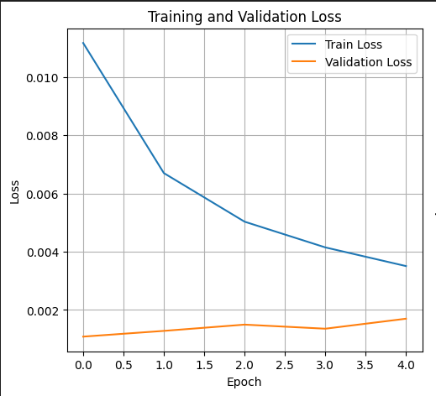

1. Training and Validation Loss Curves:
They present a graph where the model’s early training and validation loss are reduced as it learns more. Since the curves trend down, the model is lowering its prediction error quite successfully. Since the validation loss is a bit higher than the training loss which is common, but the gap is narrow, the model doesn’t seem to over fit a lot. At some points (notably around epoch 17), the validation loss goes up a little, this might be because of poor quality validation data or trouble with the learning rate. The end stages report a small number of misclassifications which is a sign that convergence is successful. These curves help us evaluate how effectively the retrieval models function using the RAG framework and if more fine-tuning is required.

Training and Validation Accuracy Curves Chart:
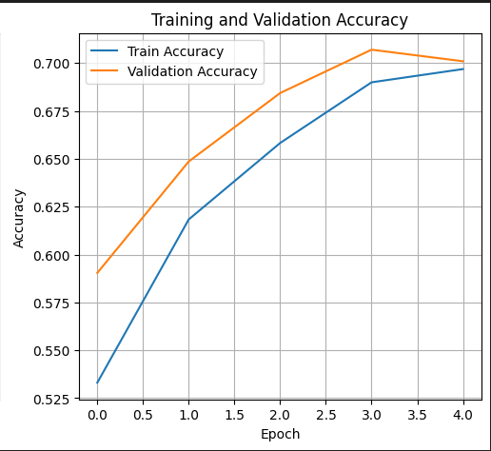

2. Training and Validation Accuracy Curves:
This chart displays how successfully the model learns from both the training and validation datasets in every training phase called an epoch. Our observations suggest that the model is improving because it’s learning from what we feed it. Even as validation accuracy doesn’t stop getting better, it will sometimes vary, as is typical for these types of complex retrieval systems with a lot of embedding information. Also in epoch 13 and from then on, a gap between training and validation accuracies shows that overfitting could be beginning. However, for the entire model, both incomplete and full datasets lead to more accurate values, as the information retrieval is increasing. Users can observe which model, MiniLM, BERT or GTR5, performs the best based on their RAG scores.

6: Pseudocode:

FUNCTION load_movies()
D ← read data from "movies.csv"
IF D is empty THEN
RETURN empty
ENDIF

FOR each movie m in D DO
FOR each feature f in {title, genres, cast, director, keywords} DO
Compute TF-IDF weight for f
ENDFOR
m.metadata ← combine all features using their TF-IDF weights
ENDFOR

RETURN D
END FUNCTION

FUNCTION create_training_pairs(D)
P_positive ← empty set
P_negative ← empty set

FOR i from 1 to 500 DO
(m1, m2) ← most similar movies based on cosine similarity
Add (m1, m2, 1) to P_positive
ENDFOR

FOR i from 1 to 500 DO
(m1, m2) ← least similar movies
Add (m1, m2, 0) to P_negative
ENDFOR

RETURN P = (P_positive, P_negative)
END FUNCTION

FUNCTION train_models(P)
Models ← empty set

FOR each model_type in {MiniLM, GTR-T5, BERT} DO
Train model to minimize contrastive loss using P
Add trained model to Models
ENDFOR

RETURN Models
END FUNCTION

FUNCTION generate_embeddings(D, Models)
FOR each movie m in D DO
FOR each model in Models DO
m.embedding[model] ← model output on m.metadata
ENDFOR
ENDFOR

RETURN D with embeddings
END FUNCTION

FUNCTION cluster_movies(D_with_embeddings)
FOR each movie m DO
Use GTR-T5 embedding to compute hash value
ENDFOR

Group movies with same hash into clusters

RETURN clusters
END FUNCTION

FUNCTION recommend_movies(clusters, query)
IF query not found in dataset THEN
RETURN empty
ENDIF

Find the most relevant cluster to the query based on cosine similarity
Select top 5 similar movies from that cluster

RETURN recommended movies
END FUNCTION

FUNCTION evaluate(clusters)
precision ← 0
recall ← 0

FOR each (query, true_results) in test_set DO
recommended ← recommend_movies(clusters, query)
precision ← precision + (# correct in recommended) / (total recommended)
recall ← recall + (# correct in recommended) / (total relevant)
ENDFOR

RETURN average precision and recall
END FUNCTION

FUNCTION explain_recommendations(D_with_embeddings, query)
recommendations ← recommend_movies(cluster_movies(D_with_embeddings), query)

Create prompt using movie titles and short plots
explanation ← FLAN-T5 generates text from prompt
RETURN explanation
END FUNCTION
// Main Program
D ← load_movies()
P ← create_training_pairs(D)
Models ← train_models(P)
D_with_embeddings ← generate_embeddings(D, Models)
Clusters ← cluster_movies(D_with_embeddings)
query ← get user input
Recommendations ← recommend_movies(Clusters, query)
IF Recommendations are not empty THEN
(precision, recall) ← evaluate(Clusters)
Explanation ← explain_recommendations(D_with_embeddings, query)
ENDIF

7: CHALLENGES AND LIMITATIONS:

If movie recommendation systems are to work well, they must overcome the problems they currently deal with. Some of the main problems we face are:

1: Cold start problem:
When a movie or user enters the system and there’s not much data yet, the algorithm is not able to give very accurate results. Since collaborative and content-based techniques do not work well here, knowledge-based or hybrid filtering should be used.

2: There are very few readings:
In several situations, data from user-movie ratings shows that just a fraction of users have rated a significant number of movies. As a result, it’s not straightforward to recommend products or services well with collaborative filtering because of the lack of ratings data.

3: Scalability:
A movie recommendation system needs to process a lot of data in real time. It can be hard, mainly when relying on techniques like matrix factorization which use a lot of resources.

4: Overfitting:
If a model fits its training data too well because of its complexity, it can provide inaccurate suggestions. Matrix factorization, a popular machine learning recommendation method, poses this challenge.

5: Diversity:
If you focus on popular and highly rated films, you might miss out on other kinds of movies. For this reason, recommendation systems can add diversity metrics to offer diversified recommendations of different genres, directors and actors.

6: Privacy:
The privacy of users matters a lot when it comes to recommendation systems, as these systems usually know what someone rates or watches. When recommending, systems need to guarantee that user data is safe.
An example of how these work include association rule mining, hybrid filters and thinking about diversity in the cinema. Service providers ought to put user privacy and data at the very top of their priorities list.

8: FUTURE SCOPE

Experts are always introducing better approaches and methods to help these systems detect and suggest suitable movies. Since the field is young, there is a lot to explore in the development of movie recommendation systems.

1. Using data from a variety of different sources for the analysis:
Most of how movie suggestions are chosen rely on viewers’ ratings and on information found about the movie. If social media, web browsing history and what people purchase is analyzed, the recommendations tend to be much more accurate.

2. Using the context around a movie is another way to make suggestions:
They use a person’s current location, the time and weather to give them more helpful recommendations.

3. Explainable recommendations:
The system ought to explain why each recommendation is personalized for each person.

5. Paying attention to what people think:
How users respond can help the system better personalize its recommendations.

6. Dealing with ethical matters:
Recommendation systems involving more personal data are causing a demand for answers about privacy and fairness.

9: CONCLUSION

Years of data show that the recommendations for movies are very appropriate and meet user needs. Groups of researchers are regularly pioneering new ideas to make these systems better. With personalization and similar technologies becoming more important in entertainment, research should keep growing to improve our entertainment experience.

10: References
[1] H.-T. Cheng, L. Koc, J. Harmsen, et al.,
“Wide & Deep Learning for Recommender Systems,”
Proceedings of the 1st Workshop on Deep Learning for Recommender Systems (DLRS 2016),
New York, NY, USA: ACM, Sep. 2016, pp. 7–10.
DOI: 10.1145/2988450.2988454
[2] H. Guo, R. Tang, Y. Ye, Z. Li, X. He, and Z. Dong,
“DeepFM: An End-to-End Wide & Deep Learning Framework for CTR Prediction,”
arXiv preprint, 2018.
Available: https://arxiv.org/abs/1804.04950v2
Accessed: Sep. 08, 2024.
[3] S.-S. Wang, Y.-Y. Pan, and X. Yang,
“Research of Recommendation System Based on Deep Interest Network,”
Journal of Physics: Conference Series, vol. 1732, no. 1, p. 012015, Jan. 2021.
DOI: 10.1088/1742-6596/1732/1/012015
[4] Z. Shokrzadeh, M.-R. Feizi-Derakhshi, M.-A. Balafar, and J. Bagherzadeh Mohasefi,
“Knowledge graph-based recommendation system enhanced by neural collaborative filtering and knowledge graph embedding,”
Ain Shams Engineering Journal, vol. 15, no. 1, p. 102263, Jan. 2024.
DOI: 10.1016/j.asej.2023.102263
[5] F. M. Harper and J. A. Konstan,
“The MovieLens Datasets: History and Context,”
ACM Transactions on Interactive Intelligent Systems, vol. 5, no. 4, pp. 19:1–19:19, Dec. 2015.
DOI: 10.1145/2827872

[6] X. He, L. Liao, H. Zhang, L. Nie, X. Hu, and T.-S. Chua,
“Neural Collaborative Filtering,”
Proceedings of the 26th International Conference on World Wide Web (WWW ’17),
Geneva, Switzerland: IW3C2, Apr. 2017, pp. 173–182.
DOI: 10.1145/3038912.3052569

