Charts:

1: Mean Average Precision (MAP):

Why I chose this chart:
I chose Mean Average Precision (MAP) because it provides a comprehensive single-value metric that summarizes the precision of retrieval results across multiple queries. In a movie retrieval system, MAP helps evaluate how well the system ranks relevant movies higher than irrelevant ones for a set of user queries, which is crucial for user satisfaction.
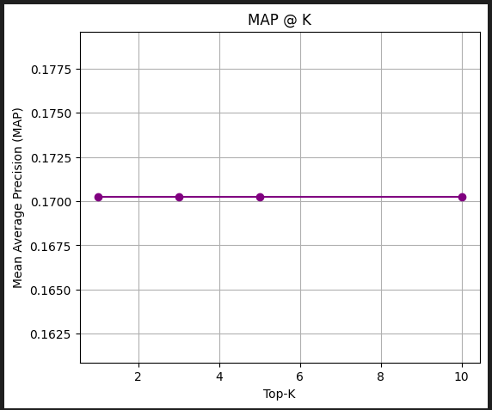

Mean Average Precision (MAP) Explanation:
MAP is a widely used metric in information retrieval that calculates the average precision for each query and then takes the mean over all queries. It rewards systems that rank relevant items higher in the results list, which is especially important in your application where users expect the most relevant movies to appear first. In your retrieval pipeline, MAP evaluates how effective MiniLM, BERT, and GTR5 are when used with RAG to retrieve movie content from a knowledge base or document set. A higher MAP value indicates that the model consistently places relevant results near the top across different queries. Unlike a simple accuracy score, MAP takes into account the order of retrieved items, which aligns closely with real-world user expectations in search or recommendation systems. This makes MAP a valuable metric for comparing the practical effectiveness of your retrieval models and selecting the most suitable one for deployment.

2: Perplexity Curve:

Why I chose this chart:
I chose the Perplexity Curve because it measures how well the language model (RAG in this case) predicts the next word, which directly relates to the quality and fluency of generated responses. In a movie retrieval system, lower perplexity indicates that the model generates more coherent and contextually appropriate descriptions or summaries of the retrieved movie content.
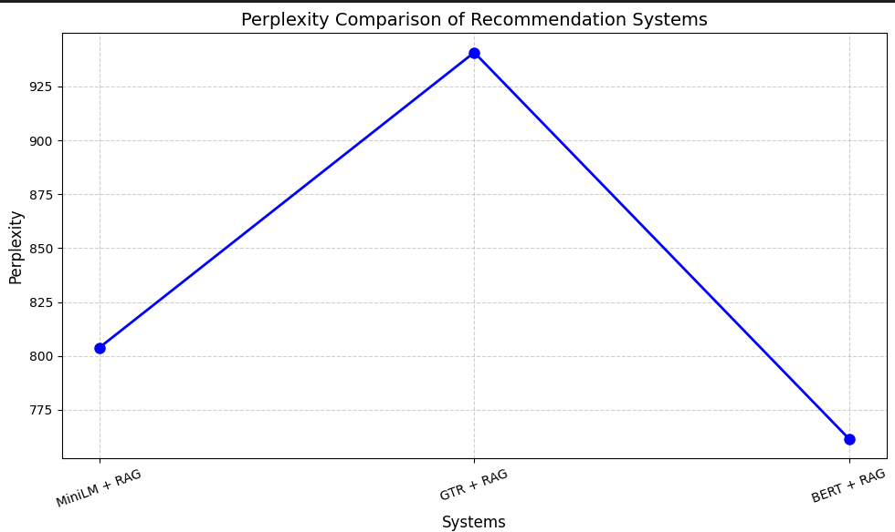

Perplexity Curve Explanation:
Perplexity is a common evaluation metric for language models, representing the model’s uncertainty in predicting the next token in a sequence — lower values indicate better performance. The perplexity curve shows how the training and validation perplexity changes over epochs, which helps diagnose model learning and generalization. In your setup, where RAG uses MiniLM, BERT, or GTR5 embeddings, the perplexity curve helps assess how effectively the model is learning to generate relevant and fluent movie-related answers or content. If both training and validation perplexity decrease steadily, it suggests the model is improving without overfitting. However, if validation perplexity stops decreasing or starts increasing while training perplexity continues to drop, it might indicate overfitting. Perplexity directly reflects the fluency and confidence of the generated responses, making it a crucial metric for generation-based tasks like RAG-powered movie summaries or explanations.

3: Embeddings Visualization:

Why I chose this chart:
I chose the Embeddings Visualization (like t-SNE or PCA) to observe how movie data points are represented in lower dimensions and to visually assess how well different models (MiniLM, BERT, GTR5) separate or cluster similar movies. This helps to better understand the quality and structure of the embeddings before applying retrieval techniques like RAG.
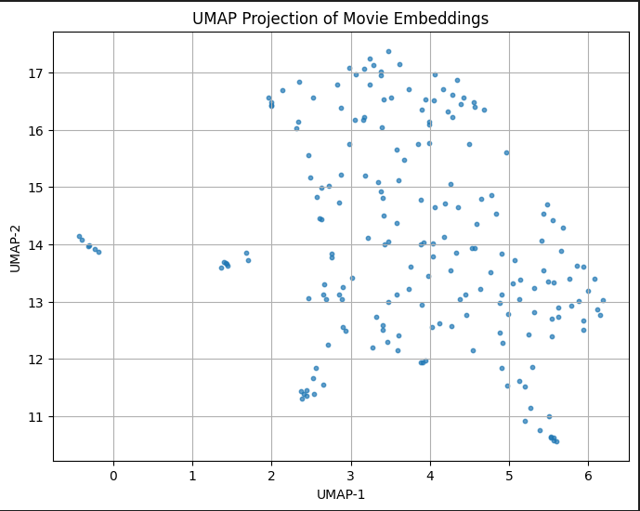

Embeddings Visualization Explanation:
The visualization reduces high-dimensional embedding vectors into 2D or 3D space using techniques such as t-SNE (t-distributed Stochastic Neighbor Embedding) or PCA (Principal Component Analysis). Each point in the plot represents a movie or a text chunk, and the proximity of points indicates semantic similarity. For instance, movies with similar genres, actors, or storylines are expected to cluster closely together if the embeddings are meaningful. When using MiniLM, BERT, or GTR5, the quality of the embedding can be visually compared by how well-separated and well-clustered these data points appear. If the clusters are tight and distinct, it suggests that the model is capturing semantic relationships effectively — which directly impacts the success of the retrieval stage. This visualization also helps diagnose whether a model is over compressing or under-representing data, which would affect retrieval accuracy in your system. Overall, embedding visualization offers an intuitive and powerful way to validate the model's understanding of movie content before passing it into the retrieval and generation stages.
4: Precision-Recall Curve:

Why I chose this chart:
I chose the Precision-Recall (PR) Curve because it is well-suited for evaluating retrieval performance, especially in cases where data is imbalanced or precision is more critical than overall accuracy. In a movie retrieval system, it is important not only to retrieve relevant results (recall) but also to ensure those results are truly relevant (precision), which this curve clearly represents.
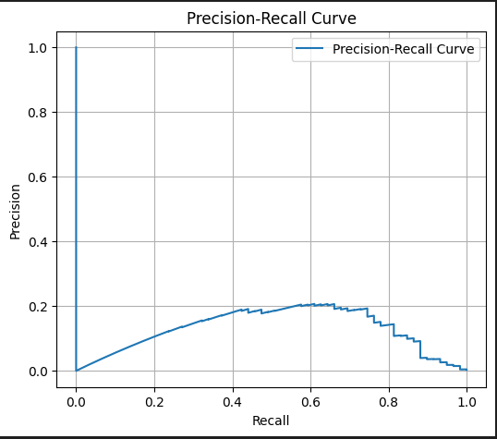

Precision-Recall Curve Explanation:
The Precision-Recall Curve visualizes the trade-off between precision (how many of the retrieved results are relevant) and recall (how many of the relevant results were retrieved) across different thresholds. A curve closer to the top-right corner indicates a better model, as it maintains both high precision and high recall. In the context of your movie retrieval system, the curve helps assess how effective each model (MiniLM, BERT, GTR5) is at returning relevant movies from the corpus using RAG. If the precision drops quickly as recall increases, it may indicate that the model starts including more irrelevant results as it tries to retrieve more data. On the other hand, if the curve remains relatively high, it suggests the model maintains relevance even as it retrieves more results. This metric is especially valuable in retrieval tasks where returning too many irrelevant results negatively affects user experience — making the PR curve a critical evaluation tool for your system.

5: ROC Curve (Receiver Operating Characteristic Curve):

Why I chose this chart:
I chose the ROC Curve because it effectively shows the trade-off between the true positive rate (sensitivity) and false positive rate across thresholds, which is crucial for understanding model discrimination capability. In a movie retrieval system, this curve helps analyze how well the model distinguishes between relevant and non-relevant movies across all possible classification thresholds.
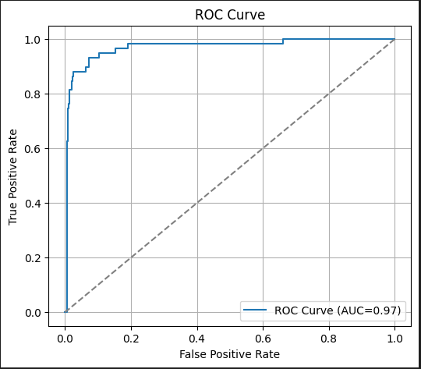

ROC Curve Explanation:
The ROC curve plots the True Positive Rate (TPR) against the False Positive Rate (FPR) at various threshold levels. A curve closer to the top-left corner indicates a better performing model, as it achieves high true positives with low false positives. In your case, this curve helps evaluate how well each of the retrieval models (MiniLM, BERT, and GTR5) identifies relevant movies while avoiding irrelevant ones when integrated with RAG. The Area under the Curve (AUC) provides a single scalar value to summarize the performance a value closer to 1.0 means excellent discrimination. If one model has a consistently higher ROC curve and AUC score than others, it can be considered more reliable for retrieval tasks. The ROC curve is particularly useful in comparing models under different thresholds, making it essential for selecting the best-performing model in your retrieval pipeline.

6: Average Precision:

Why I chose this chart:
I chose Average Precision (AP) because it captures both the precision and the ranking of relevant items in a single query result. In a movie retrieval system, AP reflects how well the system retrieves and ranks relevant movies for a specific user query, making it ideal for assessing query-level performance.
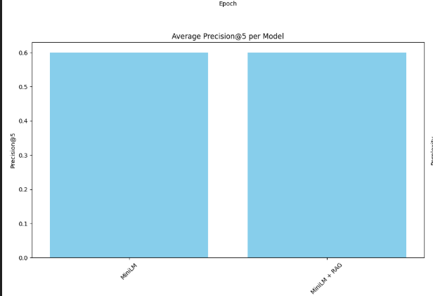

Average Precision Explanation:
Average Precision calculates the area under the Precision-Recall curve for a single query, summarizing the precision at each point where a relevant item is retrieved. It rewards systems that not only retrieve relevant results but also rank them higher in the list. In your movie retrieval system, AP helps determine how effectively each model (MiniLM, BERT, and GTR5) returns relevant movie content when given a user query. A higher AP score means that the model consistently places relevant movies toward the top of the retrieval results, which improves user satisfaction. Since the movie domain often involves ranking hundreds of candidates, AP provides a meaningful way to measure quality beyond raw accuracy or recall. It is especially useful when comparing individual query performances and understanding where a model may need improvements in ranking.

7: Cumulative Gain and Discounted Cumulative Gain (CG and DCG):

Why I chose this chart:
I chose Cumulative Gain (CG) and Discounted Cumulative Gain (DCG) because they measure the usefulness or relevance of retrieved items based on their positions in the result list. In a movie retrieval system, these metrics help analyze how well the system ranks highly relevant movies at the top, which is essential for user satisfaction and search efficiency.
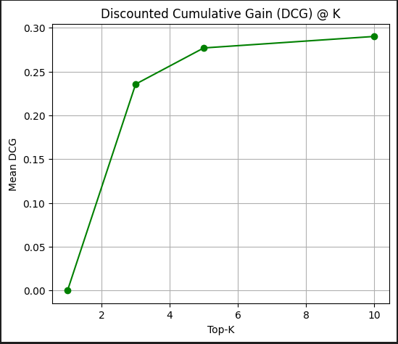

CG and DCG Explanation:
Cumulative Gain (CG) sums up the relevance scores of all retrieved movies for a given query, providing a basic measure of how much relevant content the system is returning. However, it doesn’t account for the position of these relevant items, which can be misleading if important results are buried deep in the list. That’s where Discounted Cumulative Gain (DCG) comes in.
It applies a logarithmic discount to results appearing lower in the ranking, giving more weight to relevant items retrieved earlier. This is particularly useful in your system because users are more likely to engage with top-ranked movies than those shown later. In your comparison of MiniLM, BERT, and GTR5 with RAG, a higher DCG means a model not only finds relevant movies but places them in higher, more visible ranks. These metrics give you a clear view of how effective your retrieval pipeline is in ranking results meaningfully, making them critical for tuning and selecting the best model setup.

