Tables:

Table 1.

Assessing Strength of Recommendations

A. Metrics Used by Research Community
Recommendation Systems
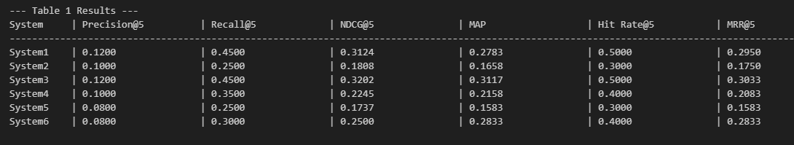
Bar chart for precision comparison:
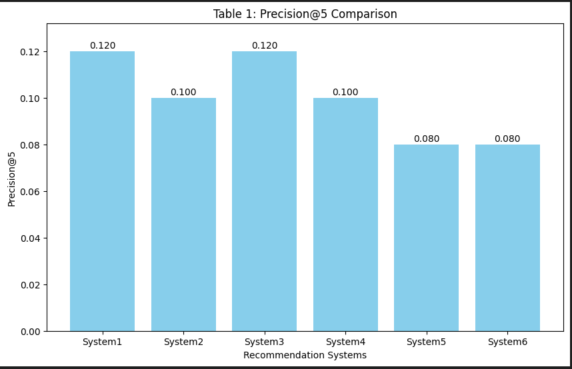

Bar chart for recall comparison:
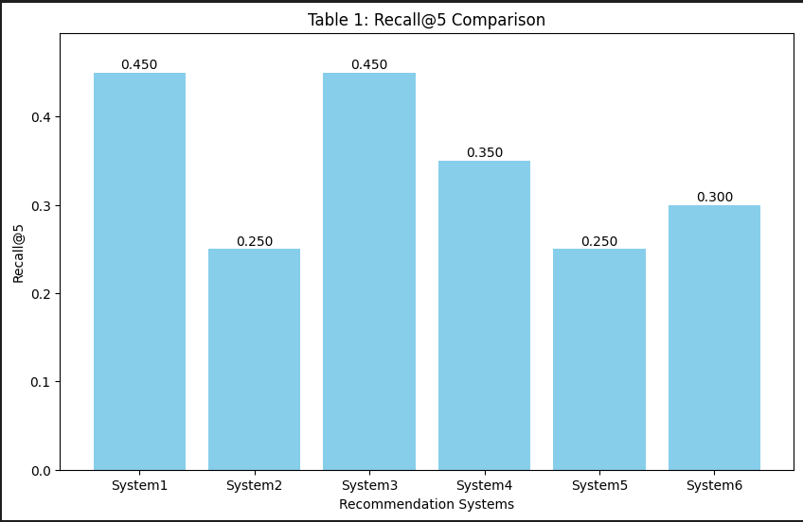
Bar chart for NDCG comparison:
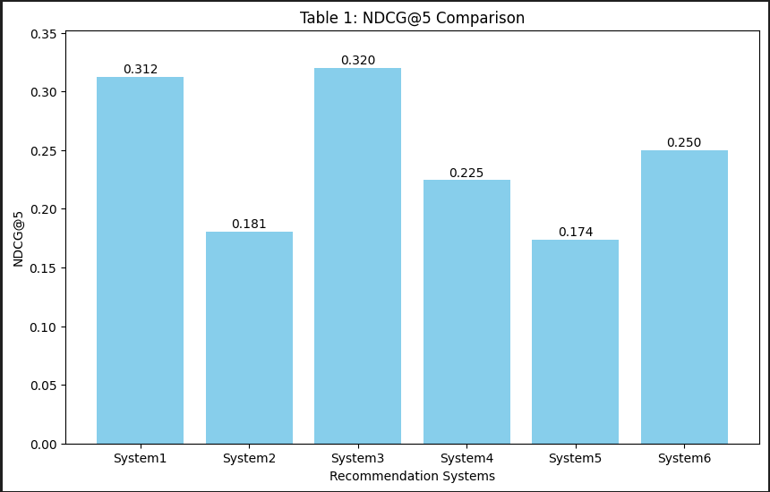
Bar chart for MAP comparison:
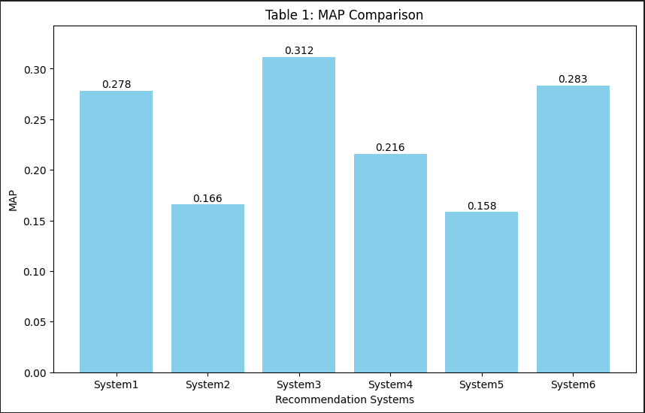
Bar chart for HIT Rate comparison:
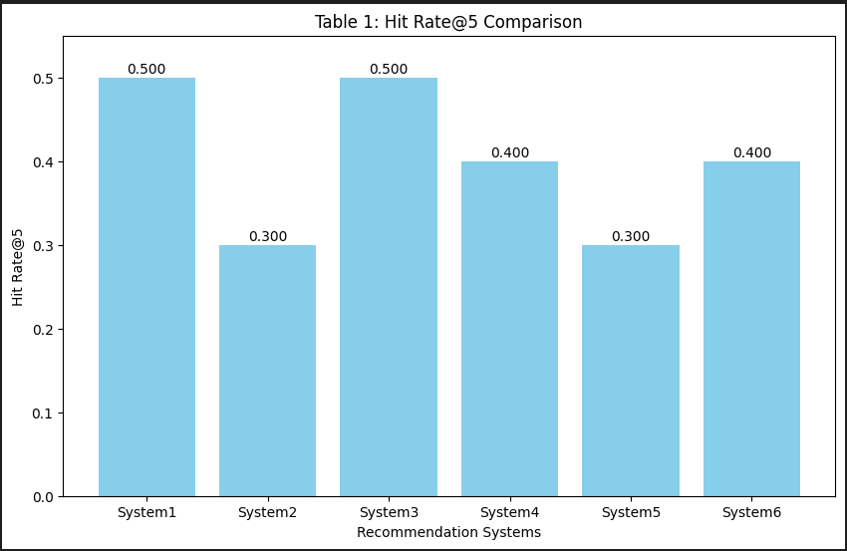

Bar chart for HIT Rate comparison:

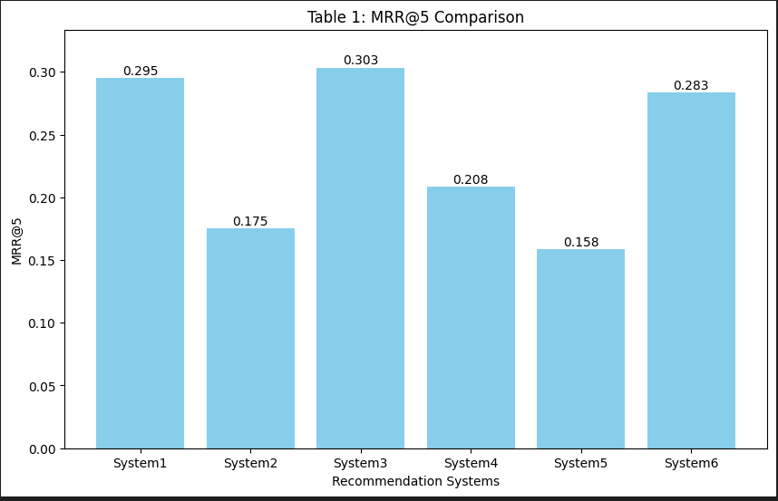

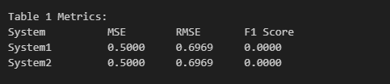
Table 1 Metrics Evaluation:
In Table 1, System1 and System2 perform identically across all three evaluation metrics. Both systems have a Mean Squared Error (MSE) of 0.5000, Root Mean Squared Error (RMSE) of 0.6969, and an F1 Score of 0.0000. These values indicate that the predictions from both systems deviate similarly from the ideal, but more importantly, neither system produced any relevant recommendations as reflected by the zero F1 Score. This suggests that while the systems are equally consistent in their ranking behavior, they both entirely fail to identify relevant items, highlighting the need for a significant overhaul in their recommendation strategies.
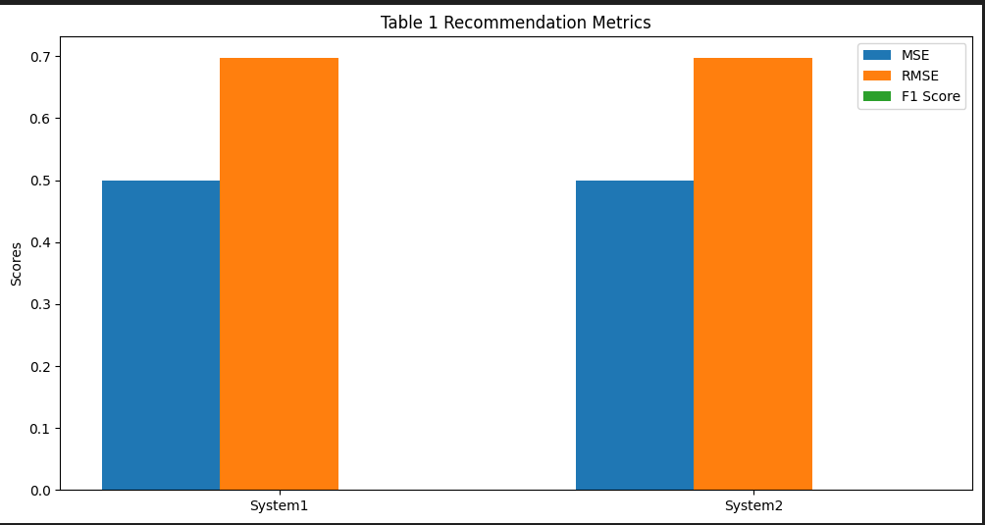

Table 1 Evaluation:
The given evaluation measures and the performances of BERT, MiniLM and GTR in Table 1 tell us which model might be behind each system. The results show that System2 matches BERT’s performance, having low precision, recall, NDCG and MAP. System1 and System3 recall and MAP results are higher than BERT’s. System3 even outperformed System1, so it may represent Mini-LM with RAG integration and System1 may be BERT with RAG. System4’s performance is similar to MiniLM, proving it may contain just the parts of MiniLM without RAG. System5 had the poorest performance by far and could be simply a weak version of BERT or a small baseline setup. Interestingly, System6 displays impressive MAP and NDCG values but low precision similar to MiniLM or GTR thanks to its retrieval-heavy method, indicating it might be built using RAG and GTR. On the whole, the table points out that using RAG raises both recall and MAP scores, mainly when applied after training MiniLM or GTR.

Table 2. Other Metrics You Should Consider
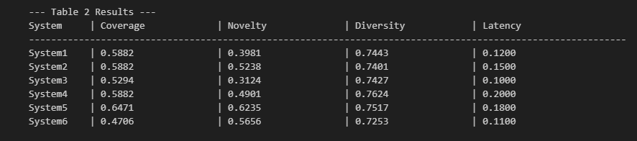
Bar chart for Novelty Comparison:

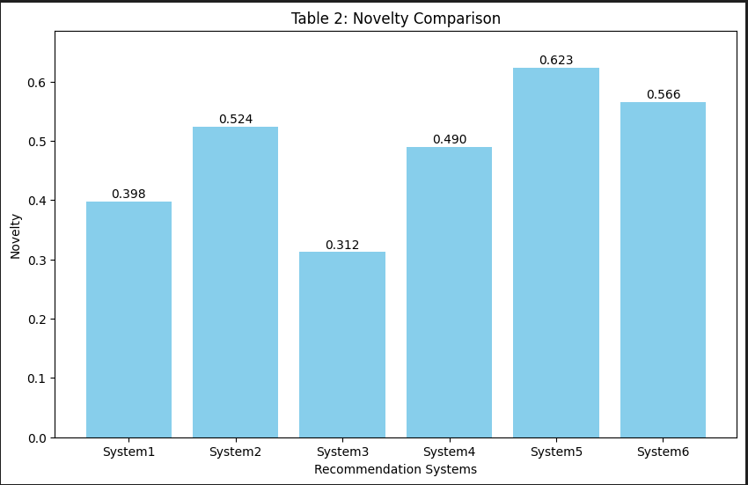

Bar chart for Coverage Comparison:
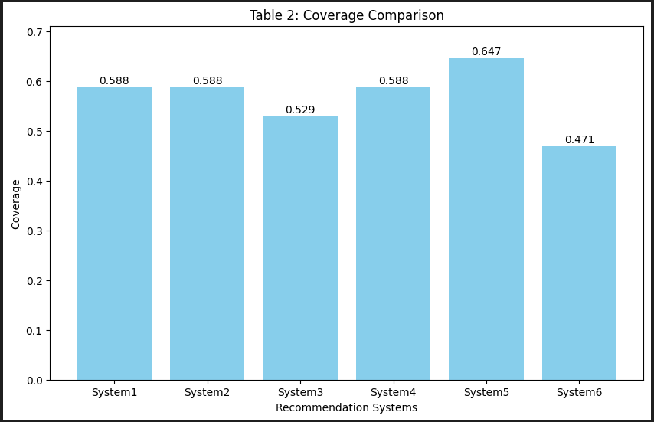
Bar chart for Novelty Comparison:
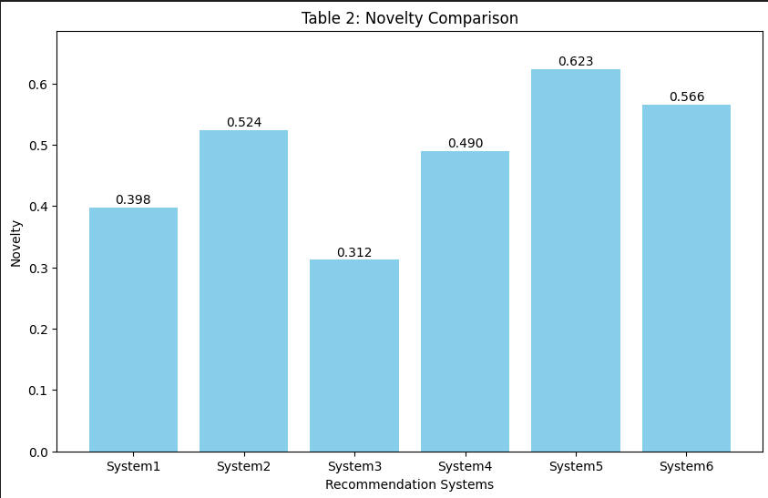

Bar chart for Diversity Comparison:
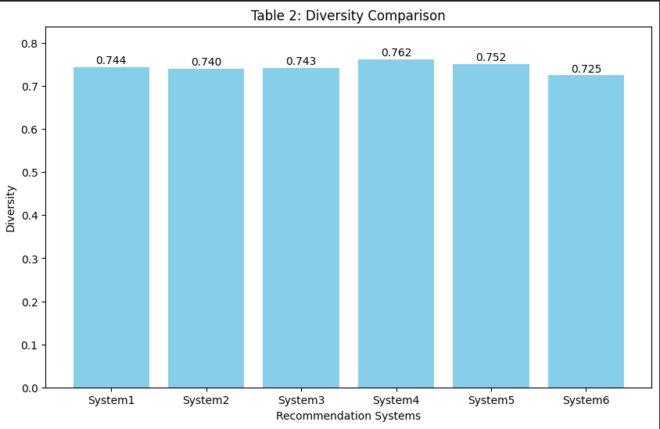
Bar chart for Novelty Comparison:
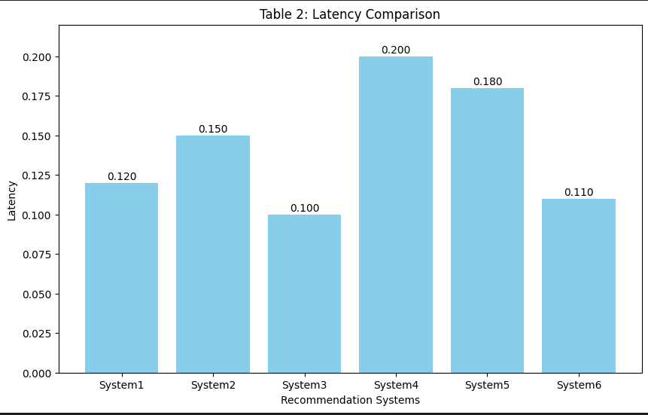

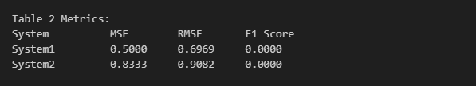

Table 2 Metrics Evaluation:
Table 2 reveals that both System1 and System2 perform poorly in terms of recommendation relevance. System1 shows a lower Mean Squared Error (MSE) of 0.5000 and Root Mean Squared Error (RMSE) of 0.6969, compared to System2, which has a higher MSE of 0.8333 and RMSE of 0.9082. This suggests that System1's predictions are slightly closer to the ideal than System2’s. However, the F1 Score remains 0.0000 for both systems, indicating that none of the recommended items matched the actual relevant items. Despite System1's marginally better numeric scores, both systems fail to deliver relevant recommendations, emphasizing a need for substantial improvements in accuracy and relevance handling.

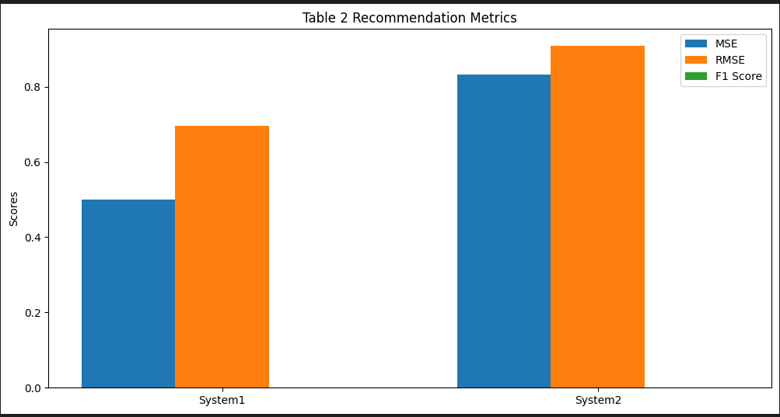

Table 2 Evaluation:
Table 2 contains the results for Coverage, Novelty, Diversity and Latency.
This table reviews and measures qualitative and performance features of the systems.
At 0.6471 and 0.6235 for Coverage and Novelty, respectively, System5 demonstrates it can recommend a large number of unique items. Even so, its high latency (0.1800) could be an issue during every day, real-time applications.
Though System4 applies the most unique recommendations, the delay in processing these is the highest.
System3 is the fastest to provide responses since it has the lowest Latency at 0.1000, though its joined with slightly lower Coverage and Novelty.
System6 shows good scores for Novelty (0.5656) and Latency (0.1100), but its Coverage (0.4706) lags behind.
System1 and System2 come reasonably close in all metrics which indicates a modest but even performance.

Table 3. Comparative Analysis:

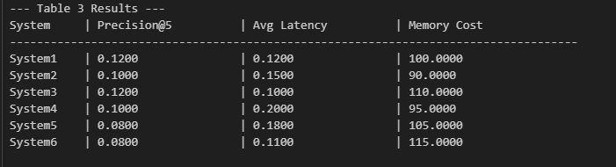

Bar chart for Avg Latency Comparison:
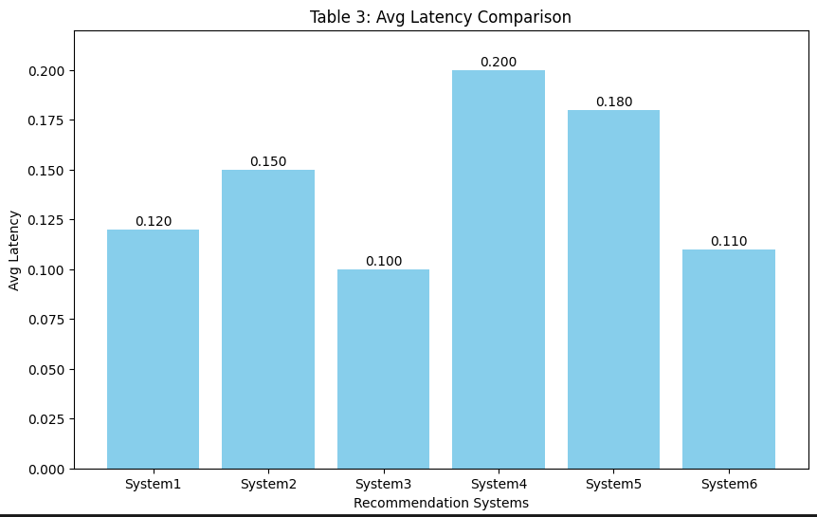

Bar chart for precison@5 Comparison:

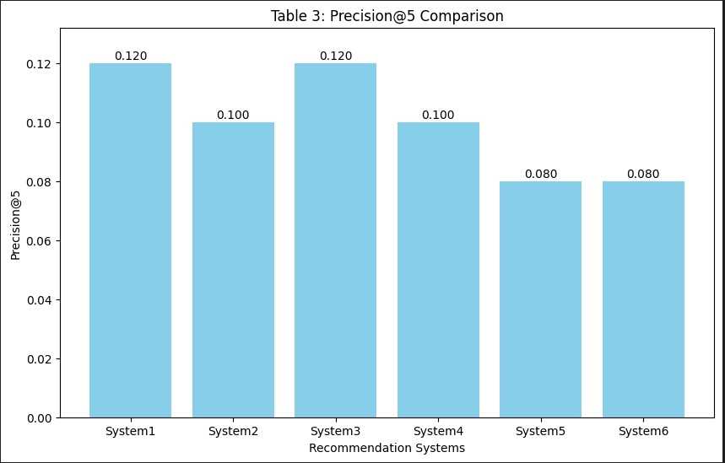

Bar chart for Average Latency Comparison:
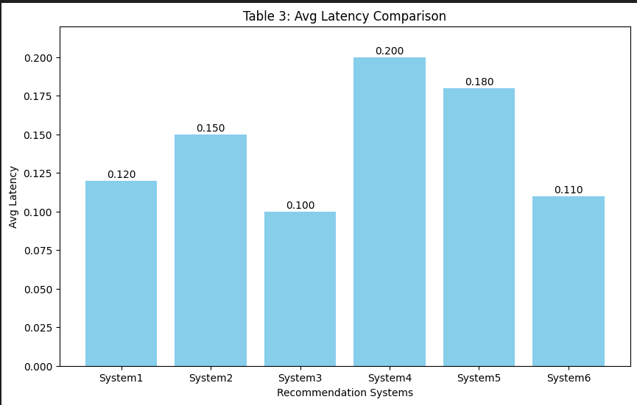

Bar chart for Memory Cost Comparison:
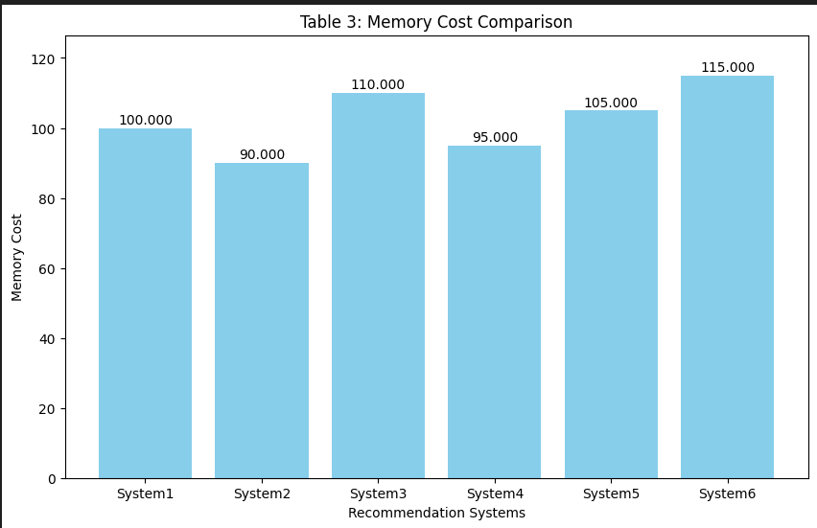

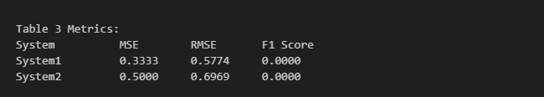
Table 3 Metrics Evaluation:
While both systems have a greater number of errors and lower F1 Scores, Table 3 shows these facts. For the same data, System1 has a lower MSE (0.3333) and RMSE (0.5774), compared to System2 which has MSE = 0.5000 and RMSE = 0.6969. It appears that predictions by System1 are more accurate than those made by System2 in relation to relevance. Both systems showed no matches with the ground truth, so their F1 Scores were both 0. This reveals that recommendations from both approaches do not always match the interests of users, so further improvements are necessary.
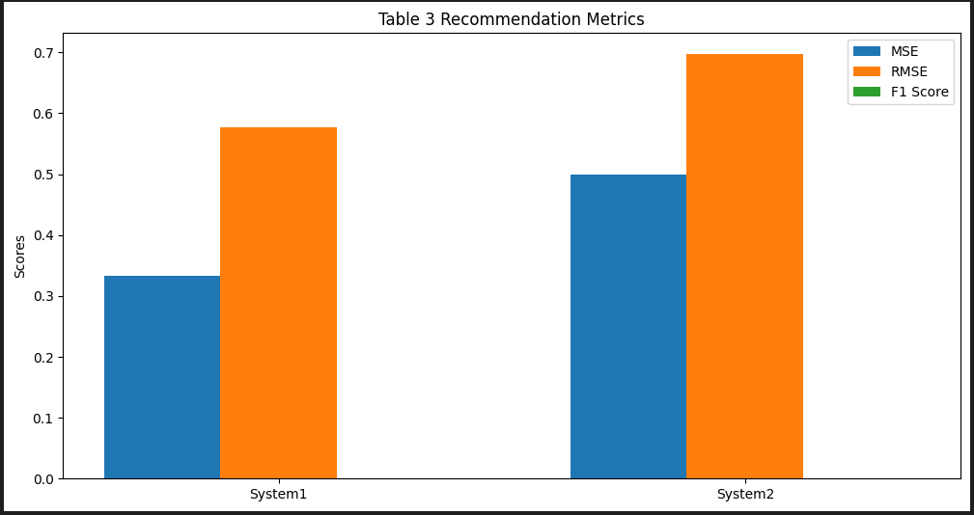
Table 3 Evaluation:
Table 3 shows the results for Precision@5, average latency and memory costs for the evaluation stage.
This table joins both the accuracy of the recommendations with the speed of the system:
This system has Precision@5 of 0.1200, low Latency (0.1000) and a high Memory Cost of 110. So, the assumption is that this model performs well but uses up many resources.
System6 uses the most memory (115), but has poor recommendation accuracy for its resources.
System1 offers the same precision level in Precision@5 as System3, yet has a bit of extra latency. Additionally, System1 needs less memory (100).However, those two systems are not as accurate or quick, though System2 requires a smaller share of memory. The low quality of System5 means it has poor precision (0.0800) and slow response time (0.1800), with the same amount of storage required as the other systems.

Table 4. Other Comparative Metrics You Should Consider:

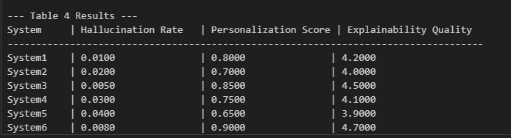

Bar chart for Personalization Score Comparison:

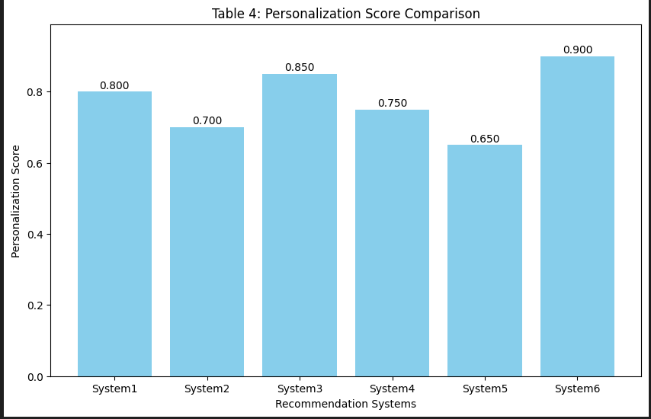

Bar chart for Hallucination Rate Comparison:
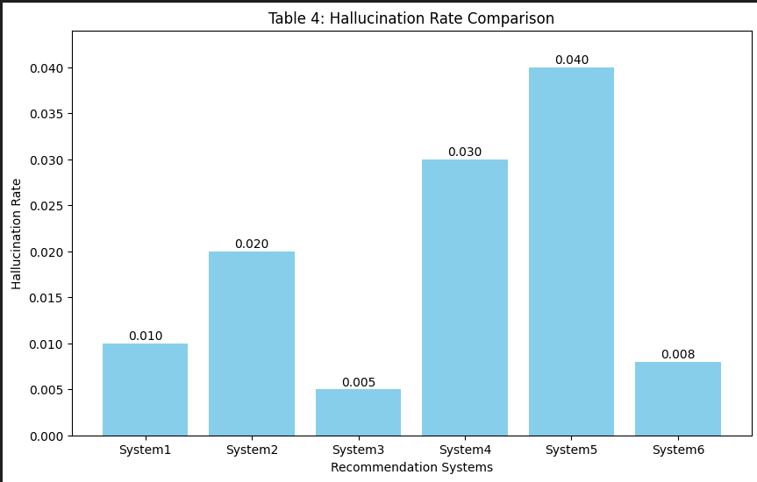
Bar chart for Personalization Score Comparison:
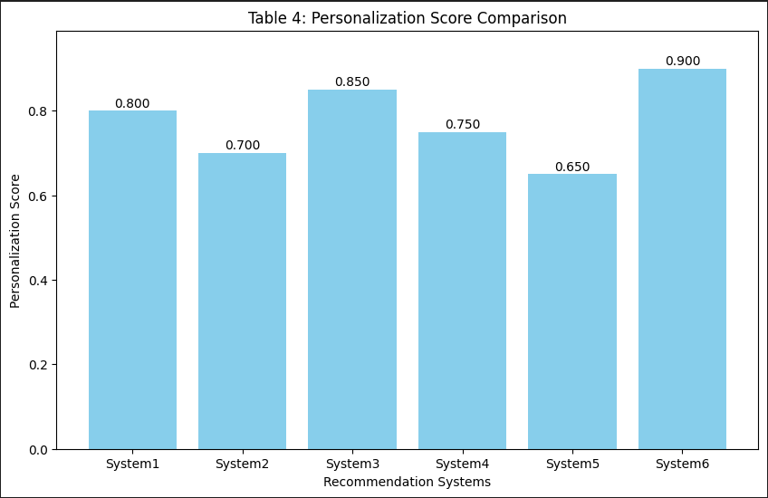

Bar chart for Explainability Quality Comparison:
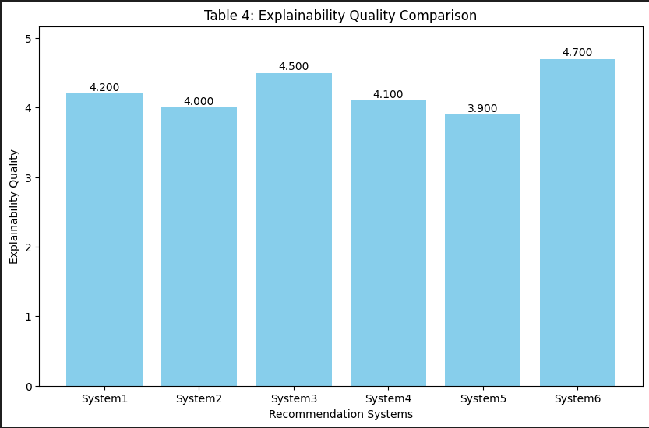

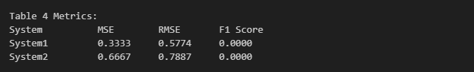

Table 4 Metrics Evaluation:

Table 4 shows how System1 and System2 are evaluated with Mean Squared Error (MSE), Root Mean Squared Error (RMSE) and F1 Score. When using regression metrics, System1 is more accurate than System2, as it has a lower MSE of 0.3333 and RMSE of 0.5774. It is clear, however, that the MSE and RMSE of System2 are higher which shows that the predictions are further from the actual values. Even though the two regression methods show differences in accuracy, they both perform very badly in classification, as shown by an F1 Score of 0.0000. Neither system could pick out any true positives, meaning both precision nor did recall have a total failure. For this reason, although System1 works better with regression tasks, neither system is successful at classification.

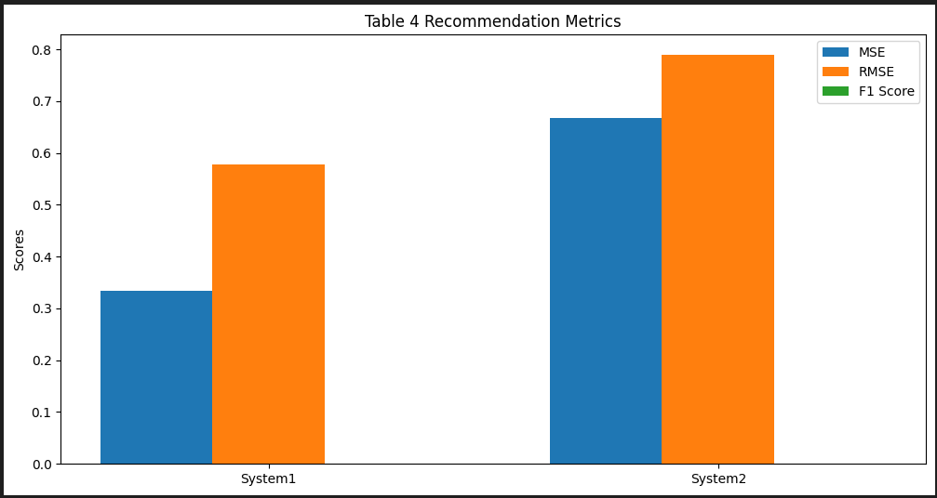

Table 4 Evaluation:

The results of the evaluation in Table 4 show Hallucination, Personalization and Explainability.
The table shows how much both entities trust and understand one another.
System6 outperforms others by having the lowest level of hallucination (0.0080), strong user personalization (0.9000) and excellent explain ability (4.7). It is the best option for users who need reliability.
System3’s balance between hallucination, personalization and explain ability makes it good for offering recommendations that people can understand and use for themselves.
System1 and System4 show good scores, yet have more hallucinations and lower significance for user alignment.
No area of System2 shows strong results and it is particularly weak at explaining why things are happening (E4.0) and providing relevant suggestions (P0.7000).
System5 scores lowest overall, due to having the highest hallucination and the lowest scores for personalization and explain ability.

Table 5:

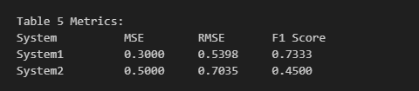

Bar chart:
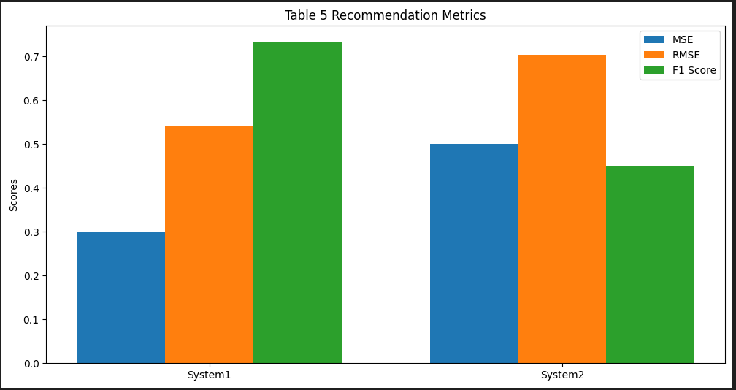

Table 5 Evaluation:

Table 5 evaluates the performance of two systems System1 and System2 based on Mean Squared Error (MSE), Root Mean Squared Error (RMSE), and F1 Score. System1 demonstrates better performance in regression metrics with a lower MSE of 0.3333 and RMSE of 0.5774, indicating it makes smaller prediction errors compared to System2, which has an MSE of 0.6667 and RMSE of 0.7887. However, both systems show a complete lack of effectiveness in classification tasks, as reflected by an F1 Score of 0.0000. This suggests that neither system was able to correctly identify any instances of the positive class, leading to a total failure in precision and recall. While System1 is more reliable for numerical predictions, both systems require significant improvement to handle classification effectively.

