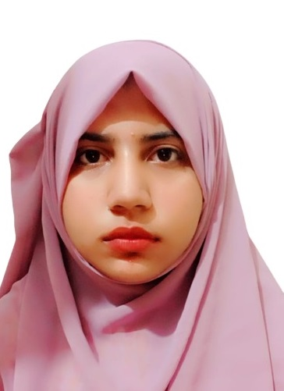

Fatimat Ul Zahra

+92 3365451035 | fatimatzahraa407@gmail.com

# About me

I am an Electrical engineer with the majors in computer engineering.I have strong foundation in math and programming skills. I made this profile to show my basic coding skills. Currently I am looking for position in lab as a researcher in the feild of Artificial Intellegence and Data Science.

# Education

**BS In Electrical Engineering**Grade A   
International Islamic University Islamabad  *2018~ 2022*

# projects

**Real Time Face emotion recognition** *Sep 2022* --> Deep Learning   
 --> DeepFace   
 --> Opencv

**Movie Recommendation System** *Aug 2022* --> Clustering models   
 --> K-nearest neighbors   
 --> Bayesian networks

**Predictive Intelligence-based Store Management System** *January 2023* --> Image Recognition   
 --> Recommender systems   
 --> Deep Learning  
 --> Edge Computation