

**E-project**

**Lab automation Online website**

**Faculty : Sir Talha**

**Project Lead By: Fatima zehra**

**Batch : 2208F2**

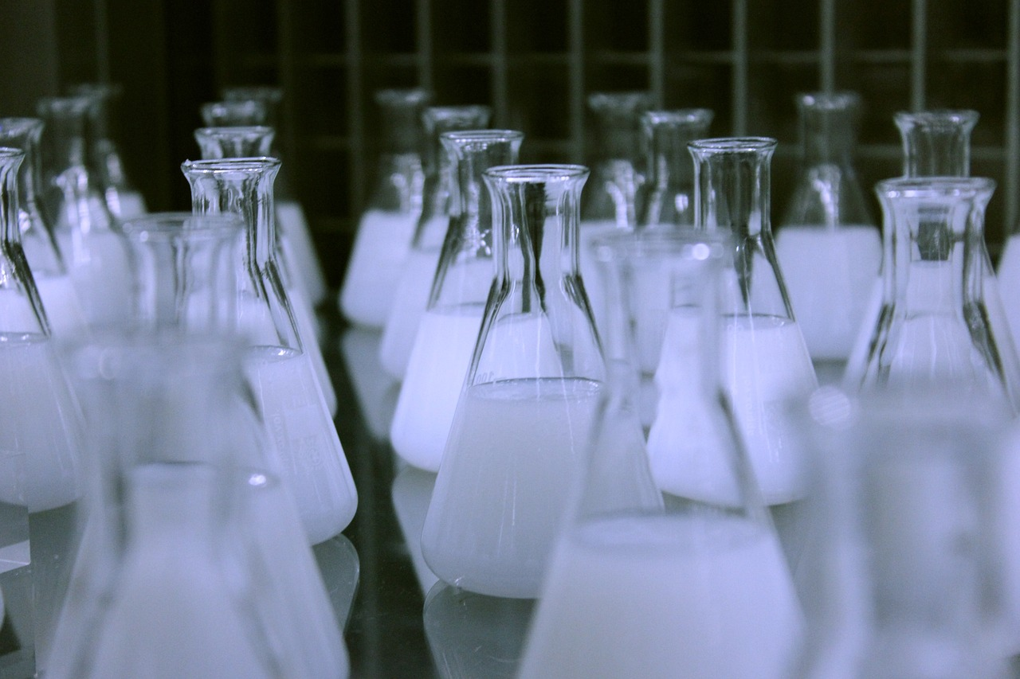



**DECLARATION**

This is to certify that this project is our original work.. Any material reproduced in this project has been properly acknowledged.

Fatima zehra (Group Leader)

Batch ID : 2208f2

StudentID:Student1408969

Kinza sheikh

Batch ID : 2208f2

StudentID:Student1405989

Muskan

Batch ID : 2208f2

StudentID: Student1408860



**ACKNOWLEDGEMENT**

 In completing this Dynamic project We have been fortunate to have help, support and encouragement from Our Group.

We would like to acknowledge them for their

cooperation. First,

We would like to thanks Sir Talha, our project advisor, for

guiding us through each and every step of the process with knowledge and support.

Thank you for your advice And guidance



DataBase diagram :

**Look of our database:**

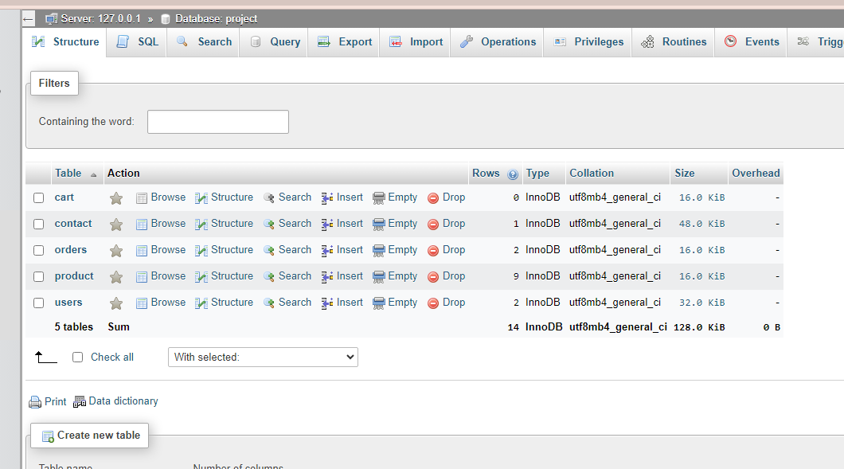

**Tables and their keys :**

Cart Table

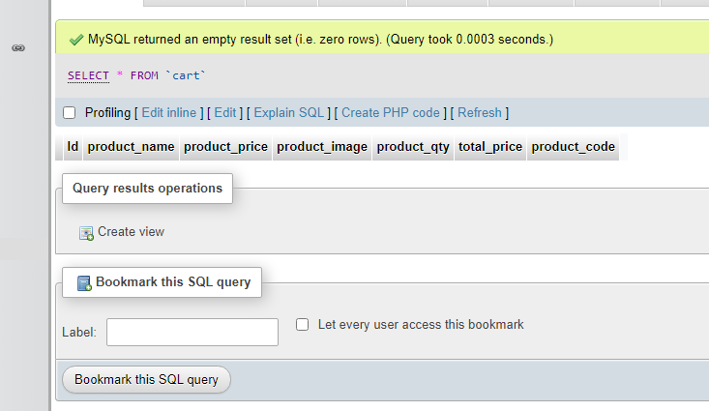

Contact table

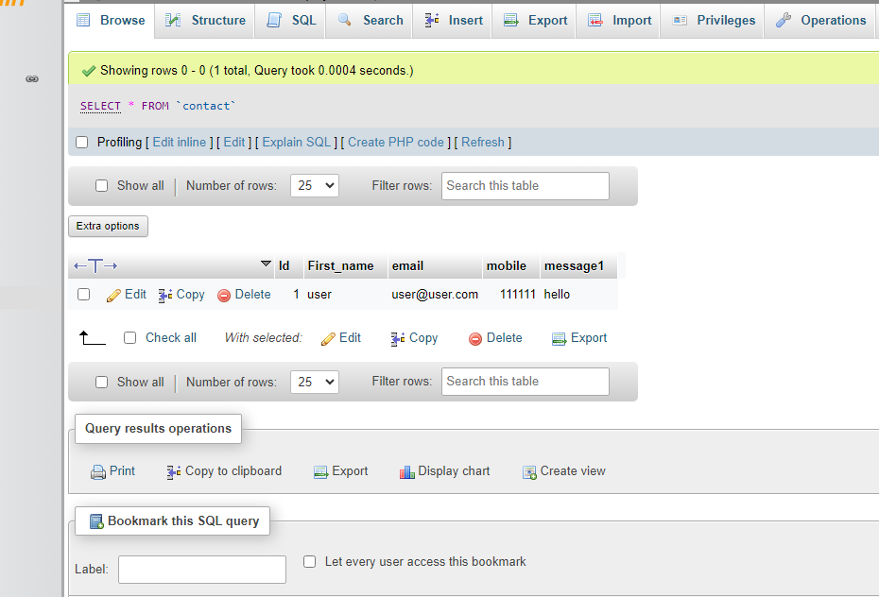

Orders table

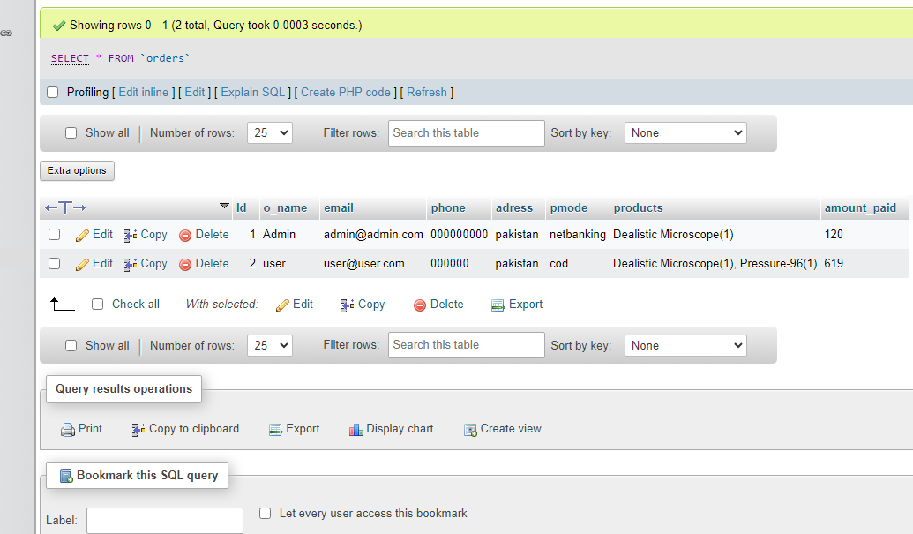

product table

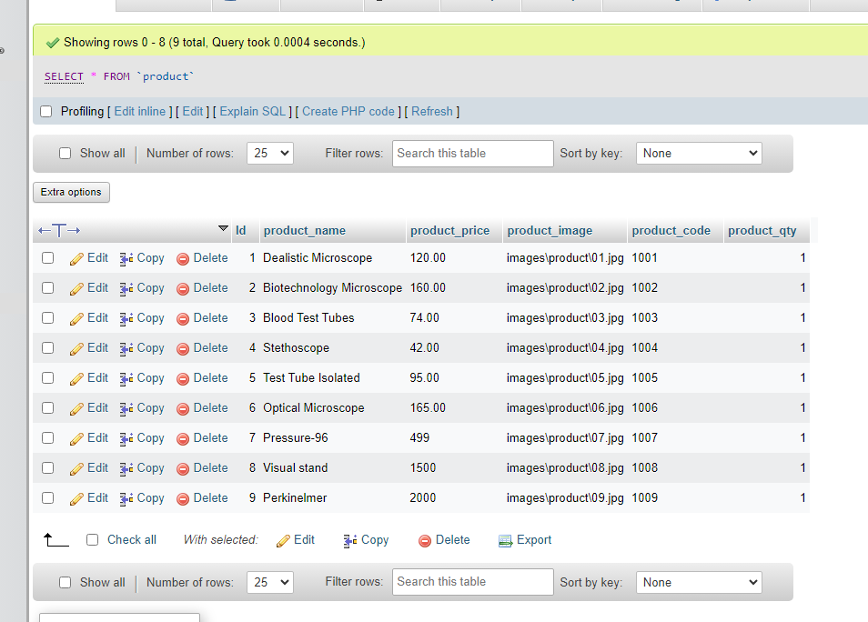

users table

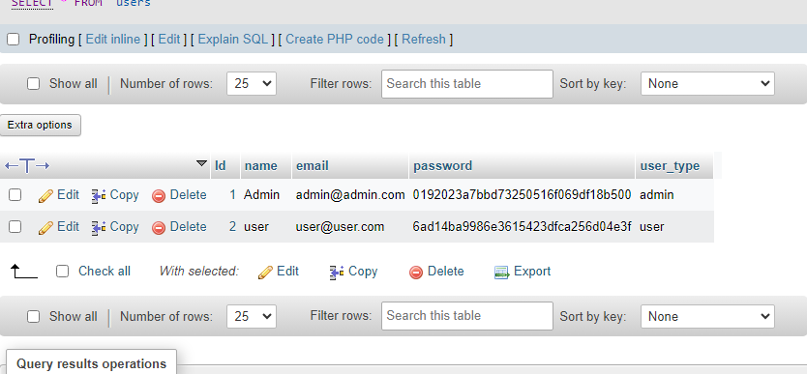

**Some  Foreign keys and primary key that joins table you can see in that picture**

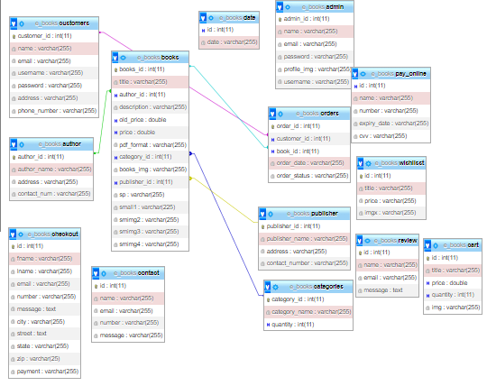

**Lab automation Introduction**

Lab automation online websites ’re here to care for you and your entire family doctor will general health!

Skills :  Our doctors include highly qualified male and female practitioners who come from a range of backgrounds and bring a diversity of skills.

Vision: Labortech will be administered through customizable programs incorporate partnership between family illness or disease management. Labortech Made With Latest Technology Bootstrap 5

### services from a clinical lab Diabetes Testing

 We have put protocols to protect our patients and staff care. Service overview With experience contracting and professional industry latest generation technological. Excepturi vero aliquam id. Lorem ipsum dolor sit amet, consectetur adipisicing elit.

### Pharmaceutical Research

Our design professionals are equippe Totam mollitia incidunt vero cupiditate obcaecati iusto tempora unde! Numquam officiis, quae adipisci quam laudantium nulla modi. adipisci quam laudantium nulla modi. Totam mollitia incidunt vero cupiditate obcaecati

Admin Panel Diagram :

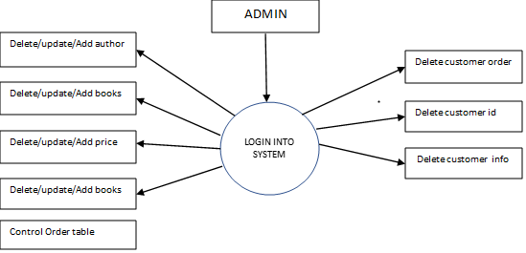

Requirements Of diagram:

the ADMIN have to enter their username or email associated with their admin account. It provides a unique identifier to ensure proper identification of the user.

Password Field: This field is used for entering the password associated with the admin account…

Admin Login Form :

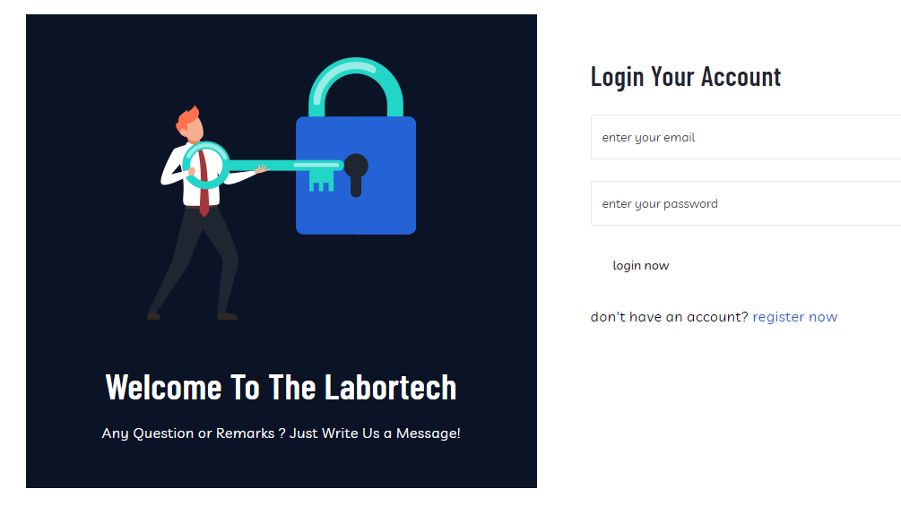

The Admin Panel Log In form is an essential component of an admin panel that allows authorized users to access the administrative functionalities and settings of a system or website. This form typically consists of input fields for the user to provide their credentials, such as username or email and password, to authenticate their identity. Here's an explanation of the key elements of an Admin Panel Log In form…

**Admin Panel DASHBOARD:**

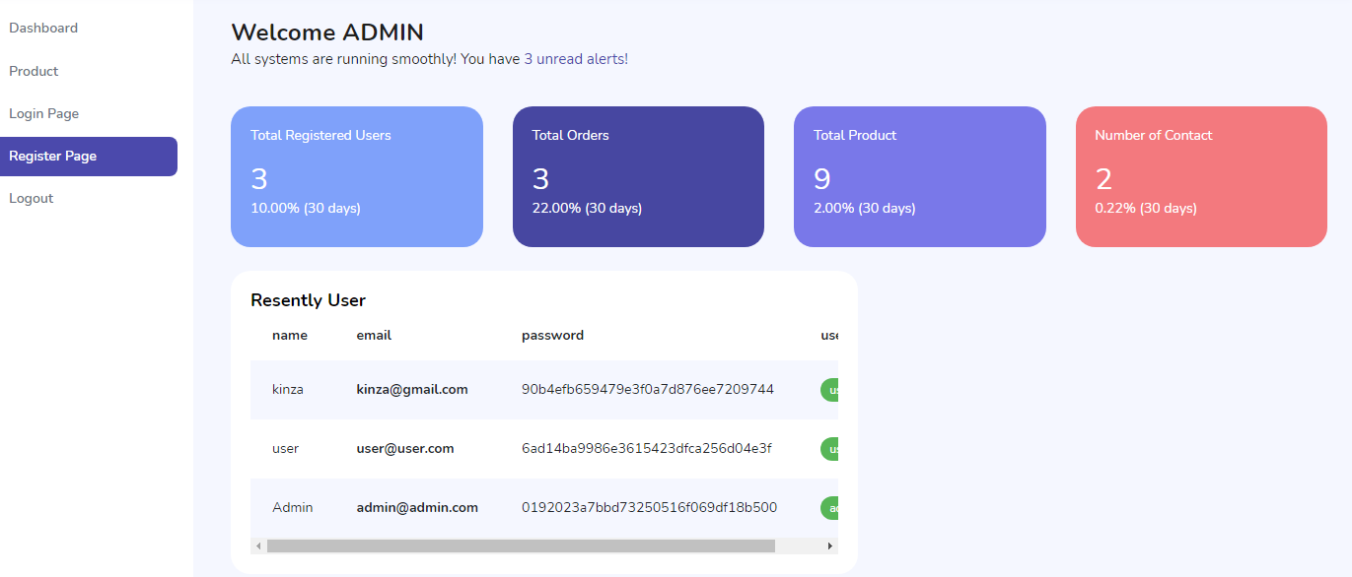

**The admin panel provides a user-friendly interface that allows administrators to perform a wide range of tasks related to managing the content, users, and settings of the labautomation website. These**

**tasks typically include:**

**min panel, also known as a backend or administrative interface, is a web-based application or section of a website that is designed specifically for website administrators or content managers to manage and control various aspects of the lab auotmation website.**

**equipments , expertise , cases  , award winning:**

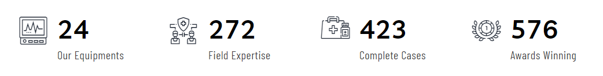

**These sections and panels in the admin panel help administrators gain insights into user activity, track , and monitor the overall performance of the website in terms of order volume.**

**This panel provides an overview of the cases of record on the website.**

**User Diagram :**

  user

  Home

Pages Shop Services Research News

**product**

**cart blog**

**checkout**

**about us**

**team**

**contact us**

**element**

**utilites**

**pathologycam testing**

**biochemistery solution**

**chemical research**

**pharmaceutical research**

**diabetes testing**

**Team page:**



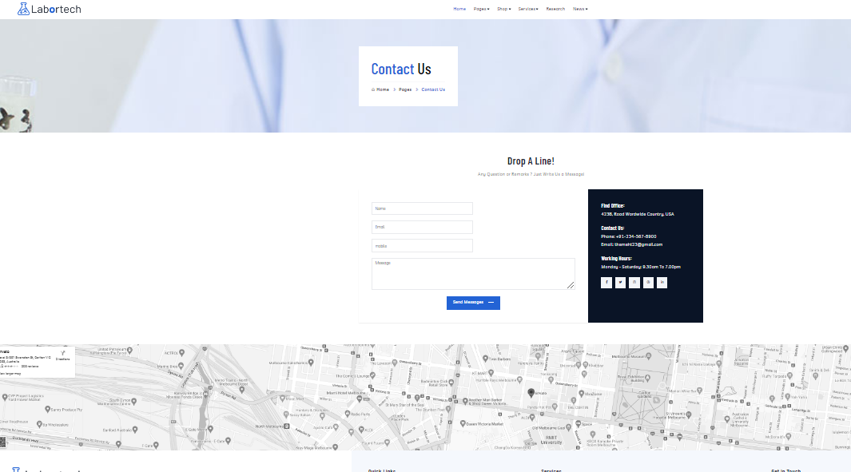

Contact form :

You can easily Contact us though our contact us page you can also send your feedback .

Here are the links we used in our project ...

<script src="https://code.jquery.com/jquery-3.6.0.min.js"></script>

<link rel="stylesheet" href="css/bootstrap.min.css">

<link rel="stylesheet" href="css/owl.theme.default.min.css">

<script src="js/vendor/jquery-1.12.0.min.js"></script>

<script src="js/bootstrap.min.js"></script>

<script src="js/plugins.js"></script>

<script src="js/slick.min.js"></script>

<script src="js/owl.carousel.min.js"></script>

<script src="js/waypoints.min.js"></script>

<script src="js/main.js"></script>

  Thank you

