**Comprehensive Analysis of Heat Transfer Mechanisms in Heat Exchanger Applications**

Fatin Uddin Bhuiyan

**Abstract**

A heat exchanger is a device designed to facilitate the transfer of thermal energy between two or more fluids at different temperatures in thermal contact. They are extensively utilized across various industries, including aerospace, chemical processing, power generation, refineries, and HVAC refrigeration systems. The optimal design and efficient operation of heat exchangers and heat transfer networks are critical for enhancing industrial efficiency, reducing production costs, and minimizing energy consumption.

This study examines the influence of inner pipe geometry in double-pipe heat exchangers, specifically comparing triangular, hexagonal, and octagonal configurations. Additionally, the performance of double-pipe heat exchangers was evaluated with and without dent patterns using Computational Fluid Dynamics (CFD) analysis in ANSYS. The results provide insights into efficient heat transfer outcomes derived from CFD simulations. Based on a review of the literature, key factors affecting heat exchanger efficiency and methods for improvement are also discussed.

**Keywords:** CFD analysis, Heat exchangers, Heat transfer analysis, Heat equation temperature, Temperature equilibrium.

**Introduction**

Industrial heat exchangers are industrial equipment that is designed to exchange heat from one medium to another. The primary purpose of heat exchangers is heating the element or cooling it down. Within the industrial sector, cooling has a more important function to prevent equipment from overheating. There are many types of heat exchangers, each has its advantages and drawbacks. Heat exchangers have a broad range of industrial applications. They are used as air conditioning components in various cooling systems and heating systems. In general, many industrial processes need to be operated at certain degree of heat. For this, Great care must be taken to maintain these processes at optimum temperature. Within industrial plants, heat exchangers are highly required to keep machinery, chemicals, water, gas and the other substances within a safe operating temperature. Heat exchangers are also used to capture the excessive heat or steam, that is released as a byproduct during the operation, So that heat can be put to better use elsewhere, thereby efficiencies are improved. Different types of heat exchangers function in different ways, use different flow arrangements, equipment, and design features. One common thing in all heat exchangers is that, they all function to directly or indirectly expose a warmer medium to a cooler medium. Heat exchangers are usually accomplished with a set of tubes within some type of casing.

Heat exchangers are generally classified by following ways,

• Nature of the heat exchange process.

• The physical state of the fluid.

• Heat exchangers flow arrangements.

The heat exchanger classification method depends on, whether or not the substance between which the heat is being exchanged come into direct contact with each other or not, whether they are separated by a physical barrier such as the walls of their tubes. In direct contact heat exchangers, the hot and cold fluid comes into direct contact with each other within the tubes rather than on radiant heat or convection. Direct contact is an extremely effective means of transferring heat since the contact is direct, These Direct contact heat exchangers must function in a safe environment. Direct contact heat exchangers are suitable if the hot and cold fluid have slight temperature variation. When it comes to the in-direct contact heat exchanger, the hot and cold fluids are physically separated from each other. In general, an indirect contact heat exchanger will keep hot and cold fluids in a different set of pipes instead of radiating energy and convection to exchange the heat. This is done to prevent contamination of one fluid by the other.

Heat exchangers may also be classified based on the physical state of the hot and cold fluid such as,

• Liquid → Gas.

• Liquid → Solid.

• Gas → Solid.

In some situations, immiscible liquids may also exist that will not blend. E.g.: Oil and water. The arrangement of fluids flow within the heat exchanger is another important way of classifying heat exchangers. The three major categories are parallel flow, Counterflow, and Crossflow. In the parallel flow heat exchanger, the hot and cold fluid moves into the heat exchanger from the same end and flow parallel to each other in the same direction. Although, these arrangements result in lower efficiency than a counterflow arrangement, it allows achieving greater thermal uniformity across the walls of the heat exchanger. In the counterflow heat exchanger, the hot and cold fluid enters the heat exchanger from the opposite direction and flow towards each other.

The most commonly employed configuration of the flow is counter flow arrangements. This arrangement exhibits the highest efficiency as it allows a greater amount of heat transfer between fluids. In the cross-flow heat exchanger, fluids flow perpendicular to one another. The efficiency of the heat exchanger which employs this flow type falls between that of counter-current and co-current heat exchanger.

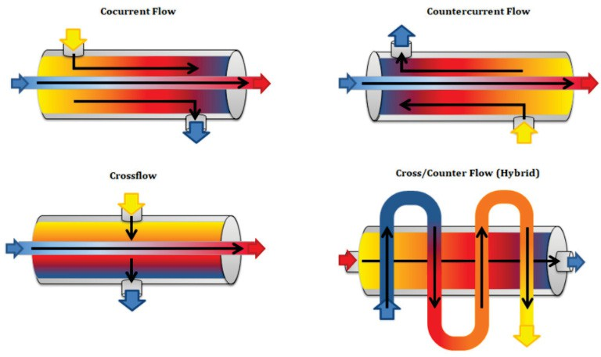

Figure 1: Heat exchanger flow configuration.

## Literature Review

A heat exchanger is a device used to transfer thermal energy between two or more fluids, between a fluid and a solid, or between solid particles and fluid particles, at different temperatures while maintaining thermal contact. Typically, heat exchangers are used for heating or cooling fluid streams and for the evaporation or condensation of various fluids. They are employed to reject heat or facilitate processes such as distillation, concentration, crystallization, and fluid control. In heat exchangers, heat transfer occurs between the fluid and a separating wall, or across the wall to the surrounding environment, typically in a transient manner. The fluids are separated by a heat transfer surface, and ideally, there is no mixing or leakage between them. Such exchangers are termed **direct heat transfer exchangers**.

In **indirect heat transfer exchangers**, heat exchange occurs intermittently between hot and cold fluids, transferring and releasing thermal energy through the heat exchange surface. These types of exchangers may face issues such as fluid leakage between the two fluids due to valve switching, matrix rotation, or pressure differences. In cases where fluids are immeasurable, the separating wall may be removed entirely, resulting in **direct contact heat exchangers**.

Common heat exchangers include shell-and-tube heat exchangers, automobile radiators, air pre-heaters, cooling towers, evaporators, and condensers. Heat exchangers can be designed for specific applications depending on requirements, such as those with internal heat sources like electric heaters or nuclear fuel elements. In heat exchangers like boilers and fired heaters, chemical reactions (e.g., combustion) are used for heat exchange. Meanwhile, in inscribed surface exchangers and stirred tank reactors, mechanical devices are used for heat transfer. In **conduction or heat pipe heat exchangers**, heat transfer occurs between separating walls, where the pipe does not act as a separating wall but enables heat transfer through conduction, evaporation, and conduction of the working fluid inside the heat pipe.

A new design for heat exchangers was proposed by Josua P. Meyer and Hilde Vander Vyver, aiming to significantly increase the heat transfer area using fractals. The study, through analytical, numerical, and experimental methods, showed that fractal-based heat exchangers exhibit higher heat transfer per unit volume compared to conventional tube heat exchangers.

Hesham G. Ibrahim analyzed forced convection in turbulent flow using empirical models and numerical solutions from CFD analysis to investigate turbulent flow patterns and heat transfer from air walls in a horizontal pipe. Although turbulent flow was not the focus of this study, it contributed to a deeper understanding of the empirical correlations of Nusselt’s number.

Mehrain Hashemian and Samad Jafarmadar introduced conical tubes to improve the geometry of double-pipe heat exchangers. Nine different tube arrangements with varying flow directions were examined. The study showed a 55% increase in effectiveness and a 40% improvement in heat transfer performance.

A comprehensive review of double-pipe heat exchangers was conducted by Mohamad Omidi and Mohamad Jafari, exploring the impact of geometric shape changes on heat transfer rates. The review also discussed various heat transfer enhancement methods, with a focus on the role of nanofluids in double-pipe heat exchangers. Additionally, mathematical correlations for Nusselt’s number and pressure drop coefficients were presented.

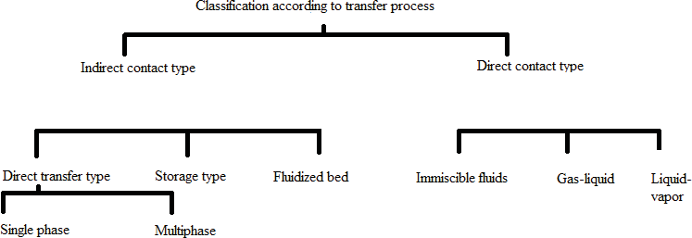

Figure 2: Classification of heat transfer.

**Methodology**

While we are considering simple heat conduction applications that consist of simple geometries with simple boundary conditions, which are easier to solve analytically. But in practical day-to-day applications, we come across various complex geometries and complex boundary conditions or variable properties which are very difficult to solve analytically in such cases accurate approximate solutions can be obtained by using computers with numerical methods. Analytical solution methods are applied by solving the governing differential equation concerning the boundary conditions these results in solution function for the temperature at every point of the medium. Whereas, on another hand numerical method are applied by replacing differential equations by a set of n algebraic equations for the unknown temperature at n selected points in the medium, solutions of these equations results in temperature values at those discrete points. There are various types of numerical methods for solving heat conduction applications such as the finite differential method, finite element method, the boundary element method, and energy balance method, etc. these methods have their advantages and disadvantages in practical usage.

**Results**

1. **Influence of heat transfer in the presence of triangular inner pipe.**

A double-pipe heat exchanger was designed using a triangular-shaped inner pipe to analyze the heat transfer along its length. The outer tube was made of brass, while the inner tube was constructed from copper. Ethanol was used as the fluid flowing through the inner pipe, and water flowed through the outer pipe. The inlet temperature of the ethanol was set to approximately 78°C, while the water entered at 100°C. After running the simulation, it was found that the temperature of the ethanol decreased by 0.5°C from the inlet to the outlet. Meanwhile, the temperature of the water increased gradually. A counterflow configuration was implemented in this simulation. Below are the contour plots showing the temperature and pressure distributions.

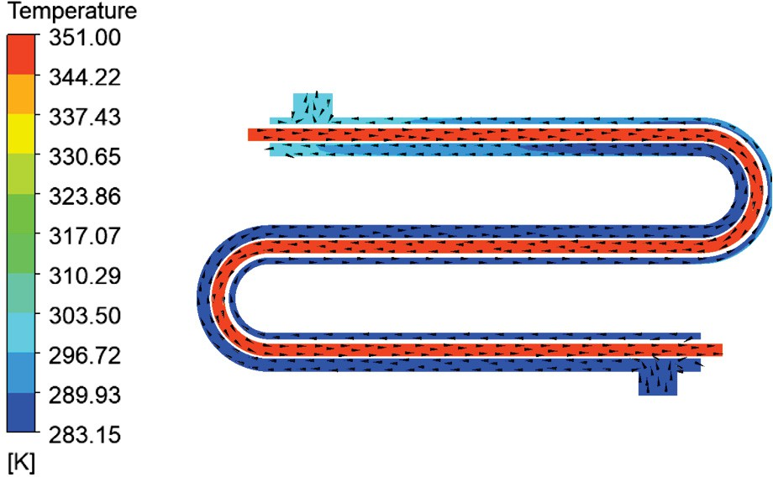

Figure 3: Temperature distribution along the length of the triangle shaped inner pipe.

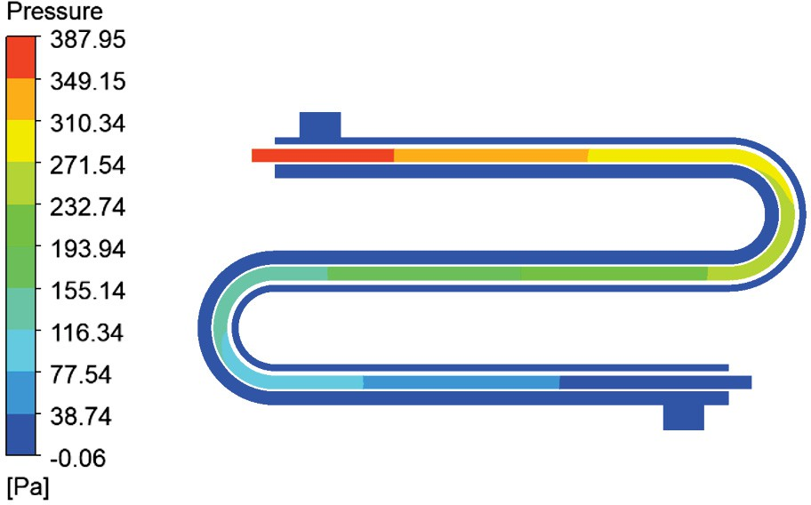

Figure 4: Pressure distribution along the length of the triangle shaped inner pipe.

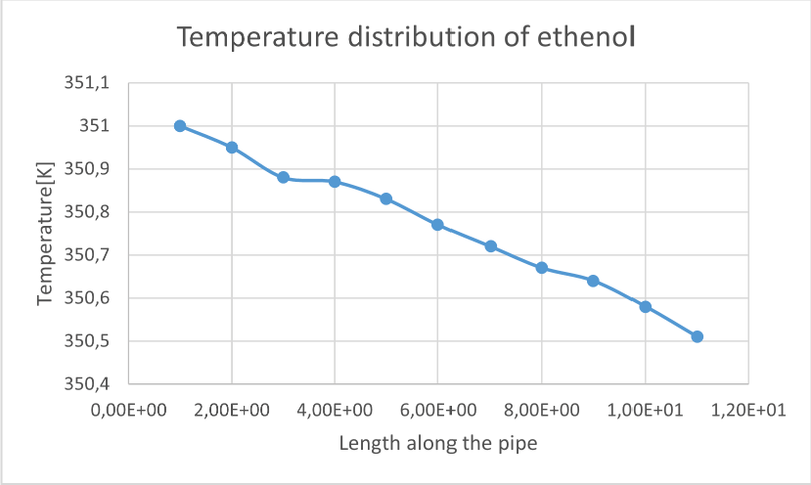

Figure 5: Temperature distribution of ethanol for triangular inner pipe.

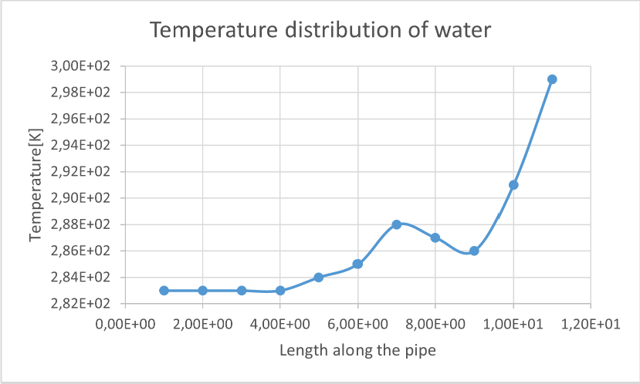

Figure 6: Temperature distribution of water for triangular inner pipe.

1. **Influence of heat transfer in the presence of Hexagonal inner pipe**

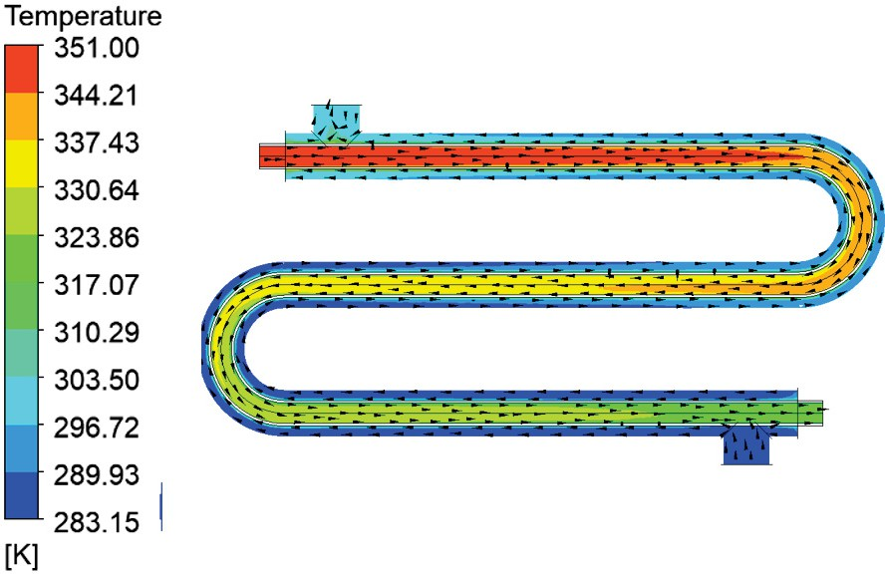A double-pipe heat exchanger was constructed using a hexagonal-shaped inner pipe to study heat transfer along the length of the exchanger. Materials such as brass and copper were chosen for the construction, with the outer pipe made of brass and the inner pipe made of copper. The temperature of ethanol was set at 78°C at the inlet, while the water temperature was maintained at 100°C at the inlet. After running the simulation, the temperature of ethanol gradually decreased from 351 K to 316.52 K. Below are the temperature and pressure contour plots for the heat exchanger with the hexagonal inner pipe.

Figure 7: Temperature distribution along the length of the hexagonal inner pipe.

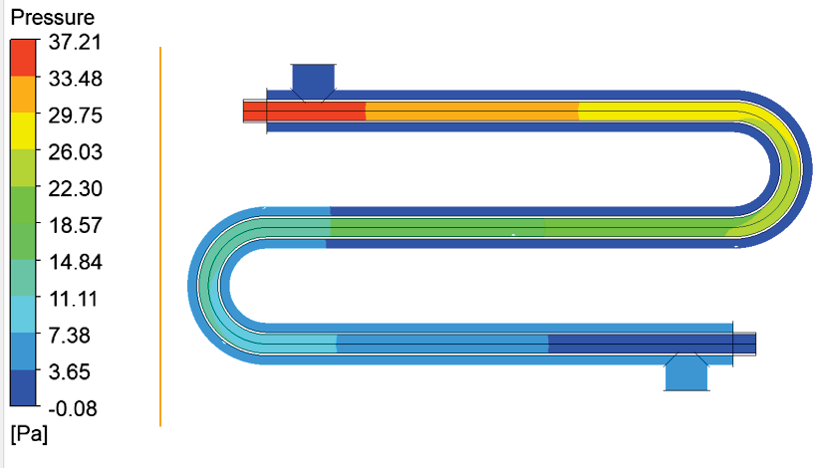

Figure 8: Pressure distribution along the length of the hexagonal inner pipe

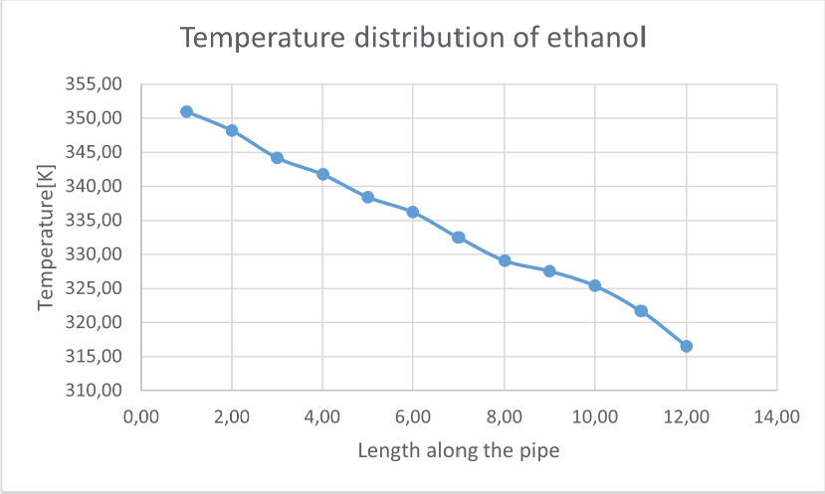

Figure 9: Temperature distribution of ethenol for hexagonal inner pipe

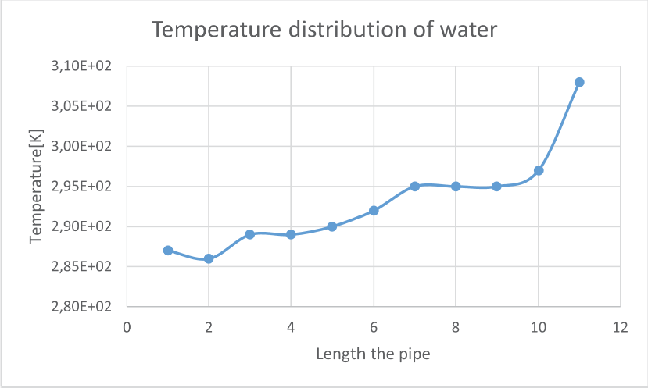

Figure 10: Temperature distribution of water for hexagonal inner pipe

1. **Influence of heat transfer in the presence of octagonal inner pipe.**

A double-pipe heat exchanger was constructed with an octagonal-shaped inner pipe to examine heat transfer along the length of the pipe. Brass and copper were used as materials for the construction. The inlet temperature of the ethanol was set to 78°C, while the water inlet temperature was 100°C. After conducting the simulation, it was observed that the ethanol temperature decreased from 351 K at the inlet to 319.84 K at the outlet.

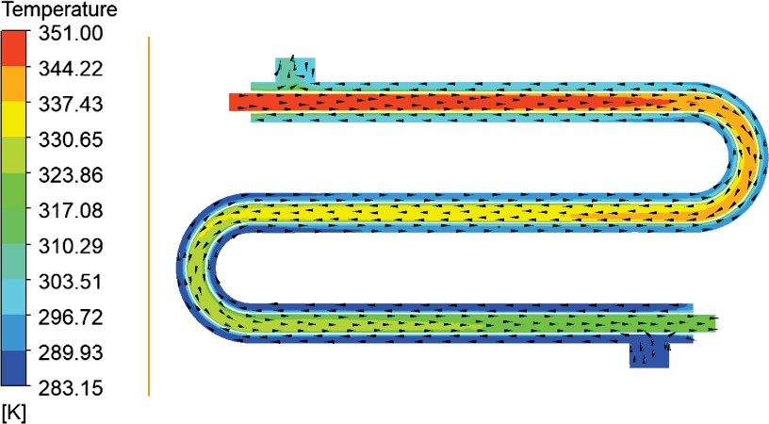

Figure 11: Temperature distribution along the length of the octagonal inner pipe.

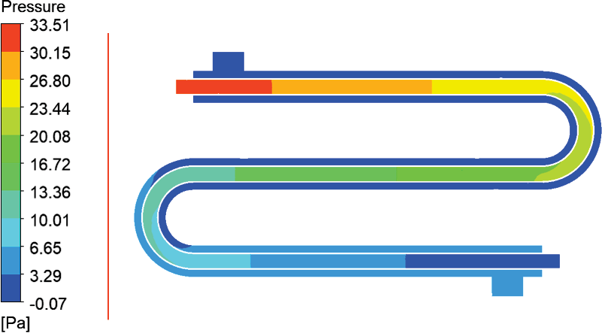

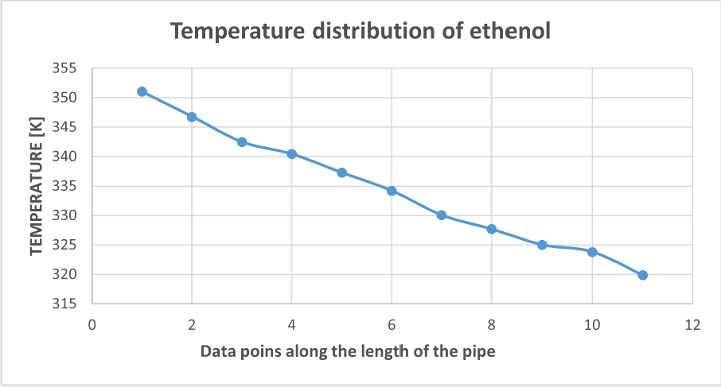Figure 12: Pressure distribution along the length of the octagonal inner pipe.

Figure 13: Temperature distribution of ethanol for octagonal shaped inner pipe

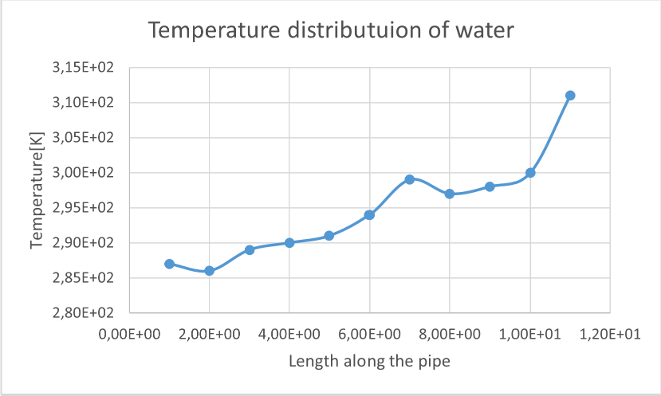

Figure 14: Temperature distribution of water for octagonal shaped inner pipe

**Comparison of temperature distribution along the length of the pipe of a double pipe heat exchanger.**

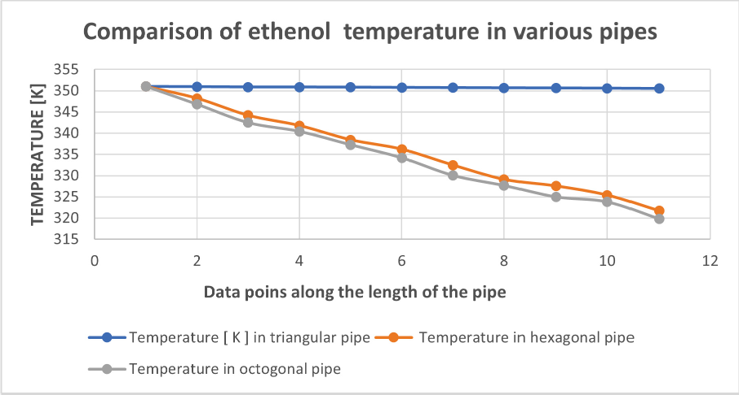

Figure 15: Temperature between various pipe shapes.

1. **Influence of heat transfer in the presence of dent to the inner pipe of heat exchanger.**

A numerical simulation was performed on a simple double-pipe heat exchanger model to analyze heat transfer and thermal hydraulic performance, with the inner pipe's external surface featuring a dent pattern. The hot fluid flows through the inner pipe from one end to the other at a mass flow rate of 0.125 kg/sec, with an inlet temperature of 82°C. The cold fluid in the outer pipe has a mass flow rate of 0.215 kg/sec, with an inlet temperature of 32°C. The simulation results indicated that the heat transfer rate of the double-pipe heat exchanger with the dented surface pattern showed a significantly better heat exchange rate compared to the plain surface.

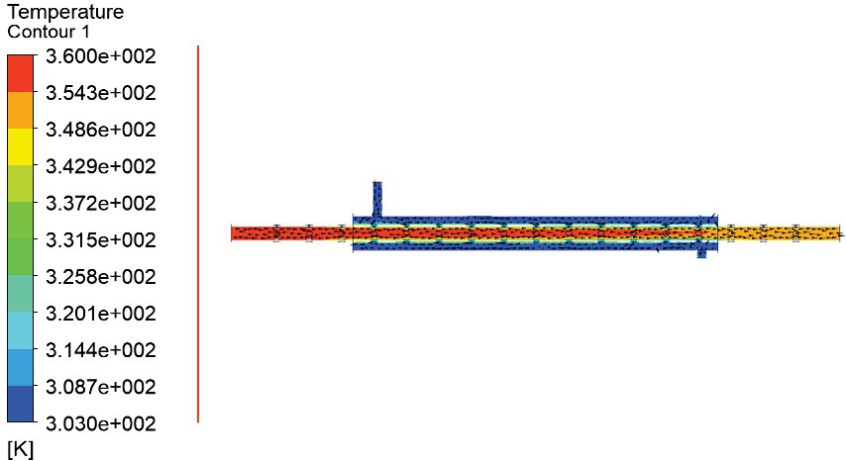

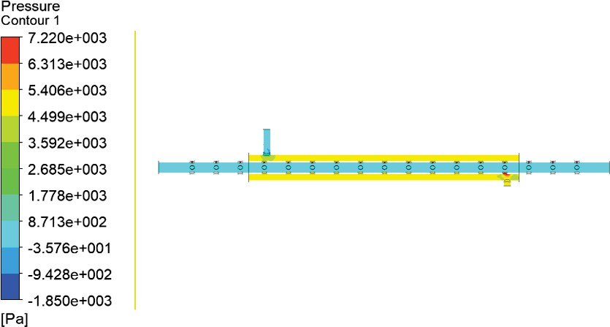Figure 16: temperature with dent along the length of the pipe.

Figure 17: Pressure distribution with dent along the length of the pipe.

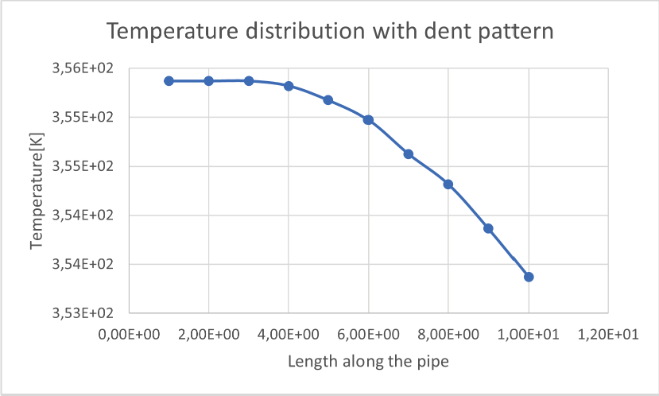

Figure 18: Temperature distribution for dent pattern along the length of the pipe.

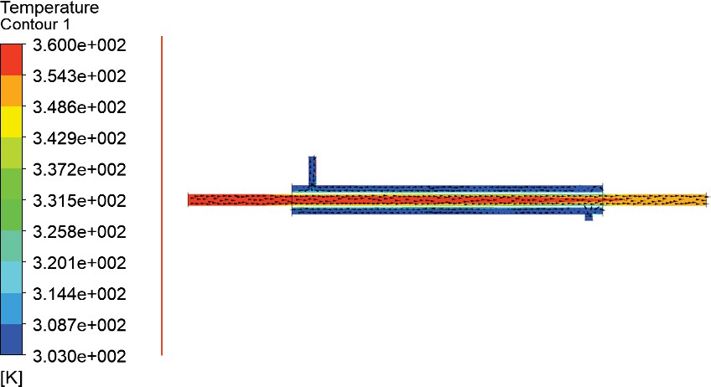

Figure 19: Temperature distribution without dent along the length of the pipe

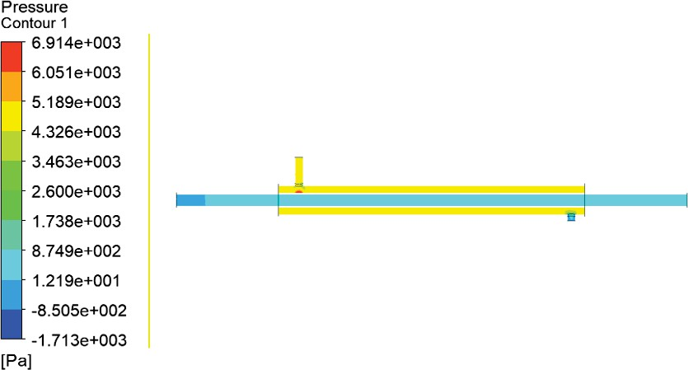

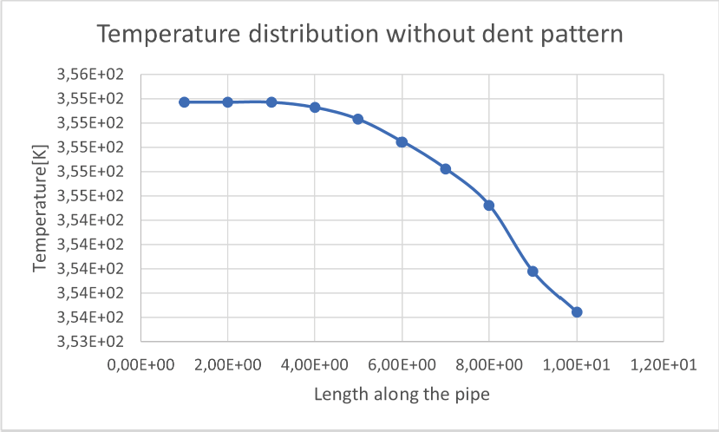Figure 20: Pressure distribution without dent along the length of the pipe.

Figure 21: Temperature distribution without dent pattern along the length of the pipe.

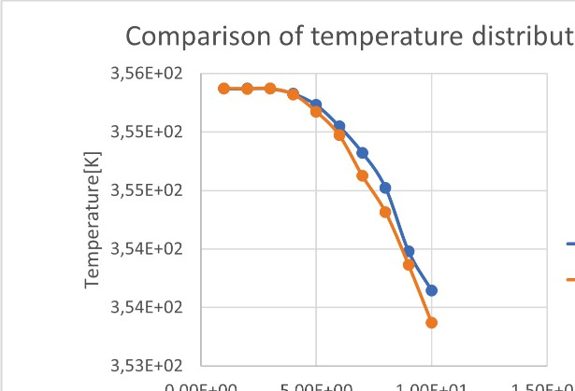

Figure 22: Comparison of temperature distribution between with and without dent.

**Conclusions and Discussions**

This thesis focuses on analyzing heat transfer parameters for various tube shapes, including triangular, hexagonal, and octagonal. In the construction of the double-pipe heat exchanger, brass was selected for the outer pipe due to its machinability, ductility, wear resistance, and hardness. Copper was chosen for the inner pipe because of its high melting point, excellent thermal conductivity, and ductility. Ethanol was used as the hot fluid flowing through the inner pipe, as double-pipe heat exchangers are commonly used in the oil and gas industries. Water was chosen as the fluid in the outer pipe to absorb heat from the heat exchanger and maintain the optimal temperature of the fluid inside.

Standard boundary conditions were applied, with the ethanol inlet temperature set to 78°C and the water inlet temperature set to 100°C. The flow volume inside the tubes was maintained constant across all pipe shapes. The results showed that the octagonal-shaped inner pipe provided the best heat transfer performance compared to the triangular and hexagonal shapes, as observed in Figures 3, 5, 7, and 9. The contour plots indicated that the pressure distribution was minimal in the octagonal inner pipe compared to the other two shapes, as shown in Figures 4, 6, and 8. Based on these results, we concluded that increasing the number of sides on the pipe while maintaining a constant inner fluid volume and pipe thickness enhances the heat transfer rate.

This study also explored various methods to improve heat transfer in double-pipe heat exchangers. One key observation was that adding a dent pattern to the external surface of the inner pipe yielded optimal results. While manufacturing pipes with complex shapes can be challenging, we focused on using a standard circular pipe and adding a dent pattern around its external surface. The simulation results demonstrated that the presence of the dent pattern led to better heat transfer compared to the plain circular pipe, as shown in Figures 10 and 12. Additionally, the maximum pressure observed in the dented pipe model, as seen in Figures 11 and 13, was higher than that of the plain circular pipe.

The efficiency of a heat exchanger is influenced by several factors, including its thermal, mechanical, and manufacturing designs. The thermal design involves optimizing heat transfer for specific flow conditions and temperatures of both cold and hot fluids. Mechanical design takes into account factors such as the temperature and pressure range, thermal expansion, and corrosion resistance. After these aspects are considered, the manufacturing design proceeds, which involves selecting appropriate materials, determining the size of tubes and shells, and ensuring the design meets the application requirements. Material selection is based on factors like water quality and operational maintenance needs. Parameters such as chloride levels, dissolved oxygen, sulfide levels, pH value, and fluid temperature must be regulated to maintain water quality.

Proper operation and maintenance of heat exchangers can extend their lifespan and improve their efficiency. Although these maintenance activities can increase production costs, they offer long-term benefits. The most common methods for improving heat exchanger performance are online and offline cleaning. Online cleaning allows for the removal of fouling and scaling without shutting down the heat exchanger, making it ideal for industries where chemical treatments are used to prevent performance degradation and prolong tube life. This method typically involves a recirculating ball-type system or bracket system.

Offline cleaning, also known as the pigging method, involves using a bullet-like substance to clear the tubes of debris by forcing it through the pipes under high pressure. This technique, along with chemical cleaning, hydro blasting, and hydro lancing, is widely used to restore heat exchanger efficiency and reduce operational costs. Regular use of these cleaning methods helps maintain optimal performance before scaling and fouling impact the efficiency of the heat exchanger.