

**East West University**

***Department of Computer Science and Engineering***

**Project Report**

**Course Code: CSE365**

**Course Title: Artificial Intelligence**

**Section: 03**

**Semester: Fall-2017**

***Submitted By:***

**Md. Fatin Istiaq 2015-1-60-044**

**Md. Ruhel Talukder 2015-1-60-013**

***Submitted To:***

**Amit Kumar Das**

**Lecturer**

**Department of Computer Science and Engineering**

**East West University**

**Date of Submission: December 10, 2017**

**Abstract:**

A chatbot (also known as a talkbot, chatterbot, Bot, IM bot, interactive agent, or Artificial Conversational Entity) is a computer program which conducts a conversation via auditory or textual methods.Such programs are often designed to convincingly simulate how a human would behave as a conversational partner, thereby passing the test. Chatbots are typically used in dialog system for various practical purposes including customer service or information acquisition. The name of our project is chatbot (admission help zone). In our project we try to develop a web based chatbot with what people can get information about EWU. In this work, we explain the design of a chatbot that is specifically tailored for providing information system for university students and with the objective of an undergraduate advisor in student information desk. The chatbot accepts natural language input from users, navigates through the Information Repository and responds with student information in natural language. The design semantics includes HTML (Hyper Text Mark up Language) specification language for authoring the information repository such that chatbot design separates the information repository from the natural language interface component.

**Introduction:**

A chatbot is a program that is used to participate in conversations with humans. It uses an appropriate interface for input and output and with the use of AI techniques it can provide realistic answers so the user will think that the communication taking place is with another human. The implementation of such systems varies from using keyword matching, string similarity or complex natural language processing techniques. More sophisticated chatbots could learn from the user input. Nowadays chat bots are used widely in web applications in order to provide help or information when it is asked by the users.

Although the admissions process works properly as it is, it is very difficult and time consuming to contact a member of staff of the university. However, the problem would be partially solved if the applicant could talk to a convincing chatbot, able to respond to their concerns with information about admissions, booking accommodation, paying fees in instalments and what pre-sessional courses are on offer. The chatbot should be able to communicate with a user in a way similar to the following:

ChatBot: Hello how can I help you?

User: What is the minimum score of HSC required for entry into BSc Computer Science?

ChatBot: The minimum requirement is a total score of 4.0 with no less 3.5 in any subject.

User: what is the minimum requirement to admit in department of CSE?

ChatBot: To enter the program, you need to have at least GPA 5.0 in SSC or HSC.

**Related work:**

Chatbots are used in many organisations instead of humans when this is possible. Most of the time systems like that are based on the ways ELIZA, ALICE, Mitsuku, Cleverbot or Answer Bot communicates and also now a days chatbot is also used in facebook platform which is reduced the admins time to chat manually with the user.

**Chatterbot Eliza:**

Created in 1966 as an early natural language processing (NLP) computer program that emulates a Rogerian psychotherapist, a clinical practice that allows clients to take more action and progression in discussions. This is also known as person-centered therapy. Developed by Joseph Weizenbaum, ELIZA, named after a character in the play Pygmalion by George Bernard Shaw, is generally known as the first chatbot.

**Mitsuku:**

Mitsuku is a Chatterbot created from AIML technology by Steve Worswick. It has won the Loebner Prize, which is awarded to the most "human-like" Chatbot, three times (in 2013, 2016, and 2017). Mitsuku is available as a flash game on Mousebreaker Games and on Kik Messenger under the username "Pandorabots", and was available on Skype under the same name, but was removed by its developer.

Mitsuku claims to be an 18-year-old female chatbot from Leeds. It contains all of Alice's AIML files, with many additions from user generated conversations, and is always work in progress. Worswick claims she has been worked on since 2005.

Her intelligence includes the ability to reason with specific objects. For example, if someone says "Can you eat a house?", Mitsuku looks up the properties for "house". Finds the value of "made_from" is set to "brick" and replies no, as a house is not edible.She can play games and do magic tricks at the user's request.

**Cleverbot:**

Cleverbot is a chatbot web application that uses artificial intelligence to communicate with humans. Rollo Carpenter launched it in 1997, and it has since gone through a number of redevelopments that allows it to collect a large amount of data based on conversational exchanges with people online (or through crowdsourcing).

This form of obtaining information from the collective intelligence of a large number of people allows Cleverbot to respond in new conversations by taking into account the context of the conversation typed by a user and searching its database for an appropriate response. It scans its history for every user-submitted response to the given question and replies accordingly, which creates a more human-like conversation with users.

Existor is the algorithm used to developed Cleverbot, as well as EvieBot, BoiBot, PewDieBot, and ChimBot. It offers a wide-range of bot and AI-related products alongside bot development, such as apps and mobiles games, the Clever data set, and Cleverscript for scripted conversations. The underlying technology in Cleverbots not only processes verbal and textual interactions, but also the timing and degree of the avatars’ facial expressions and movements to create a more authentic conversation experience.

**Answer Bot:**

Developed by Zendesk, a customer service platform that started in Copenhagen, Answer Bot is designed to help companies create customer relationships that are more personal and productive. Businesses can customize Answer Bot to answer and assist customers that visit their website without having to develop a customer service bot from scratch. When Answer Bot is unable to answer a customer’s request, customers are redirected to one of the businesses’ support agents.

**Learning chatbots:**

Learning chatbots have the ability to learn from user input. The intelligence of the chatbot is based on specified rules and by assuming that the user will give a correct answer. There are two types of learning and both use the same learning rules. The first one will understand what the user said, will store it for the current session and will reply with that answer if the user asks about. The second one will store the information in its database and will reply with that answer for any user. Certain rules can be specified to understand from previous user input if the possibility of a user saying the truth is high or not and decide to store the information for future users. Also questions and answers among users can be saved in the database and compared to identify the possibility of something being true.

**Used language:**

HTML and CSS HTML is the standard mark-up language used for the development of web interfaces. It must be used in combination with CSS, which is responsible for the layout of the HTML components.

MYSQL is an open source relational database management system. It has been chosen because it is supported by a variety of operating system , it works efficiently with increasing load and has many advanced features. Furthermore there are a number of command line, web and GUI front end tools that can be used to manipulate databases.

PHP:PHP is a [server-side scripting](https://en.wikipedia.org/wiki/Server-side_scripting) language designed for [web development](https://en.wikipedia.org/wiki/Web_development) but also used as a [general-purpose programming language](https://en.wikipedia.org/wiki/General-purpose_programming_language). Originally created by [Rasmus Lerdorf](https://en.wikipedia.org/wiki/Rasmus_Lerdorf" \o "Rasmus Lerdorf) in 1994, the PHP [reference implementation](https://en.wikipedia.org/wiki/Reference_implementation) is now produced by The PHP Group. PHP originally stood for Personal Home Page, but it now stands for the [recursive](https://en.wikipedia.org/wiki/Recursive_acronym) [backronym](https://en.wikipedia.org/wiki/Backronym) PHP: Hypertext Preprocessor.

**Proposed project:**

Experience has shown that applicants are more likely to choose to come to a department where they believe that they are treated as a valued individual. The opportunity to communicate with on a one to-one basis is highly valued. However with many hundreds of applications each year, one-to-one conversations are not feasible in most cases. Although the admissions process works properly as it is, it is very difficult and time consuming to contact a member of staff of the university. However, the problem would be partially solved if the applicant could talk to a convincing chatbot, able to respond to their concerns with information about admissions, booking accommodation, paying fees in installments and what pre-sessional courses are on offer.lets see a demo of our project

In our project the user needs to type their message in a box and they can ask whatever they want regarding admission in EWU and press send button to send the message.

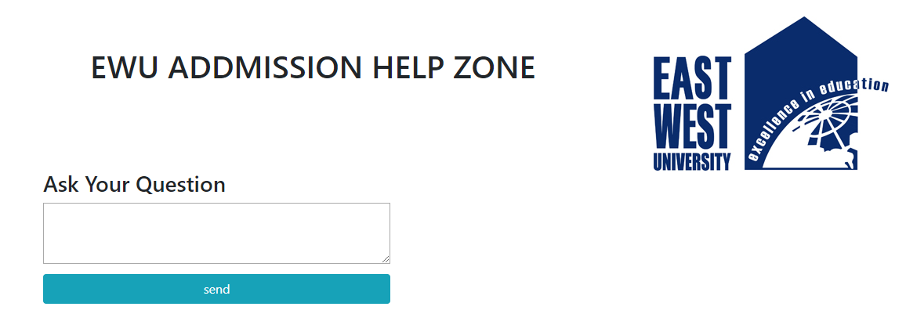 After while they will get their answer. Like if user send ‘Hi’ or ‘Hello’ our project will show ‘hello…… how can I help you?’.

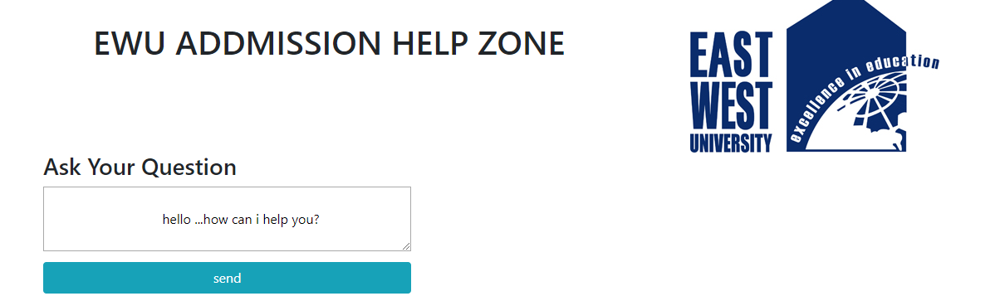

and this process continue until the user get him/her required answer.

**Conclusion:**

We develop a simple chatbot that can answer only basic question, that answer’s stored in it’s database. We have also some limitation. In future we have plan to develop this project. Then the chatbot will be more advanced. It can store more data. And It can answer efficiently like human. It can give the decision like human. From the information gathered from the research the strongest points and weaknesses of each have been identified and a list of desired features that should be in the system has been created. Finally the conclusion was that the system should contain a combination of the keyword matching with the String matching. Furthermore an administration part should be created where the administrator will be able to add, update and delete information related to the system.