

School of Computer Sciences CAT405 Intelligent Computing Major Project
System Requirements and Design Report
NutriAid4B40: Food Distribution Optimization using Genetic Algorithm

FATIN NAJIHAH BINTI HALIM 165515

Supervisor: Dr. Azleena Mohd Kassim Examiner: Dr. Fadratul Hafinaz Hassan

Academic Session 2025/2026

DECLARATION
“I declare that the following is my own work and does not contain any unacknowledged work from any other sources. This report was undertaken to fulfill the requirements of the Undergraduate Major Project for the Bachelor of Science in Computer Science (Honors) program at Universiti Sains Malaysia”.


Signature :
Name : FATIN NAJIHAH BINTI HALIM Date : 2 JANUARY 2026

ABSTRAK

Pengagihan bantuan makanan kepada isi rumah B40 di Malaysia sering menghadapi pelbagai cabaran seperti ketidakcekapan perancangan laluan, kekangan sumber, pertindihan agihan serta kelewatan dalam membuat keputusan, terutamanya semasa tempoh krisis ekonomi atau bencana. Kerumitan logistik ini menyebabkan bantuan tidak sampai kepada penerima yang paling memerlukan secara tepat pada masanya dan adil. Sehubungan itu, projek ini mencadangkan pembangunan satu sistem sokongan keputusan berasaskan aplikasi web progresif yang bertujuan untuk mempercepatkan dan mengoptimumkan proses penjadualan serta pengagihan bantuan makanan kepada isi rumah B40.
Modul pengoptimuman dalam sistem ini akan memodelkan masalah pengagihan bantuan makanan sebagai masalah pengoptimuman kombinatorial yang melibatkan pelbagai kekangan seperti bilangan isi rumah B40, lokasi geografi, kapasiti kenderaan, kuantiti bekalan makanan dan keutamaan penerima. Bagi menyelesaikan masalah ini, Algoritma Genetik (Genetic Algorithm, GA) digunakan sebagai pendekatan utama untuk mencari penyelesaian hampir optimum melalui proses pemilihan, persilangan dan mutasi secara iteratif. Pendekatan ini membolehkan sistem meneroka ruang penyelesaian yang luas dan menyesuaikan jadual agihan secara dinamik berdasarkan perubahan data semasa.
Dengan mengintegrasikan Algoritma Genetik ke dalam aplikasi web progresif moden, sistem yang dicadangkan akan menyediakan papan pemuka interaktif untuk pemantauan status agihan secara masa nyata serta peta geografi bagi memvisualisasikan lokasi isi rumah B40, pusat pengumpulan makanan dan laluan penghantaran. Antara hasil yang dijangkakan ialah pembangunan satu prototaip berfungsi yang dapat menunjukkan keberkesanan Algoritma Genetik dalam meningkatkan kecekapan, keadilan dan ketepatan masa pengagihan bantuan makanan. Projek ini juga diharapkan dapat menjadi bukti konsep bagi penggunaan teknik pengoptimuman pintar dalam menyokong inisiatif keselamatan makanan dan kebajikan sosial bagi komuniti B40 di Malaysia.
Kata kunci: Algoritma Genetik, Pengagihan Bantuan Makanan, Isi Rumah B40, Pengoptimuman Jadual, Sistem Sokongan Keputusan, Aplikasi Web Progresif

ABSTRACT

Food aid distribution to B40 households in Malaysia is often hindered by logistical complexities such as inefficient route planning, limited resources, overlapping deliveries, and delays in decision-making, particularly during periods of economic hardship or emergency situations. These challenges result in food assistance failing to reach the most vulnerable households in a timely and equitable manner. In response to these issues, this project proposes the development of a Progressive Web Application (PWA)–based decision support system aimed at accelerating and optimizing the scheduling and distribution of food aid to B40 households.
The optimization module of the proposed system models the food aid distribution process as a combinatorial optimization problem involving multiple constraints, including the number of B40 households, geographical locations, vehicle capacity, food supply availability, and recipient priority levels. To address this problem, the Genetic Algorithm (GA) is employed as the primary optimization technique to generate near-optimal distribution schedules through iterative processes of selection, crossover, and mutation. This approach enables efficient exploration of a large solution space and allows the distribution plan to adapt dynamically to real-time data changes.
By integrating the Genetic Algorithm into a modern Progressive Web Application, the system provides an interactive dashboard for real-time monitoring of distribution activities and a geographical map for visualizing the locations of B40 households, food distribution centers, and delivery routes. The expected outcome of this project is a functional prototype that demonstrates the effectiveness of the Genetic Algorithm in improving the efficiency, fairness, and timeliness of food aid distribution. Furthermore, the project serves as a proof of concept for applying intelligent optimization techniques to support food security initiatives and social welfare programs for B40 communities in Malaysia.
Keywords: Genetic Algorithm, Food Aid Distribution, B40 Households, Scheduling Optimization, Decision Support System, Progressive Web Application

ACKNOWLEDGEMENTS

First and foremost, I would like to express my sincere appreciation to my supervisor, Dr. Azleena Mohd. Kassim, for her continuous guidance, constructive feedback, and unwavering support throughout the completion of this project. Her expertise, insightful suggestions, and encouragement were instrumental in overcoming challenges and maintaining steady progress. I am truly grateful for her patience and dedication, which played a significant role in shaping the direction and quality of this work.
I would also like to convey my heartfelt thanks to Associate Professor Ts. Dr. Chew Xin Ying, the CAT405 course coordinator, for her clear and well-structured course briefings that provided a strong foundation for understanding the project requirements at each milestone. Her systematic guidance and practical explanations greatly enhanced my understanding and made the overall project development process more organized and manageable.
Lastly, I would like to thank my family and friends for their constant support and encouragement throughout this journey. Their understanding, motivation, and emotional support gave me the strength to persevere during challenging times. Whether through words of encouragement or their constant presence, their support has been invaluable.
I am deeply thankful to everyone who contributed, directly or indirectly, to the completion of this project. This achievement would not have been possible without the collective support, kindness, and encouragement of all those involved.

TABLE OF CONTENTS

DECLARATION ii
ABSTRAK iii
ABSTRACT iv
ACKNOWLEDGEMENTS v
TABLE OF CONTENTS vi
LIST OF TABLES viii
LIST OF FIGURES x
LIST OF ABBREVIATIONS AND SYMBOLS xi
- INTRODUCTION 1
  - Background 1
  - Problem Statements 2
  - Motivation 4
  - System Objectives 5
  - Proposed Solutions 5
  - Benefits and Uniqueness of the Proposed Solutions 6
  - Organization of the Report 10
- BACKGROUND & RELATED WORK 12
  - Status of Project Development 12
  - Existing Systems / Projects / Applications 12
  - Feature Comparison of Existing Systems / Projects / Applications 17
  - Existing Technique / Algorithm / Method 18
  - Strengths and Weaknesses of Existing System / Work 20
  - Brief Introduction of Proposed Work 21
- SYSTEM REQUIREMENTS / ANALYSIS 22
  - Scope of the Project 22
  - System Capabilities & Limitations 24
  - Project Management 27
  - Development Methodology 36
  - Detailed Requirements of New System 37
3.6 Analysis of New System 41
  - Detailed Description of Proposed System/Solution 54
  - Description of Data Source 57
  - Technology Deployed 59
- SDG ALIGNMENT 61
- CONCLUSION 62
REFERENCES 63

LIST OF TABLES

Table 2.1 :Comparison of Existing System 17

Table 2.2 Strengths and Weaknesses 21

Table 3.1 Functional Scope 23

Table 3.2 WBS for Module 1 29

Table 3.3 WBS for Module 2 29

Table 3.4 WBS for Module 3 31

Table 3.5 WBS for Module 4 33

Table 3.6 SWOT Analysis 35

Table 3.7 Functional Requirements 39

Table 3.8 Non-Functional Requirements 40

Table 3.9 Use Case Description 42

Table 3.10 Use Case Description 43

Table 3.11 Use Case Description 44

Table 3.12 Use Case Description 44

Table 3.13 Use Case Description 45

Table 3.14 Use Case Description 45

Table 3.15 Use Case Description 46

Table 3.16 Hardware Specification 59
Table 3.17 Software Specification 59
Table 3.9.3. Programming Languages/tools 60

LIST OF FIGURES

Figure 1.1: System Architecture Diagram 6

Figure 1.2: System Overall Module Diagram 7

Figure 2.2.1 eKasih (Malaysia’s National ) 13

Figure 2.2.2 MyKasih Foundation System 14

Figure 2.2.3 Food Bank Malaysia (FBM) 15

Figure 2.2.4 Sahana Eden 16

Figure 3.3.2. Gantt Chart 34

Figure 3.2 Use Case Diagram 41

Figure 3.6.3 Class Diagram 47

Figure 3.6.4 SSD for Login Use Case 49

Figure 3.6.5 SSD for Manage Beneficiary Household Use Case 50

Figure 3.6.6 SSD for Configure Priority Scoring Criteria Use Case 51

Figure 3.6.7 SSD for Generate Optimised Allocation Plan Use Case 52

Figure 3.6.8 SSD for Execute Allocation Optimisation Use Case 53

Figure 3.6.9 SSD for View Allocation Results and Analysis Use Case 54

Figure 3.6.10 SSD for Evaluate Allocation Performance Use Case 55

Figure 3.6.11 Flowchart 56

Figure 3.7.1 System Module 58

Figure 3.7.2. System Architecture Diagram 58

Figure 3.8. Description of Data Source 61

LIST OF ABBREVIATIONS AND SYMBOLS

Abbreviation / Symbol | Description
API | Application Programming Interface
B40 | Bottom 40% income households in Malaysia
CAD | Computer-Aided Dispatch
CPU | Central Processing Unit
DBMS | Database Management System
GA | Genetic Algorithm
GIS | Geographic Information System
GPU | Graphics Processing Unit
IoT | Internet of Things
JSON | JavaScript Object Notation
M40 | Middle 40% income households in Malaysia
NADMA | National Disaster Management Agency
NoSQL | Not Only SQL
OS | Operating System
PWA | Progressive Web Application
RAM | Random-Access Memory
SDG | Sustainable Development Goals
SDK | Software Development Kit
SSD | Solid State Drive
SSD | System Sequence Diagram

Abbreviation / Symbol Description

SWOT | Strengths, Weaknesses, Opportunities, Threats
WBS | Work Breakdown Structure
Firebase | Real-time NoSQL Cloud Database Platform
QUBO | Quadratic Unconstrained Binary Optimization
SA | Simulated Annealing
UI | User Interface
UX | User Experience
GA-Optimizer | Genetic Algorithm-based Optimization Module
PEP | Program for Economic Protection (used in B40 aid context, optional)

INTRODUCTION

Background
Food insecurity remains a persistent and critical socioeconomic issue in Malaysia, particularly among households classified under the B40 group, which represents the bottom 40% of income earners with monthly household incomes below RM4,850 [1]. Despite various food aid initiatives introduced by government agencies, non-governmental organisations (NGOs), and charitable bodies, a significant portion of vulnerable households continue to experience inconsistent access to sufficient and nutritious food. Rising living costs, unstable employment, household health burdens, and increasing urban poverty have further intensified the demand for food assistance among B40 communities.
Food aid programs play a crucial role in mitigating short-term hunger and ensuring basic survival needs for low-income households [2]. However, the effectiveness of these programs is highly dependent on how fairly and efficiently resources are allocated. In practice, many food aid distribution efforts rely on manual registration systems, first-come-first-served approaches, geographical proximity, or subjective judgement by organisers and volunteers. Such methods often result in unequal distribution, where some households receive food aid repeatedly or in excess, while others with higher vulnerability are overlooked or receive insufficient assistance. This imbalance not only reduces the overall impact of aid programs but also undermines public trust in welfare initiatives.
One of the primary challenges in food aid distribution is the absence of a systematic and objective vulnerability assessment mechanism. Household vulnerability is multi-dimensional and influenced by various socioeconomic factors such as income level, family size, presence of persons with disabilities (OKU), elderly dependents, and health conditions. Current allocation practices frequently fail to evaluate these factors collectively, leading to decisions that do not accurately reflect actual household needs. As the number of beneficiaries increases, manual decision-making becomes increasingly complex, error-prone, and difficult to scale, especially when resources are limited.
From an operational perspective, food aid organisations must balance multiple conflicting objectives, including maximising coverage, prioritising the most vulnerable households, maintaining fairness across communities, and ensuring efficient use of limited food supplies. These challenges form a complex optimisation problem that is difficult to solve using

conventional planning methods. Similar to other resource allocation domains, such as disaster response and logistics, food aid distribution requires intelligent decision-support tools capable of handling multiple constraints and objectives simultaneously.
Advancements in optimisation techniques and artificial intelligence provide promising opportunities to address these challenges. Genetic Algorithm (GA), a population-based metaheuristic optimisation technique inspired by natural selection, has demonstrated effectiveness in solving complex, multi-objective allocation problems [3]. By iteratively evolving solutions based on fitness evaluation, GA is well-suited for scenarios where optimal solutions cannot be easily derived through deterministic or rule-based methods. Applying GA to food aid allocation enables systematic exploration of allocation strategies that balance fairness, coverage efficiency, and priority satisfaction.
In this context, this project focuses on the development of an intelligent, priority-based food aid allocation system specifically designed for Malaysia’s B40 communities. The system aims to objectively assess household vulnerability using relevant socioeconomic indicators and optimise food aid distribution decisions through Genetic Algorithm. Rather than replacing existing distribution mechanisms, the proposed system acts as a decision-support tool to assist NGOs and government agencies in making transparent, fair, and data-driven allocation decisions. By addressing the core challenge of allocation optimisation, the project seeks to enhance the effectiveness of food aid programs, reduce inequality, and contribute to national and global efforts aligned with Sustainable Development Goal 2 (Zero Hunger) and Sustainable Development Goal 12 (Responsible Consumption and Production).

Problem Statements
The current food aid allocation practices for B40 communities in Malaysia face several critical challenges that significantly affect their fairness, efficiency, and overall effectiveness. The first major problem lies in the absence of a systematic and objective prioritisation mechanism for determining which households should receive food aid and in what quantity. In many existing initiatives, allocation decisions are made based on simplified criteria such as registration order, geographical location, or manual judgement by organisers and volunteers. As the number of beneficiary households increases, the number of possible allocation combinations grows rapidly, making it extremely difficult for human decision-makers to consistently identify fair and optimal allocation plans [4]. This often forces organisations to

rely on ad hoc or “good enough” distribution decisions, which may overlook households with higher vulnerability and urgent needs [2].
Secondly, the lack of intelligent optimisation leads to inefficient utilisation of limited food aid resources. Food aid programmes typically operate under strict budget and supply constraints, where available food items are insufficient to fully satisfy all households in need. Without an optimisation-based approach, there is a high risk that resources are either over-allocated to certain households or distributed evenly without considering differences in vulnerability. Research and reports on Malaysia’s food aid programmes indicate that some households receive repeated or excessive assistance while others receive inadequate or no support at all, despite having greater needs. Such sub-optimal allocation reduces coverage efficiency, increases inequality among beneficiaries, and limits the number of vulnerable households that can be served with the available resources.
Another significant problem is the inadequate assessment of household vulnerability using multi-dimensional socioeconomic indicators. Household vulnerability cannot be accurately represented by a single factor such as income alone. Factors including family size, presence of persons with disabilities (OKU), elderly dependents, and other social risks collectively influence a household’s level of need. However, existing food aid allocation systems often fail to integrate these factors in a structured and transparent manner. As a result, allocation decisions may not reflect the true severity of household conditions, leading to perceived unfairness and reduced trust in aid distribution programmes among beneficiary communities.
Finally, as food aid programmes scale up to serve larger populations, manual and semi-manual allocation processes become increasingly difficult to manage and prone to errors. Managing beneficiary records, evaluating eligibility, and planning monthly allocations for hundreds or thousands of households places a heavy administrative burden on NGOs and government agencies. The lack of a centralised, data-driven decision-support system restricts the ability of organisations to evaluate alternative allocation strategies, adjust decisions based on changing resource availability, and consistently apply prioritisation rules. Without an automated optimisation tool capable of rapidly generating and evaluating allocation plans, food aid distribution remains reactive rather than strategic, limiting its potential to effectively reduce food insecurity among B40 communities

Motivation
The primary motivation for this project arises from the urgent need to improve the fairness and effectiveness of food aid distribution for Malaysia’s B40 communities. Despite the presence of numerous welfare initiatives, food insecurity remains a persistent issue due to limitations in how food aid resources are allocated. As demand for food assistance continues to rise while resources remain constrained, NGOs and government agencies are increasingly required to make difficult decisions regarding who should receive aid and in what quantity. The lack of objective, transparent, and data-driven allocation mechanisms has created a critical gap between the intent of food aid programmes and their actual impact on vulnerable households. Addressing this gap is essential to ensure that limited food resources reach those who need them the most.
From an operational standpoint, existing food aid allocation processes rely heavily on manual assessment, simplified rules, or subjective judgement, which struggle to cope with the growing scale and complexity of beneficiary populations. As the number of households and vulnerability factors increases, allocation decisions become a complex optimisation problem involving multiple constraints and competing objectives such as fairness, coverage, and priority satisfaction. Without advanced decision-support tools, organisations are forced to adopt “good enough” distribution strategies that may unintentionally reinforce inequality. This situation highlights the need for more intelligent allocation methods that can systematically evaluate numerous possible allocation plans and identify solutions that best balance these competing objectives.
The technical motivation of this project is rooted in the limitations of traditional allocation approaches when dealing with multi-objective and large-scale resource distribution problems. Classical rule-based or greedy methods are insufficient for capturing the complex interactions between socioeconomic vulnerability indicators and resource constraints. Genetic Algorithm, as a metaheuristic optimisation technique, offers a powerful alternative by efficiently searching large solution spaces and evolving high-quality solutions through iterative improvement. Its ability to handle non-linear objectives and trade-offs makes it particularly suitable for food aid allocation scenarios, where fairness and efficiency must be considered simultaneously rather than independently [5],[6].

Ultimately, this project is motivated by the potential of intelligent optimisation techniques to transform social welfare decision-making. By applying Genetic Algorithm to the allocation of food aid, the project aims to demonstrate how artificial intelligence can be responsibly used to support equitable resource distribution in real-world social contexts. The development of a practical, priority-based allocation system not only contributes technical insight into optimisation methods for social welfare applications but also provides NGOs and government agencies with a viable tool to enhance transparency, accountability, and trust in food aid programmes. Through this approach, the project aspires to contribute meaningfully to national welfare objectives and global sustainability goals, particularly SDG 2 (Zero Hunger) and SDG 12 (Responsible Consumption and Production).

System Objectives
The main objectives of this project are as follows:

- To develop a priority-based food aid allocation system that objectively assesses the vulnerability of B40 households using relevant socioeconomic indicators such as household income, family size, and OKU status.
- To implement an intelligent optimisation approach using Genetic Algorithm (GA) to optimise food aid allocation decisions, ensuring improved fairness, efficient resource utilisation, and higher priority satisfaction among vulnerable households.
- To develop a system interface that enables NGOs and government agency staff to manage beneficiary data, configure allocation parameters, and visualise allocation outcomes along with performance metrics such as coverage efficiency, priority satisfaction rate, and Gini coefficient.

Proposed Solution
The proposed solution for this project is an intelligent, priority-based food aid allocation decision support system designed to optimise the distribution of food aid to B40 households using Genetic Algorithm (GA). The system focuses on addressing the core challenge of fair and efficient allocation by systematically evaluating household vulnerability and optimising distribution decisions under limited resource constraints. The overall system design follows the System Architecture Diagram shown in Figure 1.1, which illustrates the interaction between data management, priority assessment, optimisation, and result visualisation components.

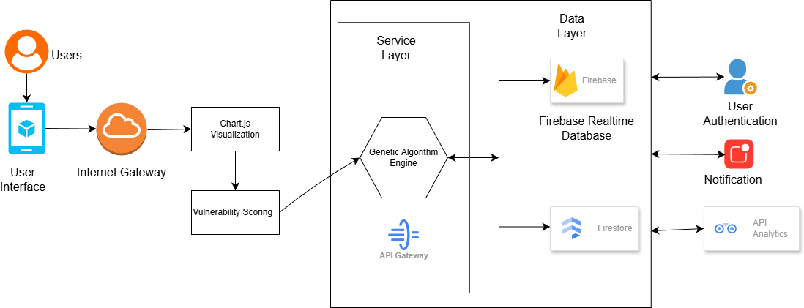
Figure 1.1: System Architecture Diagram

The NutriAid4B40 system is organised into four primary modules, as illustrated in Figure 1.2, each serving a distinct role in supporting intelligent and fair food aid allocation. Together, these modules form a centralised decision-support platform that enhances transparency, consistency, and efficiency in food aid distribution for B40 communities.
The first module is the Beneficiary Management Module, which functions as the core data management component of the system. This module is responsible for collecting, storing, and maintaining household-level information, including income category, family size, OKU status, and other relevant socioeconomic indicators. By ensuring that beneficiary data is systematically recorded and kept up to date, this module provides a reliable foundation for subsequent vulnerability assessment and allocation processes.
The second module is the Priority Scoring Module, which performs objective vulnerability evaluation based on predefined scoring rules. Using the socioeconomic indicators managed by the Beneficiary Management Module, this module computes a composite priority score for each household, where lower scores indicate higher vulnerability and greater allocation priority. This structured assessment mechanism replaces subjective or ad hoc decision-making practices and ensures consistency and fairness across allocation cycles.
The third module is the Allocation Optimisation Module, which serves as the computational core of the system. This module implements a Genetic Algorithm to generate optimised food aid allocation plans under resource constraints. Allocation decisions are modelled as a multi-objective optimisation problem that seeks to maximise coverage efficiency, prioritise highly vulnerable households, and minimise inequality in distribution. Through iterative processes of selection, crossover, mutation, and elitism, the algorithm evaluates multiple

allocation scenarios and converges towards high-quality solutions that balance fairness and efficient resource utilisation. This module enables aid organisations to adopt evidence-based, optimised decision-making rather than relying on heuristic or “good enough” allocation strategies.
The fourth module is the Visualisation and Analysis Module, which provides an interactive interface for NGO and government agency personnel to interpret and evaluate allocation outcomes. This module allows users to review household priority rankings, view recommended allocation quantities, and analyse system performance through intuitive charts and tables. Key evaluation metrics such as priority satisfaction rate, coverage efficiency, and the Gini coefficient are presented to support transparent decision-making and facilitate justification of allocation outcomes to stakeholders and beneficiary communities.
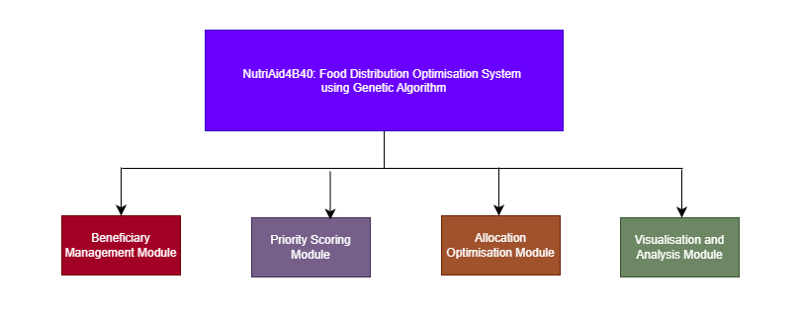
Figure 1.2: System Overall Module Diagram
Collectively, these modules deliver a practical and intelligent solution that supports fair, transparent, and efficient food aid allocation. By focusing specifically on the optimisation of allocation decisions rather than physical logistics, the proposed system addresses the most critical challenge faced by food aid organisations: determining how limited resources can be distributed equitably to maximise social impact among B40 households.

Benefits and Uniqueness of the Proposed Solutions

    - Benefits of the Proposed Solutions

The development of the proposed intelligent food aid allocation system is expected to deliver significant benefits to NGOs, government agencies, and B40 communities in Malaysia by improving fairness, efficiency, and transparency in food aid distribution.

Improved Fairness and Objective Decision Making

The most direct and significant benefit of this project is the improvement in fairness and objectivity of food aid allocation decisions. By employing a priority-based scoring mechanism grounded in socioeconomic indicators such as household income, family size, and OKU status, the system ensures that allocation decisions are based on measurable vulnerability rather than subjective judgement. This structured approach reduces bias and inconsistency in decision-making, ensuring that households with the highest level of need are prioritised appropriately. As a result, food aid distribution becomes more equitable, addressing long-standing concerns regarding unequal access and perceived unfairness among B40 beneficiary communities.

Enhanced Resource Utilisation and Coverage Efficiency

The proposed system enables more efficient use of limited food aid resources through optimisation using Genetic Algorithm. Instead of equal or arbitrary distribution, the system generates allocation plans that maximise coverage while respecting resource constraints. This ensures that available food supplies are distributed in a way that reaches a larger number of vulnerable households without unnecessary over-allocation. By minimising waste and preventing redundant assistance to the same households, NGOs and government agencies can serve more beneficiaries using the same level of resources. This improved efficiency is particularly crucial in high-demand situations where food aid supplies are insufficient to meet all needs.

Increased Transparency and Trust in Food Aid Programmes

Another key benefit of the proposed solution is the enhancement of transparency in food aid allocation. By clearly displaying household priority rankings, allocation outcomes, and performance metrics such as priority satisfaction rate, coverage efficiency, and Gini coefficient, the system provides justifiable and explainable decisions. This transparency strengthens trust between aid providers and recipients by allowing organisations to clearly communicate how and why allocation decisions are made. Improved accountability also supports internal auditing and reporting processes, enabling organisations to demonstrate the effectiveness and fairness of their food aid programmes to stakeholders and donors.

Uniqueness of the Proposed Solutions

      - Application of Genetic Algorithm for Social Welfare Allocation

The core uniqueness of this project lies in the application of Genetic Algorithm to a real-world social welfare problem, specifically food aid allocation for Malaysia’s B40 communities. While optimisation techniques are widely studied in engineering and logistics, their application to prioritised food aid distribution using locally relevant vulnerability indicators remains limited. This project demonstrates how GA can be effectively adapted to handle multi-objective social allocation challenges involving fairness, priority satisfaction, and resource constraints, offering a novel contribution within the context of social welfare optimisation.

Context-Specific and Priority-Based Allocation Framework

Unlike generic resource allocation systems, the proposed solution is specifically tailored to the Malaysian B40 context. The priority scoring framework incorporates nationally relevant income thresholds and social vulnerability indicators such as OKU status, making the system highly contextualised and practically applicable. This localised design ensures that allocation decisions reflect the real socioeconomic conditions faced by B40 households, rather than relying on abstract or one-dimensional eligibility criteria. Such a targeted approach distinguishes the system from conventional food aid distribution methods.

Practical Decision-Support Tool for Non-Technical Users

Another unique aspect of the proposed solution is its focus on usability for non-technical users. The system is designed as a decision-support tool that abstracts the complexity of Genetic Algorithm optimisation into a simple and intuitive interface. NGO staff and government officers do not need to understand optimisation algorithms or mathematical formulations; instead, they can manage beneficiary data, configure allocation parameters, and generate optimised allocation plans through straightforward interactions. This emphasis on accessibility ensures that advanced optimisation techniques can be effectively adopted in real-world food aid programmes without requiring specialised technical expertise.

Organization of the Report

This report is structured into five main chapters, each focusing on different aspects of the proposed intelligent food aid allocation system for B40 communities.

Chapter 1: Introduction

This chapter introduces the project by presenting the background of the study, problem statements, motivation, system objectives, proposed solutions, and the benefits and uniqueness of the proposed system. It provides an overall understanding of the project scope and establishes the foundation for the subsequent chapters.

Chapter 2: Background and Related Work

Chapter 2 explores the theoretical background and reviews related work relevant to food aid distribution, resource allocation, and optimisation techniques. This includes a review of existing food aid systems and welfare allocation approaches, analysis of optimisation methods such as Genetic Algorithm, and examination of fairness metrics used in social resource allocation. The chapter identifies limitations in existing approaches and highlights research gaps that the proposed system aims to address.

Chapter 3: System Requirements and Analysis

This chapter outlines the system requirements and analysis of the proposed solution. It covers the project scope, system capabilities, and constraints, as well as project planning elements such as the Work Breakdown Structure (WBS), Gantt chart, and SWOT analysis. Additionally, it presents the development methodology, user requirement analysis, and system design models including use case diagrams and system architecture. Technical requirements such as hardware, software tools, programming languages, and optimisation algorithms are also detailed.

Chapter 4: Sustainable Development Goal (SDG) Alignment

Chapter 4 discusses how the proposed system aligns with the United Nations Sustainable Development Goals (SDGs), particularly SDG 2 (Zero Hunger) and SDG 12 (Responsible Consumption and Production). This chapter explains how the system contributes to reducing food insecurity, improving resource efficiency, and supporting sustainable and equitable food aid distribution practices.

Chapter 5: Conclusion

The final chapter summarises the entire project, highlighting key findings, system contributions, and achieved objectives. It also discusses the overall impact of the proposed solution and outlines recommendations for future work and potential system enhancements.

BACKGROUND & RELATED WORK

Status of Project Development

This is a new project. The system is being designed and developed entirely from scratch for this Intelligent Computing Major Project. The complete project lifecycle, from initial problem analysis and system architecture design to the development of the priority-based allocation module and the web application interfaces, will be executed wholly within the scope of this project to ensure its originality.
The system will focus on optimising food aid allocation for B40 households in Malaysia, incorporating a priority scoring mechanism based on household income, family size, OKU status, and other vulnerability indicators. It also includes an intelligent optimization engine using Genetic Algorithm (GA) to generate fair and efficient allocation plans [6].

Existing Systems / Projects / Applications

In analyzing existing food aid and social welfare systems, multiple software solutions were reviewed to identify strengths, weaknesses, and opportunities for improvement. While current platforms often provide basic administrative and reporting functionalities, they generally lack computational intelligence to optimize allocation decisions based on multi-criteria vulnerability indicators. The following systems were reviewed:

eKasih (Malaysia’s National Poverty Database)

eKasih is a national web-based system maintained by the Ministry of Rural Development (KPLB) to identify and monitor households living below the poverty line (KPLB, n.d.). The platform collects household demographic data, income levels, and social assistance history.

Strengths:

      - Centralized database for all low-income households.

      - Provides accurate household profiles for planning social aid.

Limitations:

      - Does not perform automated allocation of resources.

      - Food aid and assistance distribution decisions are manually made by agencies, which may result in unequal or delayed distribution.
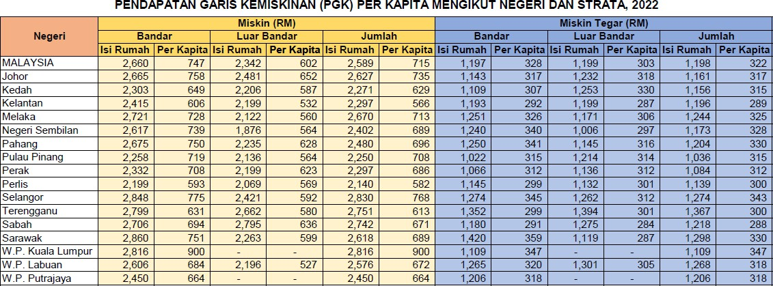

Figure 2.2.1 eKasih (Malaysia’s National 1)

MyKasih Foundation System

MyKasih Foundation operates a digital welfare platform to distribute financial aid and food vouchers to B40 communities in Malaysia.

Strengths:

      - Uses card-based or digital voucher distribution, allowing households to redeem aid at partner merchants.
      - Provides transparency and accountability in tracking disbursements.

Limitations:

      - Allocation is primarily uniform or based on simple criteria like registration order.

      - Does not incorporate multi-criteria prioritization to optimize fairness across socio-economic vulnerability factors.

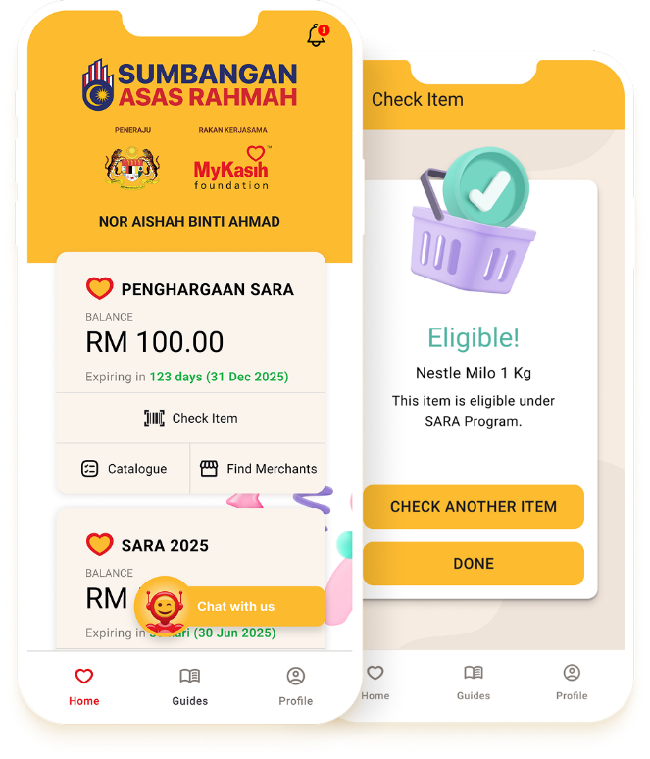

Figure 2.2.2 MyKasih Foundation System 1

Food Bank Malaysia (FBM) Management System

Food Bank Malaysia manages inventory, distribution, and donations of food items to various NGOs and communities.

Strengths:

      - Centralized inventory tracking.

      - Coordination with NGOs and distribution centres.

Limitations:

      - Scheduling and allocation of food to households rely heavily on manual planning.

      - No computational model to maximize coverage efficiency or ensure equitable distribution.

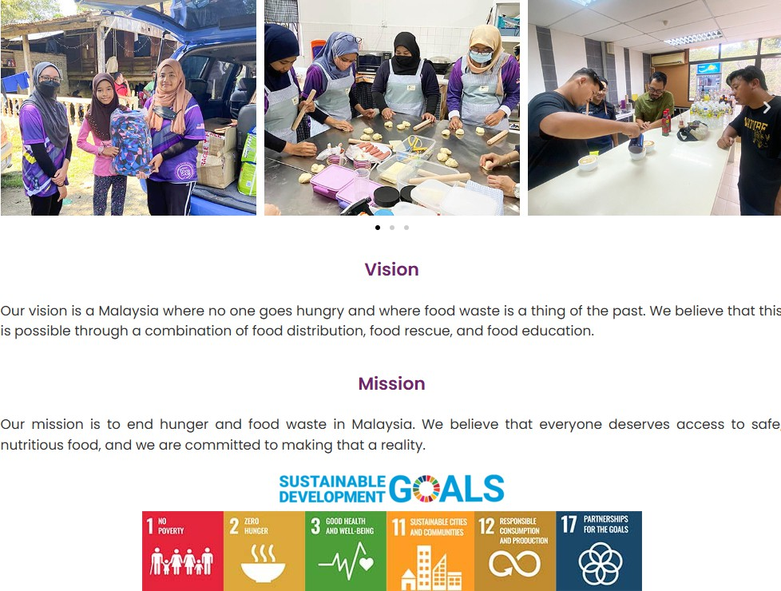
Figure 2.2.3 Food Bank Malaysia (FBM)

Sahana Eden (Adapted for Social Welfare)

Sahana Eden is an open-source platform initially designed for disaster management but has been adapted for social welfare in some NGOs.

Strengths:

      - Modular, flexible system for managing beneficiaries, volunteers, and resources.

      - Provides GIS-based visualization for distribution planning.

Limitations:

      - Scheduling is manual and largely experience-based.

      - Does not use algorithmic optimisation to allocate resources efficiently or fairly.

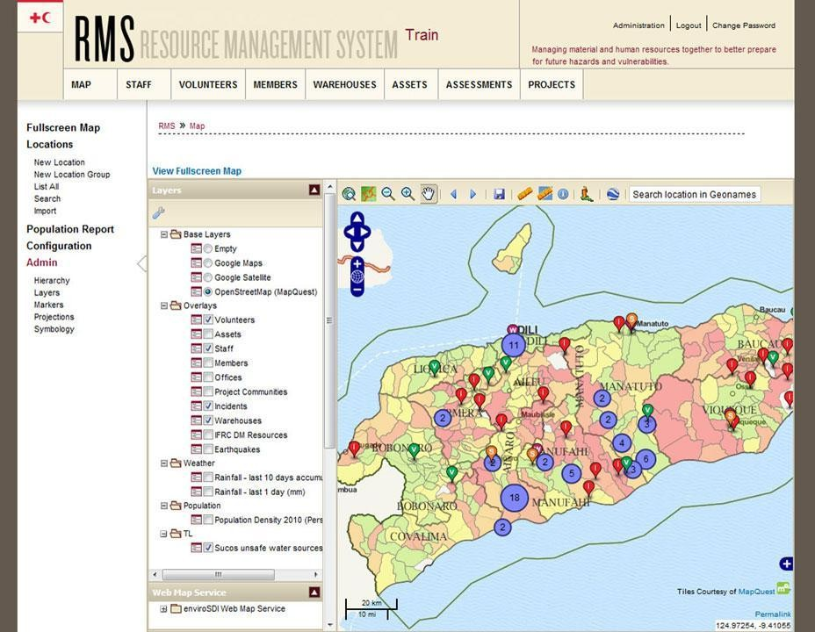

Figure 2.2.4 Sahana Eden 1

Custom NGO Systems

Several NGOs in Malaysia use internally developed spreadsheets or simple web platforms to track beneficiaries and allocate aid.

Strengths:

      - Simple and familiar interface for staff.

      - Immediate access to local household data.

Limitations:

      - Lack of optimization algorithms; allocations are rule-based or ad hoc.

      - Cannot scale effectively when household numbers increase.

      - Limited transparency and accountability for fairness.

Feature Comparison of Existing Systems / Projects / Applications

Features | eKasih | MyKasih | Food Bank Malaysia | Sahana Eden | Custom NGO Systems
Web-Based Platform | Yes | Yes | Yes | Yes | Yes
Mobile Application Support | No | Yes (App) | No | Yes | Yes
Real-time Data Visualization | No | Yes | Yes | Yes | Limited
Automated Allocation Engine | No | No | No | No | No
Intelligent Allocation Optimization | No | No | No | No | No
Dynamic  Re-optimization | No | No | No | No | No
Multi-Agency / NGO Integration | Yes | Yes | Yes | Yes | Limited
Table 2.1 :Comparison of Existing System

The features of the existing food aid and social welfare systems have been compared in Table
2.1. eKasih provides a centralized database for low-income households but lacks an automated allocation engine or optimization capability. MyKasih supports digital voucher distribution with real-time tracking, yet allocations are uniform or rule-based, without prioritization based on multiple vulnerability factors. Food Bank Malaysia effectively manages inventory and coordinates NGO distribution but relies on manual scheduling of food aid.
Sahana Eden provides a flexible system for administrative management and GIS-based visualization, but scheduling and allocation still depend on human operators rather than algorithmic optimization. Custom NGO systems provide familiarity and ease of use for staff, yet these platforms are generally limited in scalability and do not integrate intelligent decision-making or dynamic reallocation.

The proposed Intelligent Food Aid Allocation System is distinguished from these existing systems by combining centralized data management, real-time household visualization, and an intelligent Genetic Algorithm optimization engine. Unlike current systems, it will automatically calculate fair and efficient allocations for multi-criteria household prioritization, dynamically adjusting allocations as resources or household data change. This ensures that the most vulnerable households receive aid in a transparent, equitable, and optimized manner, which existing platforms do not address.

Existing Technique / Algorithm / Method

    - Optimization Model (Priority-based Genetic Algorithm)

The first step in solving the food aid allocation problem is to model it mathematically in a format suitable for computational optimization. This project uses a Genetic Algorithm (GA) to allocate food aid fairly and efficiently to B40 households.
In this model, each possible allocation decision is represented as a gene in a chromosome. A chromosome encodes a complete allocation plan, where each gene represents the quantity of food aid assigned to a specific household. The fitness function evaluates how well an allocation plan meets multiple objectives:
      - Priority satisfaction: ensuring households with higher vulnerability scores receive sufficient aid.
      - Coverage efficiency: maximizing the number of households served within available resources.
      - Fairness: minimizing inequality in aid distribution, measured using metrics like the Gini coefficient.
The GA iteratively improves the population of allocation plans through selection, crossover, and mutation. Selection favors chromosomes with higher fitness, crossover exchanges allocation patterns between two chromosomes to explore new solutions, and mutation introduces random changes to maintain diversity and avoid local optima.
By evolving the population over multiple generations, the algorithm converges to an optimal or near-optimal allocation plan that balances fairness, priority, and resource constraints.

Multi-objective Optimization Approach

Food aid allocation is a complex "multi-objective" challenge because it requires balancing goals that often pull in opposite directions. For instance, giving more food to one household to ensure fairness might reduce the total number of households the system can reach. To navigate these trade-offs, the Genetic Algorithm (GA) provides a flexible framework that evaluates every potential allocation plan through a multi-objective fitness function. This function specifically weighs three core pillars:
      - Priority-based Scoring: Using the data from the Priority Scoring Module, the system ensures that households with the lowest income, largest family sizes, or OKU
members are moved to the front of the queue.
      - Resource Utilization: The algorithm monitors food inventory in real-time to ensure that aid is distributed efficiently, preventing over-allocation and ensuring that every available package is put to its best use.
      - Mathematical Fairness (Gini Coefficient): Crucially, the system integrates the Gini Coefficient to measure the level of inequality in any given distribution plan. By minimizing this coefficient, the GA actively works to close the gap between different households, ensuring a "fair spread" of aid rather than leaving some families significantly better off than others.
By combining these factors, the optimization engine can automatically generate allocation plans that are far more sophisticated than what a manual or rule-based system could produce. While a human coordinator might struggle to balance the needs of thousands of families at once, the GA iteratively refines these plans until it finds the "Pareto optimal" solution—the perfect balance where no further improvement in fairness can be made without hurting overall efficiency. This data-driven approach ensures that the final distribution is not only fast but also transparent and objectively just.

Strengths and Weaknesses of Existing System / Work

This section provides a comparative analysis of the strengths and weaknesses of existing food aid distribution or welfare management systems to assess their overall performance.

Application / System | Strengths | Weaknesses
eKasih (Government B40 Database) | - Centralized database of B40 households and demographics.  - Provides verified beneficiary data for targeting aid. | - Mainly focused on  record-keeping, not real-time allocation.  - Does not optimize food aid distribution based on priority or logistics.  - Limited visualization and reporting for operational planning.
Food Bank Management Systems | - Tracks inventory and donation levels.  - Supports volunteer scheduling and reporting. | - Allocation to beneficiaries is often manual.  - Lacks automated prioritization for vulnerable households.  - Real-time logistics and optimization missing.
NGO Distribution Apps | - Enables coordination among NGOs for food aid delivery.  - Some support volunteer assignments and reporting. | - Focused on individual NGO workflow rather than  multi-agency integration.  - No intelligent optimization for fair and efficient allocation.  - Manual decisions create potential delays and inequality.
Manual Government Welfare Planning | - Uses experienced officers to manually allocate aid.  - Can apply qualitative  knowledge for special cases. | - Highly time-consuming and prone to human error.  - Not scalable for large-scale disasters or multiple locations.

 |  | - Difficult to track fairness and resource utilization objectively.
Excel or  Spreadsheet-based Allocation Tools | - Flexible and easy to implement.  - Allows data filtering and basic reporting. | - Cannot handle dynamic updates in real time.  - No automated optimization or prioritization.  - Error-prone for large-scale or multi-location allocation.
Table 2.2 Strengths and Weaknesses

Analysis:

The existing systems provide useful administrative and record-keeping capabilities, but they lack real-time optimization, automated prioritization, and multi-agency coordination. Current approaches rely heavily on manual decisions, making them slow, inefficient, and potentially unfair. The proposed food aid allocation system using a genetic algorithm addresses these gaps by offering intelligent, data-driven, fair, and dynamic allocation in real time, which existing systems cannot achieve.

Brief Introduction of Proposed Work

The proposed solution is a web-based decision support tool designed to optimize food aid allocation by integrating real-time visualization with automated decision-making. Unlike most current food aid distribution methods, which rely on manual planning or static spreadsheets, this system introduces an Intelligent Food Aid Allocation Module that utilizes Genetic Algorithm (GA) optimization to generate fair and efficient allocation plans.
The system transforms raw beneficiary and inventory data into optimized distribution schedules, taking into account factors such as household income, family size, and disability status. By automating the allocation process, the proposed solution drastically reduces planning time, ensures equitable distribution, minimizes wastage, and allows coordinators to make data-driven decisions. This intelligent system is especially useful during large-scale crises or simultaneous distribution demands, where traditional methods are too slow or error-prone to manage effectively.

SYSTEM REQUIREMENTS & ANALYSIS

Scope of the Project

The project, titled "NutriAid4B40: Food Distribution Optimization using Genetic Algorithm," is an intelligent decision-support system designed to streamline and optimize the distribution of food aid to B40 households. The scope focuses on replacing manual, ad-hoc allocation methods with a computational approach that ensures resources are distributed equitably based on objective vulnerability metrics.

Target Users

To maintain simplicity and operational efficiency, the system is designed for a single primary actor:
      - System User: This actor represents any authorized administrator or social welfare officer who is responsible for managing the food aid lifecycle. The System User
performs all necessary functional tasks, including managing beneficiary profiles, configuring optimization parameters, and monitoring the distribution status through a centralized interface.

Functional Scope
The functional scope is defined by four core modules that the System User interacts with:

Functionality | Key Features
Beneficiary Management | Allows the System User to register household data, update  socioeconomic indicators (income, family size, OKU status), and maintain an accurate database of recipients.
Priority Scoring | Automates the assessment of household vulnerability by calculating composite priority scores based on the provided  socioeconomic data, ensuring high-need households are identified objectively.
Allocation Optimization | Features an optimization engine using a Genetic Algorithm (GA). The System User can input resource constraints and trigger the algorithm to generate allocation plans that maximize coverage and satisfy priority needs.

Visualization and Analysis | Provides a real-time dashboard and geographical map. The System User can visualize beneficiary locations, review recommended allocation quantities, and analyze performance metrics such as the Gini coefficient to ensure fairness.
Table 3.1. Functional Scope

Geographical Scope

      - The system is designed primarily for specific districts or regions where food aid distribution is active.
      - It includes logistical coordination within road networks to optimize delivery routes and manage constraints like traffic, vehicle capacity, and access restrictions.
      - The initial implementation focuses on a controlled pilot region, with architecture supporting future scaling to larger areas or nationwide deployment.

System Capabilities & Limitations

    - System Capabilities

The proposed system, Food Aid Allocation using Genetic Algorithm, is designed to provide a comprehensive, intelligent, and real-time decision support platform for organizations and agencies managing food distribution. Its primary capability is the rapid optimization of multi-objective allocation problems, allowing for efficient and equitable distribution of food aid to a large number of beneficiaries across multiple regions. Unlike traditional manual methods, which require coordinators to assess requests sequentially, this system evaluates all requests, available resources, and distribution constraints simultaneously. This ensures that decisions are made holistically and maximize the impact of available food stocks.
At the core of the system is the Genetic Algorithm (GA) optimization engine, which is capable of exploring a vast search space of possible allocation combinations. The system can analyze variables such as the number of beneficiaries per location, available stock at distribution centres, transport availability, priority needs (e.g., children, elderly, or low-income households), and regional accessibility constraints. By simulating evolutionary processes such as selection, crossover, and mutation, the GA identifies high-quality allocation plans that balance efficiency, equity, and logistical feasibility. For example, the system can determine whether a truck should prioritize delivering to a densely populated urban area with multiple beneficiaries or a smaller rural area with urgent need while minimizing overall travel distance and ensuring perishable items are delivered promptly.
In addition to allocation optimization, the system provides real-time situational awareness through a geographical map interface. Integrated mapping tools display the locations of beneficiaries, distribution centres, transport vehicles, and current delivery progress. Using a real-time cloud database, such as Firebase or a similar real-time service, updates made by one user—such as recording delivered stock, reporting vehicle unavailability, or marking a distribution point as temporarily inaccessible are immediately synchronized across all user dashboards. This eliminates the risk of information silos, a common problem in large-scale logistics operations where different teams may operate with outdated or conflicting information. For instance, if a truck becomes unavailable due to a mechanical issue, the system can immediately reassign the delivery to another vehicle and update all relevant field officers without delay.

Another key capability is cross-platform accessibility through a Progressive Web Application (PWA). The system is designed to operate seamlessly across desktop computers, tablets, and mobile devices, enabling coordinators and field officers to access the platform wherever they are. PWA architecture allows for offline access to previously loaded data, such as distribution schedules and last updated maps, which is critical in areas with intermittent internet connectivity [7]. This feature ensures that food aid coordinators can continue to operate even during connectivity disruptions, such as in remote or disaster-affected areas.
The system also provides automated reporting and analytics, allowing decision-makers to track resource utilization, measure delivery efficiency, and identify areas where stock shortages or bottlenecks are occurring. Visual dashboards display metrics such as remaining inventory at each centre, the number of beneficiaries served, and projected time for completing all deliveries. This capability supports data-driven decision-making, enabling managers to optimize resource allocation dynamically, based on real-time operational conditions.
Finally, the system is designed to be highly scalable. It can accommodate additional distribution centres, vehicles, and beneficiaries as the operation grows, making it suitable for both small regional deployments and large-scale nationwide food aid programs. By integrating multiple functionalities, optimization, mapping, reporting, and real-time synchronization into a single platform, the system eliminates the inefficiencies associated with using multiple disconnected tools. This integration ensures that food aid operations are cohesive, transparent, and highly responsive to changing circumstances.

System Limitations

Despite its advanced capabilities, the proposed system has several inherent limitations that must be acknowledged. One of the most significant limitations is its dependence on real-time connectivity. While the PWA architecture allows for limited offline access to previously loaded data, the optimization engine, which runs in the cloud, requires an active internet connection to generate or update allocation plans. This means that in regions with prolonged connectivity outages, the system’s full functionality, particularly dynamic reallocation of resources in response to unexpected changes, may be temporarily unavailable.

Another limitation is the system’s reliance on accurate user input. Unlike fully automated logistics systems that integrate IoT sensors or GPS tracking, this system depends on coordinators and field officers to manually input data such as current stock levels, vehicle availability, or beneficiary attendance. Inaccurate or delayed data entry can lead to suboptimal allocation decisions. For example, if a distribution centre incorrectly reports having excess stock, the algorithm may allocate more food to that centre, leaving high-need areas underserved. Similarly, if field officers fail to update delivery status in a timely manner, other teams may be sent to duplicate deliveries or miss critical beneficiaries.
The system is also limited by external dependencies, such as the mapping service API used for route visualization and distance calculation. If the mapping service is temporarily unavailable, the system cannot generate accurate routes for delivery vehicles, which may affect the efficiency of logistics planning. Furthermore, while the system calculates optimal allocation schedules, it does not perform advanced vehicle routing optimization using specialized algorithms like the Vehicle Routing Problem with Time Windows (VRPTW). As a result, while allocation plans will efficiently assign resources to beneficiaries, they may not always minimize total travel time or fuel consumption for each delivery route.
Another limitation relates to the complexity of optimization under extreme conditions. The Genetic Algorithm is highly effective at finding near-optimal solutions, but it cannot guarantee the absolute best solution in every scenario. In cases with thousands of beneficiaries, multiple constraints, and rapidly changing conditions (e.g., sudden road closures, traffic delays, or emergency interventions), the algorithm may produce suboptimal schedules that are “good enough” but not perfectly optimal. While this is acceptable for most operational contexts, coordinators should be aware that extreme complexity can affect the quality of the output.
Finally, the system is designed primarily for food aid allocation and scheduling, and does not address other aspects of disaster relief logistics, such as emergency medical services, water supply, or shelter allocation. While the system architecture could theoretically be adapted to other resource types, the current implementation is specialized for food distribution and would require additional customization to handle other aid resources effectively.
In summary, while the system provides advanced optimization, real-time monitoring, and cross-platform accessibility, its effectiveness is influenced by connectivity, data accuracy, external dependencies, and algorithmic limitations. Awareness of these limitations allows

users to implement mitigating measures, such as redundant data validation, offline contingency planning, and manual overrides, ensuring that food aid distribution remains effective even under challenging circumstances.

Project Management

Project management is a critical aspect of this system development to ensure that each phase of the project—from planning to final delivery is executed efficiently, within the timeline, and meets the objectives of the project. For the Food Aid Allocation using Genetic Algorithm system, a structured approach is adopted, combining detailed work breakdown, milestone tracking, and clearly defined deliverables.

Work Breakdown Structure (WBS)

The development of this project is divided into six major modules/phases, each containing detailed activities. This structured approach ensures that each aspect of the system, including optimization algorithms, database integration, user interface design, and testing, is completed systematically.

Module 1: Beneficiary Management Module

Activity | Sub-Activity | Start Date | End Date | Duration (Days)
1. Project Bidding | a. Submit project title and proposal for approval | 08/10/2025 | 09/10/2025 | 2
2. Project Planning | a. Meetings and discussions with supervisor to finalize project objectives and  deliverables | 13/10/2025 | 24/10/2025 | 12
 | b. Prepare initial project proposal and submission | 13/10/2025 | 27/10/2025 | 15
3. Project  Analysis and Design | a. Collect and analyze data related to food aid distribution, beneficiaries, vehicles, and distribution centres | 28/10/2025 | 03/11/2025 | 7
 | b. Prepare detailed system  requirement specification | 03/11/2025 | 08/12/2025 | 36

 | (SRS) and design documentation
 | c. Presentation of system  requirements and design to supervisor for feedback | 08/12/2025 | 12/12/2025 | 5
4. Project Development | a. Design and build required databases for beneficiaries, distribution centres, vehicles, and stock inventory | 13/12/2025 | 21/12/2025 | 9
 | b. Develop the Intelligent Food Aid Allocation Scheduling Module using Genetic Algorithm for optimization | 22/12/2025 | 25/01/2026 | 35
 | c. Conduct project progress demonstration and obtain feedback from supervisor | 30/03/2026 | 03/04/2026 | 5
5. System Testing | a. Build test cases and prepare test data for different scenarios (e.g., stock shortages, route delays, high-priority beneficiaries) | 04/04/2026 | 12/04/2026 | 9
 | b. Perform unit testing of each module, including database, scheduling algorithm, and map integration | 13/04/2026 | 26/04/2026 | 14
 | c. Perform integration testing to ensure modules work together seamlessly | 27/04/2026 | 10/05/2026 | 14
 | d. Conduct system and acceptance testing with  simulated real-world scenarios to validate overall functionality | 11/05/2026 | 17/05/2026 | 7
6. Project Final Submission and Presentation | a. Prepare final report, including system documentation, user guide, and project findings | 04/04/2026 | 25/05/2026 | 52

 | b. Final system demonstration and presentation to supervisor, faculty panel, and stakeholders | 25/05/2026 | 07/06/2026 | 14
 | c. Participation in PIXEL 2026 for project showcase | 15/06/2026 | 21/06/2026 | 7
Table 3.2 WBS for Module 1
Note: This module will be developed by Fatin Najihah binti Halim.

      - Note: This subsystem will be developed by Fatin Najihah binti Halim.

Use Cases for Module 1:
        - Register Beneficiary Household
        - Update Beneficiary Information
        - View Beneficiary Profiles
        - Remove Beneficiary Record

Module 2: Priority Scoring Module

Activity | Sub-Activity | Start Date | End Date | Duration (Days)
1. Project Bidding | a. Submit project title and  proposal for approval | 08/10/2025 | 09/10/2025 | 2
2. Project Planning | a. Meetings and discussion with supervisor to finalize objectives and scope | 13/10/2025 | 24/10/2025 | 12
 | b. Prepare initial proposal and  submit for review | 13/10/2025 | 27/10/2025 | 15
3. Project  Analysis and Design | a. Gather and analyze detailed information on food aid locations, distribution centres, beneficiary locations, and  routes | 28/10/2025 | 03/11/2025 | 7
 | b. Prepare system requirement and design report for the geographical map module | 03/11/2025 | 08/12/2025 | 36
 | c. Present system requirement and design to supervisor for  feedback | 08/12/2025 | 12/12/2025 | 5
4. Project Development | a. Build and design required databases for map locations, beneficiaries, and vehicles | 13/12/2025 | 21/12/2025 | 9
 | b. Develop real-time geographical map module to display incidents, beneficiaries, and distribution routes | 26/01/2026 | 01/03/2026 | 35

 | c. Conduct project progress  demonstration | 30/03/2026 | 03/04/2026 | 5
5. System Testing | a. Build test cases and sample map data | 04/04/2026 | 12/04/2026 | 9
 | b. Perform unit test for map rendering, markers, and route visualization | 13/04/2026 | 26/04/2026 | 14
 | c. Perform integration test  with scheduling module | 27/04/2026 | 10/05/2026 | 14
 | d. Perform system and acceptance test | 11/05/2026 | 17/05/2026 | 7
6. Project Final Submission and  Presentation | a. Prepare final report for the module | 04/04/2026 | 25/05/2026 | 52
 | b. Final system demonstration and presentation | 25/05/2026 | 07/06/2026 | 14
 | c. Participation in PIXEL  2026 | 15/06/2026 | 21/06/2026 | 7
Table 3.3 WBS for Module 2

      - Note: This subsystem will be developed by Fatin Najihah binti Halim.

Use Cases for Module 2:
        - Configure Priority Scoring Criteria
        - Calculate Priority Scores
        - Review Priority Ranking

Module 3: Allocation Optimization Module

      - Table 3.5: WBS for Module 3

Activity | Sub-Activity | Start Date | End Date | Duration (Days)
1. Project Bidding | a. Submit project title and proposal | 08/10/2025 | 09/10/2025 | 2
2. Project Planning | a. Meetings and discussion with supervisor to confirm  dashboard objectives | 13/10/2025 | 24/10/2025 | 12
 | b. Prepare initial proposal and submit for review | 13/10/2025 | 27/10/2025 | 15
3. Project Analysis and Design | a. Gather and analyze information from food aid  agencies, beneficiaries, and distribution requirements | 28/10/2025 | 03/11/2025 | 7
 | b. Prepare system requirement and design  report for the dashboard module | 03/11/2025 | 08/12/2025 | 36

 | c. Present system requirement and design for  feedback | 08/12/2025 | 12/12/2025 | 5
4. Project Development | a. Build and design required databases for dashboard  metrics | 13/12/2025 | 21/12/2025 | 9
 | b. Develop real-time food aid management dashboard  module for administrators and field officers | 26/01/2026 | 01/03/2026 | 35
 | c. Conduct project progress  demonstration | 30/03/2026 | 03/04/2026 | 5
5. System Testing | a. Build test cases and  sample data for dashboard metrics | 04/04/2026 | 12/04/2026 | 9
 | b. Perform unit test for  dashboard components | 13/04/2026 | 26/04/2026 | 14
 | c. Perform integration test with scheduling and map modules | 27/04/2026 | 10/05/2026 | 14
 | d. Perform system and  acceptance test | 11/05/2026 | 17/05/2026 | 7
6. Project Final Submission and Presentation | a. Prepare final report for the module | 04/04/2026 | 25/05/2026 | 52
 | b. Final system demonstration and presentation | 25/05/2026 | 07/06/2026 | 14
 | c. Participation in PIXEL  2026 | 15/06/2026 | 21/06/2026 | 7
Table 3.4 WBS for Module 3

      - Note: This subsystem will be developed by Fatin Najihah binti Halim.

Use Cases for Module 3:
        - Configure Genetic Algorithm Parameters
        - Input Resource Constraints
        - Execute Allocation Optimization
        - Evaluate Optimization Result

Module 4. Visualization and Analysis Module

Activity | Sub-Activity | Start Date | End Date | Duration (Days)
1. Project Bidding | a. Submit project title and proposal | 08/10/2025 | 09/10/2025 | 2
2. Project Planning | a. Meetings and discussion with supervisor to confirm dashboard objectives | 13/10/2025 | 24/10/2025 | 12
 | b. Prepare initial proposal  and submit for review | 13/10/2025 | 27/10/2025 | 15
3. Project Analysis and Design | a. Gather and analyze information from food aid agencies, beneficiaries, and distribution requirements | 28/10/2025 | 03/11/2025 | 7
 | b. Prepare system requirement and design report for the dashboard module | 03/11/2025 | 08/12/2025 | 36
 | c. Present system requirement and design for feedback | 08/12/2025 | 12/12/2025 | 5
4. Project Development | a. Build and design required databases for dashboard  metrics | 13/12/2025 | 21/12/2025 | 9
 | b. Develop real-time food aid management dashboard  module for administrators and field officers | 26/01/2026 | 01/03/2026 | 35
 | c. Conduct project progress  demonstration | 30/03/2026 | 03/04/2026 | 5
5. System Testing | a. Build test cases and  sample data for dashboard metrics | 04/04/2026 | 12/04/2026 | 9
 | b. Perform unit test for  dashboard components | 13/04/2026 | 26/04/2026 | 14
 | c. Perform integration test with scheduling and map modules | 27/04/2026 | 10/05/2026 | 14
 | d. Perform system and acceptance test | 11/05/2026 | 17/05/2026 | 7
6. Project Final Submission and Presentation | a. Prepare final report for the module | 04/04/2026 | 25/05/2026 | 52
 | b. Final system demonstration and  presentation | 25/05/2026 | 07/06/2026 | 14

 | c. Participation in PIXEL  2026 | 15/06/2026 | 21/06/2026 | 7
Table 3.5 WBS for Module 4

      - Note: This subsystem will be developed by Fatin Najihah binti Halim.

Use Cases for Module 4:
        - View Allocation Results
        - Visualize Performance Metrics
        - Compare Allocation Strategies

3.3.2. Gantt Chart
The Figure 3.1 shows the comprehensive Gantt Chart that aligns with the overall CAT405 course timeline and milestones.
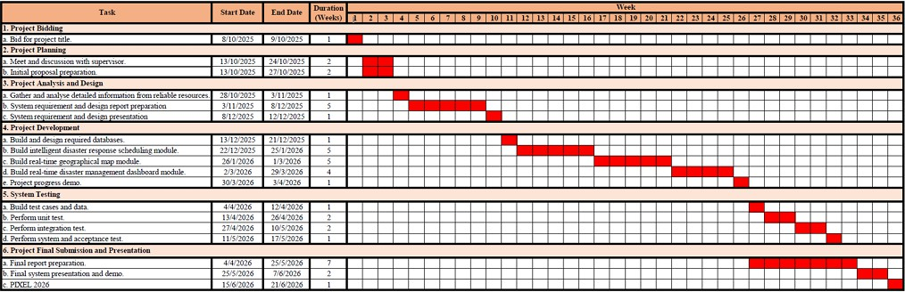

Figure 3.3.2. Gantt Chart

3.3.3. SWOT Analysis

STRENGTHS | WEAKNESSES
The Food Aid Allocation system significantly improves disaster and humanitarian response efficiency by automatically generating optimized distribution schedules using a Genetic Algorithm, eliminating delays caused by manual coordination. It enhances operational efficiency by intelligently allocating limited food resources, vehicles, and staff across multiple distribution centres. The system provides a unified, real-time visual command dashboard accessible via Progressive Web Application (PWA) architecture on desktops, smartphones, and tablets. It also offers situational awareness through real-time mapping of beneficiaries, food stocks, and vehicle locations. | The system is dependent on cloud-based infrastructure, meaning that new schedules or map updates cannot be generated without a stable internet connection. It relies heavily on manual data entry for beneficiary information, vehicle availability, and food stock levels, which may result in inaccuracies if users fail to update information promptly. Additionally, the system currently focuses on allocation optimization but does not include advanced route optimization or automated delivery tracking, which may affect efficiency in complex logistics scenarios.
OPPORTUNITIES | THREATS
This project aligns with humanitarian and smart city initiatives, such as “Penang 2030” and SDG 2 (Zero Hunger), by providing a data-driven framework for efficient food distribution. There is a significant opportunity to enhance the system by integrating IoT-enabled sensors, GPS tracking of delivery vehicles, and machine learning models to predict high-demand zones based on historical or real-time data. Expansion to include automated notifications to beneficiaries and integration with external food supply chains can further strengthen the system’s impact and scalability. | Security risks include storing sensitive beneficiary data and real-time vehicle GPS tracking, which could be exploited in the event of a data breach. Privacy concerns arise if location or personal information is misused outside operational contexts. Additionally, system performance could be affected by connectivity issues or high computational demands of the Genetic Algorithm on large-scale operations. Strict data security protocols, encryption, role-based access, and compliance with privacy regulations are essential to mitigate these risks.

Table 3.6: SWOT Analysis – Food Aid Allocation using Genetic Algorithm

Development Methodology

The Food Aid Allocation project adopts the Agile development methodology, which emphasizes an iterative and incremental approach. This methodology was selected due to the experimental and computationally intensive nature of the Genetic Algorithm and the need for continuous adaptation in the user interface design. Unlike linear methodologies such as Waterfall, Agile allows for ongoing refinement throughout the development lifecycle, ensuring that critical components like the allocation optimization engine, can be tested, adjusted, and improved early in the process.
The development started with a comprehensive analysis of current food distribution workflows, identifying bottlenecks in resource allocation, transportation scheduling, and beneficiary management. Functional requirements for the intelligent food allocation system were then defined, focusing on generating optimized schedules, tracking resource availability, and enabling real-time situational awareness.
Next, a modular system architecture was designed, integrating a Progressive Web Application (PWA) frontend, a Django backend, and cloud-based services to ensure scalability and real-time synchronization. The iterative development process follows several cycles:
- Database and PWA Infrastructure Setup: Creating the foundational database structure for tracking food resources and beneficiary details, and implementing the front-end architecture for cross-platform access.
- Genetic Algorithm & Priority Scoring Implementation: Incrementally developing and testing the priority-based scoring mechanism and the allocation optimization engine to ensure efficient and fair usage of limited resources.
- Real-time Visualization and Analysis Integration: Developing interactive maps and dashboards that allow the System User to visualize beneficiary locations, monitor resource availability, and analyze optimization outcomes.
- Unit and Integration Testing: Continuous testing of individual modules and the integrated system to validate algorithm outputs, database integrity, and dashboard functionality.
- Final Deployment and User Acceptance Testing (UAT): Ensuring the system meets operational needs, with feedback from end-users incorporated into the final version.

The Agile methodology provides the flexibility required to accommodate changes in algorithmic parameters and user interface improvements. This ensures that the Food Aid Allocation system remains adaptable, efficient, and effective in real-world humanitarian scenarios.

Detailed Requirements of New System

To gather insights for the development of the Food Aid Allocation System, a Google Form questionnaire survey titled “Food Aid Distribution: Public Insights and Needs Assessment” was conducted with 45 anonymous participants. The survey aimed to collect information on food aid access, delivery challenges, and the priorities of beneficiaries and field coordinators. The detailed survey responses are attached in Appendix A.

Section A: Demographic Information

The demographic analysis revealed that most respondents were students (66.7%) and private sector employees (77.8%), primarily based in Penang. The majority of participants were aged 18–34 (71.1%) and possessed a bachelor’s degree (73.3%), indicating a digitally literate population. This suggests that the target audience is well-equipped to adopt a modern Progressive Web Application (PWA) interface for food aid allocation without significant usability barriers.

Section B: Food Aid Distribution Experiences

The survey identified the primary challenges faced in food aid distribution:

- Delayed delivery was reported by 68.9% of respondents as the most significant issue.

- Inefficient allocation of resources was noted by 60%, including shortages of volunteers or vehicles at critical times.
- Insufficient communication and tracking was highlighted by 55.6% of participants.

Most respondents rated the current efficiency of food aid distribution in their area as moderate (3 out of 5). Moreover, 71.1% of respondents had personally experienced delays or missed deliveries. These findings justify the need for an Intelligent Food Allocation Module that leverages computational algorithms to optimize routes and resource assignment, minimizing delays and improving overall operational efficiency.

Section C: Designing the Ideal Food Aid Allocation System

Participants provided valuable input regarding system features and priorities:

- Speed of allocation was prioritized by 62.2% of respondents, while human-in-the-loop verification was preferred by 48.9%, emphasizing the need for a decision support system where coordinators can validate the recommended schedules before execution.
- Critical factors for prioritization in allocation were identified as Beneficiary Need Level (77.8%) and Distance from Warehouse/Depot (73.3%), which must be heavily weighted in the Genetic Algorithm’s fitness function.
- Real-time map visualization and push notifications were overwhelmingly requested (82.2%), highlighting the necessity of a PWA interface to ensure field officers receive immediate location-based alerts and allocation updates.

Functional Requirements

ID | Requirements Description | User(s)
FR-01 | The system shall allow the System User to log in using a secure username and password. | System User
FR-02 | The system shall allow the System User to log out and terminate the current session securely. | System User
FR-03 | The system shall allow the System User to register new beneficiary households with socioeconomic information such as income category, family size, and OKU status. | System User
FR-04 | The system shall allow the System User to update existing beneficiary household information. | System User
FR-05 | The system shall allow the System User to view detailed beneficiary household profiles. | System User
FR-06 | The system shall allow the System User to remove beneficiary household records that are no longer eligible for food aid. | System User

FR-07 | The system shall allow the System User to define and configure priority scoring criteria based on socioeconomic indicators. | System User
FR-08 | The system shall automatically calculate priority scores for all registered households based on the configured scoring criteria. | System
FR-09 | The system shall allow the System User to view and review household priority rankings generated by the system. | System User
FR-10 | The system shall allow the System User to input available food aid resource constraints, such as total food package quantity or budget limits. | System User
FR-11 | The system shall allow the System User to configure Genetic Algorithm parameters including population size, number of generations, crossover rate, mutation rate, and elitism strategy. | System User
FR-12 | The system shall formulate the food aid allocation problem as a multi-objective Genetic Algorithm optimisation model. | System
FR-13 | The system shall execute the Genetic Algorithm to generate an optimised food aid allocation plan based on priority scores and resource constraints. | System
FR-14 | The system shall evaluate allocation solutions using performance metrics including priority satisfaction rate, coverage efficiency, and Gini coefficient. | System
FR-15 | The system shall allow the System User to view the optimised allocation results for each beneficiary household. | System User
FR-16 | The system shall provide graphical visualisations of allocation outcomes and performance metrics. | System User
FR-17 | The system shall allow the System User to compare Genetic Algorithm–optimised allocations with baseline allocation strategies such as equal or random distribution. | System User
FR-18 | The system shall allow the System User to generate and export allocation analysis reports in common formats such as PDF or CSV. | System User
Table 3.7 Functional Requirements

Non-Functional Requirements

Category | Requirements Description
Availability | The system shall be available during standard operational hours for planning and analysis purposes. System downtime shall be minimized, and any scheduled maintenance shall not affect stored beneficiary data or previously generated allocation results.
Usability | The system interface shall be simple and intuitive, allowing users with basic computer literacy to perform key tasks such as managing beneficiary data, configuring parameters, and viewing allocation results without extensive training.
Compatibility | The system shall be accessible through modern web browsers on desktop and laptop computers without requiring additional plugins or proprietary software.
Performance | The Genetic Algorithm–based allocation optimisation process shall generate an allocation solution within a reasonable time frame suitable for planning activities, typically within one to two minutes for the tested dataset size.
Security | The system shall restrict access to authorised users through authentication mechanisms. Beneficiary data shall be stored securely, and access to sensitive information shall be limited to prevent unauthorised disclosure.
Scalability | The system design shall support future expansion to larger datasets, including an increased number of beneficiary households or additional vulnerability indicators, without requiring major architectural changes.
Maintainability | The system shall be developed using a modular architecture, allowing individual modules such as priority scoring or optimisation logic to be modified or enhanced independently. Code documentation shall be provided to support future maintenance.
Interpretability | The system shall provide clear visualisations and performance metrics, enabling users to understand, interpret, and justify allocation decisions produced by the Genetic Algorithm.
Reliability | The system shall consistently produce allocation results based on the same input parameters and data. Any system errors encountered during optimisation shall be handled gracefully without data corruption.
Table 3.8 Non-Functional Requirements

Analysis of New System
    - Use Case Diagram
The Figure 3.2 illustrates the overall use case diagram of the NutriAid4B40 system. The diagram shows the interactions between the System User and the major system functions across the four core modules. The <<include>> relationships indicate mandatory sub-functions that are always executed as part of higher-level use cases, such as allocation performance evaluation during the display of allocation results and analysis.
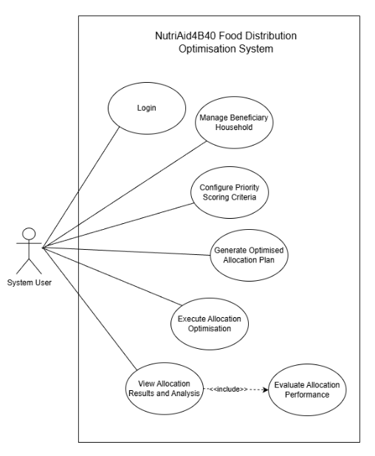

Figure 3.2: Use Case Diagram

Use Case Descriptions

Use Case ID | UC-01
Use Case Name | Login
Brief Description | This use case allows the System User to authenticate and gain access to the NutriAid4B40 system before performing any system operations.
Triggering Event | The System User launches the system application.
Actor | System User
Pre-Conditions | The System User must have a valid registered account in the system.
Post-Conditions | The System User is successfully authenticated and granted access to the system dashboard.
Flows of Activity | Actor: Enters username and password into the login interface.  System: Validates the credentials against stored user records.  System: Grants access and displays the main system dashboard.
Exception Conditions | If invalid credentials are entered, the system displays an error message and denies access.
Table 3.9 Use Case Description for Login

Use Case ID | UC-02
Use Case Name | Manage Beneficiary Household
Brief Description | This use case allows the System User to add, update, view, or remove B40 household beneficiary records in the system.
Triggering Event | The System User selects the beneficiary management function from the system dashboard.
Actor | System User
Pre-Conditions | The System User must be logged into the system.
Post-Conditions | Beneficiary household data is stored, updated, or removed successfully in the system database.
Flows of Activity | Actor: Enters or edits household socioeconomic information such as income, family size, and OKU status.  System: Validates the entered data.  System: Saves the household information and updates the beneficiary records.
Exception Conditions | If required fields are missing or invalid values are entered, the system prompts the user to correct the input.
Table 3.10 Use Case Description for Manage Beneficiary Household

Use Case ID | UC-03
Use Case Name | Configure Priority Scoring Criteria
Brief Description | This use case allows the System User to configure or adjust vulnerability scoring parameters used to calculate household priority scores.
Triggering Event | The System User selects the priority scoring configuration option.
Actor | System User
Pre-Conditions | The System User must be logged into the system.
Post-Conditions | Priority scoring criteria are successfully updated and stored for future calculations.

Flows of Activity | Actor: Defines scoring rules for income levels, family size, and OKU status.  System: Validates the scoring configuration.  System: Saves the updated criteria for priority score computation. System: validates input → updates database → synchronizes global view.
Exception Conditions | If invalid scoring values are entered, the system rejects the configuration and displays an error message.
Table 3.11 Use Case Description for Configure Priority Scoring Criteria

Use Case ID | UC-04
Use Case Name | Calculate Household Priority Scores
Brief Description | This use case calculates vulnerability-based priority scores for all registered households based on predefined scoring criteria.
Triggering Event | The System User initiates priority score calculation or updates beneficiary data.
Actor | System User
Pre-Conditions | Beneficiary household data and scoring criteria must exist in the system.
Post-Conditions | Each household is assigned a computed priority score and ranked accordingly.
Flows of Activity | Actor: Initiates the priority scoring process.  System: Applies the scoring formula to each household record.  System: Stores and displays the priority scores and rankings.
Exception Conditions | If beneficiary data is incomplete, the system excludes affected records and notifies the user.
Table 3.12 Use Case Description for Calculate Household Priority Scores

Use Case ID | UC-05
Use Case Name | Configure Genetic Algorithm Parameters
Brief Description | This use case allows the System User to configure parameters for the Genetic Algorithm used in allocation optimization.
Triggering Event | The System User selects the optimization configuration option.
Actor | System User
Pre-Conditions | Priority scores must have been calculated.
Post-Conditions | Genetic Algorithm parameters are stored and ready for optimization execution.
Flows of Activity | Actor: Sets parameters such as population size, number of generations, crossover rate, mutation rate, and elitism strategy.  System: Validates parameter ranges.  System: Saves the configuration settings.
Exception Conditions | If parameter values fall outside acceptable ranges, the system displays an error and prevents saving.
Table 3.13 Use Case Description for Configure Genetic Algorithm Parameters

Use Case ID | UC-06
Use Case Name | Execute Allocation Optimization
Brief Description | This use case executes the Genetic Algorithm to generate an optimized food aid allocation plan.
Triggering Event | The System User starts the optimization process.
Actor | System User
Pre-Conditions | Priority scores, GA parameters, and resource constraints must be defined.
Post-Conditions | An optimized allocation solution is generated and stored.
Flows of Activity | Actor: Initiates the optimization process.  System: Generates an initial population of allocation solutions.

System: Applies selection, crossover, mutation, and elitism operations.
System: Evaluates fitness using fairness and efficiency metrics.
System: Outputs the optimal allocation solution.
Exception Conditions | If resource constraints are invalid or insufficient, the system terminates the process and notifies the user.
Table 3.14 Use Case Description for Execute Allocation Optimization

Use Case ID | UC-07
Use Case Name | View Allocation Results and Analysis
Brief Description | This use case allows the System User to view optimized allocation results and performance metrics.
Triggering Event | The System User selects the results and analysis option.
Actor | System User
Pre-Conditions | An optimization process must have been completed.
Post-Conditions | Allocation results and performance metrics are displayed to the user.
Flows of Activity | Actor: Requests to view allocation results.  System: Displays household allocation details and visual performance indicators.  System: Allows comparison with baseline allocation methods.
Exception Conditions | If no optimization results are available, the system displays a notification indicating that optimization must be executed first.
Table 3.15: Use Case Description for View Allocation Results and Analysis

Class Diagram
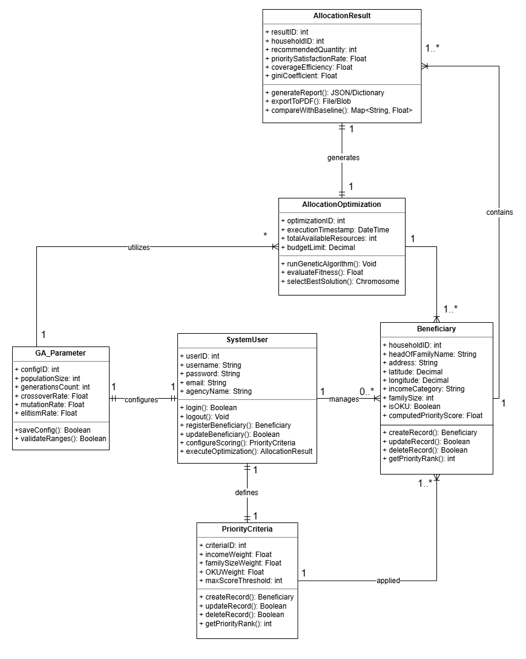

Figure 3.6.3 Class Diagram

The Class Diagram in Figure 3.6.3 illustrates the static structure of the NutriAid4B40 system, defining the key entities responsible for data management, vulnerability scoring, and the execution of the Genetic Algorithm (GA) for food aid optimization.
The core of the system is the SystemUser class, which represents the single actor responsible for administrative and operational tasks. This user manages the system’s data and triggers the optimization processes. The Beneficiary class stores the socioeconomic profiles of B40

households, including critical attributes such as income category, family size, and OKU status. These attributes are processed by the PriorityCriteria class, which defines the mathematical weights and rules used to calculate a objective vulnerability score for each household.
The optimization engine is represented by the AllocationOptimization class. This class interacts with the GA_Parameter class, which allows the System User to configure the genetic algorithm's behavior, such as population size and mutation rates. Once the optimization process is executed, it generates an AllocationResult entity. This class captures the final output, including the recommended food quantities for each household and analytical metrics such as the Gini coefficient and coverage efficiency to ensure the distribution is both fair and effective.
The operational logic and data flow of the NutriAid4B40 system are defined by the specific interactions between these entities. A single SystemUser manages a collection of Beneficiary records and maintains a set of PriorityCriteria and GA_Parameters to ensure consistency throughout the distribution cycle. The data flow begins when the PriorityCriteria are applied to all Beneficiary instances to compute their individual vulnerability rankings, which serve as the primary input for the optimization engine. Subsequently, the AllocationOptimization engine utilizes the configured GA_Parameters to process the prioritized Beneficiary data, ensuring the algorithm adapts to current resource constraints. Each successful execution of the optimizer results in a unique AllocationResult, which is linked back to the specific Beneficiary records to provide a transparent and traceable map of aid distribution based on objective priority scores. This integrated structure ensures that the system remains focused on its primary goal of utilizing intelligent computing to automate and optimize food aid distribution with maximum efficiency.

System Sequence Diagram (SSD)
The following diagrams illustrate the dynamic behavior of the NutriAid4B40 system, detailing the chronological sequence of messages between the System User and the internal system components.

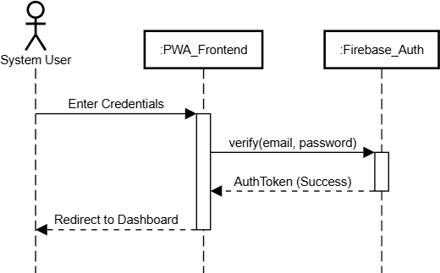
Figure 3.6.4 SSD for Login Use Case

This diagram depicts the authentication process. The System User provides credentials to the
:PWA_Frontend, which communicates with :Firebase_Auth to verify the user's identity. The activation bars show that the frontend remains active until the authentication token is returned and the user is redirected to the dashboard.

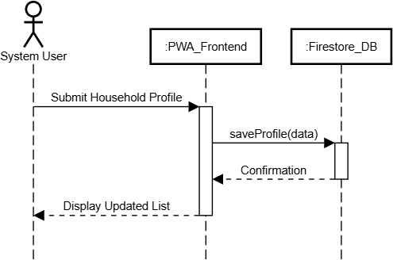

Figure 3.6.5 SSD for Manage Beneficiary Household Use Case

The sequence follows the CRUD lifecycle of beneficiary data. When the user submits socioeconomic profiles, the :PWA_Frontend sends a persistence request to the
:Firestore_DB. The process ensures that data is successfully committed to the cloud database before confirming the update to the user.

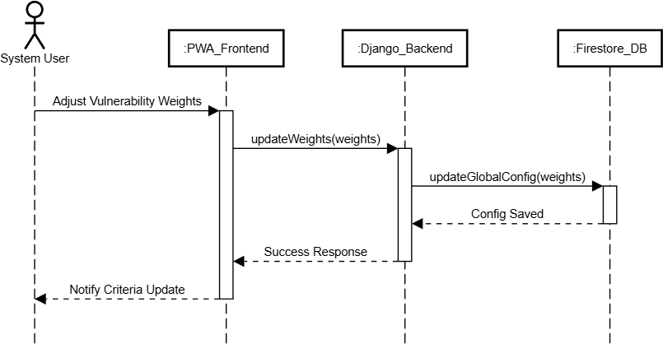

Figure 3.6.6 SSD for Configure Priority Scoring Criteria Use Case

This diagram shows the setup of the system’s logic. The user interacts with the UI to set vulnerability weights. The :PWA_Frontend triggers the :Django_Backend to update the mathematical scoring model, which is then stored in the global configuration within the

:Firestore_DB.

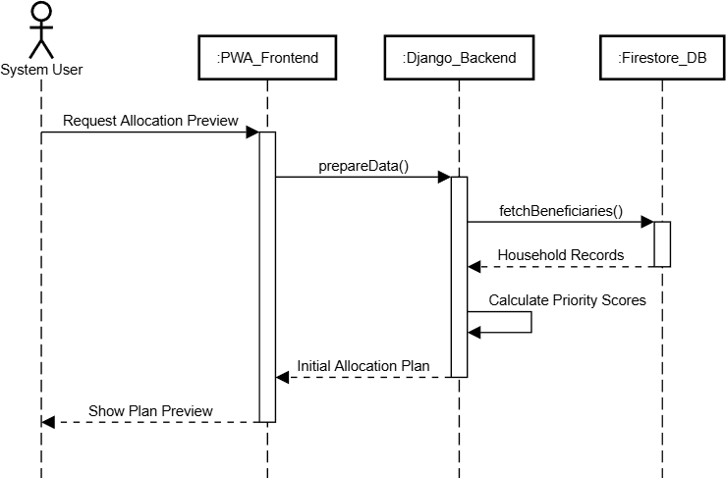

Figure 3.6.7 SSD for Generate Optimised Allocation Plan Use Case

This represents the data preparation phase. The :Django_Backend fetches all relevant household records from the :Firestore_DB to calculate priority scores. This SSD highlights the system's ability to rank households based on the previously defined criteria to create a preliminary distribution plan.

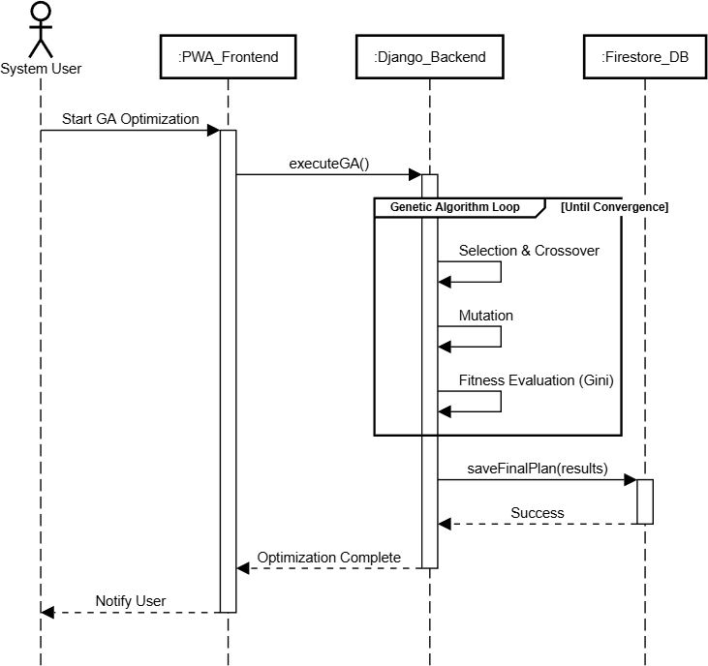

Figure 3.6.8 SSD for Execute Allocation Optimisation Use Case

This is the core "Intelligent Computing" sequence. It features a Loop Fragment (the Genetic Algorithm loop), indicating the iterative nature of selection, crossover, mutation, and fitness evaluation. The :Django_Backend repeatedly calculates the Gini Coefficient to ensure fairness until a convergence point is reached and the final results are saved.

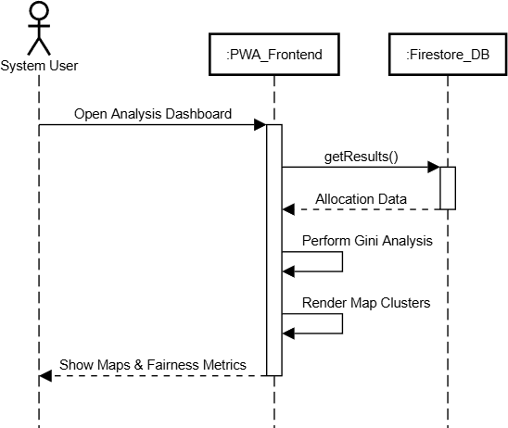

Figure 3.6.9 SSD for View Allocation Results and Analysis Use Case

The final sequence demonstrates the mandatory evaluation requirement. Upon requesting the analysis dashboard, the :PWA_Frontend retrieves the results and performs local processing to render map clusters and fairness charts. This ensures that the user receives a visual audit of the allocation's performance and equity.

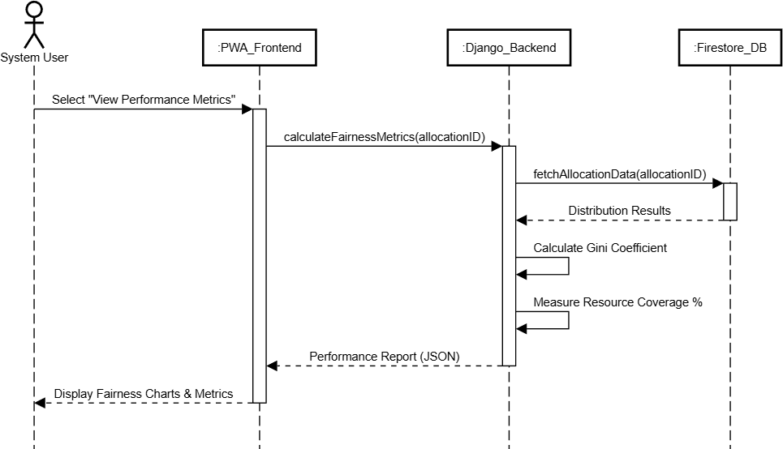

Figure 3.6.10 SSD for Evaluate Allocation Performance Use Case

This diagram illustrates the internal logic of the mandatory <<include>> sub-function triggered during the results phase. The sequence shows the :PWA_Frontend requesting a fairness audit from the :Django_Backend, which retrieves the finalized distribution data from the :Firestore_DB. The backend performs the core mathematical evaluations, specifically calculating the Gini Coefficient and resource coverage ratios, before returning the metrics to the frontend. This process ensures that every allocation plan is objectively audited for equity and performance before the final analysis is presented to the user.

Flowchart
A detailed flowchart of the NutriAid4B40 System is designed to illustrate the complete workflow of the system, from user login to the successful generation of the optimized food aid allocation plan.
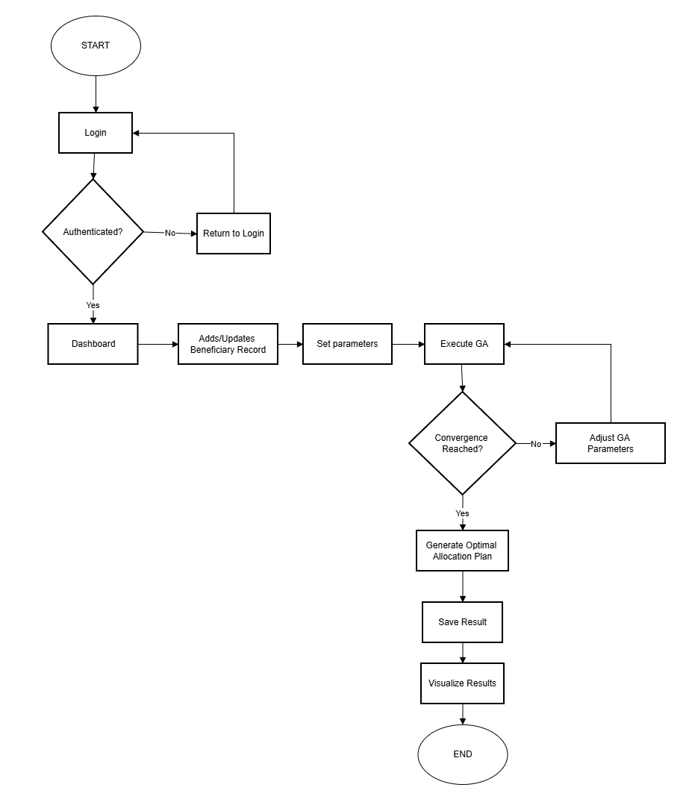

Figure 3.6.11 Flowchart

Detailed Description of Proposed System/Solution
    - System Modules

Based on the overall module diagram, the NutriAid4B40 system is built upon four interconnected modules designed to streamline the food aid process which are the Beneficiary Management Module, the Priority Scoring Module, the Allocation Optimization Module, and the Visualization and Analysis Module.
The journey begins with the Beneficiary Management Module, which serves as the foundational data layer of the system. This module provides a user-friendly interface for the System User to maintain comprehensive socioeconomic profiles of B40 households. By capturing details such as household income, family size, and OKU status, the module ensures that the system works with a clean, real-time dataset synchronized via Firebase. Building upon this data, the system transitions to the Priority Scoring Module. Here, the objective assessment of need takes place. Instead of relying on manual observation, the System User defines specific weights for various criteria, allowing the system to calculate a composite vulnerability score for every household. This step is crucial as it transforms raw data into a transparent, ranked list that identifies who needs help most urgently.
Once the priorities are established, the process moves into the Allocation Optimization Module, which acts as the "intellectual engine" of the system. This module retrieves the prioritized list and matches it against current resource constraints. By simulating the process of natural evolution—using selection, crossover, and mutation—the GA explores thousands of possible distribution plans to find the most efficient one. A standout feature here is the use of the Gini Coefficient within the fitness function, which mathematically ensures that the food is distributed fairly rather than just efficiently.
Finally, the results of this complex computation are handed over to the Visualization and Analysis Module for human review. This module acts as the central command hub, translating abstract mathematical results into intuitive visual tools. Through an interactive geographical map and statistical charts, the System User can see exactly where the aid is going and how well the system performed in terms of coverage and fairness. This seamless flow from data entry to visual analysis ensures that the entire food aid operation is not only optimized by AI but remains fully transparent and easy to manage for the user.

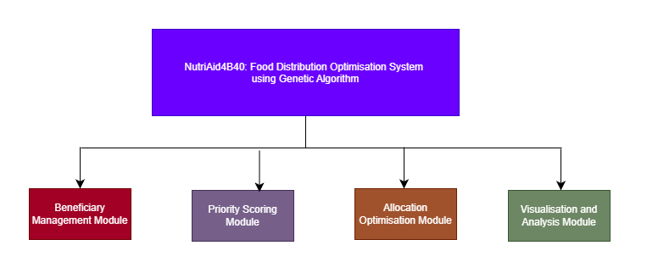

Figure 3.7.1 System Module

System Architecture Diagram
The NutriAid4B40 system is built upon a robust multi-tier architecture designed to separate concerns between the user interface, complex computational logic, and cloud-based data storage. As illustrated in Figure 3.18, this architecture ensures high scalability and real-time responsiveness through three primary layers: the Frontend Layer, the Service Layer, and the Data Layer.
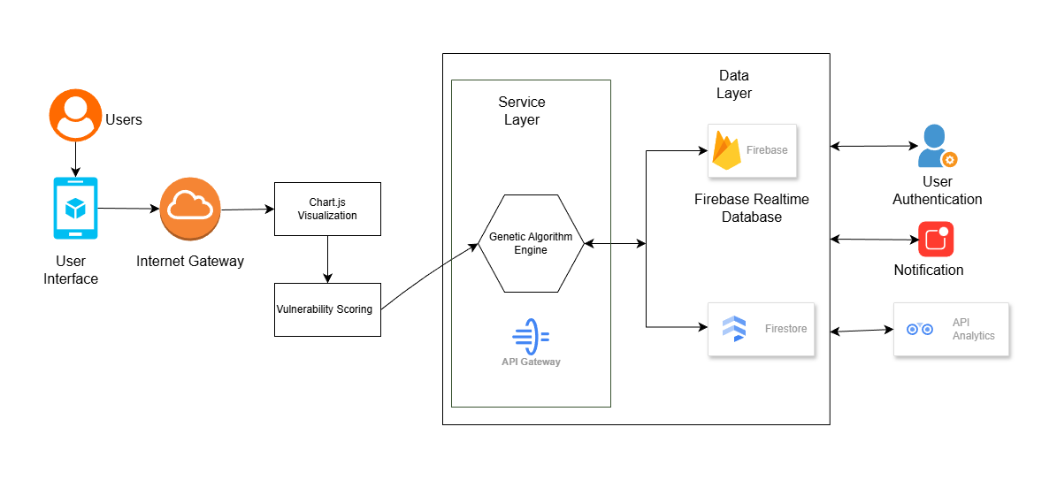

Figure 3.7.2. System Architecture Diagram

The Frontend Side (User Experience)

At the top level, the User Interface serves as the primary way the System User interacts with the technology. This layer is more than just buttons; it includes an Internet Gateway that connects the user to powerful tools like Chart.js Visualization and Vulnerability Scoring forms. By keeping the interface interactive, the user can easily input household data and see the results of the optimization in a way that makes sense, such as through maps and graphs.
- The Service Layer (The "Brain")
Moving deeper, the Service Layer is where the actual "heavy lifting" happens. This is the home of the Genetic Algorithm (GA) Engine, which is isolated from the frontend via an API Gateway to prevent the system from slowing down during intense calculations. Because this layer is separated, the GA engine can focus entirely on running thousands of simulations to find the fairest food distribution plan without affecting the user's ability to browse other parts of the dashboard.

The Data Layer (Storage and Security)
Finally, everything is anchored by the Data Layer, which uses Google’s Firebase ecosystem for speed and security. This layer is split between the Firebase Realtime Database for instant updates and Firestore for organized record-keeping. To round out the system, this layer also manages User Authentication to keep data safe and Notification services to keep the user informed. By using cloud-based storage, the system ensures that every priority score and allocation result is backed up and accessible in real-time.

Chosen Intelligent Algorithm/Method/Approach

The true intelligence of the NutriAid4B40 system resides in its Allocation Optimization Module, which utilizes a Genetic Algorithm (GA) to solve the complex challenge of distributing limited resources. Unlike traditional scheduling that focuses only on speed, this approach is uniquely designed to balance the mathematical efficiency of the distribution with the social necessity of fairness for B40 households.
To begin the process, the system gathers real-time data from the Firebase database, including specific household vulnerability scores and the total food inventory available. Once this data is collected, the GA treats each possible distribution plan as a "chromosome." This allows the

system to evaluate thousands of potential allocation scenarios simultaneously, searching for the one that best meets the needs of the community.
Central to this intelligent logic is the Fitness Function, which acts as the system's decision-maker. Instead of just looking at the total number of households served, the function is carefully tuned to consider:
      - Vulnerability Alignment: Ensuring the most critical B40 households (based on income and OKU status) are prioritized.
      - The Gini Coefficient: A sophisticated mathematical tool used within the algorithm to measure and minimize distribution inequality, ensuring a fair "spread" of resources
across the population.

As the algorithm evolves, it applies biological principles such as Selection, Crossover, and Mutation. By iteratively refining these "chromosomes," the system probabilistically discards unfair or inefficient plans while promoting those that achieve high impact. Ultimately, this evolutionary process ensures that the final allocation plan is not just a guess, but a mathematically optimized solution that can adapt to sudden changes such as new household registrations or inventory shifts while maintaining a transparent and equitable standard for food aid distribution.

Description of Data Source

The NutriAid4B40 system does not rely on historical training or test datasets. This is because the Allocation Optimization Module performs real-time optimization of food aid distribution based on current household needs rather than learning predictive models from past data. To facilitate development, a dummy dataset in JSON format has been created to simulate the structure of the Firebase NoSQL database that will be used in the production environment.
In this dataset, each JSON collection represents a core component of the system, specifically focusing on households, food package inventories, and allocation results. Each document within these collections contains essential fields such as unique identifiers, geographical coordinates (latitude/longitude), and detailed socioeconomic indicators like monthly income, household size, and disability (OKU) status. Furthermore, it includes the calculated priority scores and timestamps for when an allocation plan is generated or updated.

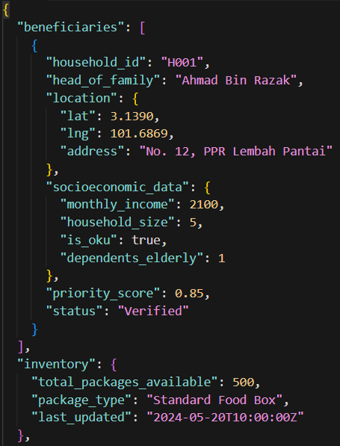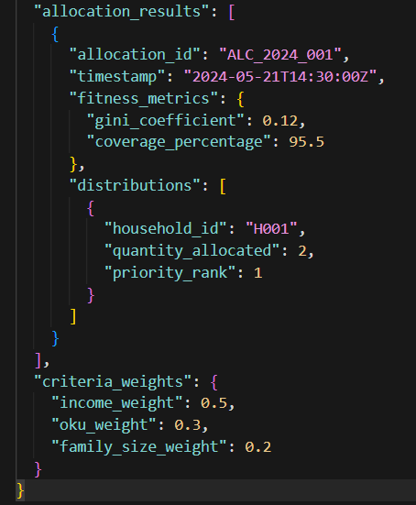

Figure 3.8. Description of Data Source

The dummy dataset is intentionally designed to align with the Genetic Algorithm (GA) logic of the system, focusing on:
- Socioeconomic Prioritization: Categorizing households based on urgency using weighted socioeconomic indicators.
- Fairness and Equity: Providing enough variation in household data to test the Gini Coefficient in ensuring an equitable distribution of aid.
- Resource Optimization: Matching the limited food package inventory against the total demand of the B40 community.
- Geographical Visualization: Enabling the system to render accurate clusters of aid distribution on the interactive map.
- Dynamic Updates: Allowing the system to re-optimize the allocation plan instantly whenever new household data is added to the simulated Firebase environment.
By using this controlled synthetic dataset, the system can undergo rigorous experimentation, verification, and tuning. This ensures that the Genetic Algorithm produces allocation plans that are not only efficient but also mathematically fair. Once the system is deployed, it will transition from this dummy data to consuming live, continuously refreshed documents from

Firebase, providing a real-time view of household needs and distribution status without the need for static training sets.

Technology Deployed
    - Hardware Specification
The hardware used to experiment and develop the Food Aid Distribution system is an ASUS TUF Gaming A16 laptop. The specifications are as follows:

Hardware | Specification
CPU | AMD Ryzen 7 620 w/ Radeon 780M Graphics
GPU 1 | NVIDIA GeForce RTX 5050
GPU 2 | AMD Radeon 750M
Installed RAM | 16GB
SSD Drive Storage | 512GB
Table 3.16 Hardware Specification
This hardware setup allows efficient experimentation with the Genetic Algorithm (GA) optimization for scheduling deliveries to multiple households while handling real-time data synchronization and visualization.

Software Specification
The software used to develop and experiment with the Food Aid Distribution system includes:

Software Name | Purpose
Windows 11 Home Single Language | Operating System
Visual Studio Code | Code development and debugging
Jupyter Notebook | Algorithm simulation and experimentation
Microsoft Edge / Google Chrome | Web application testing
Google Cloud Platform | Firebase database hosting and cloud services
Table 3.17 Software Specification

Programming Languages / Tools
The programming languages, frameworks, and tools used for the system development include:

Category | Programming Languages / Tools
Frontend | React framework, Progressive Web Application (PWA)
Backend | Python, Django
Version Control | GitHub
Database | Firebase
Table 3.18 Programming Languages/tools
The NutriAid4B40 system is developed using a modern technology stack designed for high-performance optimization and real-time responsiveness. The React-based Progressive Web Application (PWA) provides a fast, mobile-friendly interface for the System User to manage beneficiaries and view allocation maps. This is supported by a Python-Django backend, which serves as the core engine for executing the complex Genetic Algorithm and vulnerability scoring logic. To ensure data integrity and instant updates, Firebase is utilized for real-time NoSQL storage of household profiles and resource inventory, while GitHub facilitates version control and collaborative code management. This integrated approach allows the system to remain scalable while delivering mathematically fair and transparent food aid distribution.

SDG ALIGNMENT

The NutriAid4B40 system is strategically designed to contribute to the United Nations Sustainable Development Goals, specifically bridging the gap between food security and resource efficiency [8]. By moving away from manual distribution methods and embracing an intelligent, data-driven approach, the project directly supports the following goals:
SDG 2: Zero Hunger

This project serves as a direct implementation of Target 2.1, which aims to end hunger and ensure that vulnerable populations have consistent access to sufficient, nutritious food [8],[9]. Through the use of the Priority Scoring Module, the system objectively identifies B40 households in the most critical need based on income and family size. As a result, the Genetic Algorithm can generate allocation plans that maximize the reach of available food resources, ensuring that aid is delivered where it will have the most significant impact on reducing malnutrition and food insecurity within the community.
SDG 12: Responsible Consumption and Production

Complementing the goal of ending hunger, the project aligns with Target 12.3, which focuses on reducing food loss and waste through more efficient distribution systems [8], [9]. By utilizing a Genetic Algorithm to optimize food allocation, the system ensures that "production" (the available aid) is matched perfectly with "consumption" (household needs). This precision prevents the over-allocation of resources to households with lesser needs, thereby reducing potential food waste and ensuring that every package is utilized effectively. Furthermore, the real-time tracking within the dashboard provides a layer of accountability, allowing administrators to monitor resource utilization and ensure that the distribution process remains sustainable and responsible over the long term.

CONCLUSION

In conclusion, the NutriAid4B40 system offers a significant leap forward in managing food aid for B40 households by transforming traditional, subjective distribution methods into an intelligent, data-driven operation. By centralizing real-time socioeconomic data and applying a Genetic Algorithm (GA), the system ensures that aid is no longer just "delivered," but is instead strategically allocated to maximize both coverage and equity. The system achieves this through the seamless integration of its four core components: the Beneficiary Management Module, the Priority Scoring Module, the Allocation Optimization Module, and the Visualization and Analysis Module.
Building upon this technological foundation, the system moves beyond simple automation by addressing the root challenges of resource misallocation and social bias. The Priority Scoring Module ensures that households with the most urgent needs such as those with lower incomes or disabled (OKU) members are identified objectively. Building on these scores, the Allocation Optimization Module utilizes the Gini Coefficient within its fitness function to mathematically guarantee a fair distribution of resources. This approach ensures that limited food packages are spread equitably across the community, preventing aid from being concentrated in easily accessible areas while marginalizing those in deeper pockets of poverty.
Ultimately, the NutriAid4B40 platform demonstrates how advanced optimization techniques can be practically applied to strengthen social welfare. By providing administrators with a transparent, map-based view of allocation outcomes and clear analytical metrics, the system fosters greater accountability and trust in institutional aid programs. While the system’s success depends on accurate data inputs and real-time connectivity, it provides a scalable and adaptable framework that can be easily expanded to other urban welfare initiatives. Through this innovation, the project contributes to a more resilient and inclusive community, ensuring that the social safety net for B40 households is as robust, transparent, and fair as possible.

REFERENCES

- Government of Malaysia, Twelfth Malaysia Plan – Who are the B40, M40, T20? [Online].
Available: https://rmke12.ekonomi.gov.my/en/information/faq/social

- The Star, "Reducing child food poverty," 2024. [Online]. Available: https://www.thestar.com.my/news/education/2024/08/25/reducing-child-food-poverty
- D. Nasien and A. Andi, "Optimization of Genetic Algorithm in Courses Scheduling," ResearchGate, 2022. [Online]. Available: https://www.researchgate.net/publication/358678861_Optimization_of_Genetic_Algorithm_i n_Courses_Scheduling
- Department of Statistics Malaysia, "Over half a million M40 households are now B40, says PM," 2023. [Online]. Available: https://www.dosm.gov.my/uploads/content-downloads/file_20221004094605.pdf
- A. Sadegheih, "Scheduling Problem Using Genetic Algorithm and Simulated Annealing," ScienceDirect, 2005. [Online]. Available: https://www.sciencedirect.com/science/article/pii/S0307904X05000521
- P. Husbands, "Genetic Algorithms for Scheduling," University of Sussex. [Online].
Available: https://users.sussex.ac.uk/~philh/pubs/aisb.sched.pdf

- Firebase Documentation, "Use Firebase in a Progressive Web App (PWA)," 2025. [Online]. Available: https://firebase.google.com/docs/web/pwa
- UN DESA, Global SDG framework, 2023. [Online]. Available: https://sdgs.un.org/goals

- United Nations, Transforming our world: the 2030 Agenda for Sustainable Development, 2015. [Online]. Available: https://sdgs.un.org/2030agenda
- Absolutecodeworks, "Firebase database CRUD sample with Django web app," 2024. [Online]. Available:
https://absolutecodeworks.com/firebase-database-crud-sample-with-django-web-application

