Open terminal (console emulator) on laragon, input ‘mysql –u root’ to access the mysql (mariaDB) folder location. Create new database named “percobaandb” then ‘show databases;’ to see all of databases exist, get into database “percobaandb” with query ‘use’ until the database status change from none to percobaandb so I can operation all query in new database that I have created before. Here’s the ss image :

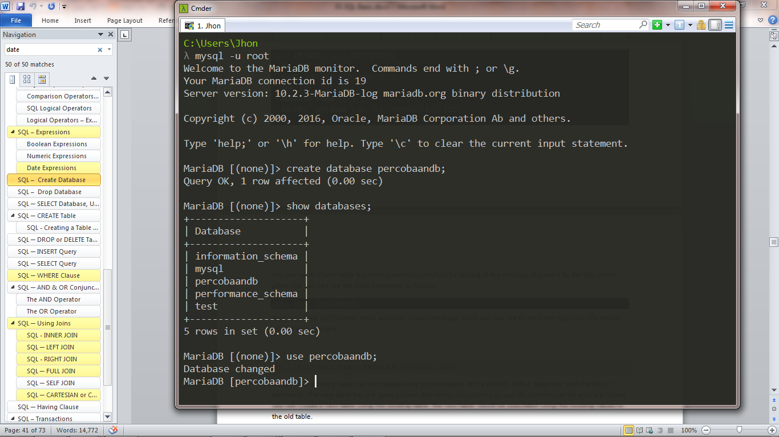

Now I create table from database “percobaandb” with name of table is “customers”, to ‘create table’ must set type data on each needed fields and I set ID as primary key NOT NULL. After finish I wanna verify table that I’ve created before so I use query ‘desc [table]’ to describe what information in my table then I input query insert 7 values in “customers” table with command ‘insert into [table] values (fields);’ Here’s the ss image :

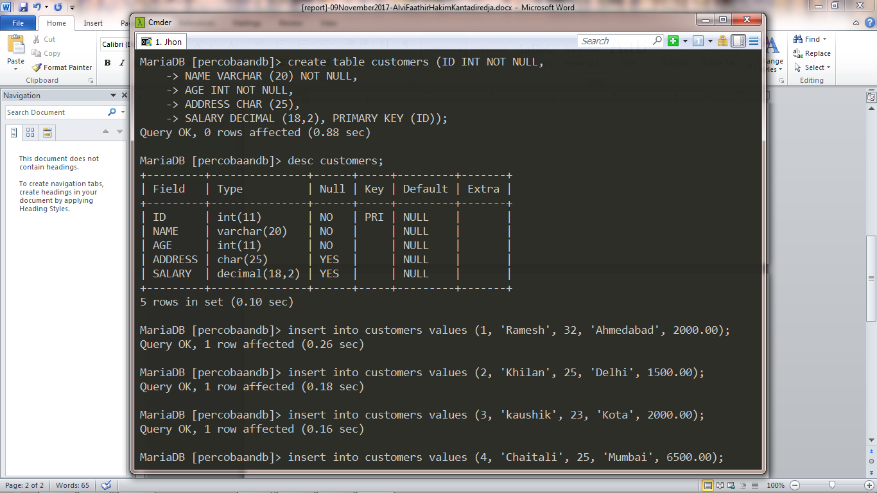

To display all the data in table I query ‘select * from customers;’ the * sign mean all data but if wanna display some column with many condition I query ‘select [fields] from [table] where [condition fields];’ for example I wanna see all name and salary with condition the age is below equal 25. Here’s the ss image :

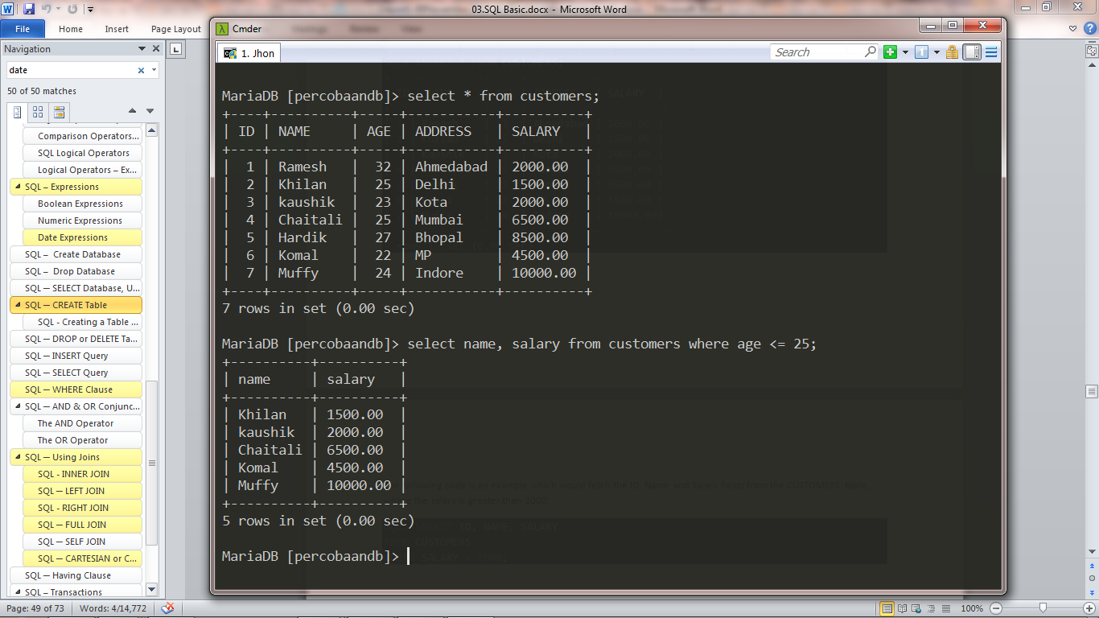

Then I create another table to prepare join query :

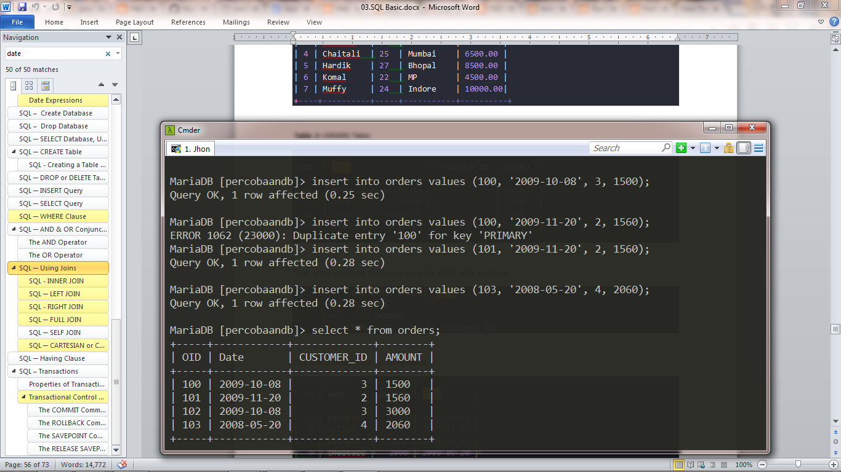

**Inner Join :**

Inner join sql query is most frequently used to combine column values based on two tables (find all pairs of rows of 2 tables). For the example I wanna see the id & name field from table customer and amount field from table orders so the ‘on’ condition must be same id. Here’s the ss image :

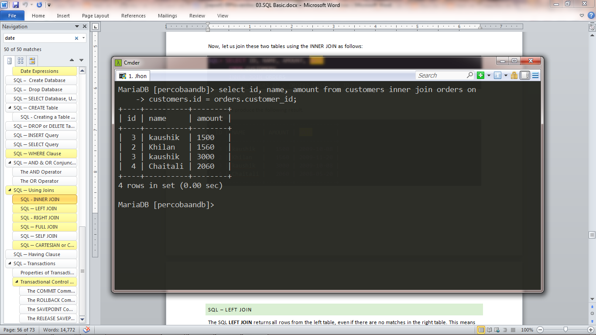

**Left Join :**

Same as inner join the left join is to combine column values based on two tables (find all pairs of rows of 2 tables) but it will get extra unmatched record so the full record only in left position. ‘on’ condition must be same id too. For the example I wanna see the name field from table customer and date & amount field from table orders. Here’s the ss image :

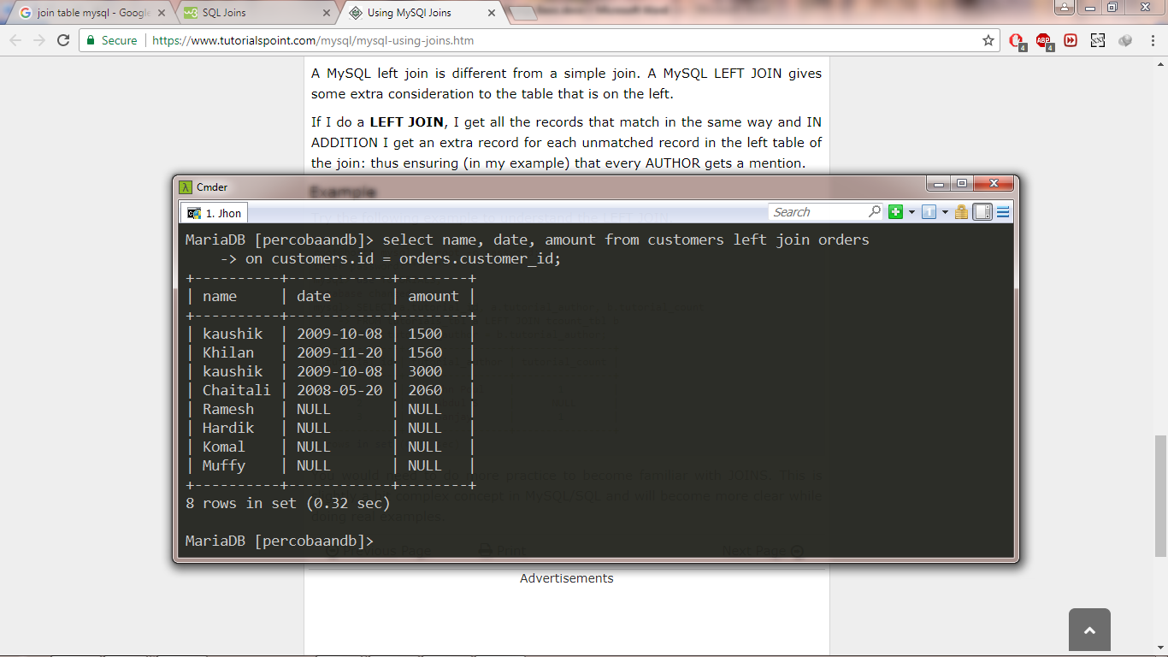

**Right Join :**

Same as left join the right join is to combine column values based on two tables (find all pairs of rows of 2 tables) with ‘on’ condition must be same id too and returns all records from the right table. For the example I wanna see the name field from table customer and date & amount field from table orders. Here’s the ss image :

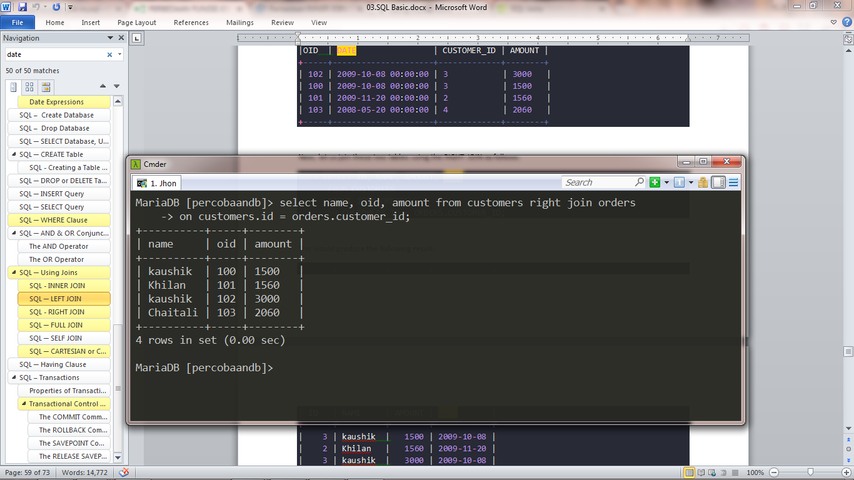

**Self Join :**

Idon’t understand yet so just random input the require of query to display self join. Here’s the ss image :

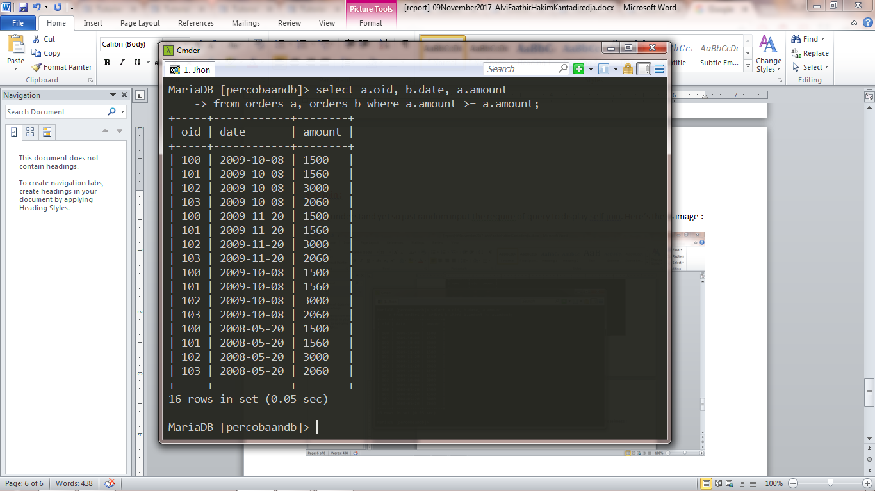

**Cross Join :**

The result of this join set appearing multiply each records without using any condition . For the example I wanna see the id & address field from table customer and date & amount field from table orders. Here’s the ss image :

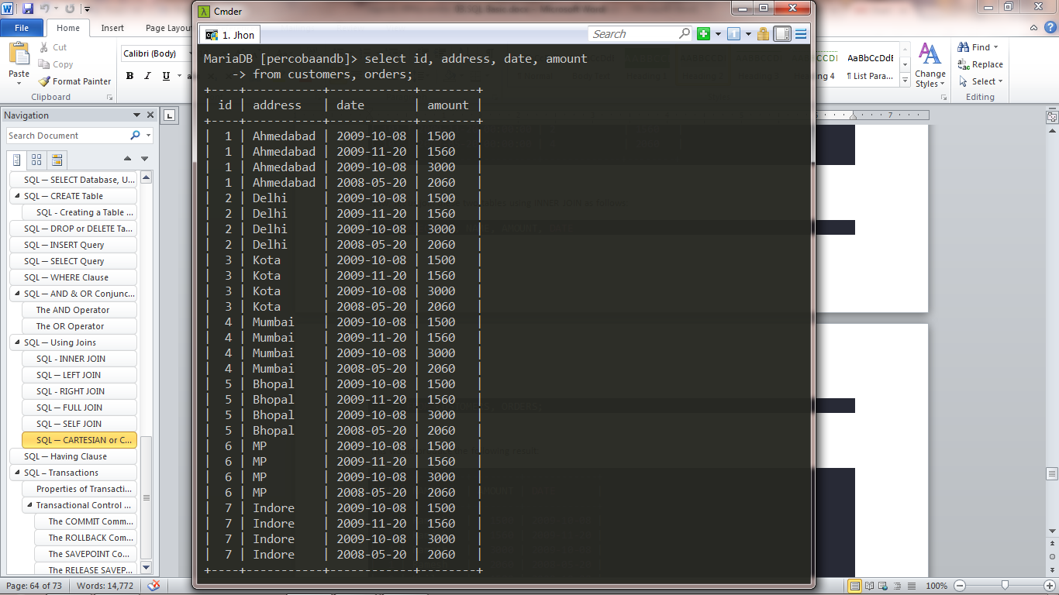

**SQL Transactions :**

Transactions in SQL use for controlling process in database. Usually use for DML Command. I’ve try commit and rollback control. Here’s the ss image :

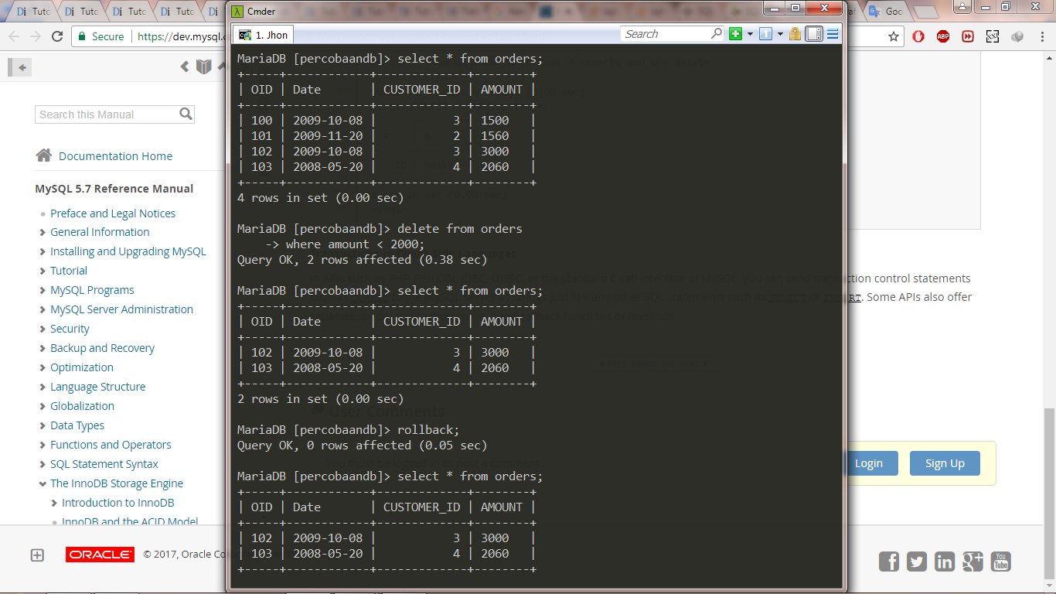

Before commit I try to delete 2 records from table “orders” then success but the problem is when rollback it still the same (no rows affected).