Node webapp tutorial notes:

install -g express-generator

(like all packages installed with -g) lives in your master NPM installation directory

express nodetest1

change dependencies (in package.json):

"dependencies": {

"cookie-parser": "~1.4.3",

"debug": "~2.6.9",

"express": "~4.16.0",

"http-errors": "~1.6.2",

"jade": "~1.11.0",

"mongodb": "^3.0.5",

"monk": "^6.0.5",

"morgan": "~1.9.0"

}

npm install

npm start

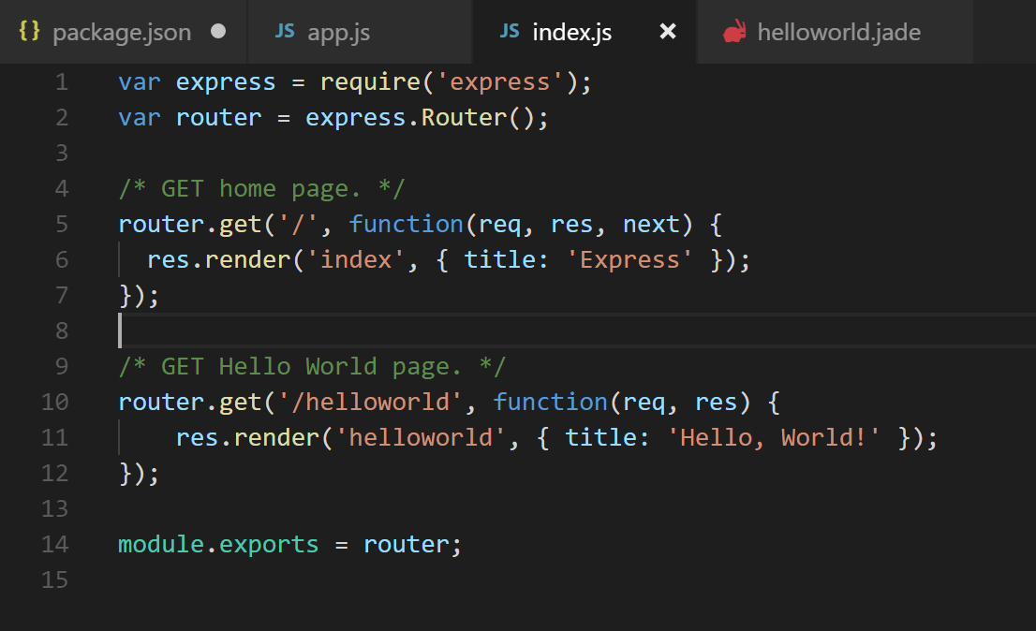

router.get('/path, function(req, res) {

res.render(html_name, { title: 'what we path as title to htmal_name.jade' });

});

Jade files are in view folder. .js files are in route.

In your nodetest1 directory, create a sub-directory called "data" with the following command:

Source: <https://closebrace.com/tutorials/2017-03-02/the-dead-simple-step-by-step-guide-for-front-end-developers-to-getting-up-and-running-with-nodejs-express-and-mongodb>

Very nice tutorial