https://cdn1.imggmi.com/uploads/2019/3/22/267927b1adb6cd5fb47c01bc0754d8fa-full.png
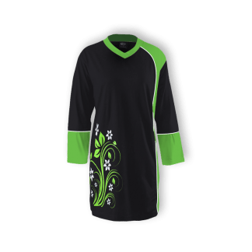

https://cdn1.imggmi.com/uploads/2019/3/22/c61fde3e7cb36692bdeaf6004bf493a3-full.jpg
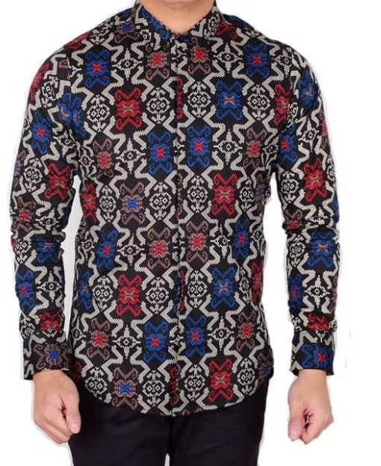

https://cdn1.imggmi.com/uploads/2019/3/22/758d2d0c5390a4ae473d5a432d2d5f57-full.jpg
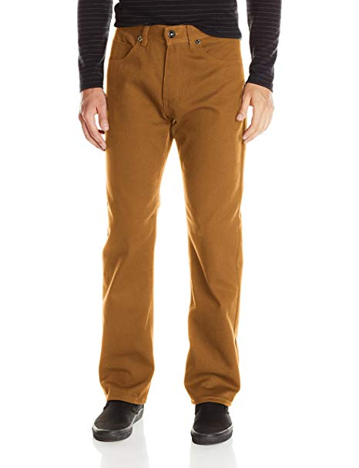

resized: https://cdn1.imggmi.com/uploads/2019/3/22/5a8da0c7bc09007034f629734029114f-full.jpg

rok cewe
https://cdn1.imggmi.com/uploads/2019/3/22/df5f2f351f06f0543fafb3c237b6af7d-full.jpg

tas cewe
https://cdn1.imggmi.com/uploads/2019/3/22/f8006f1f519b2769bfec9452bd51f654-full.jpg

yang bener yang ini
sepatu
https://i.postimg.cc/fRQC0ZsJ/sepatu.jpg

kaos muslimah
https://i.postimg.cc/mZF6cm9p/8009-black-324x324.png

celana panjang
https://i.postimg.cc/tRFS4fJp/celanapria.jpg

