.
Introduction
Ramp metering is a traffic management strategy that controls the rate at which vehicles enter a freeway from on-ramps. By regulating inflow, ramp meters aim to prevent breakdowns on the mainline and improve overall traffic performance. ALINEA is a well-known local ramp metering algorithm based on feedback control. It adjusts the on-ramp release rate in real time to maintain the downstream freeway density around an optimal set-point. This report presents a comparative study evaluating the effect of ALINEA ramp metering on traffic flow using the METANET simulation model, simulating two scenarios one with ALINEA control at a freeway on-ramp and one without any ramp metering to quantify how ramp metering influences congestion, speeds, and travel time.

Simulation Setup
The analysis uses the METANET traffic simulation model to represent a freeway corridor divided into 20 homogeneous sections. Each section represents a freeway stretch of equal length with uniform characteristics. The simulation time horizon is 2 hours, and the model updates every 10 seconds, capturing traffic dynamics. This discrete time-step approach allows the model to reflect the propagation of congestion waves and the effects of control actions in detail.
Parameter | Value | Description
N | 20 sections | Number of freeway segments
K | 900 time steps | Total simulation time steps
T | 10 | Time step size (10 seconds)
L(i) | 0.5 km | Length of each freeway segment.
Table 1. Simulation parameters

Traffic Parameters
Standard freeway traffic parameters are adopted for all sections, a typical free-flow speed of about 100–120 km/h is assumed for vehicles in unconstrained conditions and the maximum density is set to a realistic value. The critical density is a key parameter, as ALINEA will attempt to maintain densities near this value. All sections share these parameters in the simulation. The upstream boundary of the freeway is fed by an inflow demand that, combined with the ramp input, can exceed the downstream capacity, while the downstream boundary is assumed free-flow (no bottleneck imposed beyond the network).
Parameter | Value | Description
vf(i) | 120 km/h | Free-flow speed in each section, max achievable when uncongested.
rho_max(i) | 400 veh/km | Maximum vehicle density in each section.
rho_cr(i) | 110 veh/km | Critical density for ALINEA and no control the ideal target density to avoid congestion.
tau | 0.02 h | Relaxation time
l | 1.4 | Power factor
m | 4 | Exponent that shapes the steepness of speed vs. density decay.

Table 2. Traffic Parameters
Initial and Boundary Conditions
At the start of the simulation, traffic is initialized in free-flow conditions. That is, all sections begin with low vehicle densities and high speeds. The upstream inflow is gradually increased to a peak (simulating a rush hour buildup), and the on-ramp injects additional vehicles into one of the mid-sections of the freeway. In the uncontrolled scenario, ramp vehicles enter the mainline without restriction, potentially pushing the mainline flow over capacity. In the controlled scenario, the ALINEA ramp meter actively modulates the ramp entry rate.

Parameter | Value | Description
Ir(i) | Binary (0 or 1) | Indicates whether section i has an on-ramp
ramps | [5, 10, 12] | Locations of controlled on-ramps
Kr | 0.01 | ALINEA feedback gain
r_cap | 1800 veh/h | Maximum on-ramp flow allowed
dem(i,k) | up to 400 veh/h | External demand input into ramps at specific sections
rho_sez0(k) | 70 veh/km | Density at the upstream boundary
rho_sezfin(k) | 60 veh/km | Density at the downstream boundary

Table 3. Ramp Metering
ALINEA
Taking into account a segment i that has an on-ramp with ramp metering, the ALINEA control rule, at each time step k, k = 1,...,k, can be written as follows:
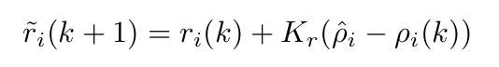

Here, r_{i}(k) denotes the controlled on-ramp flow that was permitted to enter the mainstream at time step k, r_{i}(k) is the on-ramp flow that was actually entered from the same on-ramp at time step k, Kr is the gain parameter, p_{i} is the desired set-point density, and ρ_{i}(k) is the traffic density measured downstream of the ramp metering setup, always in section i.

Results
a) Average density per section
In the ALINEA-controlled scenario, the average vehicle density along the freeway remains moderate and relatively uniform across most sections. The highest average densities appear in the sections immediately downstream of the metered on-ramp, but even there the density is maintained near the target level (around the critical density) rather than spiking toward jam conditions. This indicates that ALINEA successfully prevented the mainline from becoming oversaturated at the merge point. Downstream sections remain at lower densities, implying that traffic flowed smoothly after the merge with minimal congestion propagation.
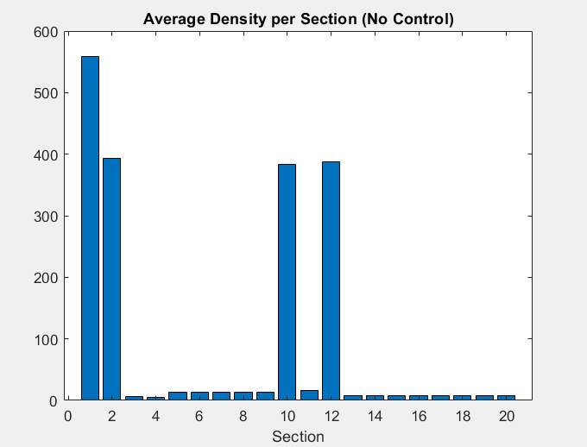
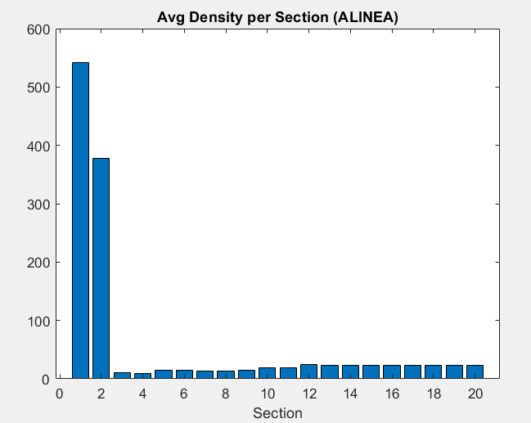

Figure 1
In the absence of ramp metering, the average densities tell a very different story. The sections around the on-ramp show very high average density values. These high densities in the no-control scenario signify heavy congestion caused by the unregulated influx of ramp traffic. Notably, the density distribution is uneven: a few upstream sections bear the brunt of the congestion, while downstream sections see lighter traffic. This contrast with the ALINEA scenario illustrates how, without control, a bottleneck forms at the merge and creates a traffic jam.
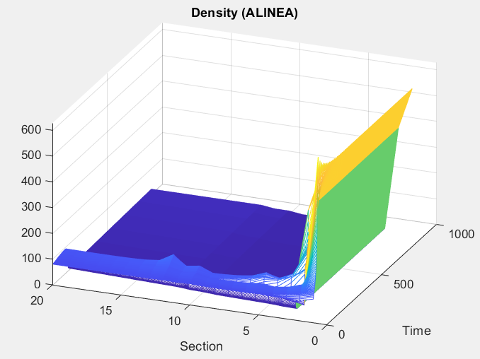
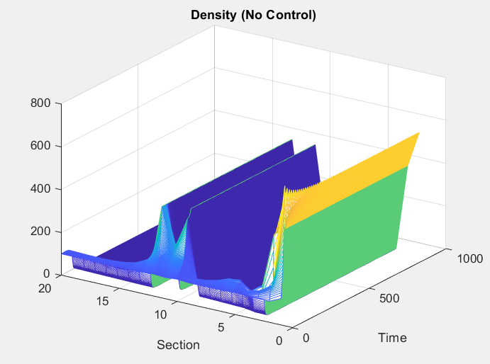

Figure 2
In the uncontrolled case, the density 3D surface confirms the development of a major congestion wave. We see a pronounced peak in density forming at the ramp merge section soon after demand surges. Over time, this high-density region expands and moves upstream, covering multiple sections. This corresponds to the physical queue of cars forming behind the bottleneck.

b) Average speed per section
The ALINEA control yields high and stable speeds across the freeway sections. Here we see that the average speeds in all sections remain close to free-flow levels throughout the simulation. Even the section downstream of the ramp maintains a relatively high average speed, only slightly reduced from the maximum. This suggests that traffic under ALINEA never experienced a severe breakdown, vehicles were able to keep moving near the speed limit on average.
Without control, average speeds across sections exhibit a stark decline in the vicinity of the on-ramp. In the uncontrolled scenario, the section immediately after the ramp suffers a very low average speed.

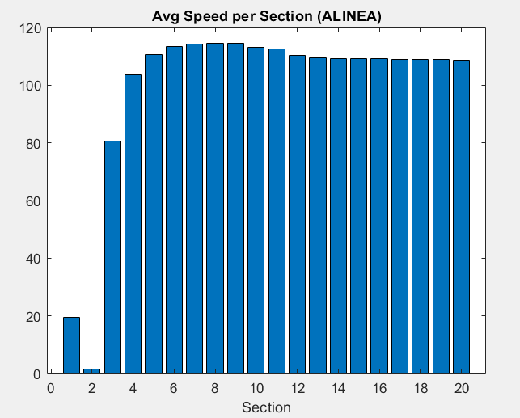
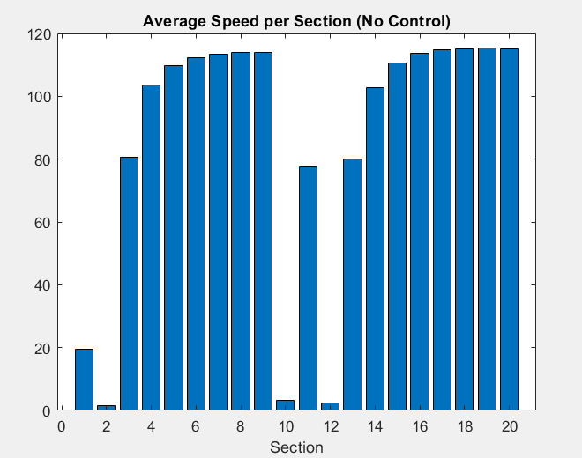

Figure 3
Under ALINEA, the surface is largely high and flat across time for most sections, confirming that free-flow or near free-flow speeds were maintained. There are no large troughs or depressions in the surface and during peak demand periods, indicating minor slowdowns.
The uncontrolled scenario’s speed evolution surface reveals a pronounced formation of congestion. At the onset of heavy demand, a pocket of slow speeds appears at the ramp merge section. As time progresses, this low speed region grows and spreads upstream to earlier sections. The 3D plot clearly shows that, in the absence of metering, a large portion of the simulation time is characterized by very low speeds in multiple upstream sections.
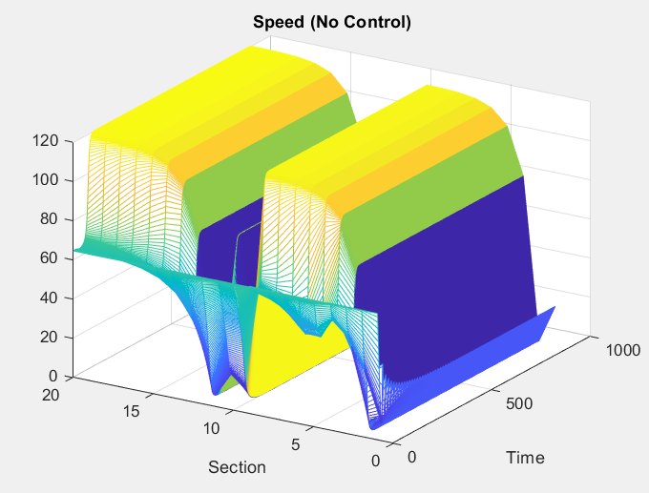
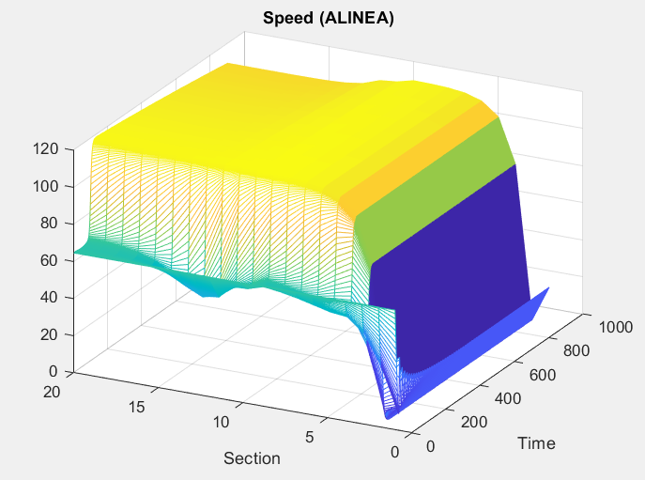

Figure 4

Total Travel Time
In quantitative terms, the benefit of ALINEA control is clearly reflected in the Total Travel Time metric. TTT represents the cumulative vehicle-hours spent by all drivers in the network over the simulation period. In the no-control scenario, the simulation yielded TTT ≈ 2347.77 veh·h, whereas with ALINEA control, TTT dropped to ≈ 1604.12 veh·h. This is a big improvement roughly a 32% reduction in total travel time achieved simply by implementing ramp metering. The controlled scenario not only moved more vehicles through in less time, but it also prevented the severe stop-and-go conditions that inflate travel times. These results quantitatively confirm that ALINEA metering produced a smoother and more efficient traffic flow, as drivers spent significantly fewer hours on the road compared to the unmanaged case.

Conclusions
Implementing the ALINEA control at a critical on-ramp dramatically improved traffic flow, as evidenced by more uniform and lower densities, higher and more stable speeds, and a substantial reduction in total travel time. The ALINEA algorithm effectively smoothed the traffic flow by preventing excessive inflow during peak periods, thereby avoiding the cascade of congestion that plagued the uncontrolled scenario.
Quantitatively, the ALINEA-controlled case achieved about a one-third reduction in Total Travel Time relative to no control, highlighting the significant efficiency gains. Drivers in the metered scenario spent far less time in traffic despite the ramp delays, confirming that the metering strategy yields a net benefit.
In conclusion, the METANET simulation clearly demonstrates the effectiveness of ALINEA ramp metering in improving traffic performance. The controlled scenario maintained smooth traffic flow and shortened travel times, whereas the uncontrolled scenario suffered from heavy congestion and delays. These findings support the deployment of intelligent ramp metering strategies as a means to maximize the throughput and reliability of freeway networks, ultimately providing a better travel experience for road users.

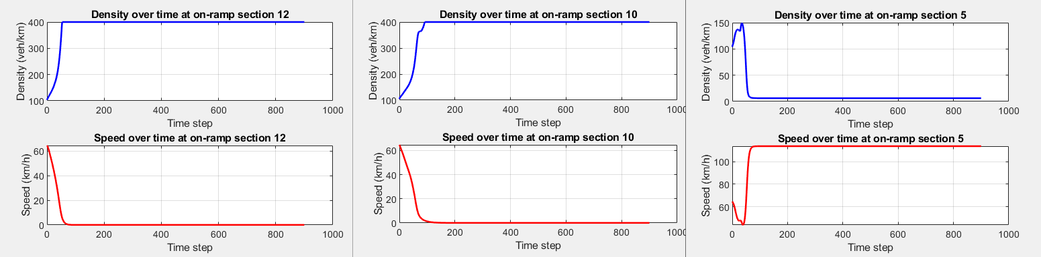

Figure 5 (No Control)

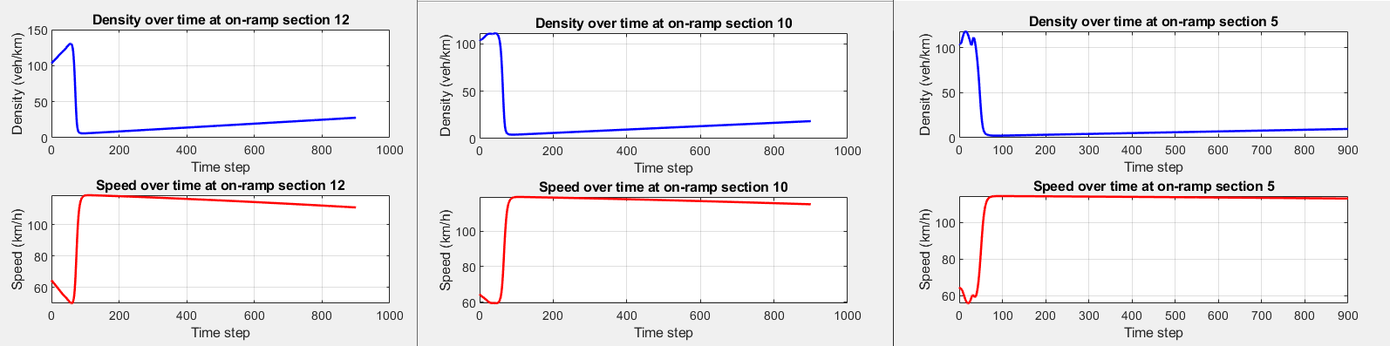

Figure 6 (Control)

