**Screenshots :**

* Create a database called "contact" and Create a collection called "contactlist"
* 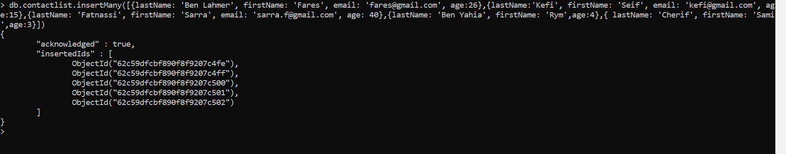Insert 5 documents  in "contactlist" :
* Display all of the contacts list.
* 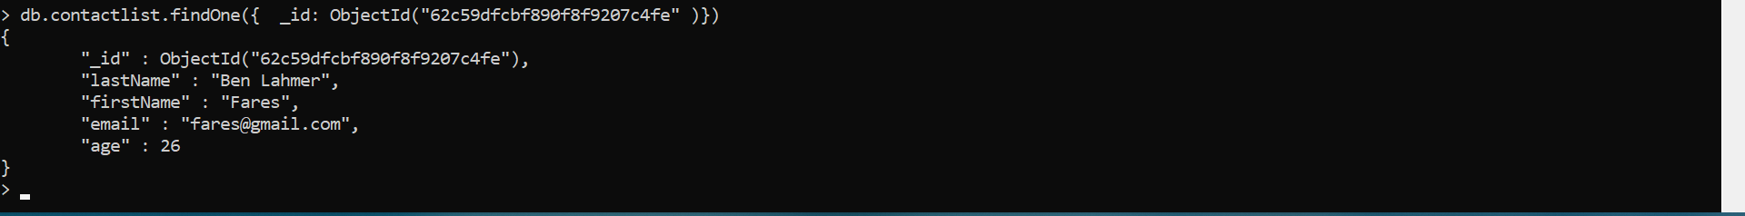Display all the information about only one person using his ID.
* Display all the contacts with an age >18.
* Display all the contacts with an age>18 and name containing "ah".
* Change the contact's first name from"Kefi Seif" to "Kefi Anis".
* Delete the contacts that are aged under <5.
* Display all the contacts list.