**Name:** Fatma Ashraf Abd Elsalam

**B.N:**587

**Topic:** programminglanguages.

**Github Link:** [**https://github.com/fatma-abdelrahman/ece001**](https://github.com/fatma-abdelrahman/ece001)

**Github pages:** [**https://fatma-abdelrahman.github.io/ece001/**](https://fatma-abdelrahman.github.io/ece001/)

**Programming Languages**

A programming language is a formal language which includes a collection of instructions that produce different output types. The programming languages are used to apply algorithms in computer programming.Many programming languages consist of the machine instructions. There are programmable machines that use a series of unique instructions instead of programming languages generally.

The description of a programming language is usually split into the two components of syntax (form) and semantics (meaning). Some languages are defined by a specification document (for example, the C programming language is specified by an ISO Standard) while other languages (such as Perl) have a dominant implementation that is treated as a reference.

**Applications:**

|  |  |
| --- | --- |
| **Application** | **Languages** |
| Applications and software. | C++/ C |
| Artificial intelligence. | C/ Python |
| Database domain. | DBASE/ SQL |
| Video games. | Java/ C++/ C#/ C/ Dark Basic |
| Web design. | Java / Java Script/ Payton/ PHP/ HTML/ CSS3/ |
| Induction programs. | C/ Assembly |
| text-writing (SCRTPTS). | Python/ Perl/ Batch/ Bash |

**Screenshots:**

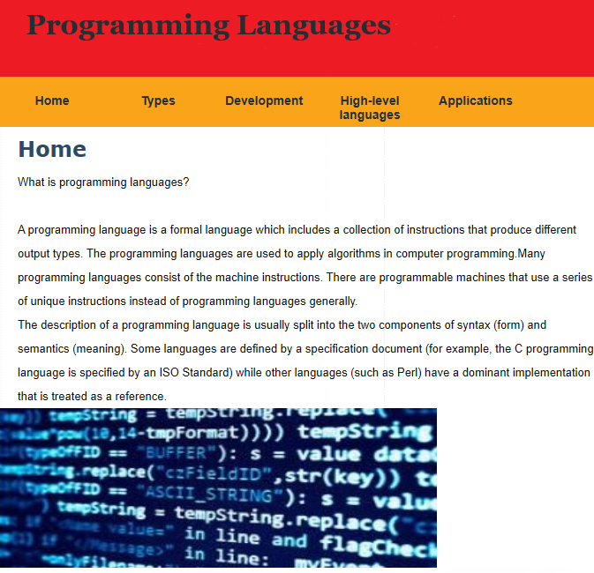

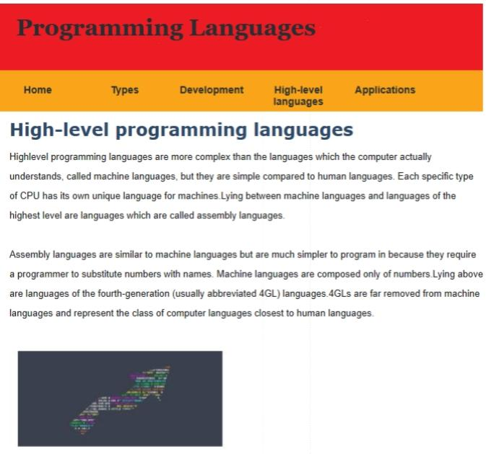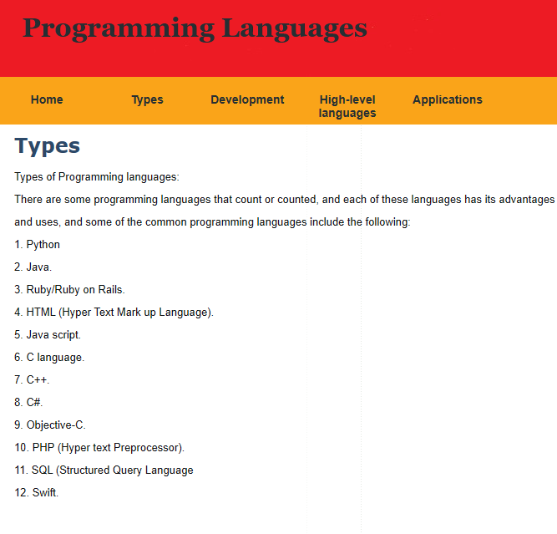

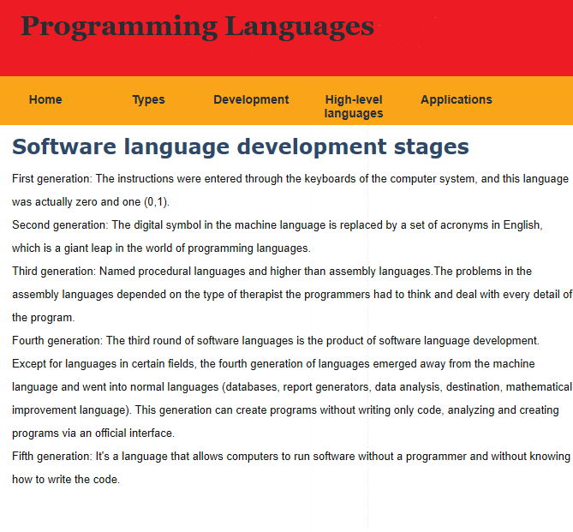

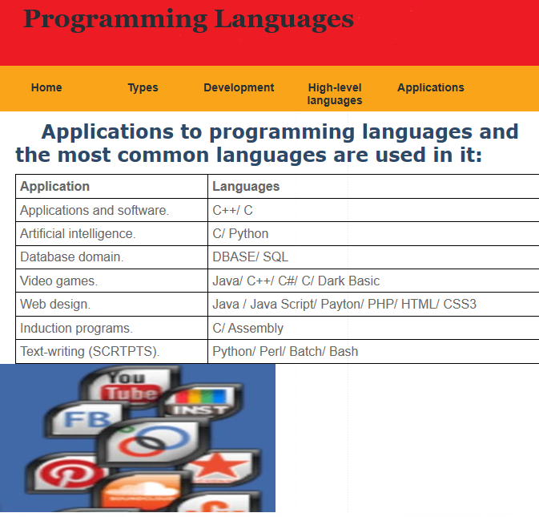

**Source code:**

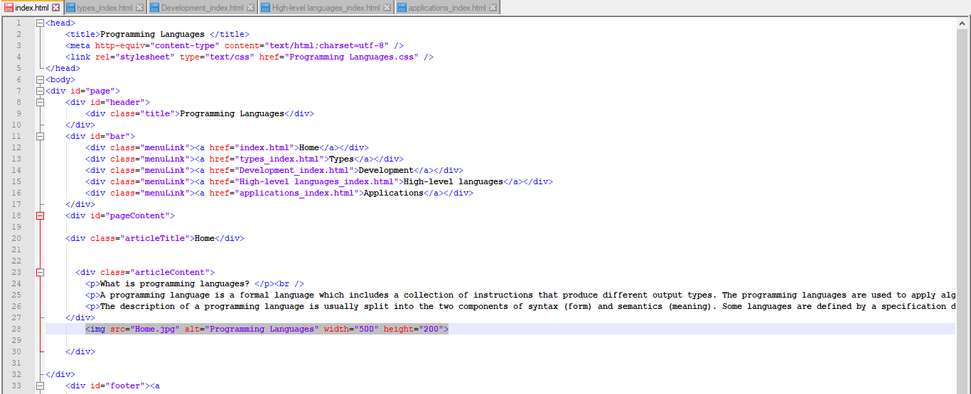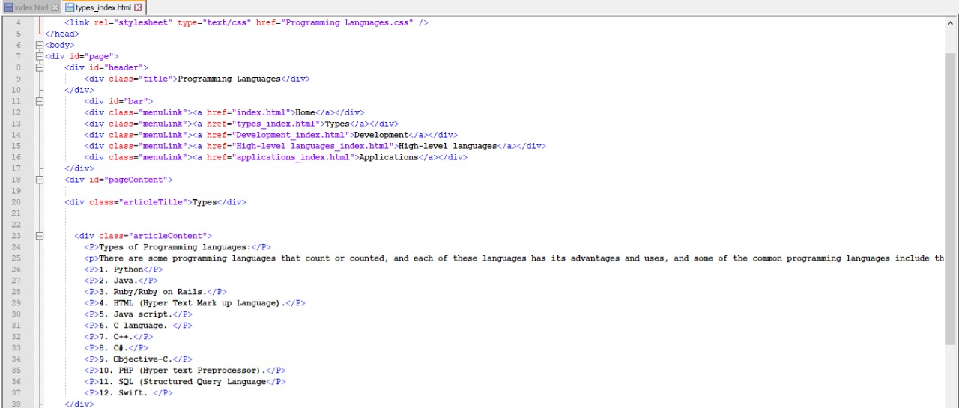

**References**

<https://www.codingame.com/work/blog/hr-news-trends/top-10-in-demand-programming-languages-2020/>

<https://hackr.io/blog/best-programming-languages-to-learn-2020-jobs-future>

<https://www.computer.org/publications/tech-news/trends/programming-languages-you-should-learn-in-2020/>

<https://www.computerscience.org/resources/computer-programming-languages/>

<https://www.whoishostingthis.com/resources/programming/>