**فاطمه رمضان عبدالمعبود الدسوقىName:**

**B.N: 588**

**Date:**  **5/6/2020**

**Topic:** **Artificial intelligence**

**GitHub link:**

**GitHub page:**

**Application brief**

What is artificial intelligence?

Artificial Intelligence (AI) is a widespread branch of computer science concerned with building intelligent machines capable of performing tasks that normally require human intelligence. Artificial intelligence is a multidisciplinary science with multiple approaches, but advances in machine learning and deep learning create a paradigm shift in virtually every sector in the technology industry.

History of Amnesty International

Smart robots and artificial beings first appeared in ancient Greek myths in ancient times. Aristotle's evolution of logical measurement and his use of deductive reasoning was an important moment in humankind's quest to understand its intelligence. While the roots are long and deep, the history of artificial intelligence as we think it today stretches back less than a century. Here is a brief look at some of the most important events in artificial intelligence.

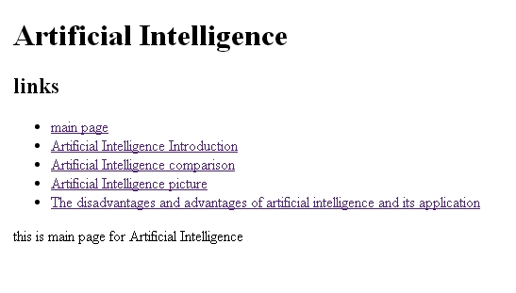**Screenshots:**

