***Checkpoint Mongo DB(CRUD)***

* Display all the information about only one person using his ID :

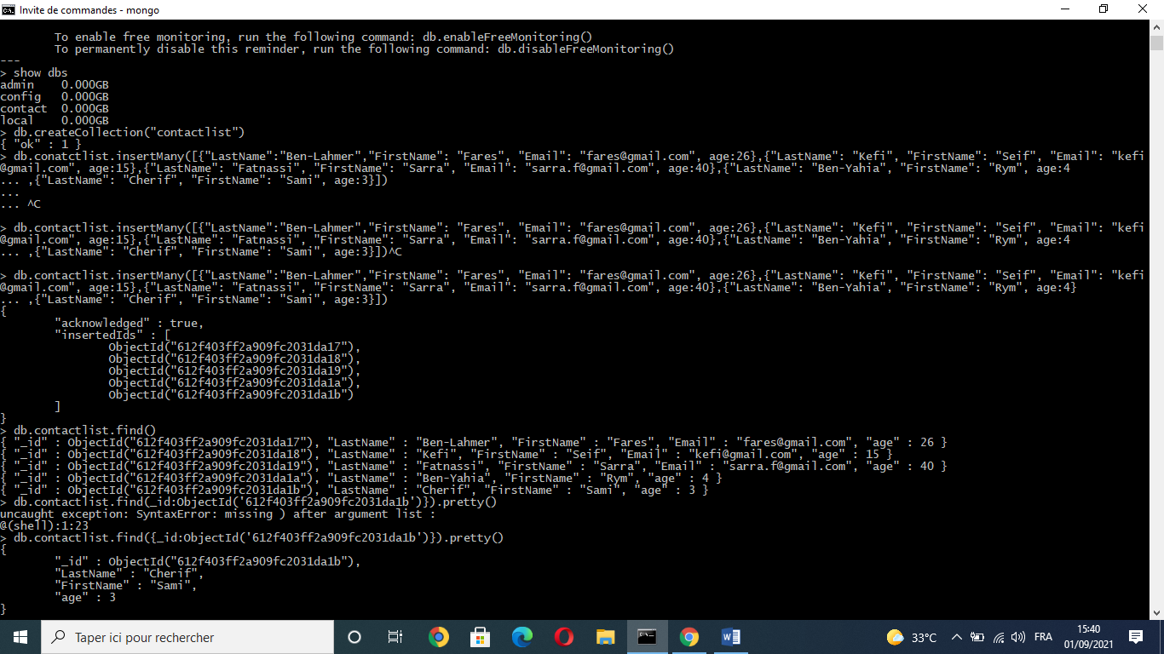

* Display all the contacts with an age >18.
* Display all the contacts with an age>18 and name containing "ah".

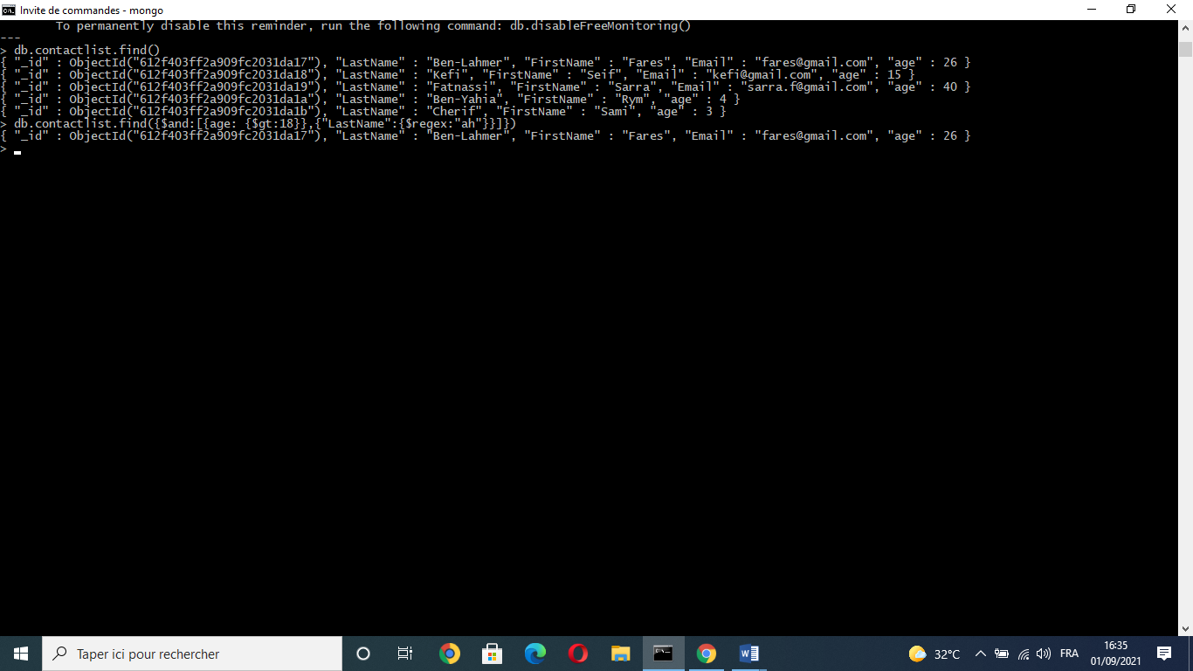

* Change the contact's first name from"Kefi Seif" to "Kefi Anis".

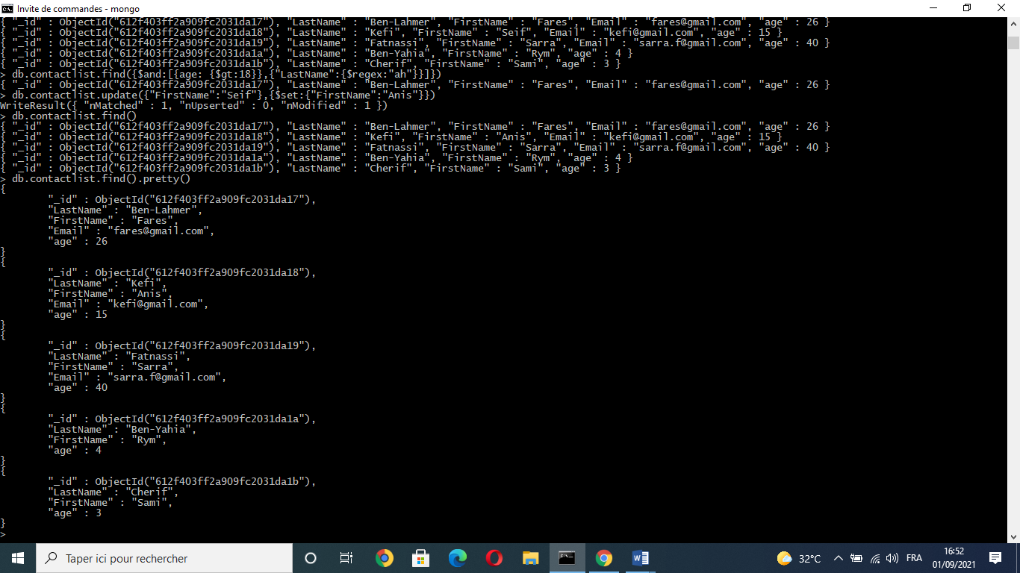

* Delete the contacts that are aged under <5.
* Display all of the contacts list.