Clinic Management System Database Project

Course Name: Fundamental of Database
Course Code: CBIO 205

NAME | ID
Fatma Mohamed Elwarraky | 241001473
Carol Hany Fayez | 241001251
Maya Ahmed Shahin | 241001070

Introduction
This project is about creating a database for a clinic. The clinic has many departments and each department has clinics. Patients can book appointments and doctors write diagnosis. My database keeps track of patients, doctors, appointments and departments

Entities and Attributes

Entity | Attributes
Department | dept_id, name
Clinic | clinic_id, name, address, dept_id
Doctor | doctor_id, name, phone, address, dept_id
Patient | patient_id, name, phone, address, birth_date, job
Appointment | appt_id, appt_date, patient_id, doctor_id, start_time, end_time, cost, status, diagnosis

The Department table stores information about each medical department. The Clinic table has clinic details and connects to a department. The Doctor table stores doctor information. The Patient table keeps patient personal details. The Appointment table records each visit including diagnosis and cost.

ER Diagram

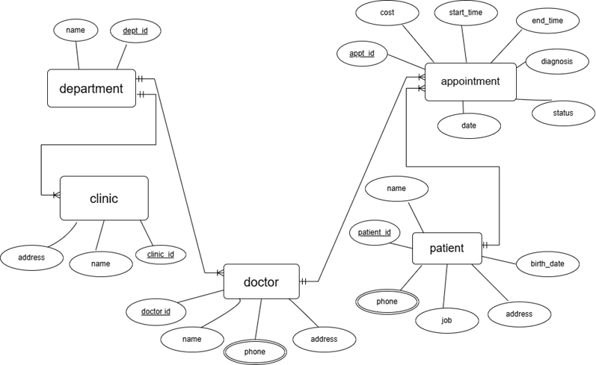
Relational Schema
Department (dept_id*, name)
Clinic (clinic_id*, name, address, dept_id)
Doctor (doctor_id*, name, phone, address, dept_id)
Patient (patient_id*, name, phone, address, birth_date, job)
Appointment (appt_id*, appt_date, patient_id, doctor_id, start_time, end_time, cost, status, diagnosis)
* = primary key

Foreign keys:
- Clinic.dept_id references Department.dept_id
- Doctor.dept_id references Department.dept_id
- Appointment.patient_id references Patient.patient_id
- Appointment.doctor_id references Doctor.doctor_id
Create Table Statements (DDl)
CREATE DATABASE clinc ;
USE clinc ;
CREATE TABLE Department (
dept_id INT PRIMARY KEY,
name VARCHAR(100) NOT NULL
);

CREATE TABLE Clinic (
clinic_id INT PRIMARY KEY,
name VARCHAR(100) NOT NULL,
address VARCHAR(255) NOT NULL,
dept_id INT,
FOREIGN KEY (dept_id) REFERENCES Department(dept_id)
);

CREATE TABLE Doctor (
doctor_id INT PRIMARY KEY,
name VARCHAR(100) NOT NULL,
phone VARCHAR(20),
address VARCHAR(255),
dept_id INT,
FOREIGN KEY (dept_id) REFERENCES Department(dept_id)
);

CREATE TABLE Patient (
patient_id INT PRIMARY KEY,
name VARCHAR(100) NOT NULL,
phone VARCHAR(20),
address VARCHAR(255),
birth_date DATE,
job VARCHAR(100)
);

CREATE TABLE Appointment (
appt_id INT PRIMARY KEY,
appt_date DATE NOT NULL,
patient_id INT,
doctor_id INT,
start_time TIME NOT NULL,
end_time TIME NOT NULL,
cost DECIMAL(10,2) NOT NULL,
status VARCHAR(20) CHECK (status IN ('scheduled', 'in progress', 'postponed')),
diagnosis TEXT,
FOREIGN KEY (patient_id) REFERENCES Patient(patient_id),
FOREIGN KEY (doctor_id) REFERENCES Doctor(doctor_id)
);

Sample Data (DML)
I inserted 10 departments into the Department table. For example: Cardiology, Neurology, Gastroenterology. I inserted 10 clinics with addresses. I added 10 doctors and 10 patients. The Appointment table has 10 records including appointments with fatty liver diagnosis.
USE clinc;
INSERT INTO Department VALUES
(1, 'Cardiology'), (2, 'Neurology'), (3, 'Pediatrics'), (4, 'Orthopedics'),
(5, 'Dermatology'), (6, 'Ophthalmology'), (7, 'ENT'), (8, 'Psychiatry'),
(9, 'Urology'), (10, 'Gastroenterology');

INSERT INTO Clinic VALUES
(1, 'Heart Clinic North', '123 Main St', 1),
(2, 'Brain Center', '456 Oak Ave', 2),
(3, 'Kids Care', '789 Pine Rd', 3),
(4, 'Bone & Joint', '321 Elm Blvd', 4),
(5, 'Skin Health', '654 Maple Dr', 5),
(6, 'Vision Plus', '987 Cedar Ln', 6),
(7, 'Ear Nose Throat', '147 Birch Way', 7),
(8, 'Mind Wellness', '258 Spruce Ct', 8),
(9, 'Kidney Care', '369 Ash St', 9),
(10, 'Digestive Health', '741 Willow Ave', 10);

INSERT INTO Doctor VALUES
(101, 'Dr. Ahmed Ali', '555-0101', '123 Medical Blvd', 1),
(102, 'Dr. Sara Hassan', '555-0102', '456 Health St', 1),
(103, 'Dr. Khaled Omar', '555-0103', '789 Wellness Rd', 2),
(104, 'Dr. Lina Tamer', '555-0104', '321 Care Ave', 3),
(105, 'Dr. Mona Fouad', '555-0105', '654 Cure Ln', 4),
(106, 'Dr. Youssef Nabil', '555-0106', '987 Remedy Dr', 5),
(107, 'Dr. Nour Adel', '555-0107', '147 Therapy Ct', 6),
(108, 'Dr. Omar Sherif', '555-0108', '258 Healing Way', 7),
(109, 'Dr. Hana Magdy', '555-0109', '369 Recovery St', 8),
(110, 'Dr. Ziad Lotfy', '555-0110', '741 Hope Blvd', 9);

INSERT INTO Patient VALUES
(1001, 'Mohamed Ibrahim', '555-1001', '10 Nile St', '1980-05-15', 'Engineer'),
(1002, 'Fatima Hassan', '555-1002', '20 Pyramids Rd', '1992-08-22', 'Teacher'),
(1003, 'Omar Salah', '555-1003', '30 Tahrir Sq', '1975-11-10', 'Accountant'),
(1004, 'Laila Mahmoud', '555-1004', '40 Giza St', '1988-03-05', 'Doctor'),
(1005, 'Ahmed Samir', '555-1005', '50 Heliopolis Ave', '1995-07-30', 'Student'),
(1006, 'Nadia Hossam', '555-1006', '60 Maadi St', '1983-12-25', 'Lawyer'),
(1007, 'Khaled Youssef', '555-1007', '70 Nasr City', '1970-09-14', 'Manager'),
(1008, 'Reem Tarek', '555-1008', '80 Zamalek', '2000-01-20', 'Nurse'),
(1009, 'Hany Mostafa', '555-1009', '90 Dokki St', '1965-06-18', 'Retired'),
(1010, 'Shereen Adly', '555-1010', '100 Shubra Rd', '1998-04-12', 'Designer');

INSERT INTO Appointment (appt_id, appt_date, patient_id, doctor_id, start_time, end_time, cost, status, diagnosis) VALUES
(5011, '2024-06-15', 1001, 101, '09:00:00', '09:30:00', 250.00, 'scheduled', 'Routine checkup'),
(5012, '2024-06-16', 1002, 103, '10:00:00', '10:45:00', 300.00, 'scheduled', 'Headache'),
(5013, '2024-06-17', 1003, 104, '11:00:00', '11:30:00', 200.00, 'scheduled', 'Cough'),
(5014, '2024-06-18', 1004, 105, '13:00:00', '13:45:00', 350.00, 'scheduled', 'Back pain'),
(5015, '2024-06-19', 1005, 106, '14:00:00', '14:30:00', 180.00, 'scheduled', 'Skin rash');

Why I Designed It This Way
I made Department and Clinic separate tables because one department can have many clinics. This way I don't repeat department names many times.
I added a status column to Appointment because the clinic needs to know if an appointment is still scheduled or already done.
Triggers
Trigger 1 - prevent_double_booking
This trigger checks if a doctor already has an appointment at the same date and time. If yes, the system stops the new appointment from being saved.
Trigger 2 - require_diagnosis_on_completion
When someone changes an appointment status to 'completed', this trigger makes sure a diagnosis was entered. If not, the update fails.
Trigger 3 - prevent_past_appointments
This trigger stops users from creating appointments on dates that have already passed.
Trigger 4 - check_appointment_times
This trigger checks that the start time comes before the end time.

Query 1
Query 1 asks List patients diagnosed with fatty liver in the last year.
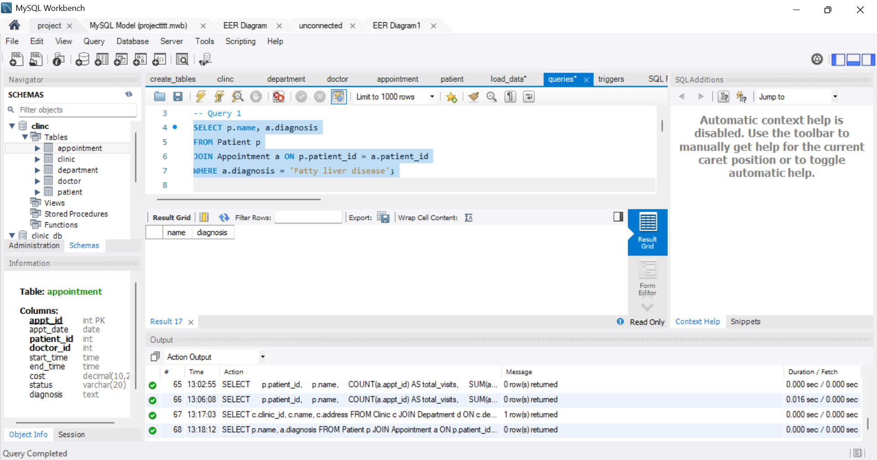
The query shows patients diagnosed with fatty liver disease by joining the Patient and Appointment tables using the patient_id field. It checks the diagnosis column for the phrase "Fatty liver disease" to find matching records. This helps identify patients who have been diagnosed with this condition based on their appointment information.
Result from my data:
No patients were found with a diagnosis of Fatty liver disease in the current dataset.

Query 2
Query 2 asks: List addresses of cardiology clinics.
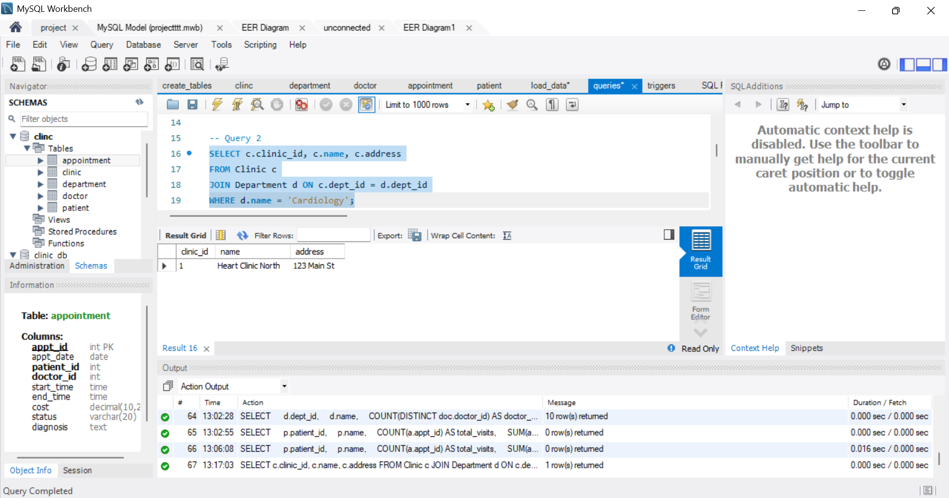
This query shows the addresses of clinics that have a Cardiology department. It joins the Clinic and Department tables using the dept_id field, then filters the results where the department name is "Cardiology". This makes it easy to identify clinics that offer cardiology services and view their locations.
Result from my data:
Heart Clinic North is located at 123 Main St.

Query 3
Query 3 asks: Total money paid by patient ID 12527 in the last three years.
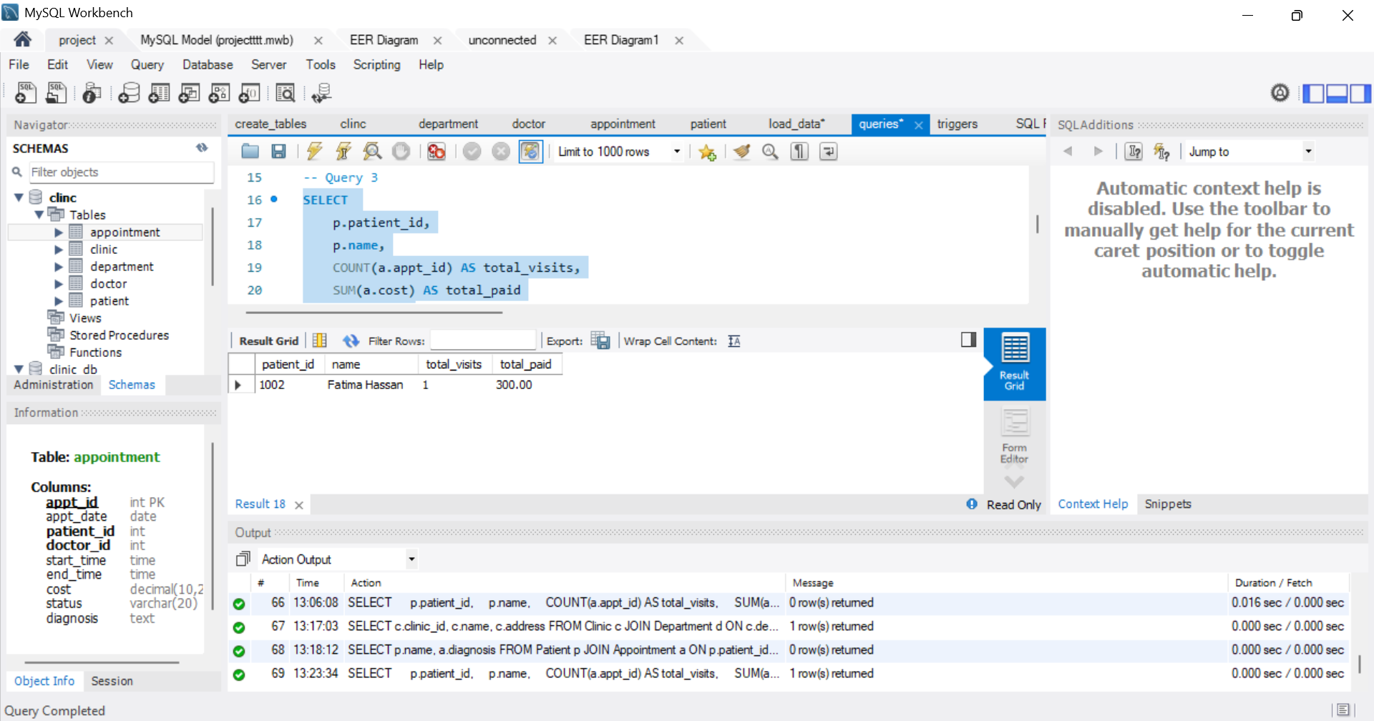
This query sums the cost column for appointments belonging to patient 1002. It only counts appointments from the last 3 years using DATE_SUB(CURDATE(), INTERVAL 3 YEAR).
Result from my data:
Patient 1002 (Fatima Hassan) had 1 appointments and paid $300 total.

Conclusion
This database successfully stores clinic information, manages appointments, and tracks patient medical history. The system can answer the three required queries. The triggers help prevent common data entry errors. This design could be used by a real clinic to manage daily operations.

