Task Day 2 :

1. Create VPC

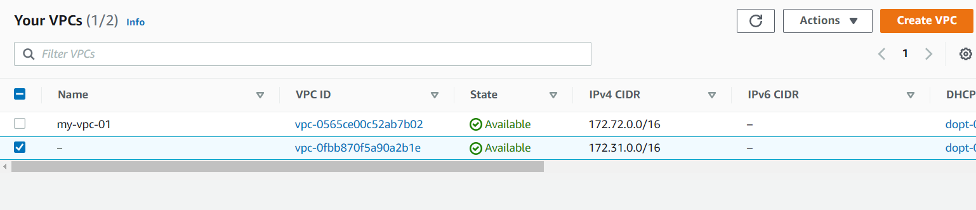

1. Create 2 subnets (pub, private)

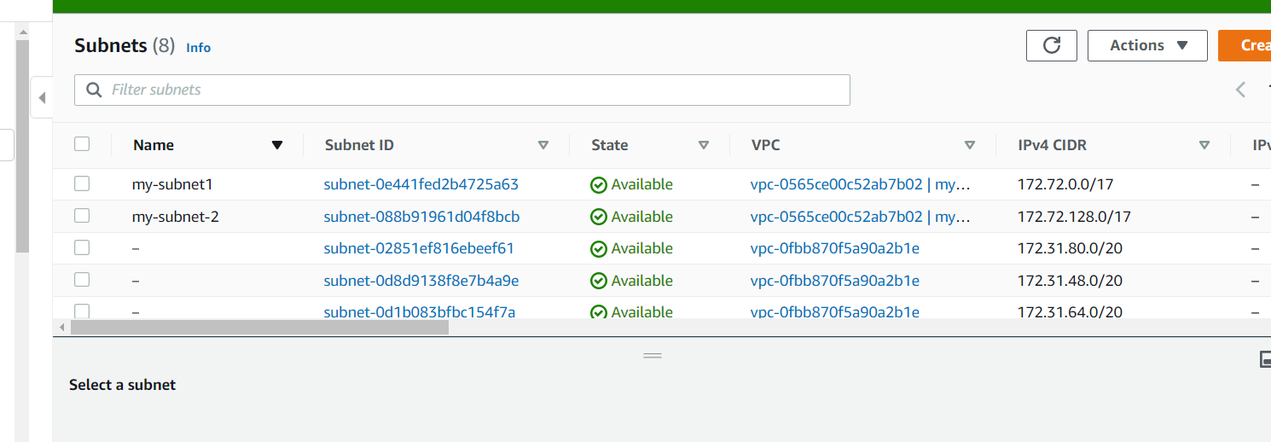

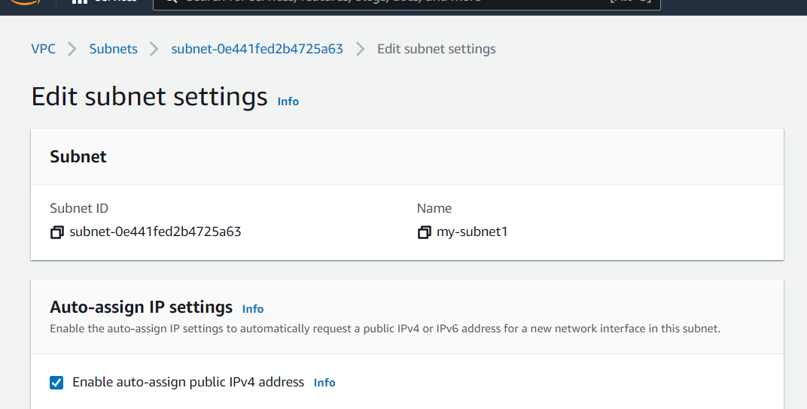

1. Create IGW, RT, NAT GW

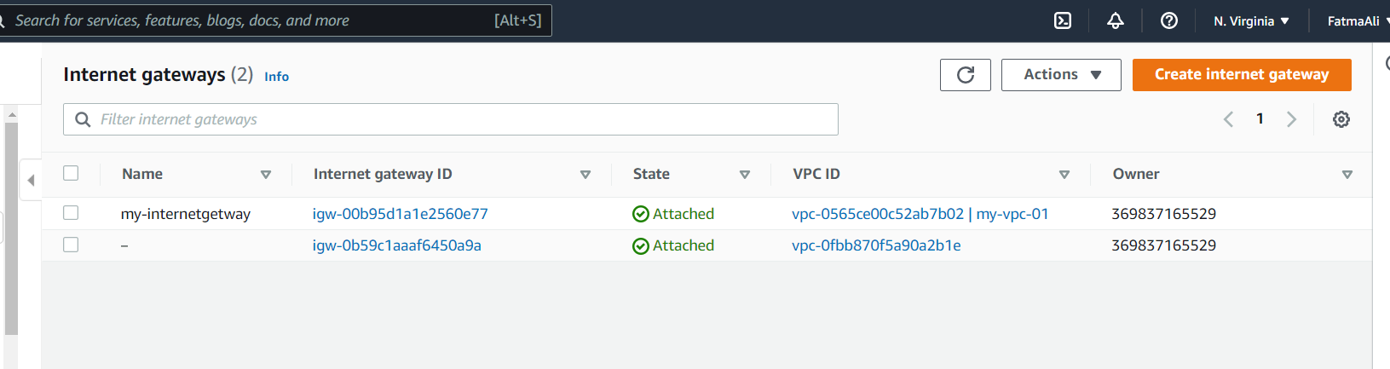

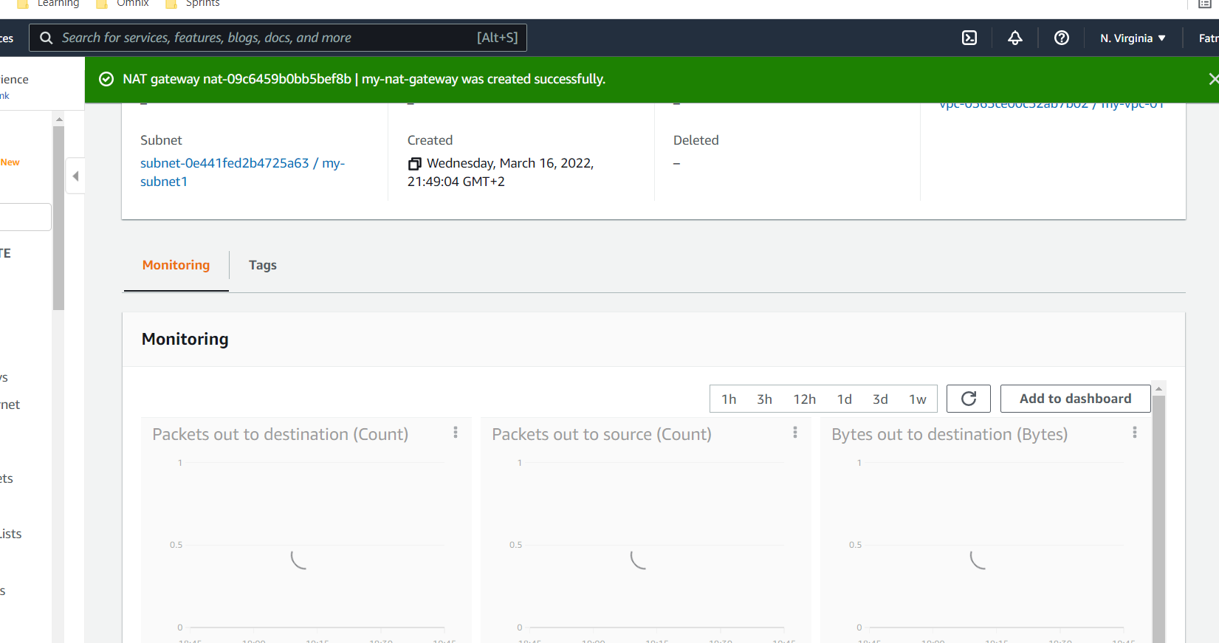

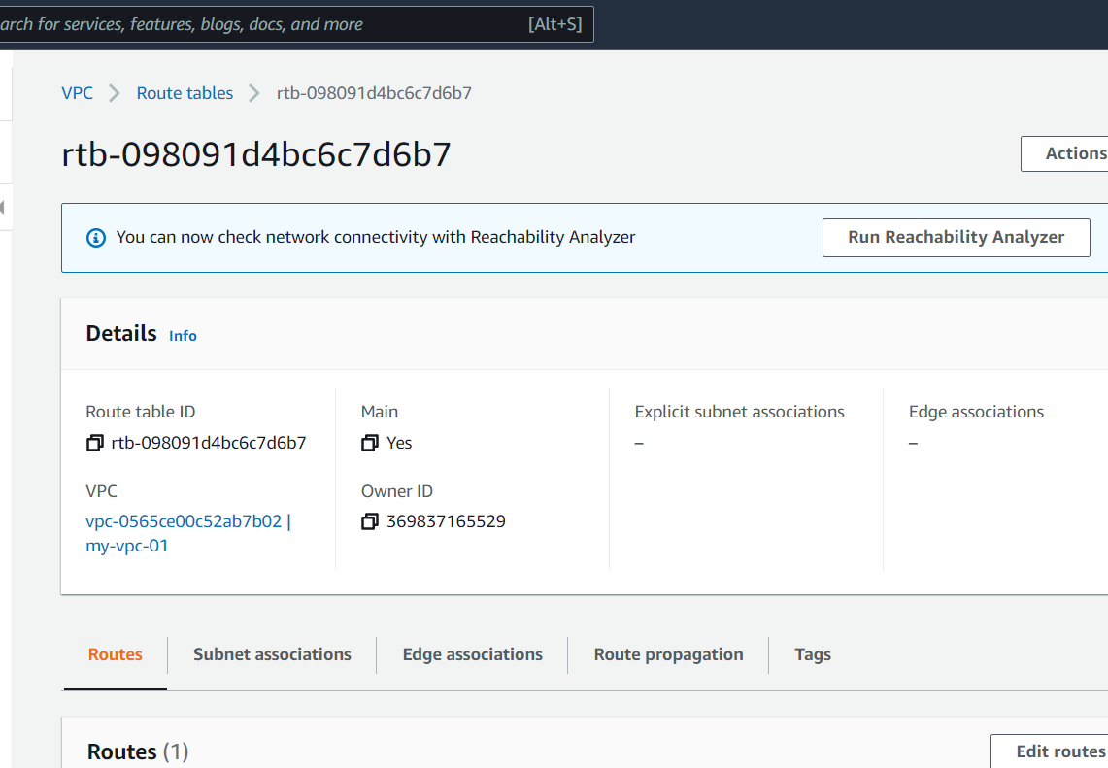

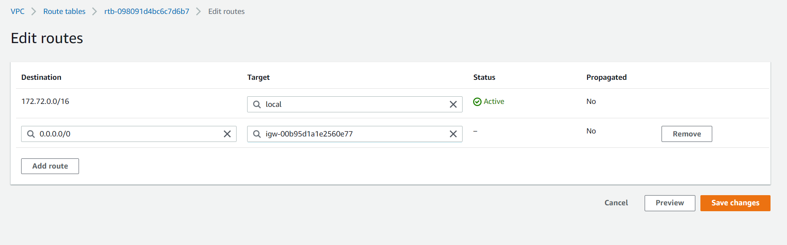 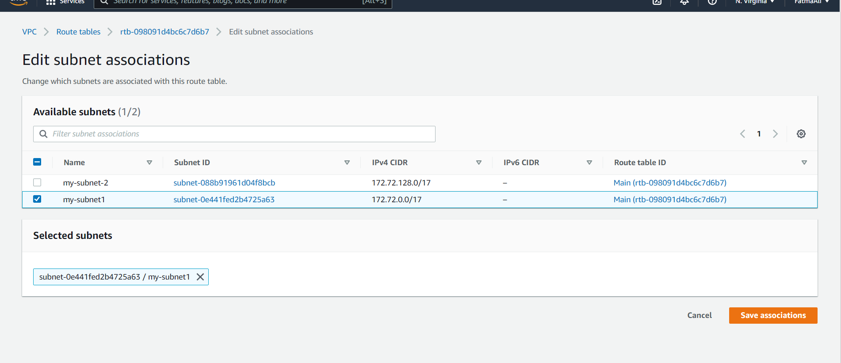

1. Create 2 SGs (public_sg, private_sg)

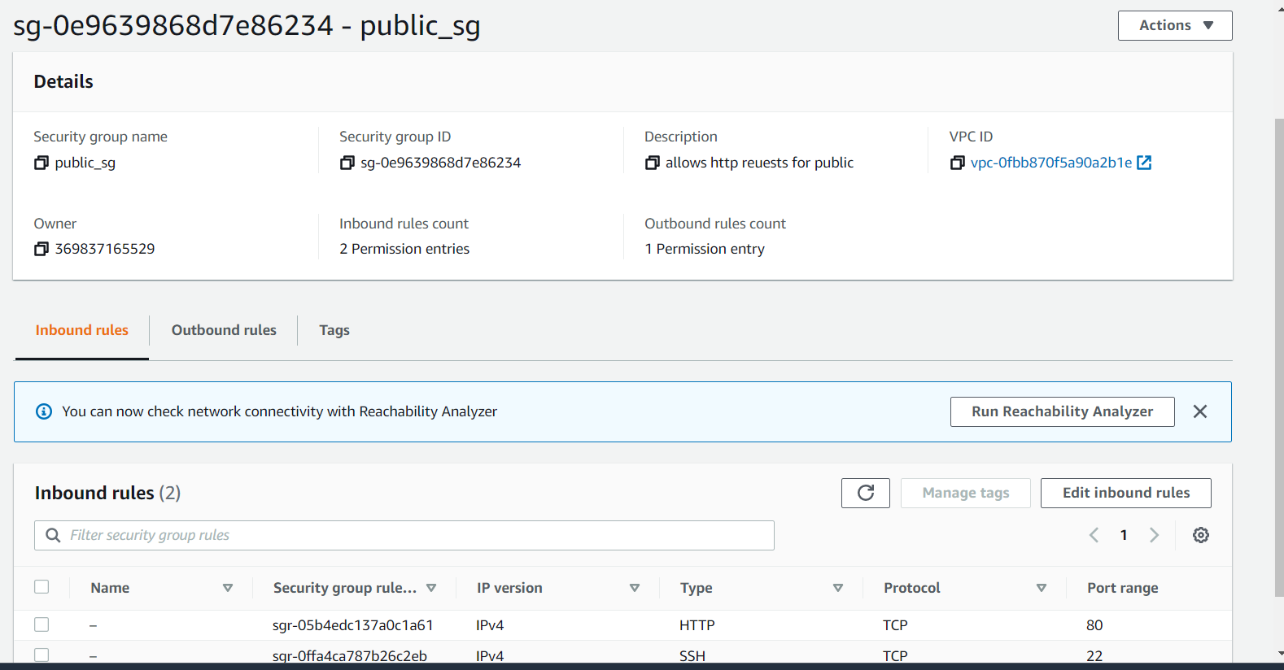

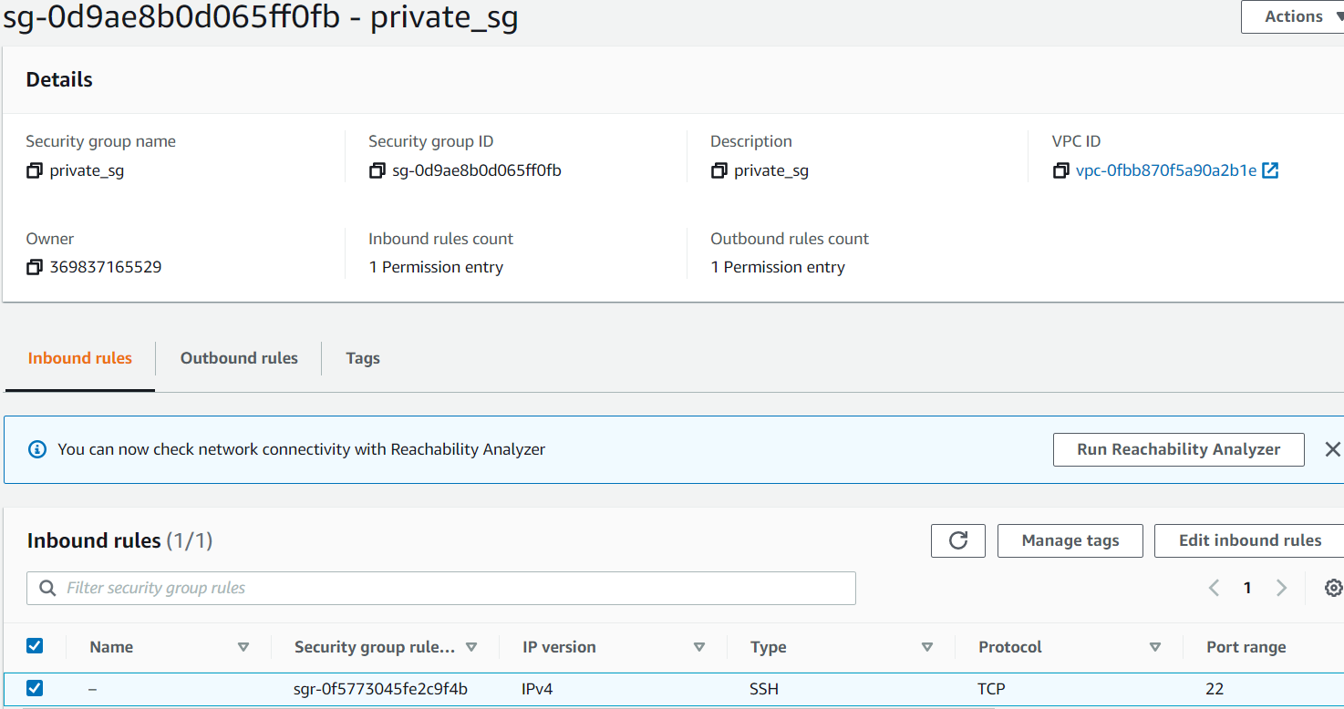

1. Create 2 instances (one in pub, one in private), and attach them to SG (public_sg, private_sg) in sequence.

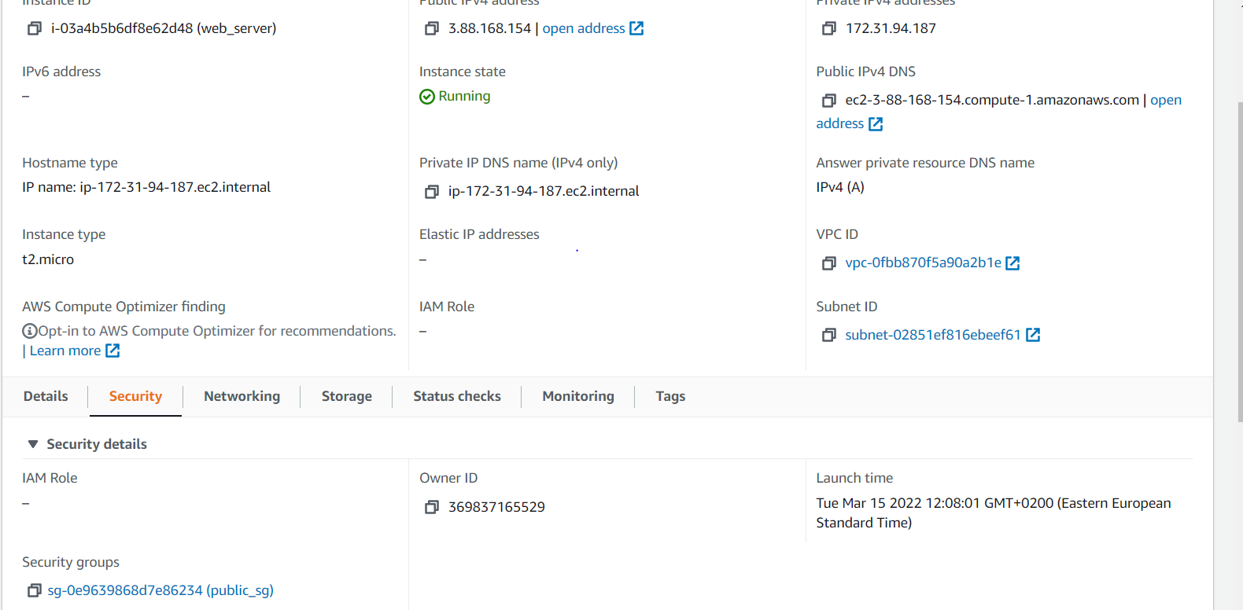

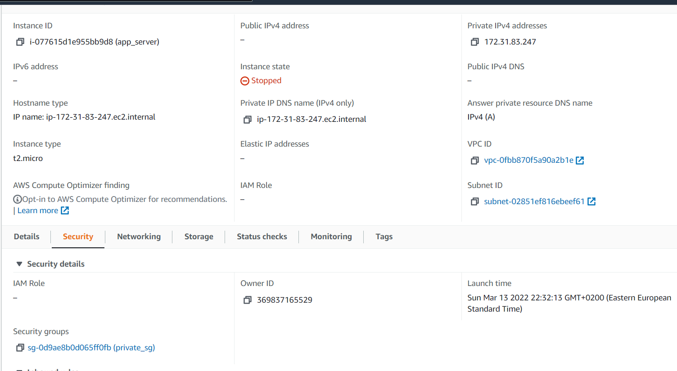

1. Connect to your public EC2 from your local server.
2. Connect to private server from public server