Task Day 3:

1. Create Company databases on RDS Mysql and connect to it (create employee table and department table)

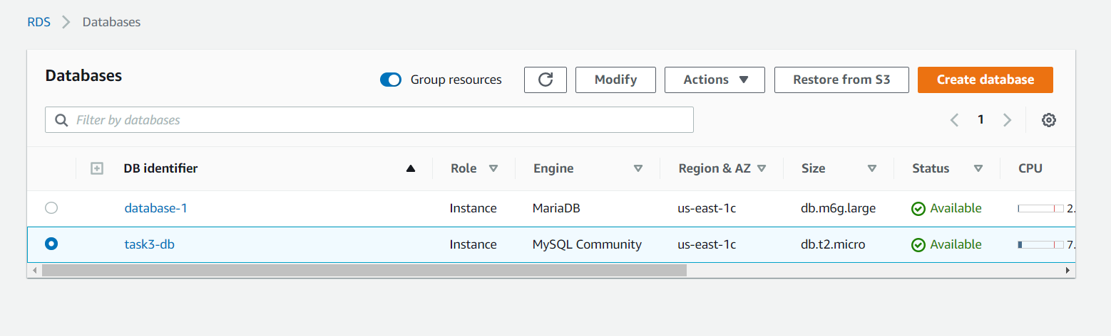

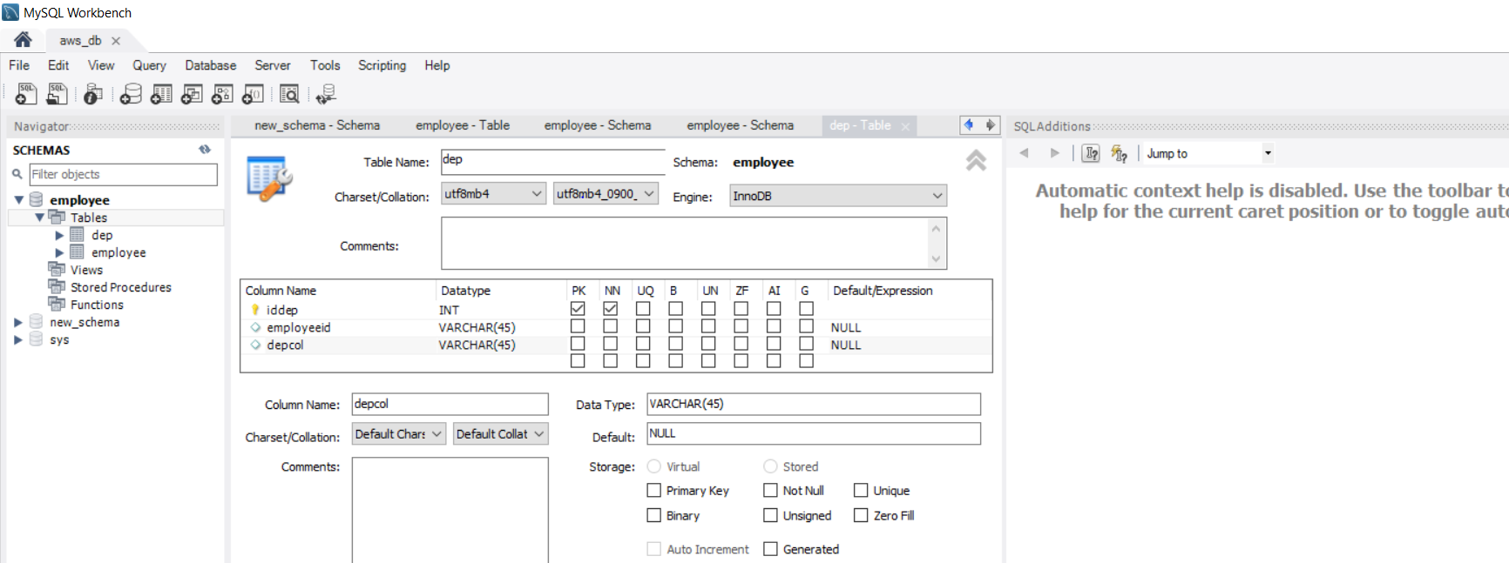

1. Create s3 bucket upload files and then expose it publicly (access it from your web browser)

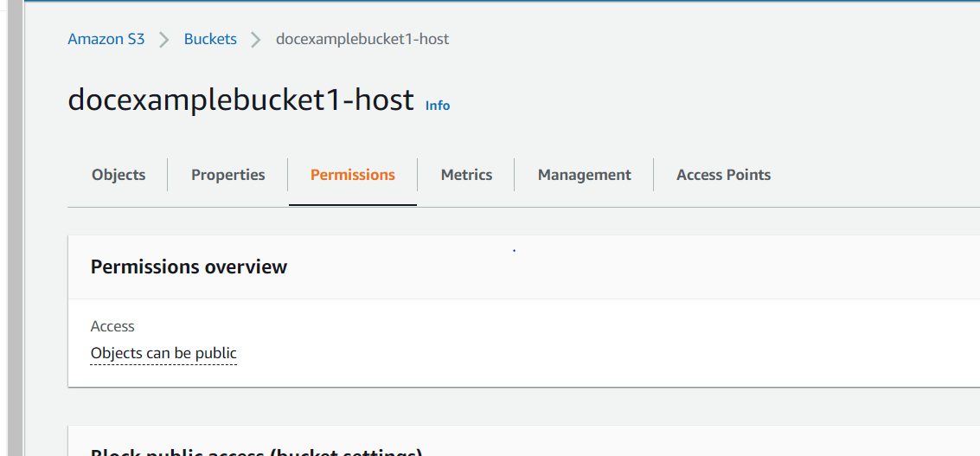

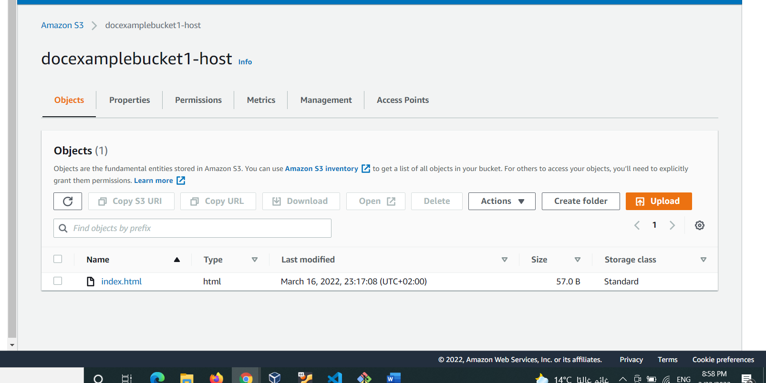

1. Create a static website using s3 buckets (access it from your web browser)

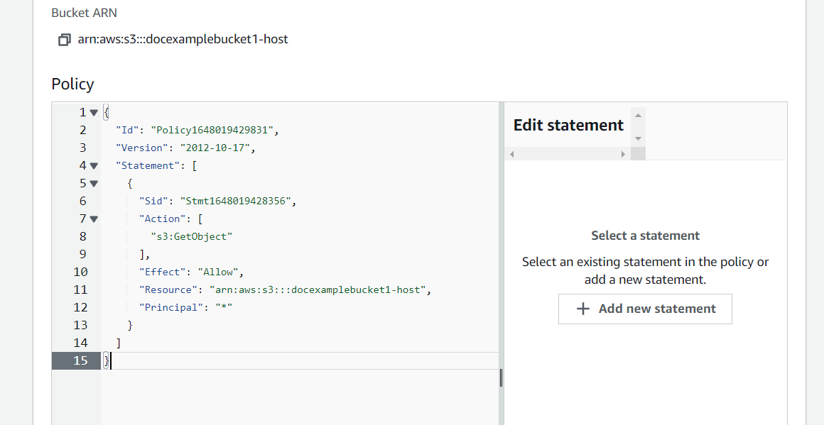

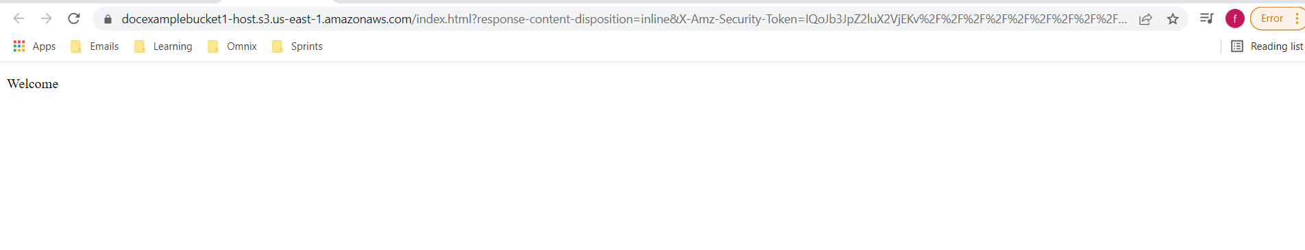

1. Create 2 EC2 (App_server, Web_server)

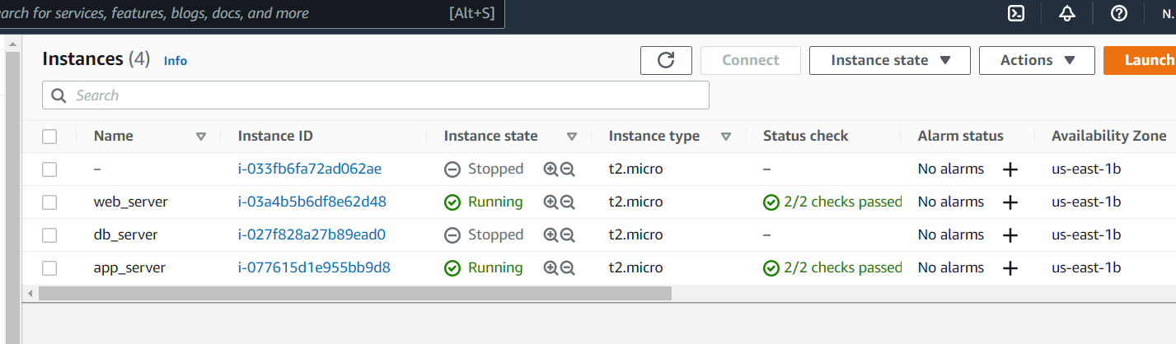

1. Create EBS volume then attach it with App_server

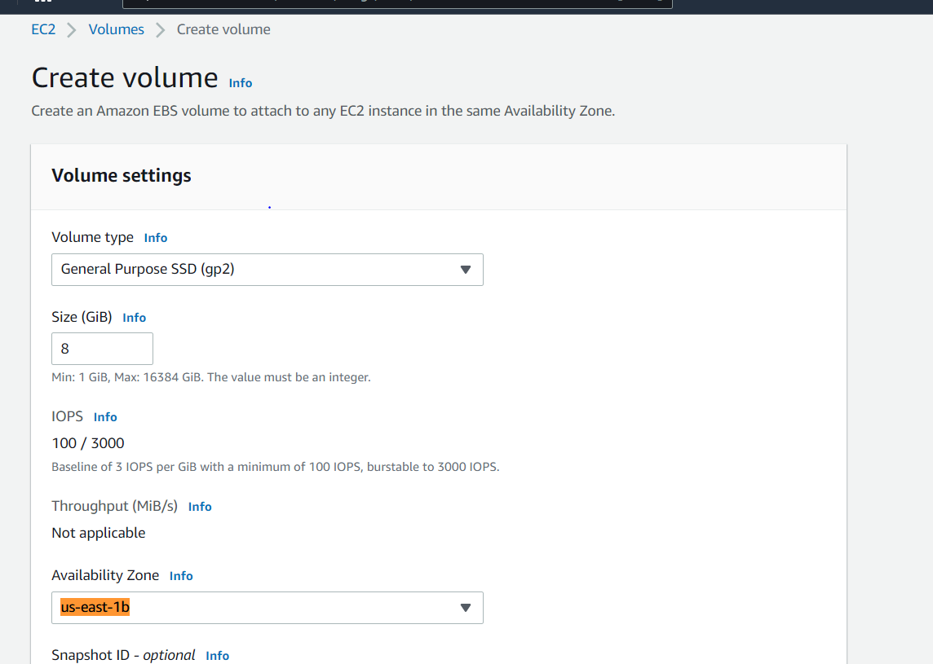

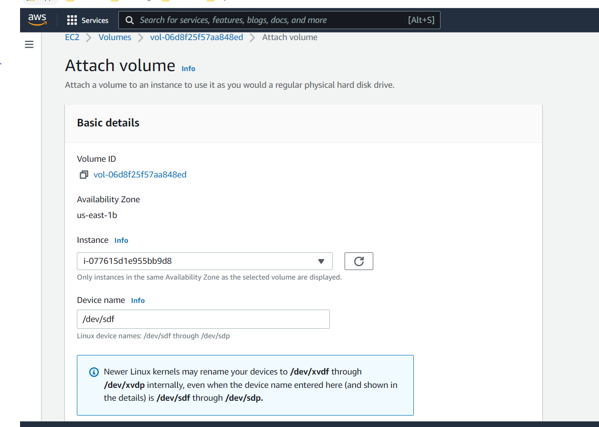

1. Create Image from App_server then create a new server from created image (Replica_App_server) in a different region

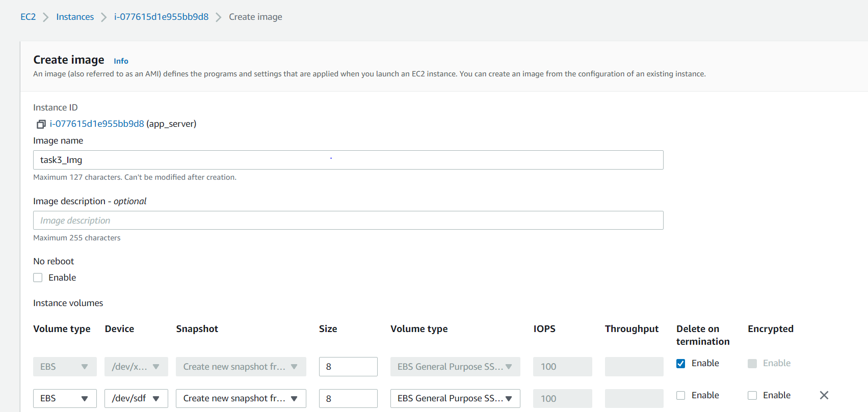

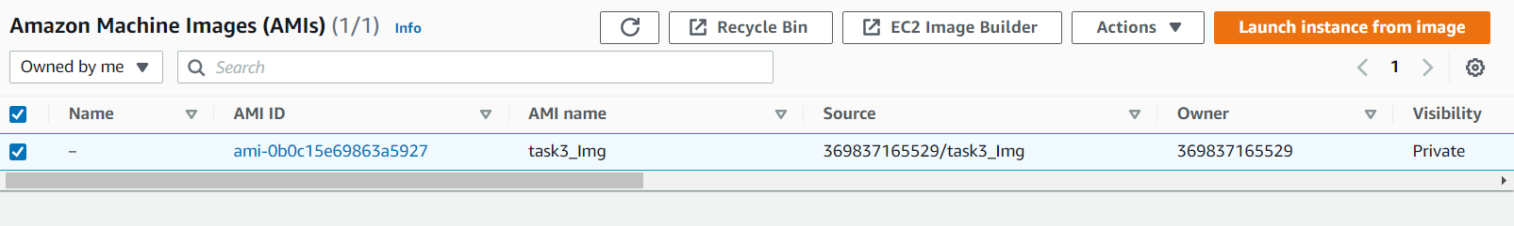

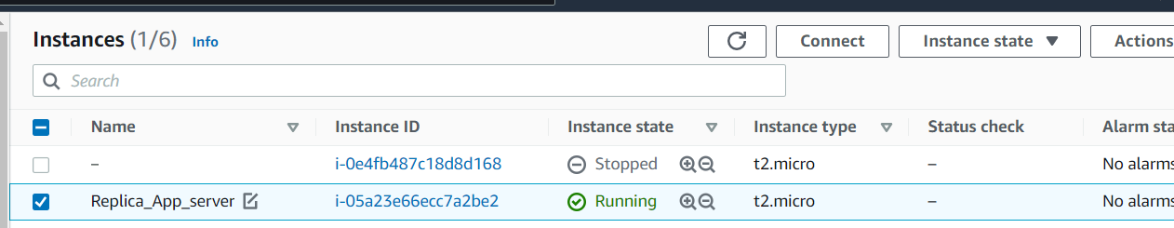

1. Create snapshot from created EBS volume in (task4)

