1. Create 2 folders in the S3 bucket (Upload_img, compressed_img), then create an alert when upload image to folder (Upload_img) trigger lambda function to compress a file and add the compressed file to (Compressed_img)

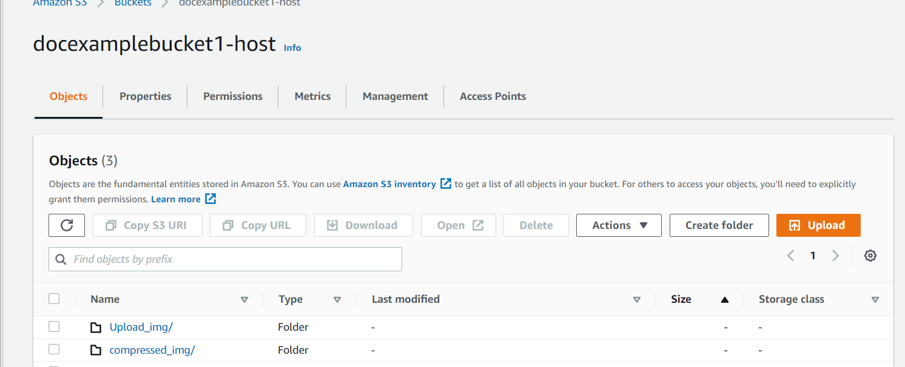

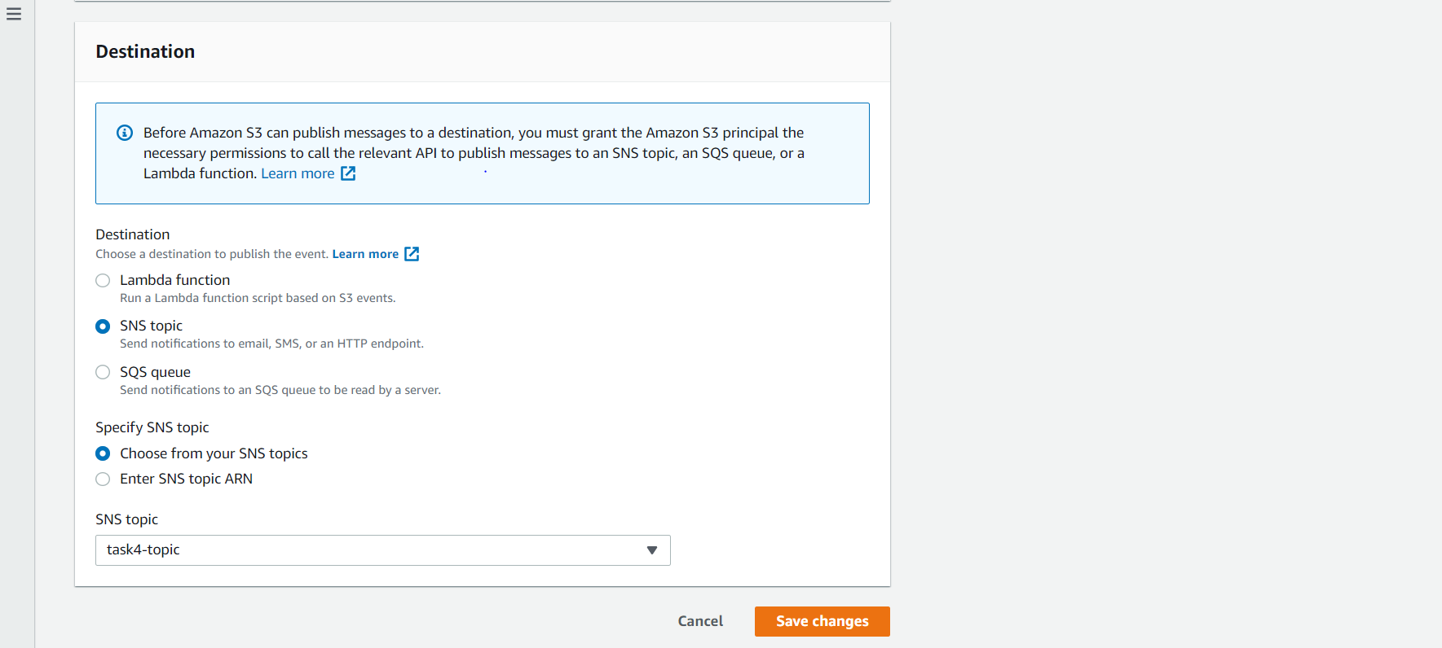

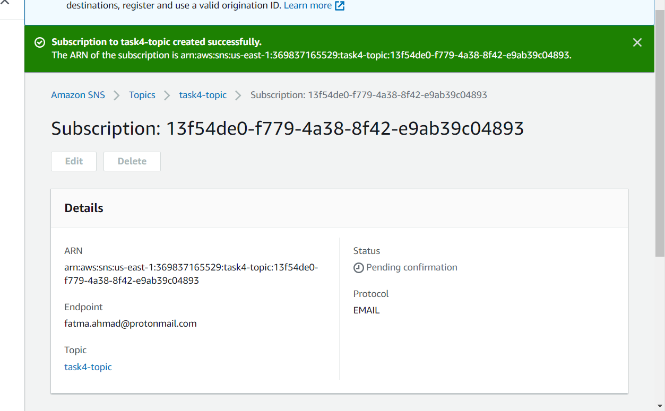

1. Create CloudFormation template for task of day2