1. Using vi write your CV in the file mycv. Your CV should include your name, age, school, college, experience.

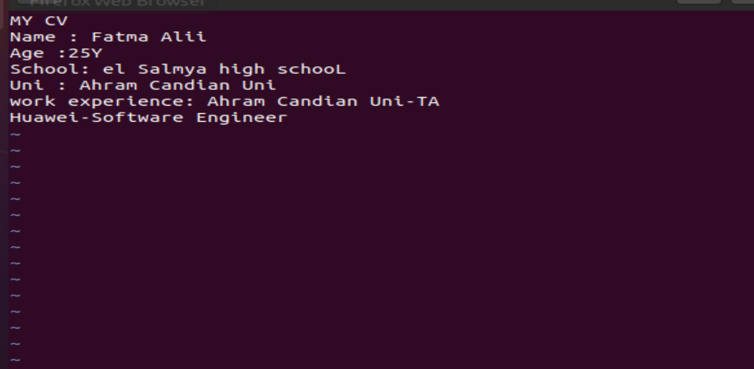

2. Open mycv file using vi command then: Without using arrows state how to:

a. Move the cursor down one line at time.

Press j

b. Move the cursor up one line at time.

Press k

c. Search for word age. 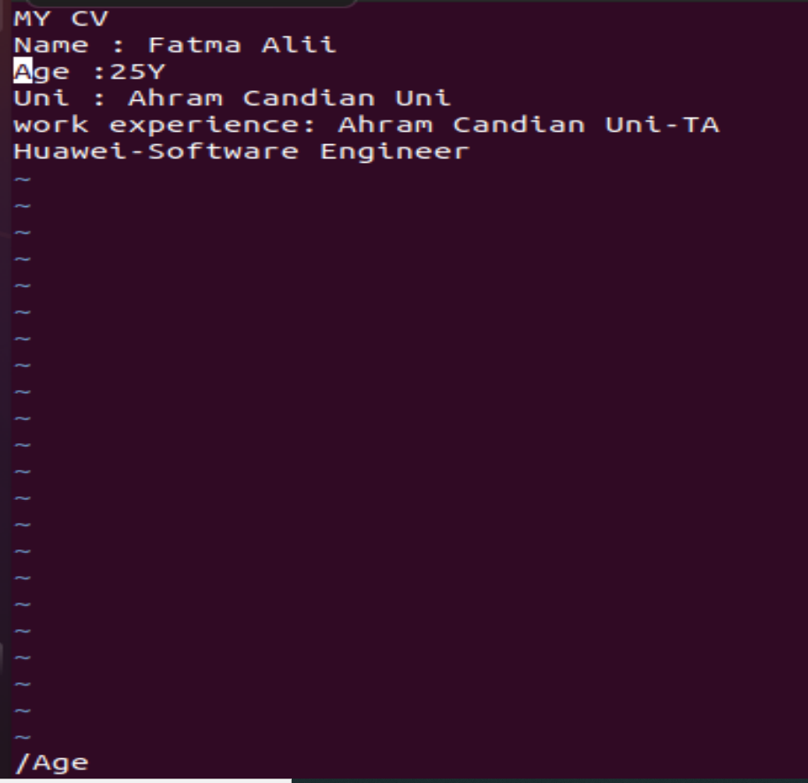

write /Age

d. Step to line 5 (assuming that you are in line 1 and file is more than 5 lines).

:5

e. Delete the line you are on and line 5.

:d

:5d

f. How to step to the end of line and change to writing mode in one-step.

Shift +G

3. List the available shells in your system.

cat /etc/shells

4. List the environment variables in your current shell.

printenv

5. List all of the environment variables for the bash shell.

printenv |grep bash

6. What are the commands that list the value of a specific variable?

Printenv variable , echo $variable .

7. Display your current shell name.

Printenv SHELL

8. State the initialization files of: sh, ksh, bash.

**Bash**

1. /etc/profile
2. /etc/bashrc
3. ~/.bash_login
4. bash_completion

**ksh**

1. /etc/profile.ksh
2. etc/suid_pro.ksh

**SH**

1. **/etc/profile**

9. Edit in your profile to display date at login and change your prompt permanently.

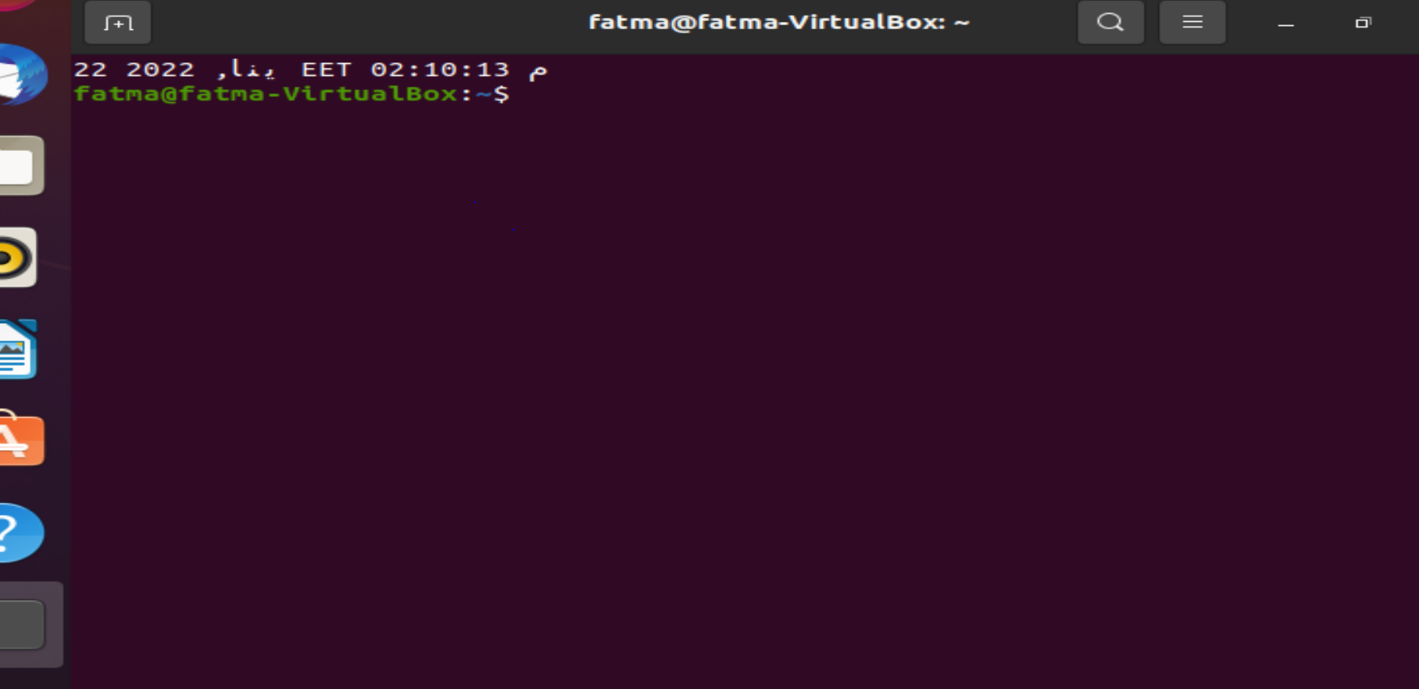

10. Create a Bash shell alias named ls for the “ls –l” command.

Alias ls=“ls –l”