01) What is Jenkins used for?

-Jenkins is an open source continuous integration/continuous delivery and deployment (CI/CD) automation software.

02) What is Jenkins agent? What is Jenkins executor (Build Executor)? An agent is typically a machine, or container, which connects to a Jenkins controller and executes tasks when directed by the controller.

An executor is a slot for execution of work defined by a Pipeline or Project on a Node. A Node may have zero or more Executors configured which corresponds to how many concurrent Projects or Pipelines are able to execute on that Node.

03) Explain Jenkins master-slave architecture? Master/slave is a model of asymmetric communication or control where one device or process (the "master") controls one or more other devices or processes (the "slaves") and serves as their communication hub.

04) Mention three security mechanisms used by Jenkins to authenticate users? -internal database to store user data and credentials.

-Lightweight Directory Access Protocol (LDAP) server to authenticate users.

-Jenkins can be configured to employ the authentication mechanism that the deployed application server uses.

05) Mention ways that a job can be run/scheduled in Jenkins?1. Choose Build trigger option “build periodically “and schedule it

2. Choose Build trigger option “Poll SCM” and schedule it.

3. click the run button

4. web hooks

06) How can we restart Jenkins server (Hint it's an endpoint we visit in the browser)?-Using the Jenkins installation URL. Jenkins_URL/restart.

- Jenkins_URL/safeRestart.

-using command line sudo service jenkins restart

07) Install jenkins with docker image.

docker run -p 8080:8080 -p 50000:50000 -v /your/home:/var/jenkins_home jenkins

08) Install role based authorization plugin. 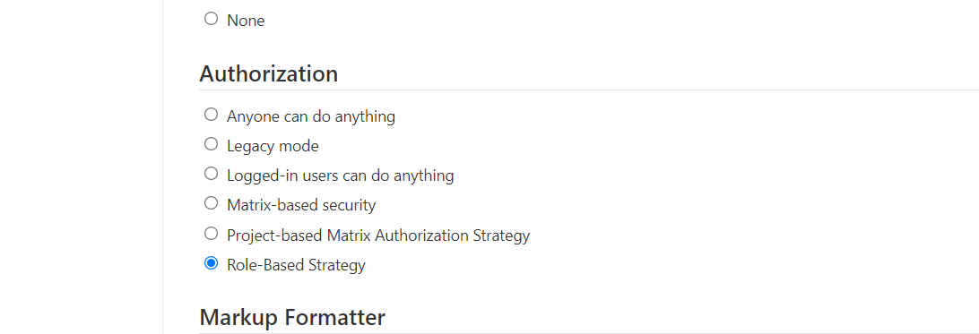

09) Create new user. 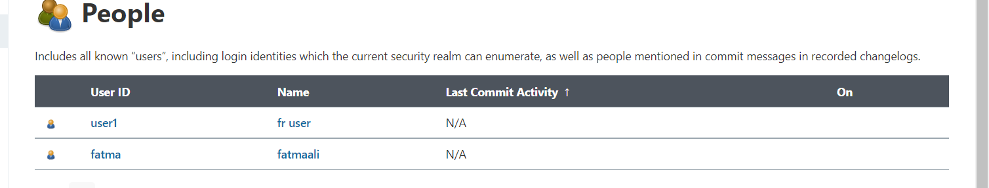

10) Create read role and assign it to the new user 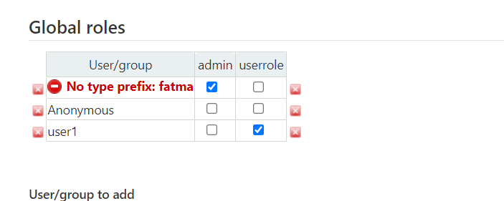

11) Create free style project and link it to private git repo(inside it create directory and create file with "hello world").

