What is the Jenkins Pipeline?

is a suite of plugins which supports implementing and integrating continuous delivery pipelines into Jenkins

02) What scripting language is Jenkins pipeline syntax based on?

Groovy programming language.

03) What are the ways you can write a pipeline in Jenkins?

1-Declarative – a new way of creating Jenkins Pipeline. Here you write groovy code containing “pipeline” blocks, which is checked into an SCM (Source Code Management)

2-Scripted – way of writing groovy code where the code is defined inside “node” blocks.

04) Create declarative in Jenkins GUI pipeline for your own repo to do "ls"

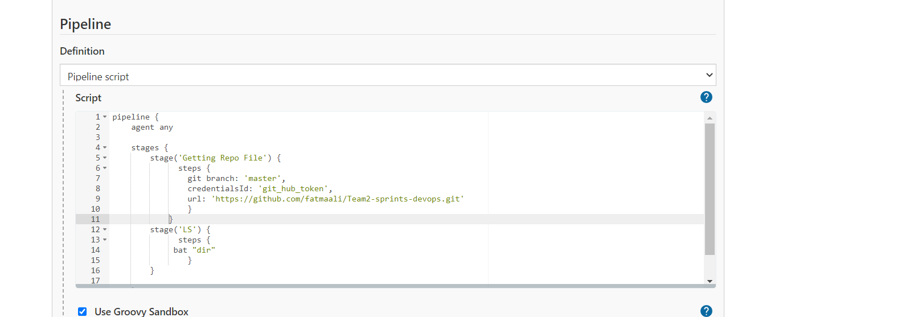 05) Create scripted in Jenkins GUI pipeline for your own repo to do "ls"

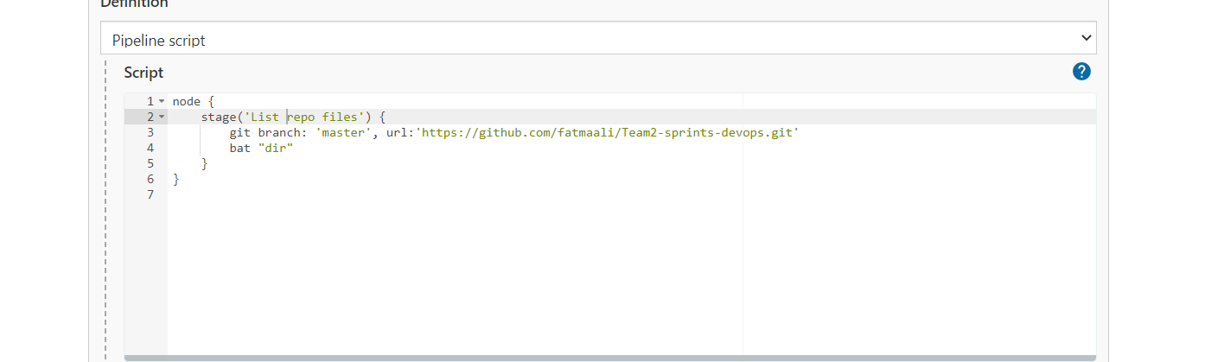

06) Create the same with Jenkins file in your branches as multi-branch pipeline

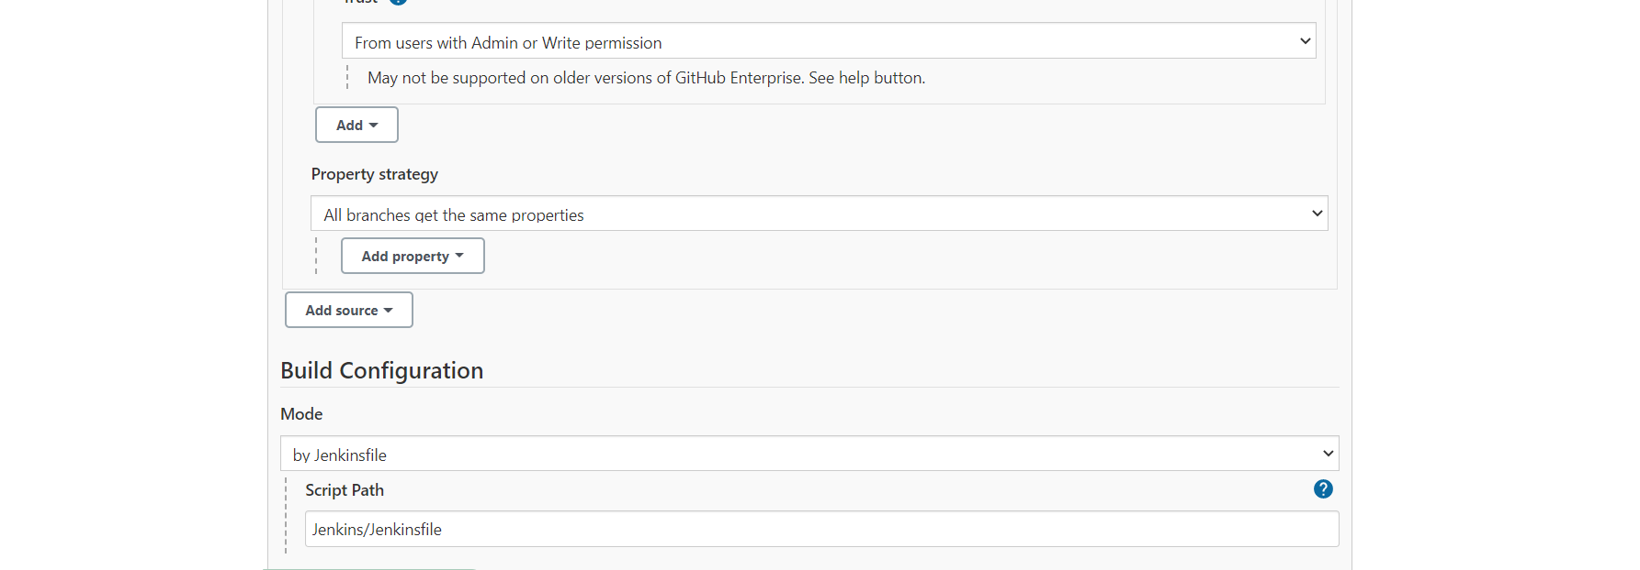07) Configure Jenkins image to run docker commands on your host docker daemon.

docker

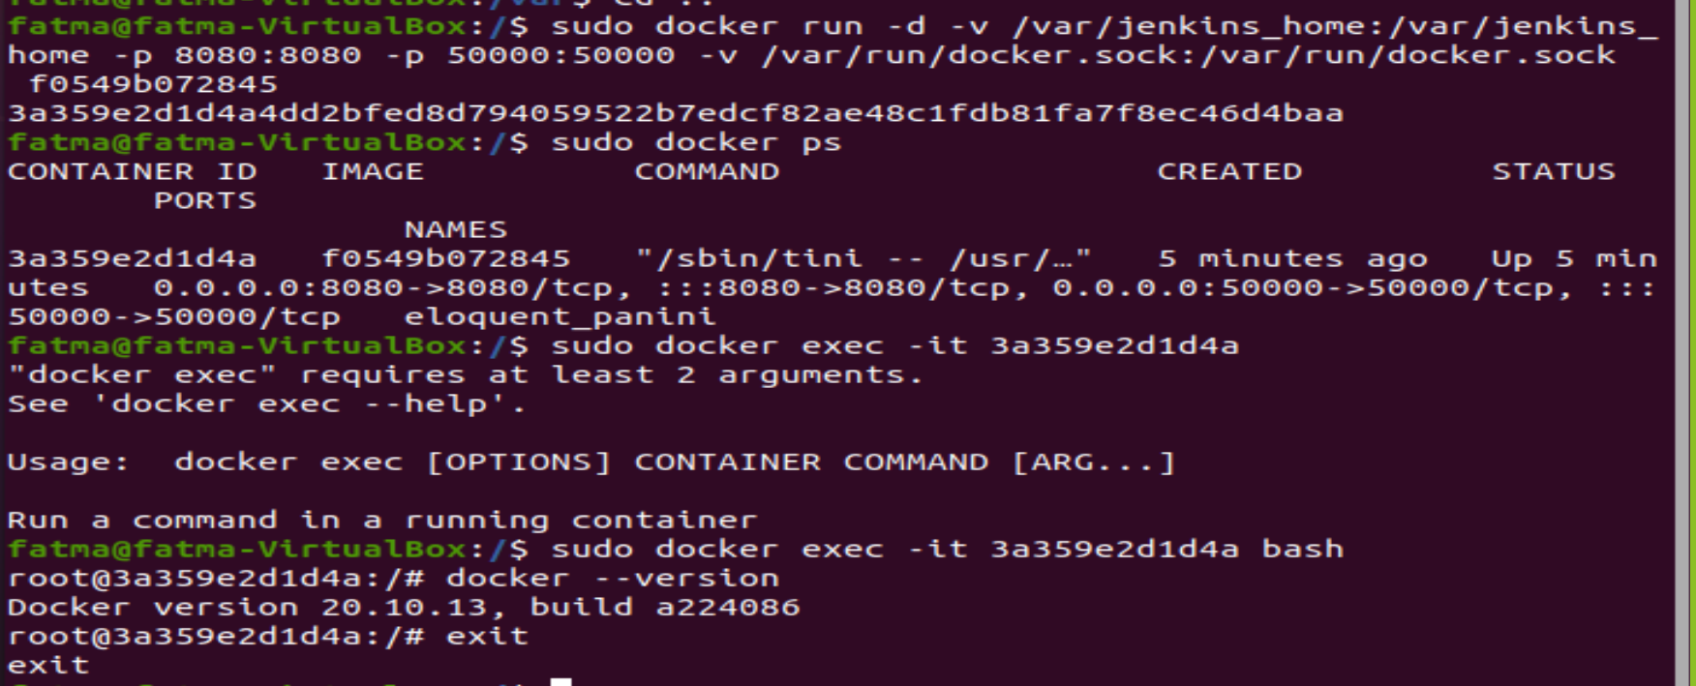

08) Create CI/CD for this repo <https://github.com/ahmedKhaled1995/simple_nodejs_app>

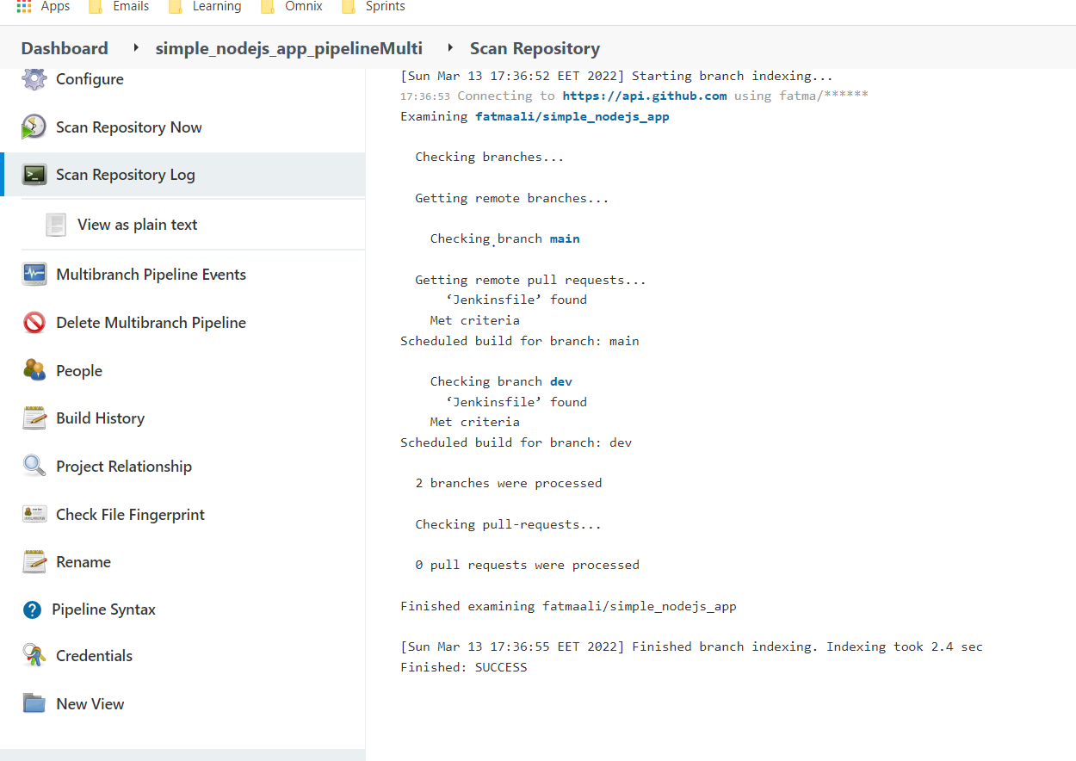

09) Using terraform:

1-Launch an EC2 instance

2-Attach a security group to that allows ssh (port 22) from anywhere (0.0.0.0./0)

3-Attach a security group to that allows traffic from port 3000 from anywhere (0.0.0.0./0)

10) Using Ansible:

1- Configure the launched EC2 instance from question 8 to have:

  a) Java 8 or higher installed

      b) Install Docker.

    4- Run the pipeline from question 8 on the Jenkins slave machine.

    5- Send pipeline status to Slack.