**GET**

**Client**

|  |  |
| --- | --- |
| **Function** | **Postman** |
| requestToEvalByID_get | Api2/…… |
| requestByClientID_get |  |
| listRatingProductID_get |  |
| categoryByID_get |  |
| clientByID_get |  |
| category_get |  |
| ListmessgClientID_get |  |
| forgetPC_get |  |
| featuredProducts_get |  |
| MyInterest_get |  |

**Eval**

|  |  |
| --- | --- |
| **Function** | **Postman** |
| requestEvaluatedByEvID_get | Mroogle/Api2/requestEvaluatedByEvID?ID=1&Start=1 |
| requestNotEvaluatedByEvID_get | Mroogle/Api2/requestNotEvaluatedByEvID?ID=1&Start=1 |
| ListEvaluatorByCateg_get | Mroogle/Api2/ ListEvaluatorByCateg?catID=1&Start=1 (to verify result) |
| ListEvaluatorByCategCH_get | Mroogle/Api2/ ListEvaluatorByCategCH?catID=1&Start=1&ch=e (to verify result) |
| forgetPE_get | [Mroogle/Api2/forgetPE?evaluatorEmail=evaluator@evaluator.com](mailto:Mroogle/Api2/forgetPE?evaluatorEmail=evaluator@evaluator.com) (smtp error) |
| evalByCH_get | Mroogle/Api2/ evalByCH?ch=e&idev=1 |

**POST**

**Client**

|  |  |
| --- | --- |
| **Function** | **Postman** |
| addProduct_post | Mroogle/Api2/addProduct (PIC 1) |
| updateClient_post | Mroogle/Api2/updateClient (PIC 2) |
| updateClientPicture1_post | Mroogle/Api2/updateClientPicture1 (PIC 3) |
| addMessageC2C | Mroogle/Api2/ addMessageC2C (PIC 4) |

**Eval**

|  |  |
| --- | --- |
| **Function** | **Postman** |
| updateEv_post |  |
| updateEvPicture1_post |  |
| updateeval_post |  |

Pic 1:

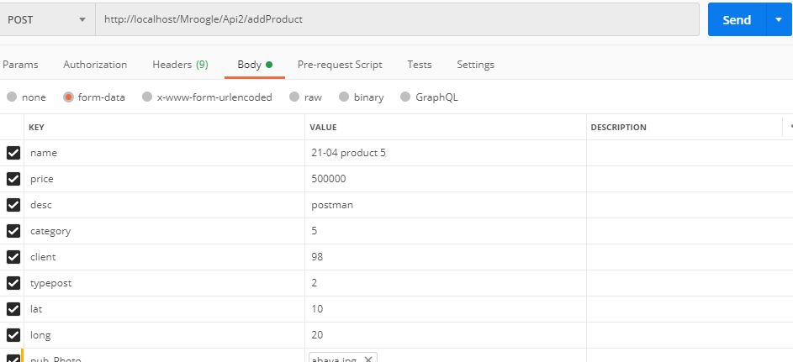

Pic 2:

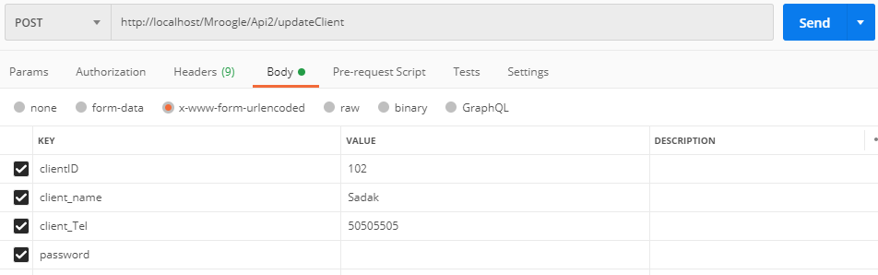

Pic 3:

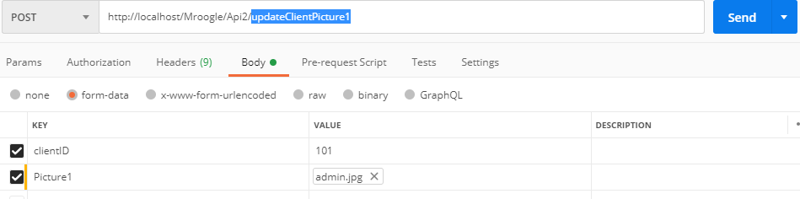

Pic 4:

