Revision Exercises
Exercise 1:
A member of the local network Rx_LAN, a student at the faculty, disconnected the cable connected to the local computer "machine 1" in the laboratory from port Fa/01 of the switch in order to connect his laptop and send data, but the transmission was unsuccessful.
Switch#show port-security interface fa0/1
Port Security : Enabled
Port Status : Secure-shutdown Violation Mode : Shutdown
Aging Time : 0 mins
Aging Type : Absolute SecureStatic Address Aging : Disabled Maximum MAC Addresses 1
Total MAC Addresses 1
Configured MAC Addresses 1
Sticky MAC Addresses 0
Last Source Address:Vlan : 0090.cc0e.5023:1 Security Violation Count 1
- Explain why the data transmission was unsuccessful.
…………………………………………………………………………………………………
…………………………………………………………………………………………………
…………………………………………………………………………………………………
- If the student attempts to reconnect the local computer "machine 1", what would happen? Describe the expected results.
…………………………………………………………………………………………………
…………………………………………………………………………………………………
…………………………………………………………………………………………………
- Which frame switching method at the switch level helps reduce the error and collision rate?
…………………………………………………………………………………………………

Exercise 2 :
Your company is planning to implement an EtherChannel network. In this context, you are trying to explain to the network engineers on your team how an EtherChannel operates and what it looks like once configured at the physical level.
- Mention two advantages obtained through the use of EtherChannel
.……………………………………………………………………………………………………
……………………………………………………………………………………………………
- Mention two requirements needed to configure an EtherChannel between two switches.?
……………………………………………………………………………………………………
……………………………………………………………………………………………………
……………………………………………………………………………………………………
……………………………………………………………………………………………………

- Fill in the following table with the appropriate mode corresponding to the PAgP or LACP negotiation description (Active, Auto, Active, Passive, Desirable, or On)

Configured Mode | Description
 | Places an interface in a passive response state. Does not initiate PAgP negotiation.
 | Initiates LACP negotiations with other interfaces.
 | Actively initiates PAgP negotiations with other interfaces.
 | Forces the EtherChannel state without any negotiation initiated by PAgP or LACP.

Exercise 3:
The company Global Tech Solutions (GTS) is composed of three distinct blocks. Its computer network is represented by the topology shown in the following figure. Three virtual networks (VLAN10, VLAN20, and VLAN30) have already been created by the network administrator.

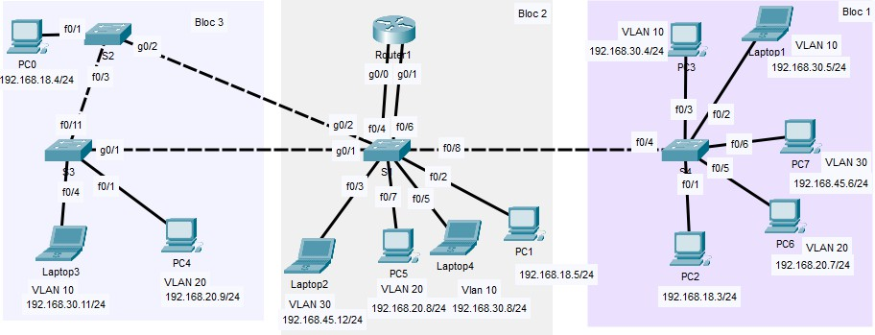

- Before starting to transfer data from Laptop1 to PC3, the administrator launched a ping request from Laptop1 to PC3 to test connectivity. The attempt was unsuccessful.
  - By examining the following screenshots, identify the cause of the connection failure between Laptop1 and PC3.
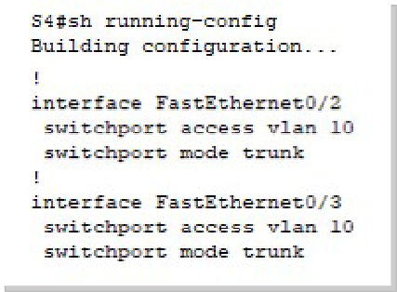
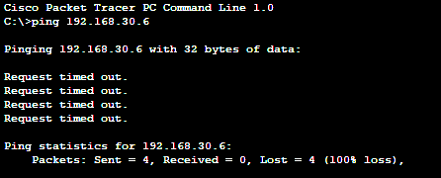
……………………………………………………………………………………………………

  - Propose a solution to establish connectivity between Laptop1 and PC3.
.…………………………………………………………………………………………………………

- For security reasons, the company GTS must restrict communication between devices belonging to VLAN 30 within the same block. Any inter-block communication for VLAN 30 will be limited. Propose a solution.
……………………………………………………………………………………………………..
- For communication between PC1 and PC2, what is the VLAN Identifier (VID) added to the frame tag sent between switches S1 and S4?
……………………………………………………………………………………………………..

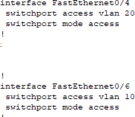
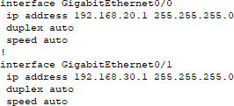
- ConsidéronsLet us consider the following configurations performed on the router and switch S1 of the topology.

- Identify which devices can communicate thanks to this configuration. Justify your answer.

……………………………………………………………………………………………………
……………………………………………………………………………………………………..

- The DTP protocol is used on the different switches in the topology. Explain how this protocol can be used to simplify the deployment of new switches in the company network.
……………………………………………………………………………………………………
……………………………………………………………………………………………………
……………………………………………………………………………………………………..

Exercise 4 :
The company Infotec is a software publishing company composed of three departments:
1- Administrative department
2- Development department
3- Sales department
The diagram below shows that the offices of the different departments are distributed across the 3 floors.

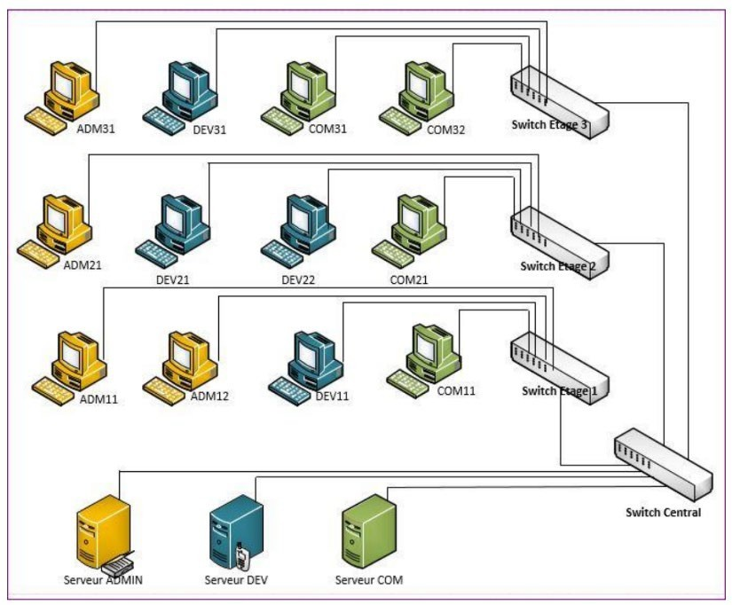
- What is a VLAN and what are the main advantages of using VLANs in a local area network?
…………………………………………………………………………………………………………
…………………………………………………………………………………………………………
…………………………………………………………………………………………………………
…………………………………………………………………………………………………………
- To logically separate traffic from different departments, we want to implement port-based VLANs. Explain how VLAN segmentation contributes to LAN security?
…………………………………………………………………………………………………………
…………………………………………………………………………………………………………
…………………………………………………………………………………………………………
…………………………………………………………………………………………………………
- What solution allows dynamic management of enabling/disabling trunk mode on a network switch port? Can a trunk be established on a link if one of the ports is configured in nonegotiation mode? Why?
…………………………………………………………………………………………………………
…………………………………………………………………………………………………………
- What type of VLAN is used by an administrator to access a switch and troubleshoot it?
…………………………………………………………………………………………………………
…………………………………………………………………………………………………………
- The ADM31 workstation sends a message to ADM21. Explain how this frame will be processed on the inter-switch links.
…………………………………………………………………………………………………………
…………………………………………………………………………………………………………

Exercise 5 :
You are a newly hired system and network administrator in a company whose network architecture is as follows (see the figure below):
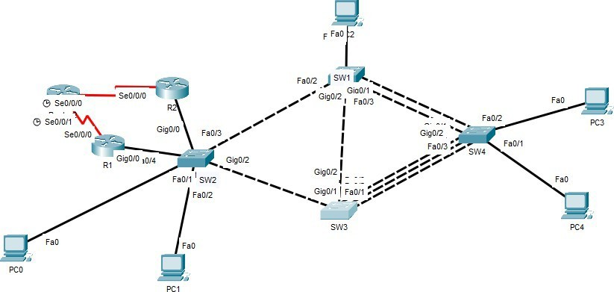
Figure: Company network topology
- What are the two main advantages of using EtherChannel in a network infrastructure? …………………………………………………………………………………………………
…………………………………………………………………………………………………
- Based on the following configurations, which aggregation protocol is used between SW4 and SW3? Justify your answer.

……………………………………………………………………………………………………
……………………………………………………………………………………………………

  - If one of the member ports of an EtherChannel goes into an error-disabled state (err-disabled), what happens to the other member ports? Does the EtherChannel continue to function?
……………………………………………………………………………………………………
……………………………………………………………………………………………………
  - Based on the following configurations, explain why the EtherChannel between the two switches was not established.

………………………………………………………………………………………………………
- If the company uses network equipment from different vendors (Cisco, HP, Juniper, etc.), which standard protocol can be used to configure a compatible link aggregation? Justify your choice.
……………………………………………………………………………………………………..

Exercise 6 :
Given the following topology:
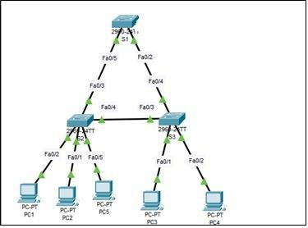
The network administrator has created and configured 3 VLANs on switches S1, S2, and S3 as follows:

Vlan | Nom | Adresse IP | Pc
Vlan 40 | Finance | 172.17.40.0/24 | PC1
Vlan 43 | IT | 172.17.43.0/24 | PC2, PC3
Vlan 42 | Marketing | 172.17.42.0/24 | PC4, PC5

- What type are VLANs 40, 43, and 42?
………………………………………………………………………………………………………
- What happens when a broadcast Ethernet frame is sent by PC4? Which device(s) will receive this frame? Justify your answer.
……………………………………………………………………………………………………
……………………………………………………………………………………………………
- Referring to the following illustrations, why can PC4 communicate with PC5, while PC2 cannot communicate with PC3?
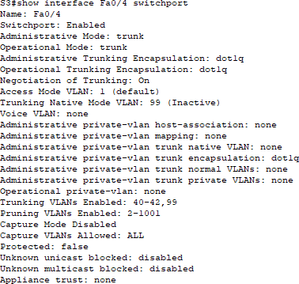
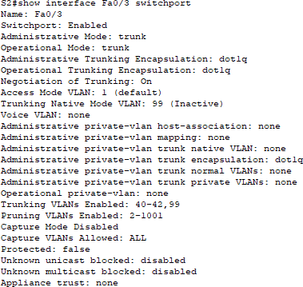
………………………………………………………………………………………………………

- Explain the difference between a trunk link and an access link?
………………………………………………………………………………………………………
………………………………………………………………………………………………………

- What protocol allows dynamic negotiation of trunk links between Cisco switches?
………………………………………………………………………………………………………

- What type of VLAN should the administrator use to allow untagged traffic to pass over a trunk link?
………………………………………………………………………………………………………

- The communication between PC1 (Finance VLAN) and PC5 (Marketing VLAN) is an inter-VLAN communication, because the two PCs belong to different VLANs, meaning they are in different logical networks and require routing to communicate?
……………………………………………………………………………………………………
- Based on the following topology and the configuration of R1 and S1:
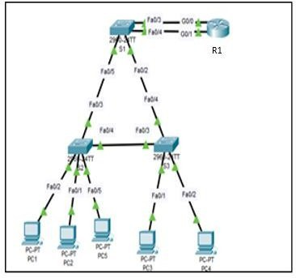
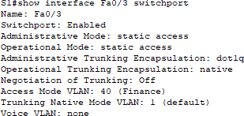
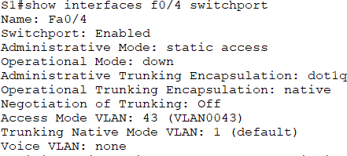

  - What type of inter-VLAN routing is used in this configuration? Justify your answer.
………………………………………………………………………………………………………
………………………………………………………………………………………………………
  - What is the limitation of this routing solution chosen by the administrator?
………………………………………………………………………………………………………

  - Which PCs are affected by this configuration??

Vlan 40 | Finance | 172.17.40.0/24 | …………...
Vlan 43 | IT | 172.17.43.0/24 | …………...

9

