* **Are Python Classes have Protected Methods or Variables ???!!!**

**YES, Python Classes have Protected Variables and Methods.**

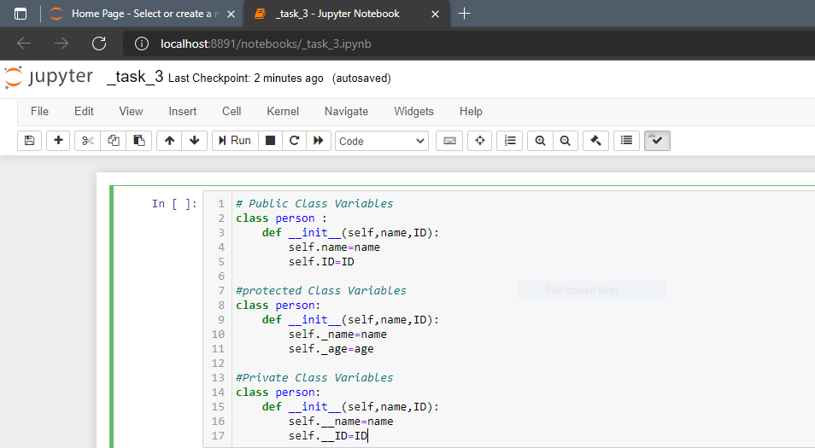

* **But there are no protected classes in python only members of the class can use this access modifier.**