Task_1

Comparison between Power Bi and Tableau !!

|  |  |
| --- | --- |
| **Tableau** | **Power BI** |
| Tableau BI can handle a huge volume of data with better performance. | Power BI can handle a limited volume of data. |
| Tableau platform is known for its data visualization functionality. The users can use 24 different types of visualizations in Tableau. | PowerBi offers numerous data points to offer data visualization. lt is offering more than 3500 data points for drilling down the dataset. |
| Tableau has excellent customer support. It has a large community forum for discussions. | Power Bl provides limited customer support to its users with a free Power Bl account. However, the paid version users will get faster support compared with the free version. |
| Tableau works best when there is a vast data in the cloud. | Power Bl doesn’t work better with a massive amount of data |
| Analysts and experienced- users mostly use for their analytics purposes. | It is used by both naive and experienced users. |
| Tableau is a little difficult. | Power BI Interface is very easy to learn. |
| The information can be stored by using the Tableau server. | Power BI concentrates more on reporting and analytical modeling but not for storing the data. |
| Suitable for medium & Large type of Organisation. | Suitable for Small, medium & large type of organization. |
| Tableau deploys MDX for measures and dimensions. | Power BI uses DAX for calculating and measuring columns. |
| Tableau can connect to numerous data sources. | Power BI connects limited data sources while increasing its data source connectors in monthly updates. |
| Embedding report is a real-time challenge in Tableau | Embedding report is easy with Power BI. |

So we can say that tableau is more better than power bi

Task_2

What is Histogram?!

A [Histogram](https://www.data-to-viz.com/graph/histogram.html) represents the distribution of a numeric variable for one or several groups. The values are split in bins, each bin is represented as a bar. And this can be represented by seaborn or matplotlib

1. Using seaborn :

Seaborn is definitely the best library to quickly build a histogram thanks to its distplot().

Ex::

# library & dataset

import seaborn as sns

df = sns.load_dataset('iris')

# Plot the histogram thanks to the distplot function

sns.distplot( a=df["sepal_length"], hist=True, kde=False, rug=False )

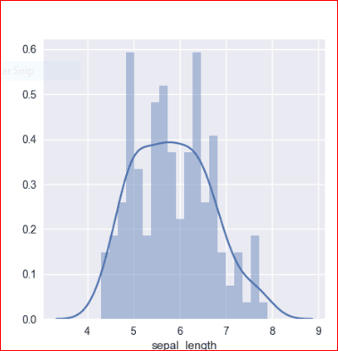

1. [Matplotlib](https://python-graph-gallery.com/matplotlib) can also build decent histograms easily. It provides a hist() function that accept a vector of numeric values as input.

Ex::

# library & dataset

import matplotlib.pyplot as plt

hours = [17, 20, 22, 25, 26, 27, 30, 31, 32, 38, 40, 40, 45, 55]

# Initialize layout

fig, ax = plt.subplots(figsize = (9, 9))

#plot

ax.hist(hours, bins=5, edgecolor="black");

